**RESPONSES OF SURVEY**

(130 RESPONSES)

1. **I have read and understood what is written above. Under these conditions, I voluntarily consent to participate in the research and to use the data obtained from my participation by the research team, without any pressure,**

Formlar yanıt grafiği. Soru başlığı: Yukarıda yazılanları okudum ve anladım. Bu koşullarda söz konusu araştırmaya gönüllü olarak katılmayı ve katılımımdan elde edilen verilerin araştırma ekibince kullanılmasını, hiç bir baskı altında olmaksızın kendi rızamla, 
. Yanıt sayısı: 130 yanıt.

I accept and agree.

**SECTION 1**

1. **Your age,**

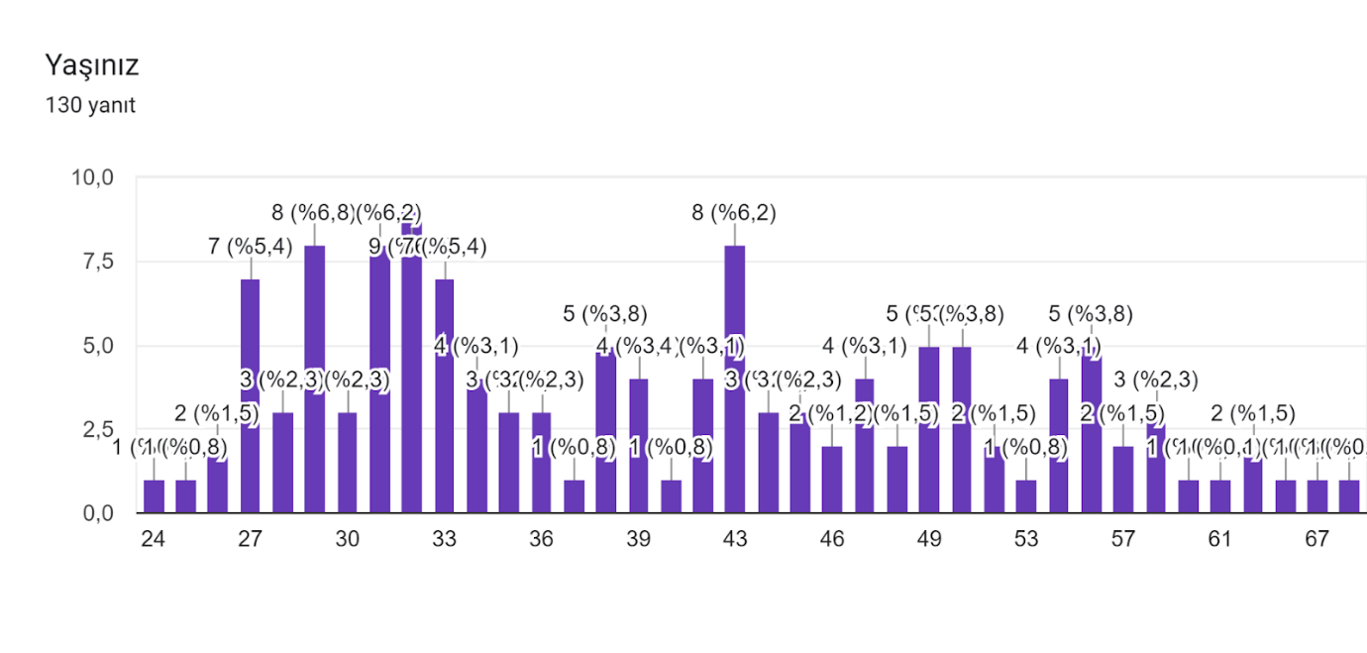

1. **Your gender,**

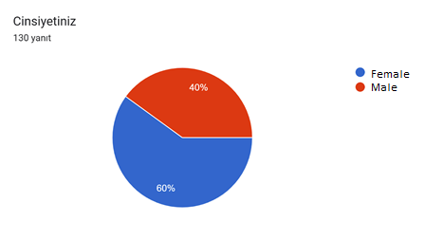

1. **What is your role in the laboratory?**

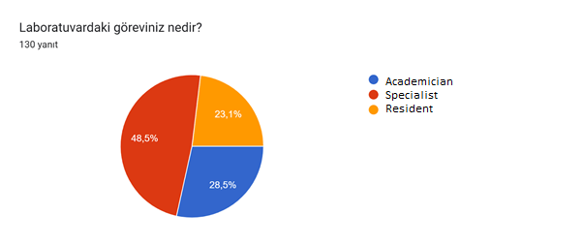

1. **Which of the following is the organization you work for?**

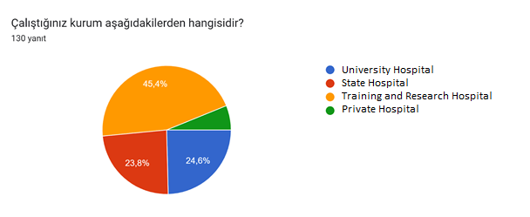

1. **How many years have you been working in this field?**

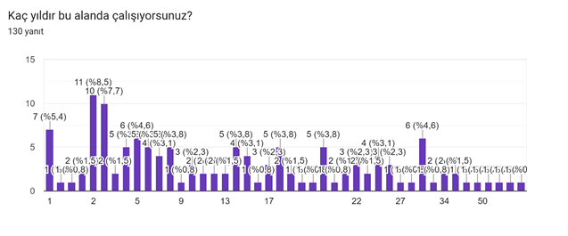

1. **Have climate change, global warming or sustainability issues been included in your professional training?**

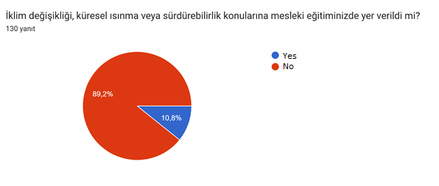

**SECTION 2**

1. **'Sustainable development is development that meets the needs of the present without preventing future generations from meeting their needs.'**

**Have you ever heard of the concept of sustainability in the above statement?**

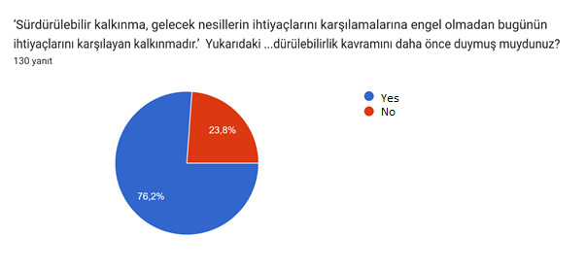

1. **Regulations in which areas in medical laboratories contribute to sustainability? You can select more than one option.**

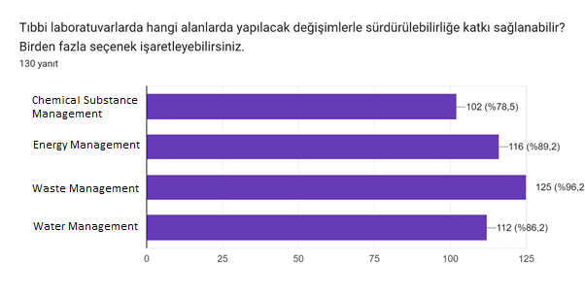

1. **The concept of Green Chemistry, defined as 'the design of chemical products and processes that reduce and/or eliminate the use or production of hazardous substances' and the twelve principles of green chemistry were developed by Paul Anastas and John Warner in the late 1990s.'**

**Have you heard of the concept of Green Chemistry in the statement above?**

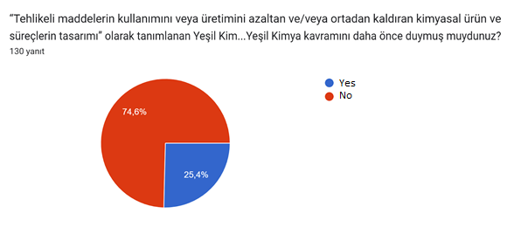

1. **Which or which of the following information do you know?**

**Please mark them.**

***Check all that apply***

1. Chemical waste is one of the most important pollutants affecting soil, water and air quality, accounting for 3% of all healthcare-related waste.
2. Roughly 60% of the more than 100,000 chemicals on the European Union market are considered hazardous to the environment and/or human health.
3. Every year €157 billion is spent on chemicals that affect the endocrine system and cause disorders, of which only 1.5 billion is related to female reproductive diseases.

None

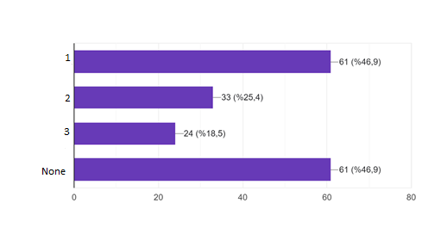

1. **Which or which of the following information do you know?**

**Please mark them.**

***Check all that apply***

1. It is estimated that most existing labs could reduce their energy consumption by 30 to 50% using new technology.
2. The average email has a carbon footprint of between 4-50 g CO₂ depending on attachments.
3. Fume hoods consume about as much energy per day as several houses and biological safety cabinets about half the energy of a house.
4. LED bulbs provide the same light intensity, last longer and use 50% less energy than fluorescent bulbs.
5. Screen savers increase energy use because they require processing power and memory.

None

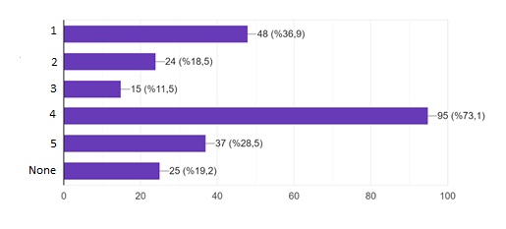

1. **Which or which of the following information do you know?**

**Please mark them.**

***Check all that apply***

1. In the United States (US), the cost of healthcare waste disposal accounts for 25% of global healthcare sector spending.
2. Globally, the production and incineration of plastics is estimated to have released more than 850 million tons of greenhouse gases into the atmosphere in 2019.
3. The most widely recyclable plastics are polystyrene (PS), polypropylene (PP) and high density or low-density polyethylene (HDPE/LDPE).
4. Europe has by far the highest collection and recycling rate of electronic waste at 42.5%.
5. None

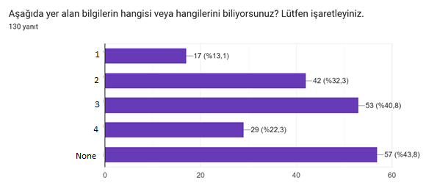

1. **Which or which of the following information do you know?**

**Please mark them.**

***Check all that apply***

1. The water crisis is identified as the most serious global risk for the next decade.
2. Paper with recycled content reduces water consumption in papermaking by around 60%.
3. Low-flow aerators are small, very inexpensive devices that simply screw onto the faucet, reduce flow to 1.5 to 0.5 gallons/minute and mix the flow with air, reducing water waste without impairing water use productivity.
4. None

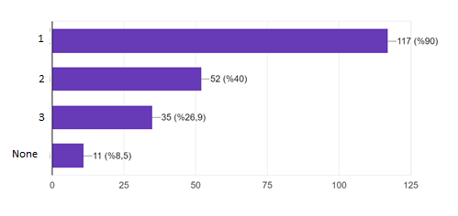

**SECTION 3**

1. **Which or which of the following practices do you individually apply frequently in the laboratory?**

***Check all that apply***

1. I do not store chemicals in a fume hood.
2. I use my personal protective equipment appropriately when working with hazardous substances.
3. When using more than one chemical substance in the laboratory, I prefer the older one.
4. None of them

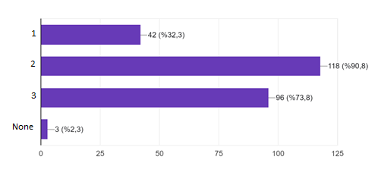

1. **Which or which of the following practices do you individually apply frequently in the laboratory?**

***Check all that apply***

1. I turn off lights, computers, instruments and equipment at the end of the day or when they are not in use.
2. I make sure that sleep mode is enabled on the computer and printer I use.
3. I do not use a screen saver on the computer I use.
4. I print only when necessary.
5. I always use a timer when using equipment such as water baths and heating blocks.
6. I turn off fume cupboards when not in use.
7. I make sure doors and windows are closed when air conditioning units are running.
8. To reduce individual carbon footprints, I use public transportation, shared car or bicycle.
9. None of them

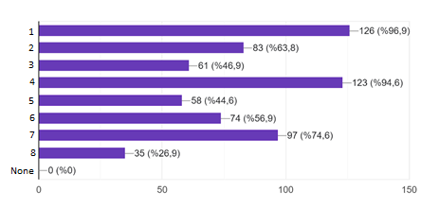

1. **Which or which of the following practices do you individually apply frequently in the laboratory?**

***Check all that apply***

1. I prefer to use glass instead of plastic as much as possible.
2. I try to decontaminate gloves with ethanol to use them longer and reduce glove waste.
3. I make sure that the waste generated in the laboratory is disposed of in appropriate waste bins
4. None of them

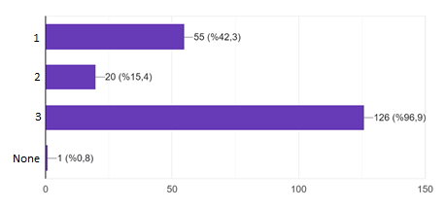

1. **Which or which of the following practices do you individually apply frequently in the laboratory?**

***Check all that apply***

1. I always turn off the taps when not in use.
2. When necessary, I rinse bulky glassware or equipment with normal tap water and use deionized water at the last stage.
3. When I notice water leakage in the laboratory, I immediately notify the relevant places I make sure the problem is fixed.
4. None

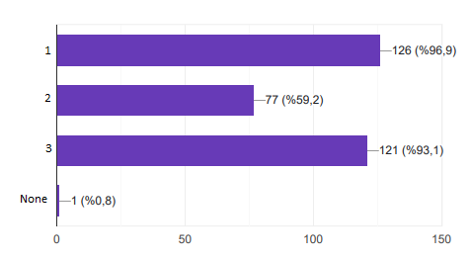

**SECTION 4**

1. **Which or which of the following applications are included in your laboratory?**

***Check all that apply***

1. Chemical inventory is kept regularly in our laboratory.
2. Chemicals and reagents are used on a first-in, first-out basis according to their dates.
3. Standard Operating Procedures for chemical waste are available and implemented in our laboratory.
4. Laboratory test requests are audited to determine unnecessary test requests and rates.
5. None

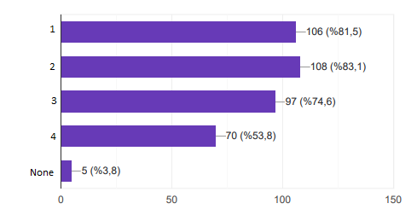

1. **Which or which of the following applications are included in your laboratory?**

***Check all that apply***

1.The vehicles and routes used to transport samples in our laboratory are selected to be fuel-efficient and their use is regularly reviewed.

2. Sensor lighting mechanisms are available in areas such as corridors, restrooms and storage areas in our laboratory.

3. Refrigerators and freezers are emptied and thawed regularly.

4. In our laboratory, energy-efficient purchase of new equipment and instrumentation (star-rated devices) is essential in the tender process.

5. None

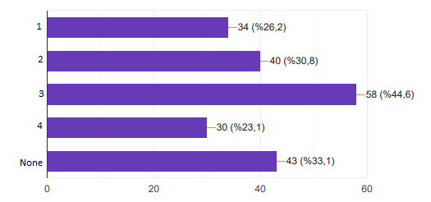

1. **Which or which of the following applications are included in your laboratory?**

***Check all that apply***

1. After the supply of instruments and equipment, suppliers take back packaging materials for reuse or recycling.
2. Our laboratory has a system for storing recyclable waste such as plastic and paper in separate areas.
3. Separate management for biological and non-biological wastes in our laboratory strategy is available.
4. None

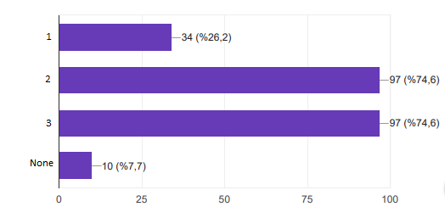

1. **Which or which of the following applications are included in your laboratory?**

***Check all that apply***

1. In our laboratory, there are faucets that open and close automatically with sensors.
2. The plumbing system in our laboratory is regularly maintained and controlled.
3. Care is taken to ensure that systems such as dishwashers, autoclaves and sterilizers are operated at full capacity in our laboratory.
4. None

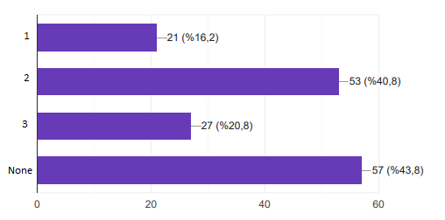

**SECTION 5**

1. **Have you heard of the Green and Sustainable Medical Laboratory Guide published by EFLM, which aims to bring together and share practices to guide laboratories in transitioning to more sustainable spaces without compromising quality? Your answer is yes please answer the next question.**

***Check only one option.***

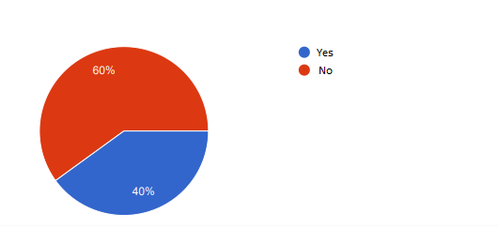

1. **Have you made an application in your laboratory using the Green and Sustainable Medical Laboratory Guide? If your answer is yes, do you want to move on to the next please answer the question.**

***Check only one option.***

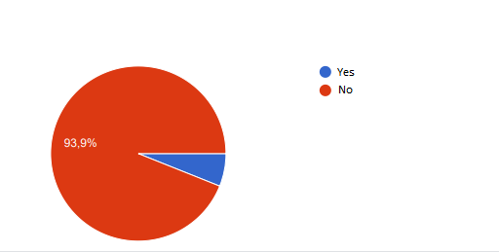

1. **Can you briefly tell us about your practice?**

* Turning off unused appliances and lights to save energy
* Defrosting refrigerators
* Giving a conference
* Promoting saving and recycling
* Reducing electricity consumption
* Reducing water use

1. **Would you consider implementing an application in your laboratory using the Green and Sustainable Medical Laboratory Guidelines published by EFLM?**

***Check only one option.***

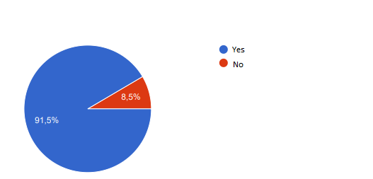

1. **Would you like to be a part of this working group if a study on becoming a Sustainable and Green Laboratory is initiated in your laboratory?**

***Check only one option.***

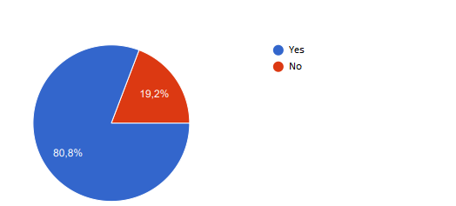

1. **In any working group within the scope of Sustainable and Green Laboratory are you involved?**

***Check only one option.***

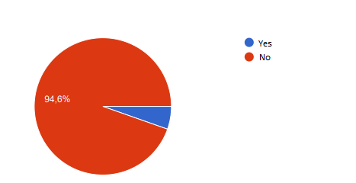

1. **The challenges we may face on the way to becoming a sustainable and green laboratory in our country What do you think is the most common barrier?**

***Check only one option.***

metin, ekran görüntüsü, yazı tipi, diyagram içeren bir resim

Açıklama otomatik olarak oluşturuldu

1. **Which of the following do you think is the most difficult obstacle to overcome to become a sustainable and green laboratory in our country?**

***Check only one option.***

metin, ekran görüntüsü, yazı tipi, diyagram içeren bir resim

Açıklama otomatik olarak oluşturuldu