**Supplementary Material**

**Synthesis of PEITC-loaded gold nanoparticles and evaluation of the hepatoprotective effect on CCl4-induced damage through Nrf2 pathway**

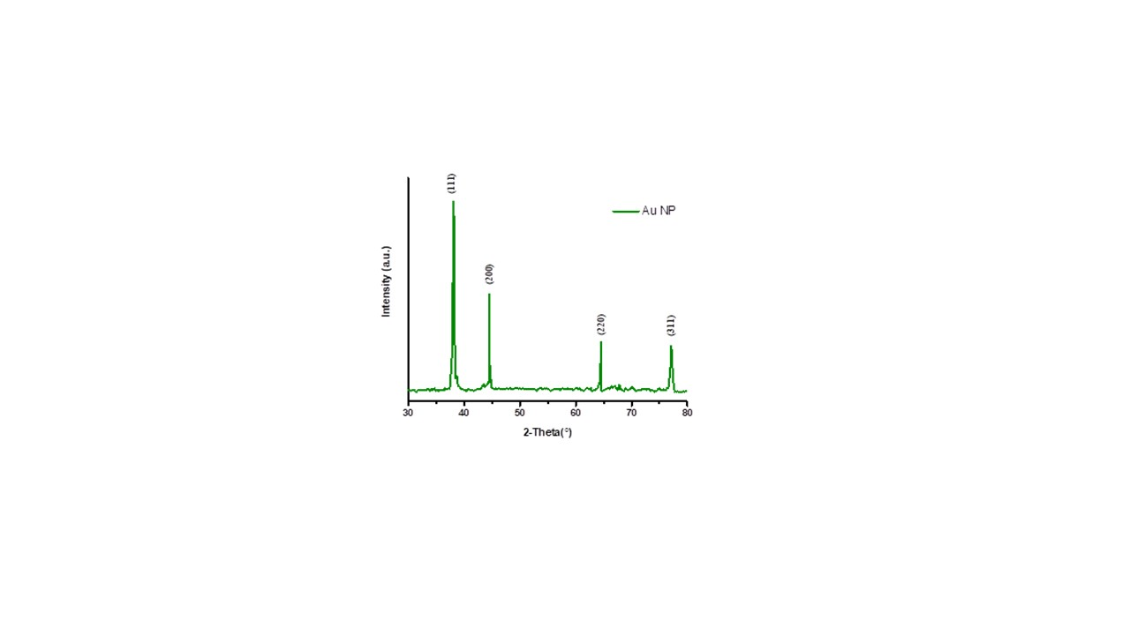

**Figure S1.** Diffraction pattern of AuNP

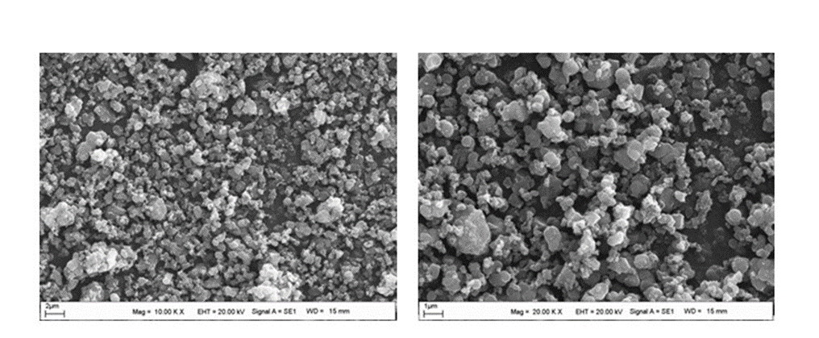

**Figure S2.** SEM images of AuNP at different magnifications

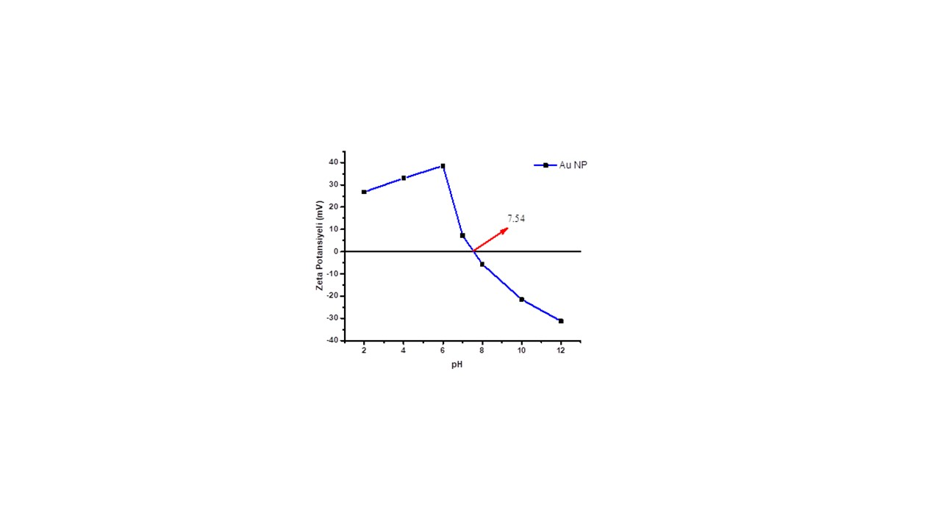

**Figure S3.** Zeta potential plot of AuNP

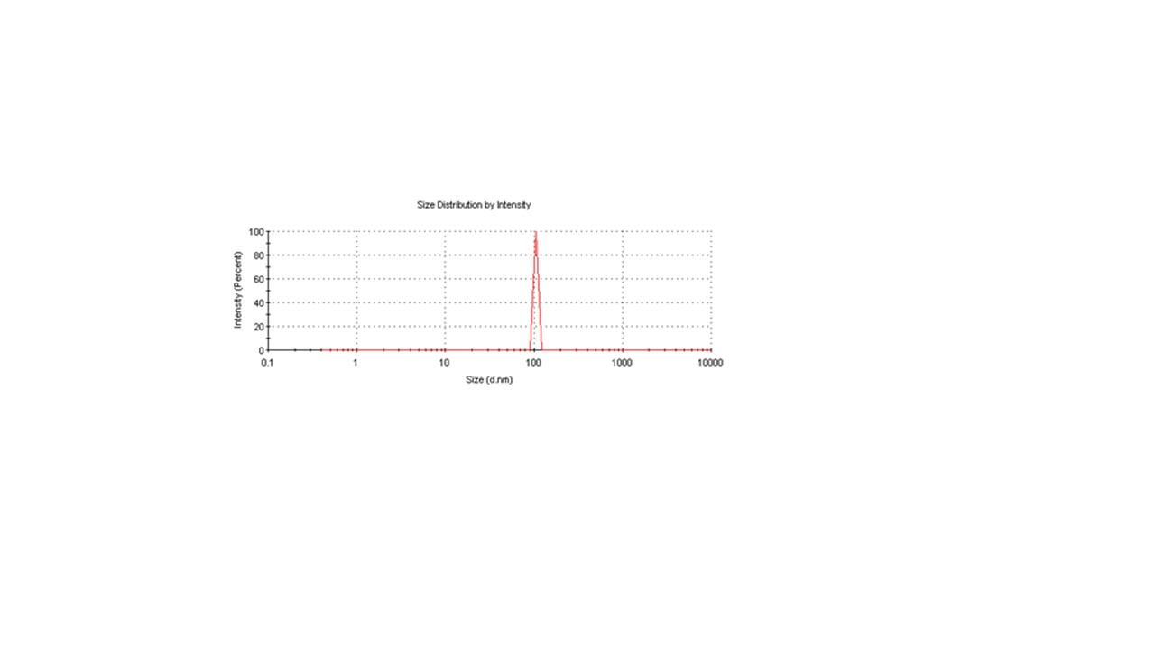

**Figure S4.** Particle size distribution graph of AuNP

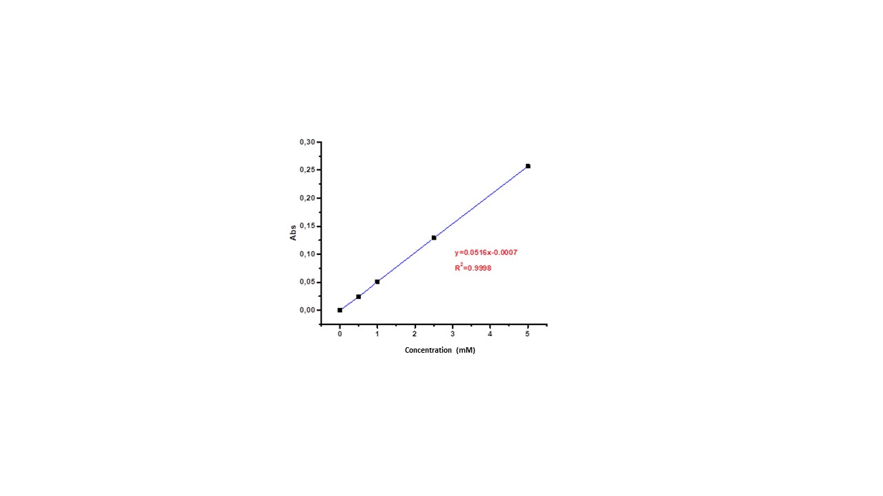

**Figure S5.** Calibration graph of PEITC