Supplemental Material 3
Results interpretation
Samples | Gel picture | F1R1  (Lane 1) | F2R2  (Lane 2) | F3R3  (Lane 3) | F4R4  (Lane 4) | F5R5  (Lane 5) | F6R3  (Lane 6) | Results
HSB3C | 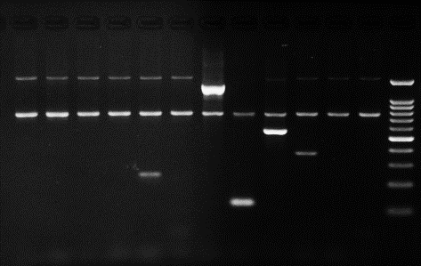  1 2 3 4 5 6 | √ | √ | √ | √ |  |  | 15:02
HSB17 | 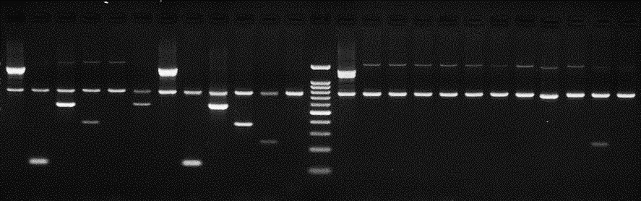  1 2 3 4 5 6 | √ | √ | √ | √ | √ |  | 15:13
HSB34C | 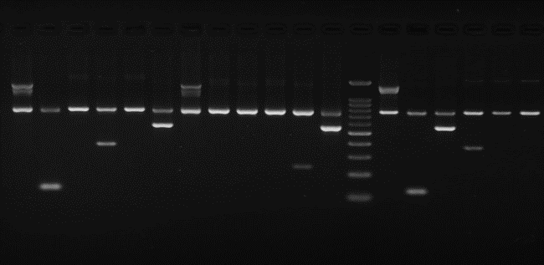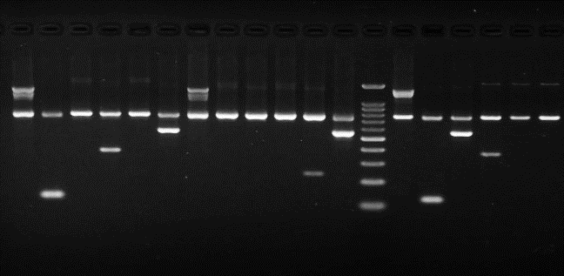  1 2 3 4 5 6 | √ | √ |  | √ |  | √ | 15:21

