**Supplementary figures**

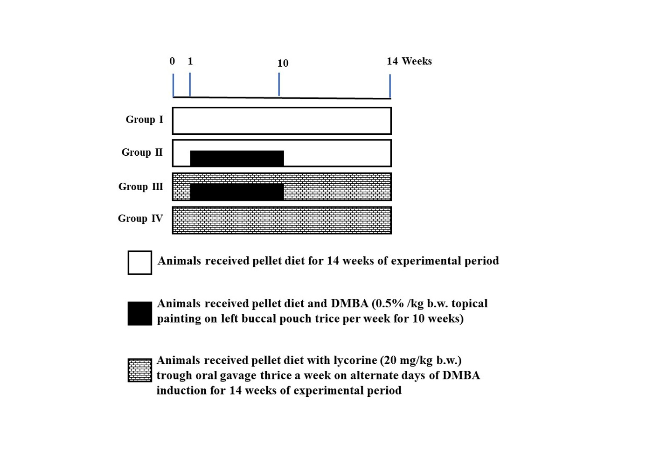

**Supplementary Figure. 1.** Experimental design of DMBA induced oral cancer in hamsters.

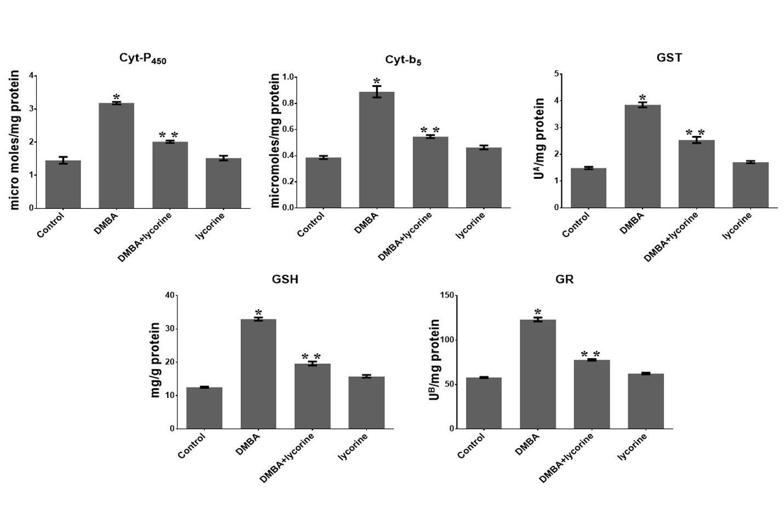

**Supplementary Figure. 2.** Status of phase I and phase II detoxification agents in the buccal mucosa of all experimental hamsters.

A-Micromoles of CDNB/GST conjugate developed per minute. B-Micromoles of NADPH oxidized per minute. Values are shown as mean ± SD (n = 6). * P<0.05, ** P <0.01 vs control group.

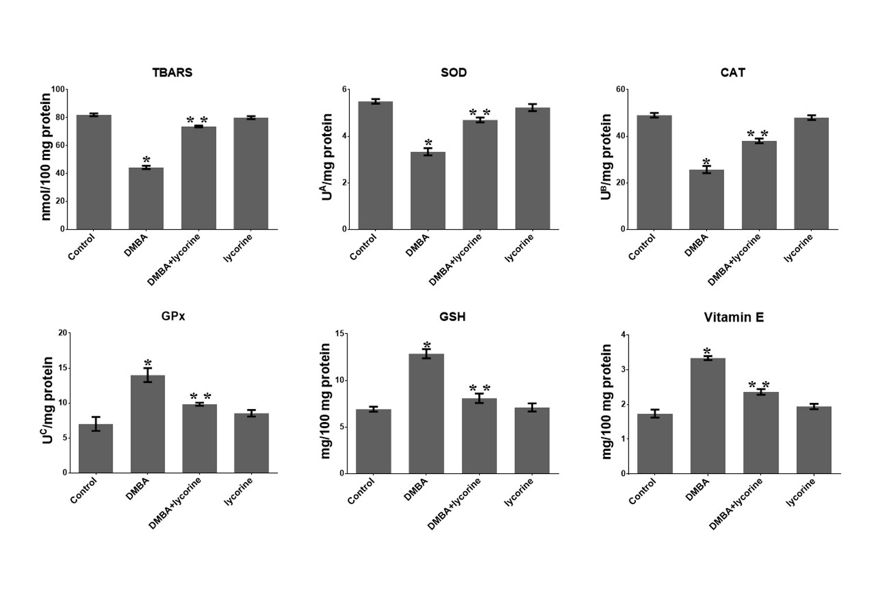

**Supplementary Figure. 3.** Effect of lycorine on TBARS and antioxidants in buccal mucosa of all experimental hamsters.

A-The quantity of enzyme essential to inhibit 50% NBT reduction, B-Micromoles of hydrogen peroxide utilized/second, C-Micromoles of glutathione utilized/minute. Values are shown as mean ± SD (n = 6). * P<0.05, ** P <0.01 vs control group.