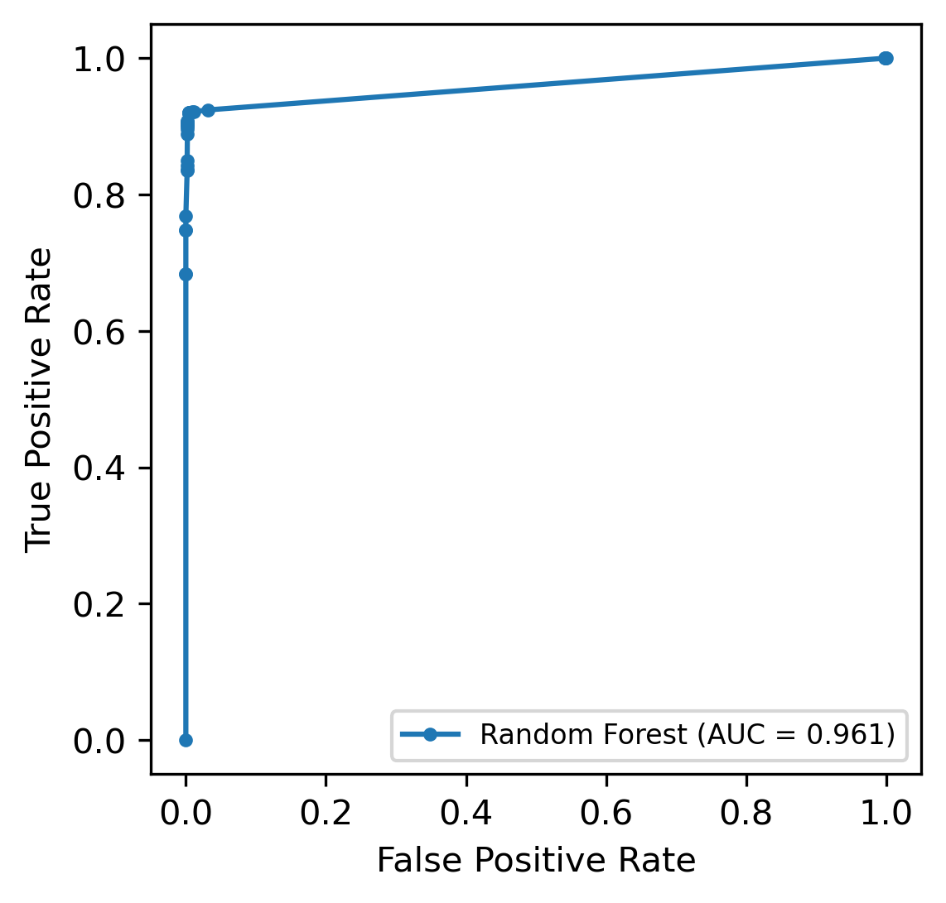

**Supplementary figure 1:** The ROC curve of Random Forest model and AUC value.

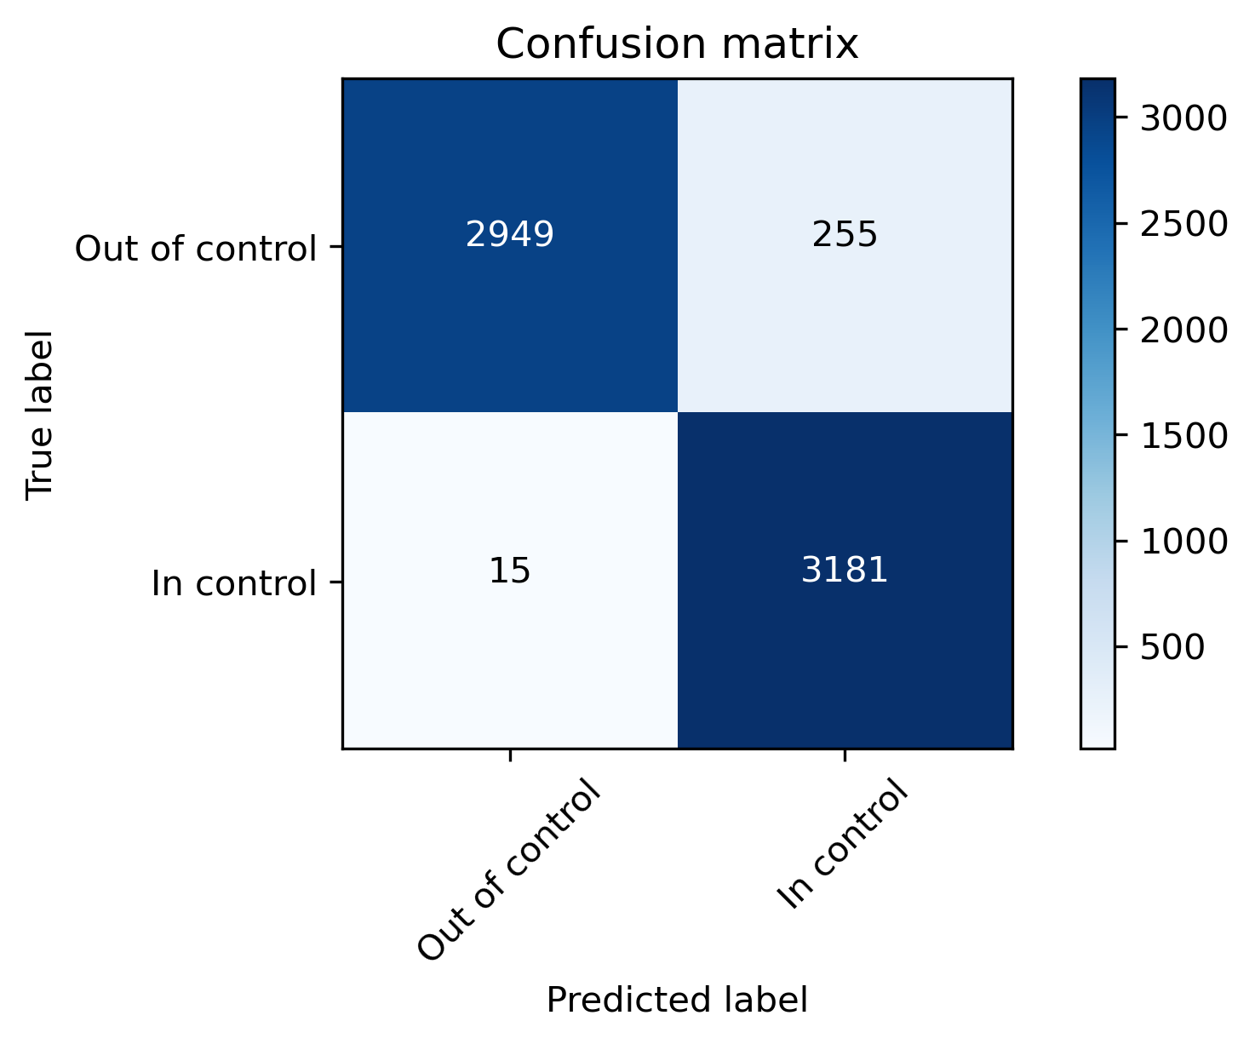

**Supplementary figure 2:** The confusion matrix