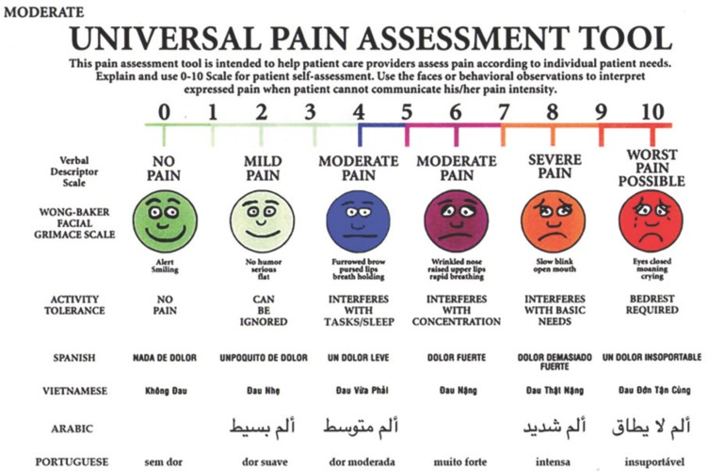

Figure 1. The Universal Pain Assessment Tool (UPAT).

