SUPPLEMENTARY MATERIAL
In this part there are NMR spectra samples of some compounds’ that were provided by us. Only some representative NMR spectra of some compounds were included to prove that these compounds could be synthesized with these reactions.

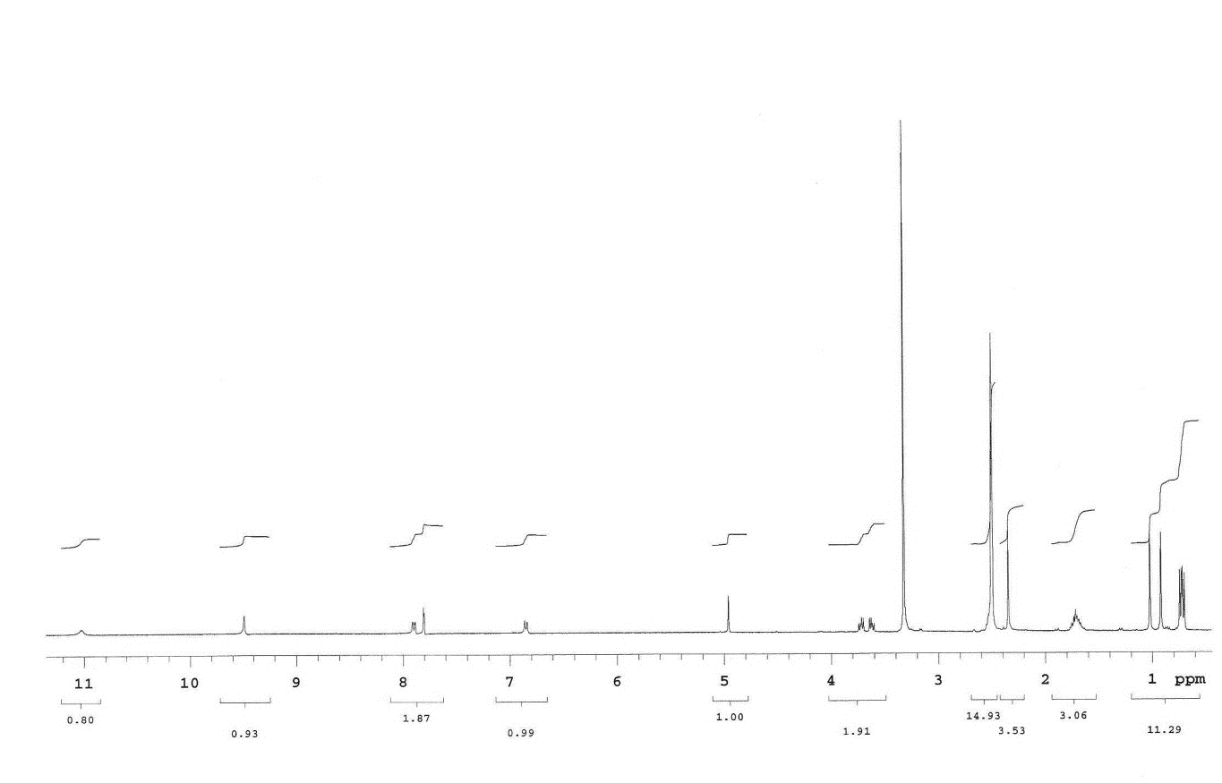
¹H-NMR spectrum of compound 4

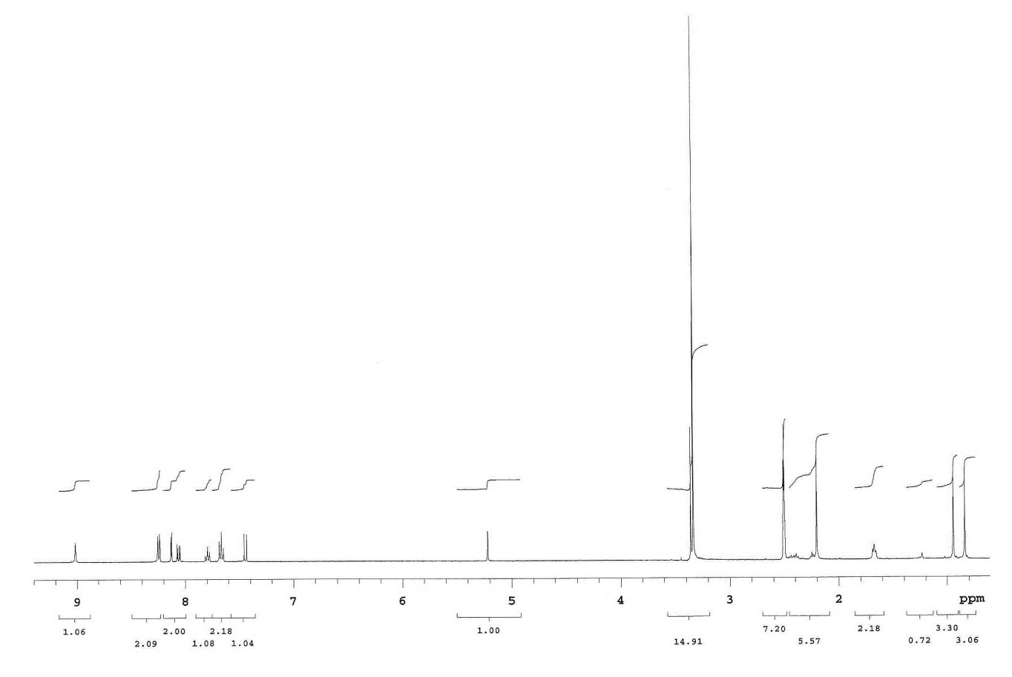
¹H-NMR spectrum of compound 6

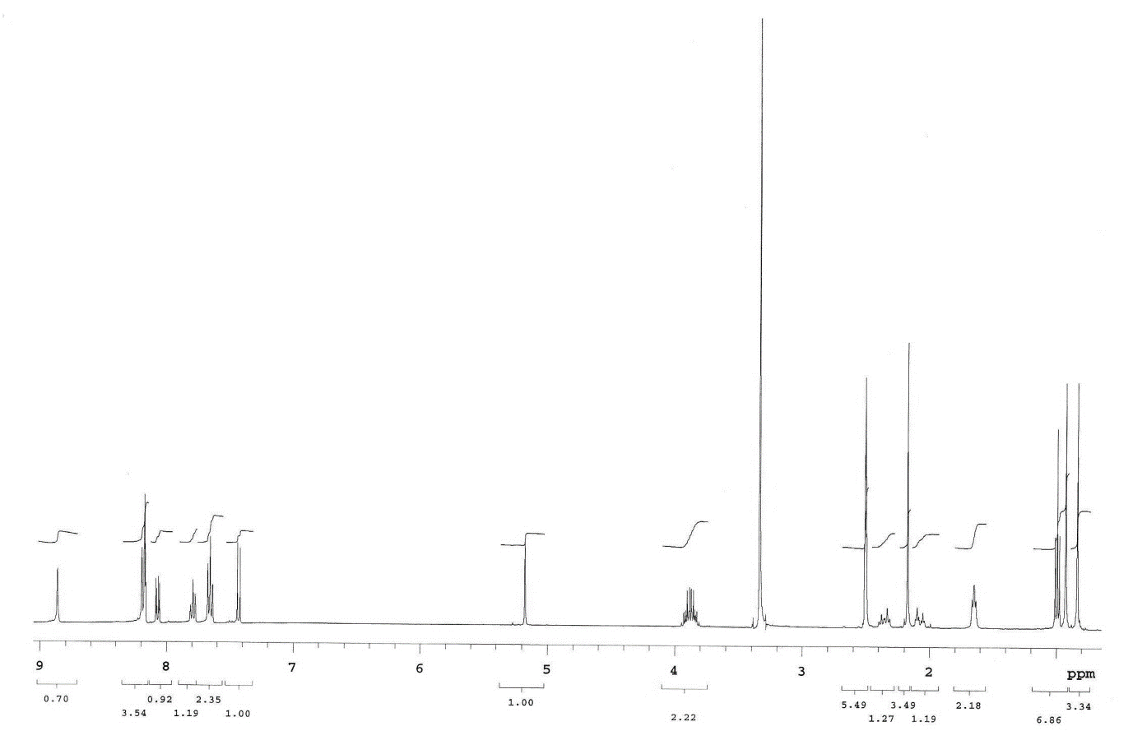
¹H-NMR spectrum of compound 7

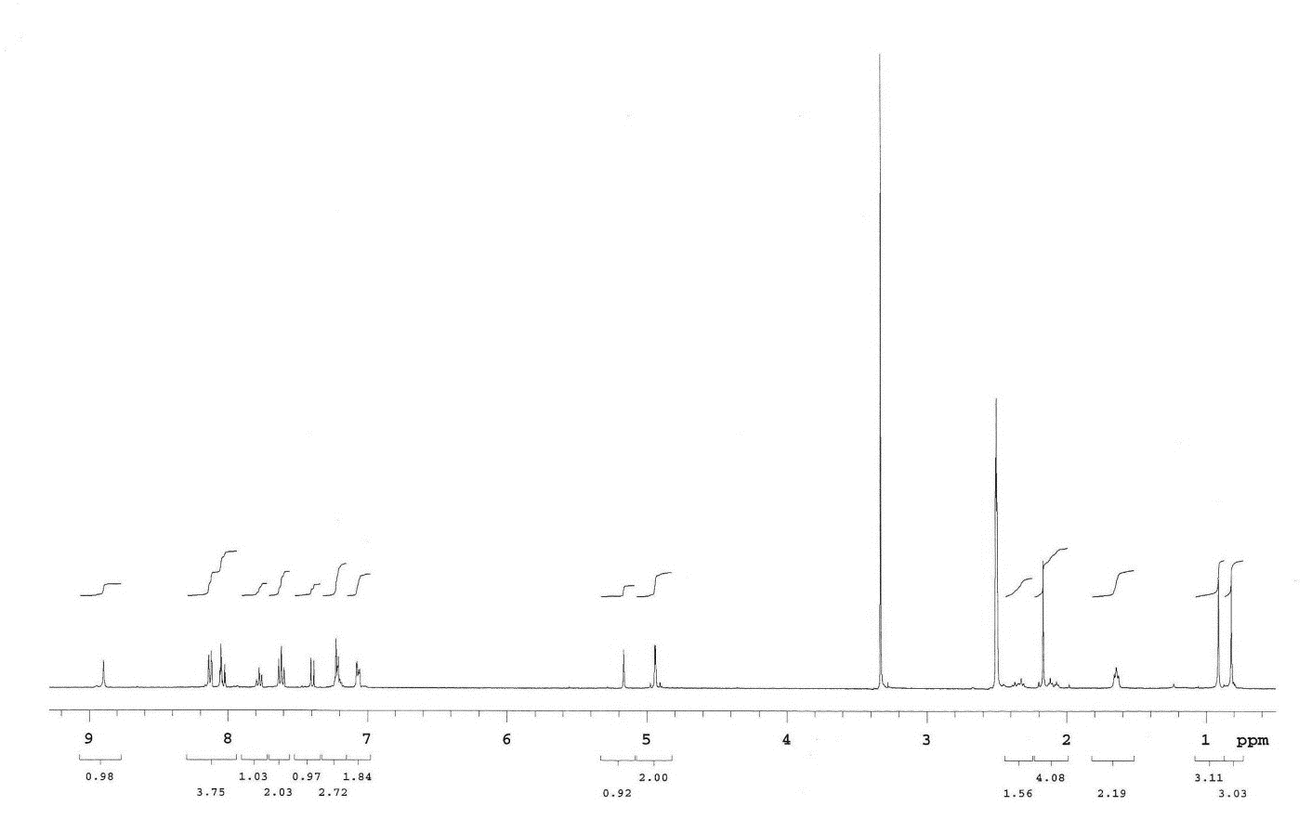
¹H-NMR spectrum of compound 8
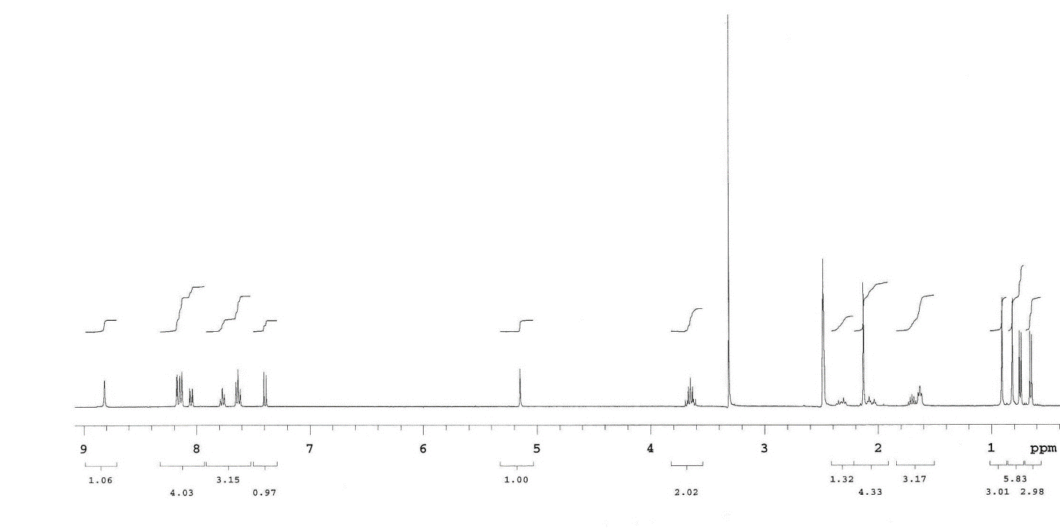
¹H-NMR spectrum of compound 9

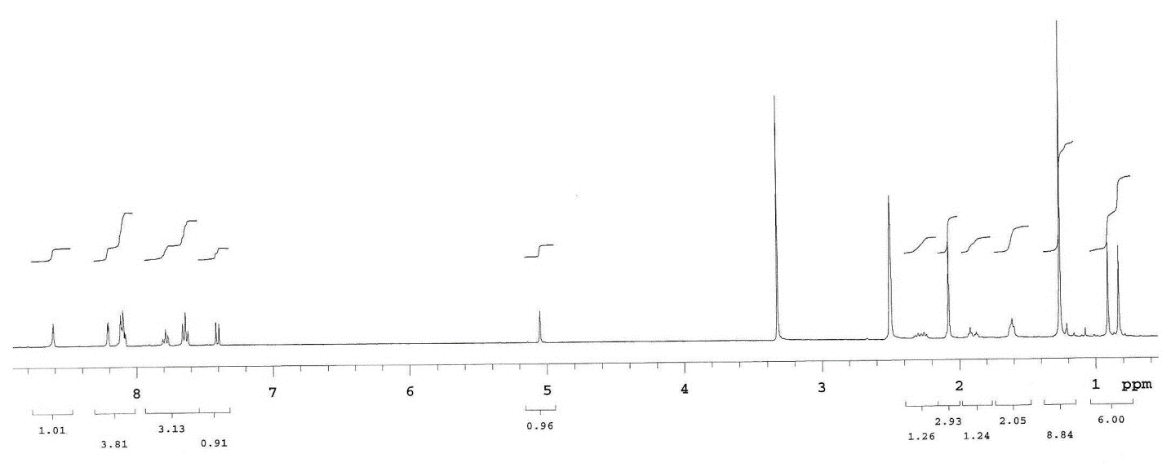
¹H-NMR spectrum of compound 10

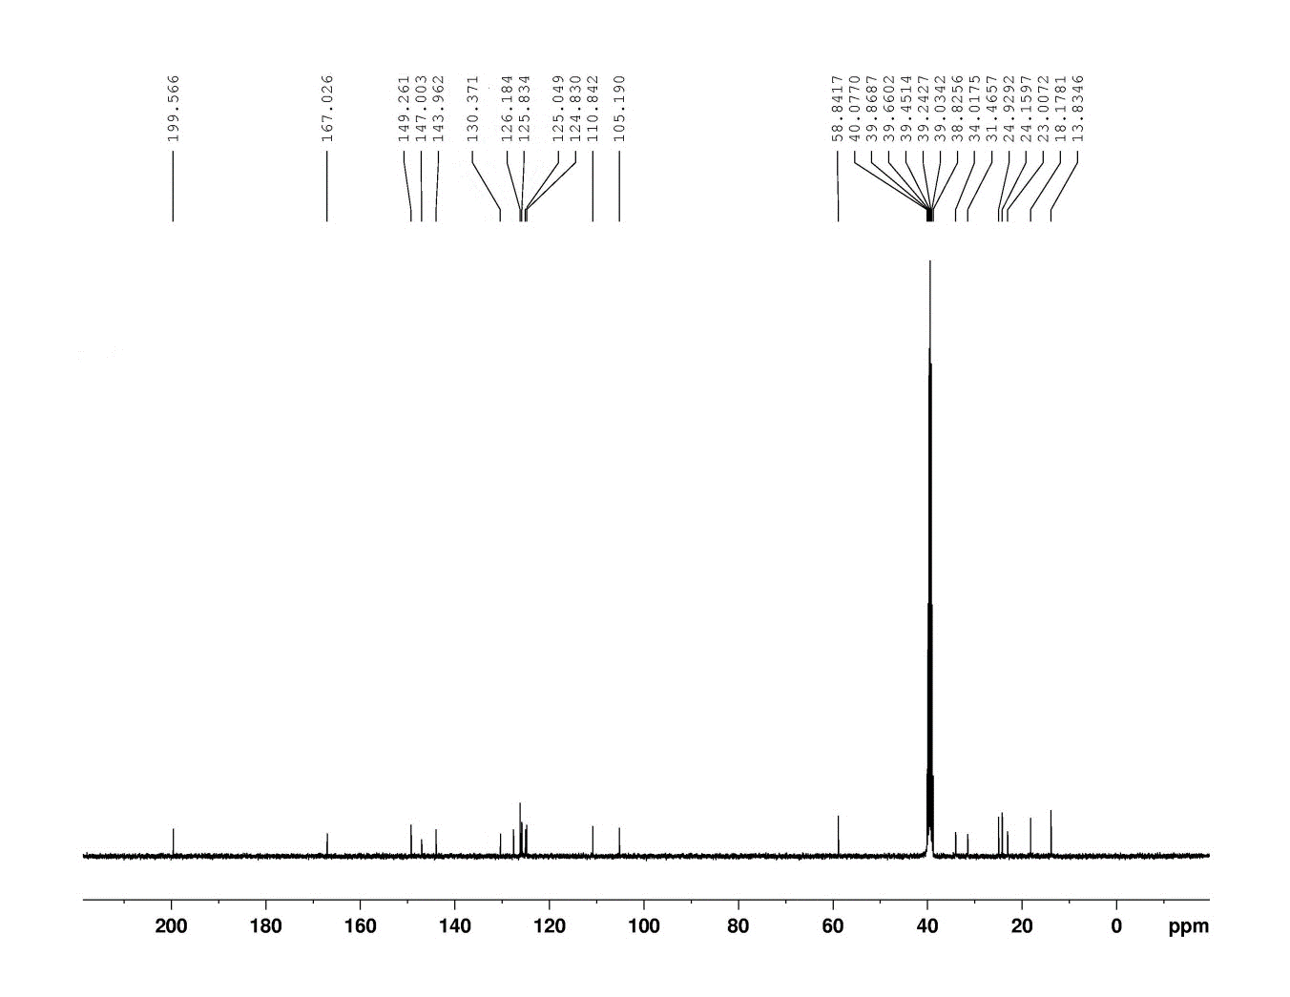
¹³C-NMR spectrum of compound 2

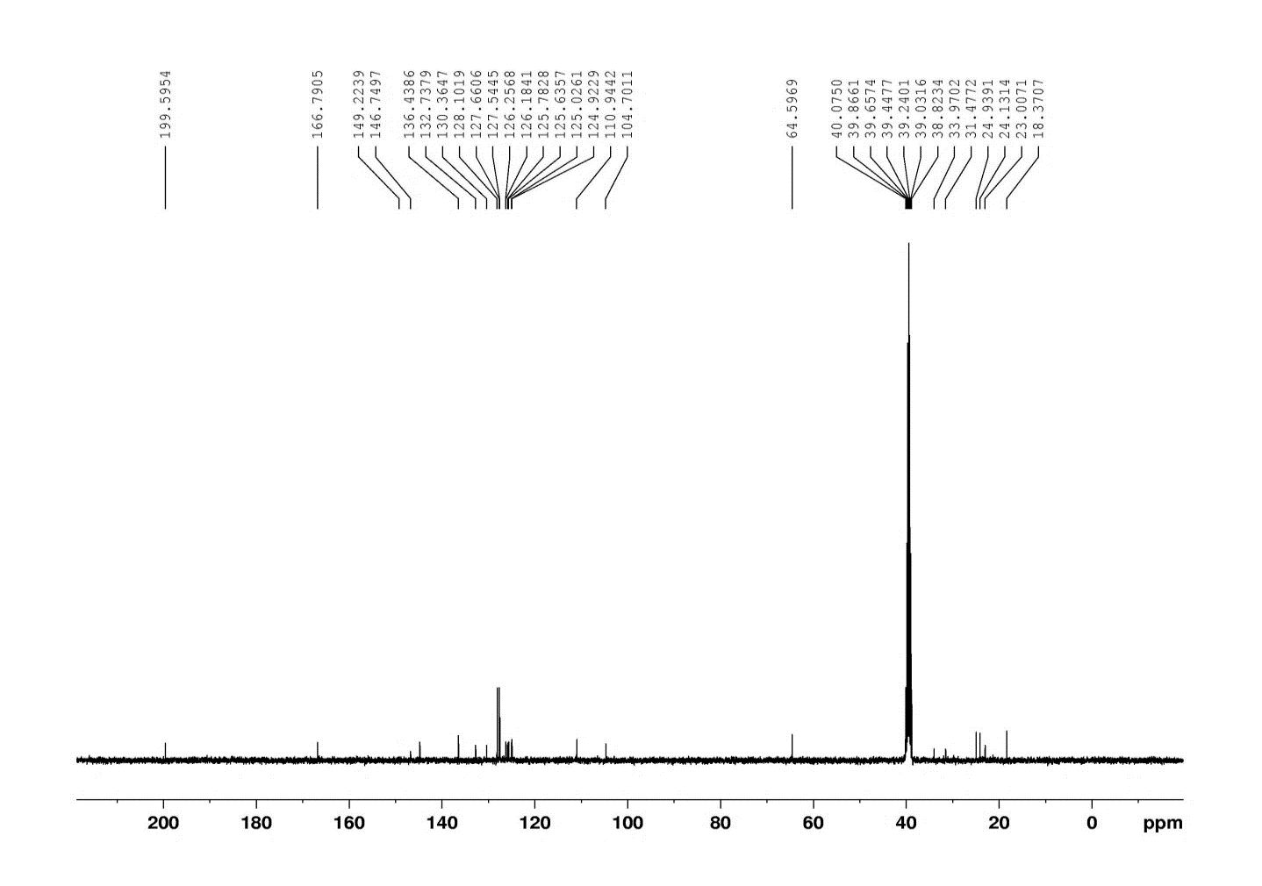
¹³C-NMR spectrum of compound 3

