Online Appendix

Supplementary materials for: “Learning about Spatial and Temporal Proximity using Tree-Based Methods”

Supplementary tables and figures

Figures

A1 | Hypothetical example: Distance to the border and support for pro-
 | immigrant policies . . . . . . . . . . . . . . . . . . . . . . . . . . . . | 3
A2 | Hypothetical example: Distance to the border and support for pro-
 | immigrant policies . . . . . . . . . . . . . . . . . . . . . . . . . . . . | 4
B1 | Geographic distribution of simulated chain of events . . . . . . . . . | 5
B2 | Example of single tree for linear DGP . . . . . . . . . . . . . . . . . . | 6
B3 | Example of single tree for complex DGP . . . . . . . . . . . . . . . . | 7
B4 | Distribution of mean squared errors (binary proximity indicators in
 | linear regression models) . . . . . . . . . . . . . . . . . . . . . . . . | 8
B5 | Distribution of proportion incorrectly classified (categorical outcome
 | variable) . . . . . . . . . . . . . . . . . . . . . . . . . . . . . . . . . . | 9
B6 | Distribution of mean squared errors (categorical outcome variable) . | 10
C1 | Single-tree model of pro-immigration attitudes (10 splits) . . . . . . | 12
D1 | Single-tree model of attitudes toward gun control (10 splits) . . . . . | 16
Tables
C1 | Linear regression models of support for pro-immigration policies . . | 11
D1 | Linear regression models of support for gun control . . . . . . . . . . | 14
D2 | Linear regression models of support for gun control (controlling for
 | shooting characteristics) . . . . . . . . . . . . . . . . . . . . . . . . . | 15

Simple hypothetical example

Figure A1: Hypothetical example: Distance to the border and support for pro-immigrant policies
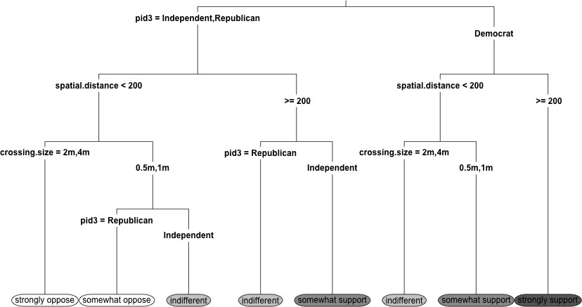

Note: The tree structure indicates how a series of decision rules (i.e. prescriptions for how to split the data based on values of predictive features) should be applied from top to bottom to produce the predictions shown in final nodes (at the bottom of the figure). For instance, this particular tree predicts that support for pro-immigrant policies is largest among Democrats living 200 km or more away from the border, and smallest among Independents and Republicans living less than 200 km from the border and close to a large entry point (with 2-4 million vehicle crossings per year).

Figure A2: Hypothetical example: Distance to the border and support for pro-immigrant policies
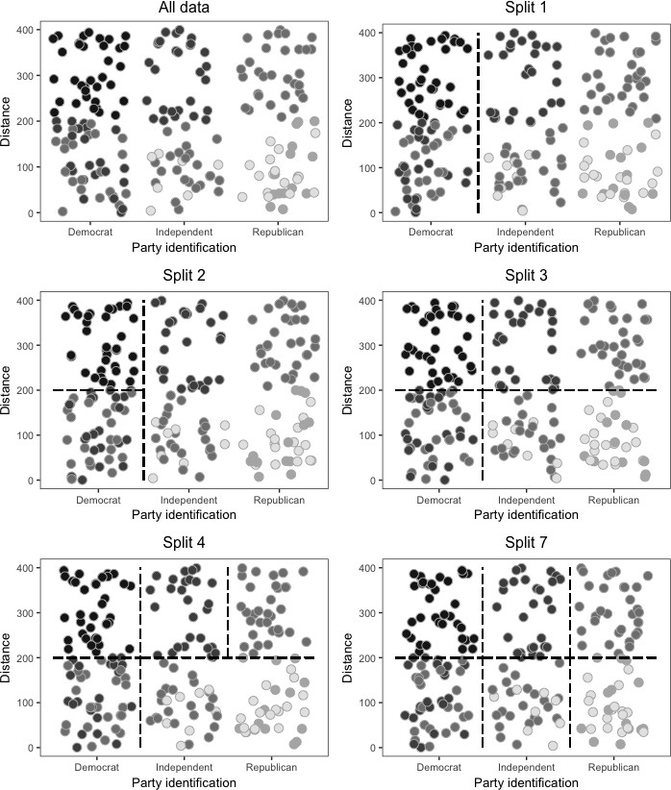
Note: The top-left plot depicts the relationship between party identification (hor- izontal axis), distance to the nearest border crossing (vertical axis), and support for pro-immigrant policies (circle fill, with darker shades representing greater sup- port), in a hypothetical data set. The rest of the plots depict the data-partitioning process corresponding to the regression tree shown in in Figure A1. First, the data is split based on Party identification (Split 1); among Democrats, and also among Independents and Republicans, it is then split based on distance to the border along a 200 km threshold (Splits 2 and 3, respectively); then among Independents and Republicans living more than 200 km away from the border, it is once again split based on party identification (Split 4). Splits 5-6, not shown, correspond to par- titioning done on the basis of size of the nearest border crossing (see Figure A1). Lastly, among Independents and Republicans living less than 200 km away from the border, the data is again split based on party identification (Split 7). Heterogeneity in outcome values within the bottom partitions occurs because of varying size of nearest border crossings (with larger size corresponding to less support).

Simulation Study

Figure B1: Geographic distribution of simulated chain of events
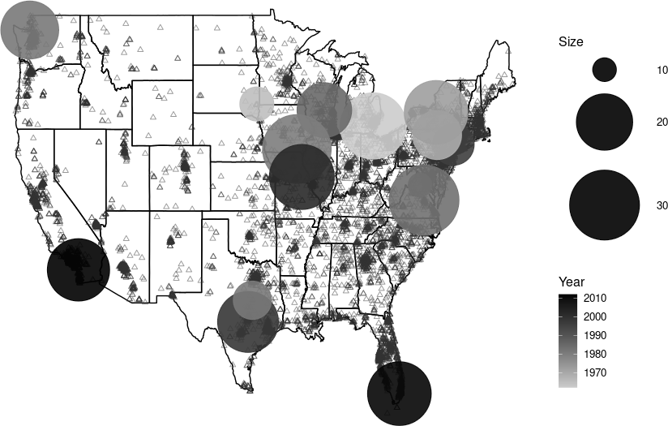

Note: Triangles represent survey respondents and circles represent hypothetical events. Darker triangles represent greater concentration of survey respondents. Larger circles indicate larger events. Darker circles indicate more recent events.

Figure B2: Example of single tree for linear DGP

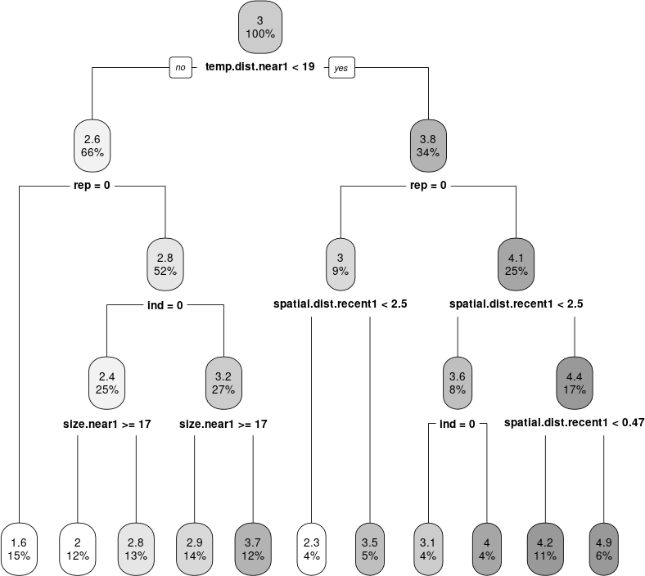

Note: The figure depicts a single-tree representation corresponding to a single simulation
for the linear DGP scenario.

Figure B3: Example of single tree for complex DGP

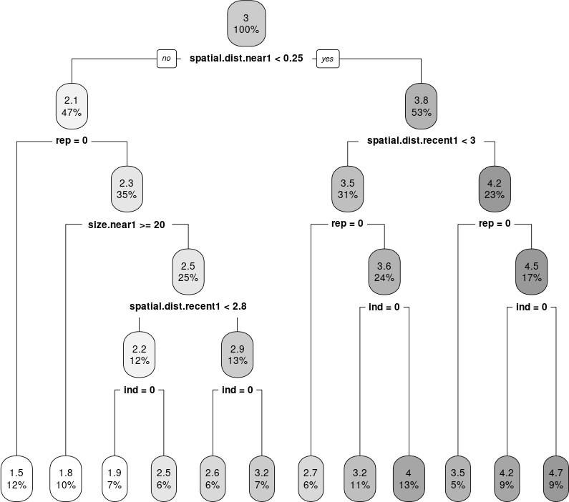

Note: The figure depicts a single-tree representation corresponding to a single simulation
for the complex DGP scenario.

Figure B4: Distribution of mean squared errors (binary proximity indicators in linear regression models)
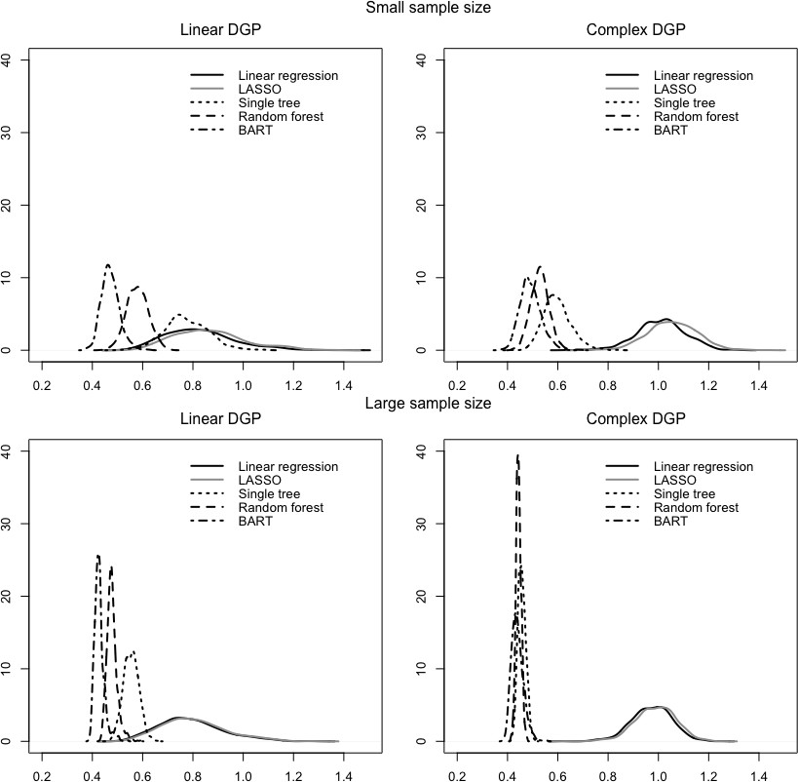
Note: The figure shows the distribution of MSEs in test data for each procedure (line type), sample size (rows), and type of DGP (columns). The five methods compared in each plot treat the 5-point outcome variable as continuous. In this figure, the linear regression models include binary indicators of proximity constructed under the wrong assumption about the threshold determining close proximity.

Figure B5: Distribution of proportion incorrectly classified (categorical outcome variable)
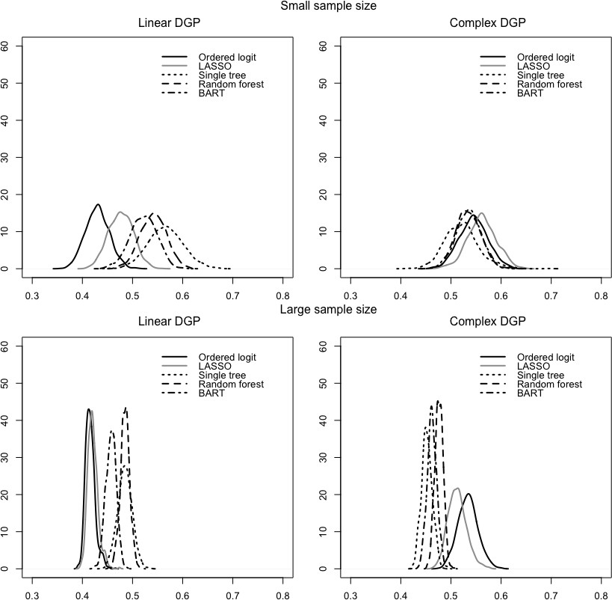
Note: The figure shows the distribution of proportion of observations incorrectly classified in test data for each procedure (line type), sample size (rows), and type of DGP (columns). The five methods compared in each plot treat the 5-point outcome variable as categorical, and all models include raw distances measured in km.

Figure B6: Distribution of mean squared errors (categorical outcome variable)
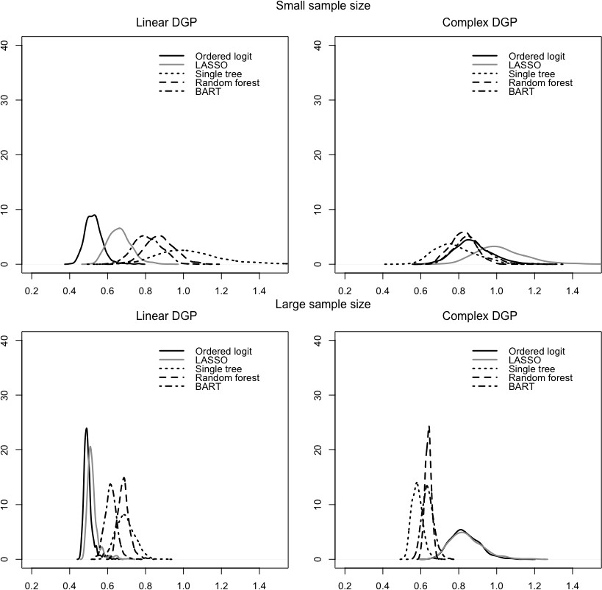
Note: The figure shows the distribution of MSEs in test data for each procedure (line type), sample size (rows), and type of DGP (columns). The five methods compared in each plot treat the 5-point outcome variable as categorical, and all models include raw distances measured in km. For the purpose of calculating MSEs after applying each model, I treated outcomes as numerical. For a measure of error that does not require making this assumption, see Figure B5.

Border crossings and support for immigration re- form

Table C1: Linear regression models of support for pro-immigration policies

Model 1 |  |  | Model 2 |  | Model 3
 | coef. | s.e. | coef. | s.e. | coef. | s.e.
Intercept | 2.72 | 0.04 | 2.74 | 0.04 | 2.69 | 0.04
Independent | -0.81 | 0.01 | -0.82 | 0.01 | -0.82 | 0.01
Republican | -1.21 | 0.02 | -1.22 | 0.02 | -1.22 | 0.02
Female | 0.18 | 0.01 | 0.18 | 0.01 | 0.18 | 0.01
Age | -0.01 | 0.00 | -0.01 | 0.00 | -0.01 | 0.00
Education | 0.09 | 0.01 | 0.09 | 0.01 | 0.09 | 0.01
Black | 0.08 | 0.02 | 0.08 | 0.02 | 0.07 | 0.02
Hispanic | 0.50 | 0.02 | 0.50 | 0.02 | 0.49 | 0.02
Asian | 0.08 | 0.03 | 0.08 | 0.03 | 0.08 | 0.03
Other | -0.10 | 0.03 | -0.10 | 0.03 | -0.10 | 0.03
California | 0.23 | 0.04 | 0.18 | 0.03 | 0.19 | 0.02
New Mexico | 0.18 | 0.04 | 0.11 | 0.04 | 0.15 | 0.04
Texas | 0.32 | 0.03 | 0.25 | 0.02 | 0.29 | 0.02
Year 2012 | 0.03 | 0.02 | 0.03 | 0.02 | 0.03 | 0.02
Year 2014 | 0.11 | 0.02 | 0.11 | 0.02 | 0.11 | 0.02
Year 2016 | 0.35 | 0.02 | 0.35 | 0.02 | 0.35 | 0.02
Dist nearest | -0.16 | 0.07
Vehicles nearest | -0.01 | 0.00
Dist nearest x Vehicles nearest | 0.03 | 0.01
Dist nearest < 0.25 & Vehicles nearest <= 3 |  |  | -0.06 | 0.02
Dist nearest < 0.25 & Vehicles nearest > 3 |  |  | -0.08 | 0.02
Dist nearest < 0.1 & Vehicles nearest <= 3 |  |  |  |  | -0.00 | 0.04
Dist nearest < 0.1 & Vehicles nearest > 3 |  |  |  |  | -0.01 | 0.02
Adj. R² | 0.263 |  | 0.263 |  | 0.262

Note: The table gives coefficients and standard errors for three different linear re- gression models of pro-immigrant attitudes estimated using ordinary least squares. Each model includes a different set of proximity indicators.

Figure C1: Single-tree model of pro-immigration attitudes (10 splits)

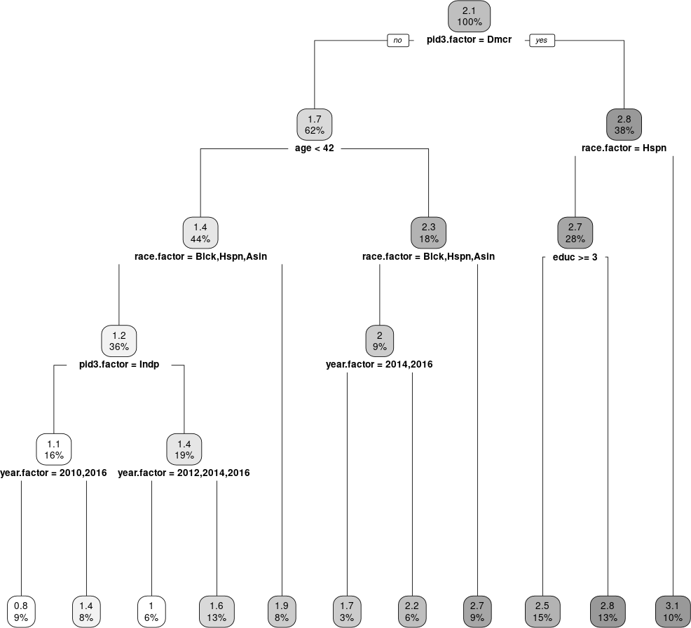

Note: The figure depicts a single-tree representation with 10 splits for the example given on section 4 on support for pro-immigration policies.

Mass shootings and attitudes toward gun control

Table D1: Linear regression models of support for gun control

Model 1 |  |  | Model 2 |  | Model 3
 | coef. | s.e. | coef. | s.e. | coef. | s.e.
Intercept | 2.587 | 0.022 | 2.617 | 0.023 | 2.628 | 0.023
Independent | -0.652 | 0.011 | -0.652 | 0.011 | -0.652 | 0.011
Republican | -1.078 | 0.012 | -1.077 | 0.012 | -1.077 | 0.012
Age | 0.003 | 0.000 | 0.003 | 0.000 | 0.003 | 0.000
Education | 0.067 | 0.005 | 0.067 | 0.005 | 0.068 | 0.005
Black | 0.056 | 0.015 | 0.053 | 0.015 | 0.055 | 0.015
Hispanic | 0.038 | 0.015 | 0.037 | 0.015 | 0.035 | 0.015
Asian | 0.288 | 0.026 | 0.286 | 0.026 | 0.285 | 0.026
Other | -0.302 | 0.025 | -0.301 | 0.025 | -0.301 | 0.025
Democratic state | 0.063 | 0.011 | 0.049 | 0.011 | 0.045 | 0.011
Republican state | -0.051 | 0.012 | -0.048 | 0.012 | -0.053 | 0.012
Crime victim | -0.173 | 0.020 | -0.172 | 0.020 | -0.173 | 0.020
Spat. dist. nearest | -0.542 | 0.052
Avg. spat. dist. 2 nearest |  |  | -0.569 | 0.050
Avg. spat. dist. 3 nearest |  |  |  |  | -0.517 | 0.047
Adj. R² | 0.196 |  | 0.197 |  | 0.197

Note: The table gives coefficients and standard errors for three different linear regression models of support for gun control estimated using ordinary least squares. Each model includes a different distance measure.

Table D2: Linear regression models of support for gun control (controlling for shooting characteristics)

Model 4 |  |  | Model 5 |  | Model 6
 | coef. | s.e. | coef. | s.e. | coef. | s.e.
Intercept | 2.407 | 0.029 | 2.262 | 0.038 | 2.324 | 0.037
Independent | -0.652 | 0.011 | -0.651 | 0.011 | -0.651 | 0.011
Republican | -1.078 | 0.012 | -1.075 | 0.012 | -1.075 | 0.012
Female | 0.446 | 0.009 | 0.447 | 0.009 | 0.447 | 0.009
Age | 0.004 | 0.000 | 0.004 | 0.000 | 0.004 | 0.000
Education | 0.067 | 0.005 | 0.067 | 0.005 | 0.068 | 0.005
Black | 0.043 | 0.015 | 0.050 | 0.015 | 0.058 | 0.015
Hispanic | 0.040 | 0.015 | 0.040 | 0.015 | 0.040 | 0.015
Asian | 0.299 | 0.026 | 0.296 | 0.026 | 0.292 | 0.026
Other | -0.293 | 0.025 | -0.293 | 0.025 | -0.295 | 0.025
Democratic state | 0.098 | 0.011 | 0.048 | 0.012 | 0.021 | 0.012
Republican state | -0.033 | 0.012 | 0.007 | 0.013 | 0.012 | 0.014
Crime victim | -0.166 | 0.020 | -0.164 | 0.020 | -0.166 | 0.020
Spat. distance nearest | -0.468 | 0.053
Temp. distance nearest | 0.000 | 0.001
pat. dist. most recent | 0.050 | 0.005
Fatalties nearest | -0.000 | 0.001
School setting nearest | -0.005 | 0.013
Avg. spat. dist. 2 nearest |  |  | -0.480 | 0.051
Avg. temp. dist. 2 nearest |  |  | 0.001 | 0.001
Avg. spat. dist. 2 most recent |  |  | 0.141 | 0.013
Avg. fatalities 2 nearest |  |  | 0.000 | 0.001
Prop. school setting 2 nearest |  |  | -0.022 | 0.019
Avg. spat. dist. 3 nearest |  |  |  |  | -0.461 | 0.047
Avg. temp. dist. 3 nearest |  |  |  |  | 0.001 | 0.001
Avg. spat. dist. 3 most recent |  |  |  |  | 0.137 | 0.014
Avg. fatalities 3 nearest |  |  |  |  | -0.000 | 0.001
Prop. school setting 3 nearest |  |  |  |  | -0.030 | 0.022
Adj. R² | 0.198 |  | 0.199 |  | 0.198

Note: The table gives coefficients and standard errors for three different linear re- gression models of support for gun control estimated using ordinary least squares. Each model includes a different distance measure and indicators of shooting char- acteristics.

Figure D1: Single-tree model of attitudes toward gun control (10 splits)

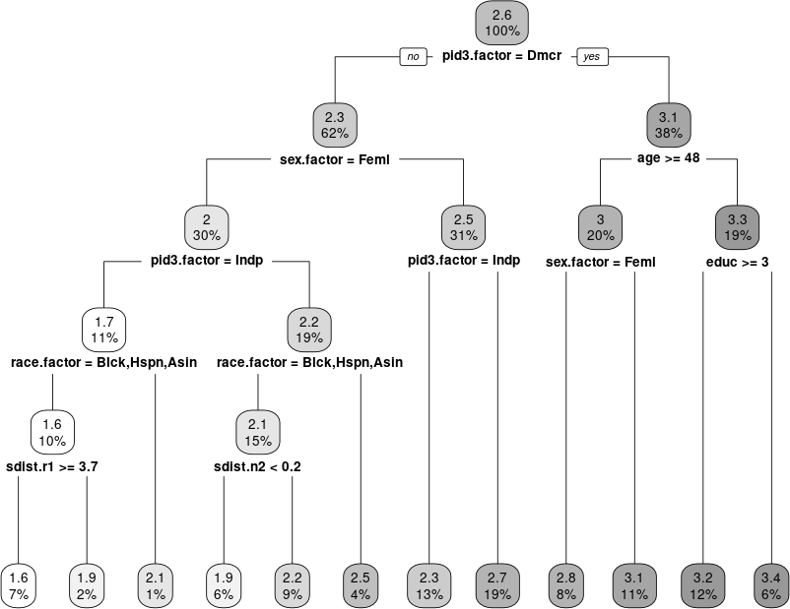

Note: The figure depicts a single-tree representation with 10 splits for the example given on section 5 on support for gun control.

