Supplementary material

Visual Rating Scales of Brain Atrophy in Dementia: A Systematic Review of Reliability and Diagnostic Accuracy

Chiara Fornari ¹, Giorgio Giulio Fumagalli ¹*
¹ Center for Mind/Brain Sciences (CIMeC), University of Trento, Corso Bettini 31, 38068 Rovereto, TN, Italy
* Corresponding author: giorgio.fumagalli@unitn.it

Database | Keywords string
Pubmed (All Fields) | (MCI OR mild cognitive impairment OR preclinical dementia OR early onset dementia OR prodromal OR early diagnosis OR Alzheimer OR FTD OR frontotemporal dementia OR PCA OR posterior cortical atrophy OR LBD OR Lewy body dementia) AND (visual rating OR visual assessment OR atrophy rating) AND (reproducibility OR rater) AND (MRI OR magnetic resonance imaging OR T1-weighted) NOT stroke
Web of Science | ((TS=MCI) OR (TS="mild cognitive impairment") OR (TS="preclinical dementia") OR (TS="early onset dementia”) OR (TS=prodromal) OR (TS="early diagnosis”) OR (TS=Alzheimer) OR (TS=FTD) OR (TS="frontotemporal dementia") OR (TS=PCA) OR (TS="posterior cortical atrophy") OR(TS=LBD) OR (TS="Lewy body dementia")) AND ((TS="visual rating") OR (TS="visual assessment") OR (TS="atrophy rating")) AND ((TS=reproducibility) OR (TS=rater)) AND ((TS=MRI) OR (TS="magnetic resonance imaging") OR (TS="T1-weighted")) NOT (TS=stroke)
Scopus | (TITLE-ABS-KEY(MCI) OR TITLE-ABS-KEY("mild cognitive impairment") OR TITLE-ABS-KEY("preclinical dementia") OR TITLE-ABS-KEY("early onset dementia") OR TITLE-ABS-KEY(prodromal) OR TITLE-ABS-KEY("early diagnosis”) OR TITLE-ABS-KEY(Alzheimer) OR TITLE-ABS-KEY(FTD) OR TITLE-ABS-KEY("frontotemporal dementia”) OR TITLE-ABS-KEY(PCA) OR TITLE-ABS-KEY("posterior cortical atrophy”) OR TITLE-ABS-KEY(LBD) OR TITLE-ABS-KEY("Lewy body dementia")) AND (TITLE-ABS-KEY("visual rating") OR TITLE-ABS-KEY("visual assessment") OR TITLE-ABS-KEY("atrophy rating")) AND (TITLE-ABS-KEY(reproducibility) OR TITLE-ABS-KEY(rater)) AND (TITLE-ABS-KEY(MRI) OR TITLE-ABS-KEY("magnetic resonance imaging") OR TITLE-ABS-KEY("T1-weigted")) AND NOT (stroke)
MEDLINE | (MCI OR mild cognitive impairment OR preclinical dementia OR early onset dementia OR prodromal OR early diagnosis OR Alzheimer OR FTD OR frontotemporal dementia OR PCA OR posterior cortical atrophy OR LBD OR lewy body dementia) AND (visual rating OR visual assessment OR atrophy rating) AND (reproducibility OR rater) AND (MRI OR magnetic resonance imaging OR T1-weighted) NOT stroke

Table S1 Database search string. Abbreviations: topic search (TS); title, abstract, keywords (TITLE-ABS-KEY)
 | Risk of Bias |  |  |  | Applicability Concerns
 | Patient selection | Index Test | Reference Standard | Flow and Timing | Patient Selection | Index Test | Reference Standard
Mårtensson et al., 2020 | low | low | low | low | low | low | unclear
Fischbach-Boulanger et al., 2018 | low | low | low | low | low | low | low
Koedam et al., 2011 | unclear | low | unclear | low | low | low | low
Möller et al., 2014 | low | low | low | low | low | low | low
Harper et al., 2016 | high | unclear | low | low | low | low | unclear
Silhan et al., 2021 | high | low | unclear | low | low | low | low
Li et al., 2019 | unclear | low | low | low | low | low | low
Chow et al., 2011 | unclear | low | low | low | unclear | low | low
Sheng et al., 2020 | unclear | unclear | unclear | unclear | unclear | low | low
Fumagalli et al., 2018 | low | low | low | low | low | low | low
Molinder et al., 2021 | low | low | unclear | low | low | low | low
Enkirch et al., 2018 | low | low | low | low | low | low | low
Tolboom et al., 2010 | high | unclear | low | low | low | low | unclear
Min et al., 2017 | low | low | low | low | low | low | low
Vanhoenacker et al., 2017 | low | low | low | low | low | low | low
Jang et al., 2015 | low | low | low | low | low | low | low
Davies et al., 2009 | high | unclear | low | low | low | low | low
Westman et al., 2011 | unclear | low | low | low | low | low | low
Chen et al., 2010 | unclear | unclear | low | low | low | low | low
Boutet et al., 2012 | low | low | low | low | low | low | low
Ferreira et al., 2016 | high | unclear | unclear | low | low | low | low
Wittens et al., 2024 | low | low | low | low | low | low | low
Falgàs et al., 2024 | low | low | low | low | low | low | low
Fumagalli et al., 2020 | low | low | low | low | low | low | low
Ferreira et al., 2015 | low | low | low | low | low | low | low
Falgàs et al., 2020 | low | low | low | low | low | low | low
Benussi et al., 2024 | low | low | unclear | low | low | low | low
Yuan et al., 2019 | unclear | low | low | low | low | low | low
Table S2 Quality Assessment of Diagnostic Accuracy Studies (QUADAS-2)
Table S3 The table summarizes the results regarding the agreement and the accuracy of other scales.
First author | Agreement | Correlation visual vs volumetric | Accuracy | Conclusion
Silhan et al., 2021 | INTER: wκ> 0.92  INTRA: in Hip-hop and PAS were almost perfect | - - | oldHC vs lateAD for Hip-hop (right AUC: 0,93; left AUC: 0,93) and PAS (right AUC: 0,6; left AUC: 0,63).  youngHC vs earlyAD for Hip-Hop (right AUC: 0,85; left AUC: 0,76) and PAS (right AUC: 0,71; left AUC: 0,76). | MTL atrophy detected using Hip-hop is universal across the whole AD age spectrum. PA detected using PAS is worth rating only in earlyAD. Hip-hop and PAS are very reliable
Li et al., 2019 | INTER: for 12 right and left sides of 20 brain regions high consistency (α > 0.8), eight regions showed moderate consistency (α: 0.6–0.8) | Correlations with volumetric measures | AD vs HC (sens=0.622, spec=1)  MCI vs HC (sens=0.483, spec=0.762)  AD vs MCI (sens=0.73, spec=0.655) | Visual ratings are better than volumetric systems for AD vs MCI.  Visual and volumetric assessments are similar for AD vs HC.  Volumetric measures are better than visual rating for MCI vs HC
Chow et al., 2011 | LAT atrophy scoring (coronal and axial) was in high agreement but reduced when raters were asked to score ventricular enlargement | Negative correlations between atrophy and volume (r: –0.61 –0.42) | FTD vs AD (accuracy=0.631). LAC and LAT to be smaller in accurately diagnosed FTD vs AD.  FTD vs HC (accuracy=0.595). | Experienced clinicians could not differentiate controls from FTD at the 90% accuracy achieved by volumetry
Jang et al., 2015 | INTER: CVRS-coronal: ICC=0.93 CVRS-axial: ICC=0.94  hip-coronal: ICC=0.865; hip-axial: ICC=0.901 Cortical atrophy-coronal: ICC=0.905  Cortical atrophy-axial: ICC=0.895  INTRA: CVRS-coronal: ICC=0.94; CVRS-axial: ICC=0.95 | - - | The AUC of the CVRS was greater than that of any other single subscale and volumetric measurement.  HC vs MCI  CVRS-coronal: AUC=0.777  CVRS-axial: AUC=0.773  AD vs MCI  CVRS-coronal: AUC=0.68  CVRS-axial: AUC=0.681 | The CVRS can be used clinically to measure structural changes of the brain. It reflected cerebral structural changes of clinical groups
Davies et al., 2009 | INTER: wκ=0.71.  AC with least agreement (ICC=0.71), while anterior hip best agreement (ICC=0.90).  INTRA: rater1 wκ=0.75 | correlations between the visual rating scale and methods of volume estimation for all regions studied | Discriminant analysis:  HC vs AD: insula, anterior hippocampus, orbitofrontal gyri and temporal pole;  HC vs SD: anterior fusiform  HC vs bvFTD: insula;  AD vs SD: temporal pole, anterior hippocampus and lateral temporal (all worse in SD)  AD vs bvFTD: orbitofrontal gyri, anterior hippocampus and lateral frontal cortex (all worse in bvFTD)  SD vs bvFTD: anterior cingulate (worse in bvFTD) and temporal pole (worse in SD). | Visual rating can be used as an alternative to quantification methods, and may be superior when dealing with single cases or small groups.
Table S3 (continued)
First author | Agreement | Correlation visual vs volumetric | Accuracy | Conclusion
Chen et al., 2010 | INTER: T1 ICC=0.89; T2 ICC=0.86. | - - | T1 and T2 showed comparable accuracy at classifying AD: AUC (0.67 0.7) | BALI rating with both T1 and T2 identify AD vs HC moderately well
Abbreviations: Parietal Atrophy (PA); Medial Temporal Lobe (MTL); Posterior Atrophy Score (PAS); hippocampo-horn percentage (Hip-hop); left anterior temporal pole (LAT); left anterior cingulate (LAC); hippocampus (hip); Anterior Cingulate (AC); brain atrophy and lesion index (BALI); comprehensive visual rating scale (CVRS); Healthy Controls (HC); Mild Cognitive Impairment (MCI); Alzheimer’s Disease (AD); Frontotemporal dementia (FTD); behavioral variant of Frontotemporal Dementia (bvFTD); semantic dementia (SD); Cohen’s weighted kappa (wκ); Cronbach's α (α); Interclass correlation coefficient (ICC); Gray Matter (GM); Area Under the Curve (AUC); versus (vs); Inter-rater agreement (INTER); Intra-rater agreement (INTRA); information not included (- -); Correlation (r); Sensitivity (sens); Specificity (spec)

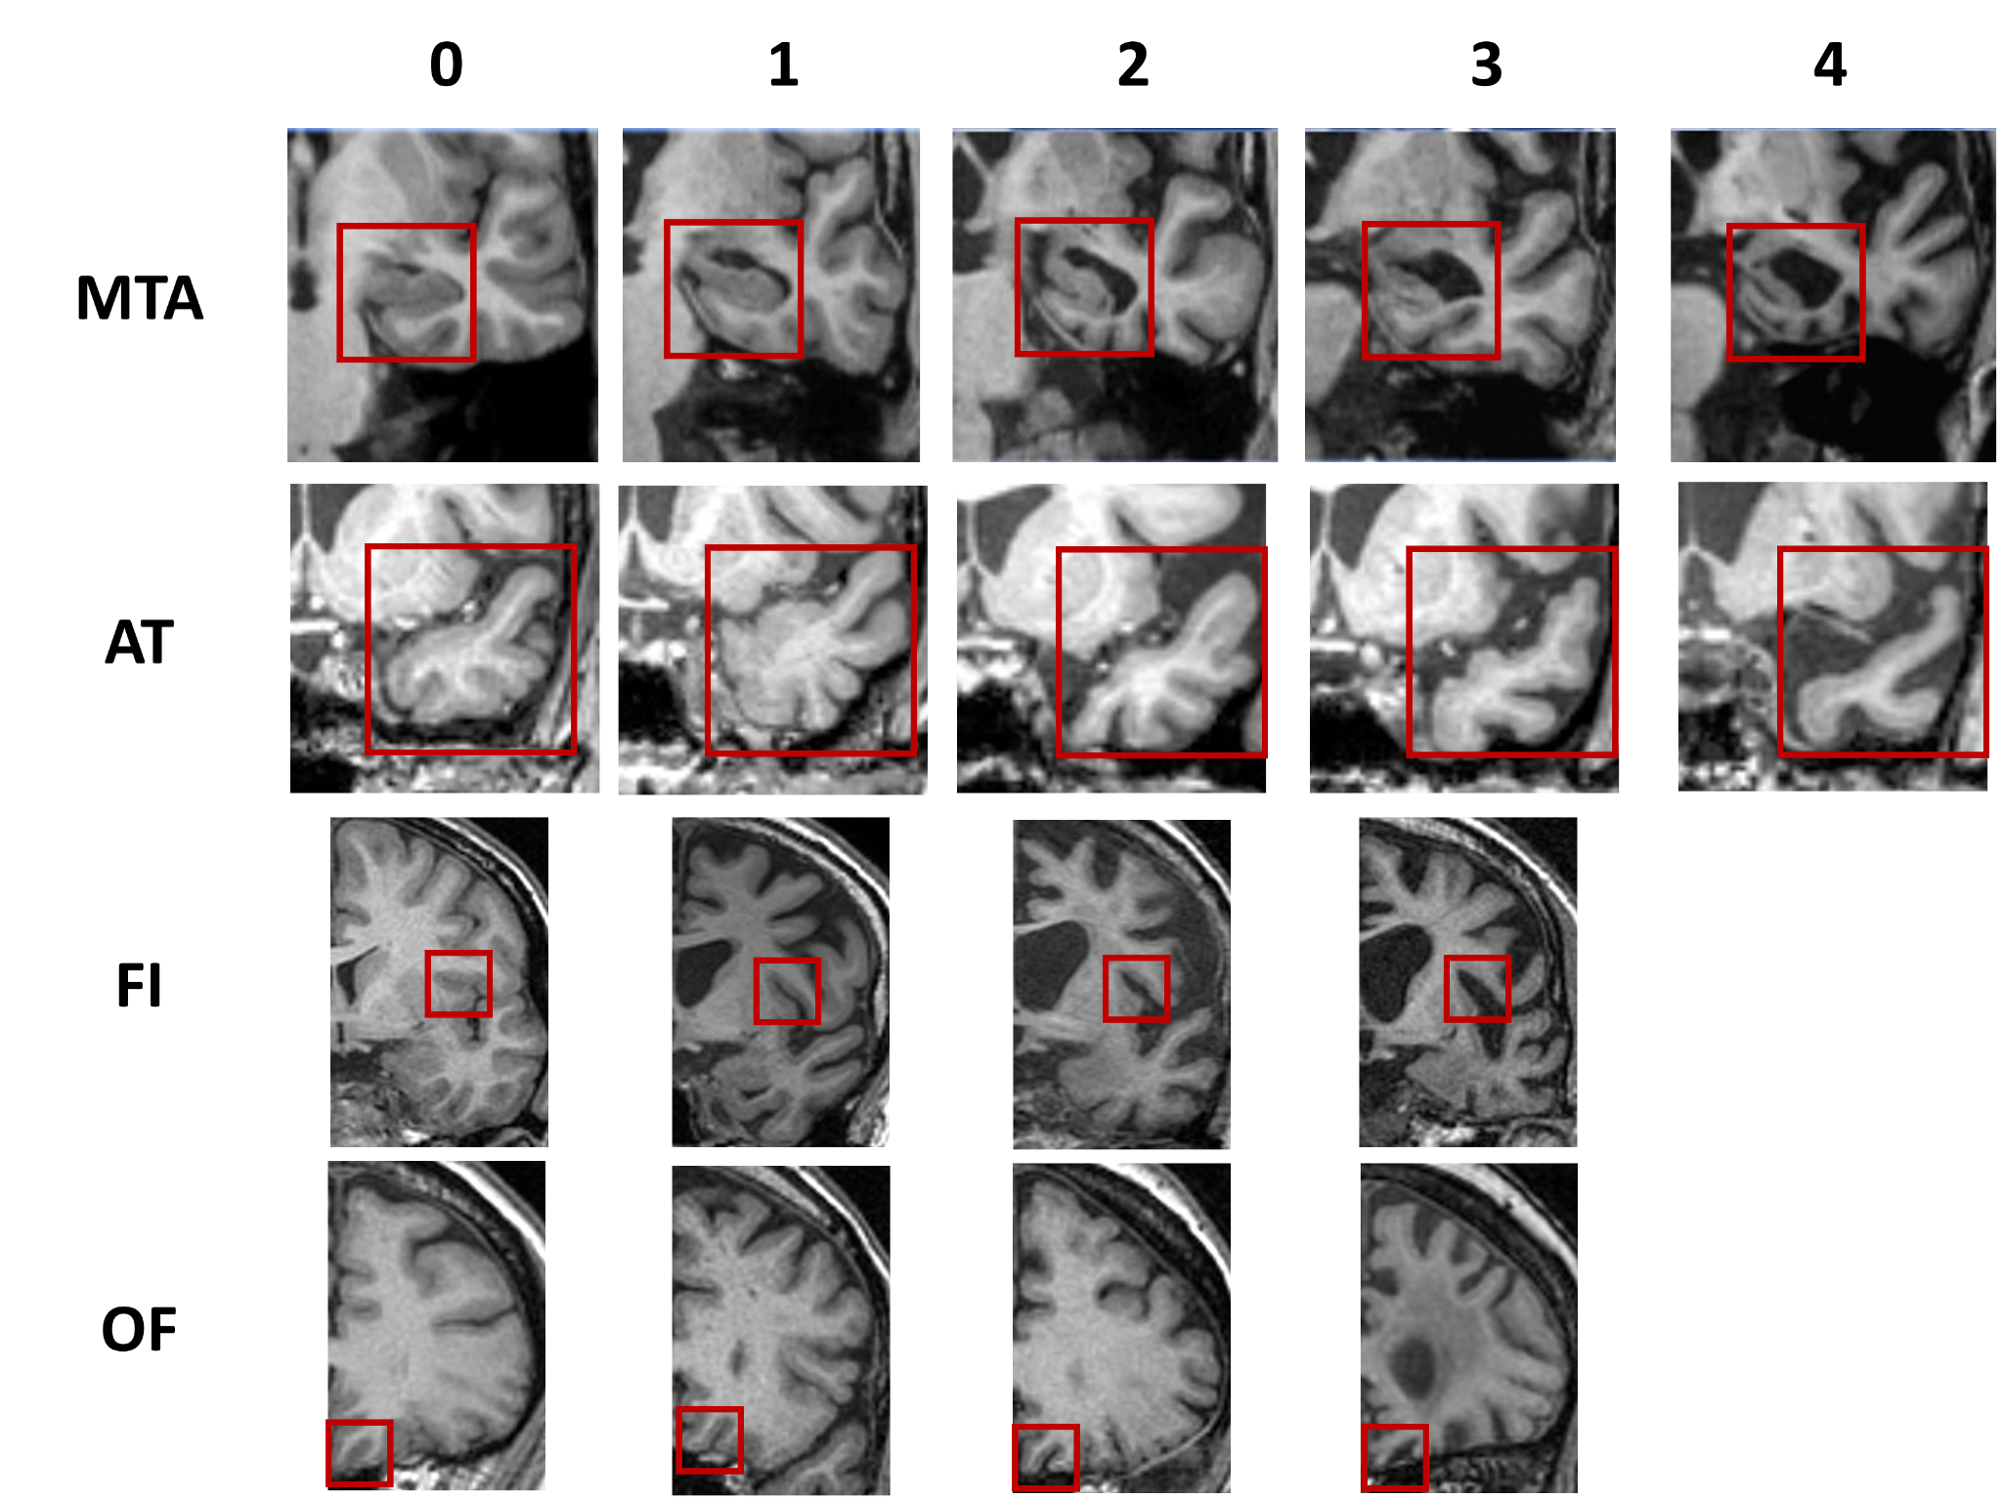
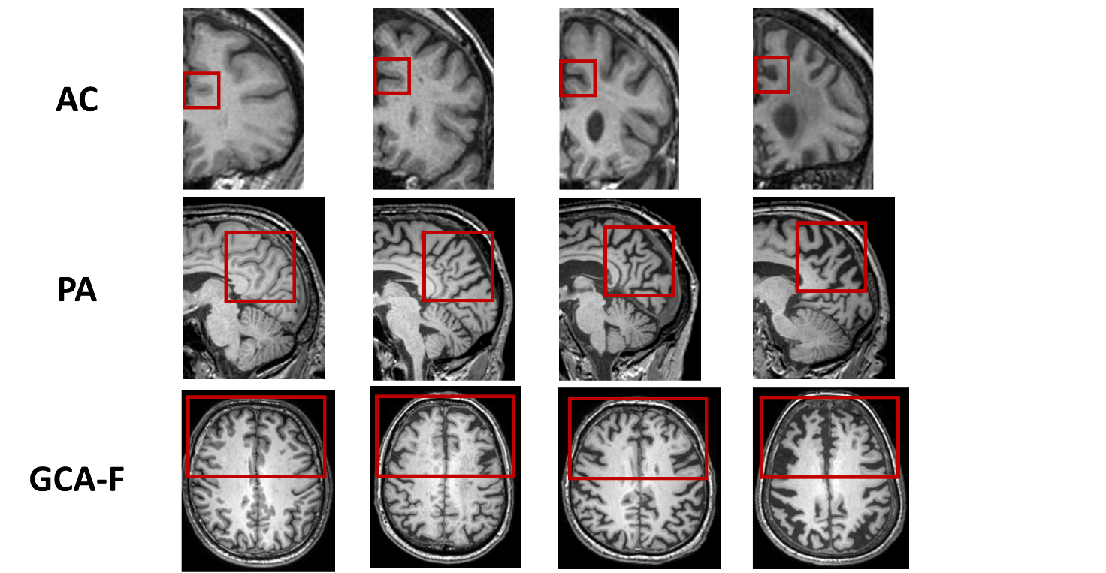
Figure S4 The scoring of the visual rating scale for Medial Temporal Atrophy (MTA), Anterior Temporal (AT), Fronto-insula (FI), Orbitofrontal (OF), Anterior Cingulate (AC), Posterior Atrophy (PA), and Global Cortical Atrophy-Frontal areas (GCA-F).

