Antituberculosis, Antimicrobial, Antioxidant, Cytotoxicity and Anti-Inflammatory Activity of Schiff Base Derived from 2,3-Diaminophenazine Moiety and its Metal(II) Complexes: Structural Elucidation, Computational Aspects, and Biological Evaluation

Saleh M. Bufarwa^{1*}, Reem M. El-Sefait², Dalal K. Thbayh³, Mustapha Belaidi⁴, Rehab K. Al-Shemary⁵, Rema. M. Abdusamea², Marei M. El-Ajaily⁶, Bela Fiser⁷, Hanan A. Bader¹, Abdulsalam A. Saleh⁸, Mohamad M. Bufarwa⁹
¹Chemistry Department, Omar Al-Mukhtar University, El-Beida City, Libya
²Natural Resources and Environmental Sciences, Omar Al-Mukhtar University, El-Beida City, Libya
³Polymer research center, Basrah University, Basrah, Iraq
⁴Chemistry, Laboratory Environment and Sustainable Development Department, Ahmed Zabana University, 48000, Relizane-Algeria.
⁵Chemistry Department, Baghdad University, Baghdad City, Iraq
⁶Chemistry Department, Benghazi University, Benghazi City, Libya
⁷Biology and Chemistry Department, Ferenc Rákóczi II Transcarpathian Hungarian College of Higher Education, Transcarpathia, 90200 Berezszáz, Ukraine
⁸Perventive Medicine and Public Health Department, Omar Al-Mukhtar University, El-Beida City, Libya
⁹College of Education, Omar Al University, El-Beida City, Libya

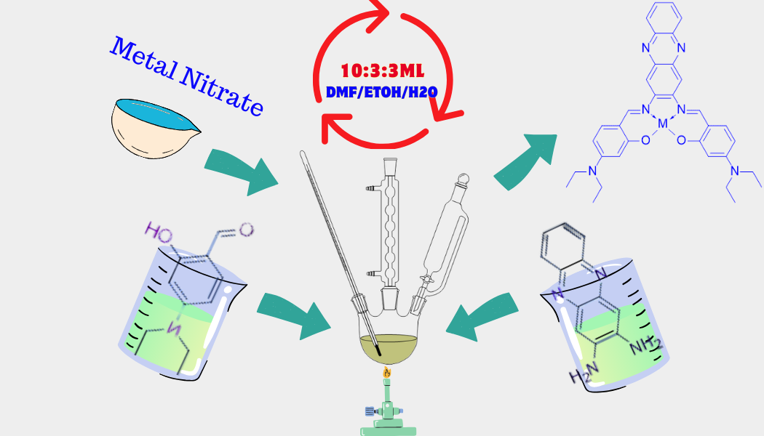

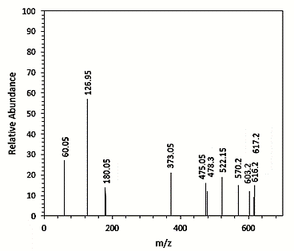
Figure(S1): Mass spectra of Co(II)complex
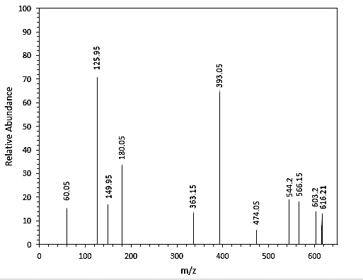
Figure(S2): Mass spectra of Ni(II) complex
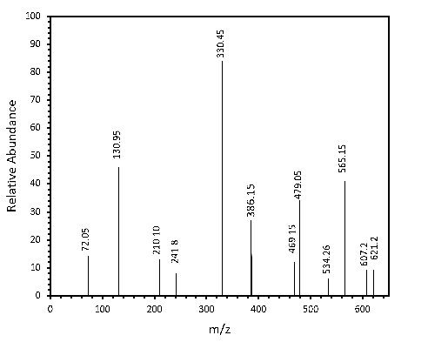
Figure(S3): Mass spectra of Cu(II) complex
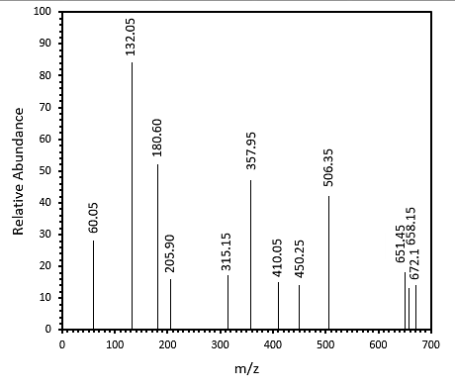
Figure(S4): Mass spectra of Cd(II) complex

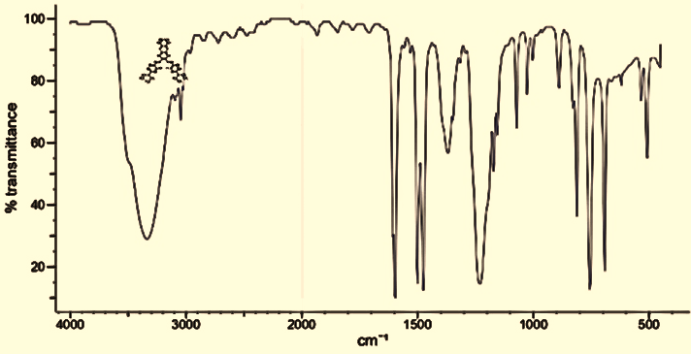 | 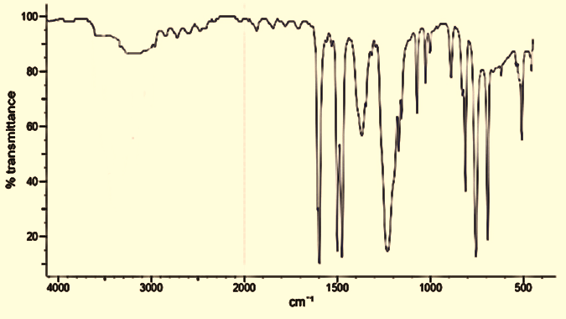
(a) | (b)
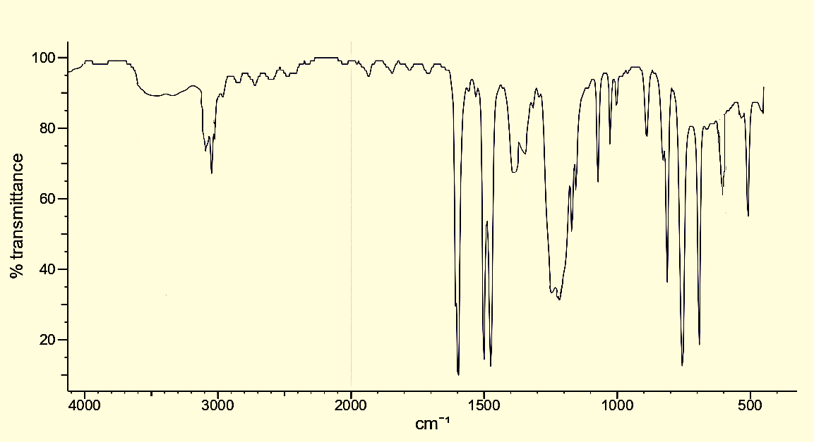 | 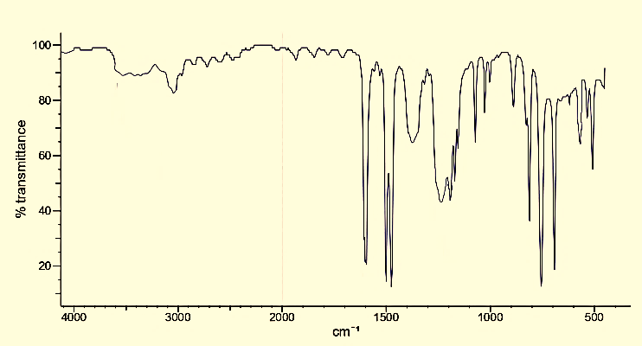
(c) | (d)
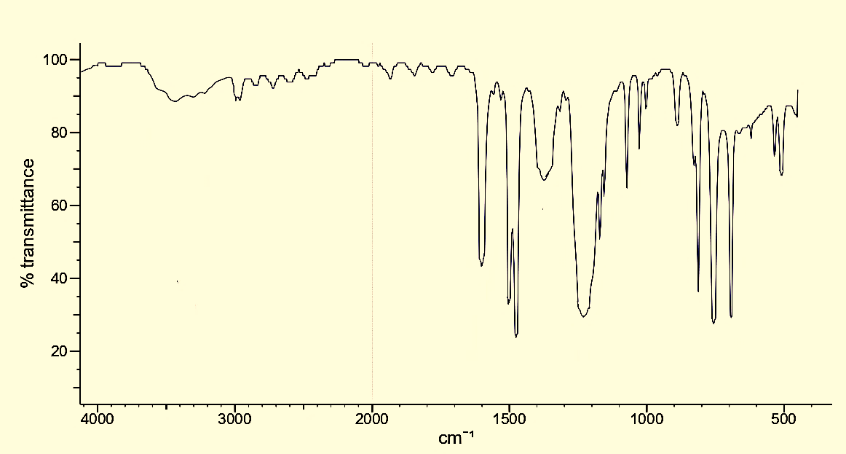
(e)
Fig (S5). FT-IR spectra of (a) H₂L; (b) C1; (c) C2; (d) C3; and (e) C4

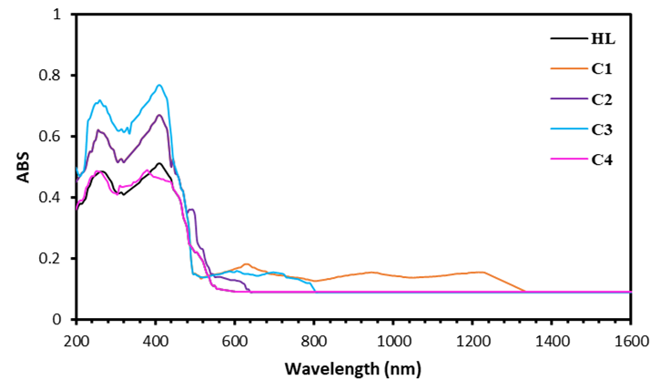
Fig (S6). FT-IR spectra of (a) H₂L; (b) C1; (c) C2; (d) C3; and (e) C4

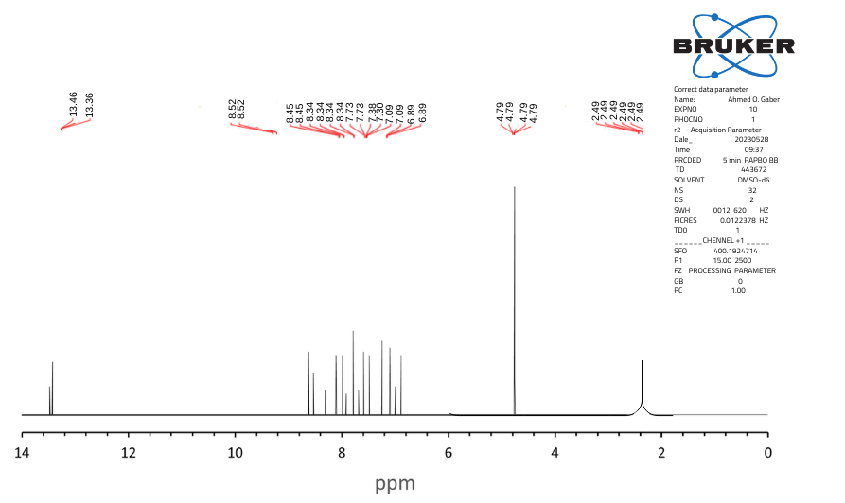
(a)
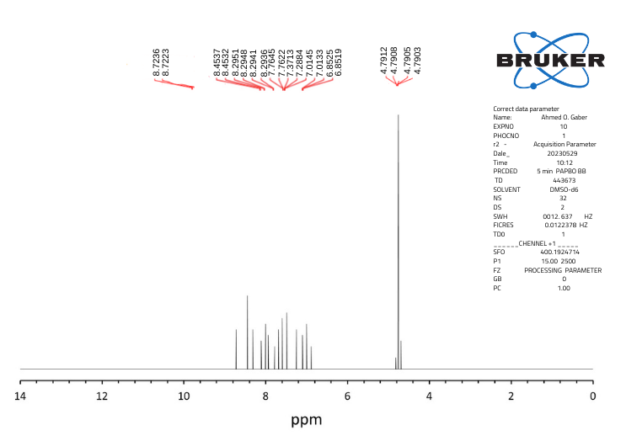
(b)

Figure(S7): (a)¹HNMR spectra of ligand (b) Cd(II) complex
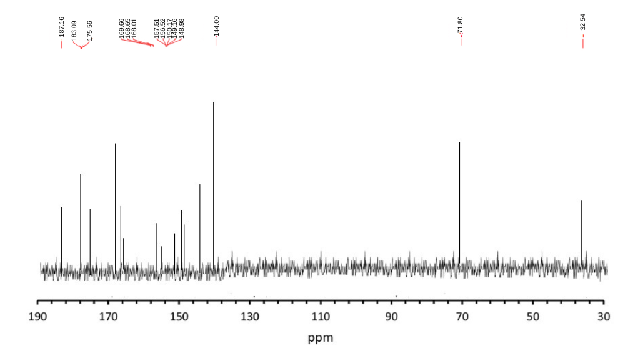
(a)
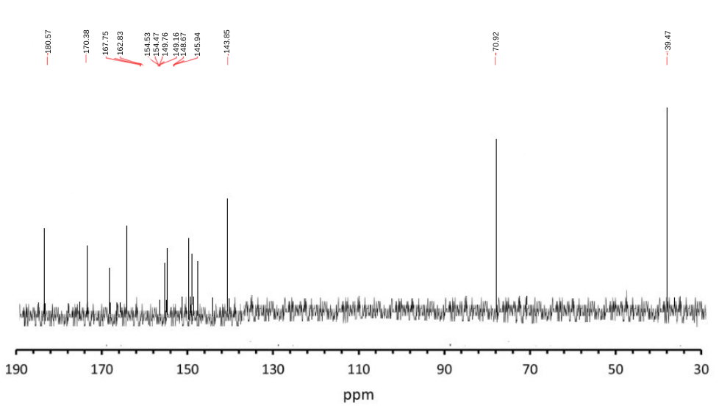
(b)
Figure (S8) ¹³CNMR spectra of (a) ligand (b) Cd(II) complex

Table(S2) The selected bond length (Aº) of complexes
Length (Aº) | Bond order | End atom | Start Atom | Type
1.3497 | 1 | C1 | O1 | O-C | HL
0.9679 | 1 | H1 | O1 | O-H | HL
1.3518 | 1 | C2 | O2 | O-C | HL
0.96118 | 1 | H2 | O2 | O-H | HL
1.4088 | 1 | C3 | C1 | C-C | HL
1.4046 | 2 | C4 | C1 | C-C | HL
1.4202 | 1 | C5 | C4 | C-C | HL
1.3952 | 1 | C7 | C6 | C-C | HL
1.3985 | 2 | C3 | C7 | C-C | HL
1.4217 | 1 | C8 | C2 | C-C | HL
1.4016 | 2 | C9 | C8 | C-C | HL
1.3937 | 1 | C10 | C9 | C-C | HL
1.4157 | 2 | C11 | C10 | C-C | HL
1.4020 | 2 | C12 | C2 | C-C | HL
1.4185 | 1 | C12 | C11 | C-C | HL
1.2912 | 2 | C13 | N1 | N-C | HL
1.4871 | 1 | C3 | C13 | C-C | HL
1.2887 | 2 | C14 | N2 | N-C | HL
1.4133 | 1 | C15 | C16 | C-C | HL
1.4136 | 2 | C17 | C15 | C-C | HL
1.3602 | 1 | N3 | C19 | C-N | HL
1.3602 | 1 | N4 | C20 | C-N | HL
1.359 | 2 | C21 | N3 | N-C | HL
1.359 | 2 | C22 | N4 | N-C | HL
1.332 | 1 | C1 | O1 | O-C | C1
1.333 | 1 | C2 | O2 | O-C | C1
1.338 | 2 | C3 | C1 | C-C | C1
1.397 | 2 | C4 | C1 | C-C | C1
1.414 | 1 | C5 | C4 | C-C | C1
1.418 | 2 | C6 | C5 | C-C | C1
1.403 | 2 | C9 | C8 | C-C | C1
1.399 | 1 | C10 | C9 | C-C | C1
1.417 | 2 | C11 | C10 | C-C | C1
1.299 | 2 | C14 | N2 | N-C | C1
1.430 | 1 | C15 | N1 | N-C | C1
1.417 | 2 | C17 | C15 | C-C | C1
1.359 | 2 | C21 | N3 | N-C | C1
1.358 | 2 | C22 | N4 | N-C | C1
1.360 | 1 | N3 | C19 | C-N | C1
1.360 | 1 | N4 | C20 | C-N | C1
1.802 | 1 | Co | O1 | O-Co | C1
1.804 | 1 | O2 | Co | Co-O | C1
1.926 | 1 | N1 | Co | Co-N | C1
1.923 | 1 | N2 | Co | Co-N | C1
1.332 | 1 | C1 | O1 | O-C | C2
1.333 | 1 | C2 | O2 | O-C | C2
1.338 | 2 | C3 | C1 | C-C | C2
1.397 | 2 | C4 | C1 | C-C | C2
1.414 | 1 | C5 | C4 | C-C | C2
1.418 | 2 | C6 | C5 | C-C | C2
1.403 | 2 | C9 | C8 | C-C | C2
1.399 | 1 | C10 | C9 | C-C | C2
1.417 | 2 | C11 | C10 | C-C | C2
1.299 | 2 | C14 | N2 | N-C | C2
1.430 | 1 | C15 | N1 | N-C | C2
1.417 | 2 | C17 | C15 | C-C | C2
1.359 | 2 | C21 | N3 | N-C | C2
1.481 | 1 | C33 | N5 | N-C | C2
1.360 | 1 | N3 | C19 | C-N | C2
1.360 | 1 | N4 | C20 | C-N | C2
1.765 | 1 | Ni | O1 | O-Ni | C2
1.766 | 1 | O2 | Ni | Ni-O | C2
1.886 | 1 | N1 | Ni | Ni-N
1.883 | 1 | N2 | Ni | Ni-N
1.359 | 1 | C1 | O1 | O-C | C3
1.359 | 1 | C2 | O2 | O-C | C3
1.434 | 1 | C3 | C1 | C-C | C3
1.400 | 2 | C4 | C1 | C-C | C3
1.397 | 2 | C9 | C8 | C-C | C3
1.418 | 2 | C10 | C9 | C-C | C3
1.400 | 2 | C12 | C2 | C-C | C3
1.280 | 2 | C13 | N1 | N-C | C3
1.280 | 2 | C14 | N2 | N-C | C3
1.426 | 1 | C15 | N1 | N-C | C3
1.426 | 1 | C16 | N2 | N-C | C3
1.482 | 1 | C33 | N5 | N-C | C3
1.822 | 1 | Cu | O1 | O-Cu | C3
1.822 | 1 | O2 | Cu | Cu-O | C3
1.851 | 1 | N1 | Cu | Cu-N | C3
1.851 | 1 | N2 | Cu | Cu-N | C3
1.355 | 1 | C1 | O1 | O-C | C4
1.355 | 1 | C2 | O2 | O-C | C4
1.430 | 1 | C3 | C1 | C-C | C4
1.419 | 1 | C5 | C4 | C-C | C4
1.416 | 2 | C6 | C5 | C-C | C4
1.416 | 2 | C11 | C10 | C-C | C4
1.400 | 2 | C12 | C2 | C-C | C4
1.419 | 1 | C12 | C11 | C-C | C4
1.285 | 2 | C13 | N1 | N-C | C4
1.285 | 2 | C14 | N2 | N-C | C4
1.429 | 1 | C15 | N1 | N-C | C4
1.429 | 1 | C16 | N2 | N-C | C4
1.482 | 1 | C33 | N5 | N-C | C4
1.938 | 1 | Cd | O1 | O-Cd | C4
1.938 | 1 | O2 | Cd | Cd-O | C4
1.968 | 1 | N1 | Cd | Cd-N | C4
1.968 | 1 | N2 | Cd | Cd-N | C4

