Supporting information

PHOTOCHEMICAL SYNTHESIS IN INORGANIC CHEMISTRY

Rimsha Kanwal¹, Riyadh R. Al-Araji², Ahmad H. Ibrahim⁴, Muhammad Adnan Iqbal^{1,3,*}, Shamsa Bibi¹, Adina Zafar¹, Muhammad Yaseen⁵, Umer Shoukat¹, Faisal Jamil¹

¹Department of Chemistry, University of Agriculture Faisalabad, Pakistan.
²College of Education for Pure Sciences, Wasit University, kut, Wasit, Iraq.
³Organometallic & Coordination Chemistry Laboratory, Department of Chemistry, University of Agriculture Faisalabad, Pakistan.
⁴Pharmacy Department, Faculty of Pharmacy, Tishk International University, 100 Mt. St, Near Baz intersection, Erbil, KRG, Iraq
⁵Department of Chemistry, Division of Science and Technology, University of Education, Lahore, Pakistan.

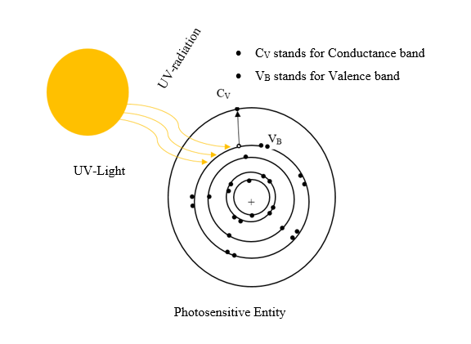
Figure S1. The transition of an electron by using UV light in order to activate the photosensitive entity for the synthesis of complexes. This figure has been drawn on ChemDraw 21.0.0.
Figure S2. Basic schemes of photochemical synthesis. A) Excited photo-catalyst transfer electron to the substrate molecules. B) Excited photo-catalyst caused the transformation of an atom. C) Excited photo-catalyst Transfer energy to the substrate.
Figure S3. Fluorophore a) assembly of photoactive material via weak interactions. b) Photo-active materials on transition metal core. c) Photo-active material on stannoxane substrate photoactive material on the dendrimaric core.

