Metal exposures and biomarkers of liver damage: A systematic review and meta-analysis of observational studies

Ibrahim Issah^{1, 2*}, Serwaa A. Bawua^{1, 2}, John Arko-Mensah^{1, 2}, Mabel S. Duah^{1, 2}, Shirley V. Simpson^{2, 3}, Thomas P. Agyekum⁴, Olalekan A. Uthman⁵, Julius N. Fobil^{1, 2}
¹Department of Biological, Environmental and Occupational Health Sciences, University of Ghana, School of Public Health, Accra, Ghana;
²West Africa Center for Global Environmental & Occupational Health, College of Health Sciences, University of Ghana, Legon, Accra, Ghana
³Department of Bacteriology, Noguchi Memorial Institute for Medical Research, University of Ghana, Legon, Ghana;
⁴Department of Occupational and Environmental Health and Safety, School of Public Health, College of Health Sciences, Kwame Nkrumah University of Science and Technology, Kumasi 00233, Ghana
⁵Warwick Applied Health, Warwick Centre for Global Health, Warwick Medical School, University of Warwick, Coventry, CV4 7AL, United Kingdom

SUPPLEMENTARY MATERIALS
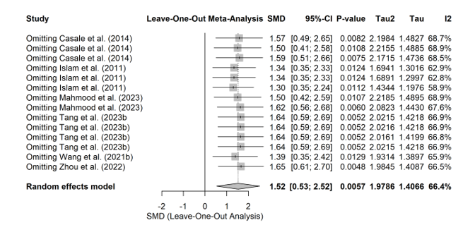
eFigure 1. Leave-One-Out Sensitivity Analysis for the Association Between Arsenic Exposure and Liver Damage

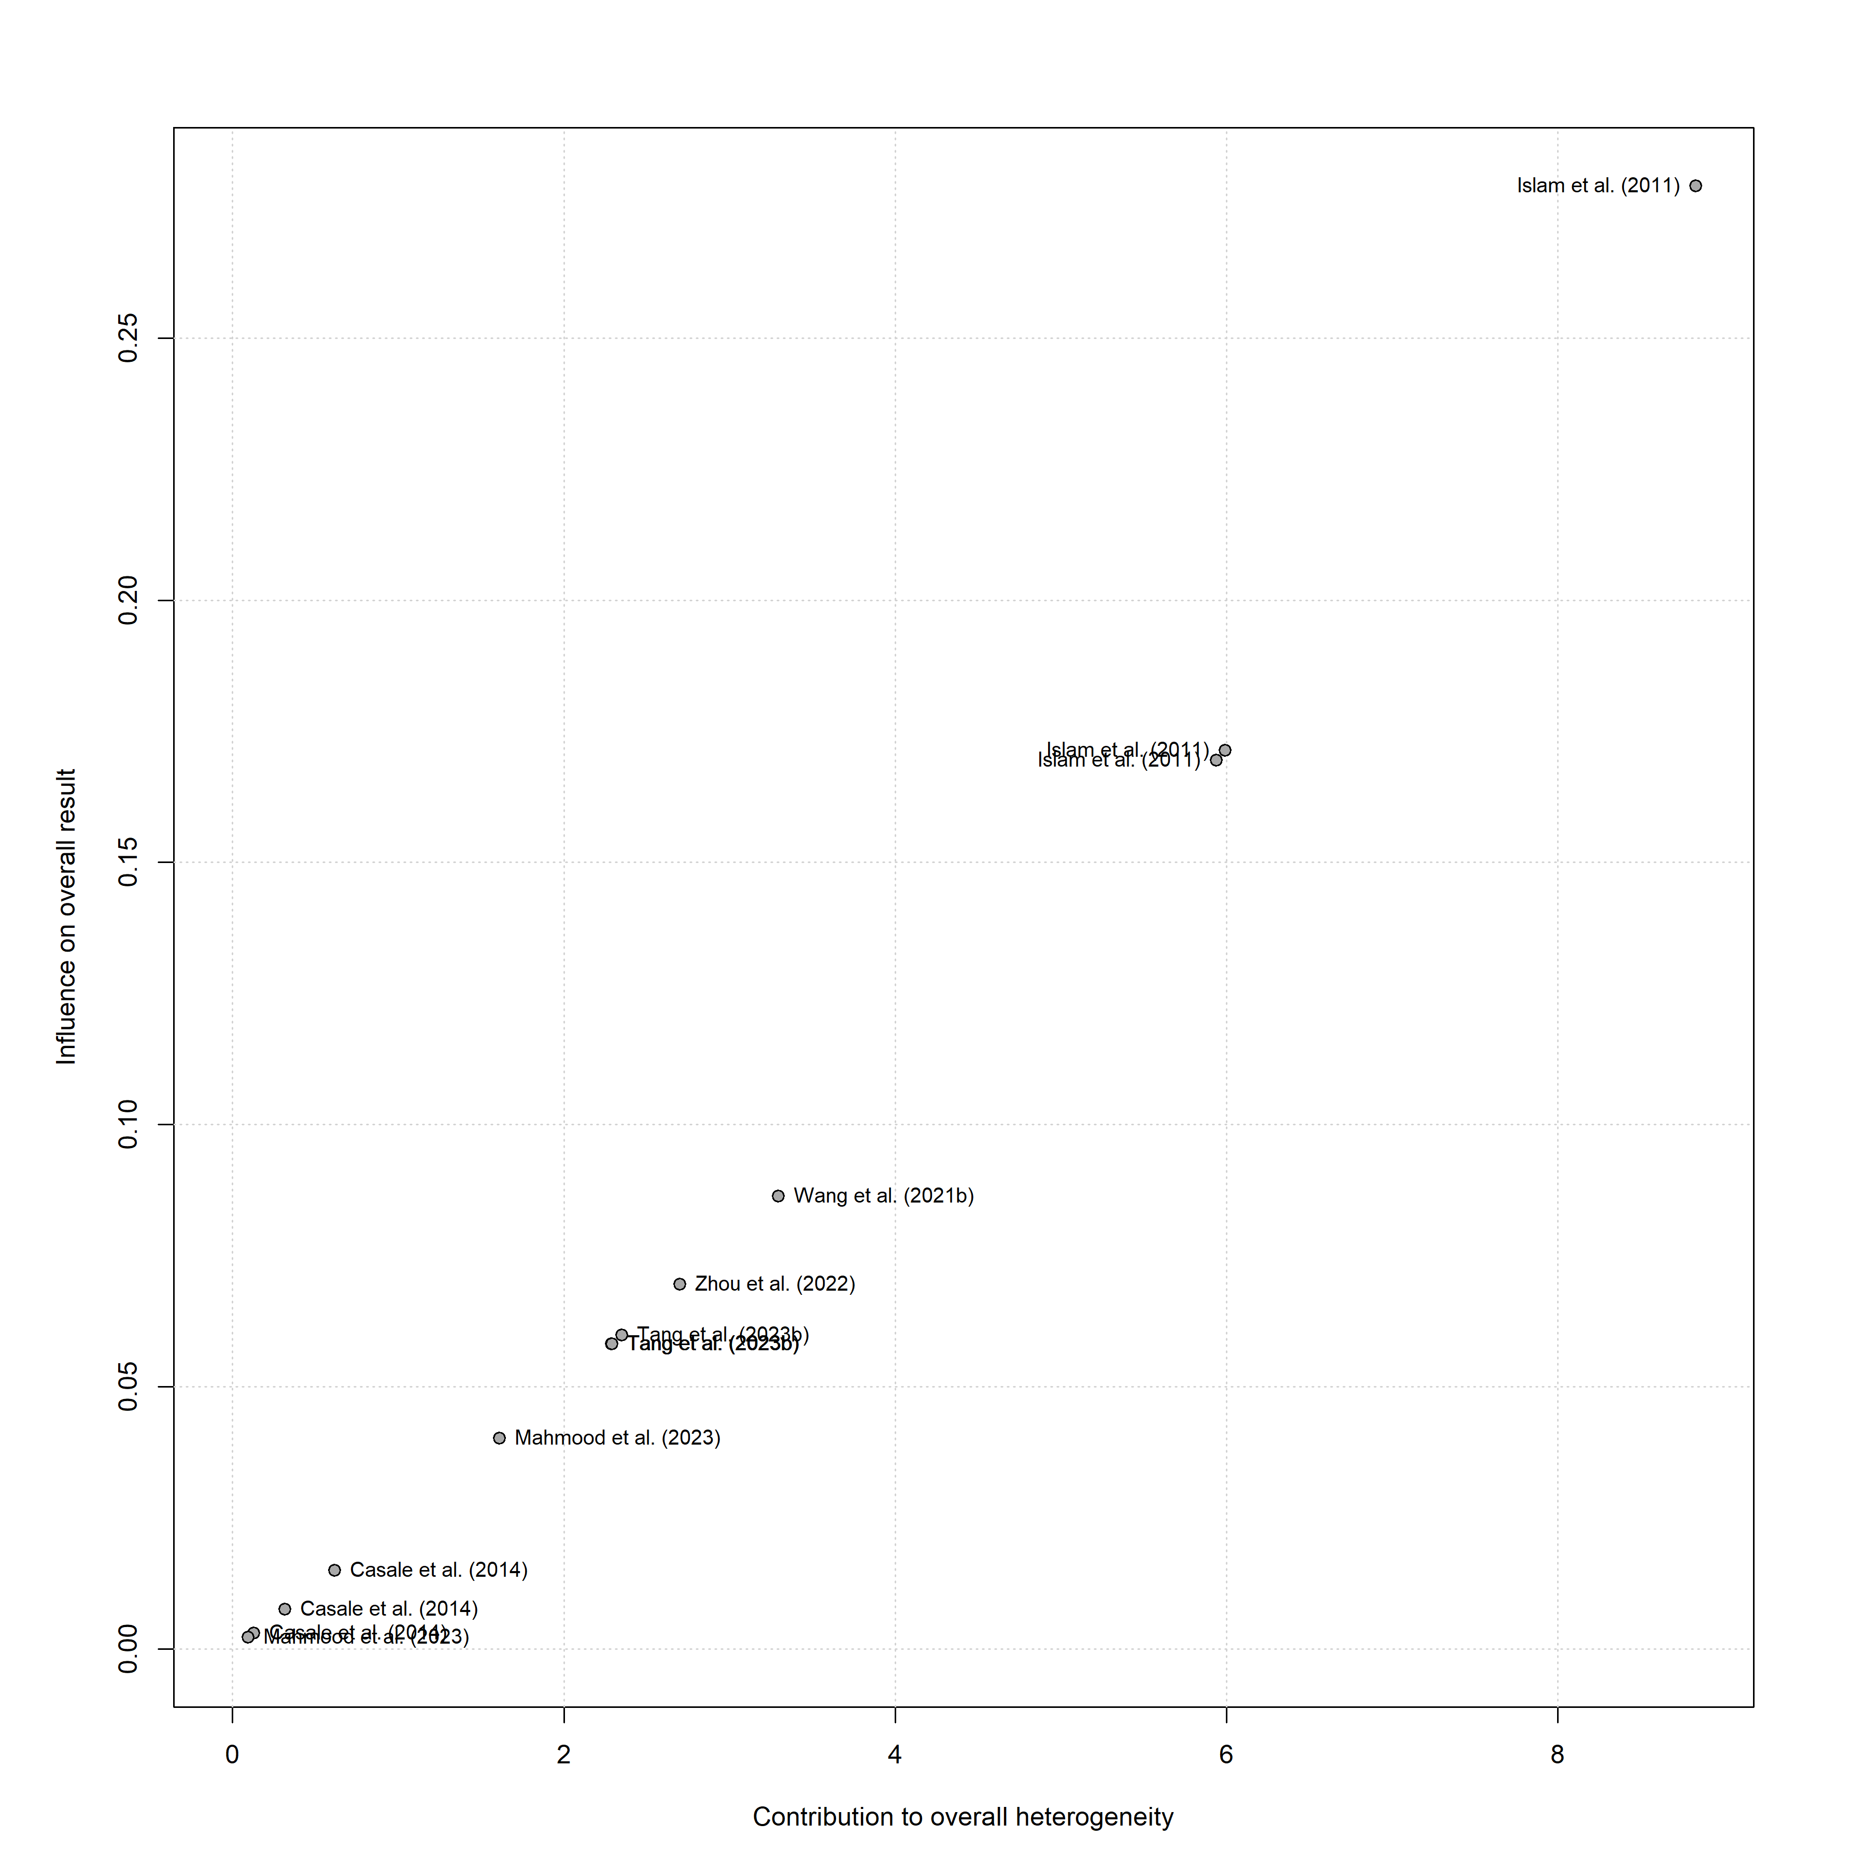
eFigure 2. Baujat Plot Identifying Influential Studies and Sources of Heterogeneity in the Meta-Analysis of Arsenic Exposure and Liver Damage

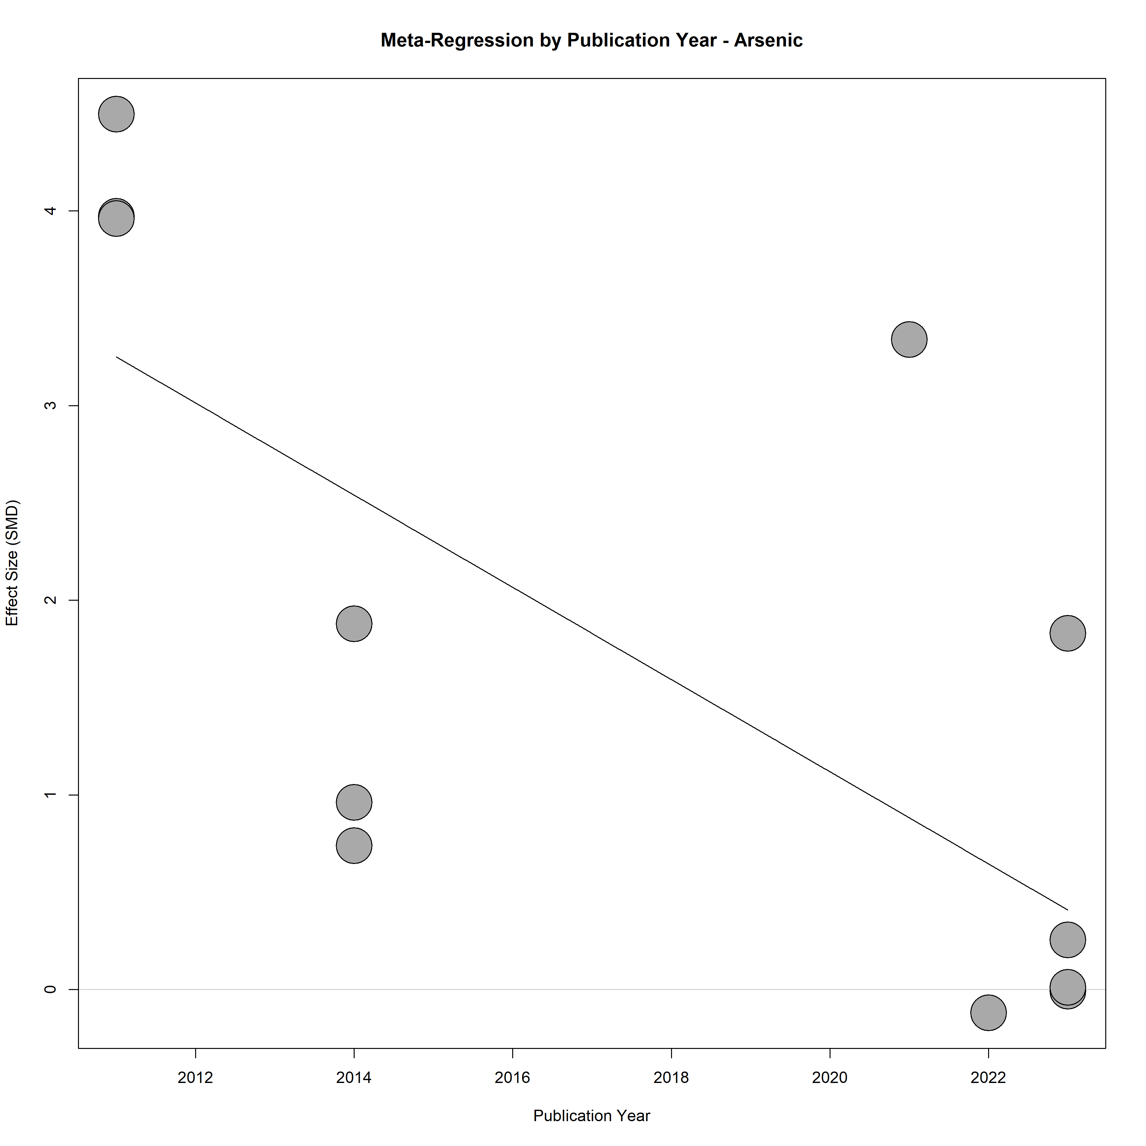
eFigure 3. Meta-Regression of Publication Year on the Association between Arsenic Exposure and Liver Damage

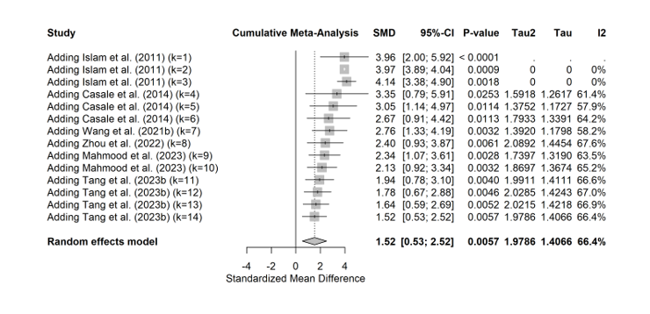
eFigure 4. Cumulative Meta-Analysis of the Association between Arsenic Exposure and Liver Damage over Time

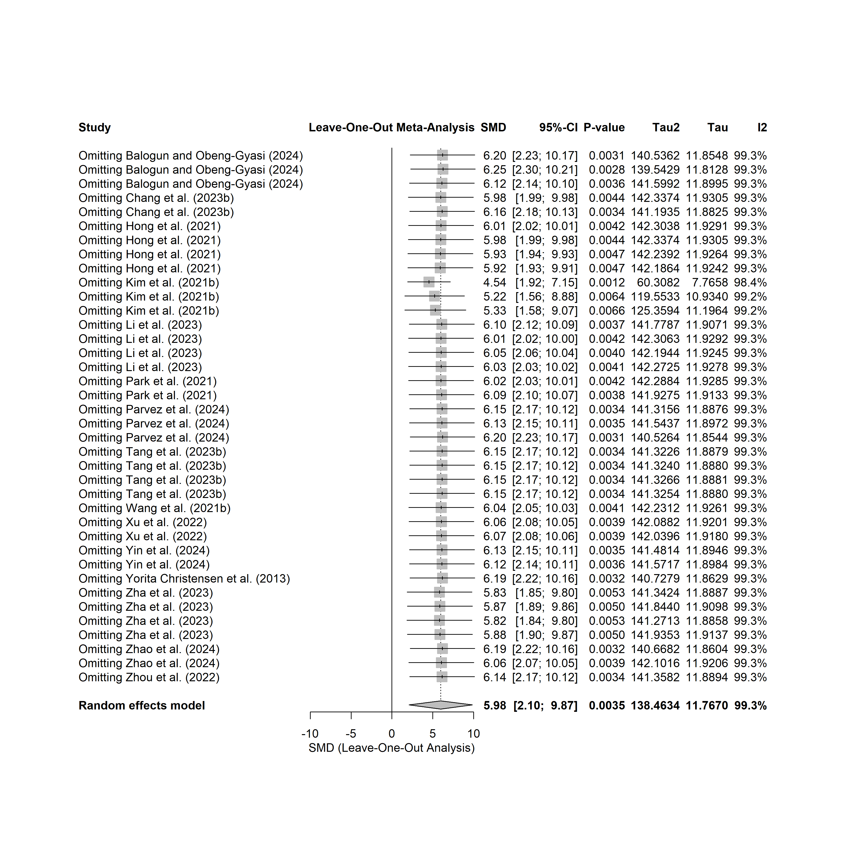
eFigure 5. Leave-One-Out Sensitivity Analysis for the Association between Cadmium Exposure and Liver Damage

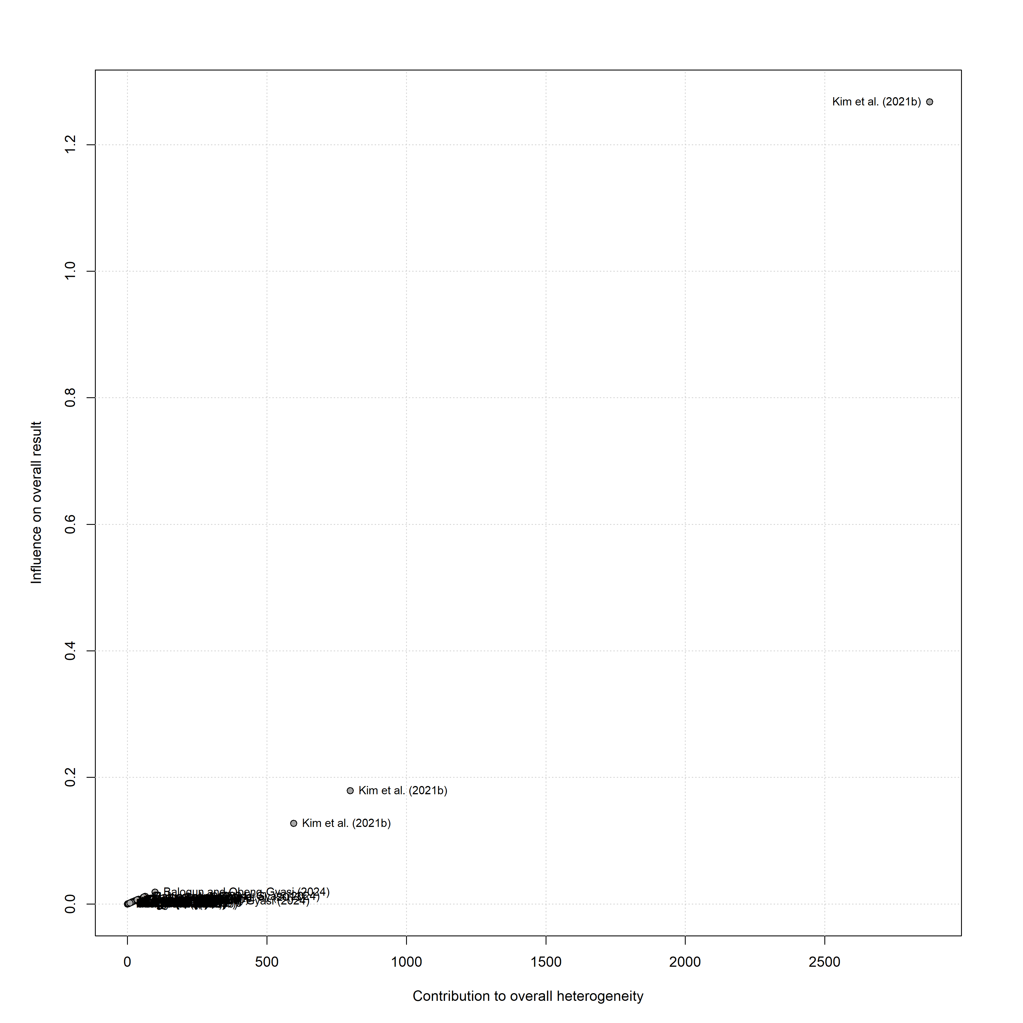
eFigure 6. Baujat Plot Identifying Influential Studies and Sources of Heterogeneity in the Meta-Analysis of Cadmium Exposure and Liver Damage

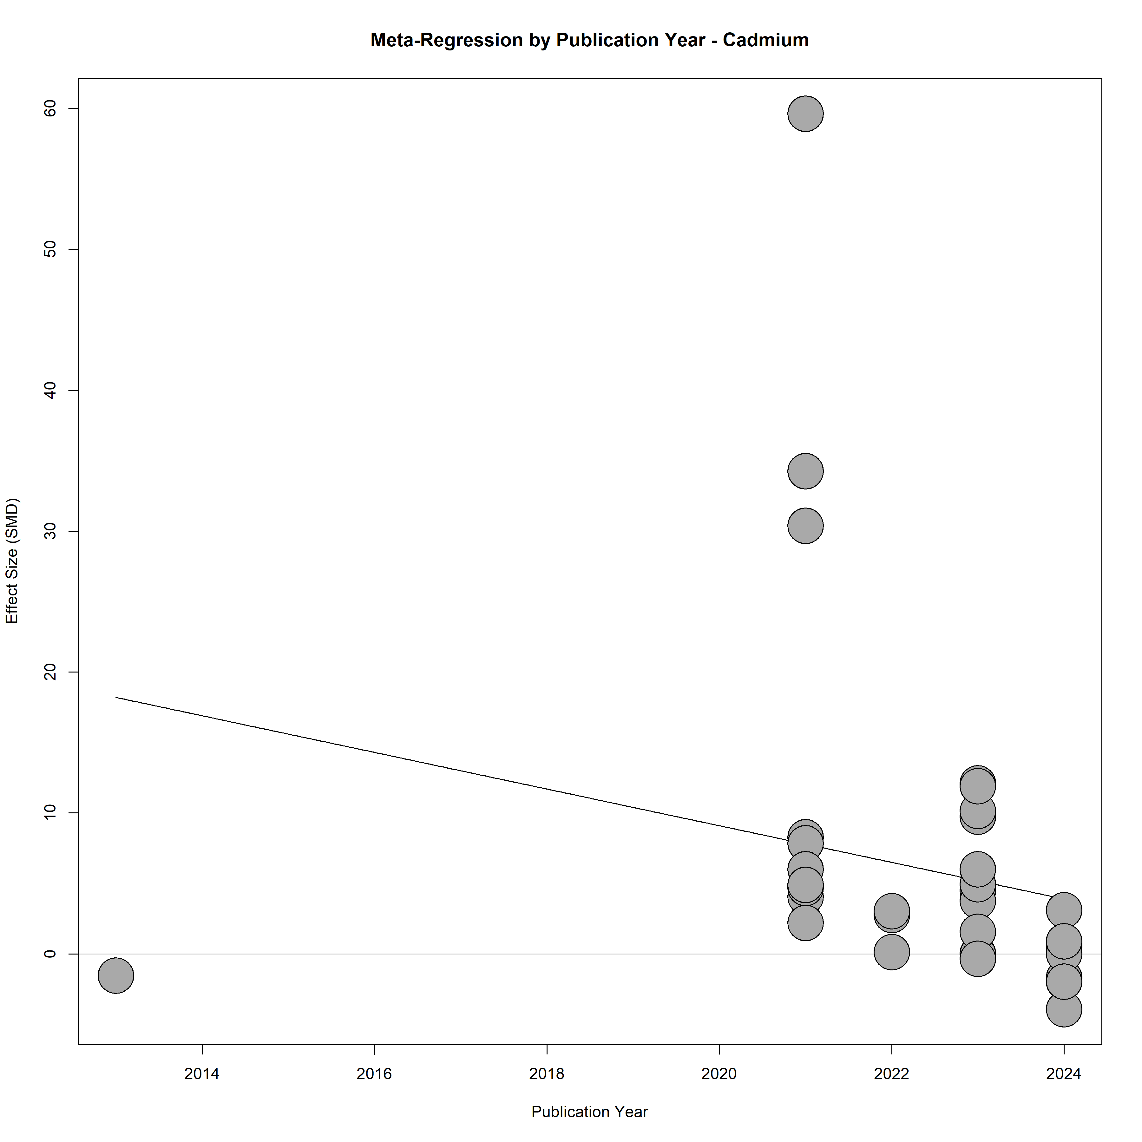
eFigure 7. Meta-Regression of Publication Year on the Association between Cadmium Exposure and Liver Damage

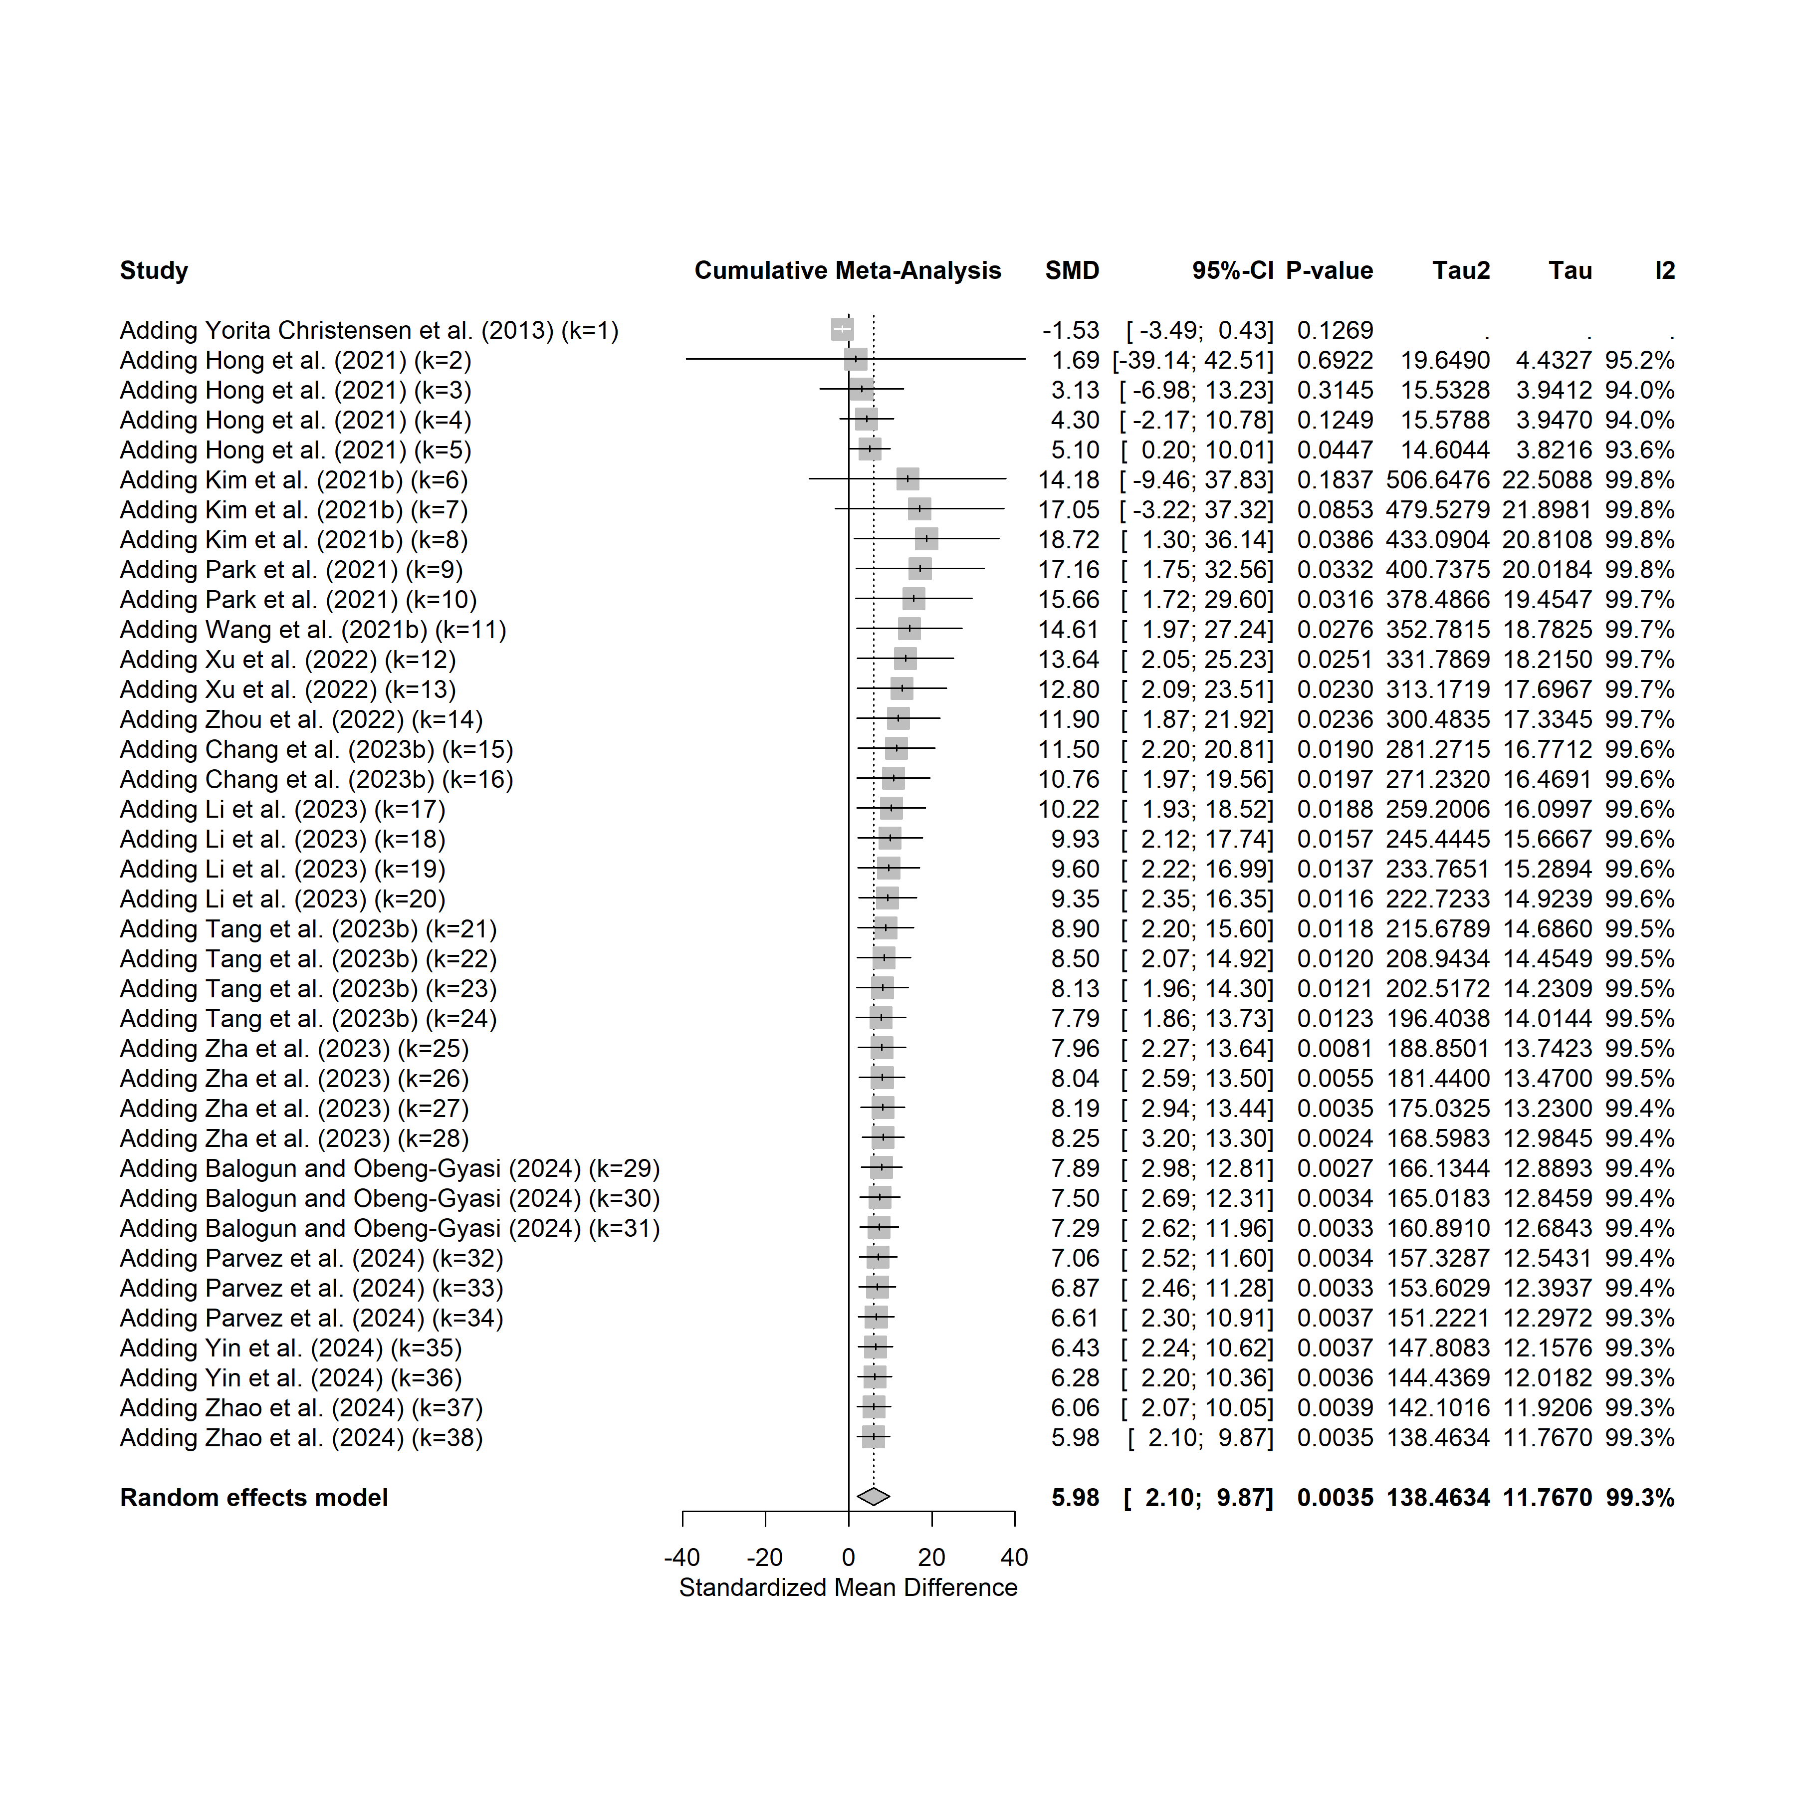
eFigure 8. Cumulative Meta-Analysis of the Association between Cadmium Exposure and Liver Damage over Time

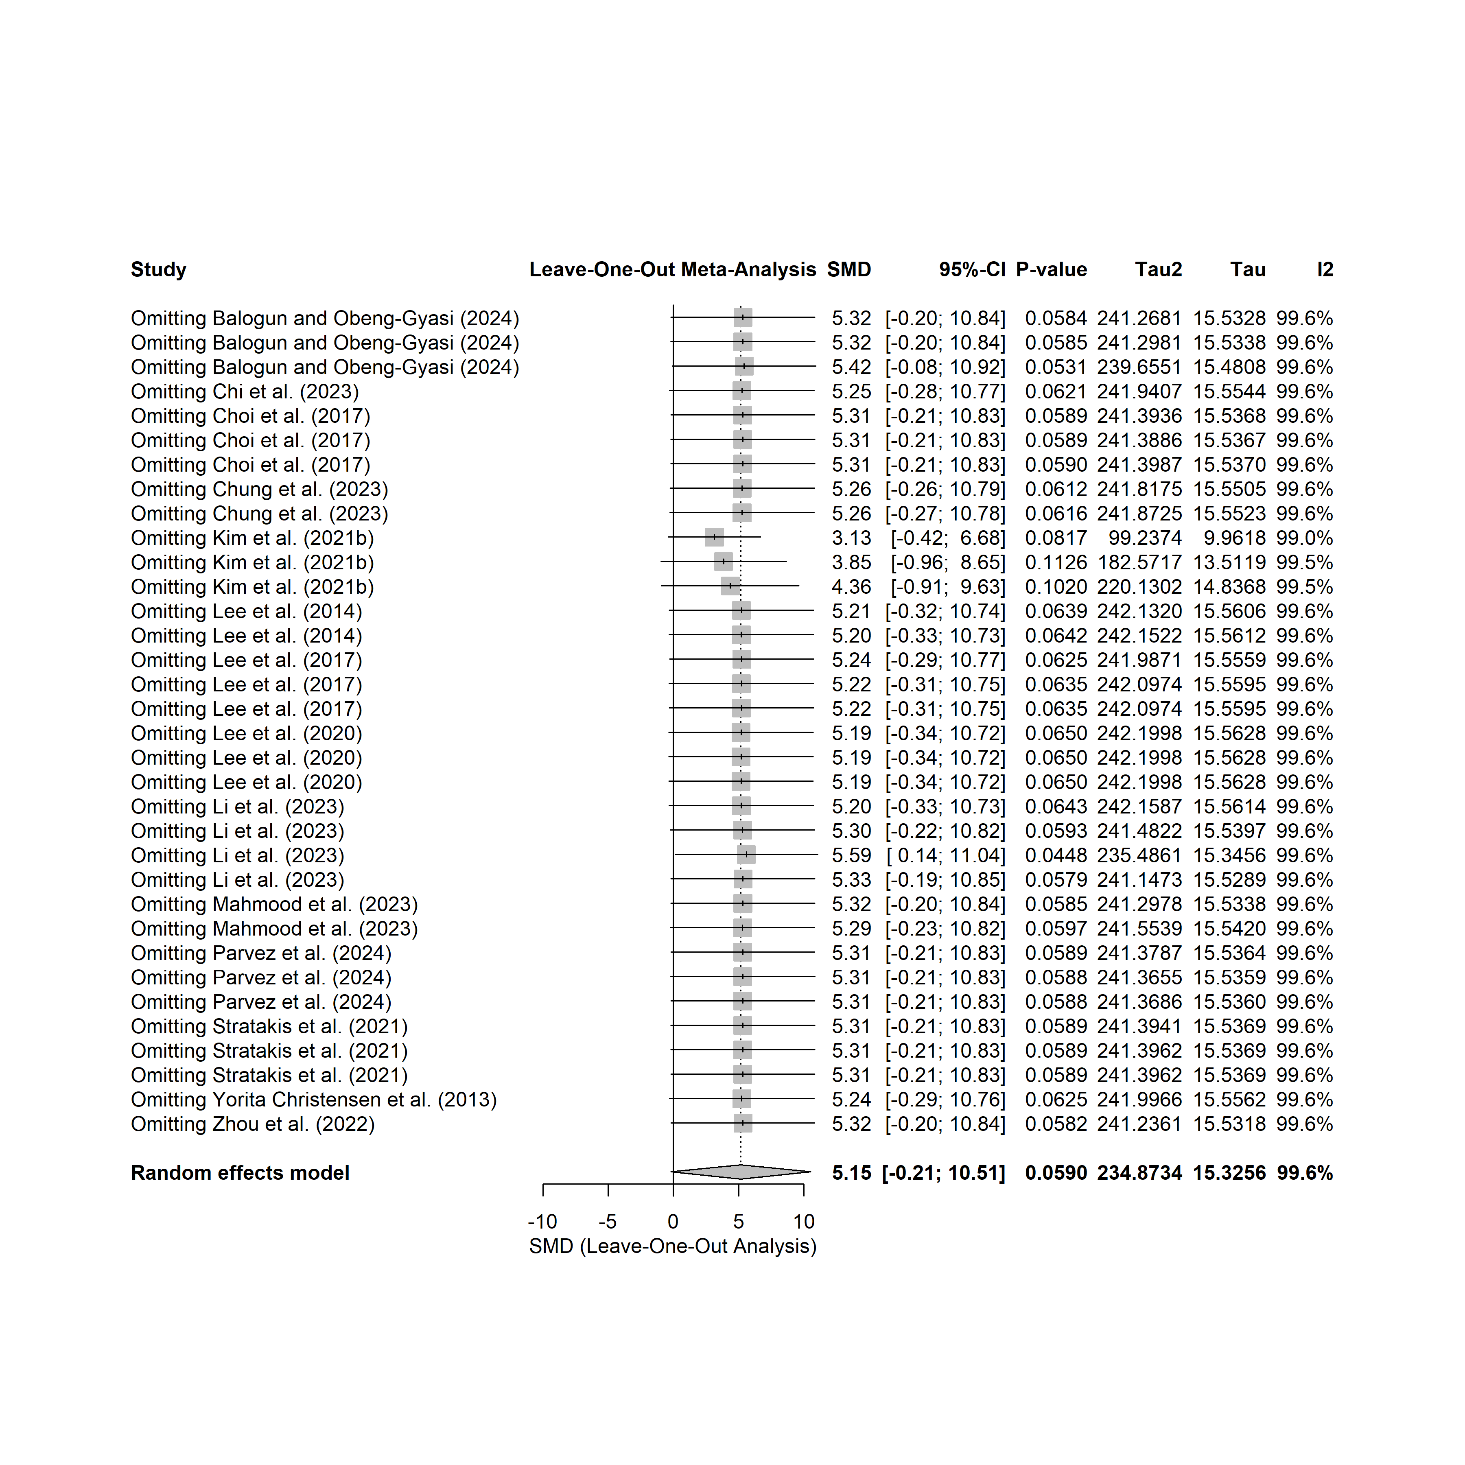
eFigure 9. Leave-One-Out Sensitivity Analysis for the Association Between Mercury Exposure and Liver Damage

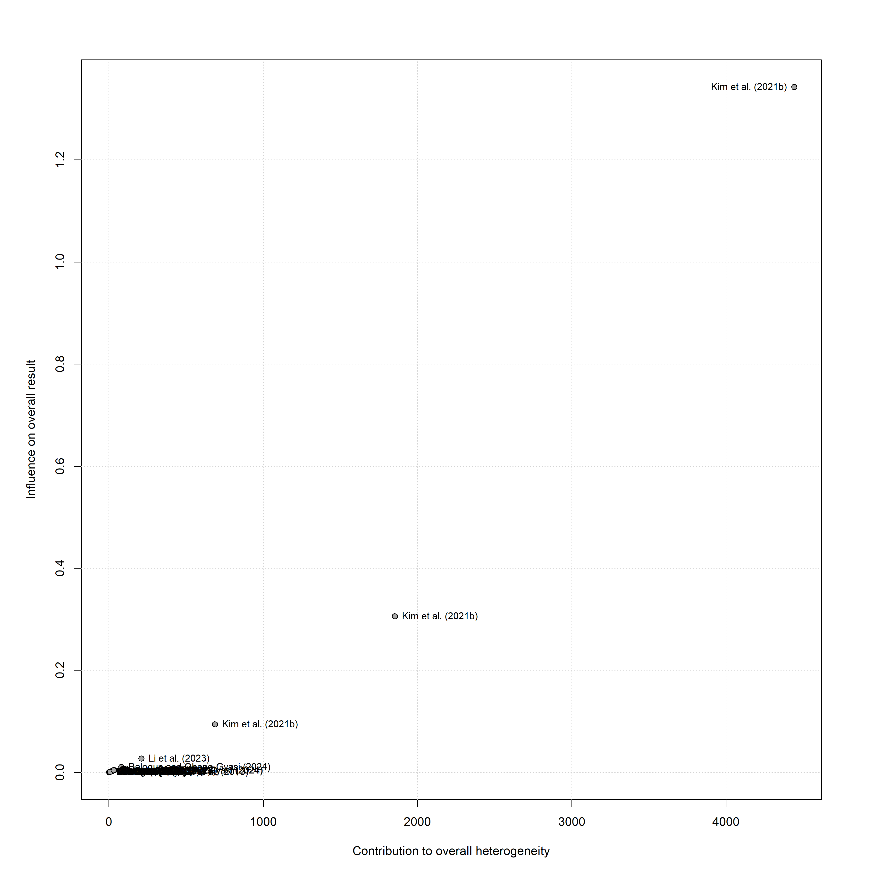
eFigure 10. Baujat Plot Identifying Influential Studies and Sources of Heterogeneity in the Meta-Analysis of Mercury Exposure and Liver Damage

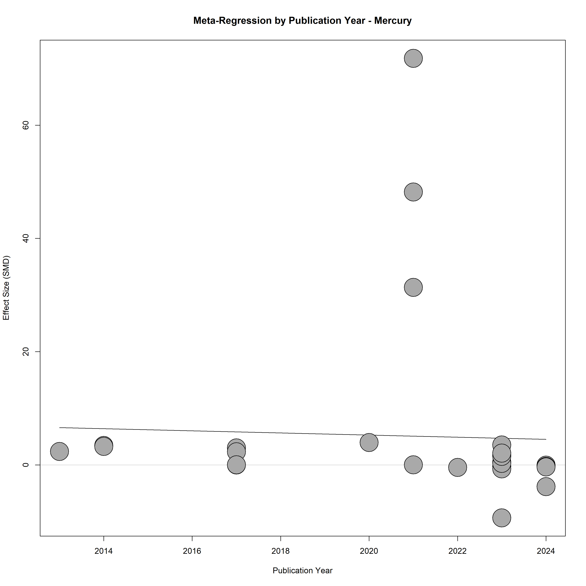
eFigure 11. Meta-Regression of Publication Year on the Association between Mercury Exposure and Liver Damage

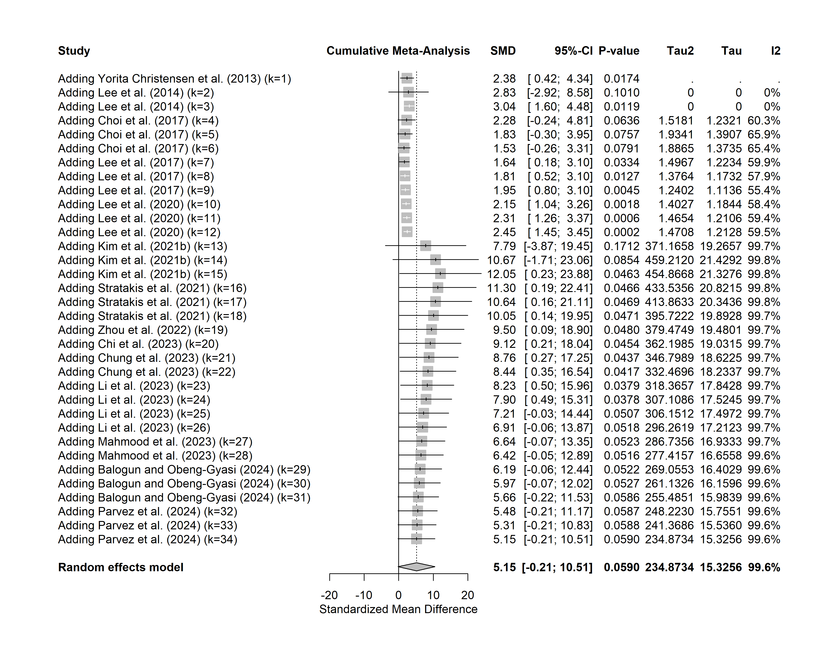
eFigure 12. Cumulative Meta-Analysis of the Association between Mercury Exposure and Liver Damage over Time

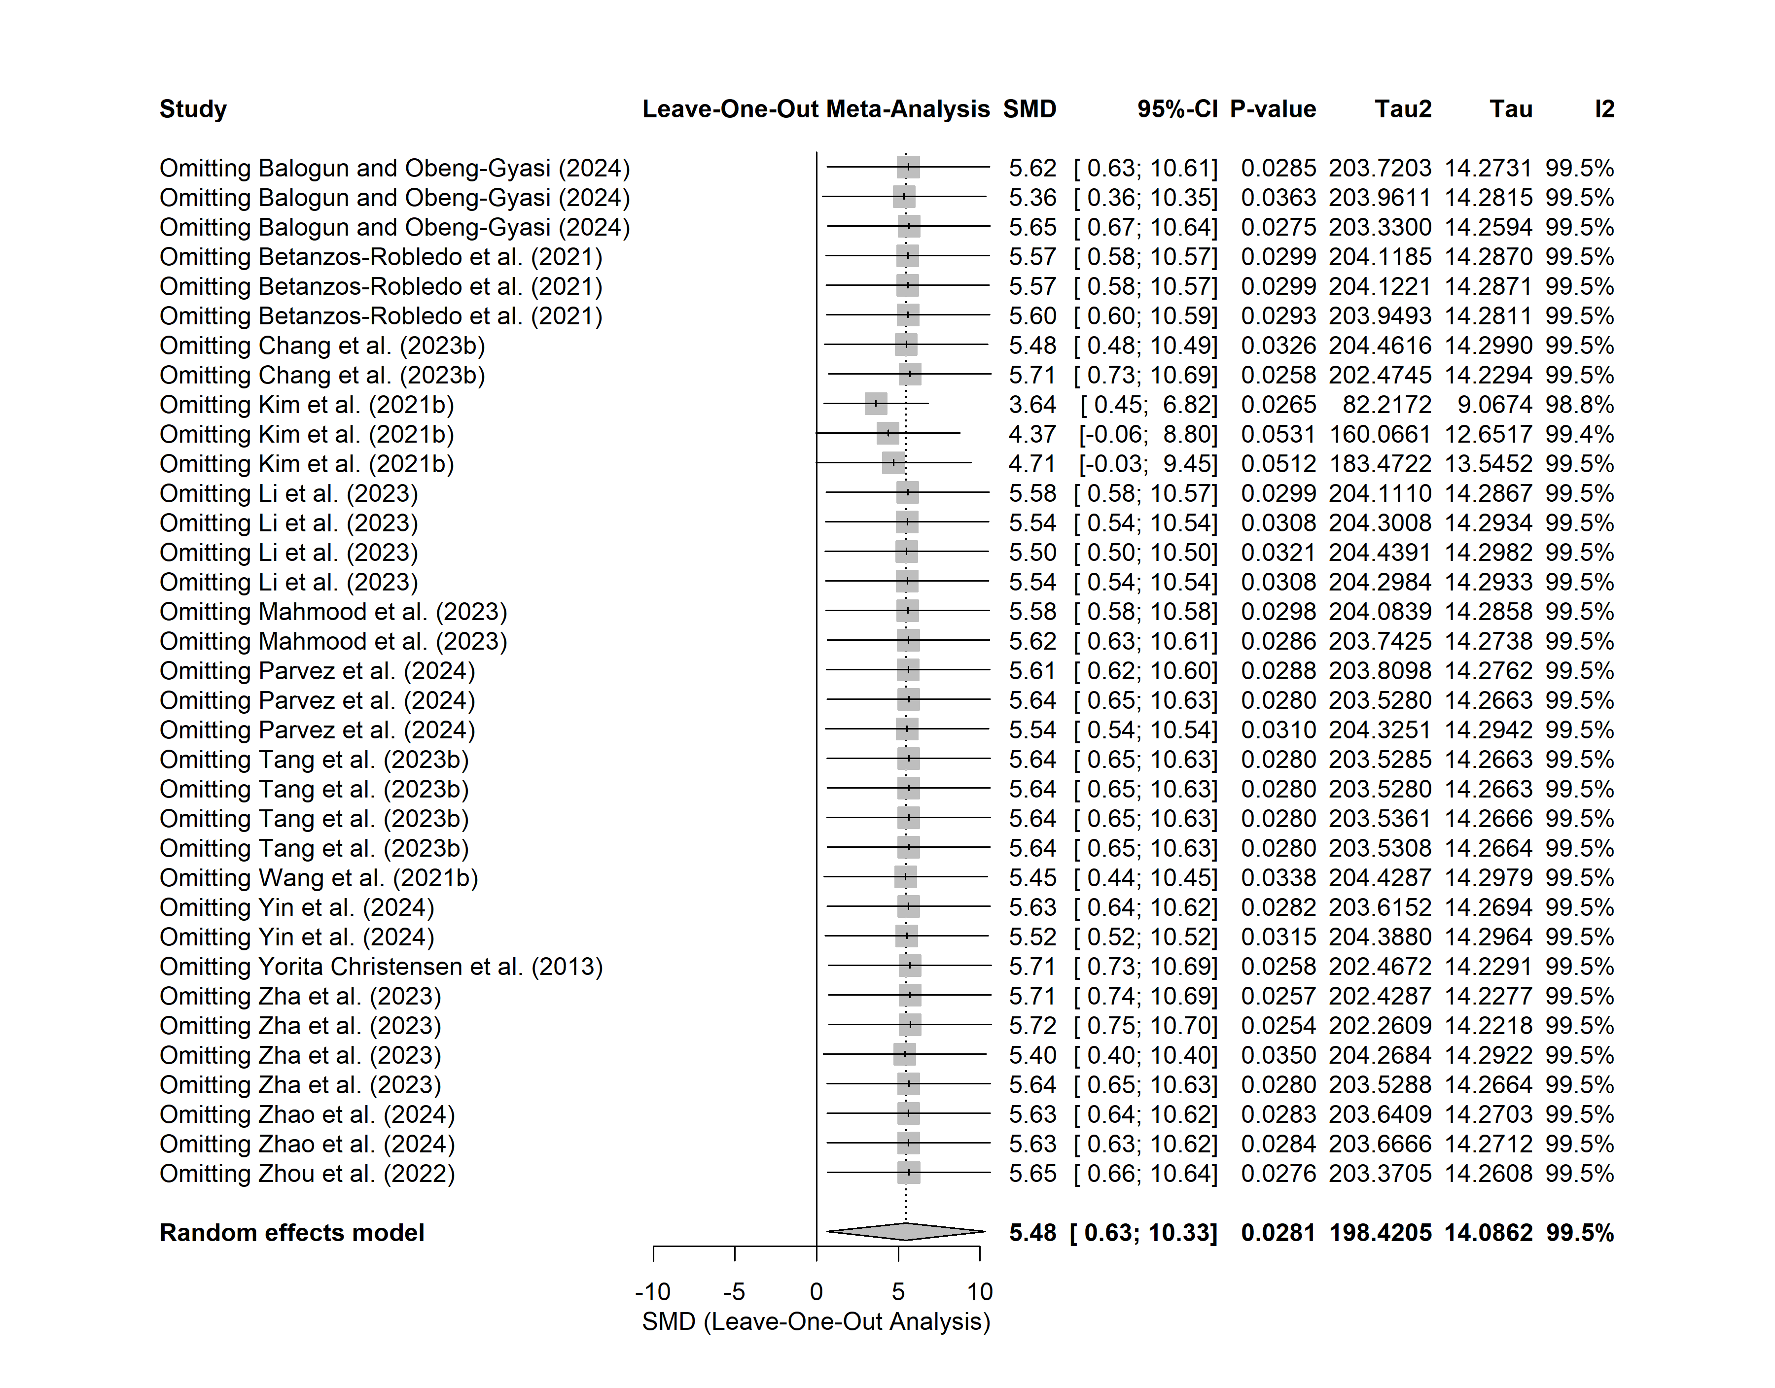
eFigure 13. Leave-One-Out Sensitivity Analysis for the Association between Lead Exposure and Liver Damage

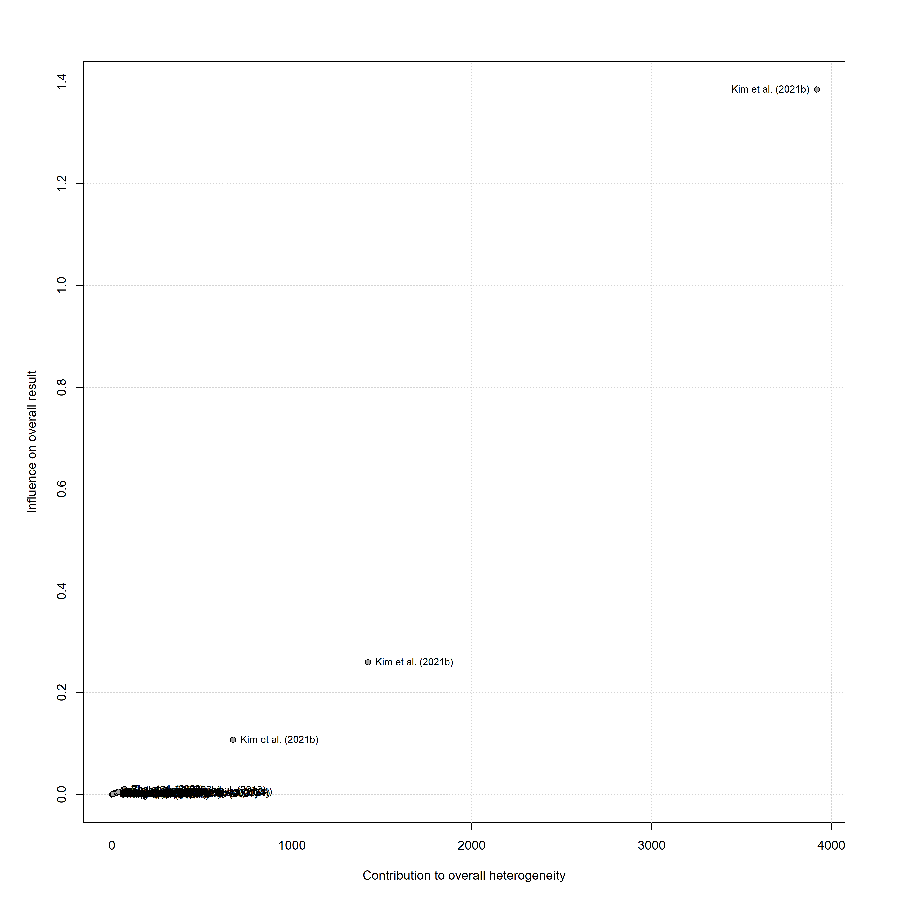
eFigure 14. Baujat Plot Identifying Influential Studies and Sources of Heterogeneity in the Meta-Analysis of Lead Exposure and Liver Damage

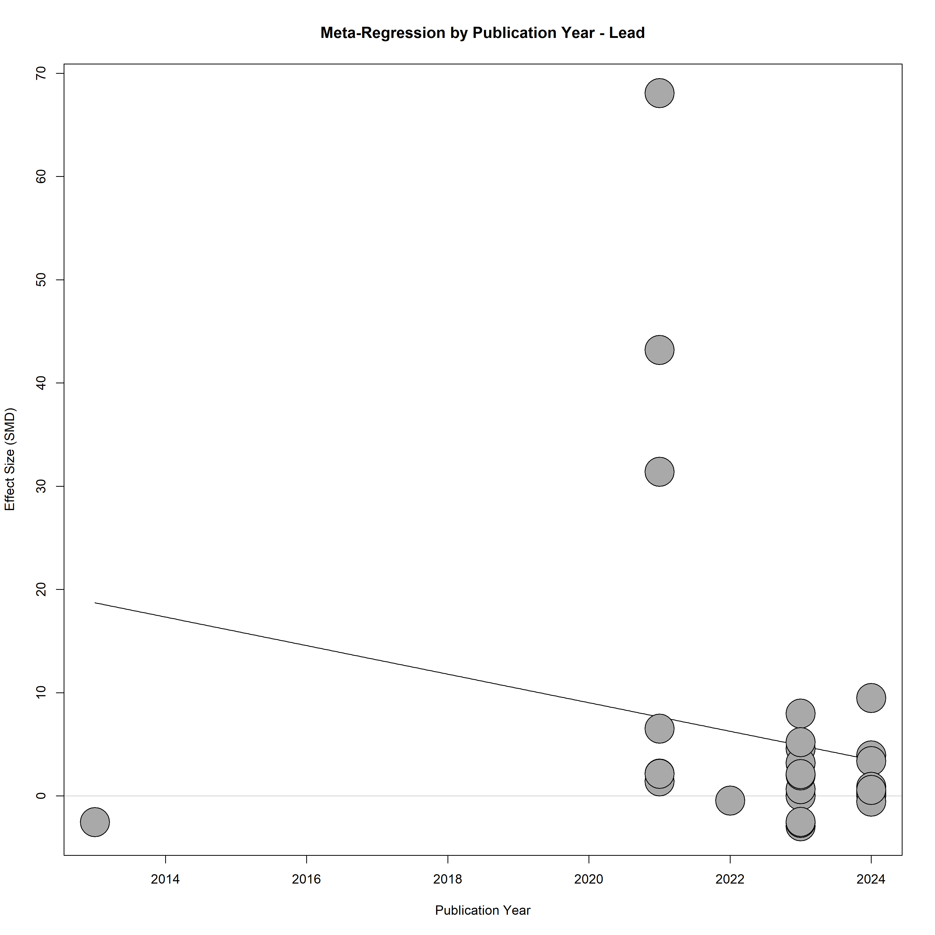
eFigure 15. Meta-Regression of Publication Year on the Association Between Lead Exposure and Liver Damage

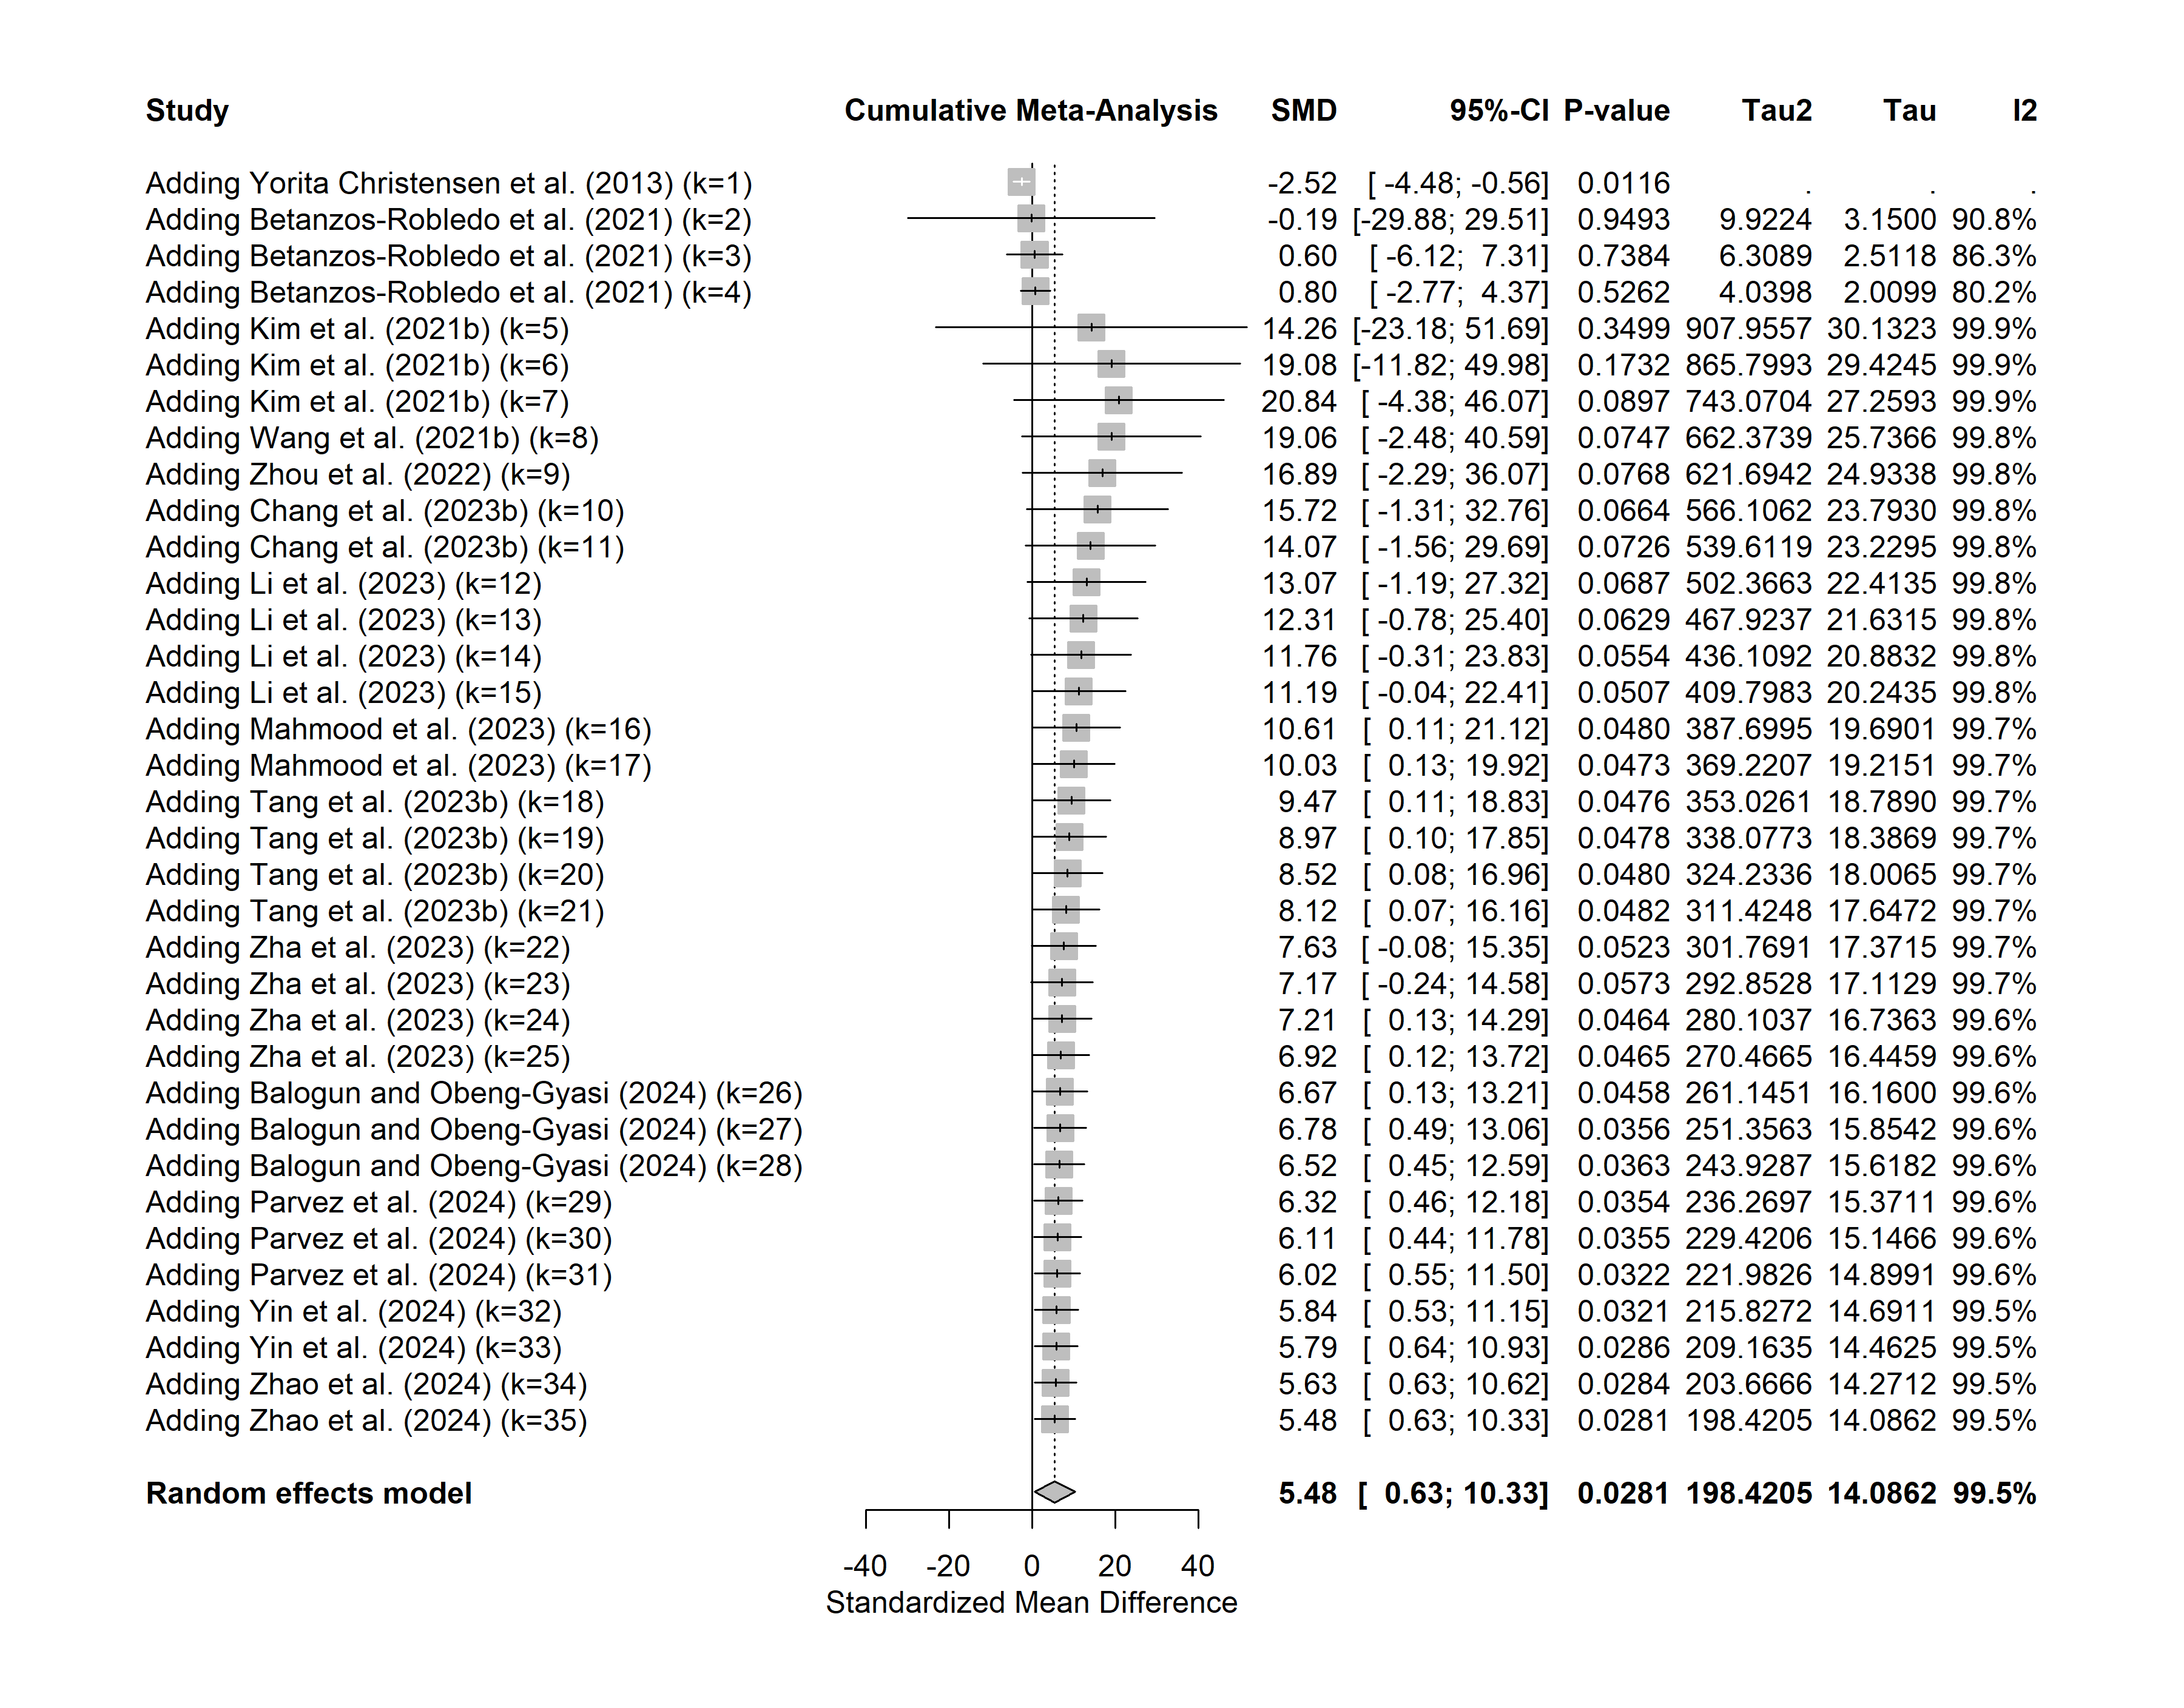
eFigure 16. Cumulative Meta-Analysis of the Association Between Lead Exposure and Liver Damage Over Time

eBox 1: Search strategy and results from databases
NO. | DATA BASE | SEARCH STRATEGY | RESULTS
1 | SCOPUS | TITLE-ABS-KEY(("heavy metals" OR metals OR "toxic metals" OR arsenic OR cadmium OR mercury OR lead OR chromium) AND ("Liver function" OR ALT OR "alanine aminotransferase" OR AST OR "aspartate aminotransferase" OR GGT OR "gamma-glutamyl transferase" ALP OR "alkaline phosphatase" OR "liver enzymes" OR "liver damage" OR "liver injury")) AND ( LIMIT-TO ( DOCTYPE,"ar" ) ) AND ( LIMIT-TO ( LANGUAGE,"English" ) ) AND ( LIMIT-TO ( EXACTKEYWORD,"Human" ) OR LIMIT-TO ( EXACTKEYWORD,"Humans" ) ) | 2,557
2 | PUBMED | ((((((((((((((((((((heavy metals[MeSH Terms])) OR (metals)) OR (toxic metals)) OR (arsenic)) OR (cadmium)) OR (mercury)) OR (lead)) OR (chromium)) AND (Liver function[MeSH Terms])) OR (ALT)) OR (alanine aminotransferase)) OR (AST)) OR (aspartate aminotransferase)) OR (GGT)) OR (gamma-glutamyl transferase)) OR (ALP)) OR (alkaline phosphatase)) OR (liver enzymes)) OR (liver damage)) OR (liver injury) Filters: Observational Study, English, Humans | 2,373
3 | CINAHL Complete | ("heavy metals" OR metals OR "toxic metals" OR arsenic OR cadmium OR mercury OR lead OR chromium) AND (“Liver function” OR ALT OR “alanine aminotransferase” OR AST OR “aspartate aminotransferase” OR GGT OR “gamma-glutamyl transferase” ALP OR “alkaline phosphatase” OR “liver enzymes” OR “liver damage” OR “liver injury”) | 1587
Total |  |  | 6517

Table S1: Quality assessment of included studies based on the modified Newcastle–Ottawa Scale for cross-sectional studies
 | Sample selection Criteria (4 stars) |  |  | Comparability (4 stars) |  | Exposure (1 star) | Outcome (1 star) | Total (10 stars)
Publication | 1.Representativeness  of sample:  a ** Random;  b * Non-Random;  c Selected Groups;  d No Description | 2. Sample Size: a * Justified and Satisfactory; b Not Justified | 3. Non-Respondents: a * Comparability and Response Rate Satisfactory; b Comparability and/or Response Rate Unsatisfactory; c No Description | 4. Comparison Group: a * Described by Authors as Geographically Distinct; b * Same Community; c No Comparison Group | 5. Subjects in Outcome Groups Comparable: a * Study Controls for Most Important Confounder; b * Study Controls for Any Additional Confounder; c Study Did not Control for Any Confounder. | 6. Exposure Measurements  a * Exposure Chemical(s) Quantified; b Exposure Chemicals not Reported | 1) Outcome Measurements a * Validated Methods Described; b No Description of methods.
Balogun et al (2024) [40] | b * | b | a * | c | a * b * | a * | a * | 6/10 (moderate)
Can et al (2008) [42] | b * | b | c | a * b * | c | a * | a * | 5/10 (moderate)
Casale et al (2014) [43] | b * | b | b | c | a * b * | a * | a * | 5/10 (moderate)
Chang et al (2023) [44] | b * | a * | a * | c | a * b * | a * | a * | 7/10 (high)
Chi et al (2023) [45] | b * | a * | a * | c | a * b * | a * | a * | 7/10 (high)
Chung et al (2023) [47] | b * | a * | a * | c | a * b * | a * | a * | 7/10 (high)
Das et al (2012) [49] | b * | b | a * | a * b * | c | a * | a * | 6/10 (moderate)
Hong et al (2021) [51] | b * | a * | a * | c | a * b * | a * | a * | 7/10 (high)
Huang et al (2021) [52] | b * | a * | a * | c | a * b * | a * | a * | 7/10 (high)
Ikeda et al (2000) [53] | b * | a * | c | c | a * | a * | a * | 5/10 (moderate)
Islam et al (2011) [54] | b * | a * | a * | c | a * b * | a * | a * | 7/10 (high)
Kim et al (2021) [55] | b * | a * | a * | c | a * b * | a * | a * | 7/10 (high)
Lee et al (2014) [56] | b * | a * | a * | c | a * b * | a * | a * | 7/10 (high)
Lee et al (2020) [58] | b * | a * | c | c | a * b * | a * | a * | 6/10 (moderate)
Li et al (2023) [59] | b * | a * | a * | c | a * b * | a * | a * | 7/10 (high)
Lin et al (2014) [60] | b * | a * | a * | c | a * b * | a * | a * | 7/10 (high)
Luo et al (2024) [61] | b * | b | a * | c | a * b * | a * | a * | 6/10 (moderate)
Mahmood et al (2023) [62] | b * | a * | c | c | a * b * | a * | a * | 6/10 (moderate)
Park et al (2021) [63] | b * | a * | a * | c | a * b * | a * | a * | 7/10 (high)
Parvez et al (2024) [64] | b* | b | a * | a* | a * b * | a * | a * | 7/10 (high)
Seo et al (2023) [65]† | b* | a * | a * | c | a * b * | a * | a * | 7/10 (high
Sivapandi et al (2020) [66] | b* | a * | c | c | c | a * | a * | 4/10 (low)
Tang et al (2023) [69] | b* | a * | a * | c | a * b * | a * | a * | 7/10 (high
Xu et al (2022) [72] | b* | a * | a * | c | a * b * | a * | a * | 7/10 (high)
Yang et al (2022) [71] | b* | b | c | b | a * b * | a * | a * | 5/10 (moderate)
Yorita Christensen et al (2013) [75] | b* | a * | c | c | a * b * | a * | a * | 6/10 (moderate)
Yu et al (2020) [76] | b* | b | c | c | c | a * | a * | 3/10 (low)
Zha et al (2023) [77] | b* | a * | a * | c | a * b * | a * | a * | 7/10 (high)
Zhou et al (2022) [73] | b* | a * | a * | c | a * b * | a * | a * | 7/10 (high)
Hernández-Zavala et al (1998) [48] | c | b | c | a * | a * b * | a * | a * | 5/10 (moderate)
†- study employed both cross-sectional and cohort designs

Table S2: Newcastle-Ottawa quality assessments of the included cohort studies
Criteria | Selection (4 stars) |  |  |  | Comparability of cohorts on the basis of the design or analysis (2 stars) |  | Outcome assessment (3 stars) |  |  | Total quality score
Sources | Representativeness of the exposed cohort | Selection of the non-exposed cohort | Ascertainment of exposure | Demonstration that outcome of interest was not present at start of study | Study controls for participants age | Study controls for any additional factor | Assessment of outcome | Was follow-up long enough for outcomes to occur | Adequacy of follow up of cohorts
Betanzos-Robledo et al (2021) [41] | * | - | * | * | * | * | * | * | * | 8/9
Choi et al (2017) [46] | * | - | * | * | * | * | * | * | * | 8/9
Firoozichahak et al (2022) [50] | * | * | * | - | * | * | * | * | * | 8/9
Lee et al (2017) [57] | * | - | * | * | * | * | * | * | * | 8/9
Seo et al (2023) [65]† | * | - | * | * | * | * | * | * | * | 8/9
Stratakis et al (2021) [67] | * | - | * | - | * | * | * | * | - | 6/9
Su et al (2024) [68] | * | - | * | * | * | * | * | * | - | 7/9
Wang et al (2021) [70] | * | - | * | * | * | * | * | * | * | 8/9
Yin et al (2024) [74] | * | - | * | * | * | * | * | * | * | 8/9
Zhao et al (2024) [78] | * | - | * | * | * | * | * | * | - | 7/9
†- study employed both cross-sectional and cohort designs

