**Supplementary Figure 1: Risk of bias summary delineating authors' judgements about each risk of bias item for each included study.**

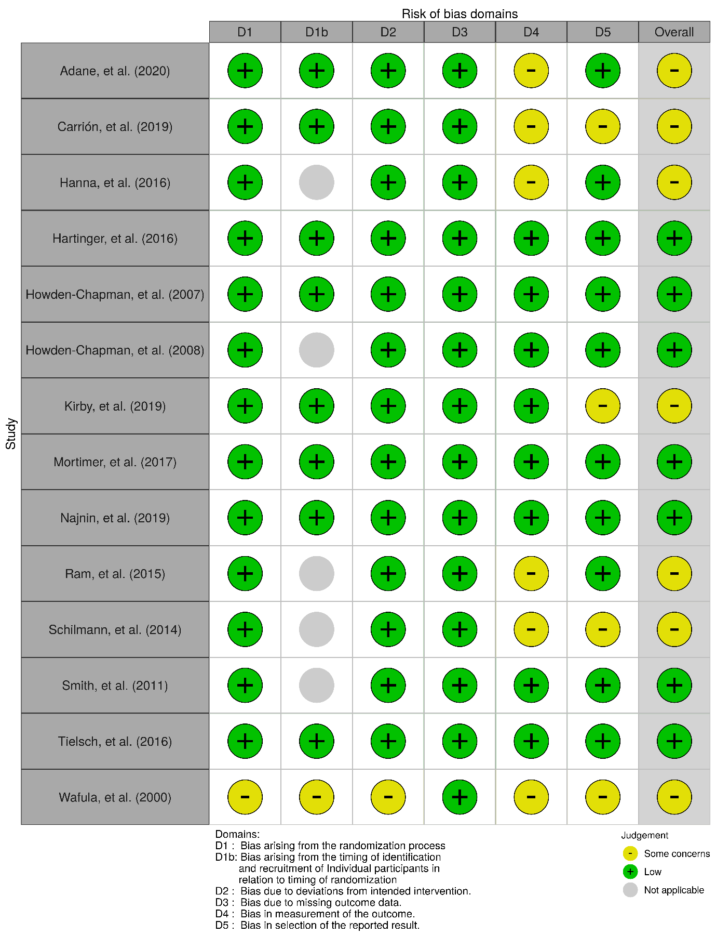

**Supplementary Figure 2: Forest plot of the effect of housing intervention versus control on severe pneumonia.**



**Supplementary Figure 3: Forest plot of the effect of improved cookstove versus traditional stove on burns.**



**Supplementary Figure 4: Forest plot of the effect of improved cookstove versus traditional stove on any reported adverse events.**



**Supplementary Figure 5: Forest plot of the effect of housing intervention versus control on any reported respiratory tract infections stratified by country income categories.**



**Supplementary Figure 6: Pooling of effect estimates reported in individual studies.**

**[A] Any respiratory tract infections (risk ratio)**



**[B] Lower respiratory tract infections (odds ratio)**



**[C] Lower respiratory tract infections (risk ratio)**



**[D] Severe pneumonia (incidence rate ratio)**

