Supplementary material
Molybdenum nitrides from structures to industrial applications: a review
Zainab N. Jaf et al.
DOI 10.1515/revce-2021-0002

Supplementary Table S1: Geometrical features of the MoN_{x} phases reported in the literature.
Mo-N system | Structure and space group | Lattice parameters (Å) | References
γ-MoN_{x} (x~0.5) | fcc rock salt , $Fm\overline{3}m$ | a = 4.16 | High-pressure–high-temperature synthesis (Bull et al., 2006)
Mo₂N | fcc | a = 4.16–4.19 | Reactive DC sputtering (Ihara et al., 1985)
γ-Mo₂N | Fcc | a = 4.124 | Pulsed laser irradiation (Wu et al., 1997)
c-Mo₂N | Fcc | a = 4.2 | Plasma immersion ion implantation (Mändl et al., 2004)
β-Mo₂N | Body centred tetragonal phase a space group of I41/amd | a = 4.16  c = 8.0 | Plasma immersion ion implantation (Mändl et al., 2004)
β-Mo₂N_{0.85} | Tetragonal | a = 4.199  c = 7.996 | Reactive DC magnetron sputtering (Stöber et al., 2015)
β-Mo₂N | Tetragonal | a = 4.18  c = 7.99 | Expanding plasma microwave discharge (Jauberteau et al., 2009)
β-Mo₁₆N₇ | Tetragonal | a = 8.4  c = 8.0 | Heat treatment of calcium nitride and molybdenum (Karam and Ward, 1970)
MoN_{(0.5-1)} | Cubic | a = 4.16–4.28 | LDA -DFT(Lowther, 2004)
δ₁-MoN | Hexagonal WC type$p\overline{6 }$m2 | a = 2.868  c = 2.810 | Plasma-enhanced chemical MoCl₅ (Ganin et al., 2006)
δ₃-MoN | Hexagonal NiAs-type P6₃mc | a = 5.73  c = 5.62 | GGA–DFT (Kanoun et al., 2007)
Mo₅N₆ | Hexagonal WC and NiAs structures | a = 4.89  c = 11.06 | Ammonolysis of MoS₂ (Ganin et al., 2006).
δ₃-MoN | Hexagonal NiAs-type P6₃mc | a = 5.71  c = 5.62 | LDA–DFT (Kanoun et al., 2007)
δ₁-MoN | Hexagonal WC-like structure with space group $p\overline{6 }$m2 | a = 2.86  c = 2.84 | GGA–DFT (Zhao et al., 2010)
B1-MoN | Cubic NaCl-type structure with space group of$Fm\overline{3}m$ | a = 4.25 | PAW–DFT (Papaconstantopoulos et al., 1985)
Mo₅N₆ | Filled 2H-MoS₂ structure | a = 4.893  c =11.06 | Ammonolysis of MoS₂ (Marchand et al., 1999)

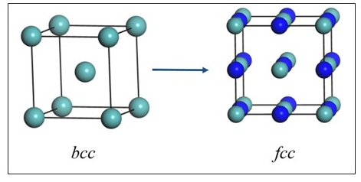
Supplementary Figure S1: Typical crystalline structures of metallic molybdenum (bcc) and molybdenum nitride (fcc) unit cells. Light blue and dark blue spheres denote Mo and N atoms, respectively.
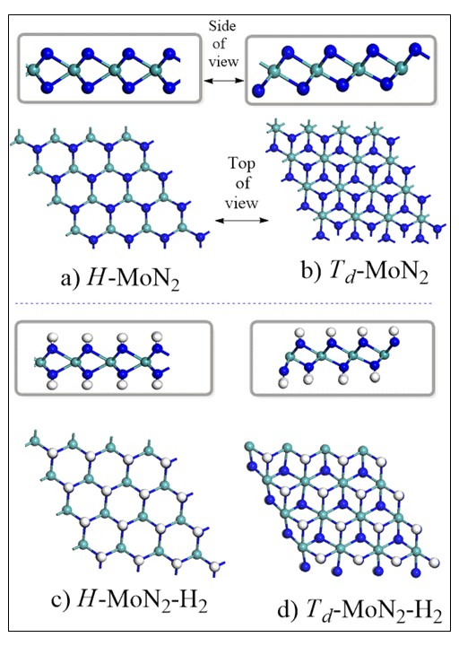
Supplementary Figure S2: Structural configurations of H–MoN₂, T_{d}–MoN₂, H–MoN₂-H₂, and T_{d}–MoN₂–H₂ sheets. White spheres correspond to H atoms (Wang and Ding, 2016). Reproduced with permission from the Royal Society of Chemistry.

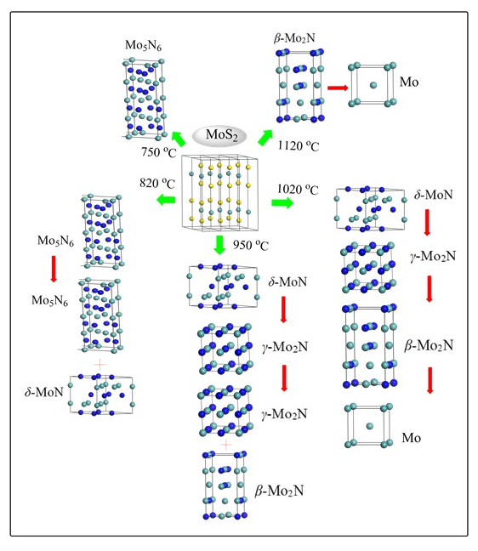

Supplementary Figure S3: Evolution of MoN_{x} phases during MoS₂ reduction by NH₃ at various temperatures (Sun et al., 2018). Reproduced with permission from John Wiley and Sons.
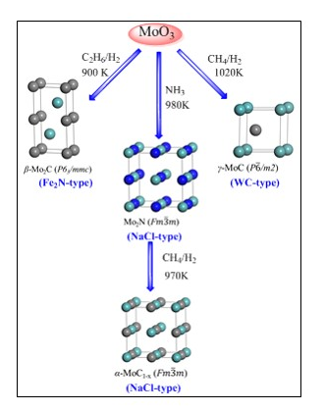

Supplementary Figure S4: Pathways to Mo–N and Mo–C phases via temperature programmed reaction (TPR) of MoO₃ (Claridge et al., 2000). Reproduced with permission from the American Chemical Society.
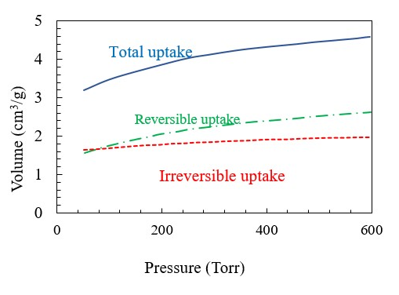
Supplementary Figure S5: Hydrogen uptakes of Mo₂N at 673 K, redrawn from Li et al. (1996).

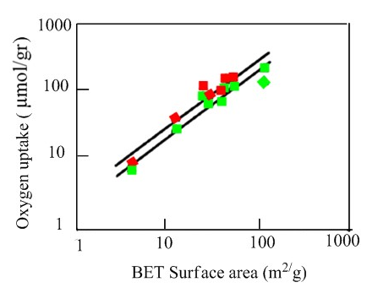
Supplementary Figure S6: Comparison of the BET surface areas and O₂ uptakes following pre-treatment in flowing H₂ at 673 K during three hours’ uptake at 298 K (red squares) and 195 K (green squares) (Choi et al., 1992). Reproduced with permission from Elsevier.

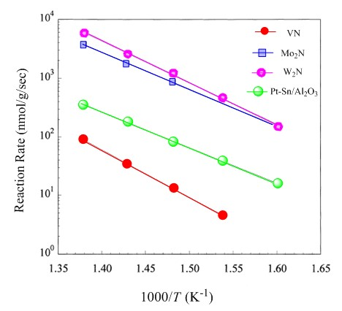

Supplementary Figure S7: Reaction rate constants of hydrogen evolution over transition metal carbides and nitrides during electrocatalysis, plotted as functions of inverse temperature (Neylon et al., 1999). Reproduced with permission from Elsevier.

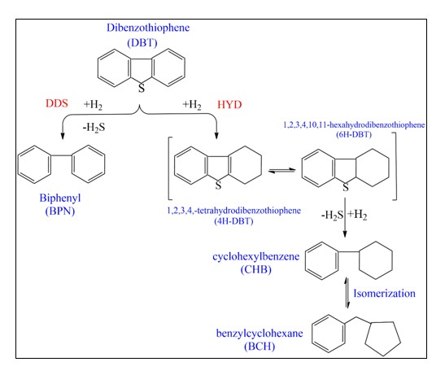
Supplementary Figure S8: HDS reaction routes of dibenzothiophene over Co-promoted molybdenum nitride (Co–Mo–N) catalysts proposed by Liu et al. (2002). DDS: direct desulfurization, HYD: hydrogenation. Reproduced with permission from the American Chemical Society.

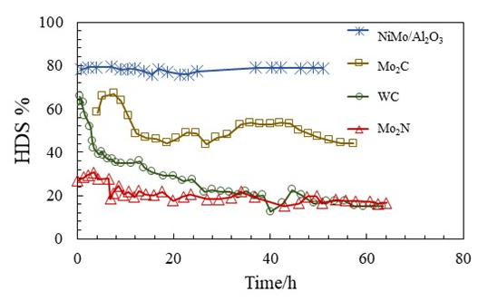
Supplementary Figure S9: HDS activities of carbides, nitrides, and (for comparison) NiMo/Al₂O₃ at 643 K and 3.1 MPa. The liquid hourly space velocity (LHSV) was 5 h^{-l} (Ramanathan and Oyama, 1995). Reproduced with permission from the American Chemical Society.

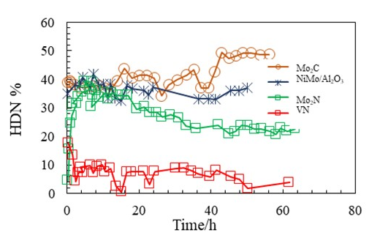

Supplementary Figure S10: HDN activities of carbides, nitrides, and (for comparison) NiMo/Al₂O₃ at 643 K and 3.1 MPa. The LHSV was 5 h^{-l} (Ramanathan and Oyama, 1995). Reproduced with permission from the American Chemical Society.

References
Bull, C. L., Kawashima, T., Mcmillan, P. F., Machon, D., Shebanova, O., Daisenberger, D., Soignard, E., Takayama-Muromachi, E. and Chapon, L. C. (2006). Crystal structure and high-pressure properties of γ-Mo2N determined by neutron powder diffraction and X-ray diffraction. J. Solid State Chem. 179: 1762-1767.
Choi, J.-G., Brenner, J. R., Colling, C. W., Demczyk, B. G., Dunning, J. L. and Thompson, L. T. (1992). Synthesis and characterization of molybdenum nitride hydrodenitrogenation catalysts. Catal. Today 15: 201-222.
Claridge, J. B., York, A. P., Brungs, A. J. and Green, M. L. (2000). Study of the temperature-programmed reaction synthesis of early transition metal carbide and nitride catalyst materials from oxide precursors. Chem. Mater. 12: 132-142.
Ganin, A. Y., Kienle, L. and Vajenine, G. V. (2006). Synthesis and characterisation of hexagonal molybdenum nitrides. J. Solid State Chem. 179: 2339-2348.
Ihara, H., Kimura, Y., Senzaki, K., Kezuka, H. and Hirabayashi, M. (1985). Electronic structures of B1 MoN, fcc Mo 2 N, and hexagonal MoN. Phys. Rev. B 31: 3177.
Jauberteau, I., Jauberteau, J.-L., Goudeau, P., Soulestin, B., Marteau, M., Cahoreau, M. and Aubreton, J. (2009). Investigations on a nitriding process of molybdenum thin films exposed to (Ar–N2–H2) expanding microwave plasma. Surf. Coat. Technol. 203: 1127-1132.
Kanoun, M., Goumri-Said, S. and Jaouen, M. (2007). Structure and mechanical stability of molybdenum nitrides: a first-principles study. Phys. Rev. B 76: 134109.
Karam, R. and Ward, R. 1(970). Preparation of. beta.-molybdenum nitride. Inorg. Chem. 9: 1385-1387.
Li, X. S., Zhang, Y. J., Xin, Q., Ji, C. X., Miao, Y. F. and Wang, L. (1996). Irreversible hydrogen uptake on Mo 2 N catalyst. React. Kinet. Catal. Lett. 57: 177-182.
Liu, Y., Liu, C. and Que, G. (2002). Hydrodesulfurization of dibenzothiophene over cobalt− molybdenum nitride catalysts. Energy fuels 16: 531-535.
Lowther, J. (2004). Lattice model for the properties of non-stoichiometric cubic and hexagonal molybdenum nitride. J. alloys Compd. 364: 13-16.
Mändl, S., Manova, D., Gerlach, J., Assmann, W., Neumann, H.andRauschenbach, B. 2004. High temperature nitrogen plasma immersion ion implantation into molybdenum. Surf. Coat. Technol. 180: 362-366.
Marchand, R., Tessier, F. and Disalvo, F. J. (1999). New routes to transition metal nitrides: and characterization of new phases. J. Mater. Chem. 9: 297-304.
Neylon, M., Choi, S., Kwon, H., Curry, K. and Thompson, L. (1999). Catalytic properties of early transition metal nitrides and carbides: n-butane hydrogenolysis, dehydrogenation and isomerization. Appl. Catal. A: Gen. 183: 253-263.
Papaconstantopoulos, D., Pickett, W., Klein, B.and Boyer, L. (1985). Electronic properties of transition-metal nitrides: the group-V and group-VI nitrides VN, NbN, TaN, CrN, MoN, and WN. Phys. Rev. B 31: 752.
Ramanathan, S. and Oyama, S. T. (1995). New catalysts for hydroprocessing: transition metal carbides and nitrides. J. Phys. Chem. 99: 16365-16372.
Stöber, L., Konrath, J., Krivec, S., Patocka, F., Schwarz, S., Bittner, A., Schneider, M. and Schmid, U. (2015). Impact of sputter deposition parameters on molybdenum nitride thin film properties. J. Micromech. Microeng. 25: 074001.
Sun, G. D., Zhang, G. H. and Chou, K. C. (2018). Synthesis of molybdenum nitrides nanosheets by nitriding 2H‐MoS2 with ammonia. J. Am. Ceram. Soc. 101: 2796-2808.
Wang, Y. and Ding, Y. (2016). The hydrogen-induced structural stability and promising electronic properties of molybdenum and tungsten dinitride nanosheets: a first-principles study. J. Mater. Chem. C 4: 7485-7493.
Wu, J., Wu, C., Zhong, X., Song, Z. and Li, F. 1997. Surface nitridation of transition metals by pulsed laser irradiation in gaseous nitrogen. Surf. Coat. Technol. 96: 330-336.
Zhao, E., Wang, J. and Wu, Z. 2010. Displacive phase transition, structural stability, and mechanical properties of the ultra‐incompressible and hard MoN by first principles. Phys. status solidi B 247: 1207-1213.

