Supplementary material
Innovative fouling-resistant materials for industrial heat exchangers: a review
Caroline Françolle de Almeida et al.
DOI 10.1515/revce-2020-0094

Tables corresponding to section 3.3.1 Antifouling/fouling release strategies

Supplementary Table S1: Dairy fouling.
Substrate | Treatment | Result | WCA (°) | SFE (mN/m) | Ra/Sa (µm) | Thermal conductivity (W/m.K) | Thickness (µm) | Classification | Properties | Durability/Stability/Reusability | Fouling/clean ability test conditions | Ref.
SS | Epoxy + NP/polyurethane + NP/PTFE |  | 91/93/  86 | - | Ra  0.95/0.06/  1.35 | - | 85.2/83.7/  22.5 | Hydrophobic | AF/FR | Under pasteurisation conditions: coating destroyed at the contact point | Pasteurisation (PHE): WPC, inlet T_{bulk} 85 °C, flow rate 1.5 L/h, for 4 h | (Kananeh et al., 2010)
SS | PTFE-CNT | 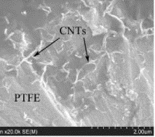 | 141 | 0.89 | - | 10.25 | 11 | Hydrophobic | AF | - | Pasteurisation with liquid recirculation (custom-designed PHE): pasteurised milk, inlet T_{bulk} 60 °C, flow rate 53 mL/min, Re number 171, for 1, 3, 5 h | (Rungraeng et al., 2012)
316 SS | Ni-P-PTFE | 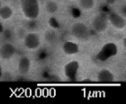 | - | 24.7 | Ra  0.17 | - | 10.45 | - | AF | No significant difference in the amount of fouling material after 10 sequential 4-h pasteurisation cycles followed by a low-flow rinse | Pilot plate heat exchanger  Model fluid: pasteurised milk, from 65-85 °C, flow rate 36L/h, Re number 256,  For 8 h | (Barish and Goddard, 2013)
SS | DLC/SICAN/SICON® | - | - | 45/46/46 | Ra  0.13/0.12/  0.12 | 0.3-1.3 | 3 | - | AF | - | Batch pasteurisation, SMUF, WPI, SMUF + WPI, inlet T_{bulk} 50 °C and 40 °C for SMUF only,  T_{substrate} 80 °C, 120 °C, 105 °C,  60 rpm, Re number 12, for 6 h | (Boxler et al., 2013)
316 2B SS | Doped DLC | - | 57/61/  51 | 48/44/41 | Ra  0.2/0.15/  0.13 | - | - | Hydrophilic | AF/FR | - | Pasteurisation (PHE): Skim and whole milk, WPI solutions, from 68 to 84 °C, volumetric flow rate 99.7 L/h , Re number 1100 (in the final PHE) for 2, 4, and 8 | (Patel et al., 2013)
316L SS | Thermolon (inorganic ceramic polymer) | 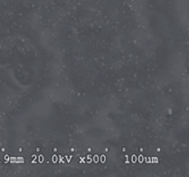 | 105.5 | 32.4 | Sa  199.0 | - | - | Hydrophobic | AF/biofilm formation | - | Pasteurisation (benchtop scale): raw whole milk, T_{bulk} from 40 to 85 °C, flow rate 1.32 L/h, for 7.5 h | (Liu et al., 2017)
304 2R S | PFA/FEP/PTFE | - | 108/108/81 | 16.9/16.9/223.8 | (Sa) 0.56/0.38/  0.74 | 0.27/0.15/0.12 | 71.2/57.8/41.8 | Hydrophobic/Hydrophilic | AF | - | Pasteurisation with liquid recirculation (bench scale): WPC and raw milk, , inlet T 61 °C, T_{substrate} 89 °C with WPC and 92.5 °C with raw milk flow rate 480 L/h, Re number 6900 for milk and 11100 for WPC, for 2.5 h | (Magens et al., 2019)
316L 2B SS | PEO – modified silicone |  | Instant WCA 105 ° | 0.02 | - | - | - | Amphiphilic | AF/FR | After 5 pasteurisation cycles WCA = 46 °, Before and After CIP: WCA from 112 ° to 98 ° | Pasteurisation (PHE) : Model fluid: WPI and calcium solution, T_{bulk} from 60-85 °C, flow rate 300 L/h, for 1.5 h | (Zouaghi et al., 2018)
SS | Fluorolink® S10 (PFPE with triethoxysilane terminal groups) | - | 107 | 19.0, after rinsing 32.0 | - | - | < 2.7 | Hybrid | AF/FR | - | Pasteurisation with liquid recirculation (bench scale): WPC, inlet T_{bulk} 61 °C, T_{surface} > 100 °C, flow rate 4.7 × 10-3 kg/s, for ≈1 h | (Huo et al., 2019)
Reprinted from Refs. Rungraeng et al. 2012, Barish and Goddard 2013, Liu et al. 2017, with permission from Elsevier.

Supplementary Table S2: Petrochemical fouling:
Substrate | Treatment | Result | WCA (°) | SFE (mN/m) | Ra (µm) | Thermal conductivity (W/m.K) | Thickness (µm) | Classification | Properties | Durability/Stability/Reusability | Fouling/clean ability test conditions | Ref.
CS | Polyurethane/Epoxy resin/ferrous phosphate/PTFE/PFA | - | 119/131/45/91/92 | - | - | - | 1000 | Lipophilic/lipophilic/hydrophilic/hydrophobic/hydrophobic | AF | - | Bench scale: crude oil and n-heptane, T_{bulk} 20-25 °C, to 40 h | (Moradi et al., 2019)
SS | NANOmel (silicon oxide) | - | 45/85 | - | 0.35/0.42 (Ridge) | - | 0.4 | Hydrophilic/hydrophobic | AF | Uncoated unit was blocked after 3 days while the coated units were only stopped after a period of 6 days | PHE run with hard tap water, 2 L/min, T_{bulk} 88 °C, for 7 days | (Christiensen et al., 2017)
Titanium | Urea-siloxane modified with 2 % of PDMS | - | 105 | 21 | - | - | 2-5 | Hybrid | AF | Attack by acetone wiping | PHE: crude oil cooling, T_{bulk} from 50 to 40 °C, to 8 months | (Holberg and Bischoff, 2014)
SS | PFPE | - | 138 | 46 | - | - | 5000 | Hybrid | Anti-scaling/FR | Immersion in a NaCl solution at 50 °C, for 7 days: WCA 129 ° before immersion, and WCA = 62 ° after immersion | Pilot plant (two shell-and-tube heat exchangers) Model fluid: water at 60 °C, flow rate 184 L/h (laminar flow) For 5 months | (Oldani et al., 2016)

Supplementary Table S3: Energy fouling.
Substrate | Treatment | Result | WCA (°) | SFE (mN/m) | Ra  (µm) | Thermal conductivity (W.m/K) | Thickness (µm) | Classification | Properties | Durability/Stability/Reusability | Fouling/clean ability test conditions | Ref.
Steel | Ni-Cu-P-PTFE | 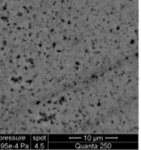 | 105 | 0.02 | 0.6 | - | - | Hydrophobic | Anti-scaling | Immersion in boiling water for 20 h | Flow pool boiling test rig: Immersion in boiling water for 4 h during 20 h | (Cheng et al., 2014)
316L SS | Polymer brushes: N-POEGMA₉ / N-POEGMEMA₉ | - | 34.8/ 42.5 | - | - | - | 0.02/0.014 | Hydrophilic | Anti-scaling | - | PHE: water solution, T_{bulk} from 20 to 80 °C, flow rate 120 L/h, Re number 605, for ≈ 165 h | (Friis et al., 2019)
316L steel | Silicone-PEG-PDMS | - | 109 | - | - | - | ~ 10 | Hydrophobic | Biofouling release | No visual degradation after run | Tubular heat exchanger: Freshwater solution at 40 °C, flow 1.6 m/s for 2 months | (Holberg et al., 2020)
316L SS | DLC/F-DLC | - | 70/ 81.3 | 46/28 | 0.017/0.020 | - | 1 | Hydrophile | Anti-biofouling/FR | - | Adhesion with Pseudomonas fluorescens | (Su et al., 2010)
Reprinted from Ref. Cheng et al. 2014 with permission from Elsevier.

Tables corresponding to section 3.3.2 Antifouling/fouling-release materials with extreme wettability and/or biomimetic
Supplementary Table S4: Dairy fouling.
Substrate | Texturing technique | Chemical treatment | Results | WCA/SA (°) | Ra (nm) | Thickness (µm) | Classification | Properties | Durability/Stability/Reusability | Fouling/clean ability test conditions | Ref.
420 martensitic SS | Picosecond laser | Immersion in stearic acid | 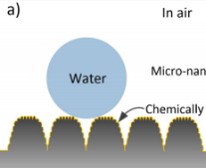  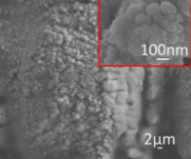 | 163/0.5 | - | - | Superhydrophobic | Antibacterial adhesion | Immersed in the NaCl (0.5 mol/L) = 30 days | - | (Pan et al., 2019)
316 SS | Electrodeposition | PEDOT-F₄ | 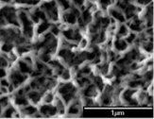 | WCA  162/2 | 244 | - | Superhydrophobic | Bacterial adhesion | - | - | (Bruzaud et al., 2017)
Plaster | Hydrothermal process | Colourful mineral pigments | - | 150/- | - | - | Superhydrophobic | AF | Heating at 70 °C and 85 % HR | Milk, coffee, Coca Cola droplets deposition on the painted surfaces | (Wang et al., 2020)
SS | Vacuum evaporation, chemical reaction and heating | Cu film + Ag NPs + Fluor compound | 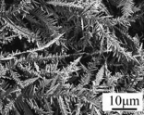 | 155/ 0 | - | 0.22 | Superhydrophobic | AF/Self-cleanability | Immersion into solutions pH (1, and 13) : WCA ≈ 151 ° Exposition in air for 30 days : WCA = 156.3 ° | Immersion into milk in static conditions for 24, 48 and 72 h | (Wang et al., 2019)
SS 316 L 2B | Femtosecond laser ablation | Fluorosilane and perfluorinated compounds | 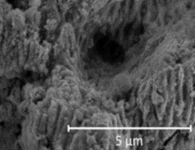 | 111.6/- | - | - | SLIPS | AF | 1 pasteurisation cycle (90 min) | Plate heat exchanger (WPI and calcium solution T= 85 °C)  Flow rate 300 L/h | (Zouaghi et al., 2017)
Glass, Al and Si | Immersion into precursor solution, spin coated, UV | TEOS, VTES, POTS, SiO₂, PFPE | - | 112/- | RMS 18.3 | - | LIS | AF/self-cleaning | Knife scratching measured/ WCA and SA measured at 60 °C for one week (WCA = 115 ° and SA = 4 °) | Vertically dipped into milk 60 times (glass substrate) | (Li and Guo, 2019)
Zn | Grafting reaction | ZnO + PDMS + silicone oil | - | 140/3 | - | - | LIS | AF | Immersion boiling water/Heated at 120 °C for 15 min/Shearing stress for 60 s, long-term immersion for 400 h and strong acid/alkali | Soaked in milk | (Jing and Guo, 2019)
Reprinted with permission from Refs. Pan et al. 2019, Wang et al. 2019, Zouaghi et al. 2017, copyright (2017, 2019, 2017) American Chemical Society, respectively. Reprinted from Ref. Bruzaud et al. 2017 with permission from Elsevier.

Supplementary Table S5: Petrochemical fouling.
Substrate | Texturing technique | Chemical treatment | Results | CA/SA (°) | Ra (nm) | Thickness (µm) | Classification | Properties | Durability/Stability/Reusability | Fouling/clean ability test conditions | Ref.
Silicon wafer | - | Polymers brushes (PMPC) | - | WCA < 3, under water OCA = 173 ° | 0.8-1.5 | 0.04 | Superhydrophilic | Antifouling/Self-cleaning | - | Oil detachment behaviour in water | (Kobayashi et al., 2012)
CS | Zn electrodeposition | Phosphatation and deposition of a silica film | 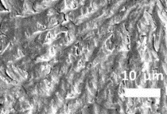 | under water OCA 164.5 ° | - | - | Superhydrophilic | Antifouling/high T resistance | Heating until 200 °C of 48 h  WCA = 0 ° | Wax deposition by cold-finger method (crude oil at 80 °C) | (Liang et al., 2015)
304 SS | Oxidation | - | 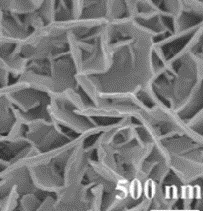 | WCA > 5 °  Under water OCA 164 ° | - | - | Superhydrophilic | Antifouling/Self-cleaning | Heating until 500 °C for 1 h (OCA 160 °) | Crude-oil detachment washed by water | (Peng et al., 2018)
Steel | Electrostatic powder spraying | PSU - CNTs-FEP | 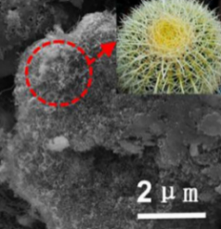 | WCA  166.0 ° / SA < 5 ° | - | - | Superhydrophobic | Self-cleaning and corrosion inhibition | Heating until 500 °C  WCA ≈158 °  0CA ≈148 ° | Sliding water droplet on the contaminate substrata | (Zhu et al., 2018)
304 SS | Electrodeposition/thermal reaction | Ni₃S₂ | 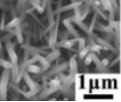 | WCA = 163 ° | 149 | 0.0103 | Superhydrophobic | Antifouling | Plasma and heating (300 °C) cycles | Immersion into kerosene and rinsed by deionized water | (Yin et al., 2020)
Cu | Anodization | CuO nanowire + FAS 17 | 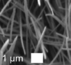 | WCA 154 ° | - | 0.5 | Superhydrophobic | Anti-scaling |  | Immersion in a mixed solution of CaCl₂ and NaHCO₃ at 90 °C for 2 h | (Jiang et al., 2015)
Steel | Electrodeposition | Immersion into alkaline solution + fluorination | 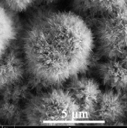 | WCA 157 ° | - | - | Superhydrophobic | Anti-scaling | Thermal stability at 200 °C for 1 h/Abrasion test | Immersion in a mixed solution of CaCl₂ and NaHCO₃ at 70 °C for 6 h | (Li et al., 2016)
Steel | Electrodeposition | Cu-Zn | 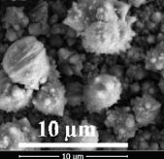 | WCA 154.7 ° / SA 6.5 ° | - | - | Superhydrophobic | Fouling release | Heating (temperature varying from 20 °C to 200 °C for 9 h | Immersion in a CaCO₃ solution | (Li et al., 2019)
Ni | Electrodeposition/thermal reaction | Ni₃S₂ + Myristic acid | 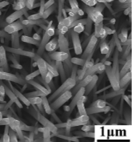 | WCA 165 ° / SA 3 ° | - | - | Superhydrophobic | Anti-scaling | Plasma and heating (300 °C) cycles | Immersion into supersaturated CaCO₃ solution at 60 °C for 6 h | (Yin et al., 2019)
Q235 CS/304 SS | Spray/cure | PPS + PTFE | - | 45 % PTFE (WCA 160 °) | - | - | Superhydrophobic | Anti-scaling | - | Immersion into CaCO₃ solution at 60 °C for up to 360 h | (Qian et al., 2017)
316 SS | Chemical etching and O₂ plasma | OTS and silicone oil | - | WCA  120.4 ° | 314 | - | LIS | High-T resistance and anti-wetting | Heating until 600 °C of 30min  WCA = 87.8 ° | - | (Zhang et al., 2016)
SS 316 L | Electrodeposition | PPy -  BMIm | 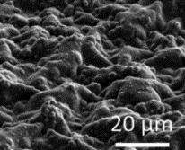 | WCA  71.0 ° | - | 5 | SLIPS | Anti-scaling | After immersion in seawater for 24 h, advanced and receding CA remained unchanged | Immersion into brine solution at 50 °C, static conditions, for 2 h (Standard bulk jar test) | (Charpentier et al., 2015)
1020 CS | Electrochemical | HDFDPA  Krytox ® | 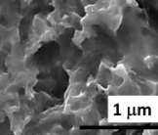 | WCA  120.0 ° | - | - | SLIPS | Anti-scaling/ and corrosion inhibition | 40 h in fouling test conditions | Immersion without turbulence into brine solution at room T | (Sousa et al., 2020)
Reprinted with permission from Refs. Liang et al. 2015, Jiang et al. 2015. Copyright (2015) American Chemical Society. Reprinted from Refs. Peng et al. 2018, Zhu et al. 2018, Yin et al. 2020, Li et al. 2016, Li et al. 2019, Yin et al. 2019, Charpentier et al. 2015, Sousa et al. 2020, with permission from Elsevier.

Supplementary Table S6: Energy fouling.
Substrate | Texturing technique | Chemical treatment | Results | WCA (°) | Ra (nm) | Thickness (µm) | Classification | Properties | Durability/Stability/Reusability | Fouling/clean ability test conditions | Ref.
PVC | Photopolymerisation | PHEMA | - | 0 | - | - | Superhydrophilic | Anti-scaling | Heating until 80 °C for 24 h | Incubation in a flowing CaCO₃ solution at 80 °C, for 24 h.  Adhesion of mineral crystals at room T in dynamic and static conditions | (Zhang et al., 2018)
304 SS | Spray coating | PMMA and BN | - | Modified 142), PMMA (133 °) and BN (135 °) | - | - | Superhydrophobic | Anti-scaling | Increase pressure drop on modified and PMMA PHE | PHE: in tap water solution, T_{bulk} from 25 to 60 °C solution, flow rate 0.133 kg/s, for 2 h | (Ahn et al., 2019)
Steel | Atmospheric plasma | Fluorosiloxane and fluoropolymer | - | TCFS (152 °) TC (158 °) | 10/17 | 0.130/0.290 | Superhydrophobic | Anti-scaling | Wear resistance test: delamination occurred at the contact points | Laboratory scale heat exchanger: recirculation CaCO₃ solution, T_{bulk} from 32 to 32.4 °C solution, fluid velocity 0.30 m/s, for ≈ 17 h | (Dowling et al., 2010)
Ti | Electrochemical deposition and CVD | Dimethyl silicone oil | 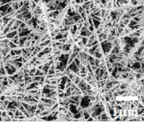 | - | - | 20 | SLIPS | Anti-biofouling | - | Immersion into algae suspension in seawater (static conditions) for 7 and 14 days | (Ouyang et al., 2019a)
SS | Electrodeposition | Polydopamine + Benzophenone + Diphenylamine | 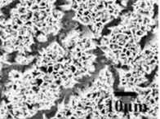 | 82 ° | - | 40 | SLIPS | Inhibition of MIC | - | Immersion into algae suspension in seawater (static conditions) for 1, 7 and 14 days | (Ouyang et al., 2019c)
Cu | Electrodeposition of cobalt dendrite | Polydopamine, dodecanethiol, dimethyl silicone oil | 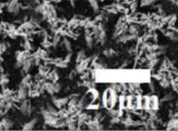 | 96 ° | - | - | LIS | Inhibition of bio-adhesion/MIC | - | SBR attachment: Immersion in a culture medium incubated with SBR at 30 °C, at 24 h | (Ouyang et al., 2019b)
Al | Anodization | PFDS/PFPE | 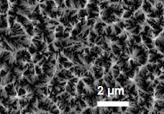 | - | - | - | SLIPS | Inhibition of SBR adhesion | Null toxicity of the lubricant | Immersed into a 3-days-old culture solution | (Wang et al., 2015)
Reprinted from Refs. Ouyang et al. 2019a, Ouyang et al. 2019c, Ouyang et al. 2019b, Wang et al. 2015, with permission from Elsevier.

