Appendix

Examples of practical application
After completing the aforementioned tests, the proposed method was used in the course of the conservation treatment of several archival records. The following are two examples of its application in different contexts.

Bound manuscript, dated 1777, National Archives in Prague
The first example is a bound manuscript convolute dated in 1777 (Fig. A1). The manuscript was written in iron gall ink on handmade paper. Its maximum dimensions were 240 x 345 x 160 mm.
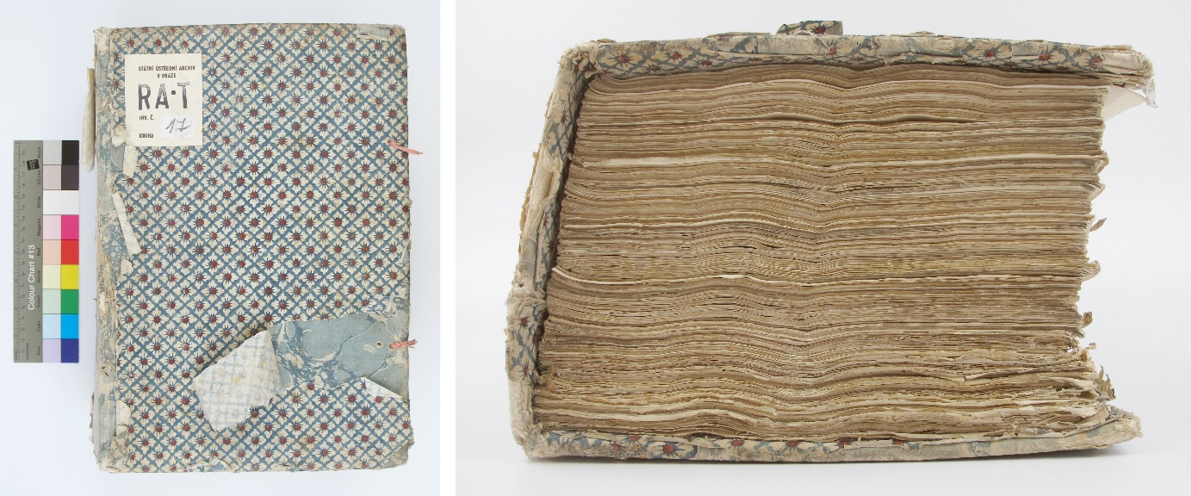
The original binding structure itself was well preserved. Its opening was excellent as no spine lining was used. The quality of the paper and ink varied considerably within the manuscript. The folios showed characteristic deformation caused by the original folding of some of them and by the weight of the volume. Several folios showed advanced ink corrosion, resulting in cracks and minor losses of paper support.
As part of the conservation treatment, an “in-situ” lining of the folios damaged by iron-gall ink corrosion was proposed. It was not possible to use a water-based method, because of the risk of migration of ferrous ions within the paper and also because of the risk of the undesirable changes in the deformation and dimensions of the treated folios. It was therefore decided to use the Butvar® B-76 pre-coated tissues. Several folios were lined from one side only, most from the both sides using the method described in section 2. The lining provided sufficient reinforcement for the folios without significantly altering the characteristic structure and deformation of the folios (Fig. A2a,b).
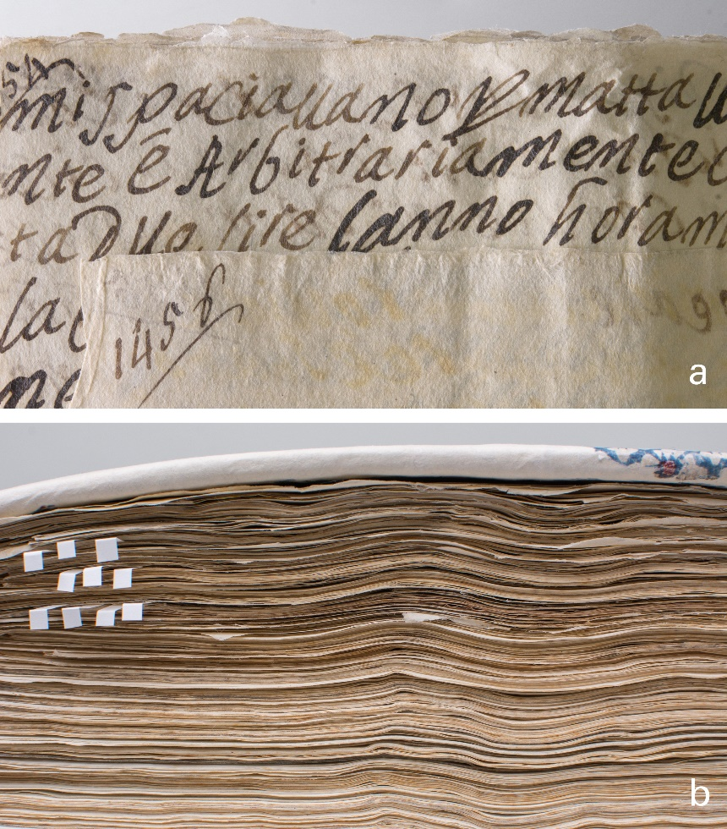

Hand-drawn map, 17th century, National Archives in Prague
The second example is a lining of a hand-drawn map from the collection of the National Archives in Prague (Fig. A3). The dimensions of the map were 431 x 349 mm. The map was drawn on handmade paper with iron-gall ink and completed with watercolours. Corrosion of the iron-gall ink caused cracks and minor losses in several places on the map. There was a red stamp and several annotations in water and ethanol soluble ink in the lower right corner.
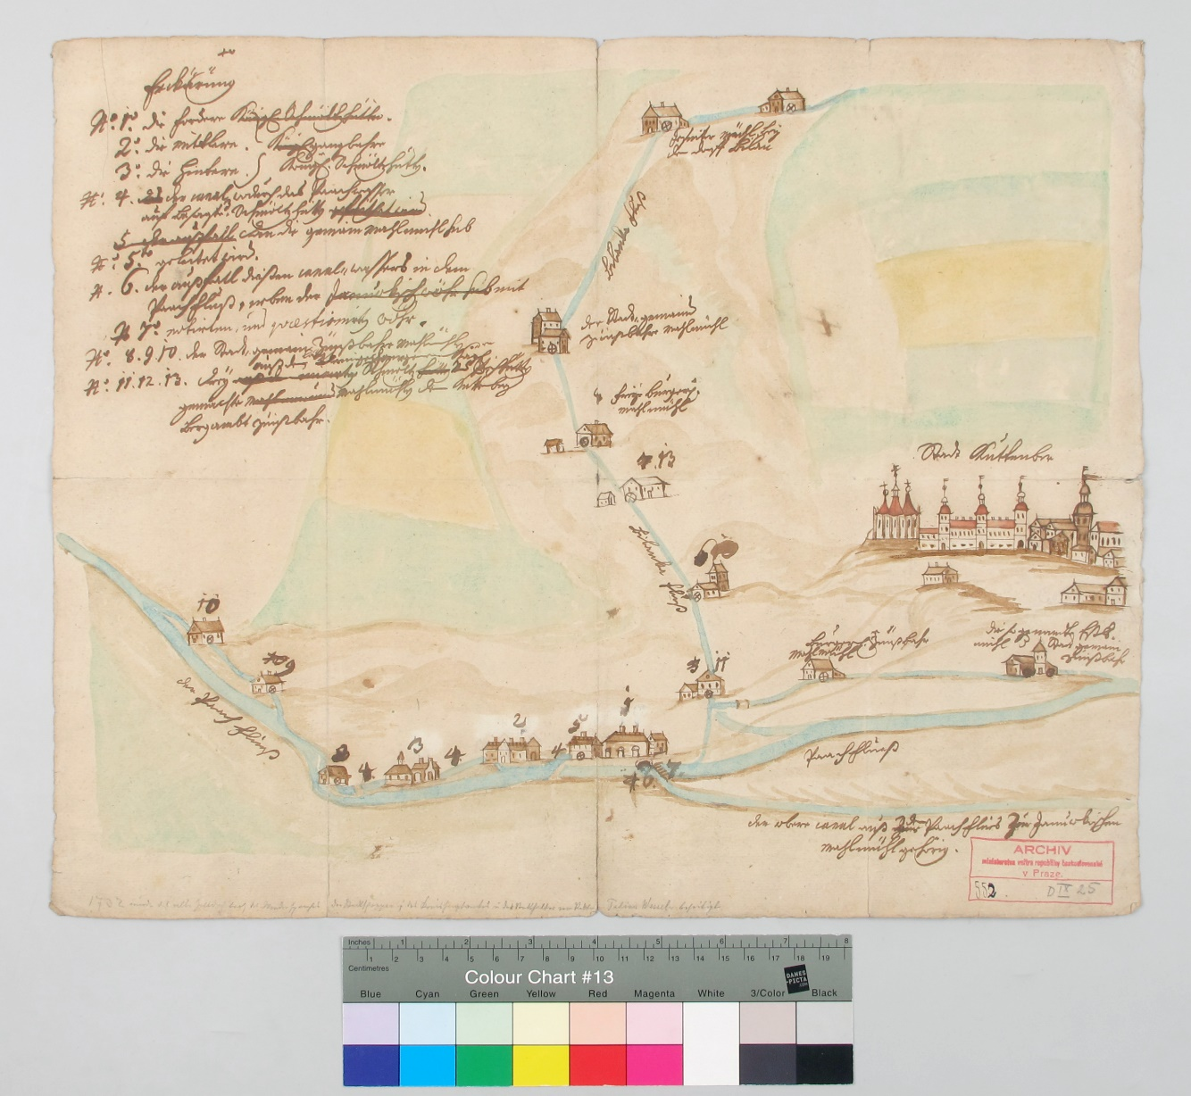
As part of the conservation treatment, the reinforcement of paper support was suggested. For this purpose, the the use of Butvar® B-76 pre-coated tissue from the verso side seemed a reasonable choice due to the presence of soluble media. The process was carried out as described in the section 2. The dimensions of the map necessitated the use of two sheets of the lining tissue, which were applied side by side on the verso side of the map. The result was considered satisfactory. The paper support was strengthened and the writing media exhibited no visible changes such as bleeding, attenuation or seepage to the opposite side of the paper, as demonstrated in Fig. A4.
