Study on the influence of papermaking process on the properties of Chinese handmade bamboo paper
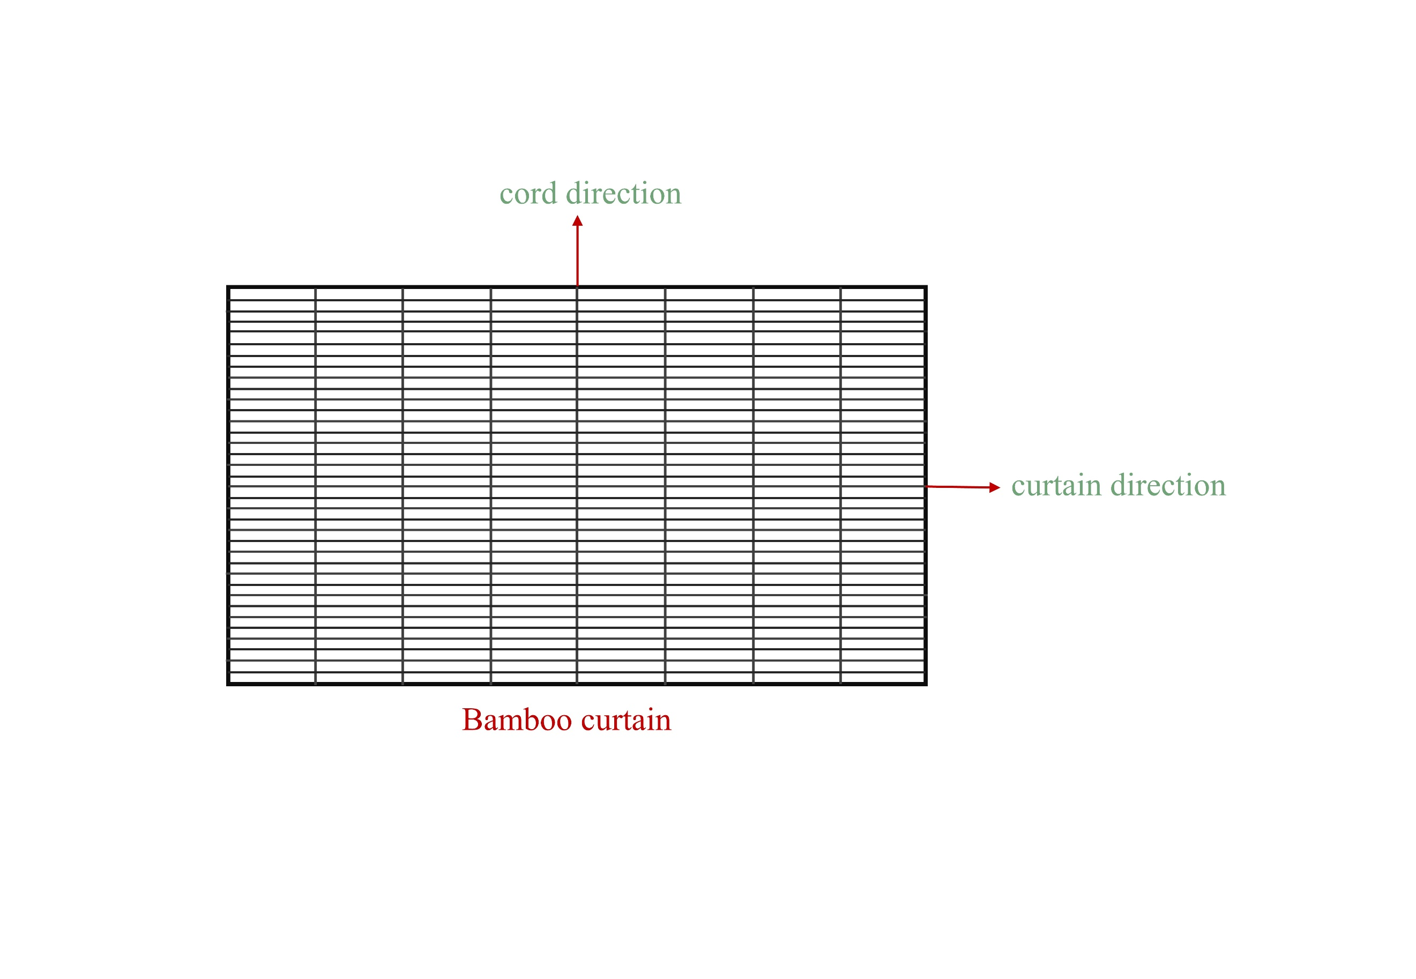
Fig.S1. Chinese Handmade Paper Bamboo Curtain Schematic

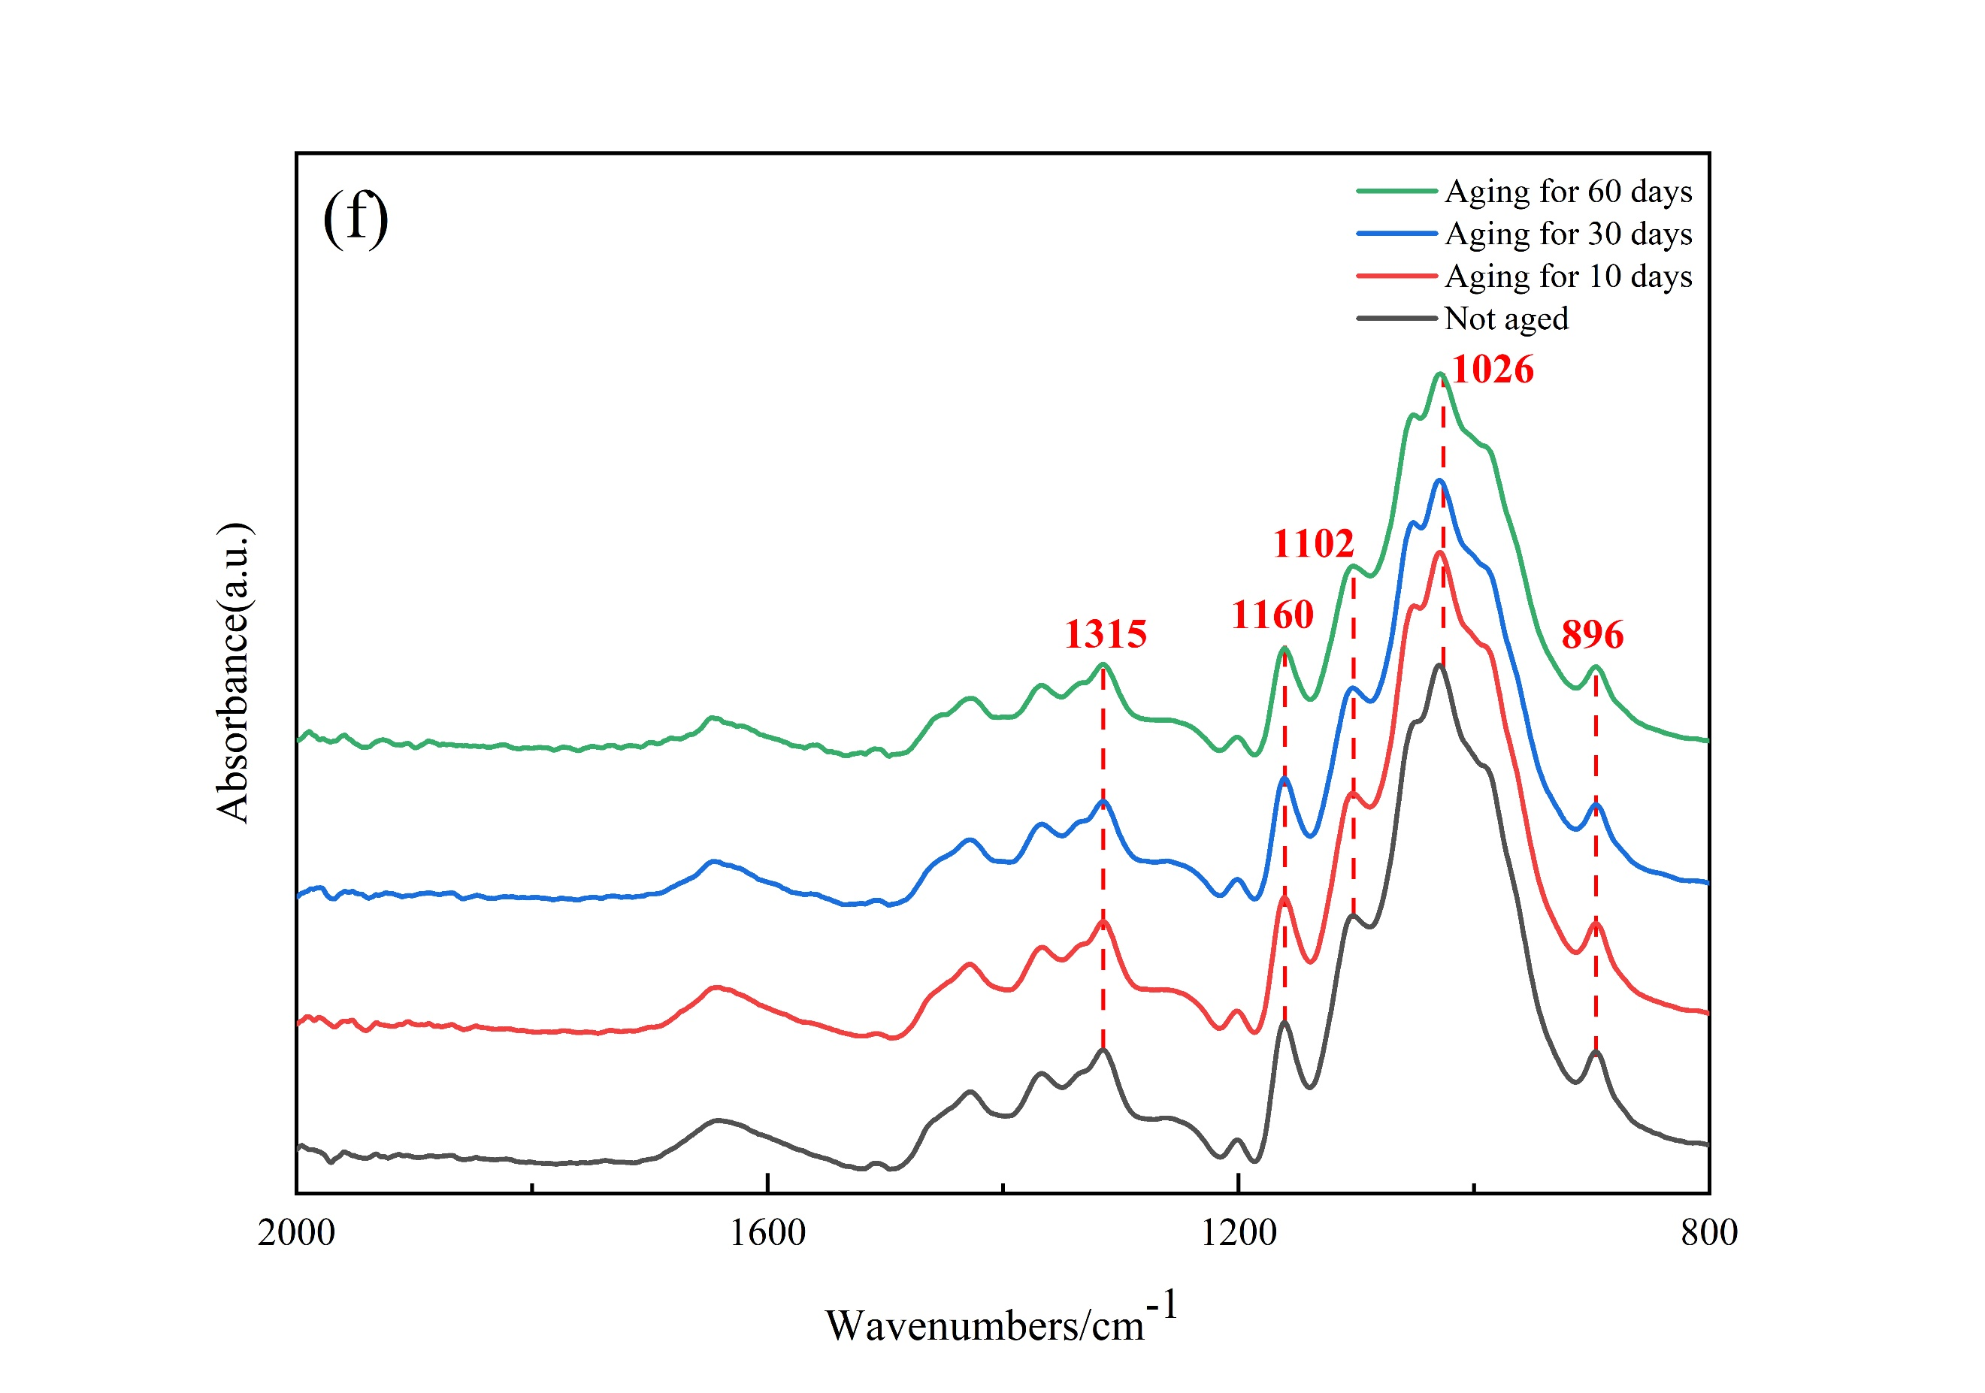
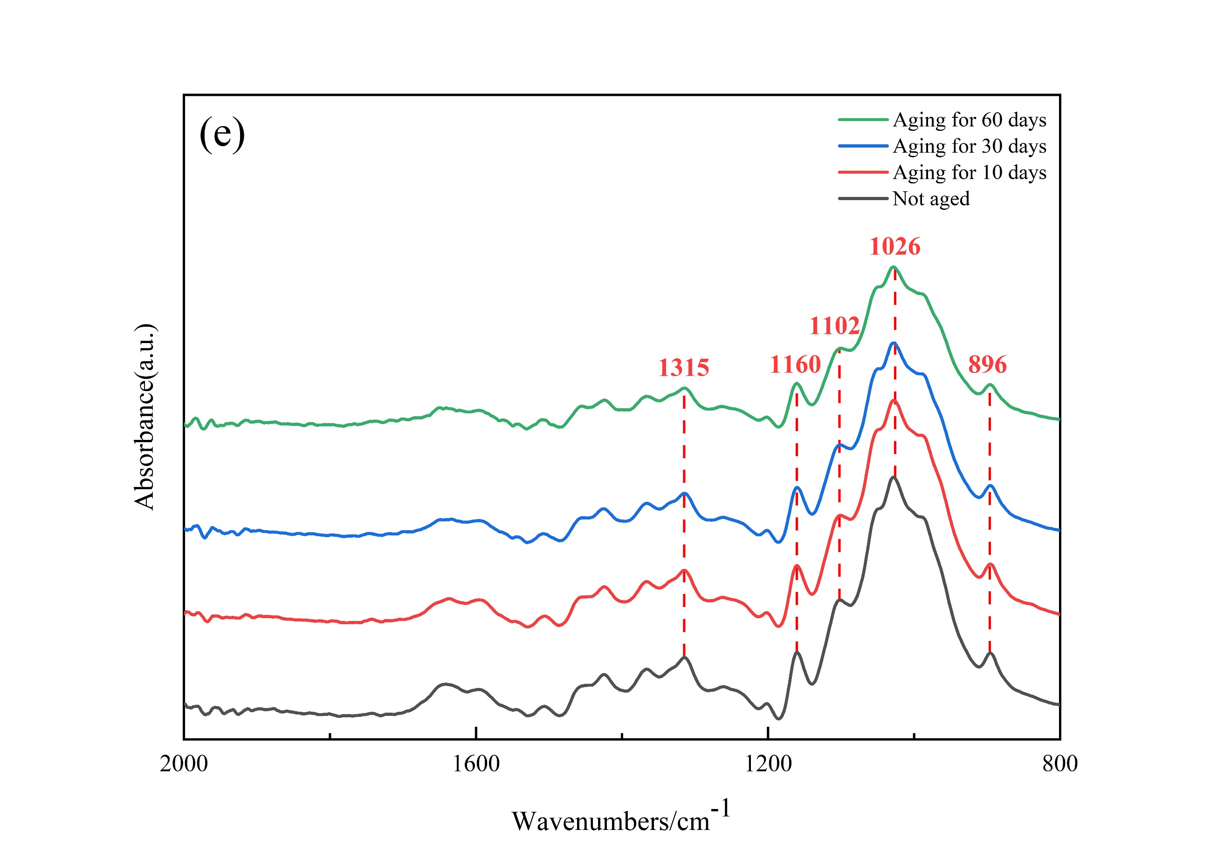
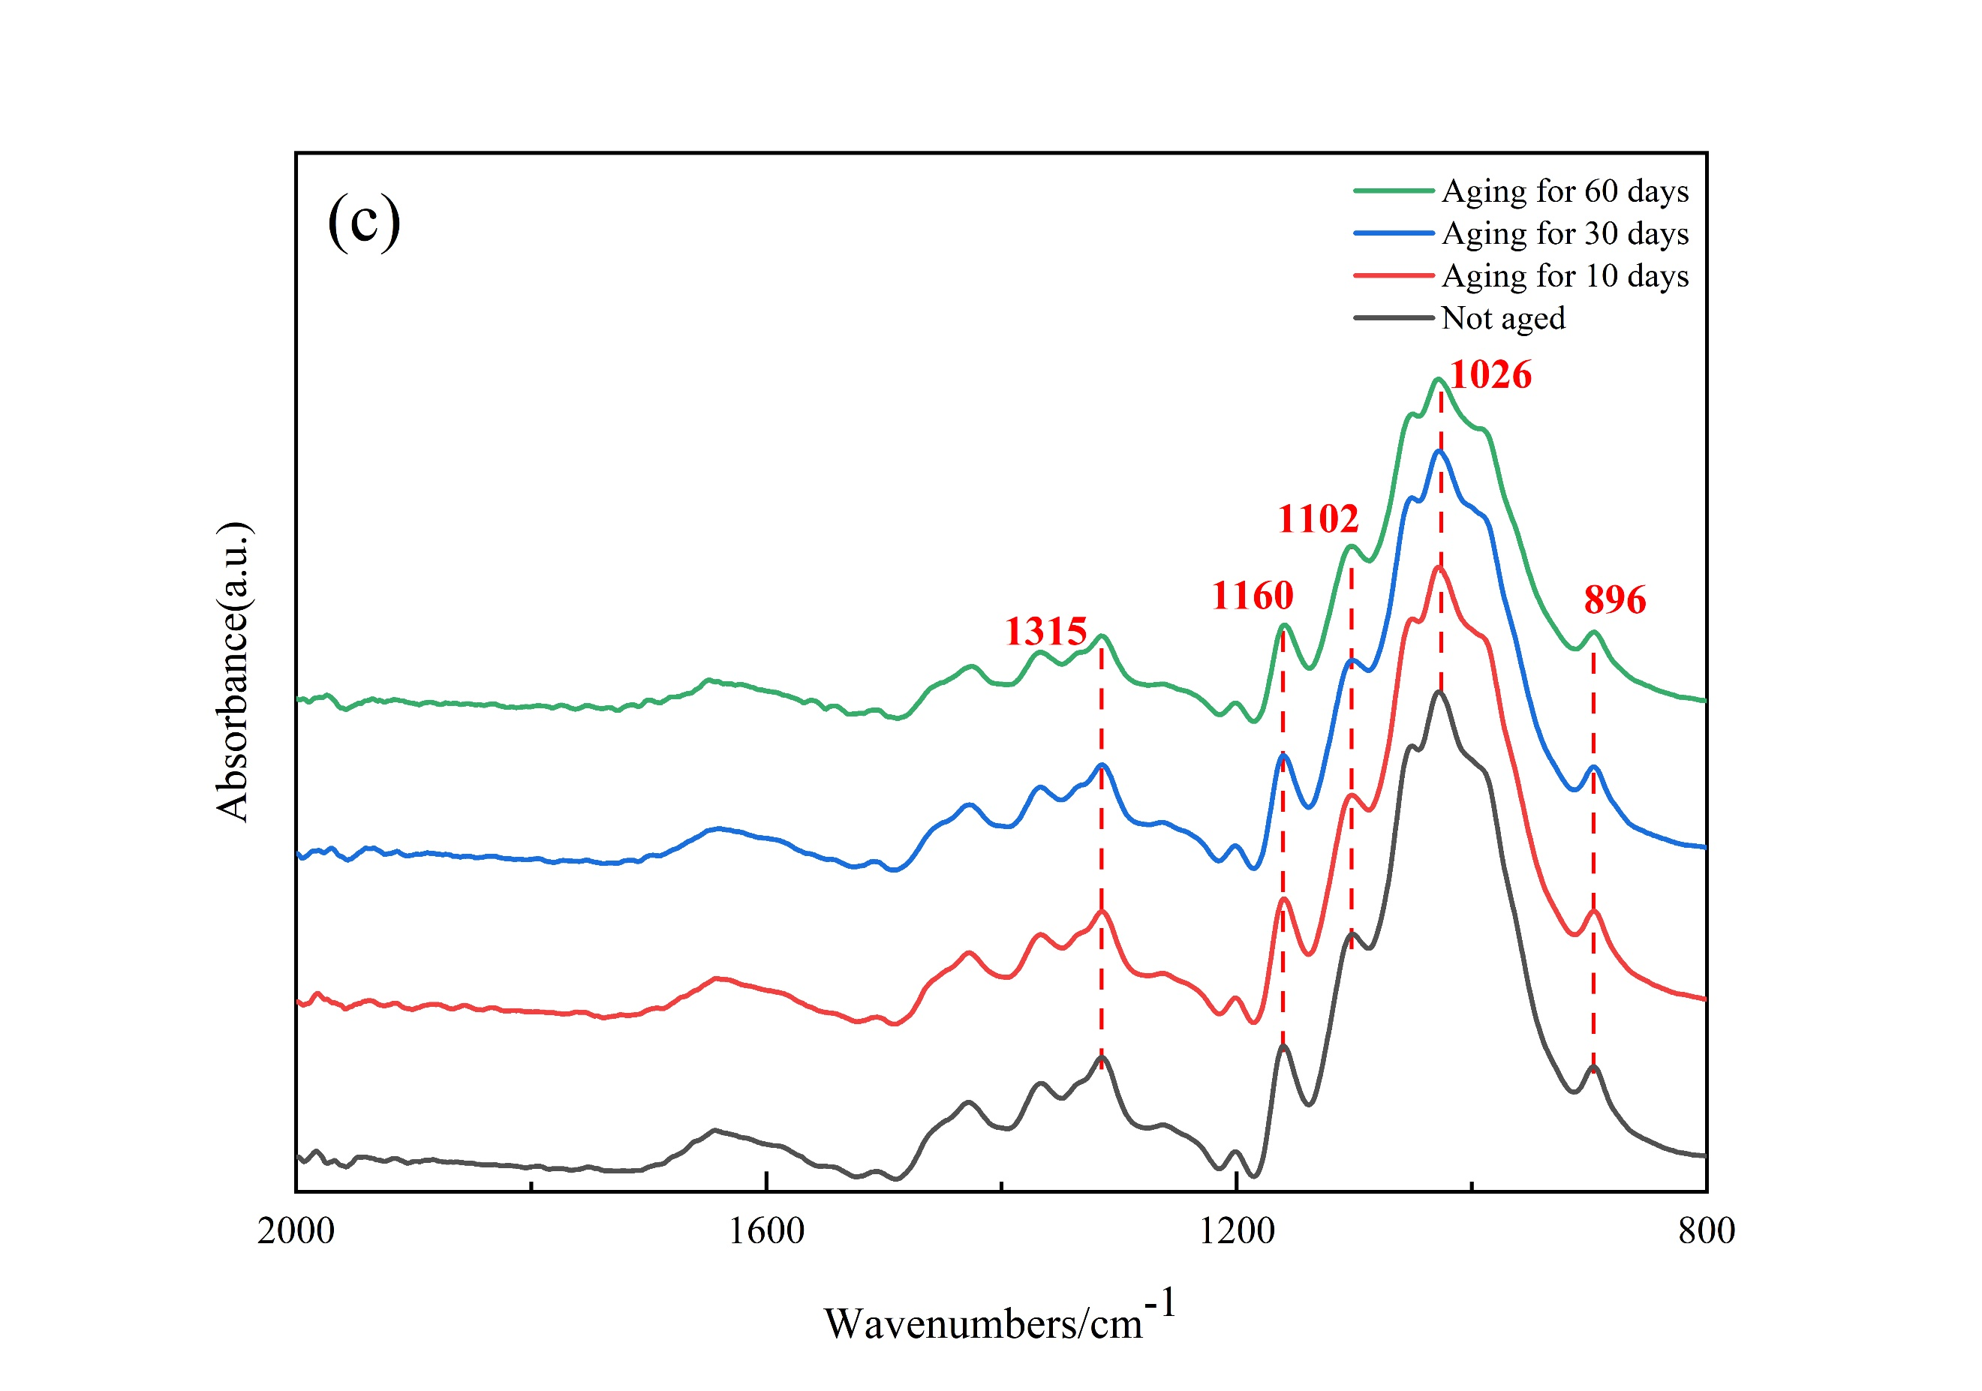
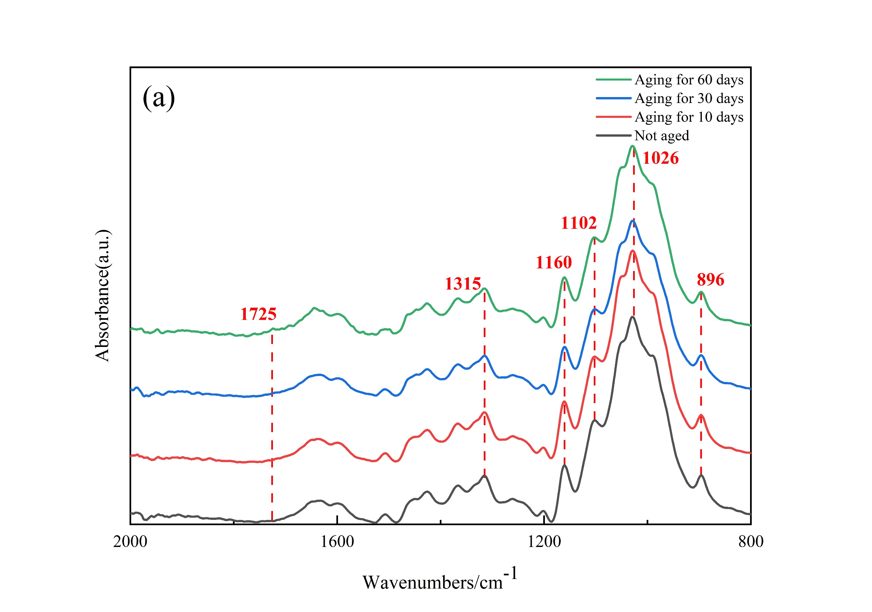
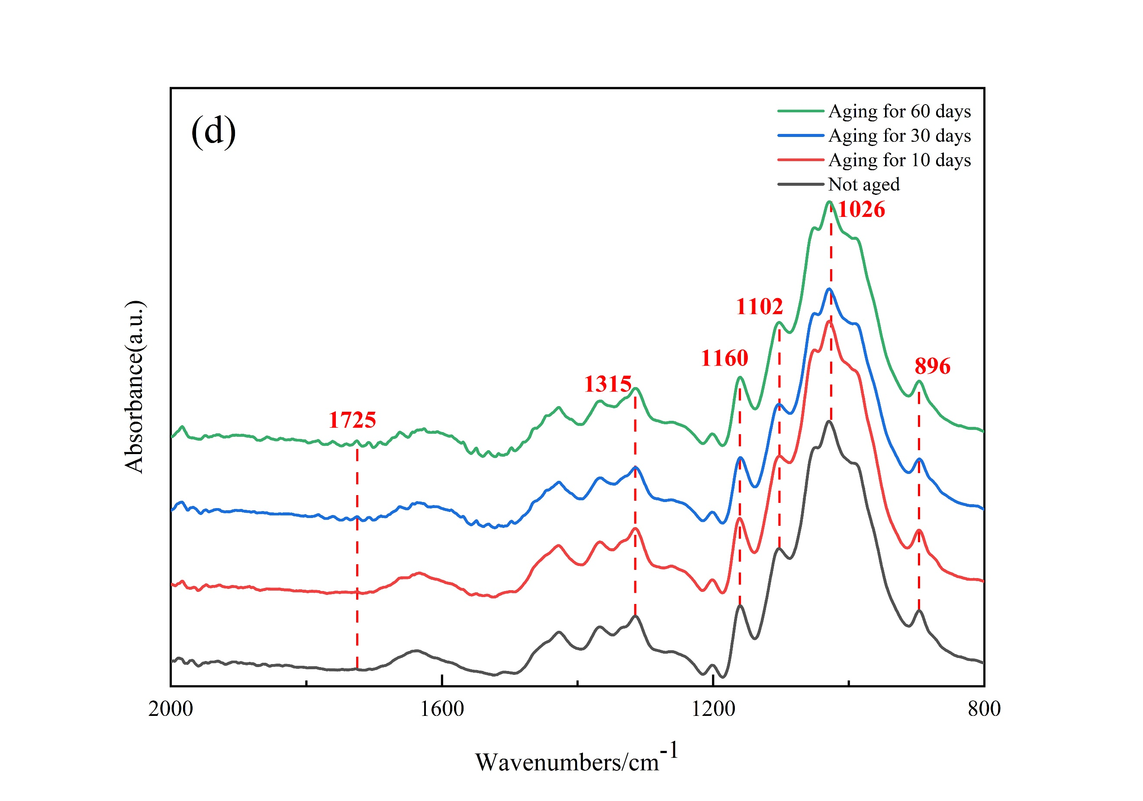
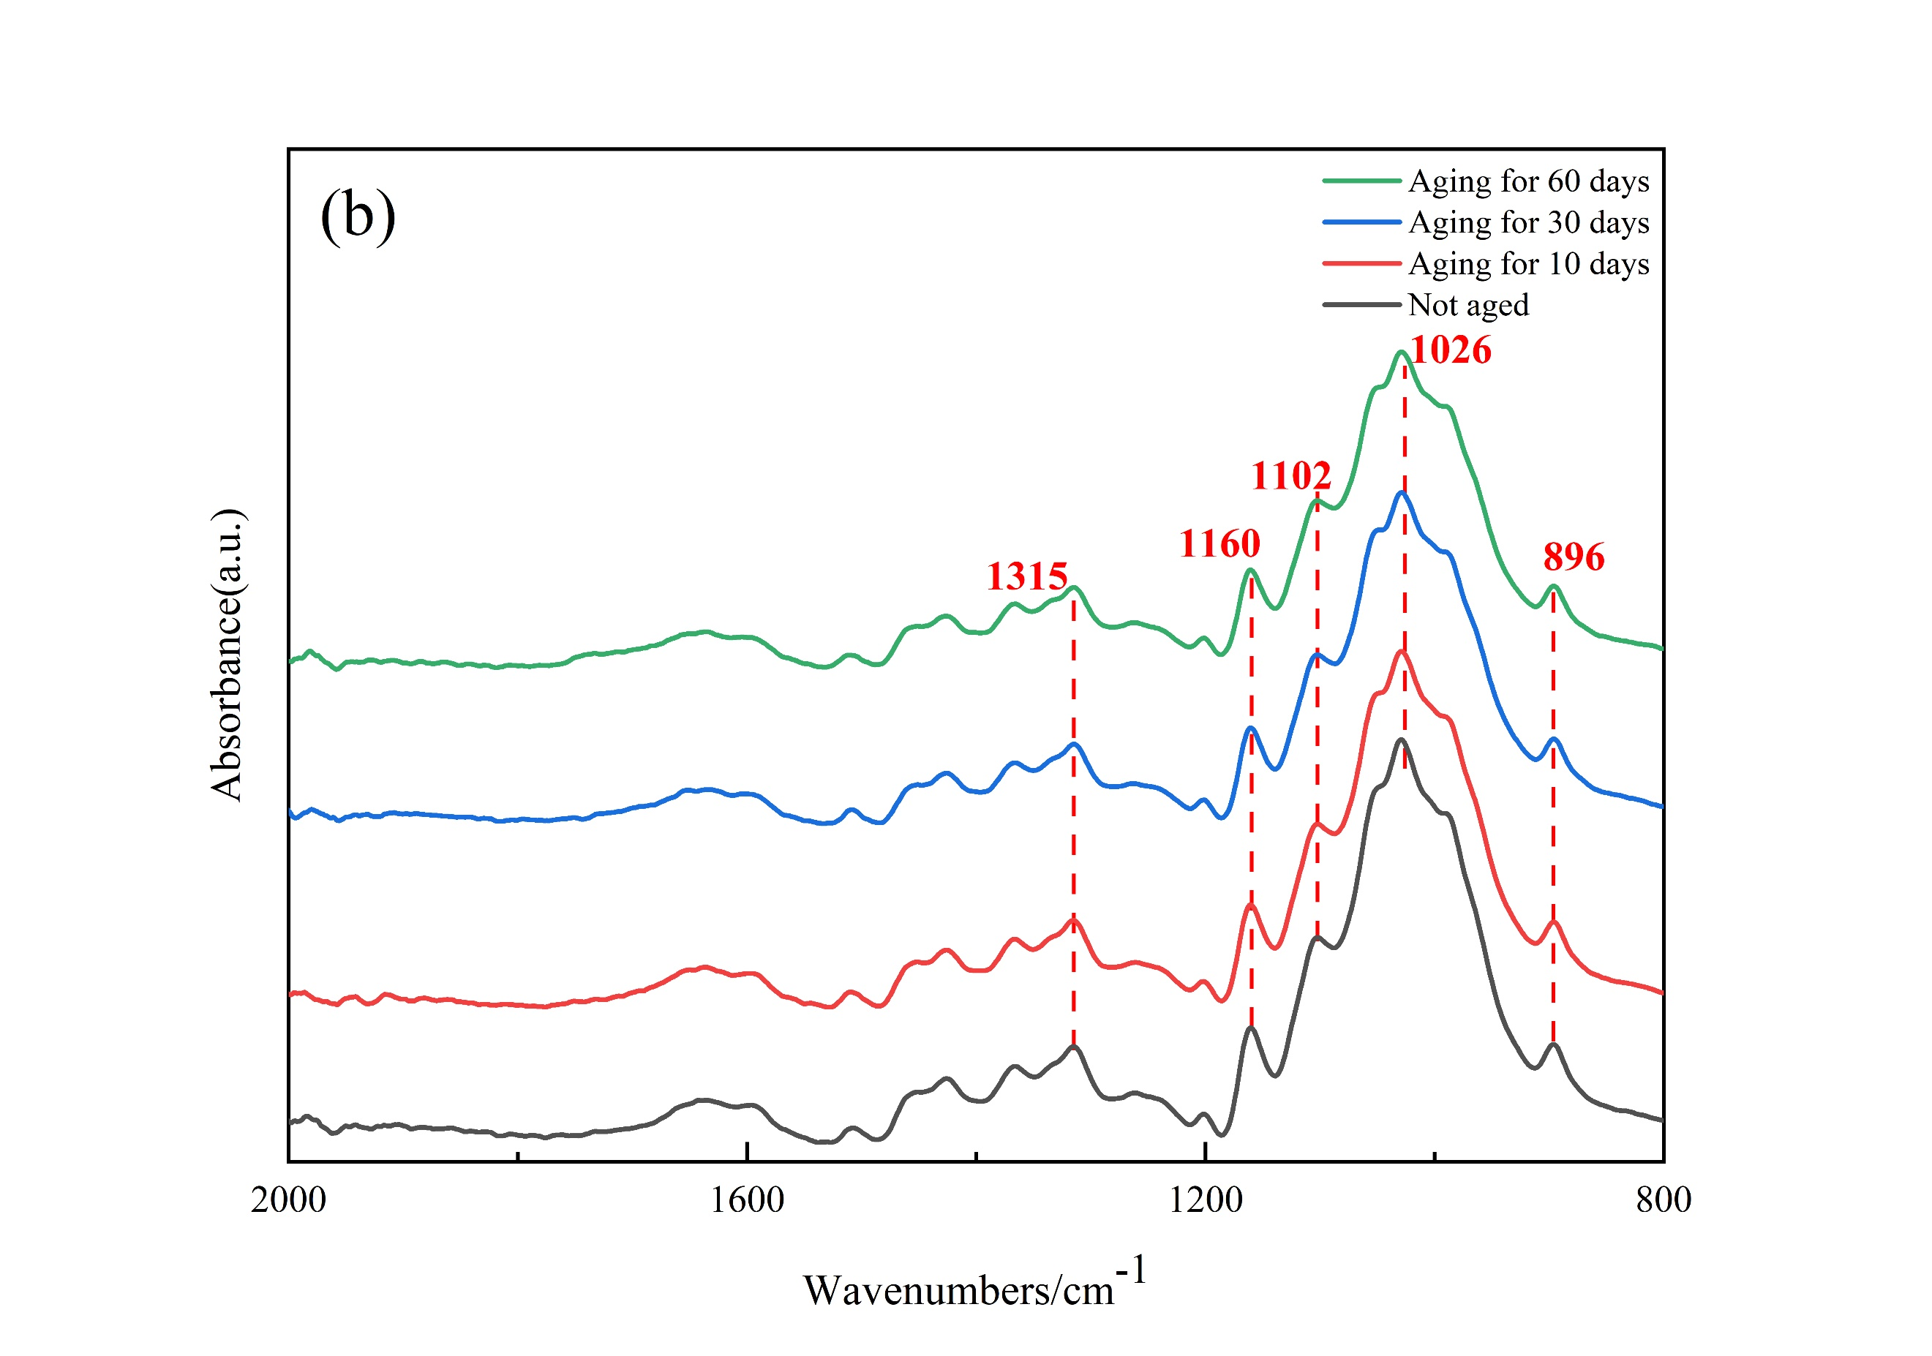
Fig.S2. ATR-FTIR spectra of paper samples. (a) Renhua paper，(b) Changting paper1，(c) Changting paper2，(d) Panxian paper，(e) Fuyang paper，(f) Liancheng paper.

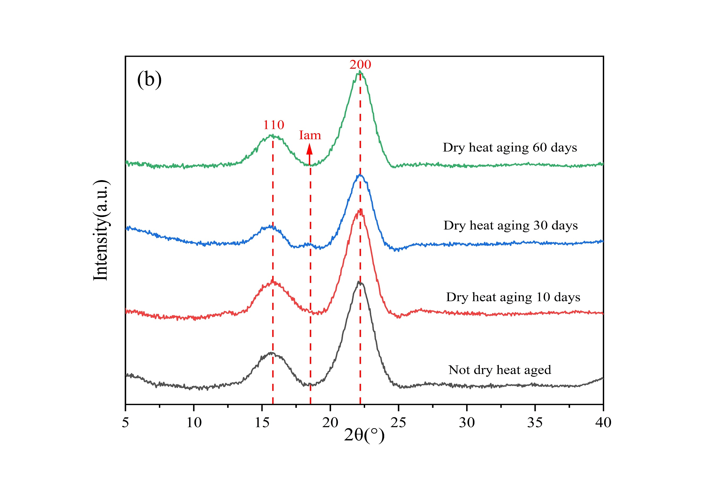
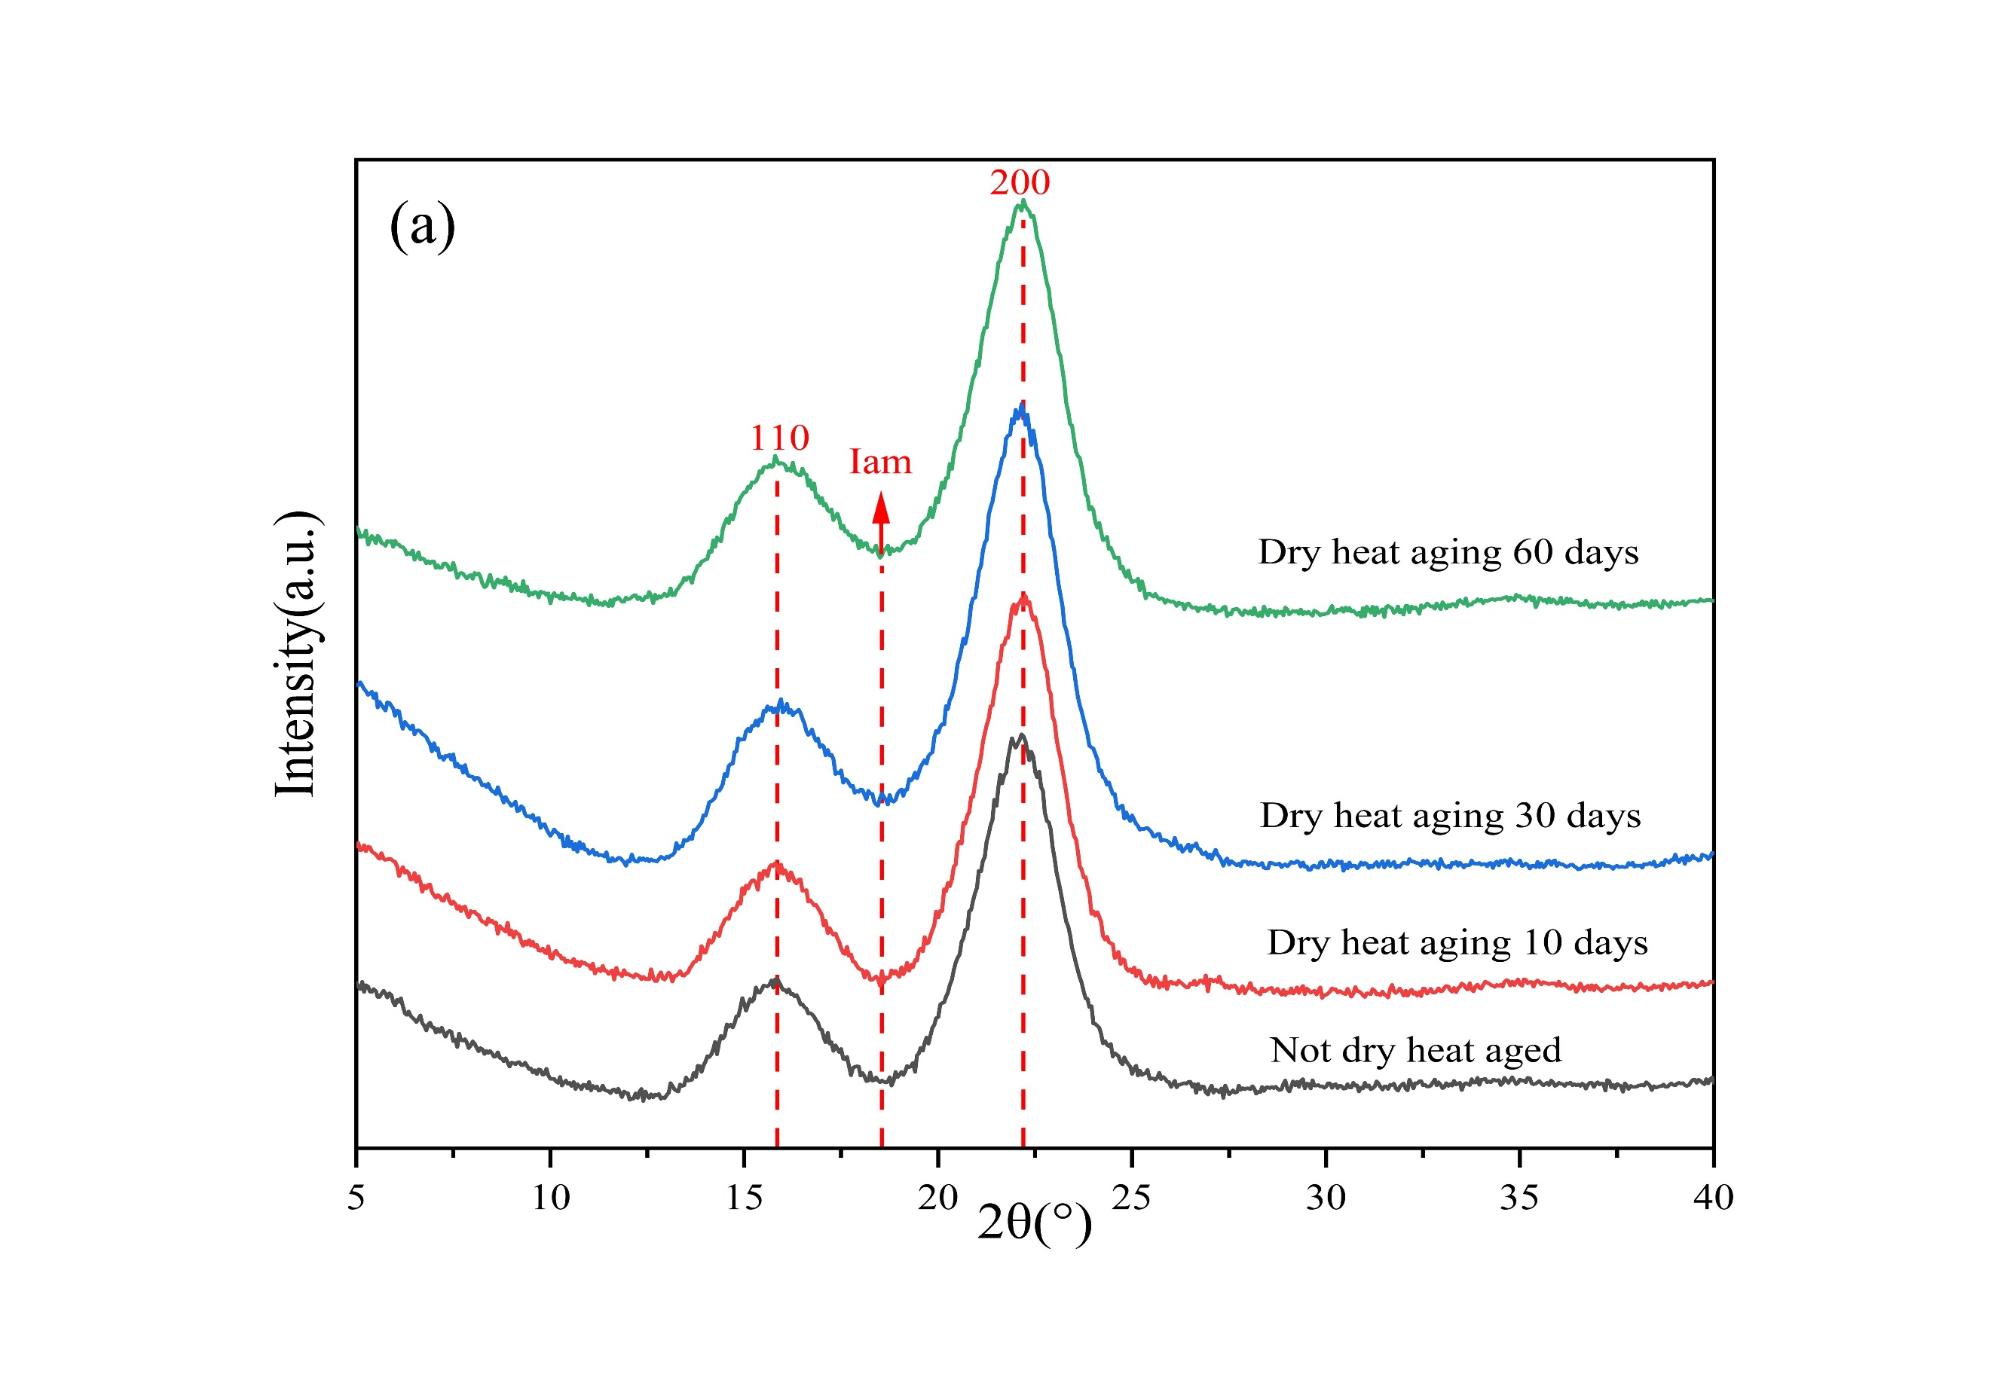
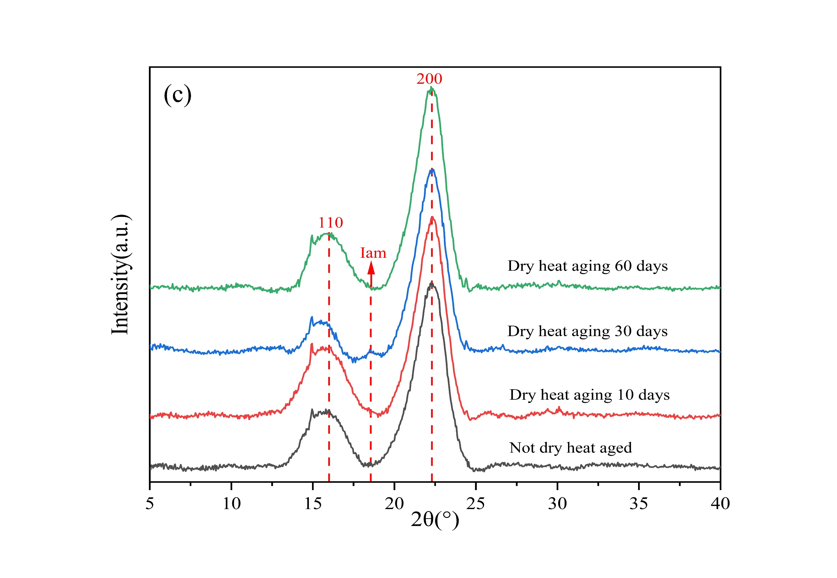
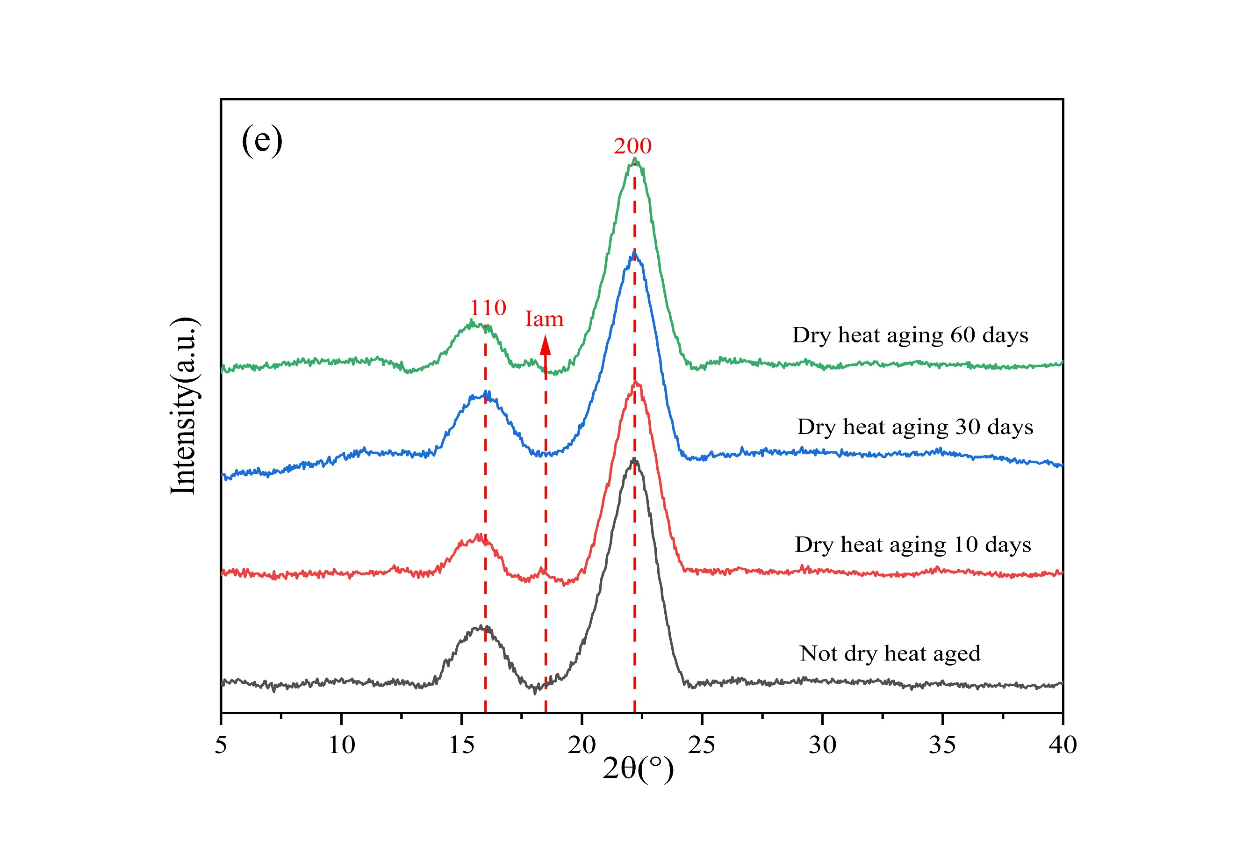
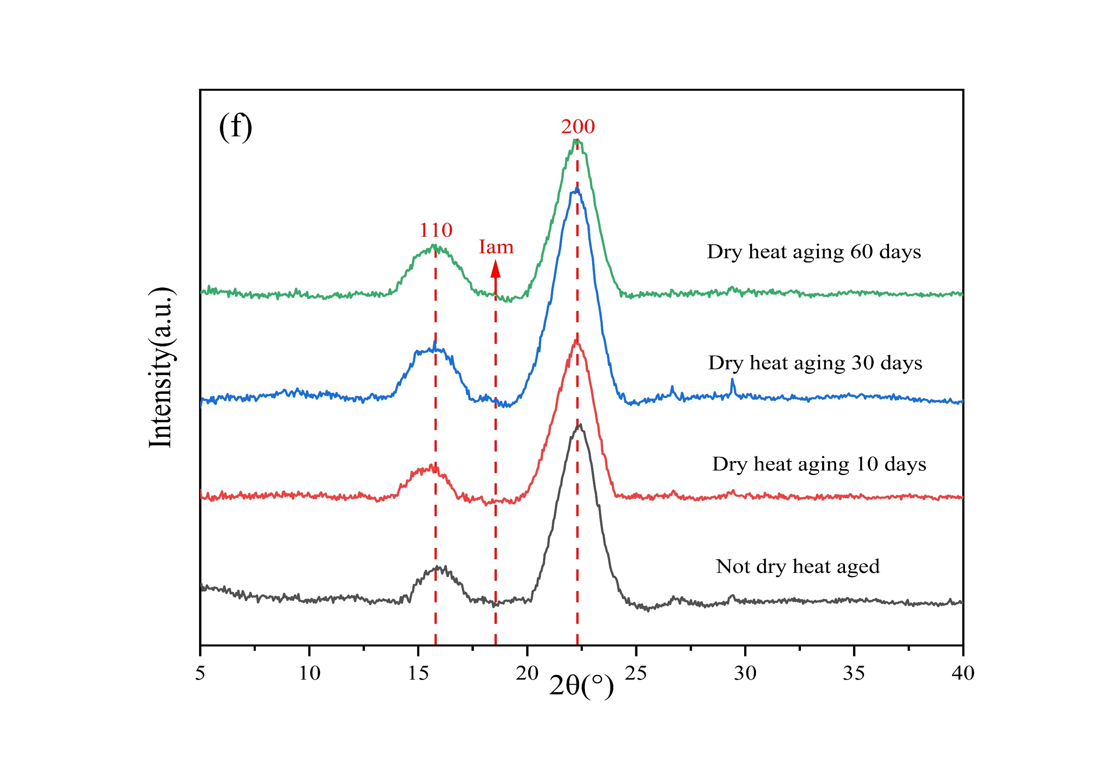
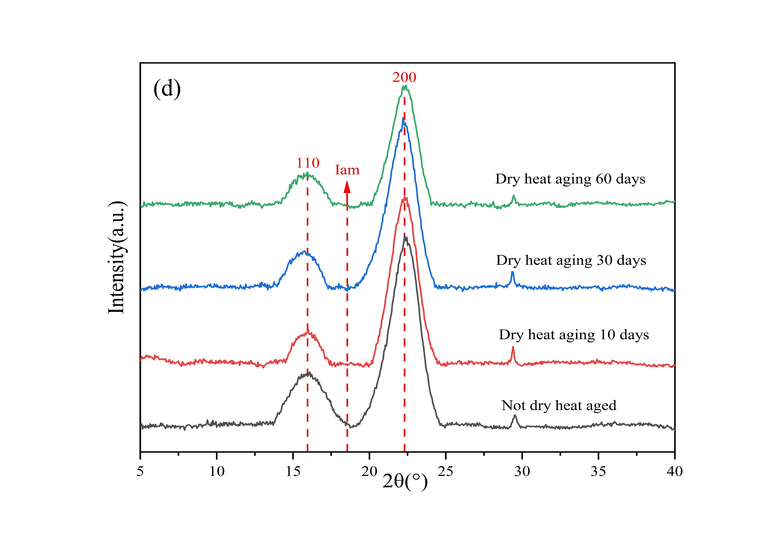
Fig.S3. XRD spectra of paper samples. (a) Renhua paper，(b) Changting paper1，(c) Changting paper2，(d) Panxian paper，(e) Fuyang paper，(f) Liancheng paper aging.

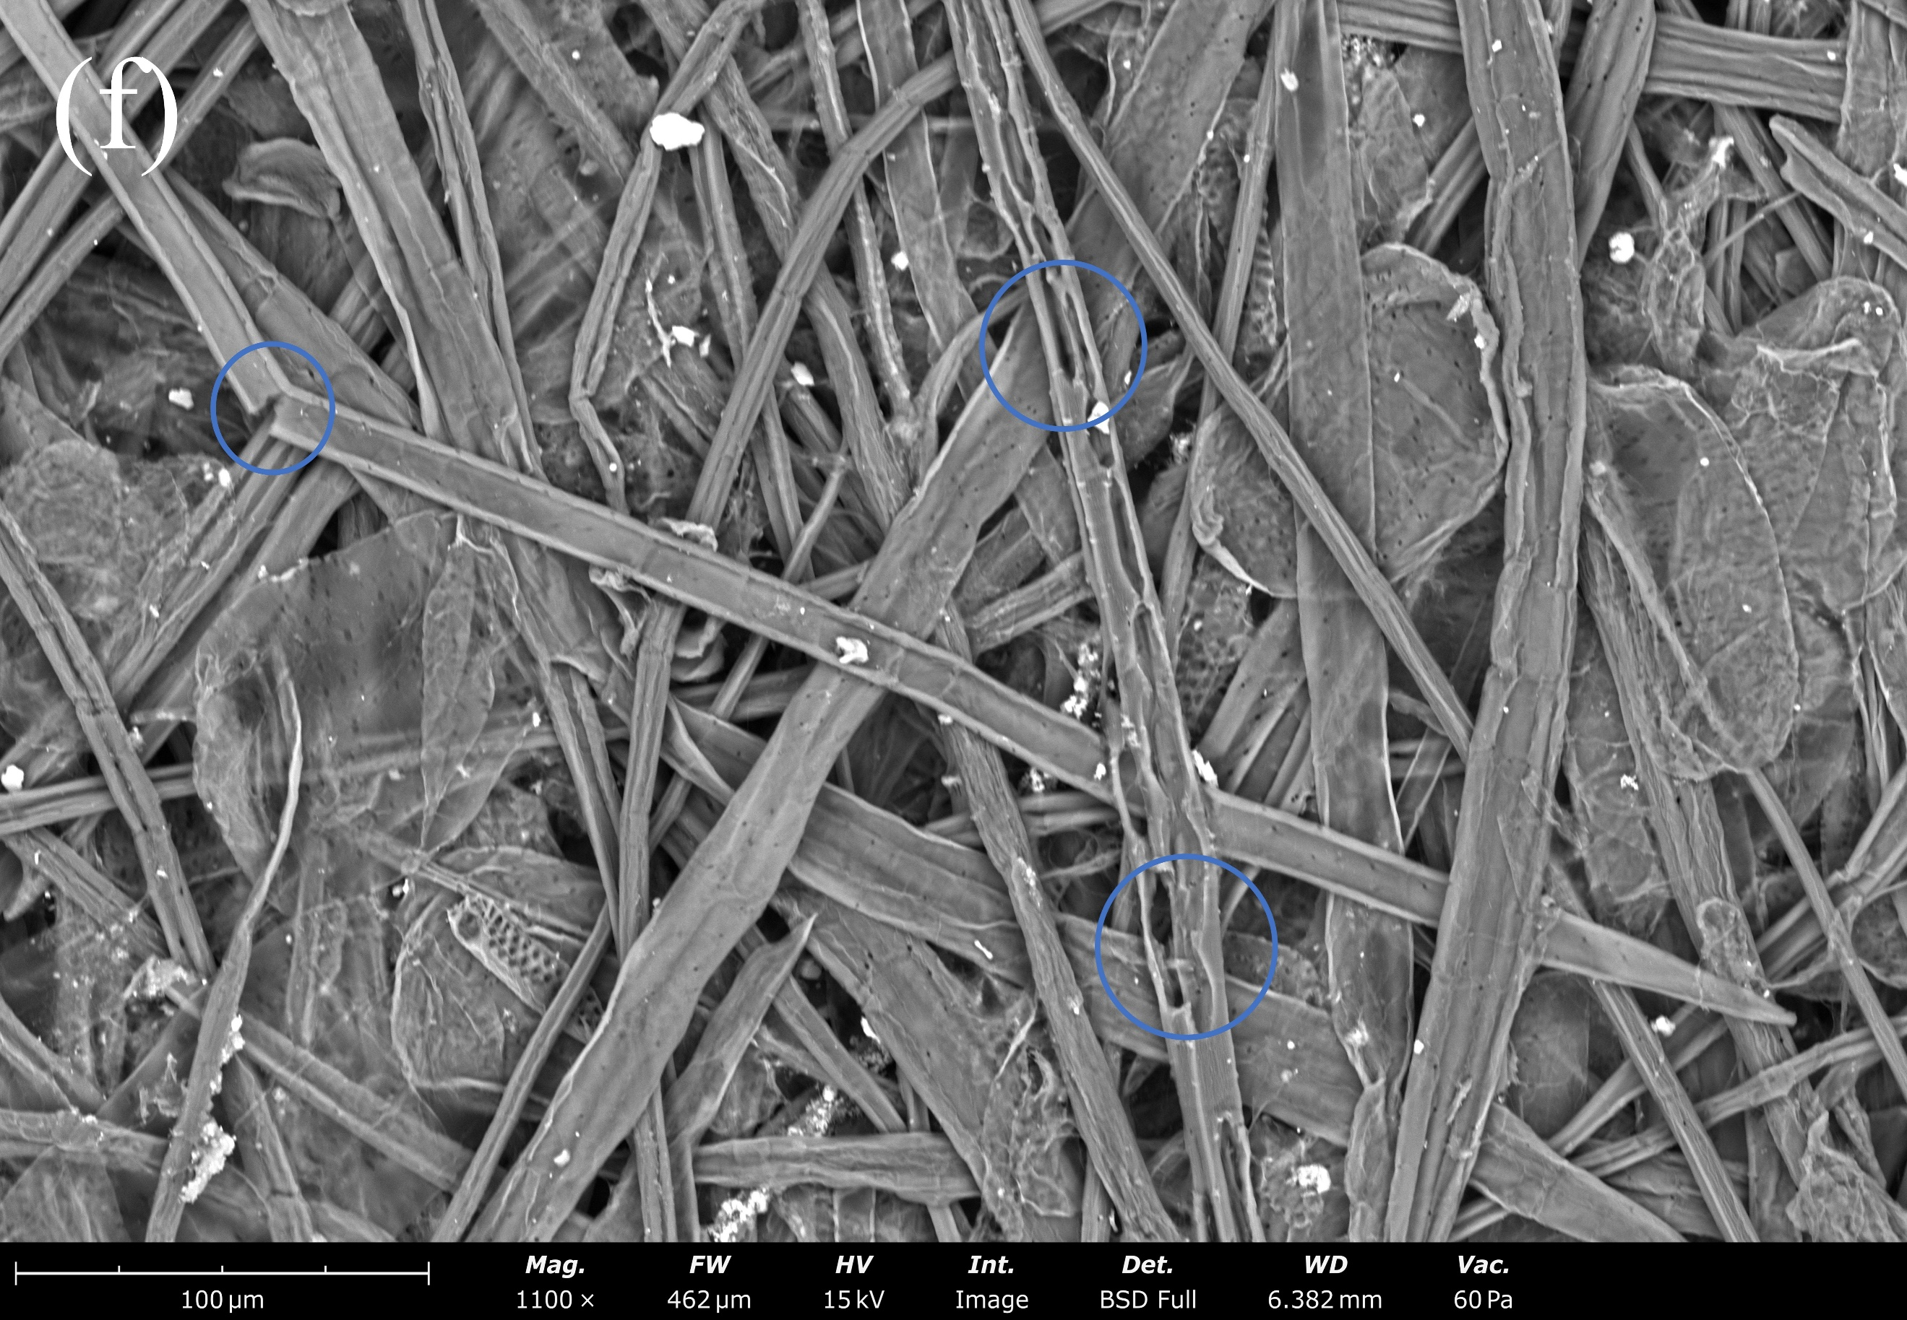
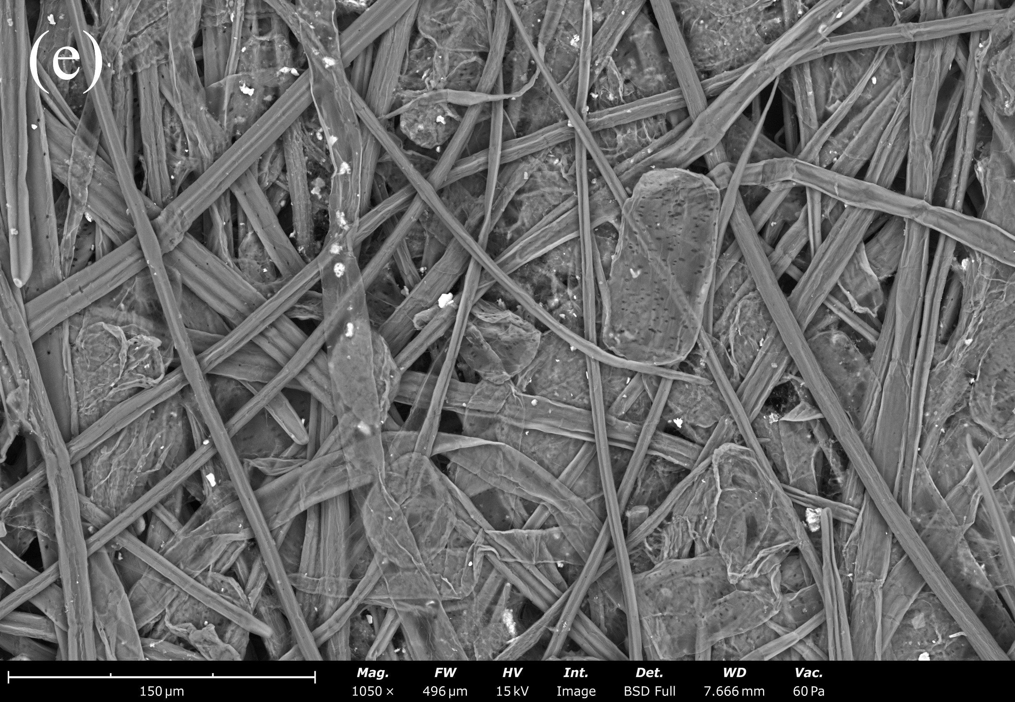
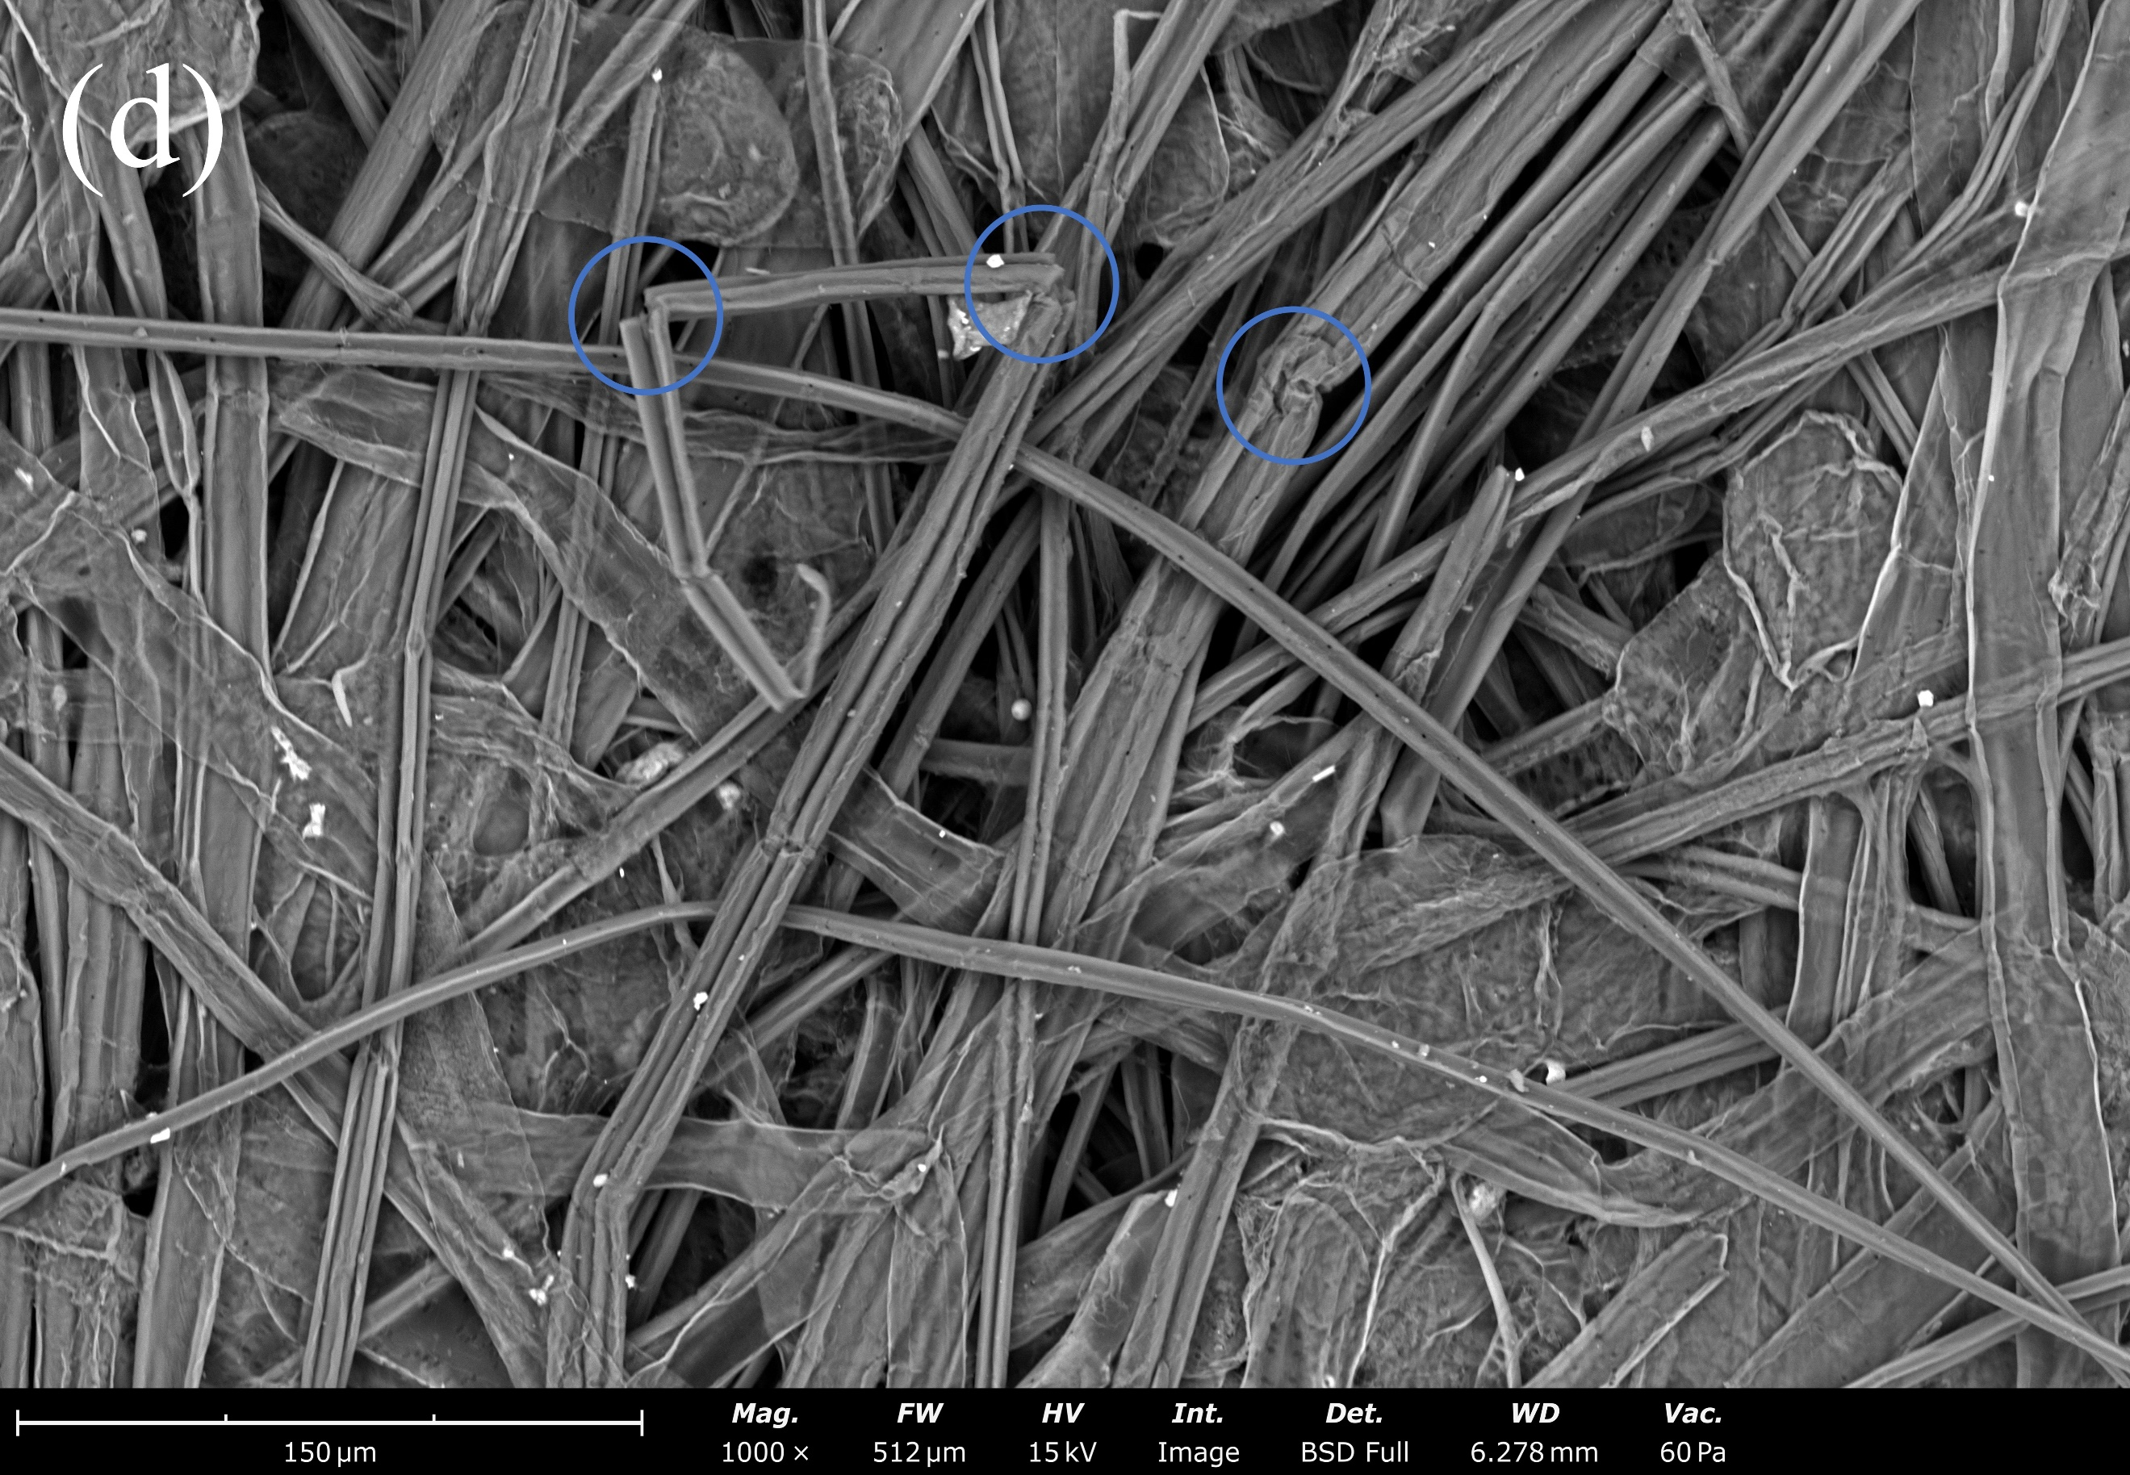
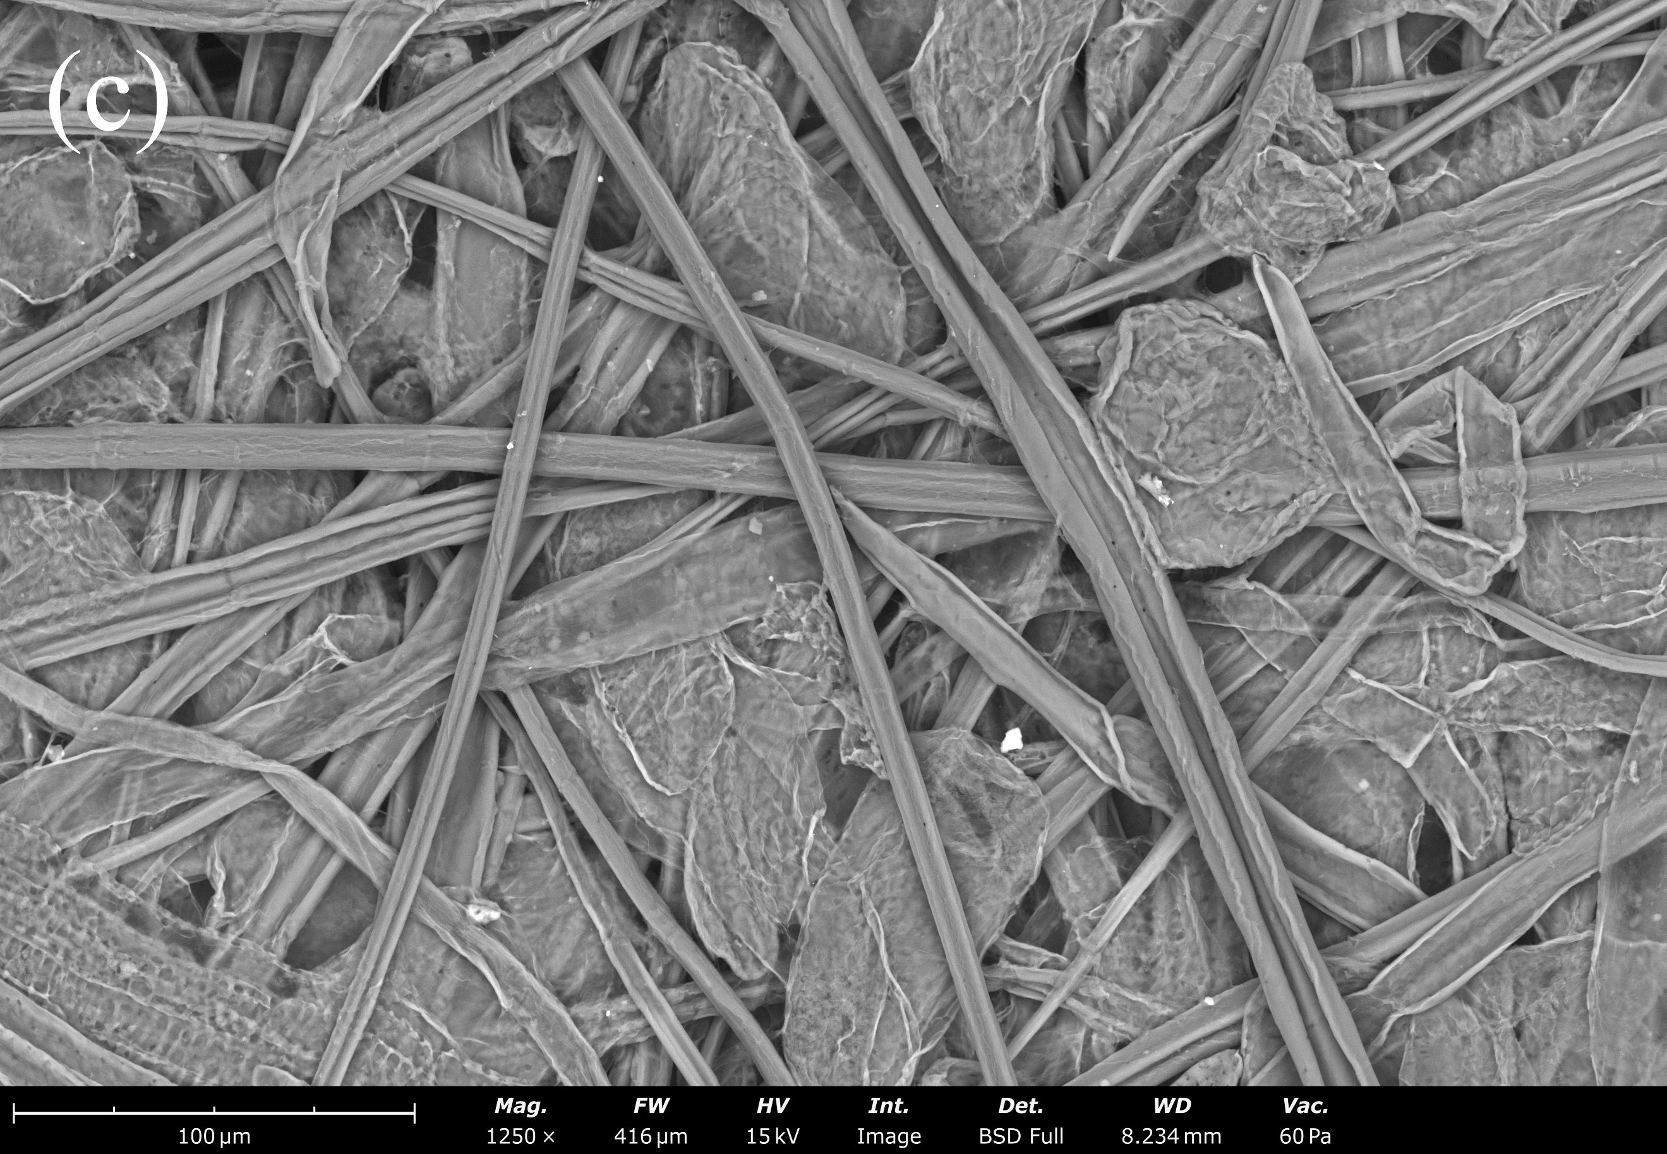
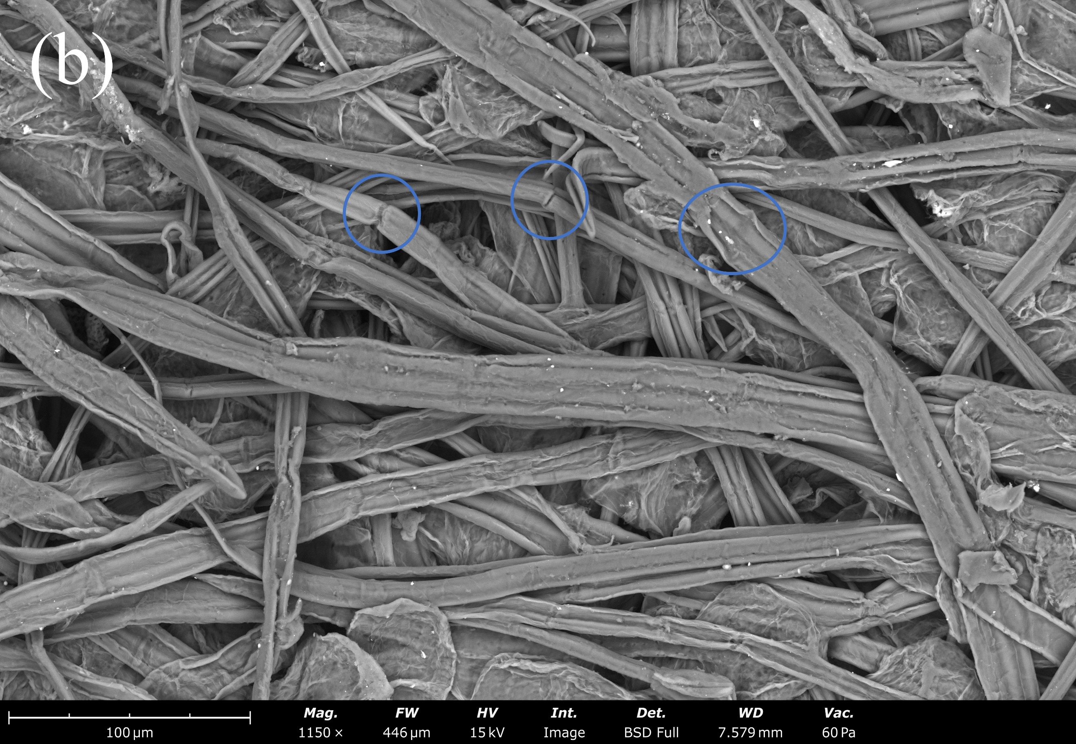
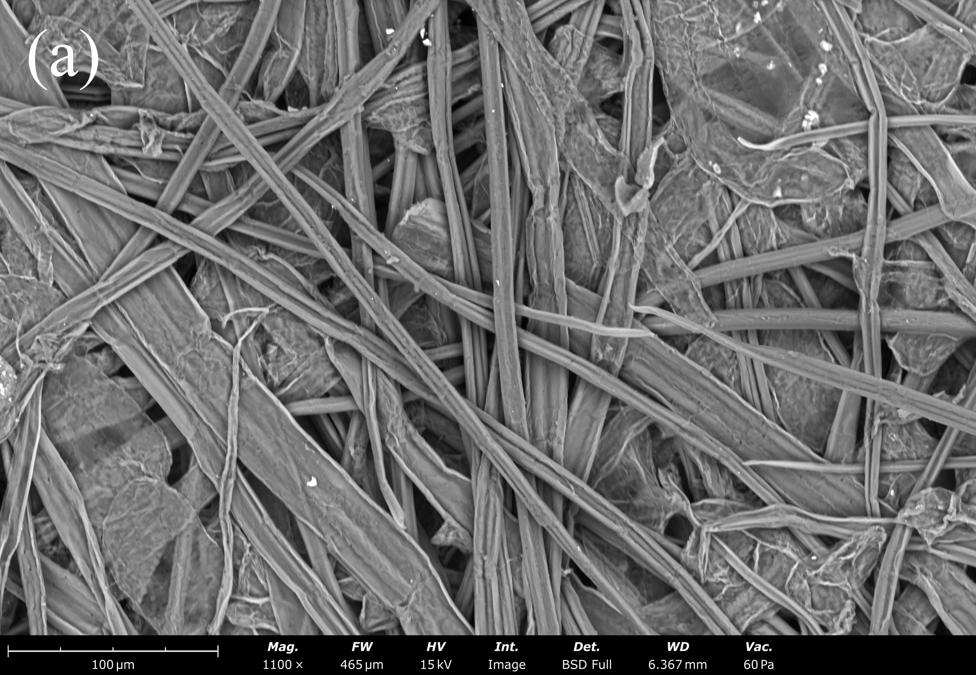

Fig.S4. Scanning electron microscope of paper samples. (a) Renhua paper，(b) Renhua paper aging for 60 days，(c) Changting paper1，(d) Changting paper1 aging for 60 days，(e) Lianchen paper，(f) Lianchen paper aging for 60 days.

SEM-EDS
Renhua paper
FW: 733 μm, Mode: 15 kV - Image, Detector: BSD
 | Element  Number | Element  Symbol | Element  Name | Atomic  Conc. | Weight  Conc.
 | 6 | C | Carbon | 33.272 | 22.000
 | 8 | O | Oxygen | 52.674 | 46.400
 | 14 | Si | Silicon | 0.453 | 0.700
 | 20 | Ca | Calcium | 12.734 | 28.100
 | 28 | Ni | Nickel | 0.867 | 2.800

Changting paper1
FW: 799 μm, Mode: 15 kV - Image, Detector: BSD
 | Element  Number | Element  Symbol | Element  Name | Atomic  Conc. | Weight  Conc.
 | 6 | C | Carbon | 29.431 | 19.000
 | 8 | O | Oxygen | 54.880 | 47.200
 | 20 | Ca | Calcium | 15.689 | 33.800

Changting paper2
FW: 799 μm, Mode: 15 kV - Image, Detector: BSD
 | Element  Number | Element  Symbol | Element  Name | Atomic  Conc. | Weight  Conc.
 | 6 | C | Carbon | 27.578 | 16.300
 | 8 | O | Oxygen | 49.911 | 39.300
 | 20 | Ca | Calcium | 22.510 | 44.400

Fuyang paper
FW: 799 μm, Mode: 15 kV - Image, Detector: BSD
 | Element  Number | Element  Symbol | Element  Name | Atomic  Conc. | Weight  Conc.
 | 6 | C | Carbon | 29.039 | 19.800
 | 8 | O | Oxygen | 59.447 | 54.000
 | 20 | Ca | Calcium | 11.514 | 26.200

Liancheng paper
FW: 799 μm, Mode: 15 kV - Image, Detector: BSD
 | Element  Number | Element  Symbol | Element  Name | Atomic  Conc. | Weight  Conc.
 | 6 | C | Carbon | 27.777 | 18.382
 | 8 | O | Oxygen | 58.698 | 51.748
 | 20 | Ca | Calcium | 13.526 | 29.870

