Supplementary Figure I: ¹³C-NMR

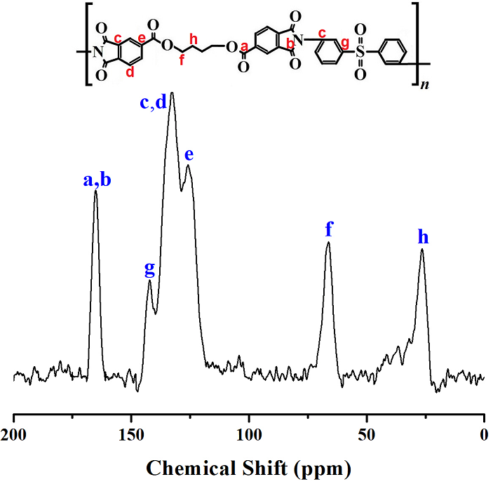
Supplementary-Figure S1. ¹³C-NMR spectrum of structure IV based on BU-DA monomer.

Supplementary-Table S1. ¹³C-NMR peak
assignments of structure IV.

Peak | Chemical Shift (ppm)
a, b | 165.27
c, d | 132.64
e | 126.07
f | 66.45
g | 142.25
h | 26.77

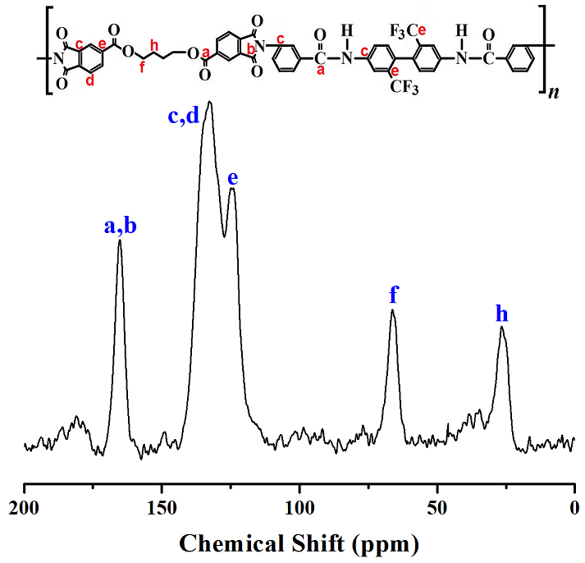

Supplementary-Figure S2. ¹³C-NMR spectrum of structure VII based on BU-DA monomer.

Peak | Chemical Shift (ppm)
a, b | 165.53
c, d | 132.68
e | 124.74
f | 66.31
h | 26.53
Supplementary-Table S2. ¹³C-NMR peak
assignments of structure VII.

Supplementary Figure II: ¹H-NMR
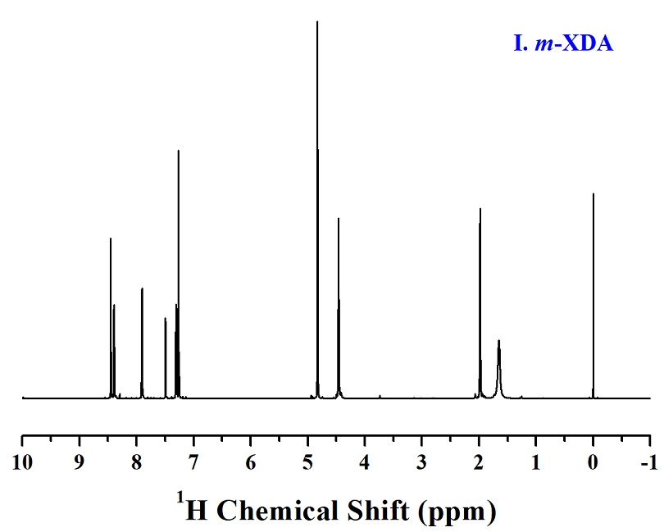

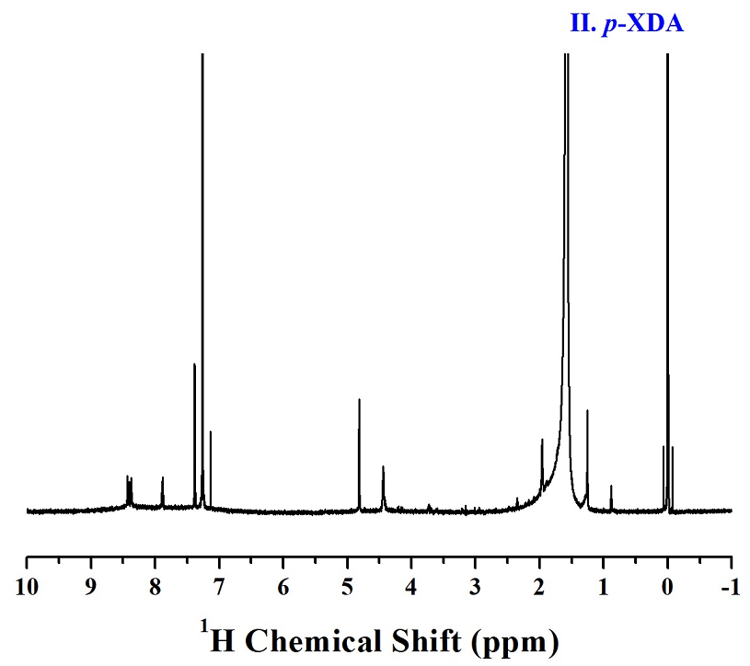

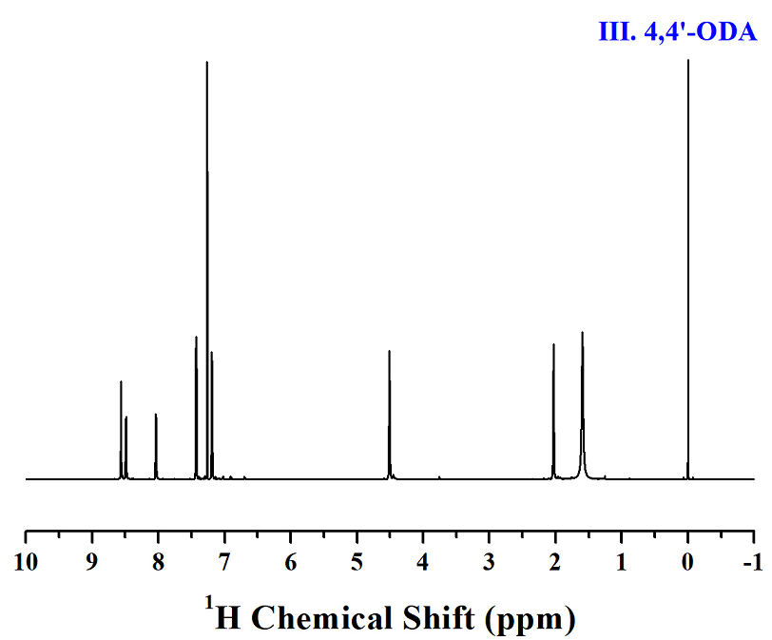
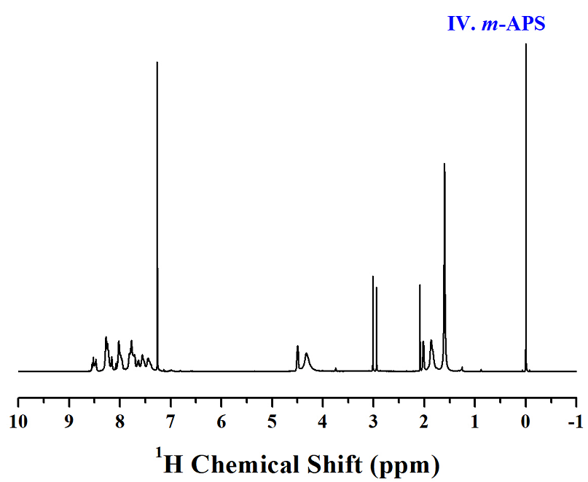

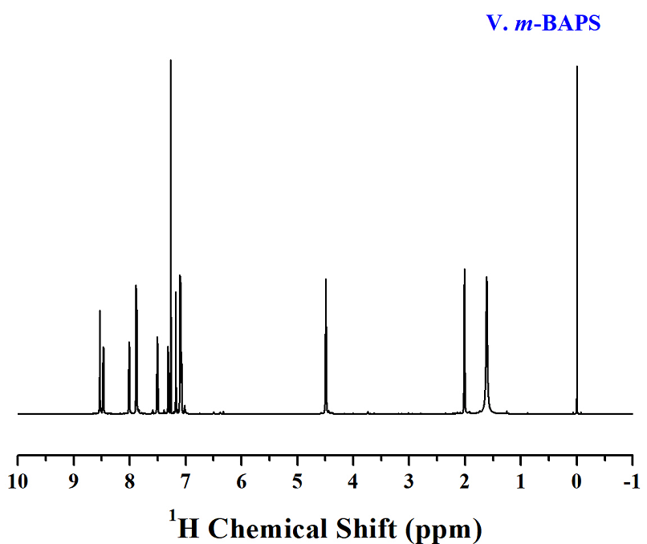

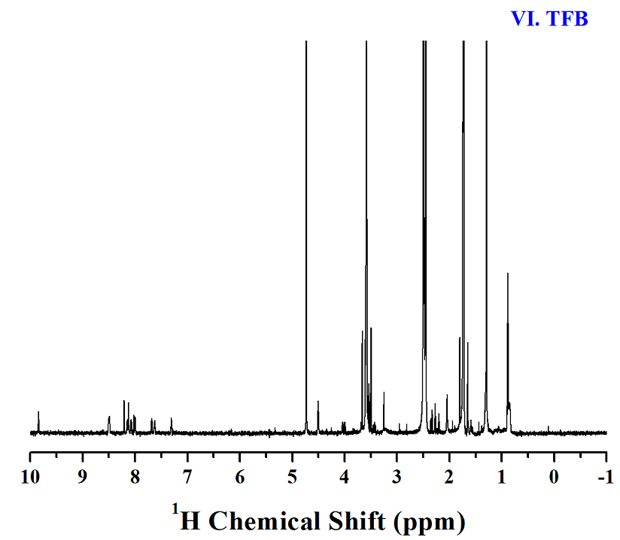

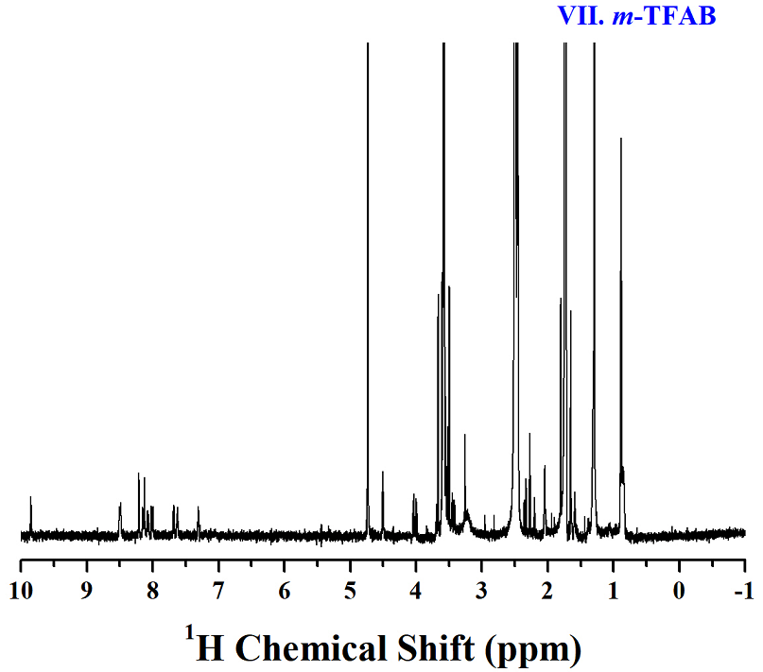

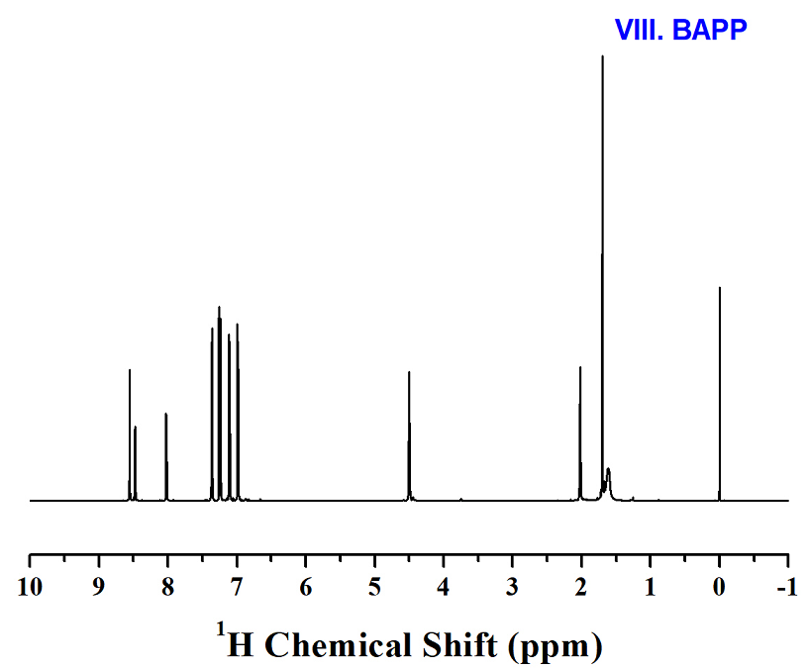

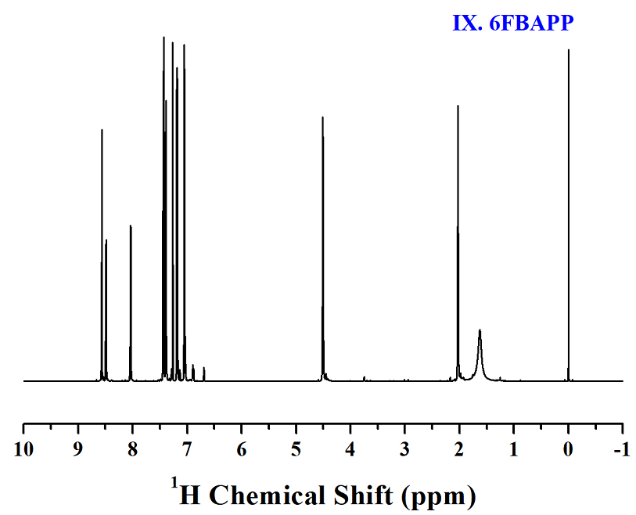

Supplementary Figure III: TGA/DTG

