Separation and Purification of Zr from A Low-Temperature LiCl-KCl-CsCl Eutectic by the Formation of Dendritic Crystal

Daoqing Ma, Jichen Xu, ZhiXuan Yi, Bin Ma, Ming Fang*, Xiaoli Tan*
*Corresponding author: Ming Fang and Xiaoli Tan, ª MOE Key Laboratory of Resources and Environmental System Optimization, College of Environmental Science and Engineering, North China Electric Power University, Beijing, 102206, P. R. China,
E-mail: xltan@ncepu.edu.cn; mfang@ncepu.edu.cn
Daoqing Ma, Jichen Xu, ZhiXuan Yi, and Bin Ma, College of Environmental Science and Engineering, North China Electric Power University, Beijing, 102206, P. R. China

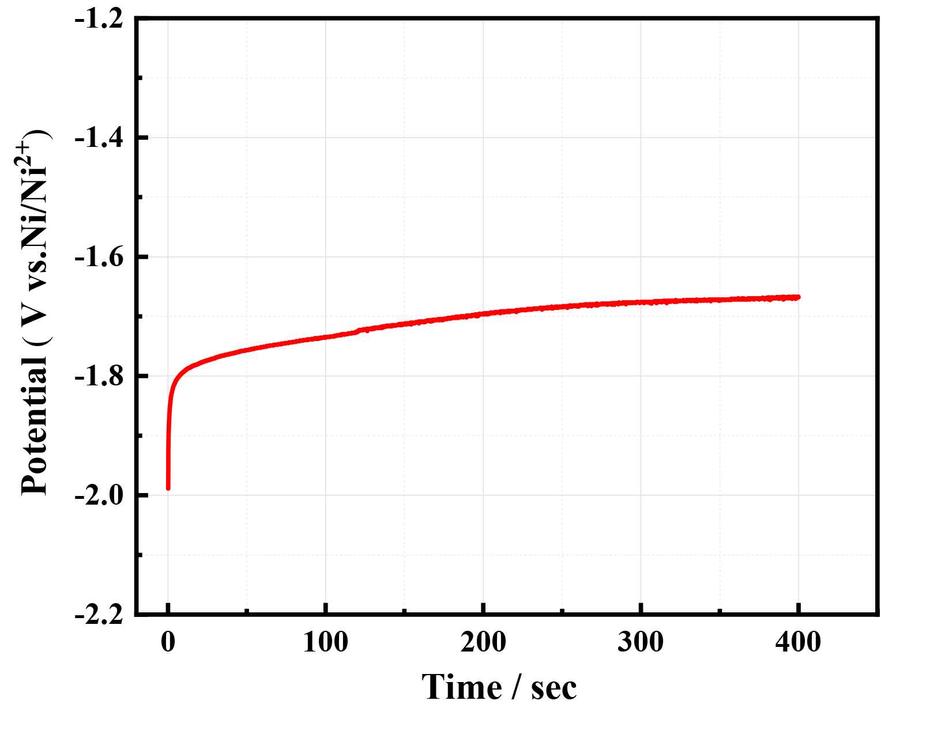
Figure. S1: Open circuit voltammogram at 573K on the W electrode after electrodepositing at -2.0 V vs. Ni/Ni²⁺ for 300s in LiCl-KCl-CsCl-ZrCl₄ (2.012×10⁻⁴mol cm⁻³) melts. Working electrode: W (A= 0.322 cm²).

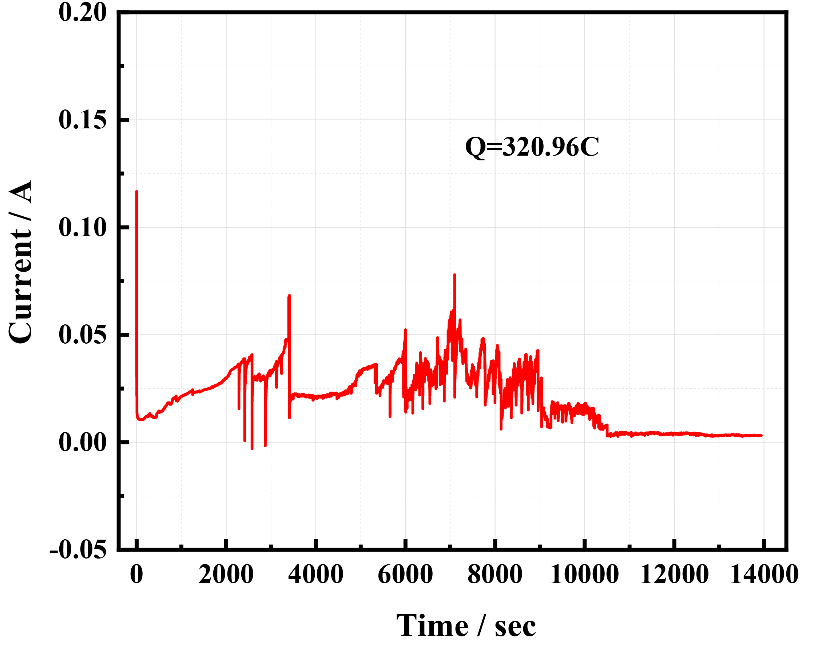
Figure. S2: Current vs. time plots obtained by PE at -2.0 V for 4 h in LiCl-KCl-CsCl-ZrCl₄ (2.012×10⁻⁴mol cm⁻³) molten salt.

