Electronic Supporting information

Synthesis of amide imidazole-based functionalized ionic liquid for separation of Th/Pu
Peng Liu, Shan Xing, Xiaomin Li, Meiying Liu, Xupeng Zhi, Xinlong Chen, Keliang Shi*, Yinglin Shen*
School of Nuclear Science and Technology, Lanzhou University, Lanzhou 730000, China

Fig.S1 Mass spectra of ionic liquid DXZ-1
Fig.S2 Mass spectra of ionic liquid DXZ-2
Fig.S3 Mass spectra of ionic liquid MIMDIDOA
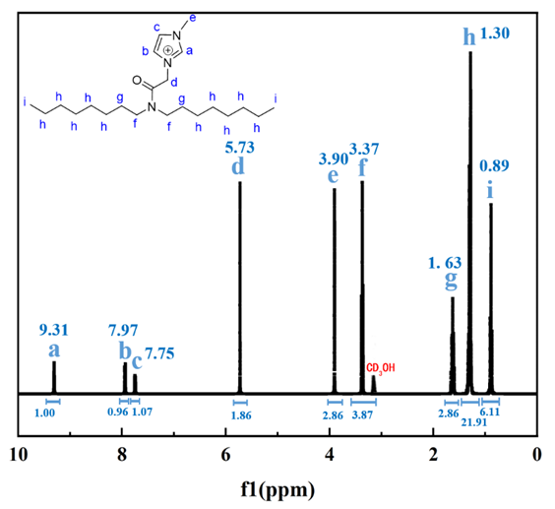
Fig. S4 ¹H-NMR of DXZ-1
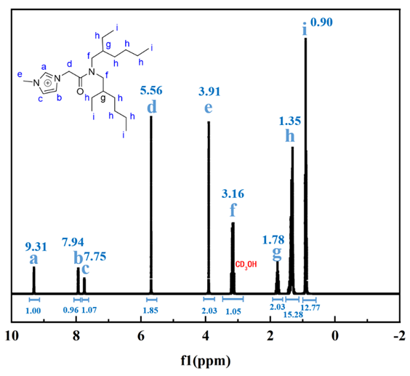
Fig. S5 ¹H-NMR of DXZ-2
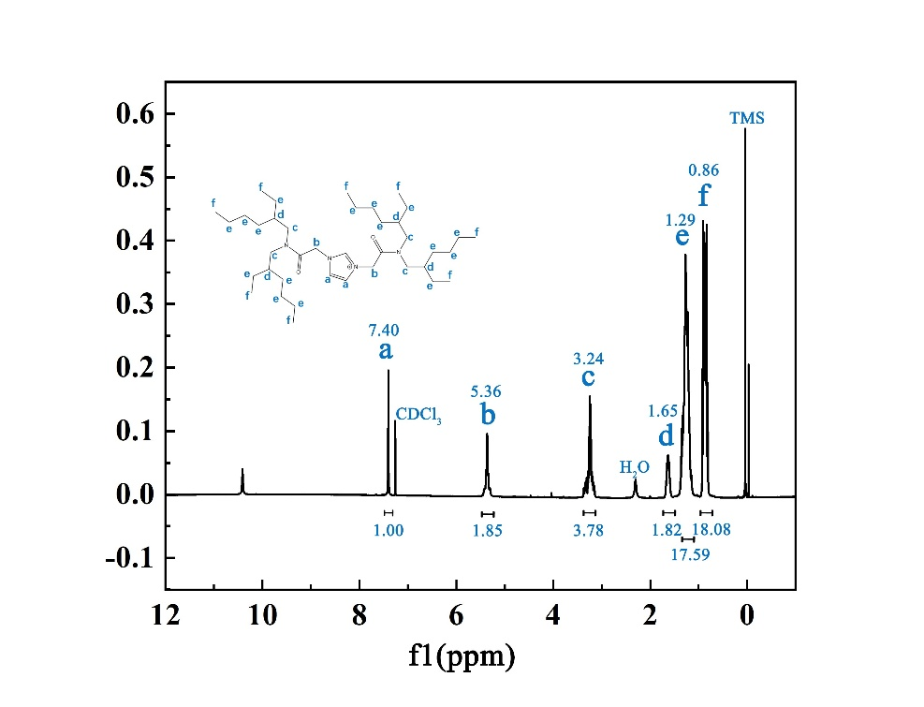
Fig. S6 ¹H-NMR of MIMDIDOA

Table.S1 The mass fractions of Cl and Th in MIMDIDOA and MIMDIDOA@Th⁴⁺
 | MIMDIDOA | MIMDIDOA@Th⁴⁺
Cl/wt% | 5.15 | 0.12
Th/wt% | 0 | 1.04

