Supplementary Information

Figure S1. XPS spectra of ZTDA. a. Full pattern of ZTDA. b. C1s. c. N1s. d. O1s. e. U4f

Figure S2. Fitting curves of U(VI) adsorption isotherm models for ZTBA
Figure S3. Fitting curves of U(VI) adsorption isotherm models for ZTDA

Table S1. Comparison of the max adsorption capacity of materials
Material |  | Qe_{(max)}  (mg g⁻¹)
ZTBA |  | 525.7
ZTDA |  | 465.7
ZDBA[53]  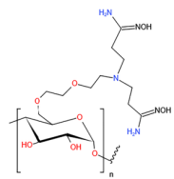 |  | 446.2
ZDDA[52]  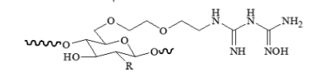 |  | 295.5
Han[56]  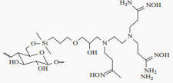 |  | 584.6
He[55]  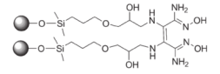 |  | 370.8
Yang[26]  Fungus Fusarium sp. #ZZF51 |  | 15.5

Figure S4. Kinetics model diagrams of ZTBA and ZTDA

