Supporting information for “Synthesis, in silico and biodistribution studies of a novel ⁴⁷Sc-radiolabeled α-amino acid ester derivative attached to pyrazine and tetrazole rings for tumor targeted radiotherapy”
Mohamed A. Gizawy^{1*}, Hesham A. Shamsel-Din¹, Mohsen M. T. El-Tahawy^{2*}, Ayman A. Ibrahim³

¹ Labeled Compounds Department, Hot Labs Center, Egyptian Atomic Energy Authority, P.O. Box 13759, Cairo, Egypt
²Chemistry Department, Faculty of Science, Damanhour University, P.O. Box 22511, Damanhour, Egypt
³Drug Radiation Research Department, National Center for Radiation Research and Technology (NCRRT), Egyptian Atomic Energy Authority, P. O. Box 29, Nasr City, Cairo 11787, Egypt

*Corresponding author: Mohamed A. Gizawy Tel: +201065975858, E-mail: dr_mgizawy@yahoo.com,

Table S1: The in-vitro serum stability of ⁴⁷Sc-dipeptide complex

Time, h | Radiochemical yield, %
2 | 98.7 ± 0.9
4 | 98.2 ± 1
6 | 98.4 ± 1.5
8 | 98.4 ± 1
10 | 98.5 ± 1.5
12 | 97.9 ± 0.8
24 | 98.7 ± 1
48 | 98.6 ± 0.5
72 | 98.3 ± 1

Table S2: The calculated Natural Charge on the individual atoms in the ligand and the complex [Sc(DPL(OH)₃)]
No. * | Atom | L | complex | charge change upon complexation
1 | N | -0.650 | -0.663 | -0.013
2 | C | -0.160 | -0.178 | -0.018
3 | C | -0.494 | -0.487 | 0.007
4 | C | -0.131 | -0.128 | 0.003
5 | C | -0.029 | -0.027 | 0.002
6 | C | 0.826 | 0.838 | 0.012
7 | O | -0.609 | -0.587 | 0.022
8 | C | -0.092 | -0.096 | -0.004
9 | C | 0.155 | 0.155 | 0.000
10 | N | -0.558 | -0.556 | 0.002
11 | C | -0.230 | -0.240 | -0.010
12 | C | -0.265 | -0.273 | -0.008
13 | C | -0.249 | -0.251 | -0.002
14 | C | -0.272 | -0.270 | 0.002
15 | C | 0.692 | 0.689 | -0.003
16 | O | -0.596 | -0.526 | 0.070
17 | O | -0.633 | -0.639 | -0.006
18 | C | 0.703 | 0.685 | -0.018
19 | C | -0.134 | -0.132 | 0.002
20 | N(N8) | -0.655 | -0.718 | -0.063
21 | C | -0.082 | -0.087 | -0.005
22 | C | -0.492 | -0.499 | -0.007
23 | C | -0.216 | -0.215 | 0.001
24 | C | -0.221 | -0.222 | -0.001
25 | C | -0.314 | -0.323 | -0.009
26 | C | 0.304 | 0.322 | 0.018
27 | C | -0.293 | -0.288 | 0.005
28 | O | -0.699 | -0.681 | 0.018
29 | C | -0.375 | -0.374 | 0.001
30 | N(N2) | -0.490 | -0.550 | -0.060
31 | C | -0.007 | 0.015 | 0.022
32 | C | -0.083 | -0.063 | 0.020
33 | N | -0.403 | -0.394 | 0.009
34 | C | -0.073 | -0.034 | 0.039
35 | C | 0.368 | 0.386 | 0.018
36 | N(N3) | -0.628 | -0.661 | -0.033
37 | C | -0.317 | -0.312 | 0.005
38 | N | -0.280 | -0.276 | 0.004
39 | C | 0.310 | 0.327 | 0.017
40 | N(N4) | -0.302 | -0.317 | -0.015
41 | N | 0.016 | 0.022 | 0.006
42 | N | -0.027 | -0.019 | 0.008
43 | O | -0.546 | -0.546 | 0.000
44 | C | -0.742 | -0.722 | 0.020
45 | C | -0.135 | -0.117 | 0.018
46 | H | 0.436 | 0.459 | 0.023
47 | H | 0.274 | 0.280 | 0.006
48 | H | 0.284 | 0.250 | -0.034
49 | H | 0.254 | 0.268 | 0.014
50 | H | 0.249 | 0.266 | 0.017
51 | H | 0.445 | 0.439 | -0.006
52 | H | 0.241 | 0.241 | 0.000
53 | H | 0.243 | 0.244 | 0.001
54 | H | 0.244 | 0.245 | 0.001
55 | H | 0.243 | 0.244 | 0.001
56 | H | 0.243 | 0.261 | 0.018
57 | H | 0.449 | 0.447 | -0.002
58 | H | 0.273 | 0.273 | 0.000
59 | H | 0.259 | 0.254 | -0.005
60 | H | 0.263 | 0.267 | 0.004
61 | H | 0.244 | 0.239 | -0.005
62 | H | 0.244 | 0.239 | -0.005
63 | H | 0.263 | 0.263 | 0.000
64 | H | 0.497 | 0.491 | -0.006
65 | H | 0.278 | 0.295 | 0.017
66 | H | 0.278 | 0.278 | 0.000
67 | H | 0.231 | 0.259 | 0.028
68 | H | 0.232 | 0.254 | 0.022
69 | H | 0.229 | 0.236 | 0.007
70 | H | 0.442 | 0.457 | 0.015
71 | H | 0.264 | 0.264 | 0.000
72 | H | 0.258 | 0.279 | 0.021
73 | H | 0.267 | 0.253 | -0.014
74 | H | 0.249 | 0.245 | -0.004
75 | H | 0.243 | 0.242 | -0.001
76 | H | 0.240 | 0.209 | -0.031
77 | H | 0.247 | 0.237 | -0.010
78 | Sc | 3.000 | 1.558 | -1.442
79 | O(O_{a1}) | -1.281 | -1.106 | 0.175
80 | H | 0.281 | 0.483 | 0.202
81 | O(O_{e}) | -1.281 | -1.022 | 0.259
82 | H | 0.281 | 0.509 | 0.227
83 | O(O_{a2}) | -1.281 | -1.061 | 0.221
84 | H | 0.281 | 0.492 | 0.210
net charge |  | 0.000 | 0.000
* for atom numeration see attached figure

Table S3: The most important interactions between NBO donor and acceptor which stabilize the [Sc(DPL(OH)₃)] complex by more than 5 kcal/mol.

Donor NBO (i) |  |  |  | Acceptor NBO (j) |  |  |  | E(2) kcal/mol* | E(j)-E(i) a.u. | F(i,j) a.u.
Orbital | hybridizations | Occ. |  | Orbital | hybridizations | Occ. |  | E(2) kcal/mol* | E(j)-E(i) a.u. | F(i,j) a.u.
LP1(N₂) | s(26.83%), p(73.14%) | 1.82 |  | LP*4(Sc) | s(72.59%), p(8.36%), d(19.03%) | 0.17 |  | 40.2 | 0.5 | 0.1
LP1(N₂) | s(26.83%), p(73.14%) | 1.82 |  | LP*2(Sc) | s(17.14%), p( 4.80%), d(77.93%) | 0.21 |  | 6.2 | 0.5 | 0.1
LP1(N₂) | s(26.83%), p(73.14%) | 1.82 |  | LP*7(Sc) | s(1.22%), p(61.37%), d(37.32%) | 0.12 |  | 4.9 | 0.6 | 0.0
Total |  |  |  |  |  |  |  | 62.3
LP1(N₄) | s(37.69%), p(62.20%) | 1.88 |  | LP*4(Sc) | s(72.59%), p(8.36%), d(19.03%) | 0.17 |  | 10.1 | 0.6 | 0.1
LP1(N₄) | s(37.69%), p(62.20%) | 1.88 |  | LP*8(Sc) | s(0.07%), p(67.48%), d(32.37%) | 0.11 |  | 7.6 | 0.7 | 0.1
LP1(N₄) | s(37.69%), p(62.20%) | 1.88 |  | LP*9(Sc) | s(2.30%), p(72.45%), d(25.20%) | 0.09 |  | 5.0 | 0.6 | 0.1
Total |  |  |  |  |  |  |  | 35.5
LP1(N₈) | p(99.99%) | 1.63 |  | LP*9(Sc) | s(2.30%), p(72.45%), d(25.20%) | 0.09 |  | 9.5 | 0.5 | 0.1
LP1(N₈) | p(99.99%) | 1.63 |  | LP*4(Sc) | s(72.59%), p(8.36%), d(19.03%) | 0.17 |  | 7.9 | 0.5 | 0.1
Total |  |  |  |  |  |  |  | 26.6
BD1(O_{a1}) | s(24.29%), p(75.63%) | 1.99 |  | LP*7(Sc) | s(1.22%), p(61.37%), d(37.32%) | 0.12 |  | 5.5 | 0.9 | 0.1
LP1(O_{a1}) | s(35.34%), p(64.64%) | 1.91 |  | LP*7(Sc) | s(1.22%), p(61.37%), d(37.32%) | 0.12 |  | 14.1 | 0.7 | 0.1
LP1(O_{a1}) | s(35.34%), p(64.64%) | 1.91 |  | LP*6(Sc) | s(0.14%), p(44.75%), d(55.05%) | 0.14 |  | 5.7 | 0.6 | 0.1
LP2(O_{a1}) | s(6.51%), p(93.46%) | 1.89 |  | LP*8(Sc) | s(0.07%), p(67.48%), d(32.37%) | 0.11 |  | 8.1 | 0.5 | 0.1
LP2(O_{a1}) | s(6.51%), p(93.46%) | 1.89 |  | LP*1(Sc) | s(1.37%), p(1.90%), d(96.68%) | 0.28 |  | 6.2 | 0.4 | 0.0
LP2(O_{a1}) | s(6.51%), p(93.46%) | 1.89 |  | LP*3(Sc) | s(2.55%), p( 3.06%), d(94.28%) | 0.20 |  | 5.1 | 0.4 | 0.0
LP3(O_{a1}) | s(33.93%), p(66.05%) | 1.83 |  | LP*1(Sc) | s(1.37%), p(1.90%), d(96.68%) | 0.28 |  | 34.1 | 0.6 | 0.1
LP3(O_{a1}) | s(33.93%), p(66.05%) | 1.83 |  | LP*2(Sc) | s(17.14%), p( 4.80%), d(77.93%) | 0.21 |  | 28.5 | 0.6 | 0.1
LP3(O_{a1}) | s(33.93%), p(66.05%) | 1.83 |  | LP*7(Sc) | s(1.22%), p(61.37%), d(37.32%) | 0.12 |  | 22.2 | 0.7 | 0.1
LP3(O_{a1}) | s(33.93%), p(66.05%) | 1.83 |  | LP*4(Sc) | s(72.59%), p(8.36%), d(19.03%) | 0.17 |  | 11.8 | 0.7 | 0.1
LP3(O_{a1}) | s(33.93%), p(66.05%) | 1.83 |  | LP*8(Sc) | s(0.07%), p(67.48%), d(32.37%) | 0.11 |  | 8.9 | 0.7 | 0.1
LP3(O_{a1}) | s(33.93%), p(66.05%) | 1.83 |  | LP*6(Sc) | s(0.14%), p(44.75%), d(55.05%) | 0.14 |  | 7.0 | 0.6 | 0.1
Total |  |  |  |  |  |  |  | 213.9
BD1(O_{e}) | s(26.06%), p(73.88%) | 1.98 |  | LP*9(Sc) | s(2.30%), p(72.45%), d(25.20%) | 0.09 |  | 5.9 | 0.9 | 0.1
CR1(O_{e}) | s(100.00%) | 2.00 |  | LP*2(Sc) | s(17.14%), p( 4.80%), d(77.93%) | 0.21 |  | 5.1 | 19.0 | 0.3
LP1(O_{e}) | s(28.33%), p(71.64%) | 1.87 |  | LP*6(Sc) | s(0.14%), p(44.75%), d(55.05%) | 0.14 |  | 35.6 | 0.6 | 0.1
LP1(O_{e}) | s(28.33%), p(71.64%) | 1.87 |  | LP*2(Sc) | s(17.14%), p( 4.80%), d(77.93%) | 0.21 |  | 17.6 | 0.6 | 0.1
LP1(O_{e}) | s(28.33%), p(71.64%) | 1.87 |  | LP*5(Sc) | s(0.14%), p(44.75%), d(55.05%) | 0.14 |  | 9.6 | 0.6 | 0.1
LP1(O_{e}) | s(28.33%), p(71.64%) | 1.87 |  | LP*1(Sc) | s(1.37%), p(1.90%), d(96.68%) | 0.28 |  | 5.2 | 0.6 | 0.1
LP2(O_{e}) | s(5.20%), p(94.78%) | 1.86 |  | LP*3(Sc) | s(2.55%), p( 3.06%), d(94.28%) | 0.20 |  | 21.0 | 0.4 | 0.1
LP2(O_{e}) | s(5.20%), p(94.78%) | 1.86 |  | LP*5(Sc) | s(0.14%), p(44.75%), d(55.05%) | 0.14 |  | 10.6 | 0.4 | 0.1
LP2(O_{e}) | s(5.20%), p(94.78%) | 1.86 |  | LP*6(Sc) | s(0.14%), p(44.75%), d(55.05%) | 0.14 |  | 5.7 | 0.4 | 0.0
LP3(O_{e}) | s(40.42%), p(59.56% | 1.79 |  | LP*2(Sc) | s(17.14%), p( 4.80%), d(77.93%) | 0.21 |  | 56.0 | 0.7 | 0.2
LP3(O_{e}) | s(40.42%), p(59.56% | 1.79 |  | LP*1(Sc) | s(1.37%), p(1.90%), d(96.68%) | 0.28 |  | 40.7 | 0.7 | 0.2
LP3(O_{e}) | s(40.42%), p(59.56% | 1.79 |  | LP*6(Sc) | s(0.14%), p(44.75%), d(55.05%) | 0.14 |  | 13.9 | 0.7 | 0.1
LP3(O_{e}) | s(40.42%), p(59.56% | 1.79 |  | LP*3(Sc) | s(2.55%), p( 3.06%), d(94.28%) | 0.20 |  | 11.9 | 0.6 | 0.1
LP3(O_{e}) | s(40.42%), p(59.56% | 1.79 |  | LP*9(Sc) | s(2.30%), p(72.45%), d(25.20%) | 0.09 |  | 9.2 | 0.7 | 0.1
Total |  |  |  |  |  |  |  | 307.3
BD1(O_{a2}) | s(23.93%), p(75.98% | 1.98 |  | LP*8(Sc) | s(0.07%), p(67.48%), d(32.37%) | 0.11 |  | 5.8 | 0.9 | 0.1
LP1(O_{a2}) | s(35.62%), p(64.34%) | 1.93 |  | LP*8(Sc) | s(0.07%), p(67.48%), d(32.37%) | 0.11 |  | 15.6 | 0.7 | 0.1
LP1(O_{a2}) | s(35.62%), p(64.34%) | 1.93 |  | LP*5(Sc) | s(0.14%), p(44.75%), d(55.05%) | 0.14 |  | 8.2 | 0.6 | 0.1
LP1(O_{a2}) | s(35.62%), p(64.34%) | 1.93 |  | LP*3(Sc) | s(2.55%), p( 3.06%), d(94.28%) | 0.20 |  | 5.6 | 0.5 | 0.1
LP2(O_{a2}) | s(0.13%), p(99.82%) | 1.84 |  | LP*5(Sc) | s(0.14%), p(44.75%), d(55.05%) | 0.14 |  | 14.9 | 0.4 | 0.1
LP3(O_{a1}) | s(40.27%), p(59.71%) | 1.81 |  | LP*1(Sc) | s(1.37%), p(1.90%), d(96.68%) | 0.28 |  | 49.1 | 0.7 | 0.2
LP3(O_{a1}) | s(40.27%), p(59.71%) | 1.81 |  | LP*8(Sc) | s(0.07%), p(67.48%), d(32.37%) | 0.11 |  | 26.9 | 0.8 | 0.1
LP3(O_{a1}) | s(40.27%), p(59.71%) | 1.81 |  | LP*3(Sc) | s(2.55%), p( 3.06%), d(94.28%) | 0.20 |  | 18.6 | 0.6 | 0.1
LP3(O_{a1}) | s(40.27%), p(59.71%) | 1.81 |  | LP*4(Sc) | s(72.59%), p(8.36%), d(19.03%) | 0.17 |  | 13.0 | 0.7 | 0.1
LP3(O_{a1}) | s(40.27%), p(59.71%) | 1.81 |  | LP*7(Sc) | s(1.22%), p(61.37%), d(37.32%) | 0.12 |  | 7.5 | 0.7 | 0.1
LP3(O_{a1}) | s(40.27%), p(59.71%) | 1.81 |  | LP*2(Sc) | s(17.14%), p( 4.80%), d(77.93%) | 0.21 |  | 6.2 | 0.7 | 0.1
LP3(O_{a1}) | s(40.27%), p(59.71%) | 1.81 |  | LP*5(Sc) | s(0.14%), p(44.75%), d(55.05%) | 0.14 |  | 5.2 | 0.7 | 0.1
Total |  |  |  |  |  |  |  | 231.64
*values in bold show the samation of the interaction between the specfic atom of the donor and the accptor

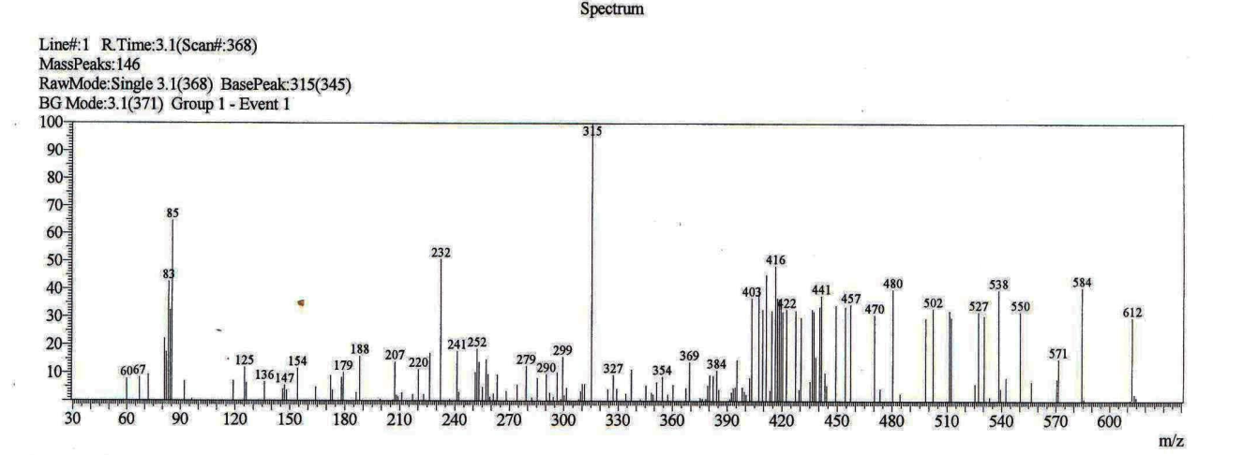

Figure S1: The mass spectrum of DPL
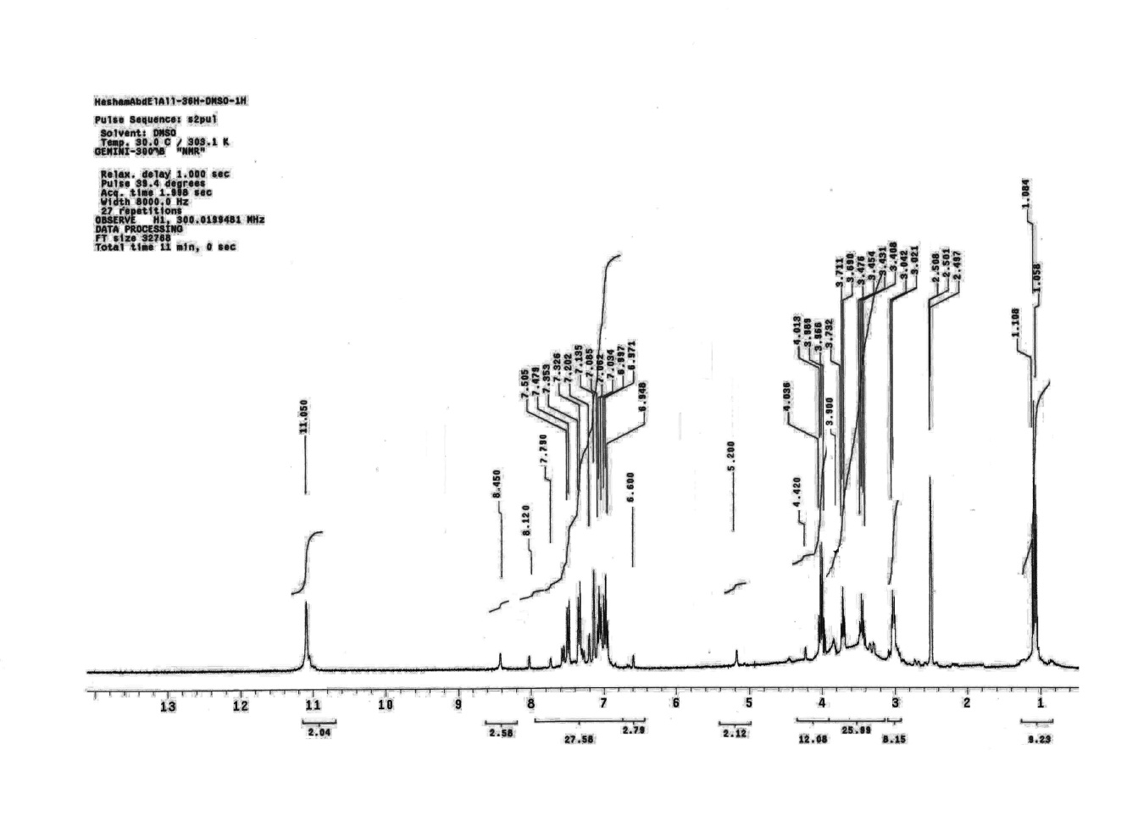
Figure S2: The ¹H-NMR spectrum of DPL

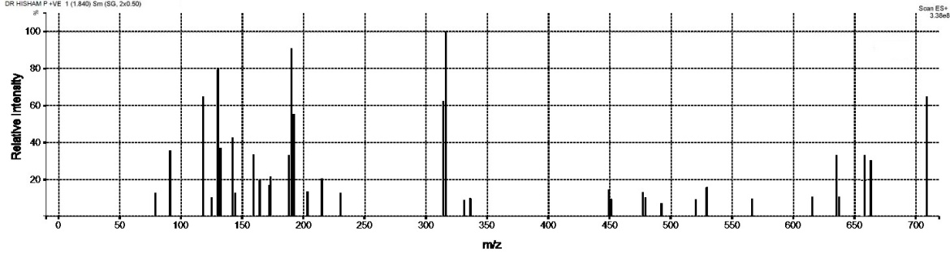

Figure S3: The LC-MS spectrum of [Sc(DPL)](OH)₃ complex

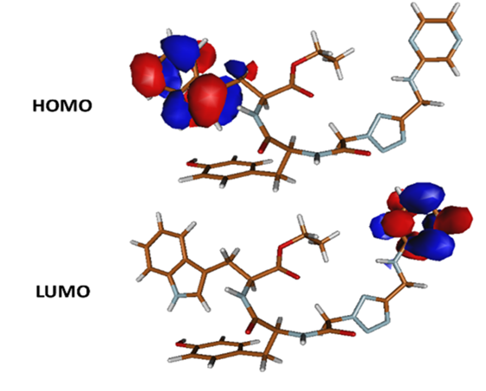
Figure S4: The frontier molecular orbitals (HOMO & LUMO) of DPL

