Supplementary Materials

Evaluation of ¹⁸⁶WS₂ target material for production of no carrier added ¹⁸⁶Re via proton irradiation: Separation, radiolabeling and recovery/recycling

Anster Charles¹, Firouzeh Najafi Khosrashahi¹, Li Ma¹, Chathurya Munindradasa¹, Rebecca Hoerres¹, John D. Lydon², Steven P. Kelley¹, James Guthrie², David Rotsch³, Dmitri Medvedev⁴, Cathy S. Cutler⁴, Yawen Li³⁵, D. Scott Wilbur⁵, Heather M. Hennkens^{1,2}, Silvia S. Jurisson^{1*}

¹Department of Chemistry, University of Missouri, Columbia, MO, USA, ²University of Missouri Research Reactor Center (MURR), Columbia, MO, USA, ³Argonne National Laboratory, Lemont, IL, USA, ⁴Brookhaven National Laboratory, Upton, NY, USA, ⁵Department of Radiation Oncology, University of Washington, Seattle, WA, USA

Table of Contents

Figure S1. ¹H NMR of 2-(tritylthio)ethyl-1-amine hydrochloride (1) in CD₂Cl₂ (500 MHz, calibrated to residual CHDCl₂ at 5.32 ppm)
Figure S2. ¹H NMR of N-(2-(tritylthio)ethyl)-2-((2-(tritylthio)ethyl)amino)acetamide (2) in CDCl₃ (500 MHz, calibrated at 7.26 ppm)
Figure S3. ¹³C NMR of N-(2-(tritylthio)ethyl)-2-((2-(tritylthio)ethyl)amino)acetamide (2) in CDCl₃ (500 MHz, calibrated at 77.36 ppm)
Figure S4. ¹H NMR of ethyl 3-((2-oxo-2-((2-(tritylthio)ethyl)amino)ethyl)(2-(tritylthio)ethyl)amino)propionate [trityl protected 222-MAMA-N-ethylpropionate] (3) in CD₂Cl₂ (500 MHz calibrated at 5.35 ppm)

Figure S5. ¹³C NMR of ethyl 3-((2-oxo-2-((2-(tritylthio)ethyl)amino)ethyl)(2-(tritylthio)ethyl)amino)propionate [trityl protected 222-MAMA-N-ethylpropionate] (3) in CD₂Cl₂ (500 MHz calibrated at 53.5 ppm)
Figure S6. ¹H NMR of ethyl 3-((2-mercaptoethyl)(2-((2-mercaptoethyl)amino)-2-oxoethyl)amino)propionate (4) in CD₂Cl₂ (600 MHz calibrated at 5.32 ppm)

Figure S7. ¹H NMR of ^{nat}ReO(222-MAMA-N-ethylpropionate) (5) in CD₂Cl₂ (600 MHz calibrated at 5.32 ppm)

Figure S8. ¹³C NMR of ^{nat}ReO(222-MAMA-N-ethylproprionate) (5) in CD₂Cl₂ (600 MHz calibrated at 53.5 ppm)
Figure S9. ESI-HR-MS of ReO(222-MAMA-N-ethylpropionate) (5)
Figure S10. Drawing of aluminum target backing used to contain graphite sandwiched ¹⁸⁶WS₂ for cyclotron irradiations.
Figure S11. Photograph of aluminum target backing used to contain graphite sandwiched ¹⁸⁶WS₂ for cyclotron irradiations.
Figure S12. HPGe spectrum of dissolved target aliquot before purification
Figure S13. HPGe spectrum of purified ¹⁸⁶Re aliquot

Table S1. ICP-MS results for the purchased ¹⁸⁶WO₃, the synthesized ¹⁸⁶WS₂, the recovered ¹⁸⁶W, and the separated ¹⁸⁶Re

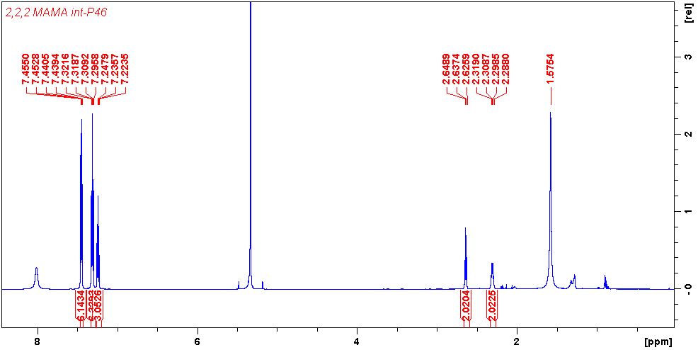

Figure S1. ¹H NMR of 2-(tritylthio)ethyl-1-amine hydrochloride (1) in CD2Cl2 (500 MHz, calibrated to residual CHDCl₂ at 5.32 ppm)

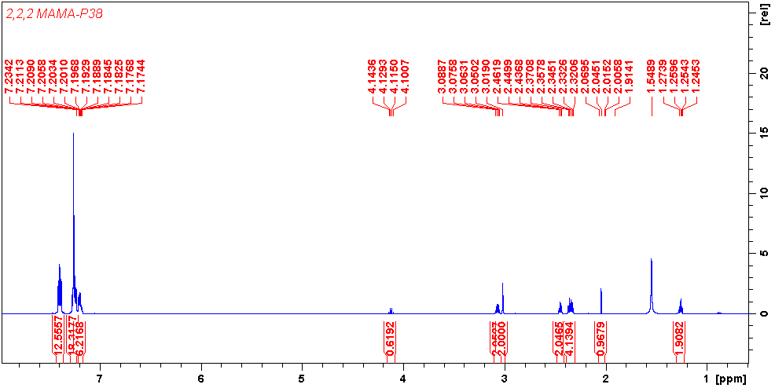

Figure S2. ¹H NMR of N-(2-(tritylthio)ethyl)-2-((2-(tritylthio)ethyl)amino)acetamide (2) in CDCl₃ (500 MHz, calibrated at 7.26 ppm)

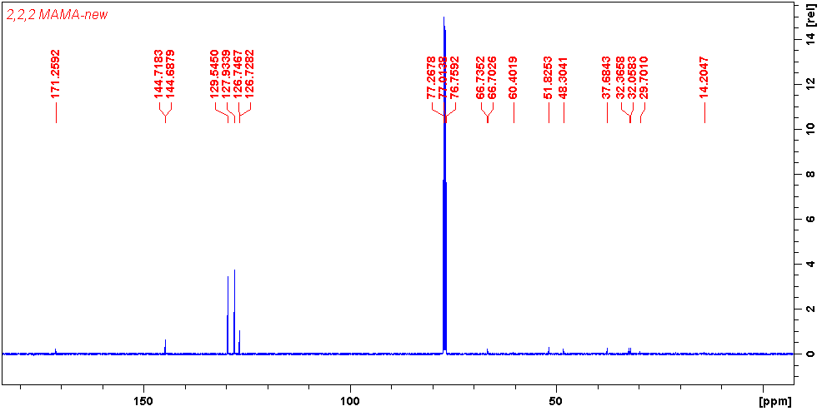
Figure S3. ¹³C NMR of N-(2-(tritylthio)ethyl)-2-((2-(tritylthio)ethyl)amino)acetamide (2) in CDCl₃ (500 MHz, calibrated at 77.36 ppm)

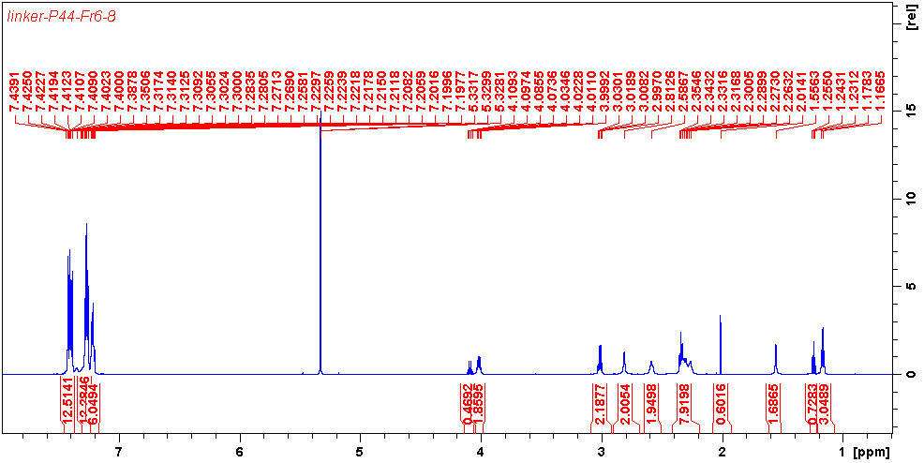

Figure S4. ¹H NMR of ethyl 3-((2-oxo-2-((2-(tritylthio)ethyl)amino)ethyl)(2-(tritylthio)ethyl)amino)propionate [trityl protected 222-MAMA-N-ethylpropionate] (3) in CD₂Cl₂ (500 MHz calibrated at 5.35 ppm)

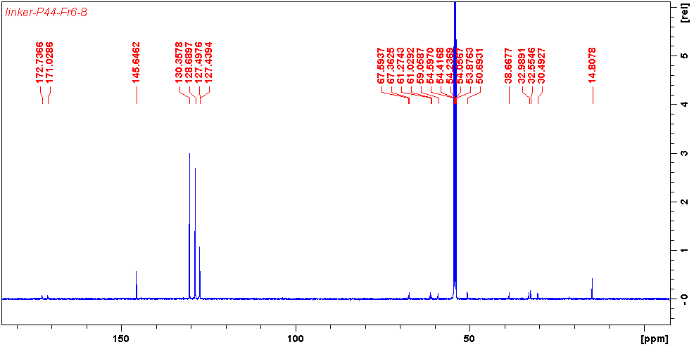

Figure S5. ¹³C NMR of ethyl 3-((2-oxo-2-((2-(tritylthio)ethyl)amino)ethyl)(2-(tritylthio)ethyl)amino)propionate [trityl protected 222-MAMA-N-ethylpropionate] (3) in CD₂Cl₂ (500 MHz calibrated at 53.5 ppm)

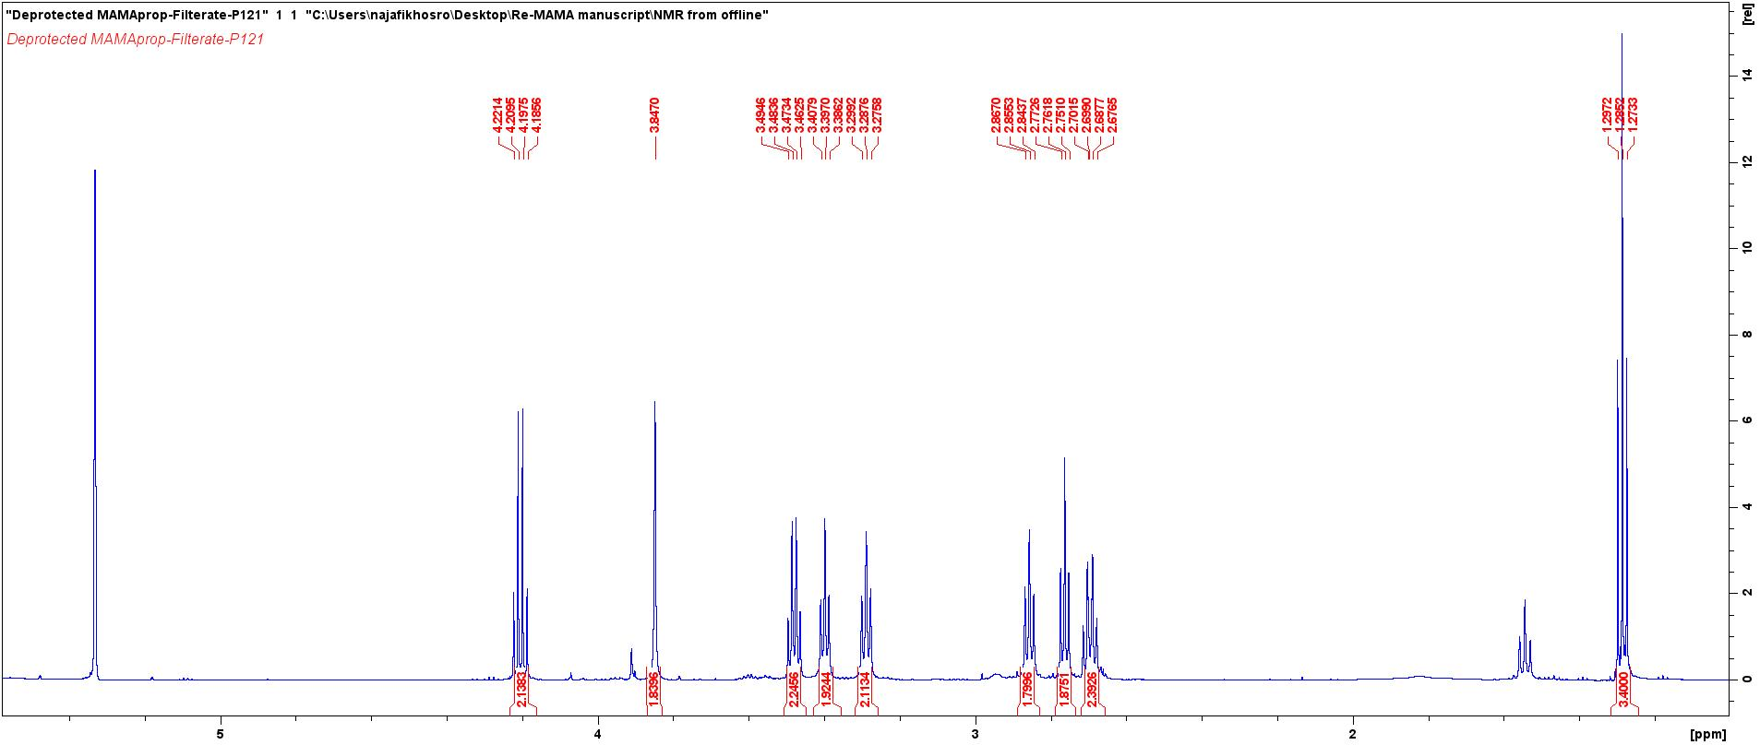
Figure S6. ¹H NMR of ethyl 3-((2-mercaptoethyl)(2-((2-mercaptoethyl)amino)-2-oxoethyl)amino)propionate (4) in CD₂Cl₃ (600 MHz calibrated at 5.32 ppm)

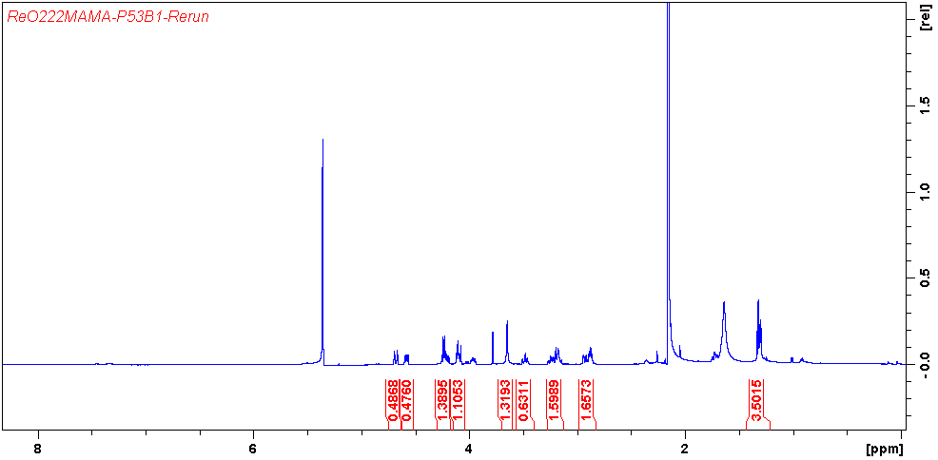

Figure S7. ¹H NMR of ^{nat}ReO(222-MAMA(N-ethylpropionate) (5) in CD₂Cl₂ (600 MHz calibrated at 5.32 ppm)

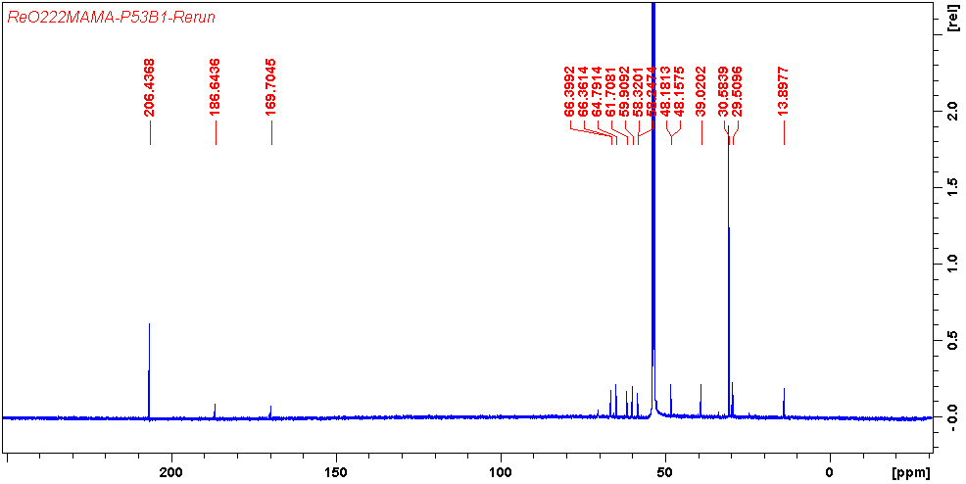

Figure S8. ¹³C NMR of ^{nat}ReO(222-MAMA(N-ethylproprionate) (5) in CD₂Cl₂ (600 MHz calibrated at 53.5 ppm)

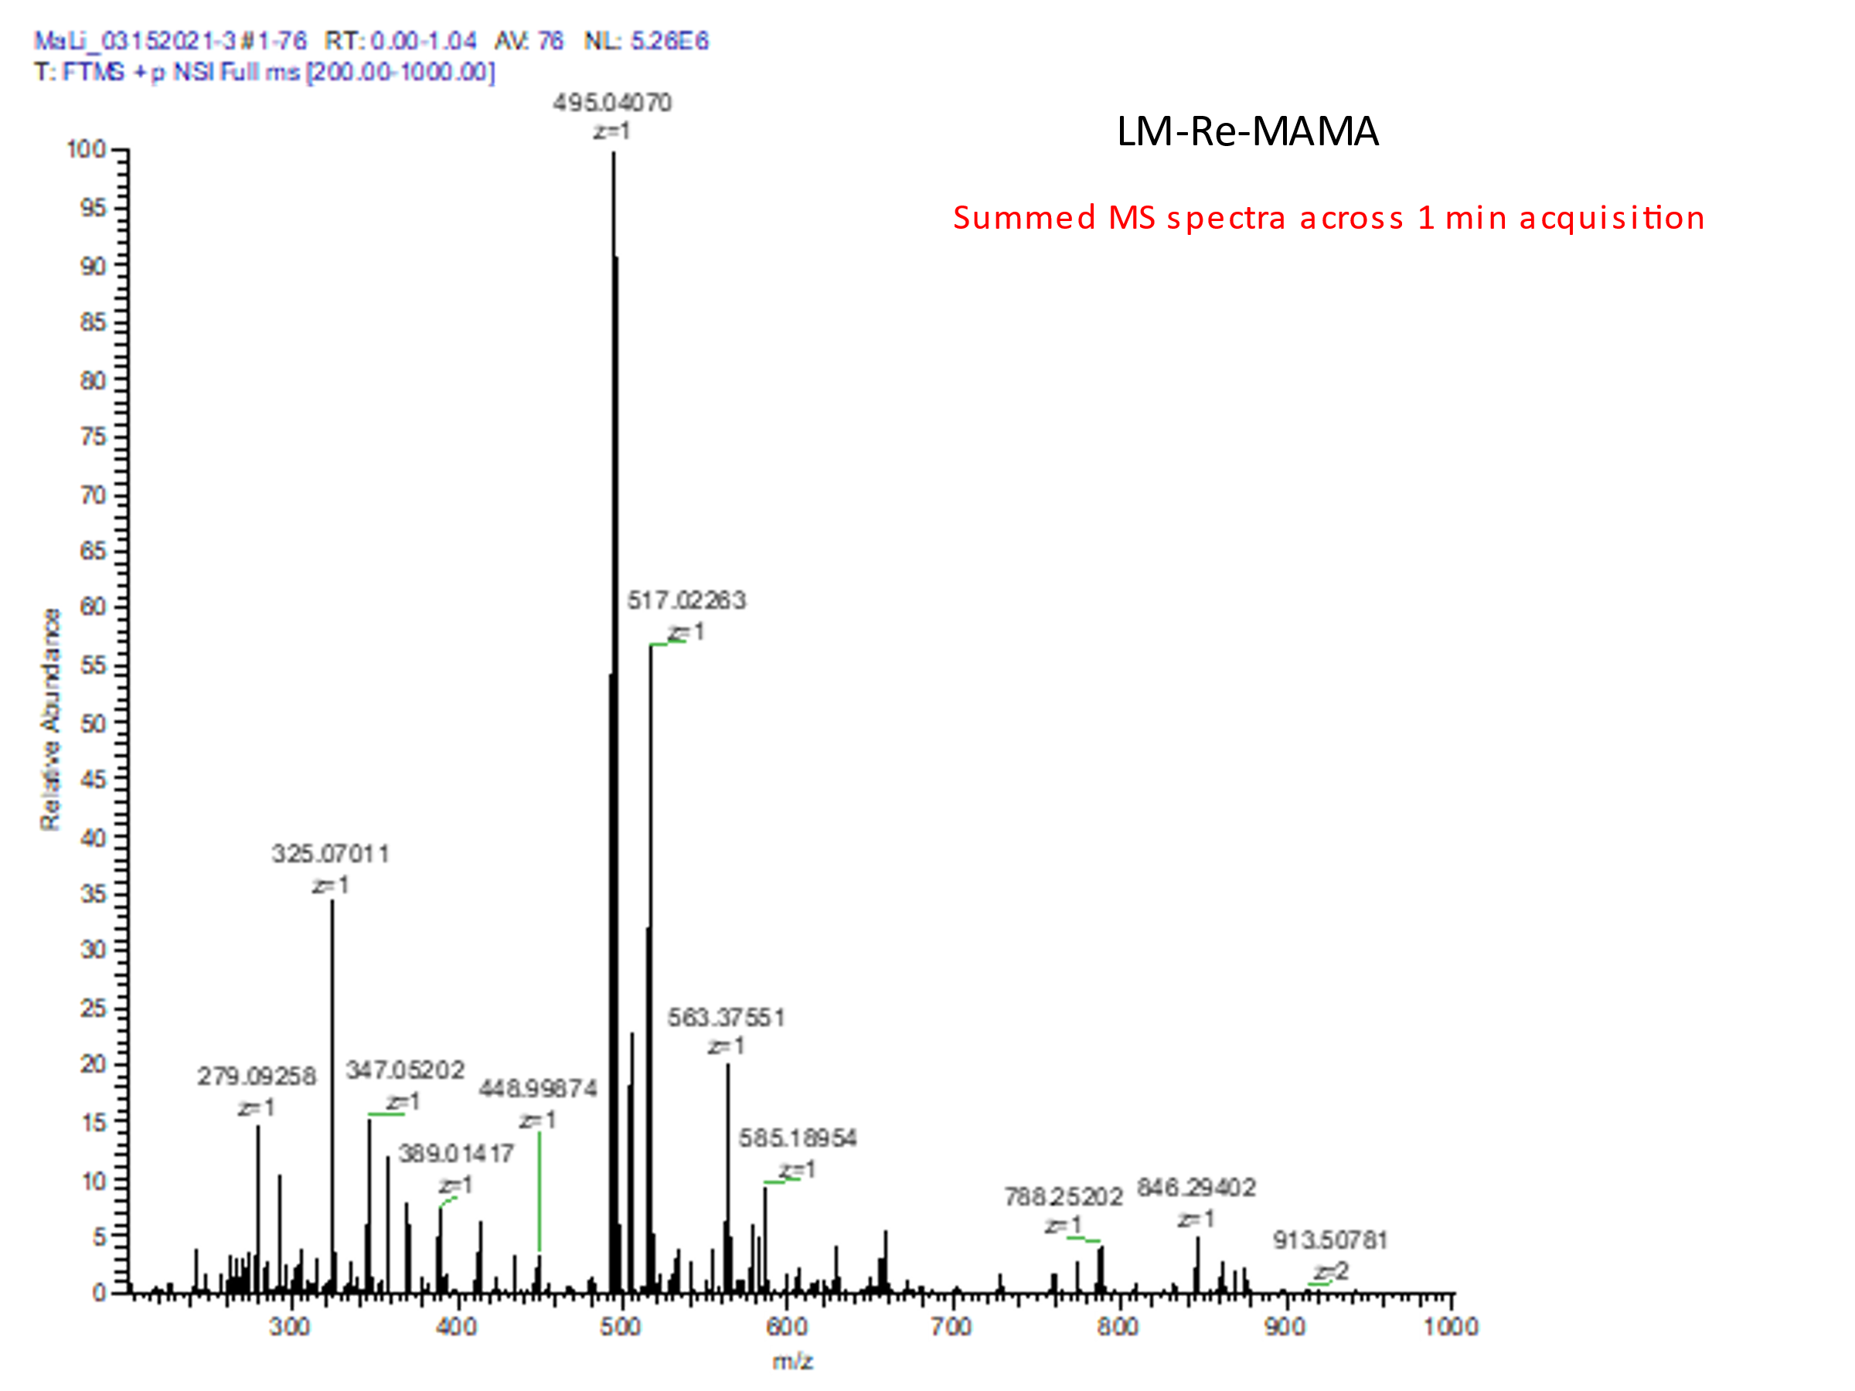
Observed mass [M+H]⁺: 495.04070
Theoretical mass [M+H]⁺: 495.04165
Mass error: 2ppm
Observed mass [M+Na]⁺: 517.02263
Theoretical mass [M+Na]⁺: 517.02360
Mass error: 2ppm
Figure S9. ESI-HR-MS of ReO(222-MAMA-N-ethylpropionate) (5)

Figure S10. Drawing of aluminum target backing used to contain graphite sandwiched ¹⁸⁶WS₂ for cyclotron irradiations.

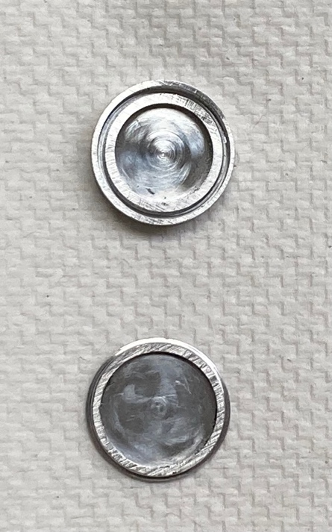
Figure S11. Photograph of aluminum target backing used to contain graphite sandwiched ¹⁸⁶WS₂ for cyclotron irradiations.

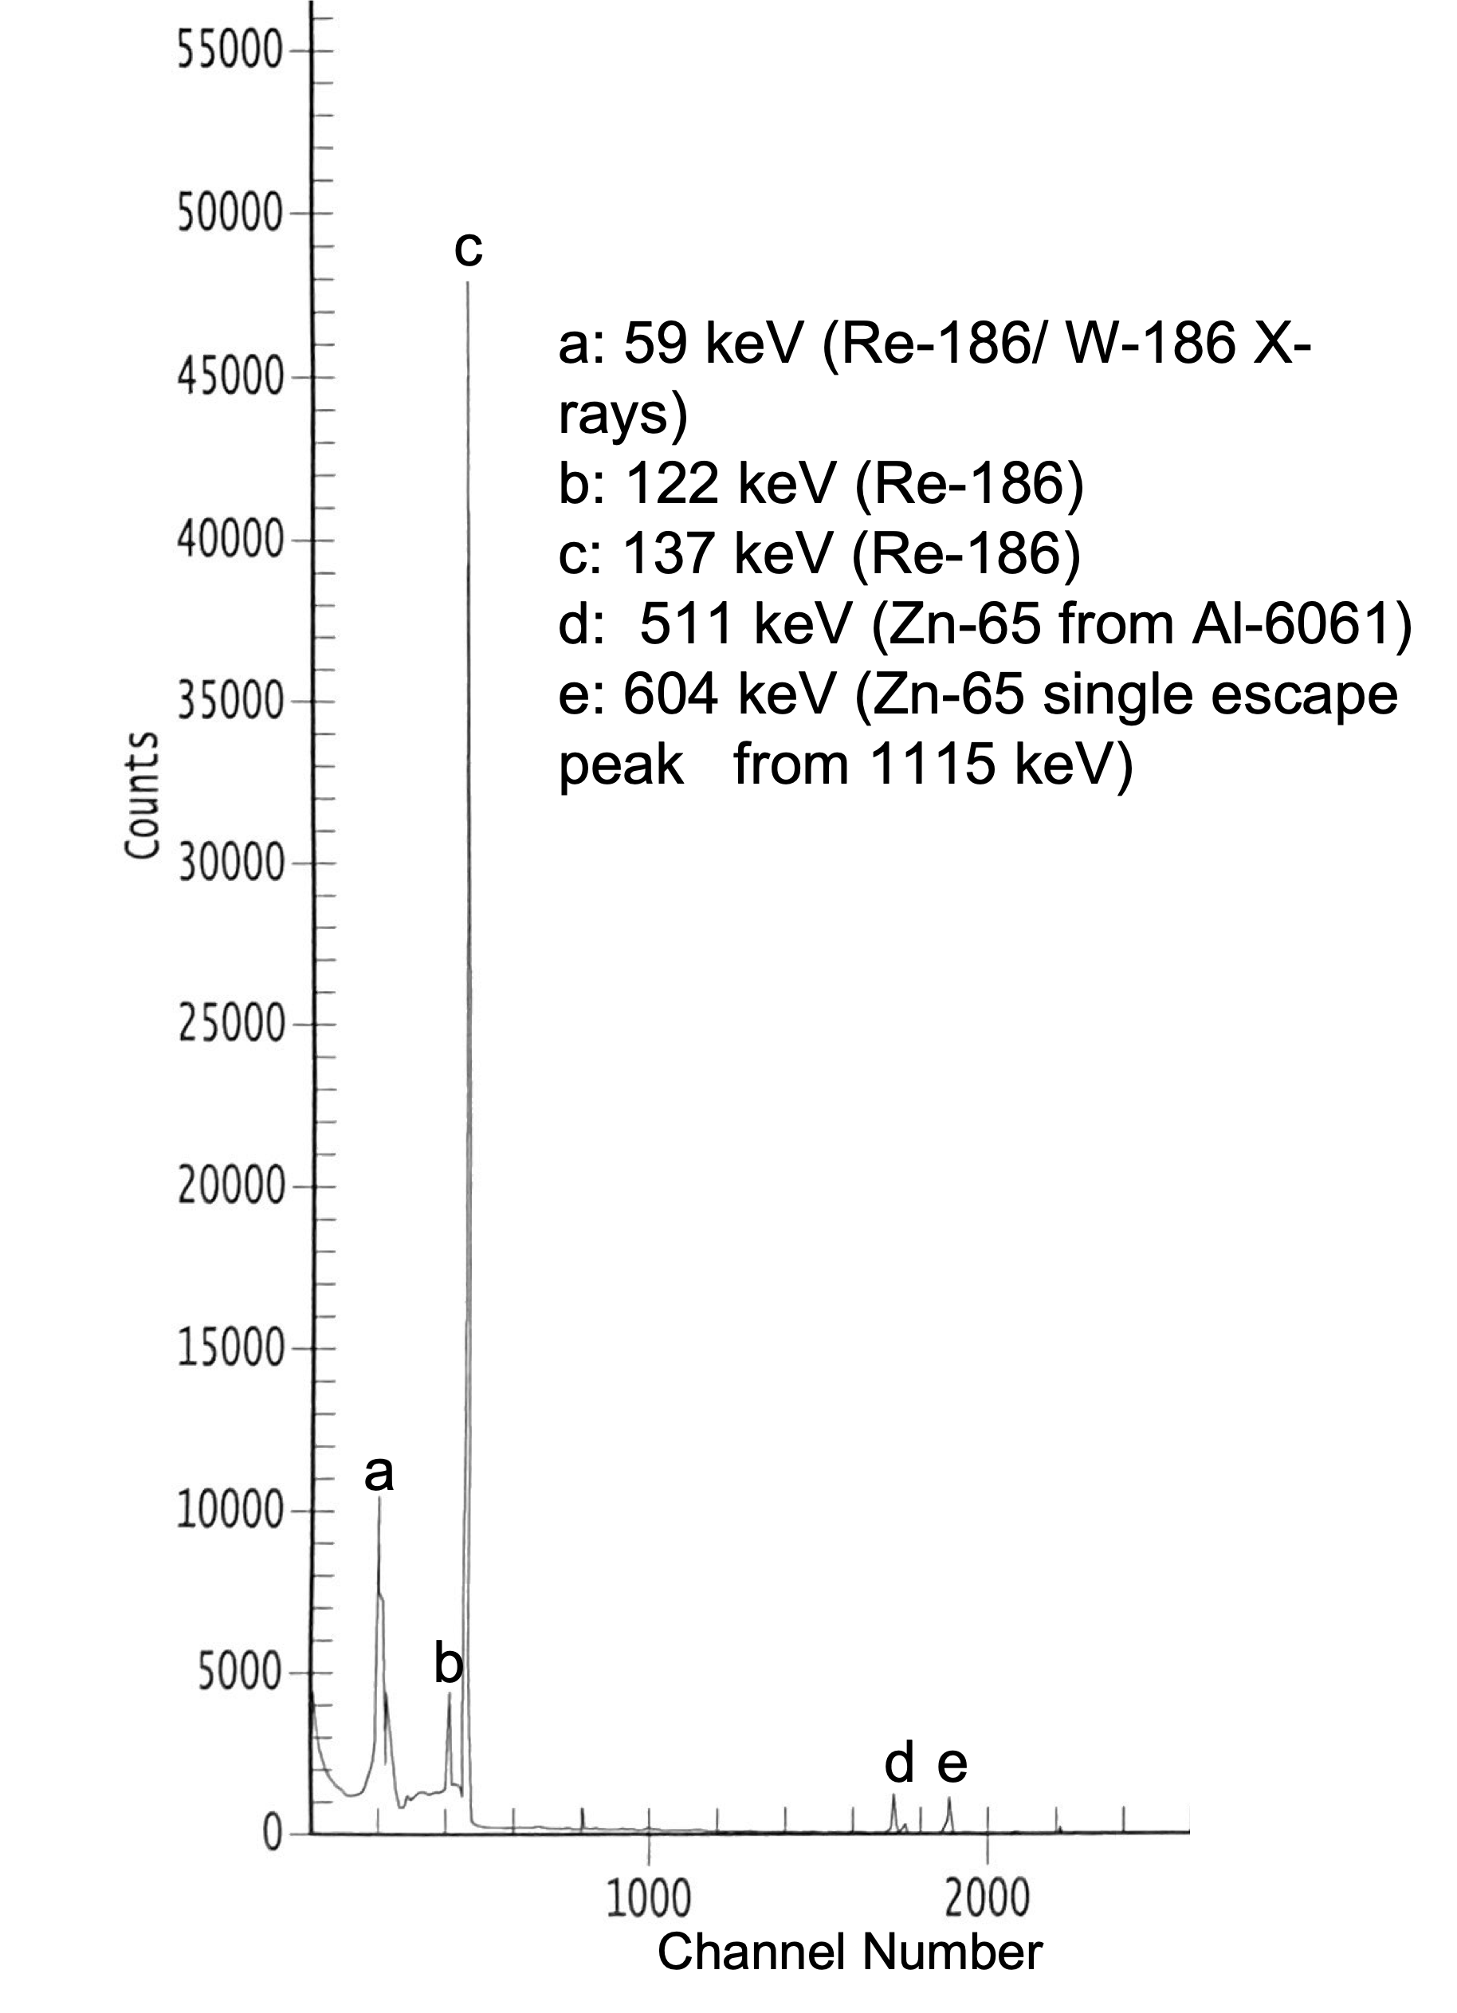

Figure S12: HPGe spectrum of dissolved target aliquot before purification

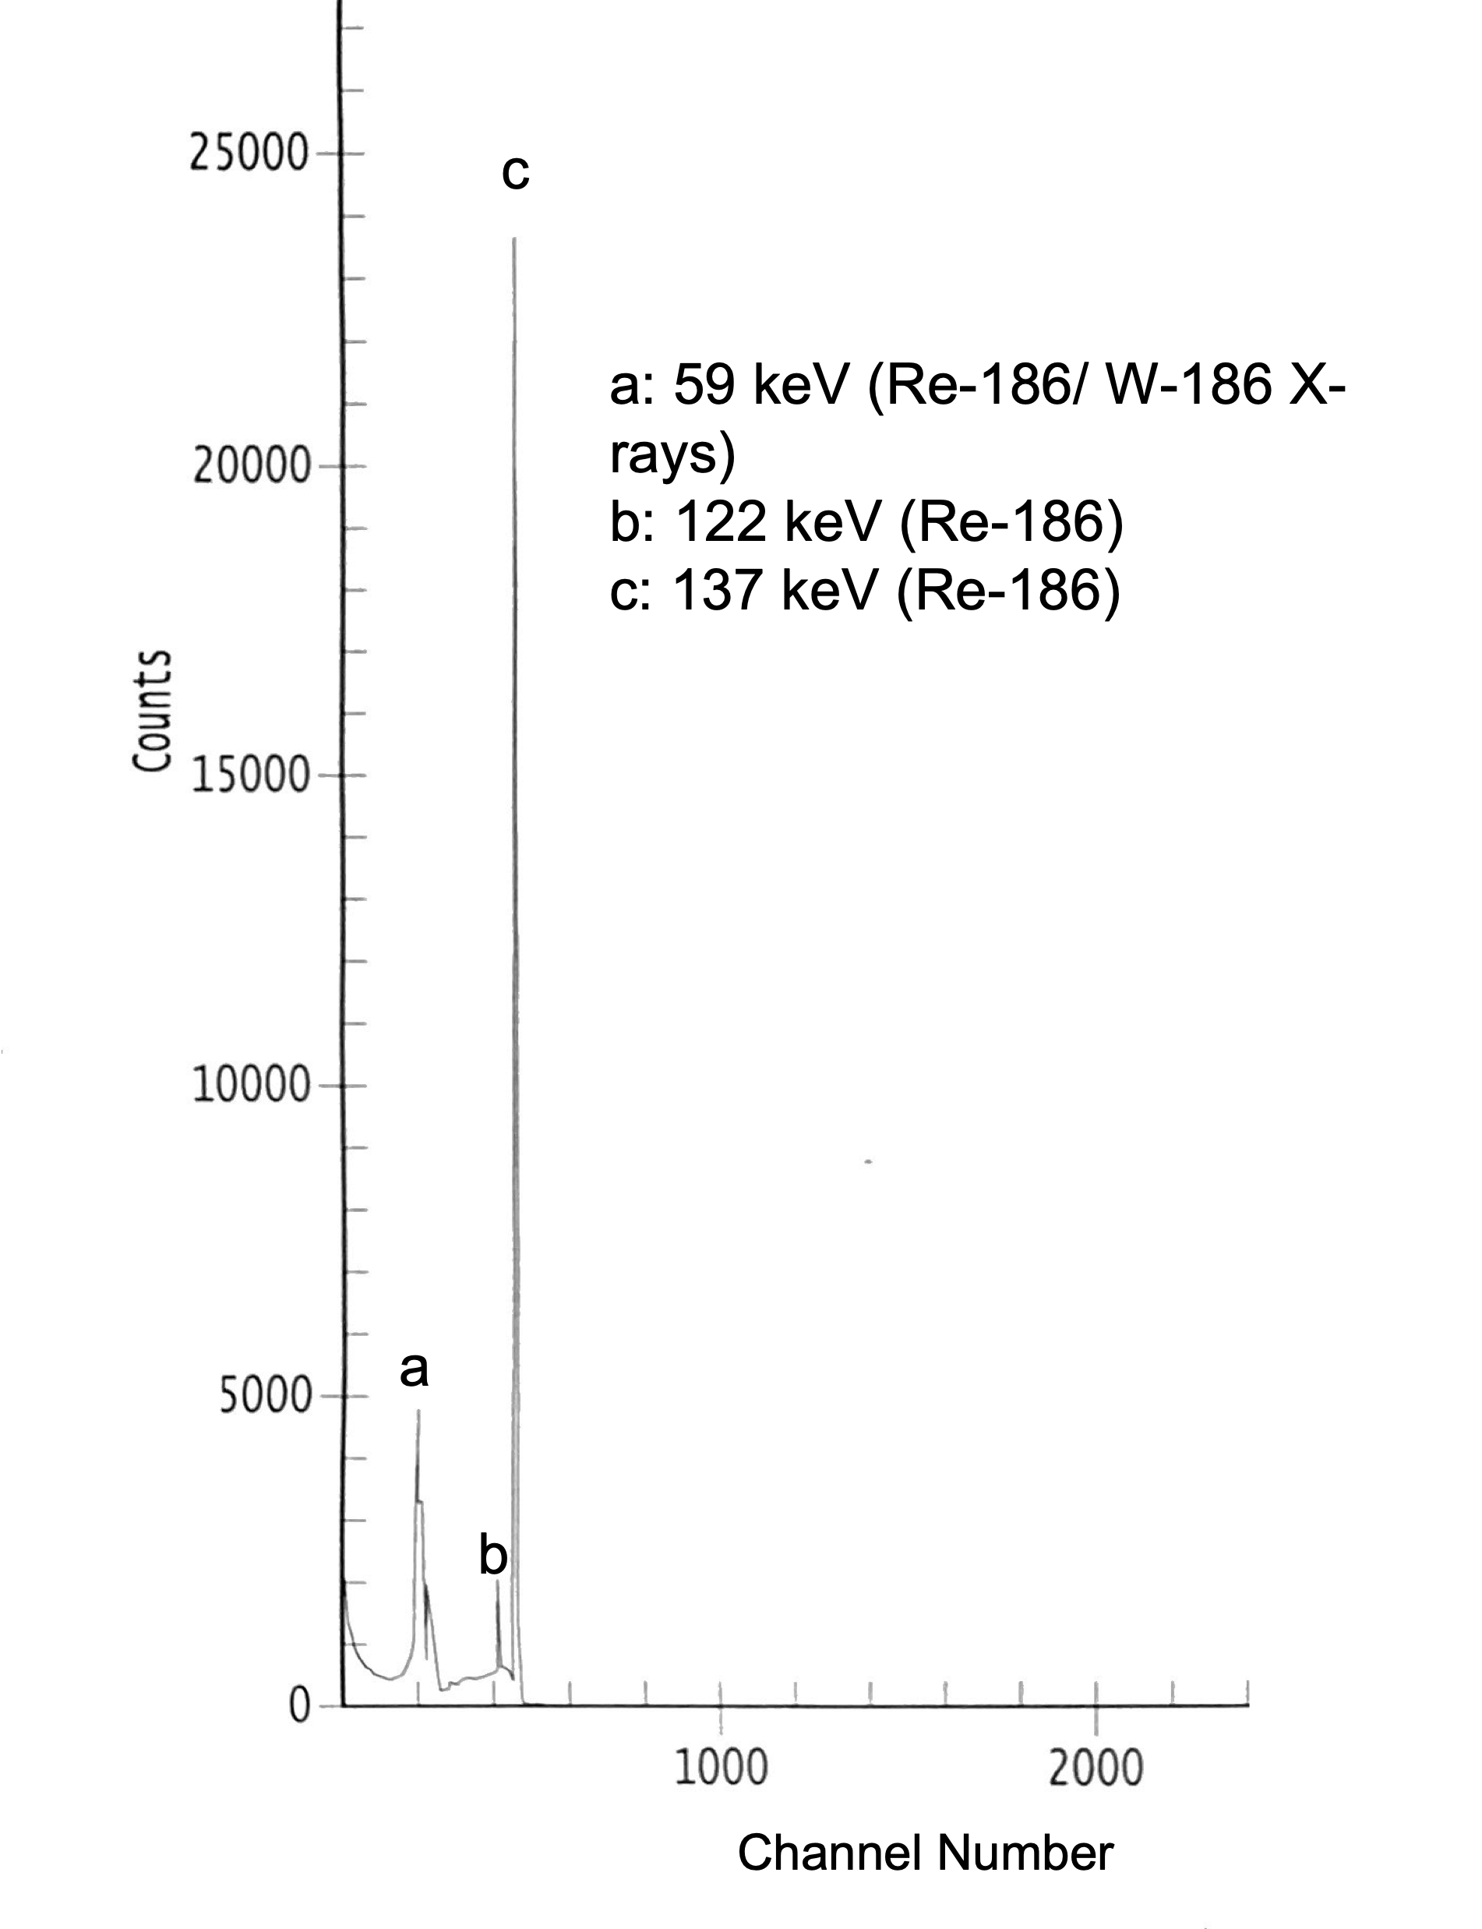

Figure S13. HPGe spectrum of purified ¹⁸⁶Re aliquot

Table S1. ICP-MS results (ppm or μg/g material) for the purchased ¹⁸⁶WO₃, the synthesized ¹⁸⁶WS₂, the recovered ¹⁸⁶W, and the separated ¹⁸⁶Re

Sample | Origin |  | Atom %
 |  | Re | ¹⁸⁰W | ¹⁸²W | ¹⁸³W | ¹⁸⁴W | ¹⁸⁶W
¹⁸⁶WO₃ | Isoflex | 13.1 | 1 x 10⁻⁷ | 0.000210 | 0.000135 | 0.000133 | 0.9983
¹⁸⁶WS₂ | Synthesized | 10.7 | 6 x 10⁻⁷ | 0.000206 | 0.000139 | 0.000132 | 0.9983
¹⁸⁶W | Recovered | <LOD | 3.2 x 10⁻⁷ | 0.00037 | 0.00022 | 0.000153 | 0.99788
 |  | Re | W total
¹⁸⁶Re | Isolated | 0.0324 | 0.2089

