Supplementary information
Enrichment and separation of U(Ⅵ) by two dimensional layered transition metal carbide composite
Yun Zhou^{a,b,c}, Huai-Xin Hao^{b.c}, Tian-Hao Dong^{a,b,c}, Xu-Feng Ni^{a,b,c}, Yi-Chen Hu^{b,c}, Jia-Ju Ma^{a,b,c}, Jun-Qiang Yang^{a,b,c}, Ke-Liang Shi^{a,b,c}, Guo-Jian Duan^{d}, Tong-Huan Liu^{a,b,c∗}
ªFrontier Science Center for Rare Isotopes, Lanzhou University, Lanzhou 730000, P. R. China
^{b} School of Nuclear Science and Technology, Lanzhou University, 730000, Lanzhou, P. R. China;
^{c}Key Laboratory of Special Function Materials and Structure Design, Ministry of Education, Lanzhou University, 730000, Lanzhou, P. R. China;
^{d}Gansu University of Chinese Medicine, Lanzhou 730000, P. R. China;
Author Contributions: Y.Z. and H.H. contributed equally to this work.

Adsorption data fitting by kinetics models
The linear equations of pseudo-first-order kinetic model and pseudo-second-order kinetic model are as follows:
$\text{ln}\left({\text{q}}_{\text{e}}\text{-}{\text{q}}_{\text{t}}\right)\text{=}\text{ln}{{\text{q}}_{\text{e}}\text{-}}{\text{K}}_{\text{1}}\text{t}$ (1)
$\frac{\text{t}}{{\text{q}}_{\text{t}}}\text{=}\frac{\text{1}}{{\text{K}}_{\text{2}}{\text{q}}_{\text{e}}^{\text{2}}}\text{+}\frac{\text{t}}{{\text{q}}_{\text{e}}}$ (2)
where k₁ (min⁻¹) and k₂ (g·mg⁻¹·min⁻¹) are the corresponding adsorption rate constants. q_{t} (mg/g) is the adsorption amount at time t.
Adsorption data fitting by isotherm models
Langmuir isotherm model, Freundlich isotherm model, and Dubinin-Radushkevich (D-R) model are shown as follows:
- Langmuir isotherm model:
$\frac{{\text{C}}_{\text{e}}}{{\text{q}}_{\text{e}}}\text{=}\frac{\text{1}}{{\text{K}}_{\text{L}}{\text{q}}_{\text{max}}}\text{+}\frac{{\text{C}}_{\text{e}}}{{\text{q}}_{\text{max}}}$ (3)
where q_{max}(mg/g) corresponds to the maximum adsorption capacity for complete monolayer coverage. K_{L}(L/g) is the adsorption equilibrium constant, representing the affinity of the adsorbent for the adsorbent.
- Freundlich isotherm model:
$\text{ln}{{\text{q}}_{\text{e}}\text{=}}\text{ln}{{\text{K}}_{\text{F}}\text{+}}\frac{\text{1}}{\text{n}}\text{ln}{{\text{C}}_{\text{e}}}$ (4)
where K_{F}(mg^{1-n}L^{n}g⁻¹) is the equilibrium constant. n is the characteristic constant ranging from 0 to 1.
- Dubinin-Radushkevich (D-R) model:
$\text{ln}{{\text{q}}_{\text{e}}\text{=}}\text{ln}{{\text{q}}_{\text{max}}\text{-}}{\text{K}}_{\text{DR}}{\text{ε}}^{\text{2}}$ (5)
$\text{ε=RT}\text{ln}{\text{(1+}\frac{\text{1}}{{\text{C}}_{\text{e}}}\text{)}}$ (6)
$\text{E=}\frac{\text{1}}{\sqrt{\text{2}{\text{K}}_{\text{DR}}}}$ (7)
where q_{e} (mol/g) and C_{e} (mol/L) are molar equilibrium concentrations. K_{DR} is equilibrium constant. E (kJ/mol) is adsorption energy. ε is polanyi potential. R (J·K⁻¹·mol⁻¹) is gas constant. T(K) is Kelvin temperature. In the D-R isotherm model, the adsorption energy E can determine the type of adsorption reaction: (1) When E>8 kJ/mol, it is chemical adsorption; (2) When E<8 kJ/mol, it is physical adsorption.
Acid stability experiment
The material was soaked at pH of 1.8 for 0, 1, 2, 3, 5 and 7 days respectively, and then removed for adsorption experiment. The specific steps are the same as the above adsorption experiment. After reaching the adsorption equilibrium for 24 h, the suspension was centrifuged and the concentration of U(VI) in the supernatant was determined by arsenazo III method. Three parallel experiments were conducted for each condition. In order to judge the stability of the material under acidic conditions, the influence of soaking time on the adsorption of the material was compared.

Figure S1. The linear fitting of kinetics data for U(VI) sorption by PAO/Ti₃C₂T_{x} with the pseudo-first-order kinetic (a) and the pseudo-second-order kinetic (b) models.
a
b
c
a
b
Figure S2. The linear fitting of sorption isotherm for U(VI) by PAO/Ti₃C₂T_{x} with the Langmuir (a), Freundlich (b) and Dubinin–Radusckevich (c) models.
Figure S3. Linear plots of ln K⁰ vs. 1/T for U(VI) sorption on PAO/Ti₃C₂T_{x}.
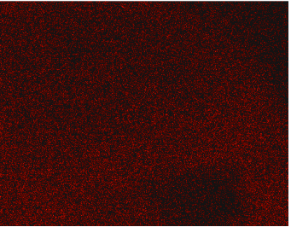


Figure S4. Ti₃C₂T_{x} EDS elemental maps of C, N, and Ti.
Ti

C

N




Ti

N

C

Figure S5. PAO/Ti₃C₂T_{x} EDS elemental maps of C, N, and Ti.
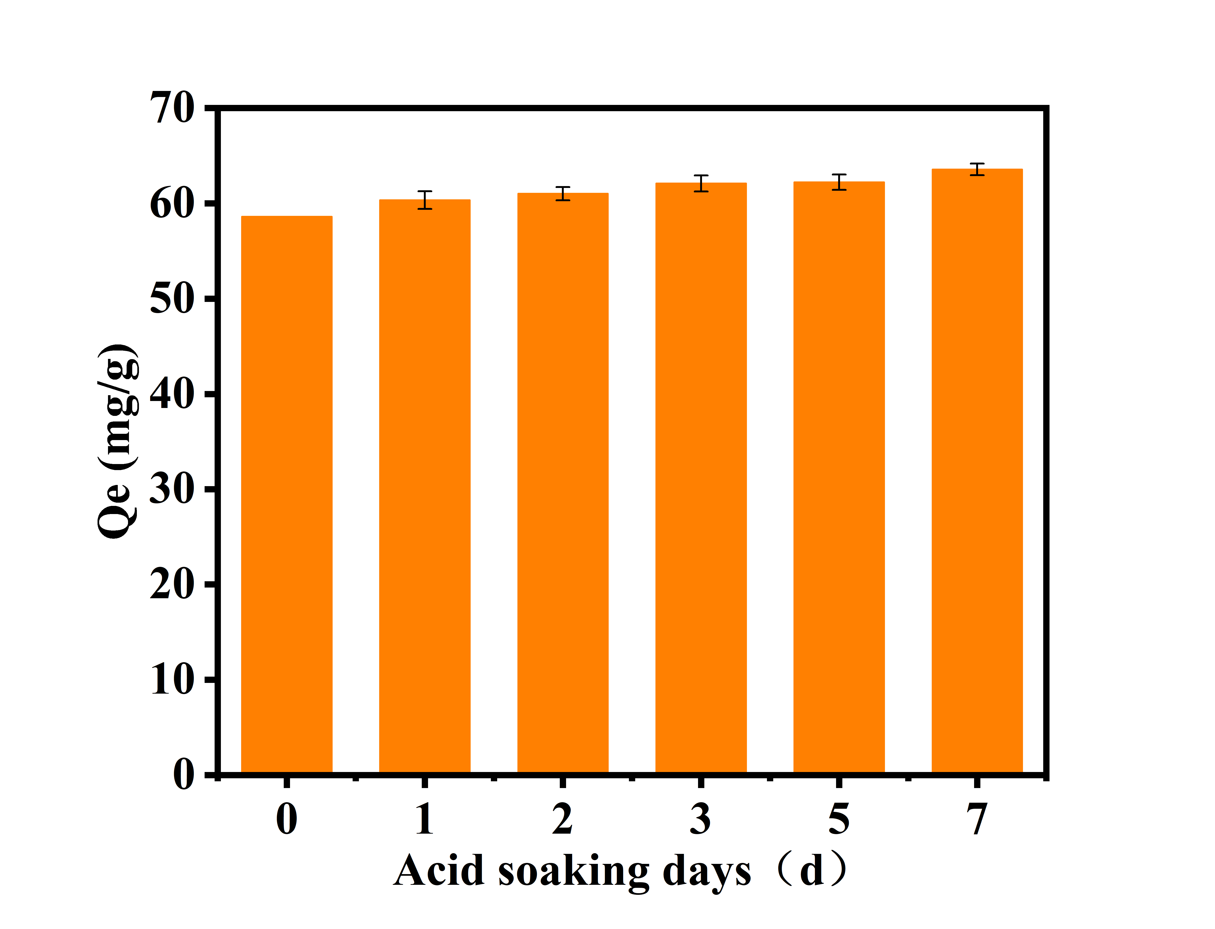
Figure S6. The influence of soaking days in acidic environment on adsorption. pH=4.00 ± 0.05, C[solid-liquid ratio]=0.24 g/L, C0[U(Ⅵ)]= 8.403×10-5 mol/L, T=25.00 ℃.
Table S1. Amount of synthesized PAN/Ti₃C₂T_{x} reactants
No. | Ti₃C₂T_{x} | Acrylonitrile
1 | 0.5g | 2mL (1.612g)
2 | 0.5g | 3mL (2.418g)
3 | 0.5g | 4mL (3.224g)

