Supporting Information

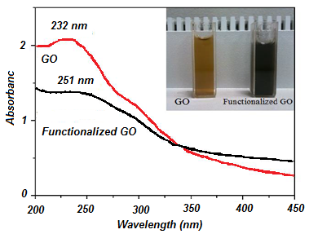
Figure S1. The UV-visible spectra of GO, and AMPA-GO hybrid.
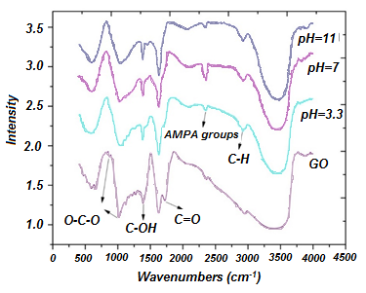
Figure S2. The FTIR spectra of the GO and AMPA-GO, functionalized at different pHs.

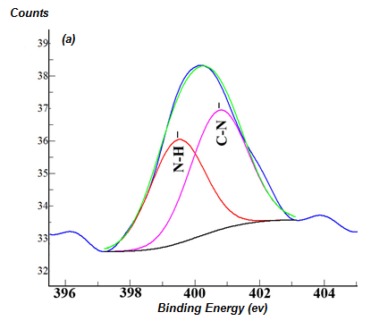 | 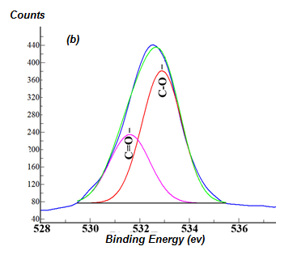
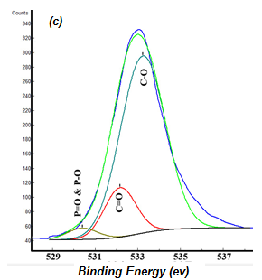

Figure S3. The N1s spectra of AMPA-GO showing the N-C bonds on the surface of GO a) 396-402 ev, b)528-536 ev and c) 529-537 ev

Figure S4. The plot of the Freundlich adsorption isotherm model, (Time= 15 min, pH= 2, Solution volume= 25 mL, Adsorbent content= 20 mg, Shake= 200 rpm, Temperature = 25 °C)

Table S1. Freundlich isotherm model parameters
Adsorbent | n | K_{F} | R²
GO | 5.64 | 77.3 | 0.813
AMPA-GO | 6.8 | 52.3 | 0.855

Table S2. Speciation of thorium as a function of pH
pH | Species
>10 | Th(OH)₄>99%
<4.5 | Th(OH)₄>25%  Th(OH)₃⁺>12%  Th(OH)₂²⁺>40%  Th(OH)³⁺>18%
3.5 | Th(IV)=26.5%  Th(OH)³⁺>42.8%  Th(OH)₂²⁺>29%  Th(OH)₃⁺ and Th(OH)₄>1.7%
<3 | Th(IV)>88%  Th(OH)³⁺<12%

Figure S5. The effect HNO₃ concentration on Th(IV) adsorption by GO and AMPA-GO adsorbent (Time= 15 min, Solution volume= 25 mL, Adsorbent content= 20 mg, Shake= 200 rpm, Th(IV) concentration = 105 mg L⁻¹, Temperature = 25 °C)

Figure S6. Effect of the adsorbent dose on adsorption of Th(IV) by GO and AMPA-GO (Time= 15 min, pH= 2, Shake= 200 rpm, Th (IV) concentration = 250 mg L⁻¹, Temperature = 25 °C)

