Supporting Information
SI-1.a: ¹H NMR spectrum of TAP
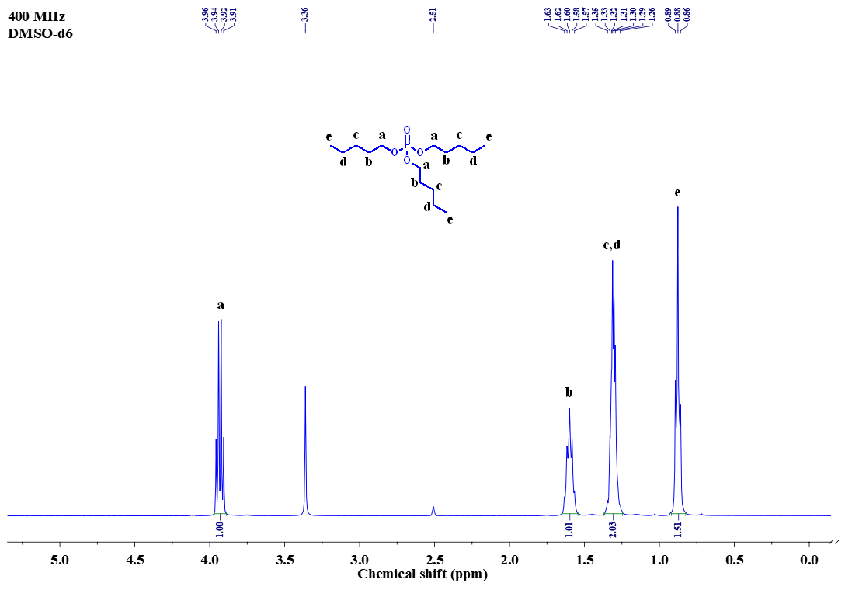
SI-1.b: ¹³C NMR spectrum of TAP
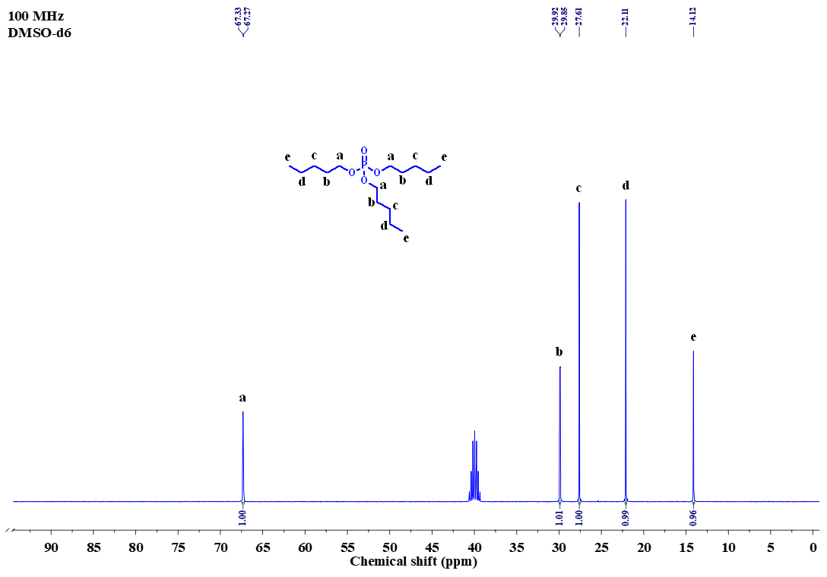
SI-1.c: ³¹P NMR spectrum of TAP

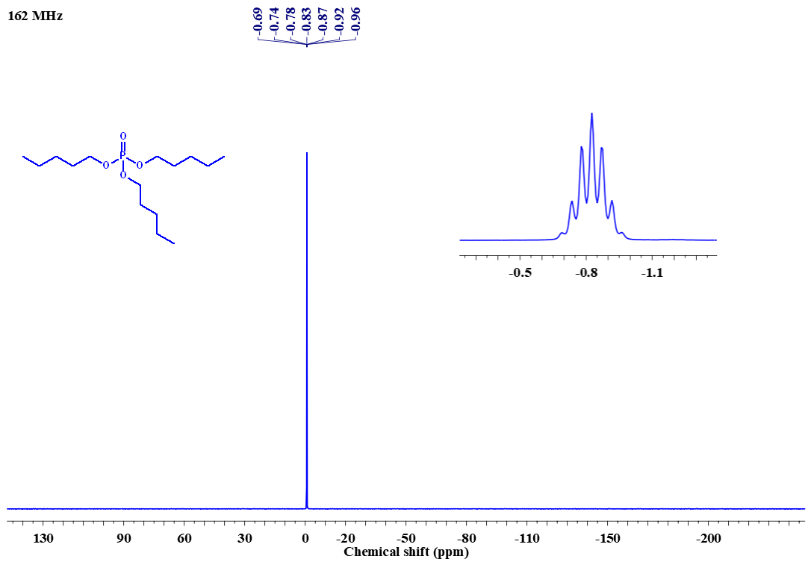
SI-2.a: ¹H NMR spectrum of T2MBP
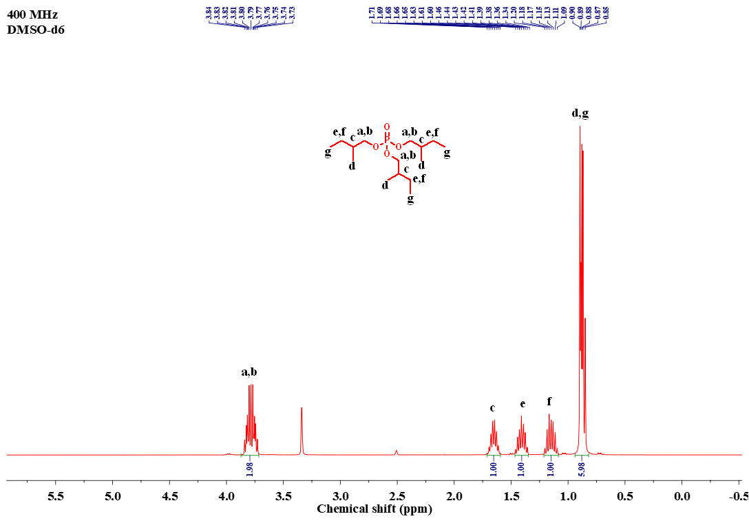
SI-2.b: ¹³C NMR spectrum of T2MBP
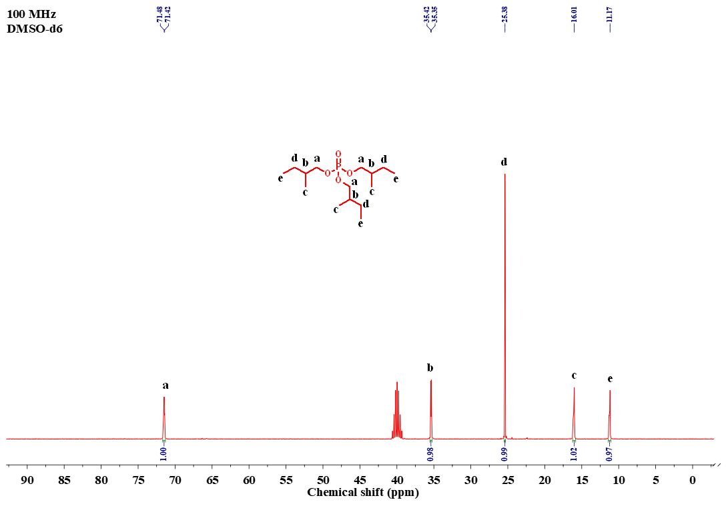
SI-2.c: ³¹P NMR spectrum of T2MBP
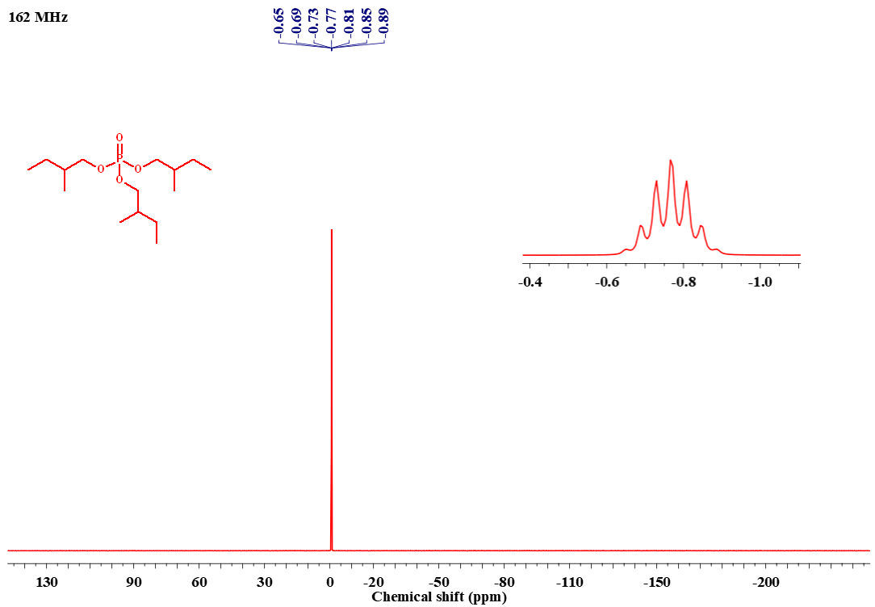
SI-3: Gas chromatography plot of T2MBP
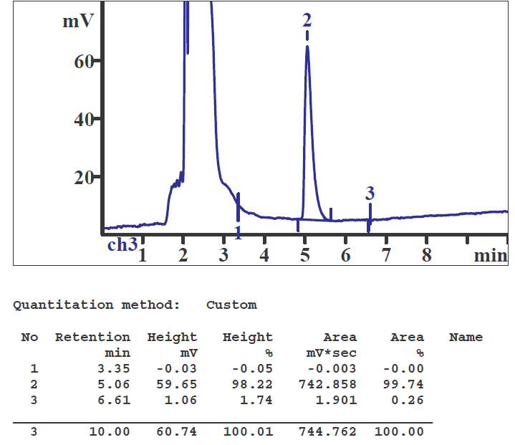
SI-4: Gas chromatography plot of TAP
