Novel Diamide Ligands with a Central Carbonyl Group and Their Comparative Evaluation with the Diglycolamide Ligands: Synthesis, Extraction, DFT and Chromatographic Studies
V. Vijayakumarª, C. Ramesh Kumar ª*, N. Sivaraman^{b}, A. Suresh^{b}, A. S. Kanekar^{c},
A. Bhattacharyya^{c}, and P. K. Mohapatra^{c}
Supplementary Information
Figures | Contents | Page No
Figure S1 | FT-IR spectrum of TOCPDA | 3
Figure S2 | ¹H NMR spectrum of TOCPDA | 3
Figure S3 | ¹³C NMR spectrum of TOCPDA | 4
Figure S4 | Mass spectrum of TOCPDA | 4
Figure S5 | FT-IR spectrum of CHADA | 5
Figure S6 | ¹H NMR spectrum of CHADA | 5
Figure S7 | ¹³C NMR spectrum of CHADA | 6
Figure S8 | Mass spectrum of CHADA | 6
Figure S9 | Retention of TOCPDA at methanol as mobile phase. [Column: C₁₈ monolithic column (10 cm x 4.6 mm)], Mobile phase: Acetonitrile, Flow rate: 1mL/min. Detection: 655 nm. | 7
Figure S10 | Retention of CHADA at methanol as mobile phase. [Column: C₁₈ monolithic column (10 cm x 4.6 mm)], Mobile phase: Acetonitrile, Flow rate: 1mL/min. Detection: 655 nm. | 7
Figure S11 | Photograph of HPLC system used in present study | 8
Figure S12 | Plots of log D_{M} of U(VI) and Th(IV) versus log [CHADA] | 9

HPLC mediated separation of U(VI)/Th(IV) and Nd(III)
The separation of uranium, thorium and neodymium using HPLC system was shown in the Fig. S11. For HPLC analysis purpose 25 µg/mL of uranium, thorium and neodymium in 0.01 N nitric acid medium samples was prepared in individual metal ions as well as mixture of these three metal ions and stored in moisture free condition. High pressure pumps used for the delivery of mobile phase and post-column reagent were collected in separate glass container. Before injecting the samples mobile phase was passed in the CHADA coated C₁₈ monolithic column for 30 minutes and injected the samples of 20 to 50 µL to the sample injecting post. The sample was pass through the CHADA coated column followed by UV-Visible detector. The data acquisition (Borwin Software) from the UV-Vis detector was done through cables, connected to a computer through a Borwin interface to shows the retention time of metal ions injected in the column.

Stoichiometric Analysis of U(VI) and Th(IV) with CHADA
The D values of U(VI), Th(IV) at the different CHADA (0.25, 0.5, 0.75 and 1 M) concentrations and a constant aqueous concentration (2 M nitric acid medium) were measured and are plotted in SI Fig. 12. The slopes for log DU(VI) and log DTh(IV) are 1.73±0.02 and 0.17±0.01. Assuming that the activity coefficient of the CHADA with respect to U(VI), Th(IV) almost constant in their concentration range used; the slope values obtained are associated with the number of CHADA molecules in the extraction reactions, namely, one or two CHADA molecules. In the case of Th(IV) extraction, the slope value is expected be two; however remarkably it was found to be lower suggesting the aggregation of CHADA having the longest backbone between two amide groups and longer carbon chains attached with amidic N atoms, Sasaki et al also found similar kind of observation for ODPA (Oxydipropionamide) [1].

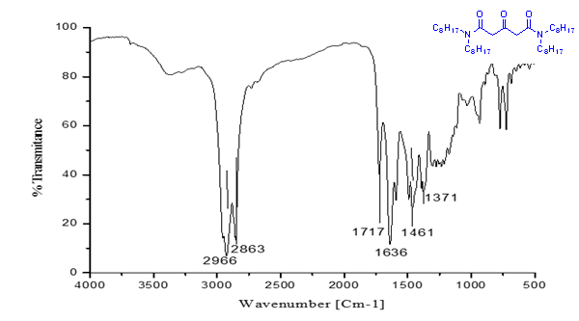Figure S1: FT-IR spectrum of TOCPDA

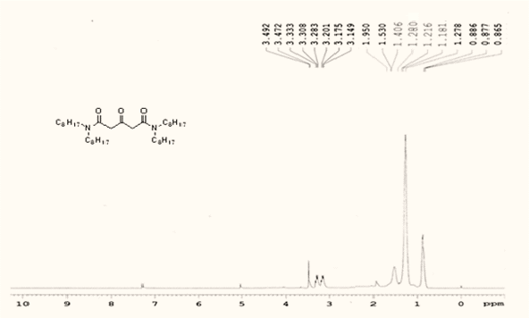

Figure S2: ¹H NMR spectrum of TOCPDA

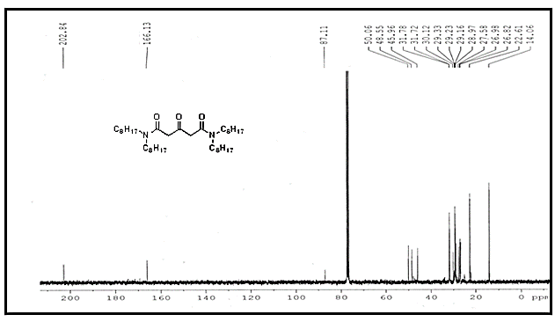

Figure S3: ¹³C NMR spectrum of TOCPDA

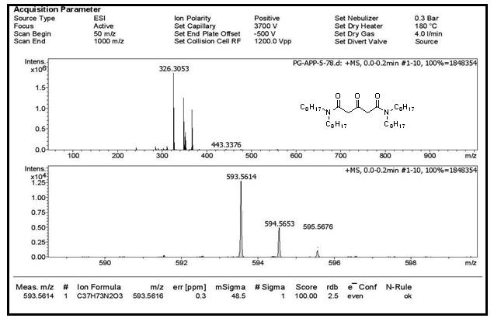

Figure S4: Mass spectrum of TOCPDA

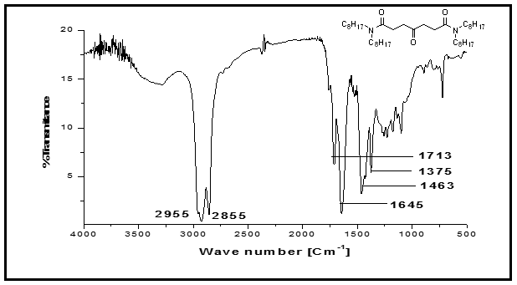

Figure S5: FT-IR spectrum of CHADA

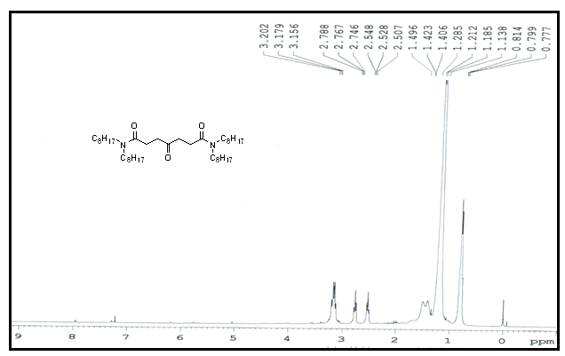

Figure S6: ¹H NMR spectrum of CHADA
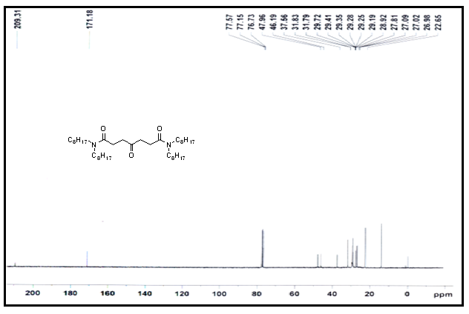

Figure S7: ¹³C NMR spectrum of CHADA

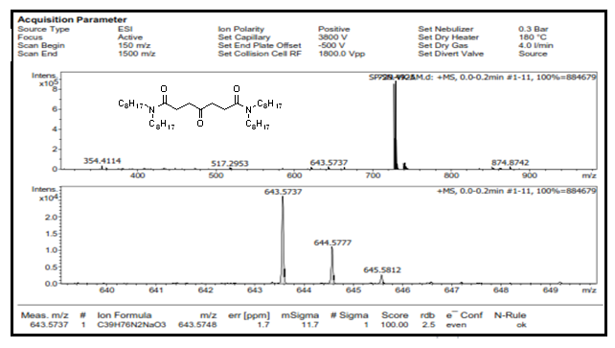

Figure S8: Mass spectrum of CHADA.

Figure S9: Retention of TOCPDA at methanol as mobile phase. [Column: C₁₈ monolithic column (10 cm x 4.6 mm)], Mobile phase: Acetonitrile, Flow rate: 1mL/min. Detection: 655 nm.
Figure S10: Retention of CHADA, methanol as mobile phase. [Column: C₁₈ monolithic column (10 cm x 4.6 mm)], Mobile phase: Acetonitrile, Flow rate: 1mL/min. Detection: 655 nm.

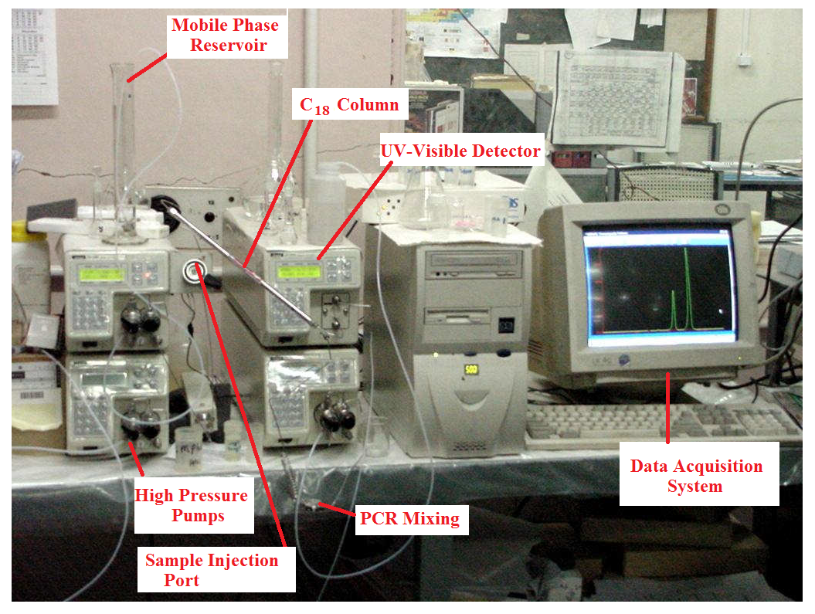
Figure S11: Photograph of HPLC system used in present study

Figure S12: Plots of log D_{M} of U(VI) and Th(IV) versus log [CHADA].

References
- Sasaki, Y.: Tachimori, S.: Extraction of actinides (III), (IV), (V), (VI), and lanthanides (III) by structurally tailored diamides. Solvent Extr. Ion Exch. 20 (1), 21 (2002).

