**Supporting Information**

**Radiation stability of phosphine oxide functionalized pillar[5]arenes**

Junshan Geng, Ying Wang,Yimin Cai, Bin Yang, Lihua Yuan, Wen Feng*

Key Laboratory for Radiation Physics and Technology of Ministry of Education, Institute of Nuclear Science and Technology, College of Chemistry, Sichuan University, Chengdu 610064, China

* Correspondence author E-mail address: wfeng9510@scu.edu.cn (W. Feng).

**Contents**

1. NMR and ESI-MS spectra**……………………......……………………………………2**
2. Heavy water (D2O) exchange experiment**……......……………………………………...6**
3. The 1H NMR spectra of **1b** at different doses in the range of 7.2-8.0 ppm..........**6**
4. Micro-FTIR spectra.**……………………………………………………………………...7**
5. Fragments of radiolytic degradation of **1b** identified by MALDI-TOF analysis.................................................................................................................... **8**



**Figure S1.** 1H NMR spectrum (400 MHz, CDCl3) of **1a**.



**Figure S2.** 1H NMR spectrum (400 MHz, DMSO-d6) of **1b.**



**Figure S3.** 1H NMR spectrum (400 MHz, CDCl3) of **1c.**



**Figure S4.** 1H NMR spectrum (400 MHz, CDCl3) of **2a.**



**Figure S5.** ESI-HRMS spectrum of **1a.**



**Figure S6.** ESI-MS spectrum of **1b.**



**Figure S7.** ESI-MS spectrum of **1c.**



**Figure S8.** ESI-MS spectrum of **2a.**

G:\FigS\Fig.S2.tif

**Figure S9.** Heavy water (D2O) exchange experiment of **1b** (400 MHz, DMSO-d6).



**Figure S10.** The 1H NMR spectra of **1b** at different doses in the range of 7.2-8.0 ppm (400 MHz, DMSO-d6).



**Figure S11.** Micro-FTIR spectra of irradiated **1a** at different doses.

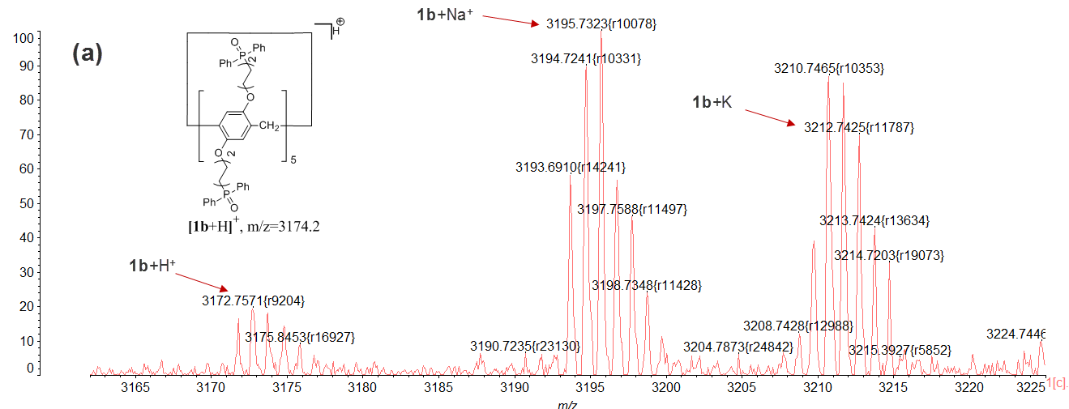

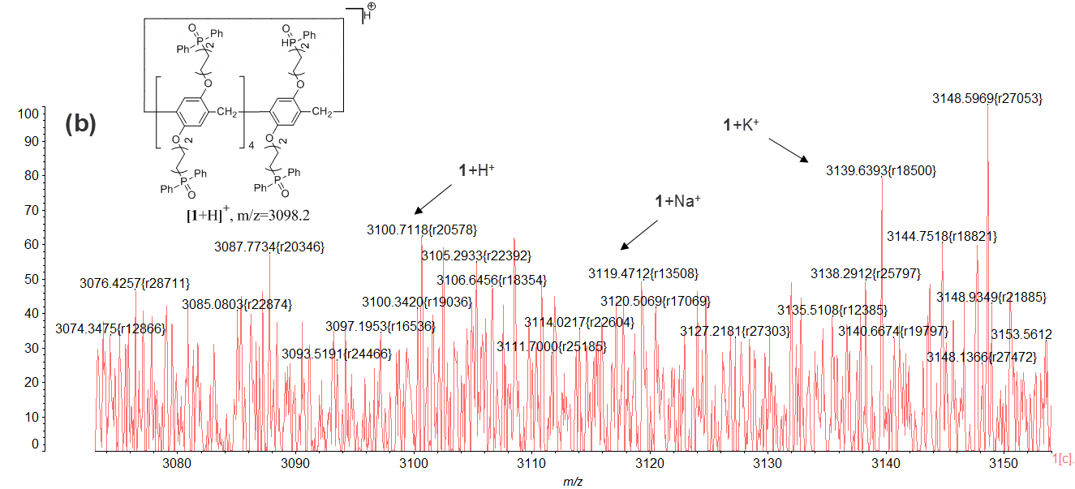

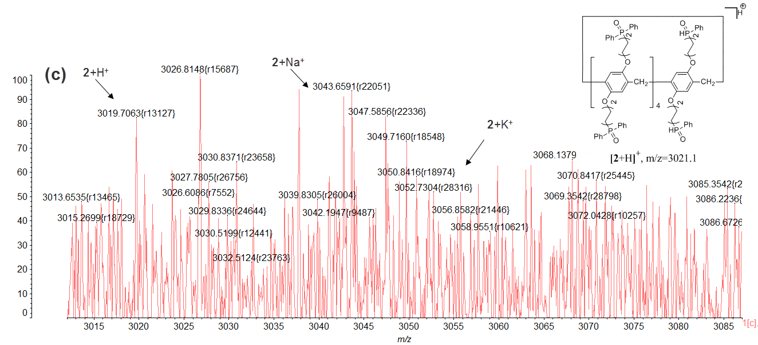

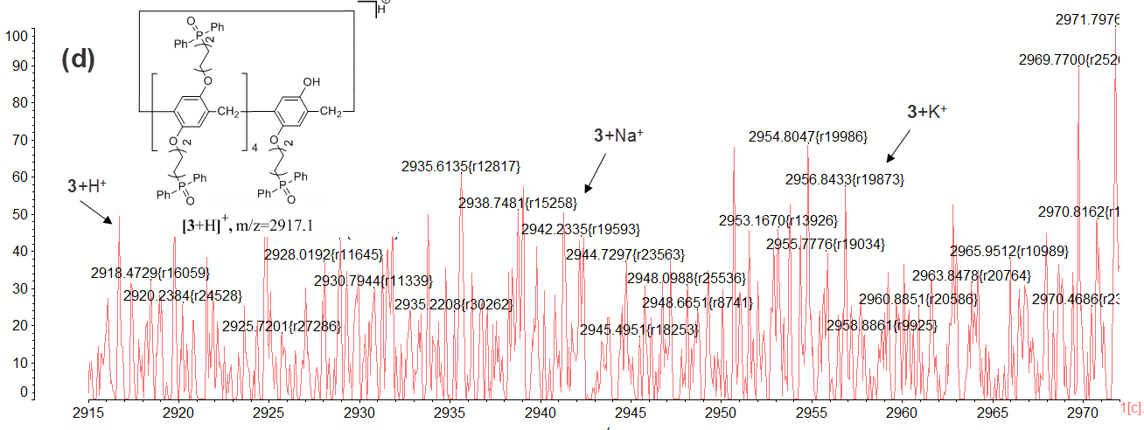

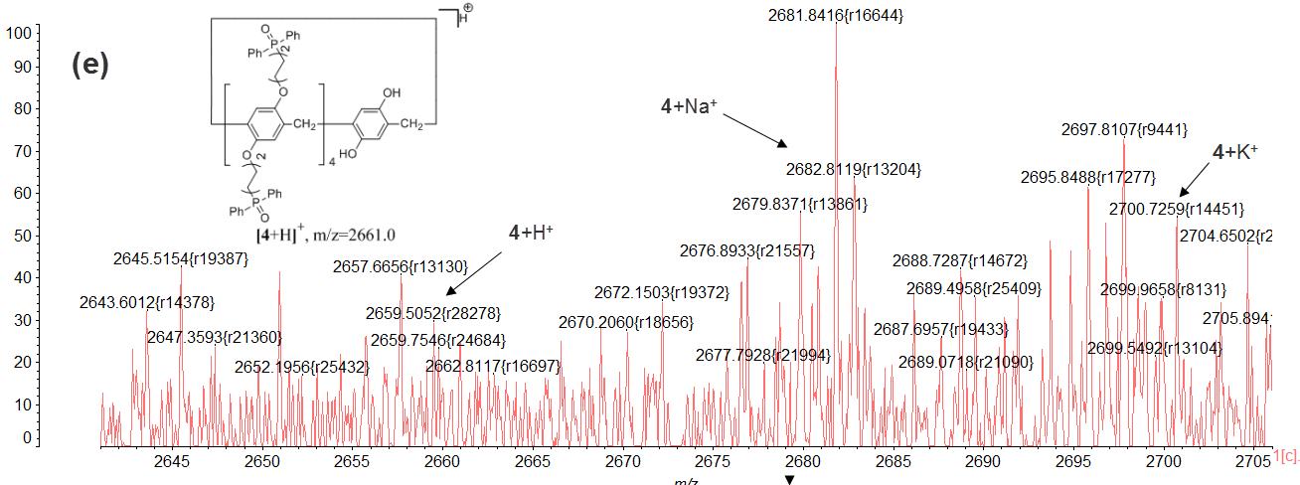

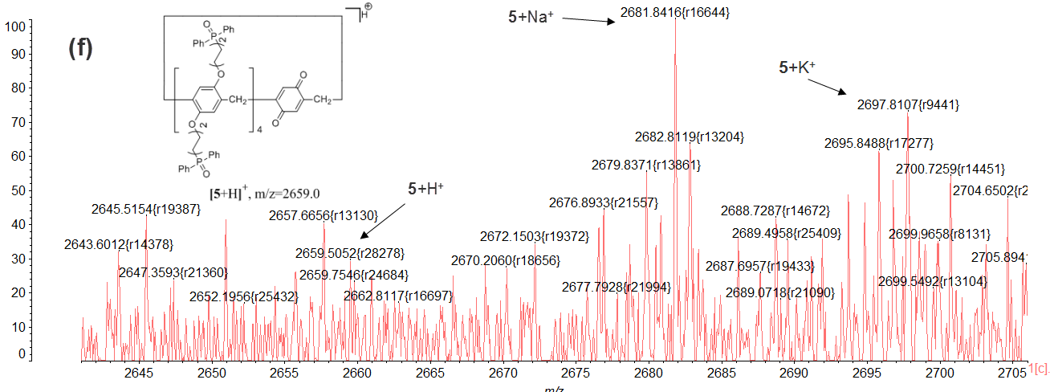

**Figure S12.** Fragments of radiolytic degradation of **1b** identified by MALDI-TOF analysis. **(a)** Magnification of the *m/z*=3165-3225 region; **(b)** Magnification of the *m/z*= 3070-3750 region；**(c)** Magnification of the *m/z*=3015-3085 region; **(d)** Magnification of the *m/z*= 2915-2970 region; **(f)** Magnification of the *m/z*=2645-2705 region; **(g)** Magnification of the *m/z*= 2645-2705 region.