- Supplementary information
  - FTIR
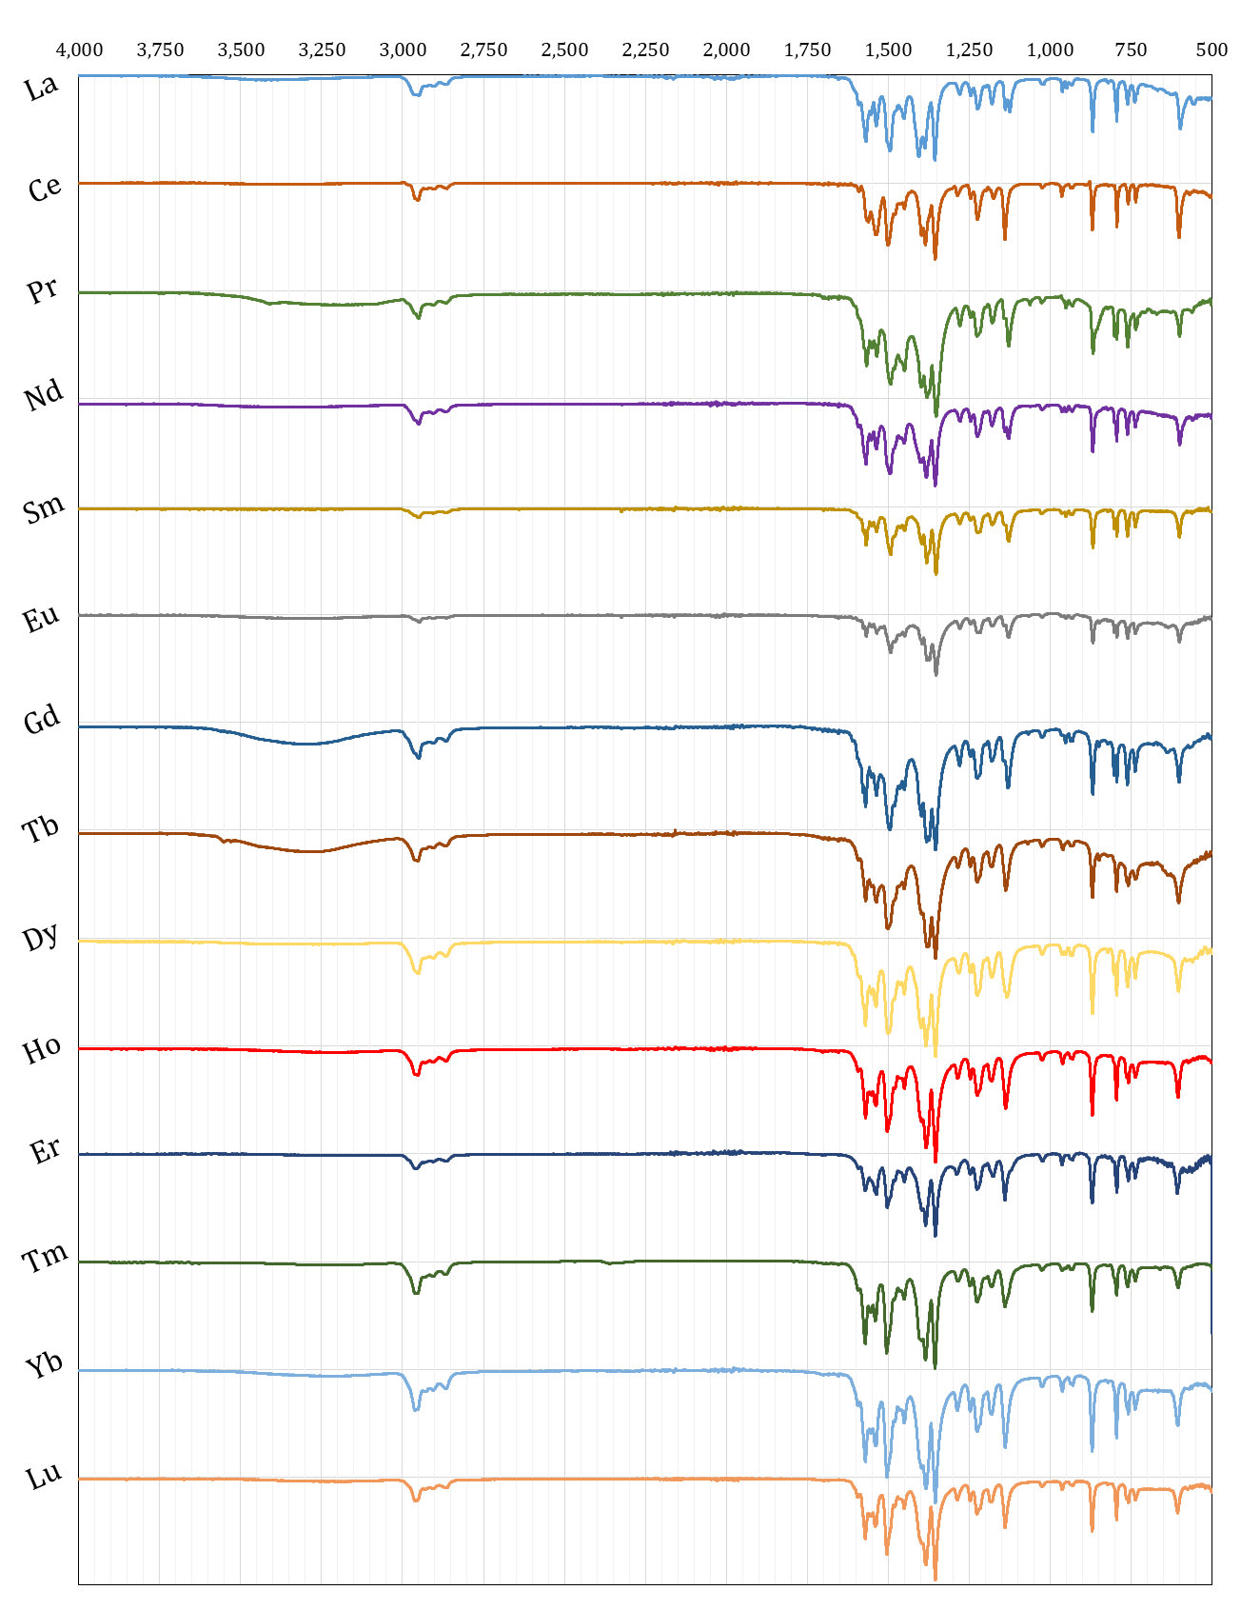
Fig. 6: FT-IR spectra for the lanthanide Dipivaloylmethanates
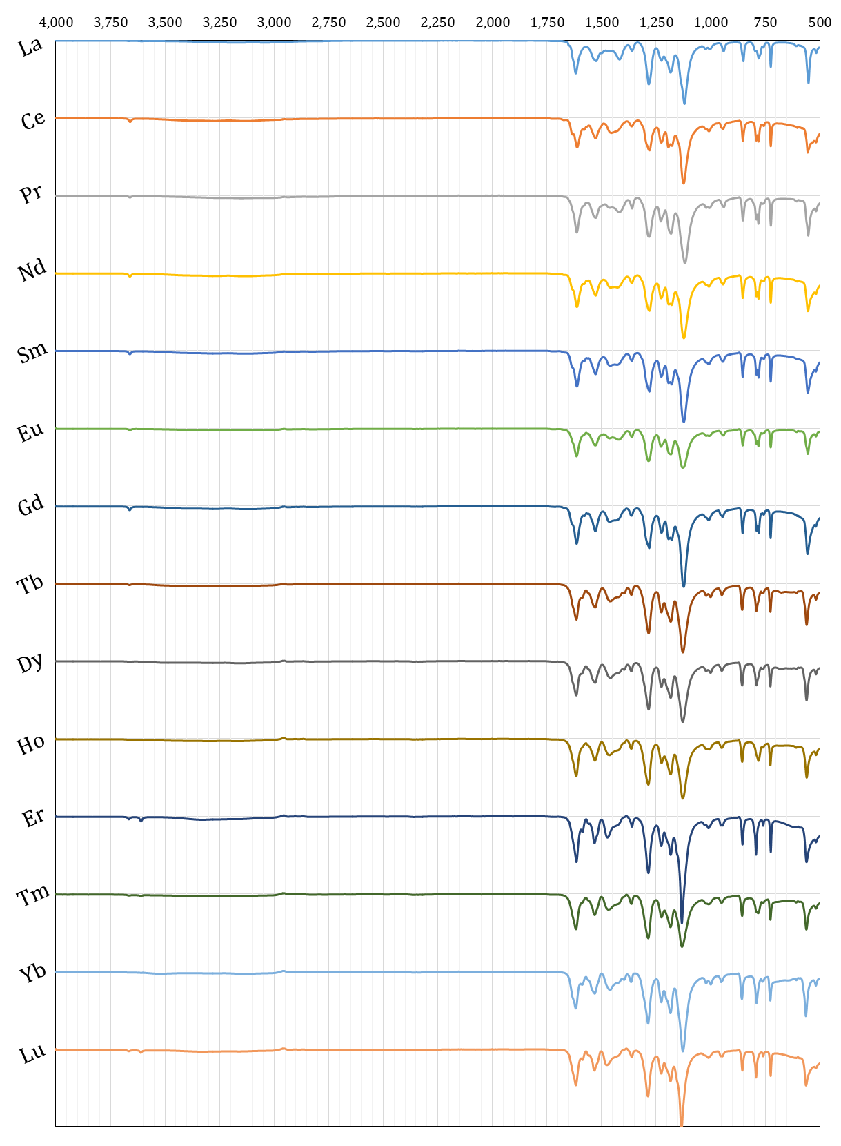
Fig. 7: FTIR Data for the Ln[tfac]₃ compounds.
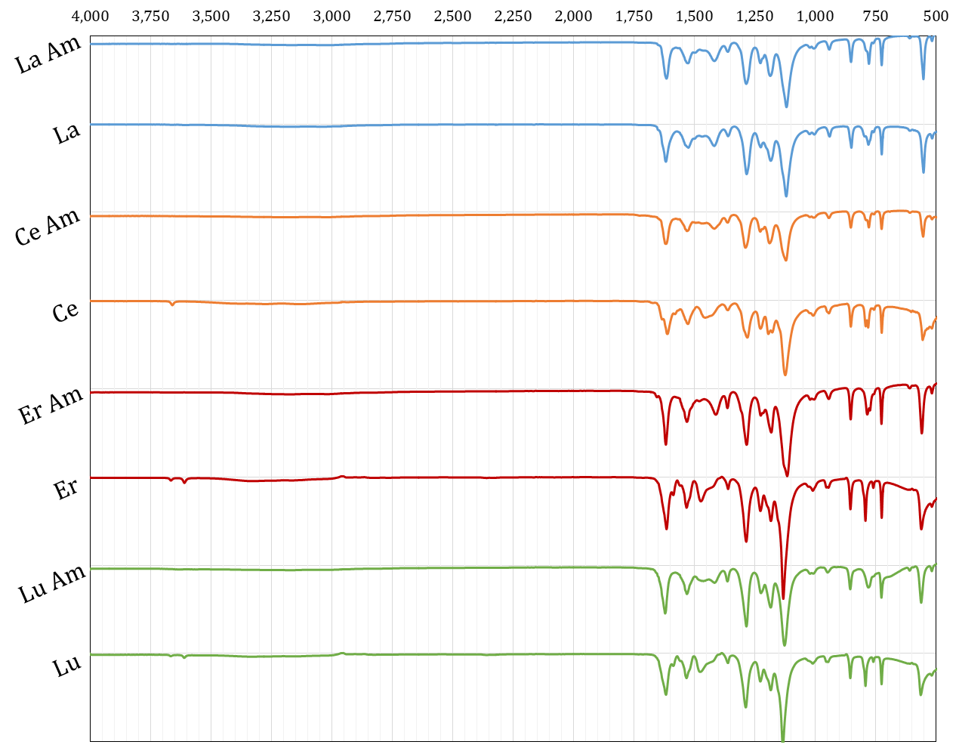
Fig. 8: Comparison of FTIR curves for the ammines (“Ln Am”) and hydrates (“Ln”) of Ln[tfac]₃.
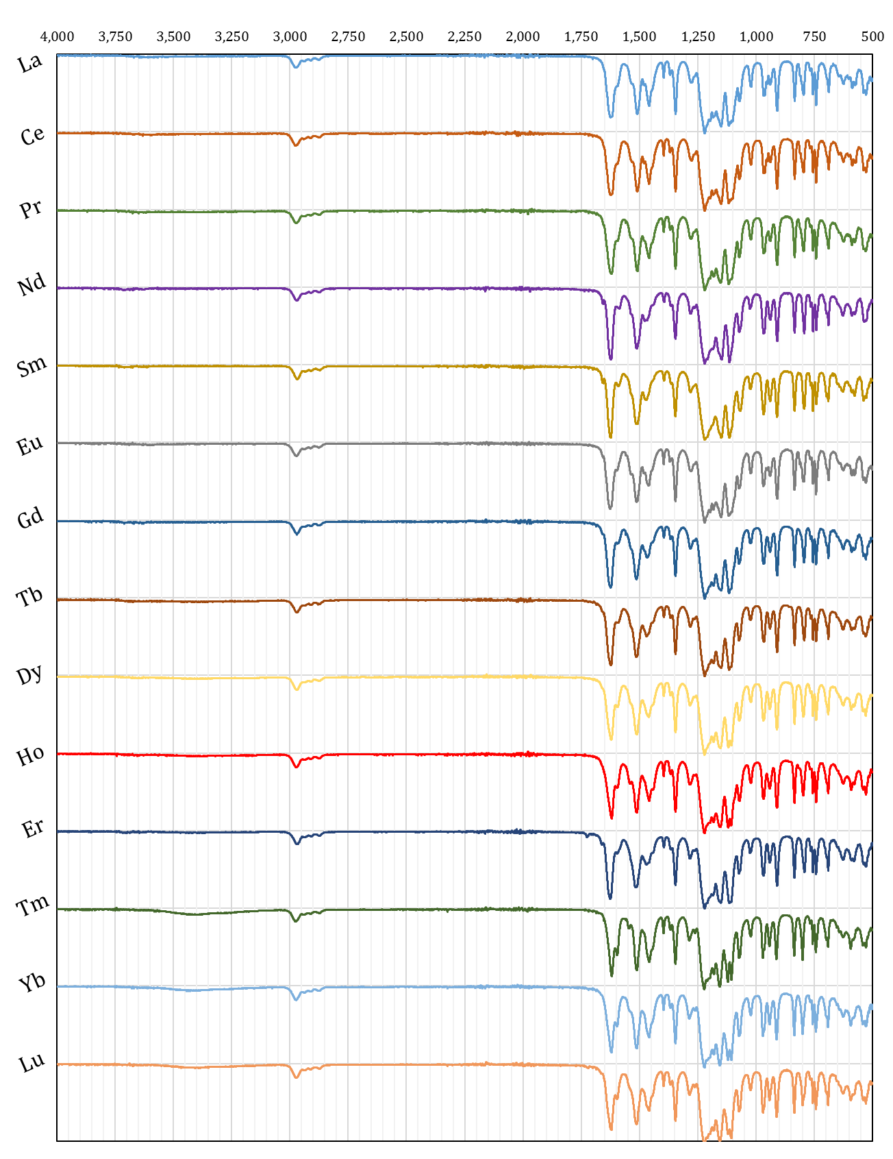
Fig. 9: FT-IR spectra for the lanthanide heptafluorodimethyloctanedionates.
Table 7 Infrared spectral results for Ln[dpm]_{n} complexesª
cm⁻¹ | peak | cm⁻¹ | peak | cm⁻¹ | peak
2950 | m, sh | 1380 | s, sh | 1135 | m
2860 | w | 1350 | s | 868 | s
1570 | m, sh | 1285 | w | 793 | m, sh
1540 | m | 1250 | w | 760 | w
1495 | s, sh | 1220 | w, sh | 735 | w
1450 | w | 1180 | w | 600 | m
ªSpectral notations: s, strong intensity; m, medium intensity; w, weak intensity; b, broad; sh, shoulder

Table 8 Infrared spectral results for Ln[fod]₃ complexesª
cm⁻¹ | peak | cm⁻¹ | peak | cm⁻¹ | peak
3600 | w, b | 1225 | s, b | 835 | m
2950 | w | 1195 | s, sh | 795 | m
1620 | s | 1180 | s | 755 | m, sh
1595 | m, sh | 1150 | s, sh | 740 | m
1530 | m, sh | 1115 | s | 695 | m, sh
1510 | s | 1105 | s, sh | 690 | m
1465 | m | 1070 | m | 625 | w
1395 | m | 1020 | w | 590 | w
1370 | m, sh | 965 | m | 575 | w
1345 | s | 940 | w | 540 | w
1275 | m | 910 | m | 525 | w
ªSpectral notations: s, strong intensity; m, medium intensity; w, weak intensity; b, broad; sh, shoulder

Table 9 Infrared spectral results for Ln[tfac]₃ complexesª
cm⁻¹ | peak | cm⁻¹ | peak | cm⁻¹ | peak
3660 | w | 1230 | m | 790 | m
1620 | s, sh | 1180 | s, sh | 780 | m
1530 | m, sh | 1120 | s | 760 | w
1420 | w, b | 1010 | w, sh | 725 | m
1360 | w | 940 | w | 553 | s
1280 | s, sh | 850 | m | 517 | w
ªSpectral notations: s, strong intensity; m, medium intensity; w, weak intensity; b, broad; sh, shoulder

