**Supporting Information**

**Encapsulated Polymeric beads impregnating unexplored amide, N,N’-bis(2-ethyl hexyl) α-hydroxy acetamide (BEHGA)- Preparation, sorption and kinetic studies for tri-, tetra- and hexa- valent radionuclides**

S.Pahana, K.K.Singhb, P.Sinha roya, S.Panjac,*, P.S.Dhamic,*, J.N.Sharmab,C.P.Kaushikd, M.Kumarb, J.S.Yadavc

a Process Development Division, bRadiation and Photochemistry Division, cFuel Reprocessing Division, dWaste Management Division

Bhabha Atomic Research Centre, Trombay, Mumbai 400085, India



**Figure S.1: TGA profile of neat BEHGA as well as BEHGA impregnated PEB**

Fig. S.1 show the TGA profiles of neat BEHGA liquid and Swollen BEHGA beads. The TGA thermogram of the BEHGA liquid, used in the synthesis of the composites beads, shows main weight loss in the temperature range of 250 to 450 oC, and a total of ~95% of the starting weight is lost up to the studied temperature of 800 oC. While in the case of BIPBs, degradation of polymer backbone begins at around 500 oC, and the weight loss of almost around 95% of the starting weight is observed up to the studied temperature (Fig. S.1. (B)). A weight loss of ~70% is observed during the heating of the beads up to the temperature of 120 oC, as shown in the Fig. S.1.(B). Further weight loss of ~15 %, which is attributed to the decomposition of BEHGA extractant is observed around 200-300 oC. These results suggest that the swollen beads contain ~70% of water, ~15 % of BEHGA and the remaining (~15 %) base polymer (PES). These swollen beads are used for the americium extraction experiments.



**Figure S.2: FTIR spectrum of neat BEHGA and BEHGA impregnated PEB**

The absorption peak at around 1483 cm−1 was attributed to the symmetrical bending motion in the aromatic rings of C–H in the plane. Absorption peaks at 1146 and 1296 cm−1 were attributed to the vibrations of the sulfone group (R2SO2). A strong aromatic ether band at around 1240 cm−1 was also observed. The hydroxyl group stretching, observed at around at 3375 cm–1, is quite broad because of the presence of hydrogen bonding in the swollen beads. Fig. S.2 (B) shows the presence of BEHGA, as evident from the bands at 2957 cm–1 (C–H stretching of methyl) and 1649 cm–1 (corresponding to amide).

**Kinetic Modeling:** Pseudo-first-order model: The Lagergren pseudo-first-order kinetic model for sorption process is given by the following eqn [1,2] :

 (S.1)

Where qe and qt are the amounts of metal ions sorbed onto the PEBs in (mg/g), at equilibrium and at time t, respectively, and k1 is the first-order rate constant (min-1).

Pseudo-second-order model: A linear form of the pseudo-second-order kinetics model which was used to describe the sorption process can be expressed as [3,4]:

 (S.2)

Where k2 (g.mg-1 min-1) is the rate constant for the pseudo-second-order sorption process.

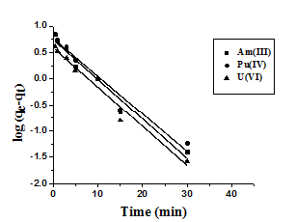 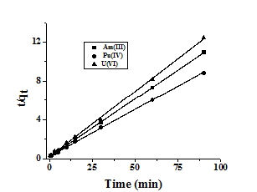

1. (B)

**Figure S.3: Kinetic models for the sorption of Am(III) by BEHGA impregnated PEBs: (A) Pseudo-first-order kinetics (B) Pseudo-second-order kinetics**

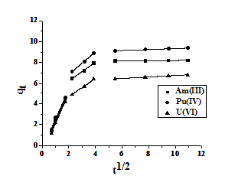

**Figure S.4: Intraparticle diffusion plot for the sorption of Am(III) by BEHGA impregnated PEBs**

**Table S.1: Linearized form of various sorption isotherms**

|  |  |  |  |
| --- | --- | --- | --- |
| **Isotherm** | **Linearized eqn.** | **Plot** | **Parameters** |
| *Langmuir* |  |  | ***qmax= (1/slope); b=slope/intercept*** |
| *Freundlich* | ***log qe = log Kf +(1/n) log ce*** | ***log qe vs log ce*** | ***Kf= intercept, n= 1/slope*** |

Where qe (mg/g) is the amount of metal ions sorbed on the solid phase, Ce the equilibrium concentration of metal ions in the aqueous phase, qmax (mg/g) the maximum sorption capacity (theoretical monolayer saturation capacity) and b (ml/mg) is the Langmuir constant, which is related to the affinity of the binding sites. Kf (mg/g) and n are Freundlich constants related to sorption capacity and the sorption intensity

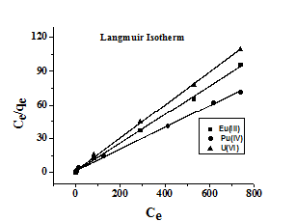 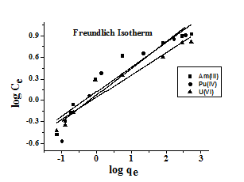

1. **(B)**

**Figure S.5: Isotherm plots for the sorption of actinides by BEHGA impregnated PEBs: (A) Langmuir plot (B) Freundlich plot**

**Reference:**

1. Srivastava, V. C., Mall, I.D., Mishra, I.M.: Characterization of mesoporous rice husk ash (RHA) and adsorption kinetics of metal ions from aqueous solution onto RHA. J. Hazard. Mater. 134, 257 (2006).
2. Ofomaja, A.E.: Sorption dynamics and isotherm studies of methylene blue uptake on to palm kernel fibre. Chem. Eng. J. 126, 35 (2007).
3. Ho, Y.S., McKay, G.: A comparison of chemisorptions kinetic models applied to pollutant removal on various sorbents. Proc. Safety Environ. Prot. 76, 332 (1998).
4. Ho, Y.S., McKay, G.: Pseudo-second order model for sorption processes. Process Biochem. 34, 451 (1999).