**Supplementary material for**

**Sorption of cobalt from aqueous solution containing EDTA under UV-C irradiation by antimony oxide**

**This file contains two equations, one figure and one table**

Equations:

The propagation of uncertainty is calculated by Equation (S1):

$∆f= ∆f\left(x_{1},x_{2},…,x_{n},{∆x}_{1},{∆x}_{2},…,{∆x}_{n}\right)=\sqrt{{\sum_{i=1 }^{n}{(\frac{∂f}{∂x_{i}}}∆x_{i})}^{2}}$ (S1)

where *∆f* is the estimated total deviation of *f* derived from the partial derivate of *f* with respect to each of the variables *x1*, *x2*, …, *xn*.

E.g. the estimated total deviation of *KD* is calculated by Equation (S2):

$∆K_{D}= \sqrt{{\left(\frac{∂K_{D}}{∂A_{0}}∆A_{0}\right)}^{2}+ {\left(\frac{∂K_{D}}{∂A_{eq}}∆A_{eq}\right)}^{2}+ {\left(\frac{∂K_{D}}{∂V}∆V\right)}^{2}+ {\left(\frac{∂K_{D}}{∂m}∆m\right)}^{2}}= \sqrt{{\left(\frac{1}{A_{eq}}∆A_{0}\frac{V}{m}\right)}^{2}+ {\left(-\frac{A_{0}}{A_{eq}^{2}}∆A_{eq}\frac{V}{m}\right)}^{2}+{\left(\left(\frac{A_{0}}{A_{eq}}-1\right)\frac{∆V}{m}\right)}^{2}+{\left(\left(\frac{A_{0}}{A_{eq}}-1\right)\left(-\frac{V}{m^{2}}∆m\right)\right)}^{2}}$ (S2)

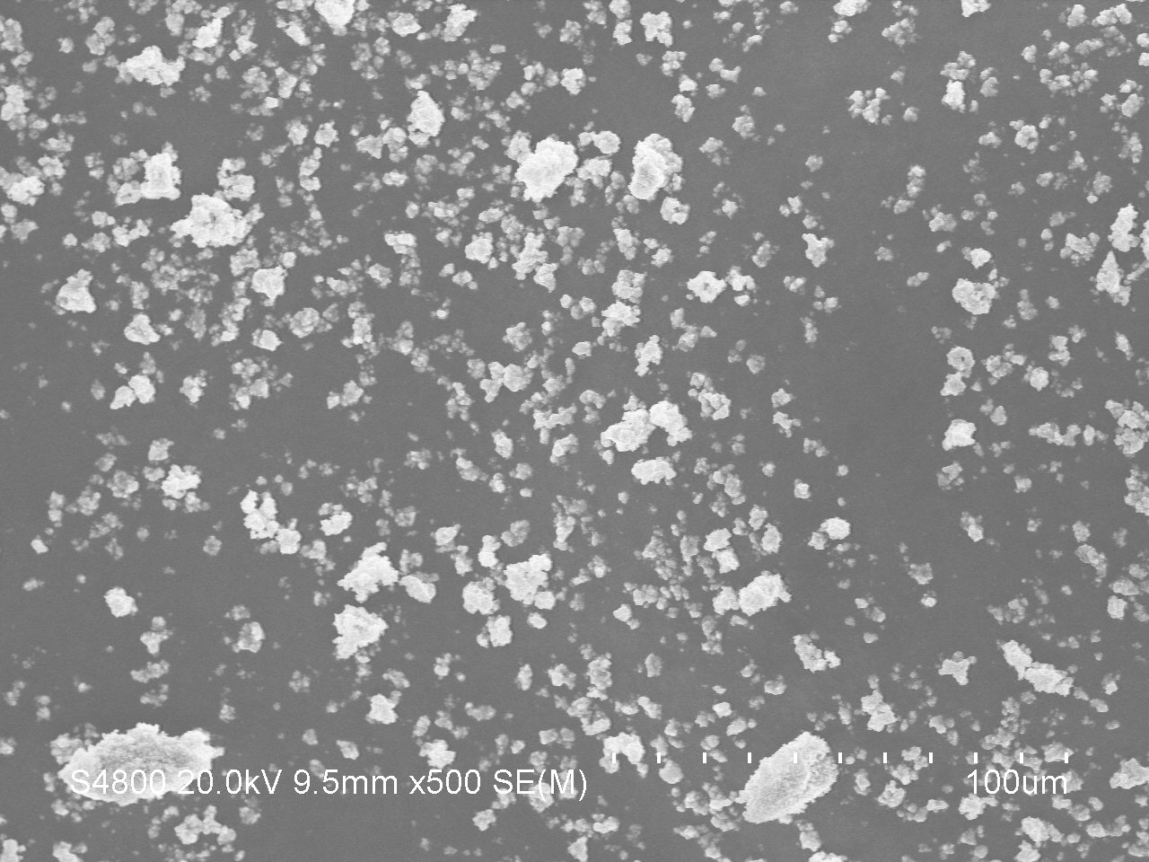

Figure S1. FESEM (field emission scanning electron microscope, Hitachi S-4800) picture of the particle size distribution of the synthesized antimony oxide.

Table S1. The intensities of the reference material, Sb6O13,[1] and the synthesized antimony oxide as derived from the XRD diffractograms.

|  |  |  |  |  |  |  |  |  |
| --- | --- | --- | --- | --- | --- | --- | --- | --- |
|  |  |  | **Reference** | |  | **Measured** | |  |
| **h** | **k** | **l** | **d [Å]** | **2Theta [deg]** | **I [%]** | **d [Å]** | **2Theta [deg]** | **I [%]** |
| 1 | 1 | 1 | 5.949 | 14.880 | 25 | 5.906 | 15.0 | 83 |
| 3 | 1 | 1 | 3.108 | 28.700 | 20 | 3.113 | 28.678 | 75 |
| 2 | 2 | 2 | 2.976 | 30.002 | 100 | 2.973 | 30.056 | 100 |
| 4 | 0 | 0 | 2.577 | 34.785 | 30 | 2.596 | 34.545 | 12 |
| 3 | 3 | 1 | 2.365 | 38.017 | 4 | 2.369 | 37.974 | 9 |
| 5 | 1 | 1 | 1.983 | 45.709 | 6 | 1.978 | 45.882 | 14 |
| 4 | 4 | 0 | 1.821 | 50.041 | 25 | 1.818 | 50.187 | 28 |
| 5 | 3 | 1 | 1.741 | 52.501 | 8 | 1.738 | 52.670 | 19 |
| 6 | 2 | 2 | 1.553 | 59.451 | 30 | 1.553 | 59.515 | 20 |
| 4 | 4 | 4 | 1.487 | 62.371 | 9 | 1.486 | 62.521 | 7 |
| 7 | 1 | 1 | 1.443 | 64.518 | 8 | 1.436 | 64.934 | 8 |
| 7 | 3 | 1 | 1.341 | 70.082 | 6 | 1.343 | 69.979 | 7 |

1. Standard X-ray Diffraction Powder Patterns, National Bureau of Standards (U.S.) Monogr*.* 25, 16 (1979) pp. 14.