**Supporting Information**

**Manuscript Title:** Speciation of citric acid on anatase (TiO2) – water interface and its effect on Eu(III) sorption

**Authors:** Sharayu Kasar, et al.

**Manuscript no.:** RACT-2014-2320

**1. Crystalline phase identification of anatase**

Fig. 1S. X-ray diffraction pattern of the Anatase powder

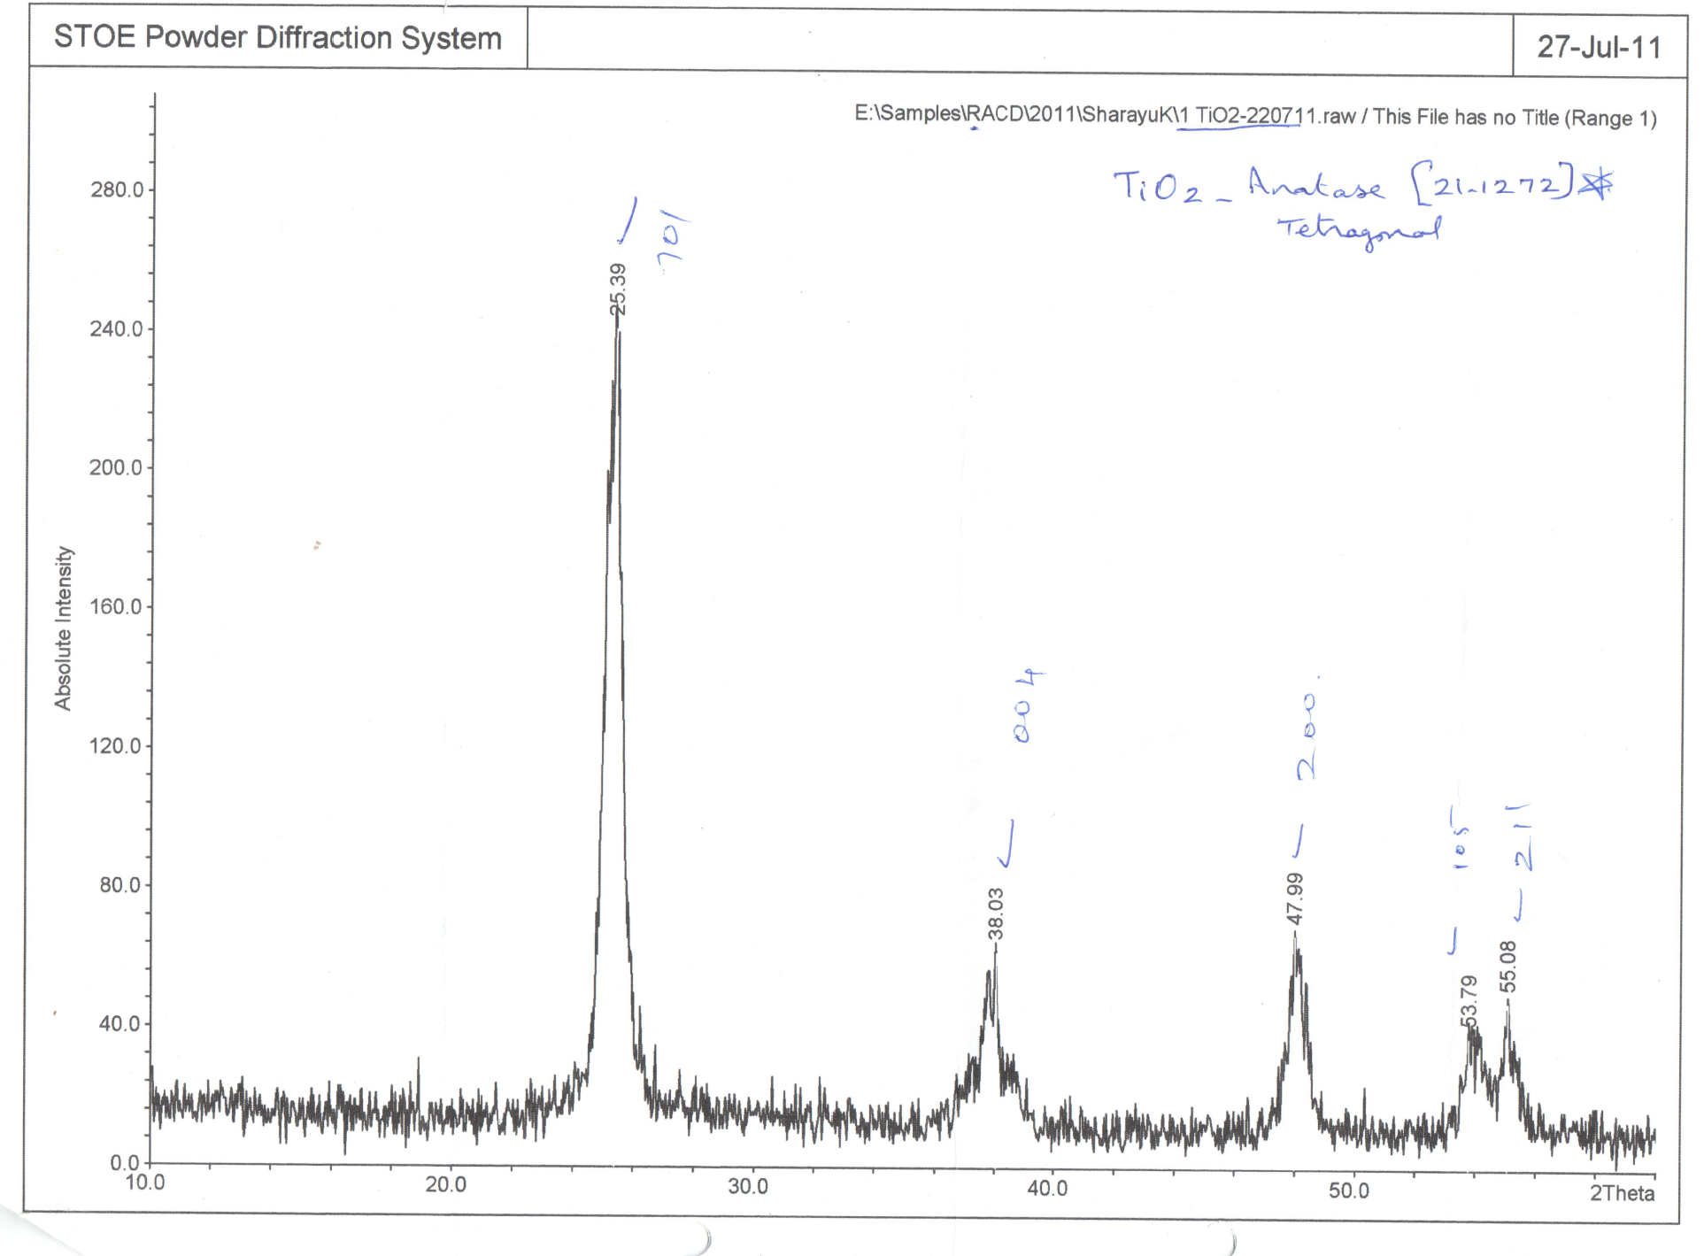

**2. Ion Chromatographic estimation of Citric acid**

0.0

1.0

2.0

3.0

4.0

5.0

6.0

7.0

8.0

9.0

10.0

11.0

12.0

-2.0

10.0

20.0

35.0

Citrate

Perchlorate

µS

min

Retention time (min)

Fig. 2S. A typical chromatogram obtained in the citrate determination



Fig. 3S. Calibration plot over varying citrate concentration (0.5-20 pm). Standard solutions of citrate were prepared in 0.01 M NaClO4 medium.