Effect of irradiation on some actinides and fission product ions extraction using several tetraalkyl diglycolamide
R.B. Gujarª, G.D. Dhekane^{b}, A. B. Patil^{c}, P.K. Mohapatra^{a,*}
ªRadiochemistry Division, Bhabha Atomic Research Centre, Trombay, Mumbai – 400085, India; ^{b}Thermax Limited, Chemical Division, 97-E,General Block, MIDC, Bhosari, Pune 411026, India; ^{c}Garware Research Centre, Department of Chemistry, University of Pune, Pune-411007, India

Electronic Supporting Information

1. IR Spectral data:
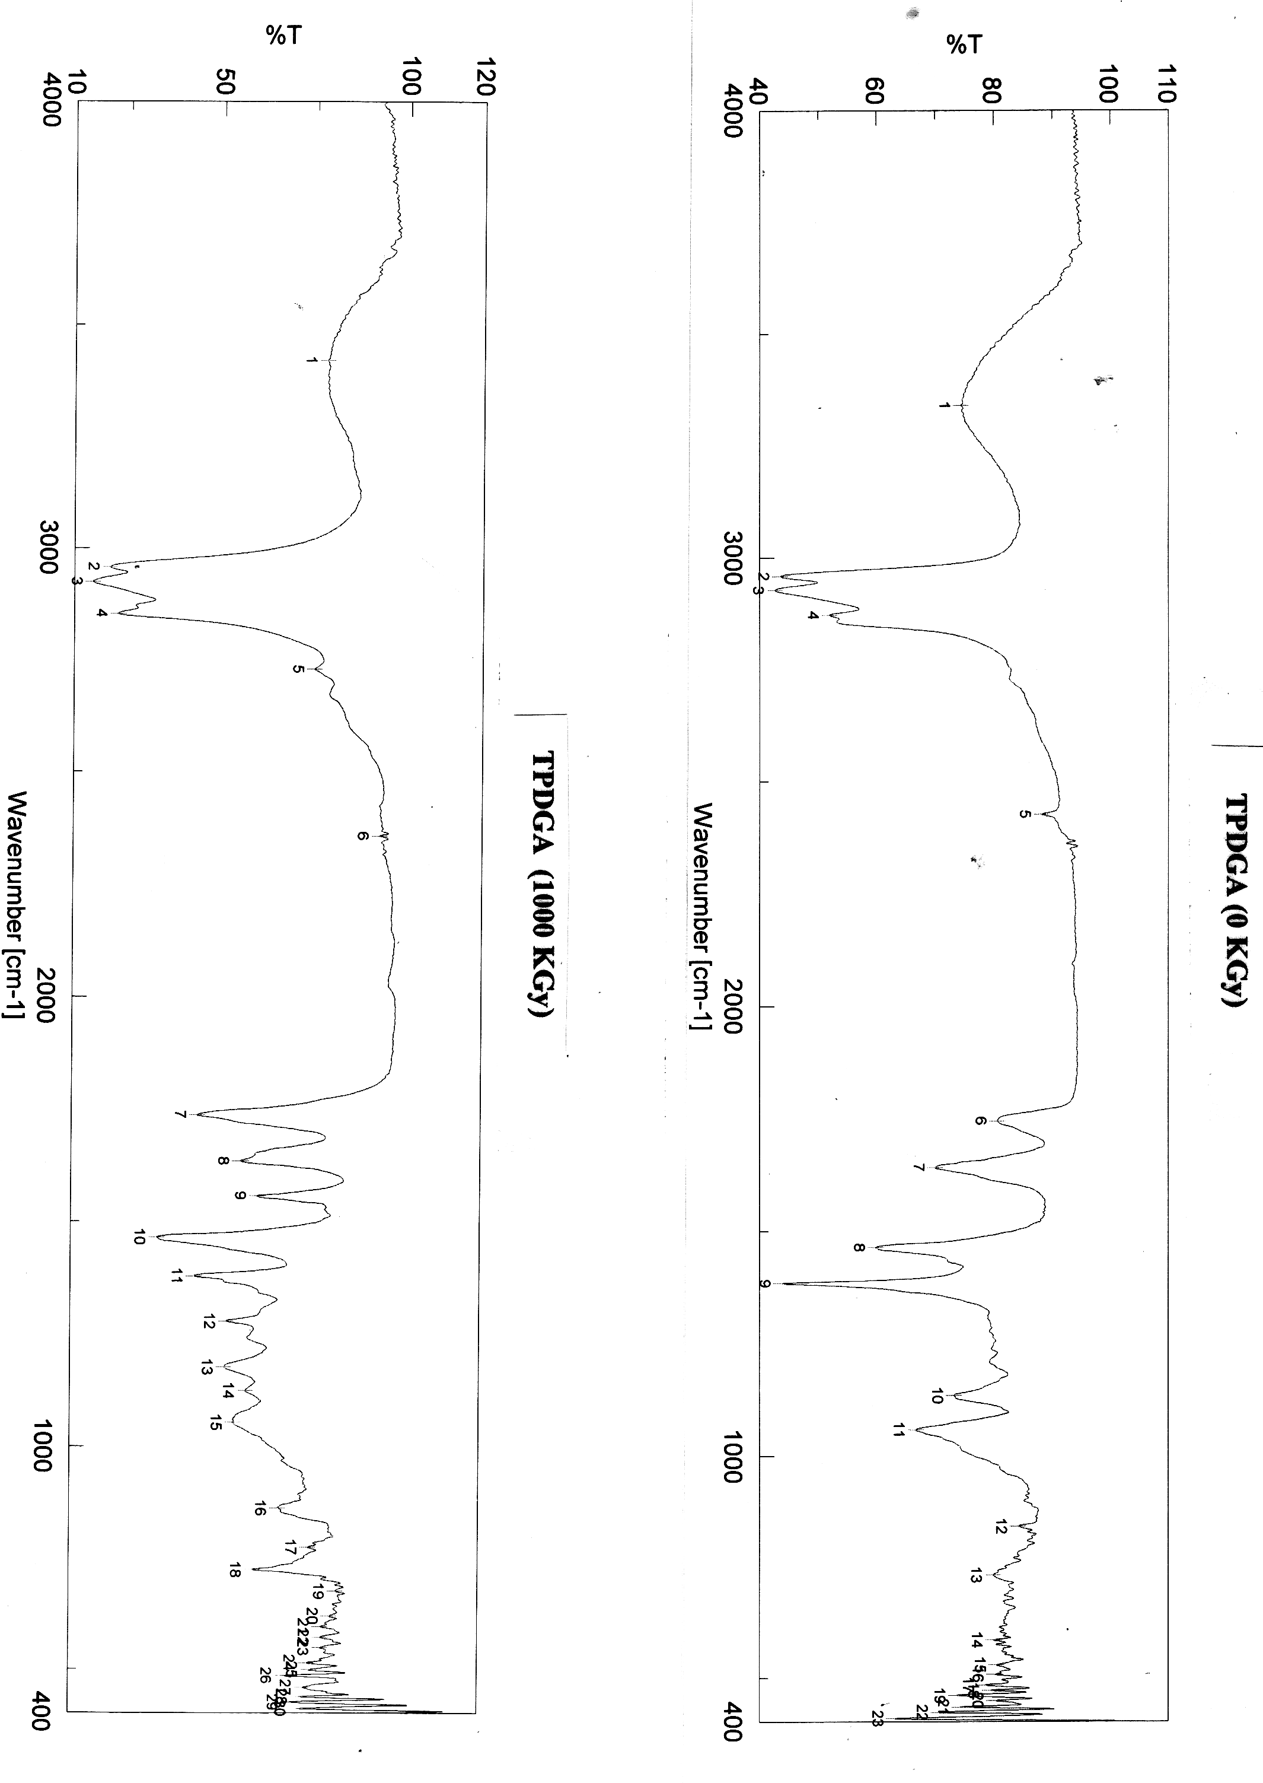
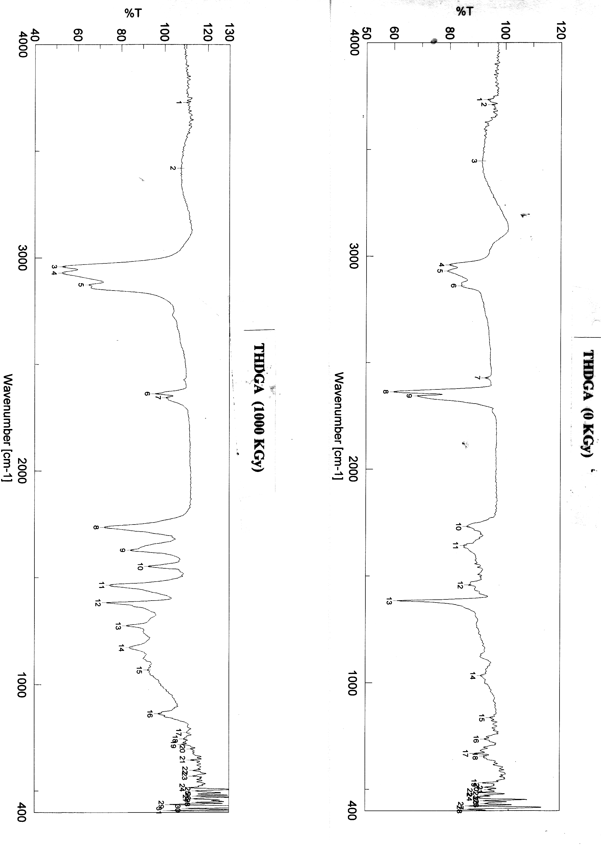
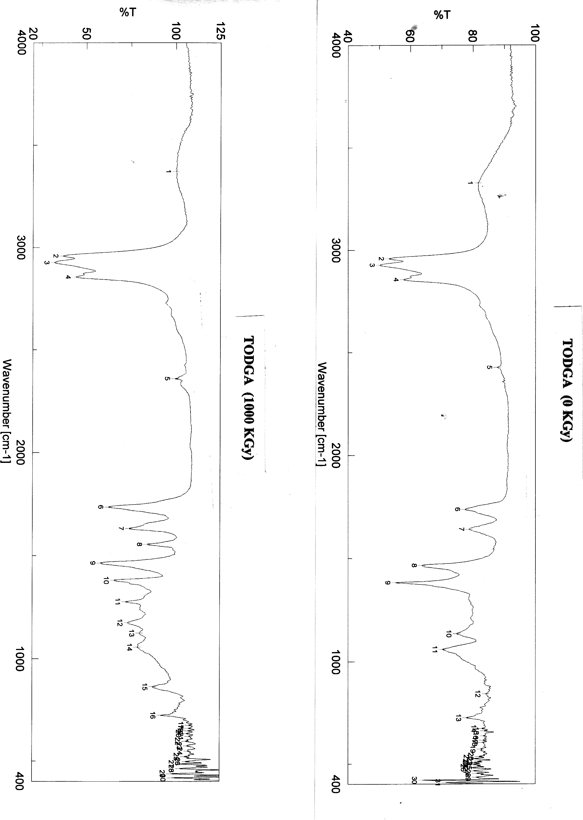
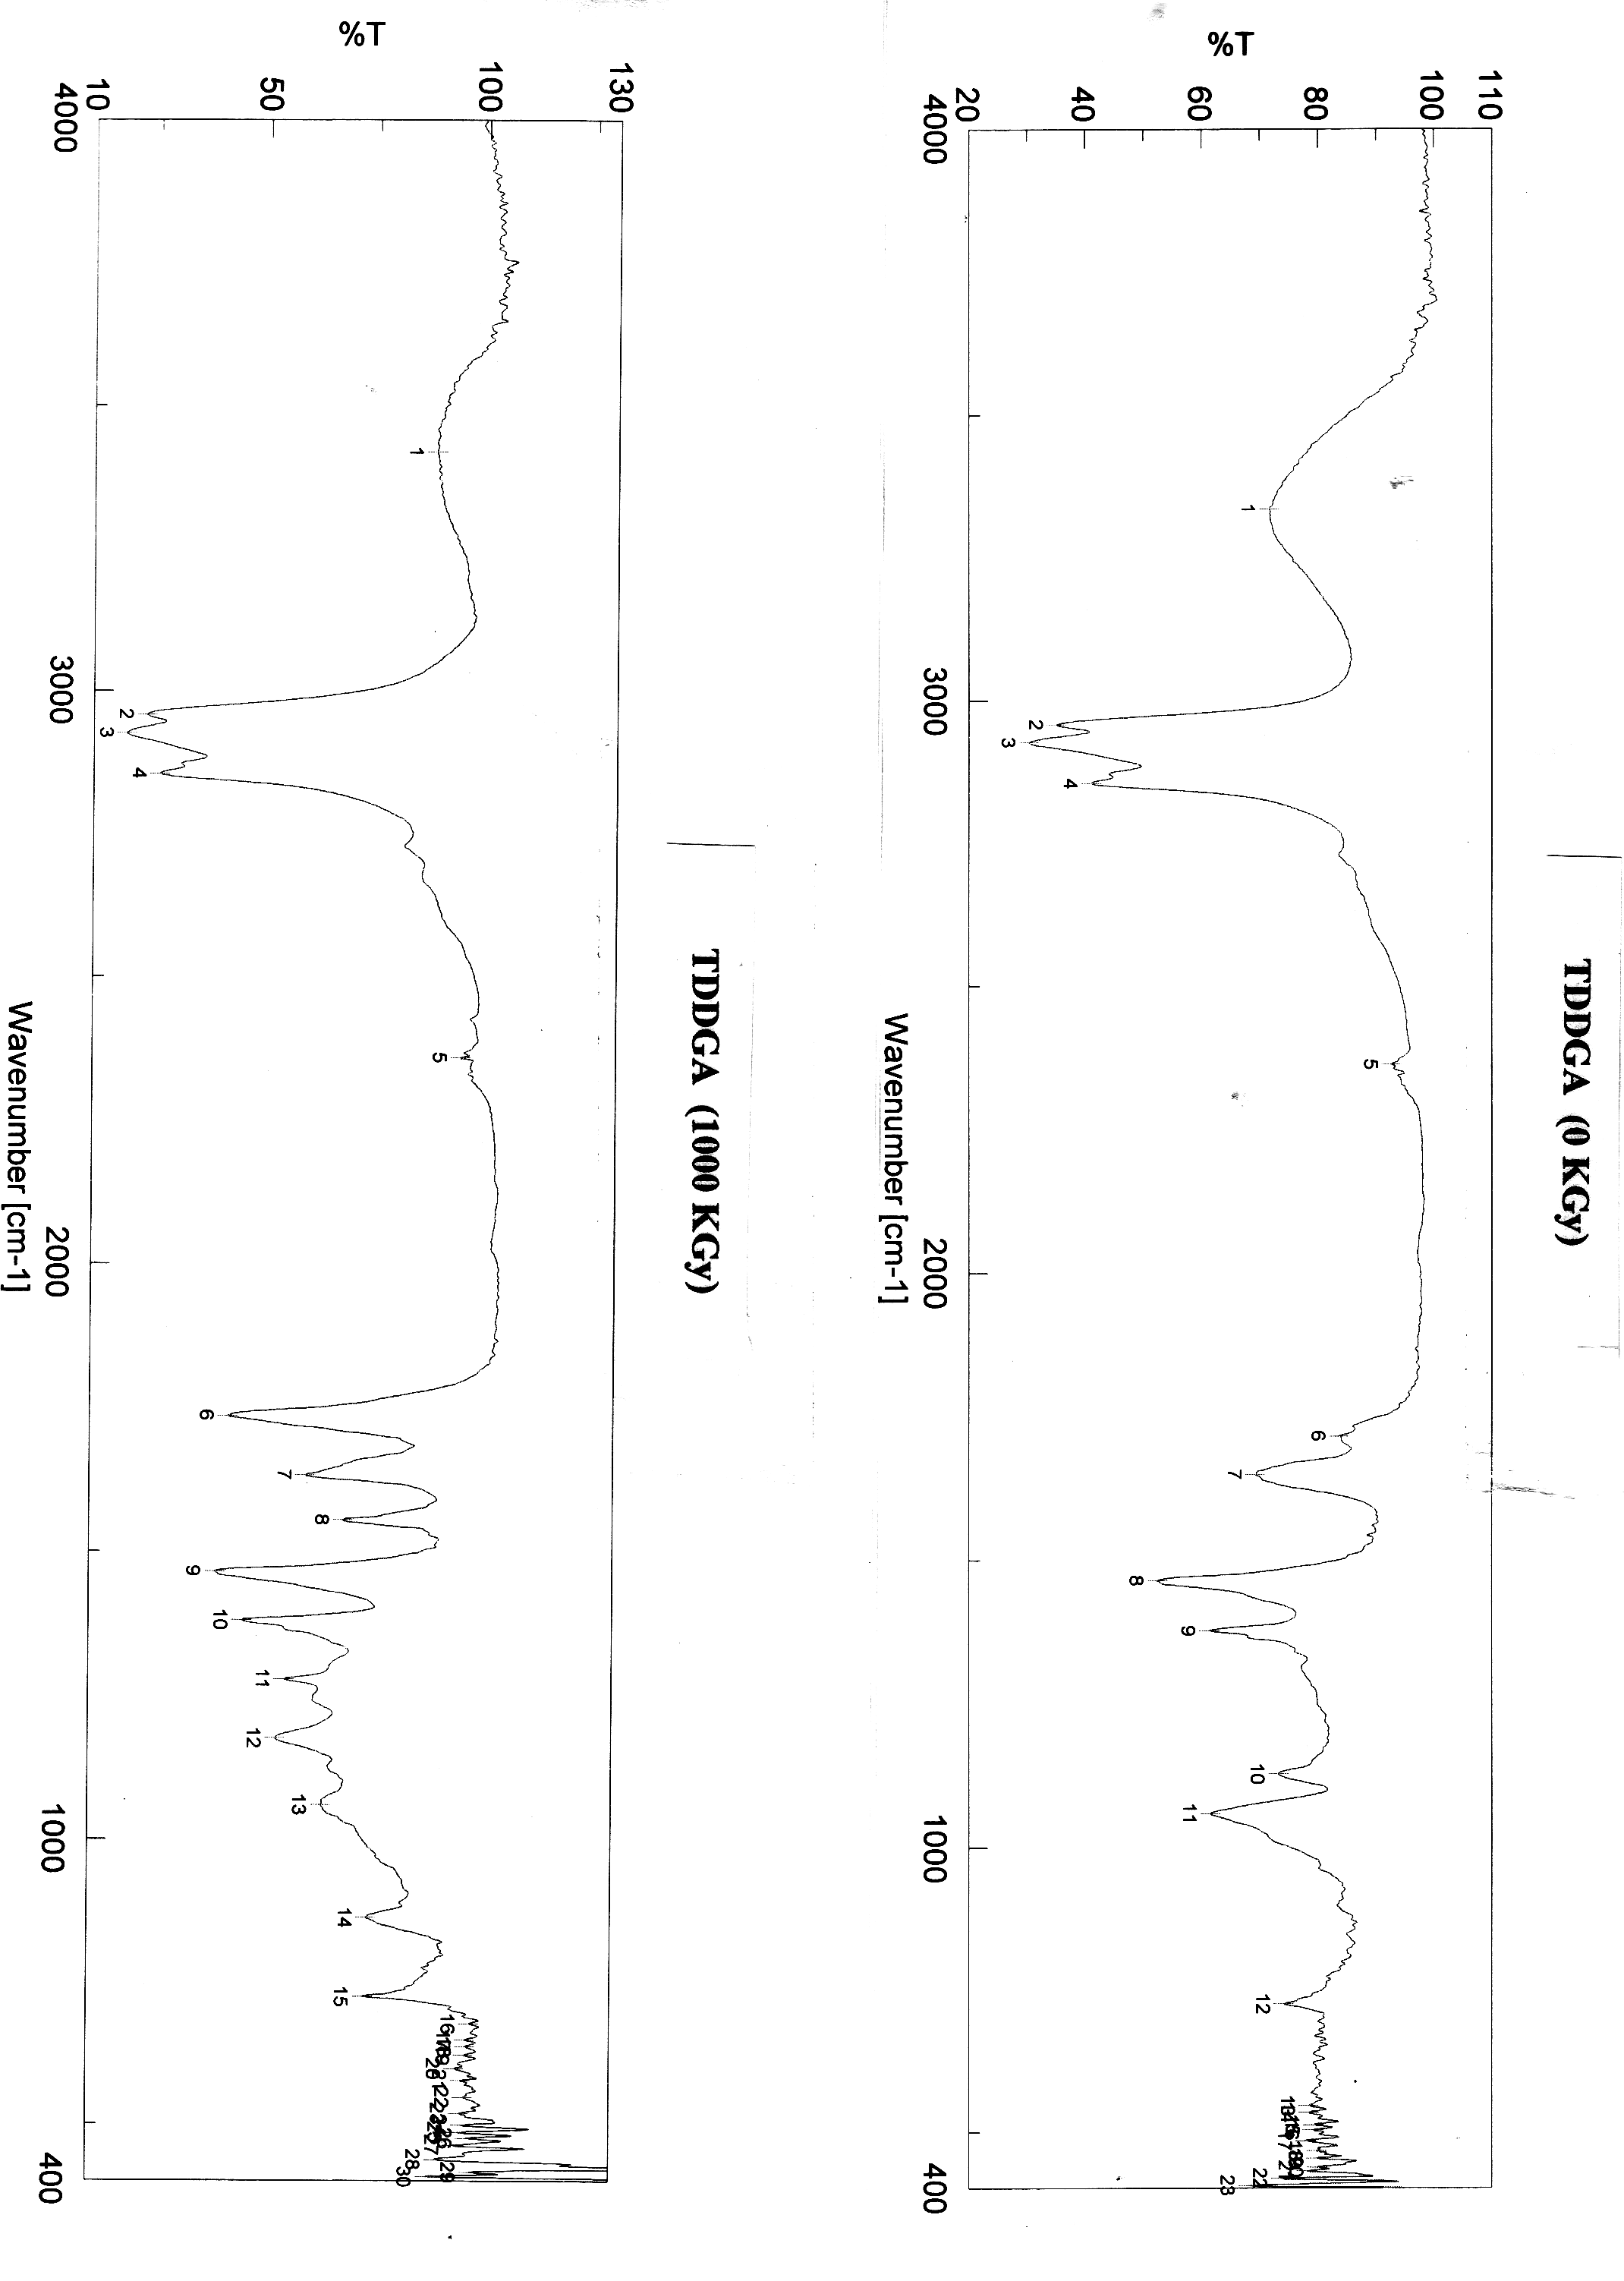
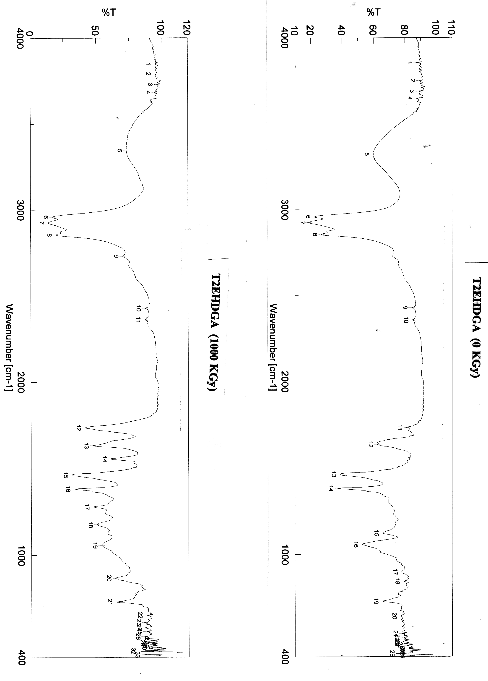
2: GC-MS Characterization of diglycolamide degradation products:
SF-1: GCMS chromatogram of TPDGA 0 kGy Dose

SF-2: GCMS chromatogram of TPDGA 10kGy dose

SF-3: GCMS chromatogram of TPDGA 50kGy

SF-4: GCMS chromatogram of TPDGA 100kGy

SF-5: GCMS chromatogram of THDGA 0kGy

SF-6: GCMS chromatogram of THDGA 10kGy

SF-7: GCMS chromatogram of THDGA 50kGy

SF-8: GCMS chromatogram of THDGA 100kGy

SF-9: GCMS chromatogram of TODGA 0kGy
SF-10: GCMS chromatogram of TODGA 10kGy

SF-11: GCMS chromatogram of TODGA 50kGy

SF-12: GCMS chromatogram of TODGA 100kGy

SF-13: GCMS chromatogram of TDDGA 0kGy

SF-14: GCMS chromatogram of TDDGA 10kGy

SF-15: GCMS chromatogram of TDDGA 50kGy

SF-16: GCMS chromatogram of TDDGA 100kGy

SF-17: GCMS chromatogram of T2EHDGA 0kGy

SF-18: GCMS chromatogram of T2EHDGA 10kGy

SF-19: GCMS chromatogram of T2EHDGA 50kGy

SF-20: GCMS chromatogram of T2EHDGA 100kGy

