Separation of ¹³⁴Cs and ¹³⁷Cs from ¹²⁵I solution for medical applications
¹Ramu Ram,²Dayamoy Banerjee and ¹Ashutosh Dash*

¹Isotope Applications and Radiopharmaceuticals Division,
²Process Development Division,

Bhabha Atomic Research Centre,

Trombay, Mumbai -400 085, India

SUPPORTING INFORMATION
2. Experimental
2.1 Determination of distribution coefficients of I⁻ and Cs⁺ ions on RF resin
Distribution coefficients (K_{d}) of Cs⁺ and I⁻ ions on RF resin matrix were determined at different pH, using ¹³⁷Cs and ¹²⁵I radiotracers. In each experiment, 200 mg of sorbent was suspended in 20 mL solution containing the radioactive ions, in a 50 mL stoppered conical flask, shaken in an wrist arm mechanical shaker for 30 min at room temperature and then filtered. The activities of the solution before and after equilibration were measured in a NaI (Tl) counter using appropriate window settings (0-100 keV for ¹²⁵I and 600-700 keV for ¹³⁷Cs). The distribution coefficients were calculated using the following expression:
K_{d} = L g⁻¹
where A_{i} is the initial total radioactivity of 1 mL the solution, A_{eq} is the unadsorbed activity in 1 mL of the solution at equilibrium, V is the solution volume (L) and m is the mass (g) of the sorbent. The standard deviation of K_{d} values were checked by three determinations.

2.2 Determination of equilibration time
With a view to study the time dependence of sorption of Cs⁺ onto RF resin at pH 13, the distribution coefficients (K_{d}) of ¹³⁷Cs was evaluated at different time intervals (5 to 90 min), following the procedure described above. In this premise, the K_{d} values (mean of three experiments) were taken as an indication of the progress of the adsorption process and the time when K_{d} remained unchanged, was considered as the equilibrium time.

2.3 Capacity measurement
The ion exchange capacity of RF resin for Cs⁺ was determined by batch equilibration method using ¹³⁷Cs tracer. In this procedure, an accurately weighed (0.5 g) was taken in different glass stoppered conical flasks and equilibrated with 50 ml of CsCl solution (10 mg of Cs/mL) spiked with ~10 μCi (370 kBq) of ¹³⁷Cs maintained at pH 10-13 for about 1 hour at room temperature. At the end, the contents were filtered through filter paper. The activities of ¹³⁷Cs in the solution before and after absorption were estimated by using a HPGe detector coupled to a multichannel analyzer, by measuring the counts at 662 keV peak corresponding to ¹³⁷Cs. All measurements were carried out at room temperature (25º C) in triplicate.
The capacity was calculated using the following expression
Capacity =
Where, C₀ and C_{e} represented initial and equilibration concentration of ¹³⁷Cs respectively, V was the volume of solution and m was the mass (g) of the adsorbent.
2.4 Flow through column studies
2.4.1 Determination of breakthrough profile and dynamic capacity of Cs⁺
The dynamic sorption capacity and breakthrough pattern were studied by passing CsCl solution (2 mg Cs mL⁻¹) spiked with ¹³⁷Cs radiotracer at pH 13, through a borosilicate glass column of dimension 4 cm× 0.5 cm (i.d.) with sintered disc (G₀) at the bottom containing 1 g of RF resin at a flow rate of 1 mL min⁻¹. A known amount of the feed ¹³⁷Cs solution, here 1 mL was kept as reference (C₀). The effluent from the column was collected in fractions of 1 mL aliquots (C). The radioactivity content of the reference solution (C_{o}), as well as each fraction of the effluent (C) was measured in a HPGe detector by counting the 662 keVγ-ray peak of ¹³⁷Cs. The ratio of the count rate ‘C’ of each 1 mL effluent to the count rate ‘C_{o}’ of 1 mL of the original feed Cs solution was taken as the parameter to follow the adsorption pattern.
2.5 Flow through column studies
2.5.1 Determination of breakthrough profile and dynamic capacity of Cs⁺
The dynamic sorption capacity and breakthrough pattern were studied by passing CsCl solution (2 mg Cs mL⁻¹) spiked with ¹³⁷Cs radiotracer at pH 13, through a borosilicate glass column of dimension 4 cm× 0.5 cm (i.d.) with sintered disc (G₀) at the bottom containing 1 g of RF resin at a flow rate of 1 mL min⁻¹. A known amount of the feed ¹³⁷Cs solution, here 1 mL was kept as reference (C₀). The effluent from the column was collected in fractions of 1 mL aliquots (C). The radioactivity content of the reference solution (C_{o}), as well as each fraction of the effluent (C) was measured in a HPGe detector by counting the 662 keVγ-ray peak of ¹³⁷Cs. The ratio of the count rate ‘C’ of each 1 mL effluent to the count rate ‘C_{o}’ of 1 mL of the original feed Cs solution was taken as the parameter to follow the adsorption pattern.
3. Results
3.1 Determination of the equilibration time
In order to determine the time necessary to get access to adsorption equilibrium, the effect of contact time on adsorption of ¹³⁷Cs⁺ onto RF resin was studied at pH 13. The plot of K_{d} vs. contact time is depicted in Fig.S1 which indicates that the rate of exchange of Cs⁺ ion on the resin changes in a time dependent manner. The curve revealed that a contact period of 60 min is required for Cs⁺ ion to establish complete equilibrium. Accordingly, a contact time of 60 minutes was kept in the batch process.
3.2 EDS analysis
Fig. S2(a) depicts the EDS spectrum of RF resin and Fig. S2 (b) of the Cs adsorbed RF resin. S2 (a) shows peaks pertaining to C and O only which inferred that the resin used for adsorption of Cs is free from adsorbed metallic impurities. Fig. S2 (a) shows peaks pertaining to Cs, C and O only which indicates adsorption of Cs on RF resin.
3.3 Quality evaluation of ¹²⁵I
While the column chromatography purification of ¹²⁵I solution using RF resin has been prolific in providing ¹²⁵I free from ¹³⁴Cs and ¹³⁷Cs impurities, quality of the product in term of radionuclidic and radiochemical purity was evaluated to ensure its safety and efficacy for human use. Spurred by the perceived need to resolve low energy photo peaks of ¹²⁵I, the radionuclide purity of the product was analyzed using a low-energy photon (LEP) detector based on HPGe. The γ-spectra of ¹²⁵I solution after purification is illustrated in Fig.S3 which show photo peaks pertaining to ¹²⁵I only.The radiochemical purity of ¹²⁵I in iodide form as determined by paper electrophoresis technique for several batches was >98%, which is within the acceptable limit (>95%) [25]. A paper electrophoresis pattern of separated ¹²⁵I is shown in Fig. S4.
Fig. S1 Time dependence adsorption of ¹³⁷Cs⁺ ions on RF resin at pH 13
Fig. S2 Energy dispersive X-ray (EDS) spectrum of (a) RF resin, (b) & (c) Cs adsorbed RF resin.
Fig. S3 γ-spectra of the ¹²⁵I solution recorded in LEP detector
Fig. S4 Paper electrophoresis pattern of ¹²⁵I on application of 400 V for 1 h and using phosphate buffer at pH ~7.5 as the electrolyte

Fig. S1 Time dependence adsorption of ¹³⁷Cs⁺ ions on RF resin at pH 13

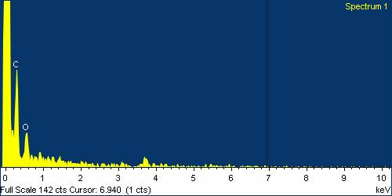
5(a)
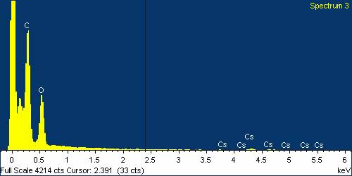  5(b) | 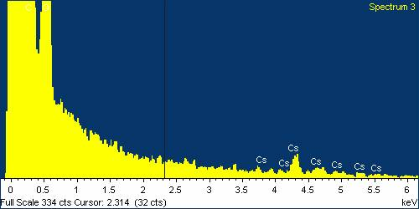  5(c)

Fig. S2 Energy dispersive X-ray (EDS) spectrum of (a) RF resin, (b) & (c) Cs adsorbed RF resin.

Fig. S3 γ-spectra of the ¹²⁵I solution recorded in LEP detector

Fig. S4 Paper electrophoresis pattern of ¹²⁵I on application of 400 V for 1 h and using phosphate buffer at pH ~7.5 as the electrolyte

