Supplemental Figure 1: Reproducibility between experiments for CIS and DOX.
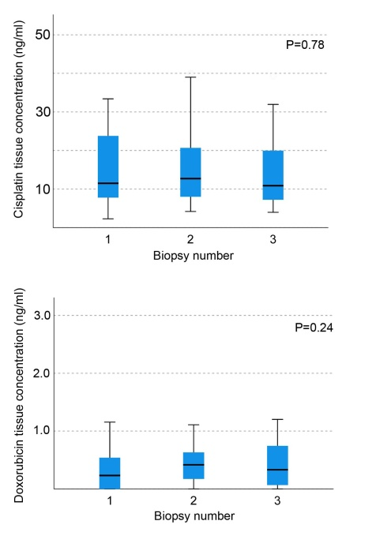
Supplemental Figure 2: Results reproducibility between the three locations on the eIBUB model (top, middle and bottom) for cisplatin and doxorubicin.
