Supplementary Appendix 2: Geographic survey distribution

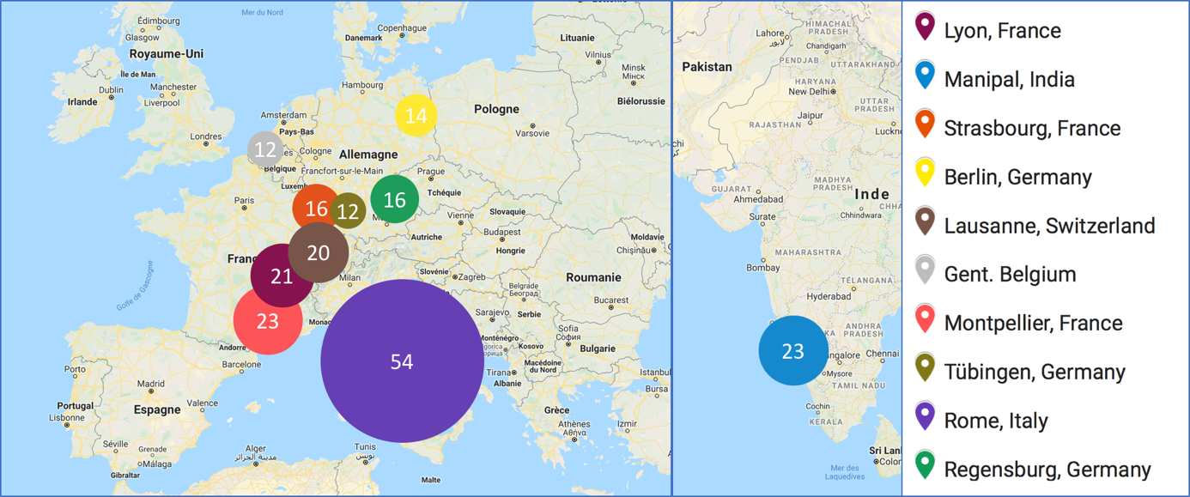

Data is outlined as number of survey participant, along with sizing cricles

Supplementary Appendix 3 : Reasons not to use potentially protection measures.
 | HIPEC | PIPAC | p-value
Not available | 31.4% | 27.6% | 0.04
Not in protocol | 29.7% | 29.2% | 0.79
Not useful | 11.4% | 11.2% | 0.84
Not at risk | 10.4% | 11.1% | 0.53
Uncomfortable | 2.9% | 2.6% | 0.63
Oversight | 3.5% | 2% | 0.03
No Explantation | 10.8% | 16.6% | <0.01

Data outlined in percentages of overall mean response.

