Online appendix 1 Survey
Priorities, actions and risks in the COVID-19 pandemic: a flash SoMe survey among surgical oncologists

Delia Cortés Guiral, Olivia Sgarbura, Mohammad Alyami, Fabian Grass, Martin Hübner

Dear colleagues:
The COVID-19 pandemic changed our professional and private lives within only a couple of weeks and the duration is uncertain. Radical measures needed to be taken in most countries to (I) contain infectious spread and (II) to increase/shift resources from most domains to emergency units and intensive care aiming to avoid a collapse of health care systems, exhaustion of care takers and to minimize the number of avoidable COVID-19 deaths due to insufficient resources.
The general principle of patient care “primum not nocere” is challenged in COVID-19 times, as most of the measures come at a price and medical, economic and socio-cultural consequences are tremendous but yet of unknown extent. For example, a compromise of cancer care is already reality in this early phase which risks to be only the beginning of a long and painful road!
This flash survey aims to open a differentiated discussion of values, priorities and necessary measures to cope with COVID-19 without jeopardizing cancer care and the economic and social fundaments of our societies.

Your answers are extremely valuable, this survey takes 5-7 min to be filled, we do appreciate your collaboration

Demographic data:

Your country:

Your center is:
- An academic hospital
- A Cancer Center
- A private hospital
- A local/regional public hospital
You are:
- General surgeon dealing with cancer
- Surgical oncologist

You are super specialized in one of the following (please choose max 3):
- Colorectal cancer
- Upper GI cancer
- HPB cancer
- Gynecological surgical oncologist
- Breast surgical oncologist
- Thoracic surgical oncologist
- Peritoneal malignancies specialist
- Not super specialized

Experience level:
- Resident
- Fellow
- Consultant

- Guiding principles
Please rank the following values according to their priority:
1 Save the most lives
2 Save the most life-years
3 Avoid collapse of the health care system
4 Protect health care workers
5 Maintain normal socio-cultural life, including schools/universities
6 Limit economic consequences including recession, bankruptcy, and unemployment

Are your priorities likely to change upon duration of the crisis?
Yes No

- Measures of containment
Please rate your support for the following measures of containment on a scale from …
_____________________________________________________________
0 1 2 3 4 5 6 7 8 9 10
Not justified Inevitable
… and declare the acceptable duration for these measures by weighing expected positive effects but also negative consequences.
2 weeks 6 weeks 3 months as long as needed

- Canceling of large public events like medical meetings and sports events
- Prohibition of traveling and closing of borders
- Closure of schools and universities
- Lock-down of social and economic life
- Handy tracking (or similar methods) to identify and sanction dissenters

- Shifting resources
Please rate your support for the following actions to shift resources on a scale from …
_____________________________________________________________
0 1 2 3 4 5 6 7 8 9 10
Not justified Inevitable
… and declare the acceptable duration for these measures by weighing expected positive effects but also negative consequences.
2 weeks 6 weeks 3 months as long as needed

- Shut-down of elective surgery program
- Deferring or modification of cancer care
Have you already changed your strategies during the current crisis?
Yes No
Please describe shortly:

- Perspective

Please give us your estimate for the duration of COVID-19 crisis and measures in your country:
- Back to normal in sociocultural life
- Back to normal in cancer care
- Back to your normal surgical practice
- Back to medical and surgical meetings

6 weeks 3 months 6months 1 year or longer

- Current management
Please tell us about the specific management for cancer patients requiring surgical treatment in your country/hospital
- Surgical treatment for cancer patients in covid-free centers
- Surgical treatment is delayed but already scheduled within the next 3 months for all patients
- Cancellation (postoponed without new appointment for surgery) of most oncologic surgeries
- starting or prolonging the new-adjuvant therapy
- Other strategies please describe shortly
Thank you for your collaboration

Online appendix 2 Demographics of the responders

- Country of origin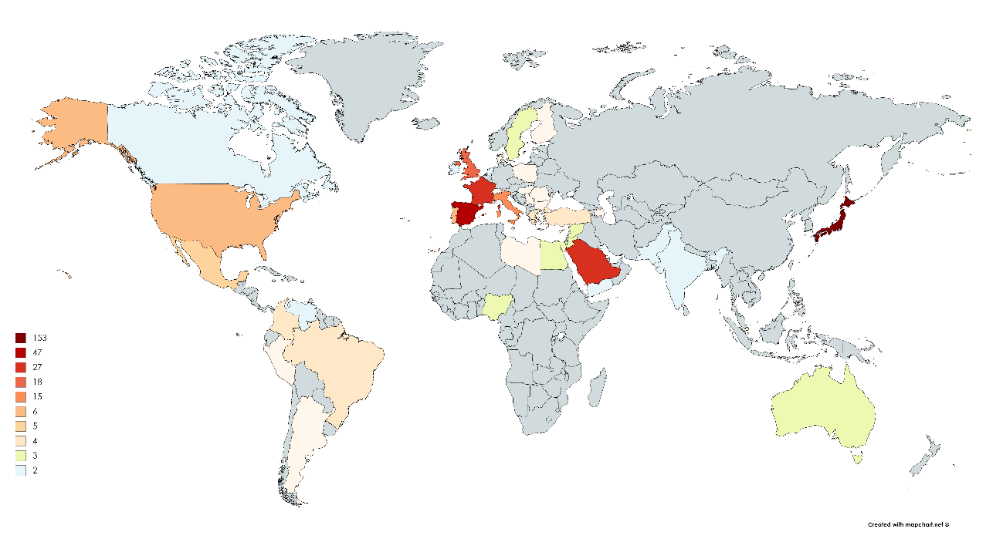
- Hospital setting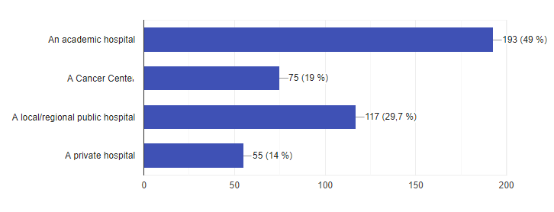
- Main activity
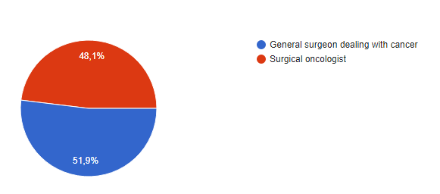
- Prevalence of sub-specialty
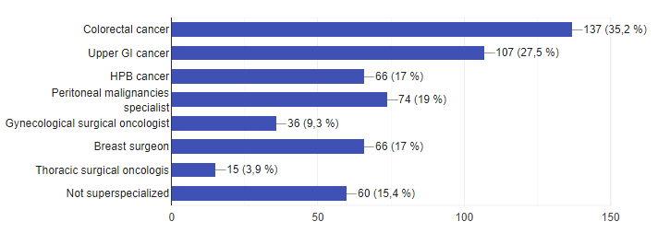
- Level of experience / position
