Supplementary Material
Curcumin-encapsulated Pluronic micelles in chitosan/PEO nanofibers: a controlled release strategy for wound healing applications
Zahra Kharat et al.
DOI 10.1515/polyeng-2024-0182

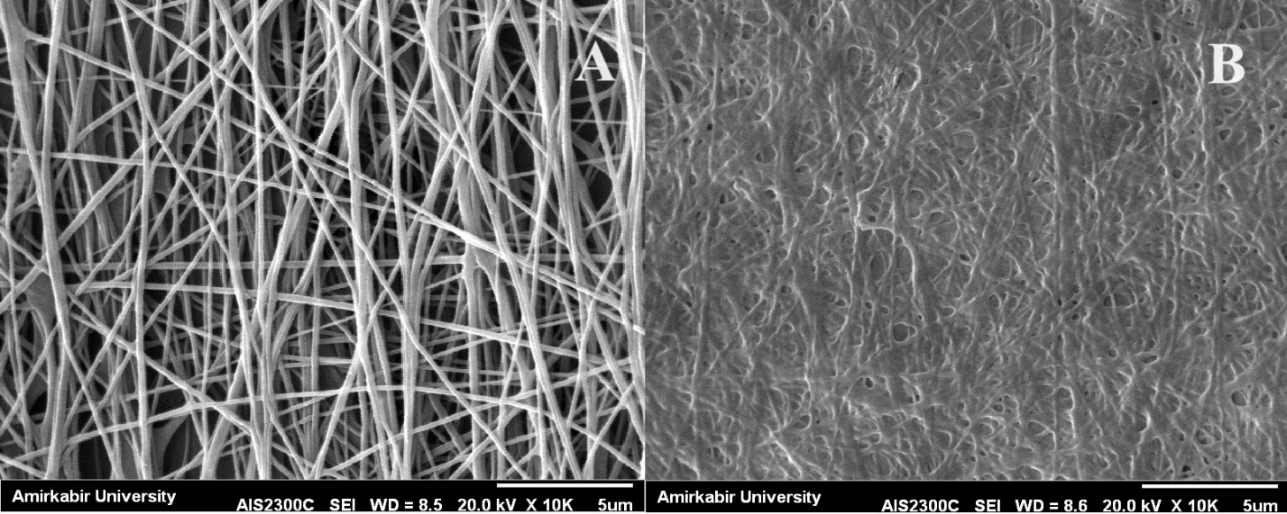

Supplementary Figure S1: SEM images of nanofibers (A) cross-linked and (B) non-cross-linked after 24 h of immersion in water. The lost fibrous structure of the non-cross-linked sample is clearly visible.

