**Supplementary Material**

**Modification of natural pigskin collagen via cryogrinding: a focused study on its physiochemical properties**

Yuling Xu et al.

DOI 10.1515/polyeng-2022-0269

**Supplementary Table** S**1:** Collagen purity and extraction rates.

|  |  |  |  |  |  |
| --- | --- | --- | --- | --- | --- |
| **Sample** | **Control group (%)** | **G3 (%)** | **G5 (%)** | **G10 (%)** | **G20 (%)** |
| Purity | 98.2±1.0 | 99.8±0.3 | 95.4±1.5 | 99.6±0.6 | 99.5±0.8 |
| Extraction rate | 22±2.0 | 32±1.0 | 35±2.0 | 37±1.0 | 40±2.0 |

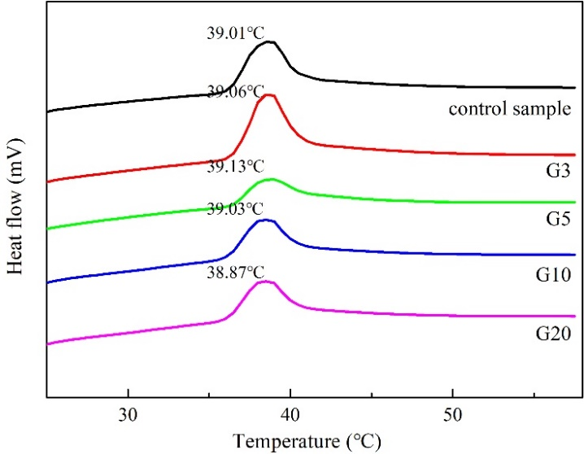

**Supplementary Figure S1:** DSC curves of the ground collagens.

**Thermostability test method**

Collagen samples (10 mg) were transferred into 400 μL of pre-cooled 0.1 M acetic acid and dissolved at a low temperature (2–10oC) until they became semi-transparent gels. DSC (Q2000, TA Instruments, USA) was harnessed to discriminate the thermal stability of samples with an empty aluminum box being the blank. The heating rate was 5oC/min with a nitrogen flow rate of 20 mL/min within 20–60oC.

**Thermostability test analyses**

Based on the DSC curves of samples depicted in Supplementary Figure S1, it is clear that there is no significant difference among samples regarding the thermal denaturation temperature; that is to say, grinding treatment does not change the thermal stability of collagen.