Supplementary Material

Enhancement of thermal conductivity in polymer composites by maximizing surface-contact area of polymer-filler interface
Vijendra Kumar et al.
DOI 10.1515/polyeng-2022-0005

1. Heat transfer equations
In this section we describe the equations governing the heat transfer in 3-D geometries. Fig. 1 shows a schematic diagram which has been used as our model system to describe the heat conduction from the top to the bottom surface in the composite-polymers considered in the present manuscript. The heat-flux is constrained in only one direction (i.e., from top to bottom surface or from left to the right surface) and the corresponding heat equations are modified with the suitable boundary conditions. All the other surfaces are considered to be insulated and do not conduct heat flux, hence the corresponding boundary conditions for heat flux from these surfaces are set to be zero.
As shown in Fig. 1, in the generation of the three-dimensional cubic cell, the heat transfer in the base or at the bottom surface of the polymer matrix is satisfied by the following equation:
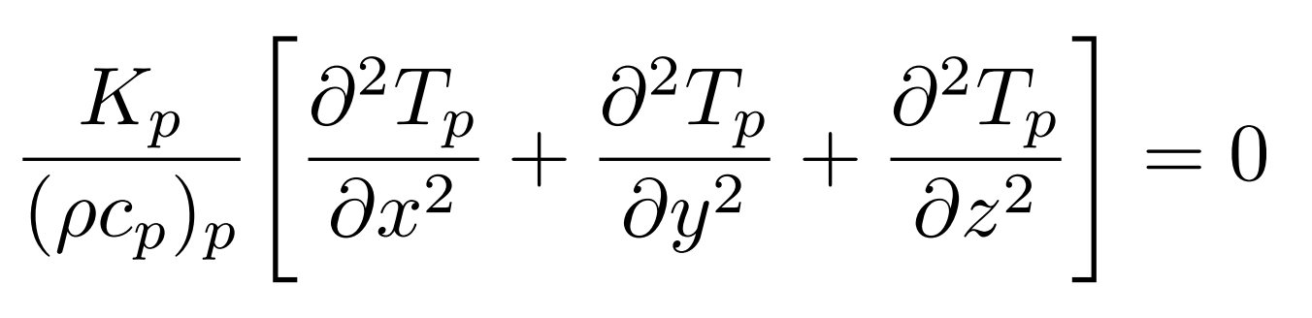 (1)
where T is the temperature and x, y, z are the spatial coordinates. The subscript p here refers to the base polymer-matrix. The parameter such as K refers the thermal conductivity, ρ is the density and c_{p} is the specific heat. These parameters better reflect the local properties of the 3D grid cell. In our numerical simulations the thermal conductivity of the matrix-polymer K_{p} is set to the 0.29 W/m-K which corresponds to the thermal conductivity of the polyethylene.
The heat transfer equation corresponding to the high conducting filler materials similar to the Eq. (1) and is given by:
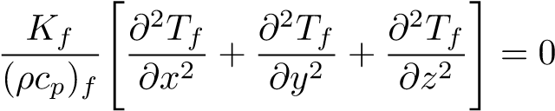. (2)
Here the subscript f refers the filler. The filler material used in the current study is the Aluminium, and the corresponding thermal conductivity K_{f} is given as 205.0 W/m-K. Note that Aluminium is very soft and non-magnetic metal. It can be given any shape due to its soft and ductile nature. Also, Aluminium is used as a good heat-exchanger in many devices due to it’s high conductivity and low-cost alternative. Although copper is the excellent thermal conductor (385.0 W/m-K) but it is less cost-effective and hence not widely used on the large scale. Other metals which can be used as filler materials are brass (109.0 W/m-K), iron (79.50 W/m-K), and steel (50.20 W/m-K) but their thermal conductivities are very low. The boundary condition for

flux
G
F
C
B
H
E
D
A
X
Z
Y

Supplementary Figure S1: A schematic diagram representing the polymer-composite in the shape of a cubical box. The box is made of polymer and metallic fillers in various shapes are filled within the box (discussed and shown in the later sections). The top and bottom surfaces represent the two different temperatures which provide the gradient for heat flux. The direction of heat-flux is in the negative y-direction as marked by an arrow. Top surface is kept at the constant temperature which is set to be T = 400 K.

the top surface ABCD corresponds to the constant temperature which is set at T = 400 K. Another boundary condition for the bottom surface EFGH is through convective heat transfer with a constant heat-transfer coefficient.
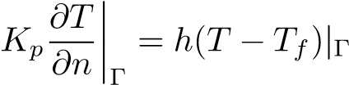. (3)
Here the convective heat transfer coefficient h, and the ambient extensive temperature T_{f} are set to be constants. In our numerical simulations, we have set h to be 20 W/m²k, and T_{f} is set to be 300K. Apart from these two specific boundary conditions (i.e., for top and bottom surfaces), we have four more boundary conditions for the remaining planes corresponding to each of the following surfaces EDAH, CDEF, BCFG, and ABGH, which can be written as,
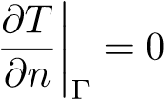. (4)
Here Γ represents the four surfaces mentioned above. These boundary conditions clearly mention that the surfaces are adiabatic and there is no heat flux through these surfaces.

2. Heat transfer coupling
Note that at the interface of the polymer and filler material, i.e., at the contact surface area, the heat-flux is same. Heat-flow in the base polymer and the filler are thus coupled. This coupling is very important to determine the effective thermal conductivity of the composite polymer-filler material. This can be written explicitly as follows
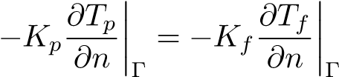 (5)
where subscript Γ represents the contact surface amid the base matrix and the fillers. When the temperature fields in the cell are calculated, the effective thermal conductivity in z direction for the cell is estimated by the following equation.
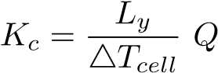 (6)
where ∆T is the mean temperature difference between the top and bottom surface of the cell. The surface represents the area of the plane such as L_{x}L_{y}. Dimensions along the x axis is L_{x}, dimensions along the y axis is L_{y} and dimensions along z axis is L_{z} which are the cell length, height and width respectively. We also write the thermal conductivity explicitly as
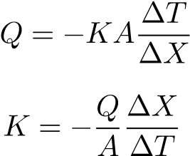
(7)
(8)
where K is thermal conductivity (W/m-k), and Q is the total heat transfer. ∆T is the difference in temperature T₂−T₁. T₁ is fixed at 400K, and T₂ is variable. A = area = 0.01 x 0.01 m². ∆X is thickness through which heat conduction takes place(m) = (0.01 m). here K=K_{c} (thermal conductivity of composites material, and K_{c}/K_{p} is the relative thermal conductivity. The three-dimensional conduction heat transfer Eqns. (1)-(2) are solved for the base polymer where K_{f} = K_{p}. The boundary condition to solve above equation is that between the planes Γ= ABCD, EFGH heat transfer is by convection.
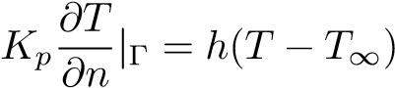. (9)
The top surface is maintained at a temperature 400K. The other four surface of the composite cube are assumed adiabatic. i.e for all four planes Γ⁰= EHDA, HGCD, FGCB, and EFBA, we have
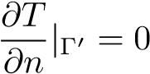. (10)
Heat flux at the interface, i.e., at the contact between filler and polymer surfaces are same. This can be expressed as 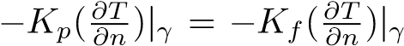. Now by using heat transfer equations and the above-mentioned boundary conditions the average temperature in the composite is calculated using the flux between the top and bottom of the polymer composites. The effective thermal conductivity is calculated in the negative Z-direction.
In Supplementary Figure S2, we have shown the 3-D temperature contours for the composite polymer comprising a single hollow box and a single hollow cylinder respectively.
Supplementary Figure S2: (a)The three-dimensional temperature contour showing the temperature variation along the heat flux and provides temperature gradient from top to the bottom surface in the static condition for a filler in the shape of hollow single box. The top surface represents the maximum temperature kept constant at 400 K which is uniform across the surface. Filler size is 0.5x0.5x0.5 cm³. (b) The three dimensional temperature contour showing the variation in the temperature across the flow. The temperature difference between the two horizontal cross sections provide gradient from top to the bottom surface in the static condition for hollow single cylinder filler. The top surface is set at constant temperature T = 400K which is uniform across the surface. filler size is 0.5x0.5x0.5 cm³.
Supplementary Figures S3, S4 and S5 correspond to the 2-D temperature contours for the fillers discussed in Figure 1. Note that Figure 5c corresponds to the single hollow cylinder of volume percent 9%.
Supplementary Figure S3: The two-dimensional temperature contours of a cross-section in the z-y plane (x = 0:5 lx) for the composite polymer representing the heat flux from the top to the bottom surface. The horizontal lines show the variations of temperature across the surface at different vertical length. The figure corresponds to the (a) hollow box, filler content: 6%, size: 0.5 × 0.5 × 0.5 cm³. (b) hollow cylinder, filler content: 6%, filler height: 0.5cm. (c) generalized box, filler content: 6% by volume fraction, filler height: 0:5 cm.
Supplementary Figure S4: The two-dimensional temperature contours for the cross-section in the z-y plane (x = 0.5 l_{x}) corresponding to polymer-composite having the fillers as (a) solid multiple boxes, filler content: 6%, filler height: 0.5cm. (b) I-shape filler, filler content: 6%, filler height: 0.5cm. (c) T-shape filler, filler content of 6% by, filler height is 0.5 cm.
Supplementary Figure S5: The two-dimensional contour of temperature (K) of the composite polymer for the cross-section in (a) z-x plane (y = 0.5 l_{y}) corresponding to Y-shape filler, filler content 6% by volume fraction, filler height is 0.5cm. (b) z-y plane (x = 0.5 l_{x}) corresponding to the spherical shape filler, filler content: 6% by volume fraction, radius: 0.278cm. (c) x-y plane (z = 0.5 l_{z}) corresponding to the hollow cylinder filler, filler content 9% by volume fraction, filler height: 0.8cm.
Supplementary Figure S6: The two dimensional temperature contour for the cross-section in z-y plane (x = 0.5 l_{x}) for the filler corresponding to (a) capsule-shape, filler content: 9% by volume fraction, base length: 0.22242 cm. (b) octahedron-shape, filler content: 9% by volume fraction, base length: 0.647 cm. (c) cube-shape, filler content: 9% by volume fraction, base length: 0.596 cm. (d) tetrahedron-shape, filler content: 9% by volume fraction, base length: 0.44814 cm.
Supplementary Table S1: The different correlation models used often in the literature for the
calculation of effective thermal conductivity.
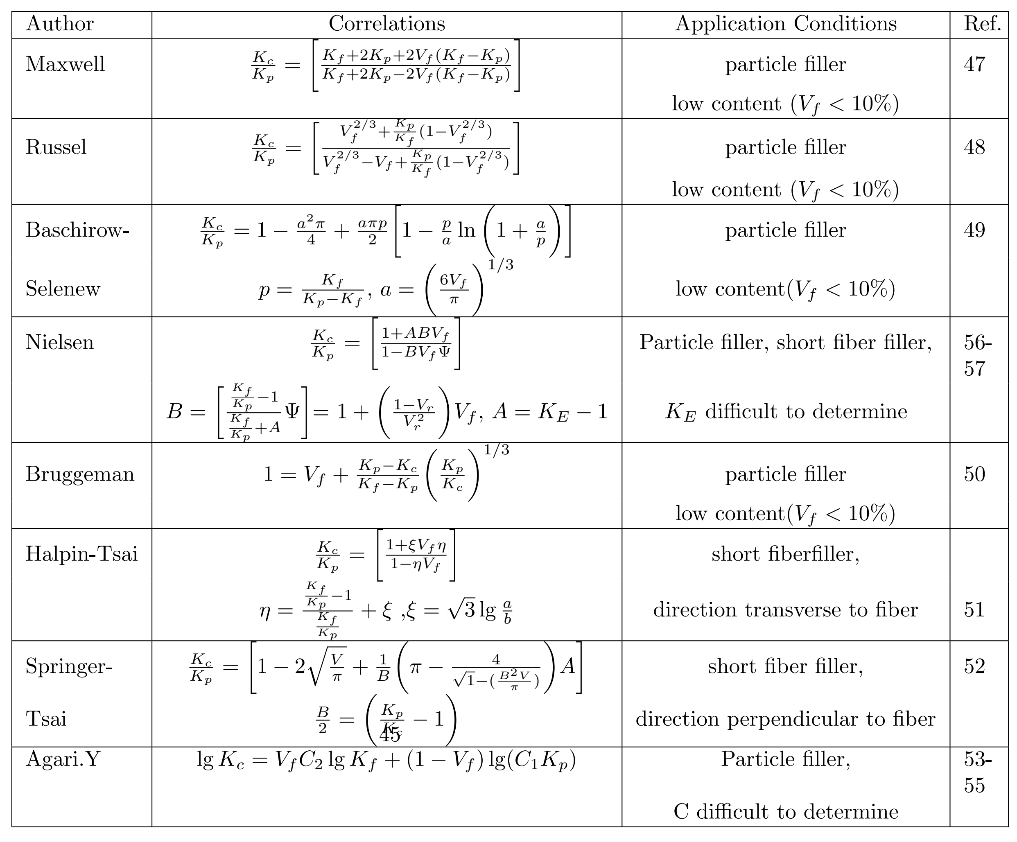

Supplementary Table S2: Parallel sheet with 2% filler by volume in composite polymer.
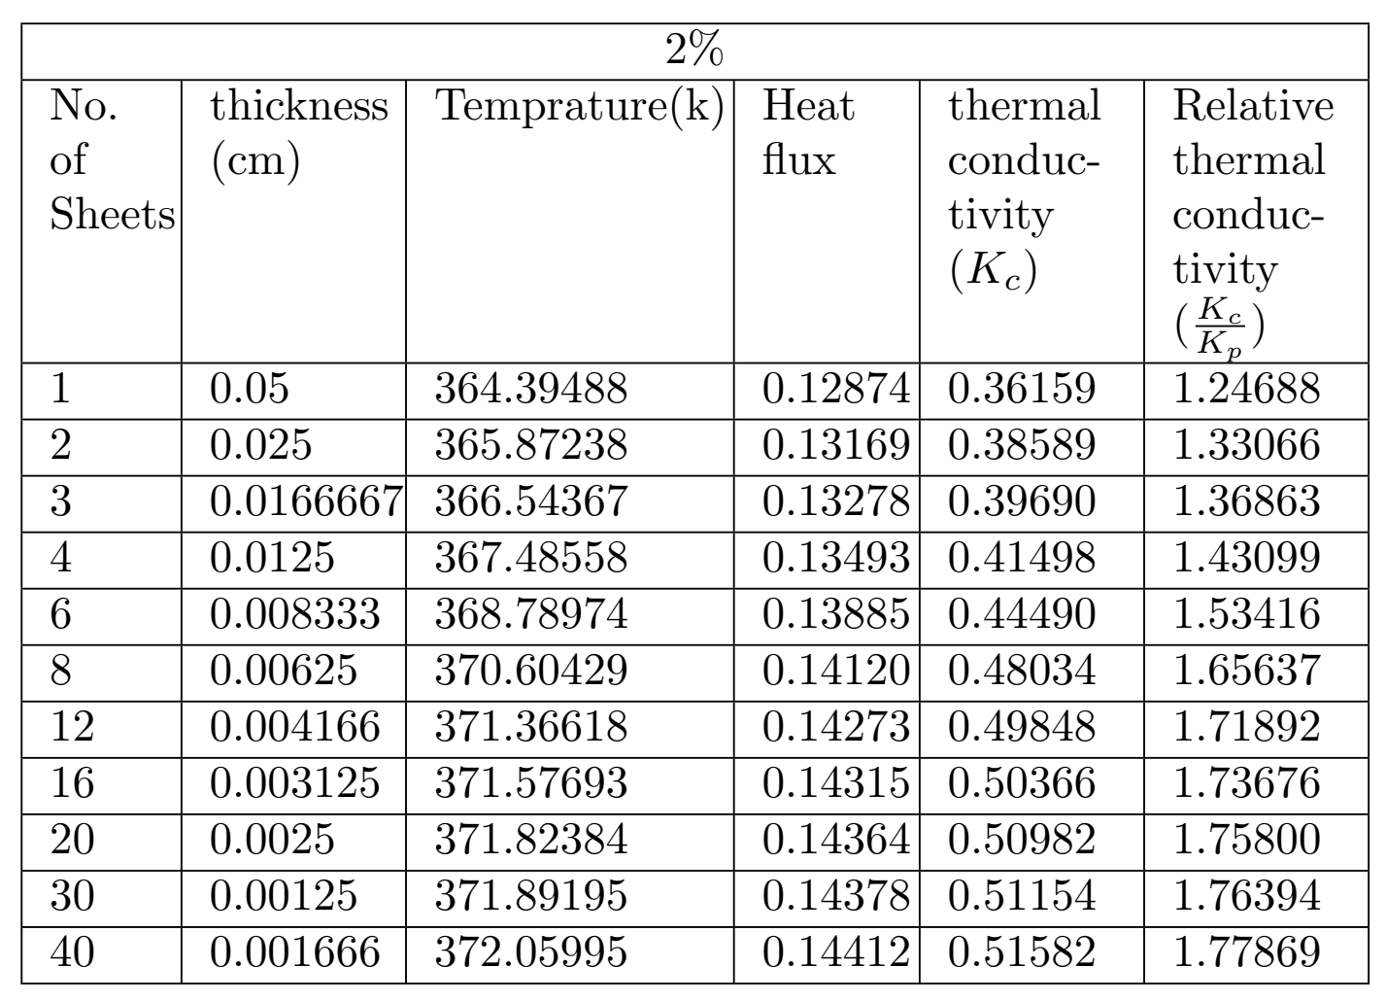

Supplementary Table S3: Parallel sheet with 6% filler by volume in composite polymer.
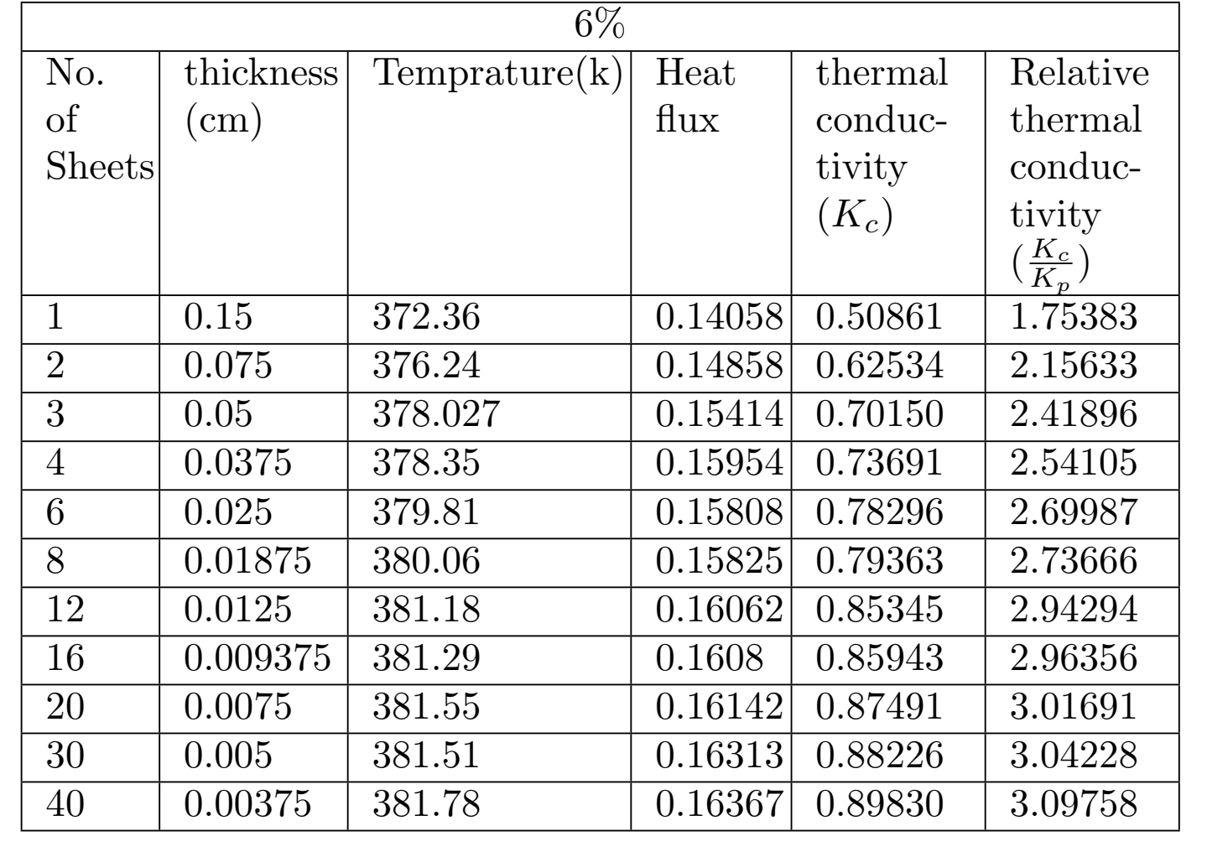

Supplementary Table S4: Parallel sheet with 9% filler by volume in composite polymer.
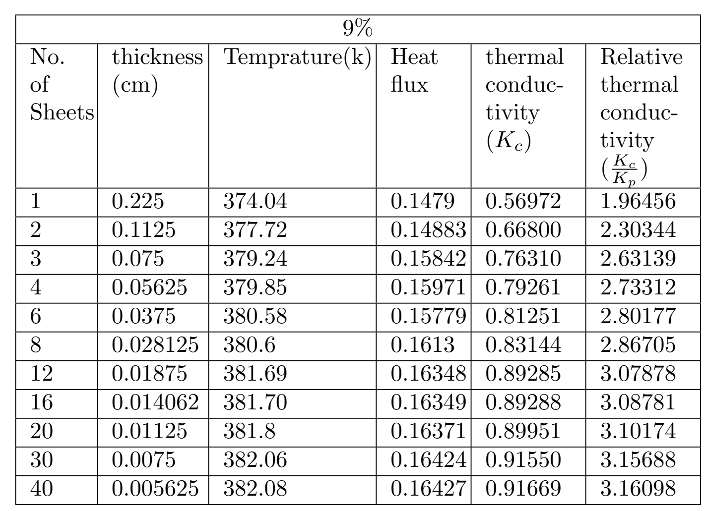

Supplementary Table S5: Fixed parallel sheets of different volume fraction in composite polymer.
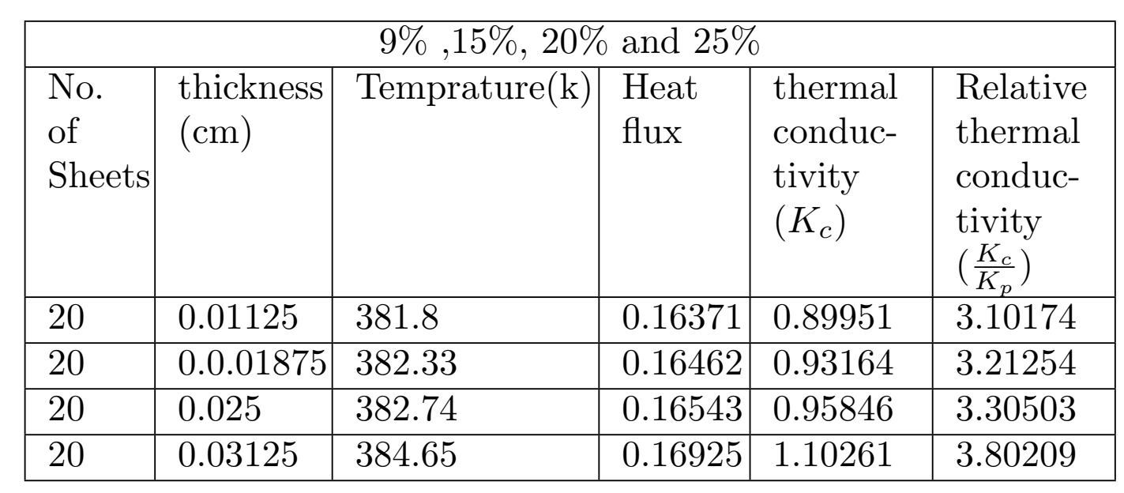

Supplementary Table S6: Parallel cylinder with 4% filler by volume in composite polymer.
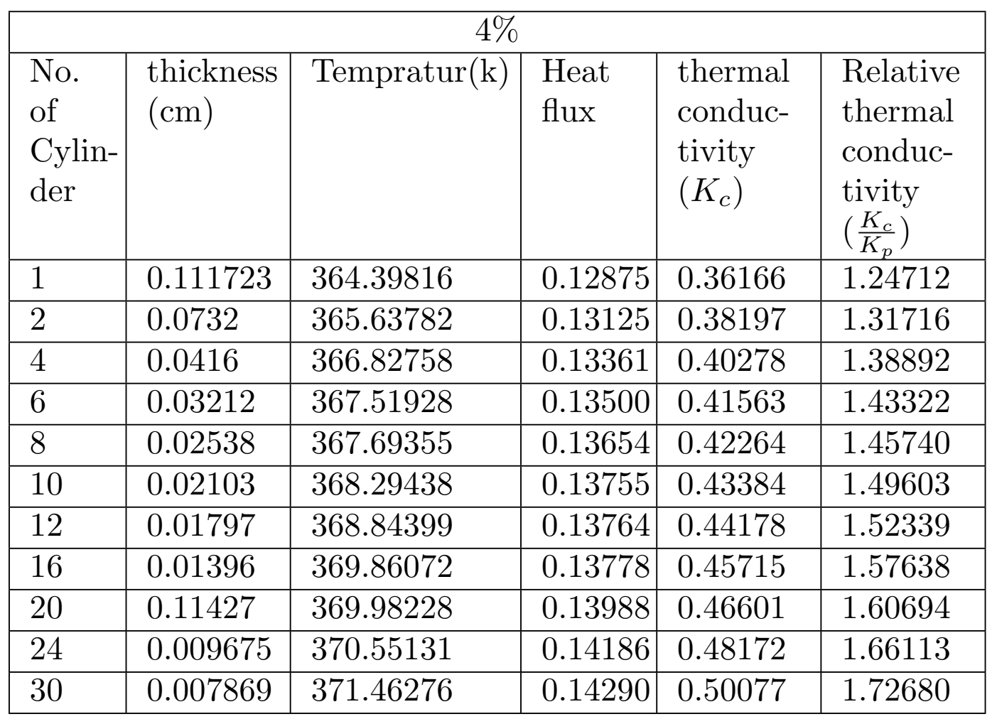

Supplementary Table S7: Parallel cylinder with 6% filler by volume in composite polymer.
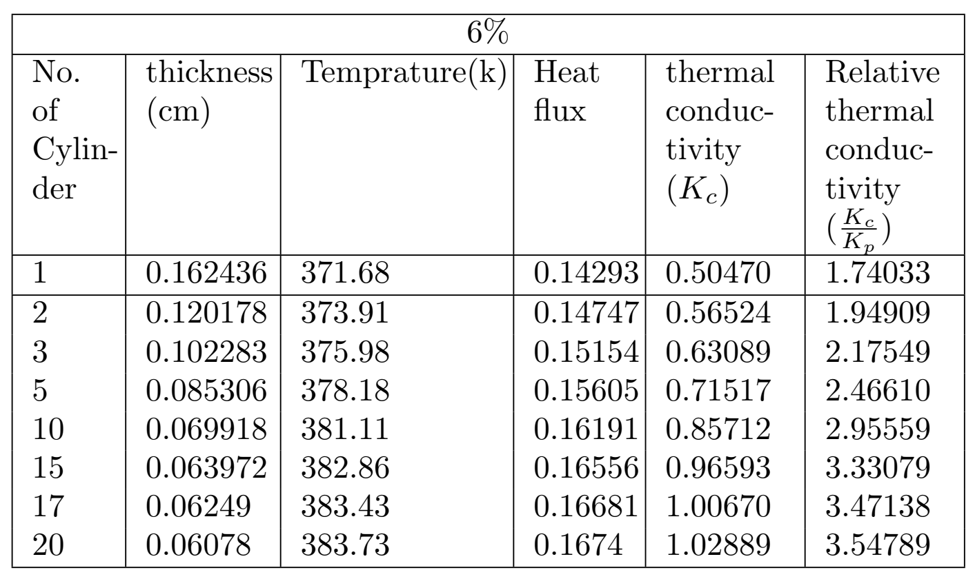

Supplementary Table S8: Parallel cylinder with 9% filler by volume in composite polymer.
