Supplemental information

Synthesis of cashew Mannich polyol via a three step continuous route and development of polyurethane rigid foams with mechanical, thermal and fire studies
Tejas S. Gandhi, Mayank R. Patel and Bharatkumar Z. Dholakiya
DOI: 10.1515/polyeng-2014-0176

Figure S1 IR spectrum of N-(2-hydroxyethyl)-1, 3-oxazolidine, the peak at, IR (KBr, ῡ cm⁻), strong absorption at 1654 cm⁻¹ (C=N imines group).

Figure S2 IR spectra of Mannich base. IR spectrum of the Mannich base from cardanol contained peaks at (m,cm-1): 3349 (-OH), 2925 (-C=C-), 2854 (-C-H), 1584 (phenyl ring), 1378(-C-N), 1274 (-C-O), and 1074 (conjugated double bond).

Figure S3 ¹H-NMR spectra of Mannich base. The Mannich base from cardanol contained peaks at ¹H-NMR (400 MHz-DMSO), 1.53-1.56δppm(3H, -CH₃), 2.56-3.75 δ ppm (2H, =N-CH₂), 5.29-5.38δppm (6H –C=C-), 6.5δ ppm (1H-Ar-OH),6.5-7.87 (Ar-H).

Figure S4 IR spectra of Mannich polyol. IR spectrum of Mannich polyol, the peak at, IR (KBr, ῡ cm⁻), 3367 (-OH), 3009 (-C-H), 2923 (-C-C-), 2852 (-C=C-), 1585 (Phenyl ring), 1454 (-C-N), 1270 (-C-O-), 1070 (conjugated double bond).

Figure S5 ¹H-NMR spectrum of Mannich polyol. ¹H-NMR Mannich polyol from Mannich base with ethylene oxide, ¹H-NMR (400 MHz-DMSO), 0.88-1.27 δppm (3-H,-CH₃), 1.30-1.55 δppm (-CH₂-CH₂-linkage), 2.75-2.84 δppm (6H,=N-(CH₂)₃), 3.30-3.74 δppm (-CH₂-CH₂-OH), 5.41-5.86 δppm (Ar-H),6.52-6.62 δppm (branch -OH).

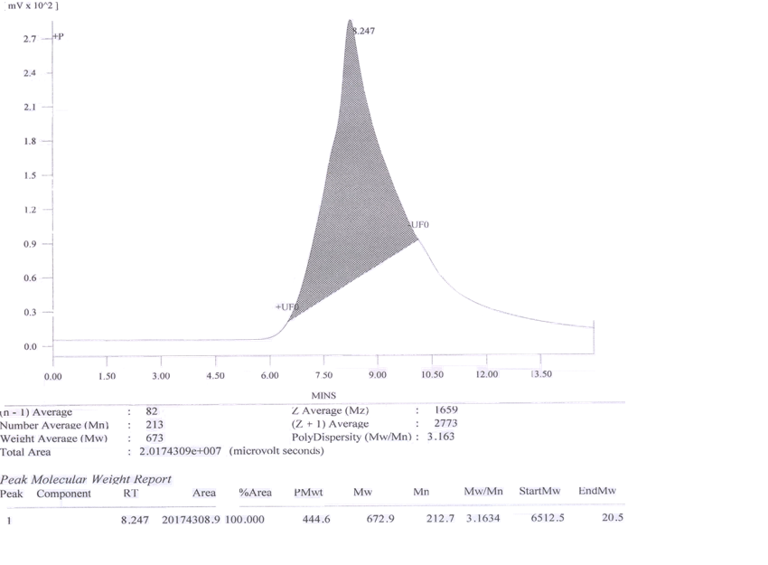

Figure S6 Molecular weight of cashew Mannich polyol.

Figure S7 Characterization image of instruments.

