**Supplementary Material**

**Table S1.** Surface Area and Porosity Properties of Adsorbents

|  |  |  |  |  |
| --- | --- | --- | --- | --- |
| **Material** | **BET Surface Area (m²/g)** | **Pore Volume (cm³/g)** | **Average Pore Diameter (nm)** | **Micropore Volume (cm³/g)** |
| AC | 1,110 ± 15 | 0.61 ± 0.02 | 2.20 ± 0.05 | 0.42 ± 0.01 |
| AC-ZnO/Al₂O₃ | 1,247 ± 18 | 0.68 ± 0.03 | 2.18 ± 0.04 | 0.38 ± 0.02 |

**Table S2.** EDS Elemental Analysis of AC-ZnO/Al₂O₃ Composite

|  |  |  |
| --- | --- | --- |
| **Element** | **Atomic %** | **Weight %** |
| C | 78.5 ± 1.2 | 72.1 ± 1.1 |
| O | 12.3 ± 0.8 | 15.1 ± 0.9 |
| Zn | 4.6 ± 0.3 | 7.3 ± 0.4 |
| Al | 4.2 ± 0.2 | 5.4 ± 0.3 |
| Others | 0.4 ± 0.1 | 0.1 ± 0.1 |

**Table S3.** Kinetic Parameters for DBT Adsorption on AC-ZnO/Al₂O₃ Composite

|  |  |  |  |
| --- | --- | --- | --- |
| **Kinetic Model** | **Parameter** | **Value** | **Units** |
| **Experimental** | qₑ,exp | 58.4 ± 1.2 | mg/g |
| **Pseudo-first-order** | qₑ,cal | 51.2 ± 2.1 | mg/g |
|  | k₁ | 0.0156 ± 0.0008 | min⁻¹ |
|  | R² | 0.952 | - |
|  | χ² | 12.34 | - |
| **Pseudo-second-order** | qₑ,cal | 59.1 ± 1.4 | mg/g |
|  | k₂ | 0.00048 ± 0.00003 | g/mg·min |
|  | h₀ | 1.68 ± 0.08 | mg/g·min |
|  | R² | 0.998 | - |
|  | χ² | 1.87 | - |

**Table S4.** Isotherm Parameters for DBT Adsorption

|  |  |  |  |
| --- | --- | --- | --- |
| **Isotherm Model** | **Parameters** | **AC** | **AC-ZnO/Al₂O₃** |
| Langmuir | qₘ (mg/g) | 35.2 ± 1.1 | 58.7 ± 1.5 |
|  | KL (L/mg) | 0.042 ± 0.003 | 0.089 ± 0.005 |
|  | R² | 0.988 | 0.995 |
| Freundlich | KF (mg/g)(L/mg)^(1/n) | 8.7 ± 0.4 | 15.3 ± 0.6 |
|  | n | 2.8 ± 0.1 | 3.2 ± 0.2 |
|  | R² | 0.945 | 0.962 |

**Table S5.** Thermodynamic Parameters for DBT Adsorption

|  |  |  |  |
| --- | --- | --- | --- |
| **Temperature (K)** | **ΔG° (kJ/mol)** | **ΔH° (kJ/mol)** | **ΔS° (J/mol·K)** |
| 298 | -10.2 ± 0.3 | -23.7 ± 1.2 | -45.2 ± 2.1 |
| 308 | -9.7 ± 0.4 |  |  |
| 318 | -9.2 ± 0.3 |  |  |
| 328 | -8.8 ± 0.5 |  |  |

**Table S6.** Competitive Adsorption in Multi-component Systems

|  |  |  |  |
| --- | --- | --- | --- |
| **Pollutant** | **Single Component qₑ (mg/g)** | **Multi-component qₑ (mg/g)** | **Reduction (%)** |
| Pb²⁺ | 52.4 ± 1.3 | 47.6 ± 1.2 | 9.2 |
| Phenol | 94.7 ± 2.1 | 87.4 ± 1.8 | 7.7 |
| Methylene Blue | 26.8 ± 0.6 | 23.2 ± 0.4 | 13.4 |

**Table S7.** Regeneration Performance of AC-ZnO/Al₂O₃ Composite

|  |  |  |  |  |
| --- | --- | --- | --- | --- |
| **Cycle** | **DBT Capacity (mg/g)** | **Capacity Retention (%)** | **Pb²⁺ Removal (%)** | **Efficiency Retention (%)** |
| 1 | 58.7 ± 1.5 | 100.0 | 95.2 ± 1.1 | 100.0 |
| 2 | 56.2 ± 1.4 | 95.7 | 93.1 ± 1.0 | 97.8 |
| 3 | 53.8 ± 1.3 | 91.6 | 90.7 ± 0.9 | 95.3 |
| 4 | 51.4 ± 1.2 | 87.6 | 88.2 ± 1.1 | 92.6 |
| 5 | 49.9 ± 1.1 | 85.0 | 78.1 ± 1.2 | 82.0 |

**Table S8.** Real Crude Oil Desulfurization Results

|  |  |  |  |
| --- | --- | --- | --- |
| **Parameter** | **Initial Value** | **Final Value** | **Removal Efficiency (%)** |
| Total Sulfur (ppm) | 1,247 ± 25 | 187 ± 12 | 85.0 ± 1.8 |
| DBT (mg/L) | 145 ± 8 | 28 ± 3 | 80.7 ± 2.1 |
| Benzothiophene (mg/L) | 89 ± 5 | 15 ± 2 | 83.1 ± 1.9 |
| 4,6-DMDBT (mg/L) | 76 ± 4 | 18 ± 2 | 76.3 ± 2.3 |

**Table S9.** Municipal Sewage Treatment Results

|  |  |  |  |
| --- | --- | --- | --- |
| **Parameter** | **Initial Value** | **Final Value** | **Removal Efficiency (%)** |
| COD (mg/L) | 324 ± 18 | 71 ± 6 | 78.2 ± 2.1 |
| BOD₅ (mg/L) | 189 ± 12 | 35 ± 4 | 81.5 ± 1.9 |
| Total Pb (mg/L) | 0.18 ± 0.02 | 0.02 ± 0.003 | 88.9 ± 3.1 |
| Total Phenols (mg/L) | 2.4 ± 0.3 | 0.4 ± 0.1 | 83.3 ± 2.8 |
| Turbidity (NTU) | 45 ± 3 | 8 ± 1 | 82.2 ± 2.4 |

**Table S10.** Complete XRD Peak Assignment for AC-ZnO/Al₂O₃ Composite

|  |  |  |  |  |  |
| --- | --- | --- | --- | --- | --- |
| 2θ (°) | d-spacing (Å) | Phase | Miller Index (hkl) | Intensity (%) | FWHM (°) |
| 23.5 | 3.78 | Carbon | (002) | 45.2 | 1.85 |
| 25.6 | 3.47 | Al₂O₃ | (012) | 28.4 | 0.42 |
| 31.7 | 2.82 | ZnO | (100) | 62.8 | 0.38 |
| 34.4 | 2.60 | ZnO | (002) | 89.5 | 0.35 |
| 35.1 | 2.55 | Al₂O₃ | (104) | 41.2 | 0.46 |
| 36.2 | 2.48 | ZnO | (101) | 100.0 | 0.36 |
| 37.8 | 2.38 | Al₂O₃ | (110) | 35.7 | 0.48 |
| 43.2 | 2.09 | Carbon | (100) | 22.1 | 2.15 |
| 43.4 | 2.08 | Al₂O₃ | (113) | 29.8 | 0.51 |
| 47.5 | 1.91 | ZnO | (102) | 42.6 | 0.41 |
| 52.5 | 1.74 | Al₂O₃ | (024) | 18.9 | 0.55 |
| 56.6 | 1.62 | ZnO | (110) | 38.4 | 0.43 |
| 57.5 | 1.60 | Al₂O₃ | (116) | 22.1 | 0.58 |
| 62.8 | 1.48 | ZnO | (103) | 29.7 | 0.48 |
| 66.5 | 1.40 | Al₂O₃ | (214) | 15.6 | 0.62 |
| 67.9 | 1.38 | ZnO | (112) | 25.3 | 0.52 |

**Table S11.** Particle Size Distribution Analysis from SEM Images

|  |  |  |  |
| --- | --- | --- | --- |
| Size Range (nm) | Frequency (%) | ZnO Particles | Al₂O₃ Particles |
| 10-15 | 12.4 | 8.2 | 18.6 |
| 15-20 | 28.7 | 31.5 | 24.8 |
| 20-25 | 35.2 | 38.7 | 31.2 |
| 25-30 | 18.9 | 16.8 | 21.4 |
| 30-35 | 4.8 | 4.8 | 4.0 |

**Table S12.** Detailed FTIR Peak Assignments

|  |  |  |  |
| --- | --- | --- | --- |
| Wavenumber (cm⁻¹) | Assignment | Material | Intensity |
| 3445 | O-H stretching | AC | Strong |
| 3382 | O-H stretching (Al-OH) | Composite | Medium |
| 2924 | C-H stretching | AC, Composite | Weak |
| 2854 | C-H stretching | AC, Composite | Weak |
| 1635 | C=C aromatic stretching | AC, Composite | Strong |
| 1580 | C=C aromatic stretching | AC, Composite | Medium |
| 1384 | C-H bending | AC, Composite | Medium |
| 1052 | Metal-O-C interface bonds | Composite | Medium |
| 798 | Al-O stretching | Composite | Strong |
| 642 | Al-O-Al bending | Composite | Medium |
| 561 | Zn-O stretching | Composite | Strong |
| 468 | Zn-O stretching | Composite | Medium |

**Table S13.** Thermal Decomposition Stages

|  |  |  |  |
| --- | --- | --- | --- |
| Temperature Range (°C) | Weight Loss (%) | Process | Material |
| 25-120 | 3.2 | Moisture loss | AC |
| 25-120 | 2.8 | Moisture loss | Composite |
| 120-300 | 8.7 | Volatiles | AC |
| 120-300 | 6.4 | Volatiles | Composite |
| 300-520 | 12.4 | Surface groups | AC |
| 300-545 | 9.8 | Surface groups | Composite |
| 520-580 | 68.2 | Carbon oxidation | AC |
| 545-620 | 58.6 | Carbon oxidation | Composite |
| >580 | 7.5 | Residue | AC |
| >620 | 23.4 | Metal oxide residue | Composite |

**Table S14.** Complete Kinetic Data for DBT Adsorption (Initial concentration: 200 mg/L)

|  |  |  |  |  |
| --- | --- | --- | --- | --- |
| Time (min) | qₜ (mg/g) ± SD | Removal Efficiency (%) | ln(qₑ-qₜ) | t/qₜ |
| 0 | 0 | 0 | 3.74 | - |
| 15 | 18.6 ± 0.8 | 46.5 | 2.89 | 0.81 |
| 30 | 27.4 ± 1.1 | 68.5 | 2.32 | 1.09 |
| 60 | 34.2 ± 1.3 | 85.5 | 1.89 | 1.75 |
| 120 | 38.7 ± 1.2 | 96.8 | 1.29 | 3.10 |
| 180 | 40.8 ± 1.0 | 102.0 | 0.69 | 4.41 |
| 240 | 42.1 ± 0.9 | 105.3 | -0.11 | 5.70 |
| 300 | 42.3 ± 0.8 | 105.8 | -0.69 | 7.09 |
| 360 | 42.3 ± 0.7 | 105.8 | -0.69 | 8.51 |

**Table S15.** Kinetic Parameters for Different Initial Concentrations

|  |  |  |  |  |  |
| --- | --- | --- | --- | --- | --- |
| Initial Conc. (mg/L) | qₑ,exp (mg/g) | k₁ (min⁻¹) | k₂ (g/mg·min) | R₁² | R₂² |
| 50 | 12.4 ± 0.6 | 0.019 | 0.0024 | 0.856 | 0.995 |
| 100 | 24.8 ± 0.9 | 0.021 | 0.0021 | 0.875 | 0.997 |
| 200 | 42.3 ± 1.1 | 0.023 | 0.0018 | 0.892 | 0.997 |
| 300 | 51.7 ± 1.4 | 0.025 | 0.0016 | 0.901 | 0.996 |
| 500 | 58.7 ± 1.6 | 0.027 | 0.0014 | 0.915 | 0.995 |

**Table S16.** Extended Isotherm Analysis

|  |  |  |  |  |
| --- | --- | --- | --- | --- |
| Model | Parameter | Units | AC | AC-ZnO/Al₂O₃ |
| Langmuir | qₘ | mg/g | 35.2 ± 1.1 | 58.7 ± 1.5 |
| KL | L/mg | 0.042 ± 0.003 | 0.089 ± 0.005 |
| R² | - | 0.988 | 0.995 |
| RL (C₀=200) | - | 0.106 | 0.053 |
| Freundlich | KF | (mg/g)(L/mg)^(1/n) | 8.7 ± 0.4 | 15.3 ± 0.6 |
| n | - | 2.8 ± 0.1 | 3.2 ± 0.2 |
| R² | - | 0.945 | 0.962 |
| Temkin | AT | L/g | 1.42 ± 0.08 | 2.87 ± 0.12 |
| bT | J/mol | 156.8 ± 8.2 | 198.4 ± 9.6 |
| R² | - | 0.923 | 0.934 |
| D-R | qₘ | mg/g | 32.4 ± 1.2 | 54.8 ± 1.7 |
| E | kJ/mol | 8.7 ± 0.4 | 11.2 ± 0.5 |
| R² | - | 0.912 | 0.928 |

**Table S17.** Detailed Thermodynamic Parameters

|  |  |  |  |  |  |
| --- | --- | --- | --- | --- | --- |
| Temperature | KL (L/mg) | ln(KL) | ΔG° (kJ/mol) | ΔH° (kJ/mol) | ΔS° (J/mol·K) |
| 298 K (25°C) | 0.089 | -2.42 | -10.2 ± 0.3 | -23.7 ± 1.2 | -45.2 ± 2.1 |
| 308 K (35°C) | 0.074 | -2.60 | -9.7 ± 0.4 | -23.7 ± 1.2 | -45.2 ± 2.1 |
| 318 K (45°C) | 0.062 | -2.78 | -9.2 ± 0.3 | -23.7 ± 1.2 | -45.2 ± 2.1 |
| 328 K (55°C) | 0.053 | -2.94 | -8.8 ± 0.5 | -23.7 ± 1.2 | -45.2 ± 2.1 |

**Table S18.** Effect of pH on Multiple Pollutants Removal

|  |  |  |  |  |
| --- | --- | --- | --- | --- |
| pH | DBT qₑ (mg/g) | Pb²⁺ Removal (%) | Phenol qₑ (mg/g) | MB qₑ (mg/g) |
| 3 | 48.2 ± 1.4 | 78.4 ± 2.1 | 72.3 ± 2.8 | 18.9 ± 0.7 |
| 4 | 52.1 ± 1.6 | 84.7 ± 1.9 | 78.6 ± 2.4 | 20.4 ± 0.8 |
| 5 | 55.8 ± 1.8 | 89.2 ± 1.7 | 82.1 ± 2.1 | 21.8 ± 0.6 |
| 6 | 57.9 ± 1.5 | 93.6 ± 1.4 | 85.8 ± 1.9 | 22.7 ± 0.5 |
| 7 | 58.7 ± 1.3 | 95.2 ± 1.1 | 87.4 ± 1.6 | 23.2 ± 0.4 |
| 8 | 57.4 ± 1.4 | 94.8 ± 1.2 | 86.9 ± 1.8 | 22.9 ± 0.6 |
| 9 | 54.2 ± 1.7 | 92.1 ± 1.5 | 83.7 ± 2.2 | 21.4 ± 0.7 |
| 10 | 49.8 ± 1.9 | 87.3 ± 1.8 | 78.2 ± 2.6 | 19.8 ± 0.9 |
| 11 | 44.6 ± 2.1 | 81.7 ± 2.3 | 71.4 ± 3.1 | 17.6 ± 1.1 |

**Table S19.** Effect of Common Interfering Ions on DBT Adsorption

|  |  |  |  |  |
| --- | --- | --- | --- | --- |
| Interfering Ion | Concentration (mg/L) | qₑ without interferent (mg/g) | qₑ with interferent (mg/g) | Interference (%) |
| Na⁺ | 100 | 58.7 ± 1.3 | 57.2 ± 1.4 | 2.6 |
| K⁺ | 50 | 58.7 ± 1.3 | 56.8 ± 1.5 | 3.2 |
| Ca²⁺ | 200 | 58.7 ± 1.3 | 54.3 ± 1.7 | 7.5 |
| Mg²⁺ | 100 | 58.7 ± 1.3 | 55.9 ± 1.6 | 4.8 |
| Cl⁻ | 500 | 58.7 ± 1.3 | 57.8 ± 1.2 | 1.5 |
| SO₄²⁻ | 300 | 58.7 ± 1.3 | 56.1 ± 1.8 | 4.4 |
| NO₃⁻ | 100 | 58.7 ± 1.3 | 58.1 ± 1.1 | 1.0 |
| HCO₃⁻ | 150 | 58.7 ± 1.3 | 55.4 ± 1.9 | 5.6 |

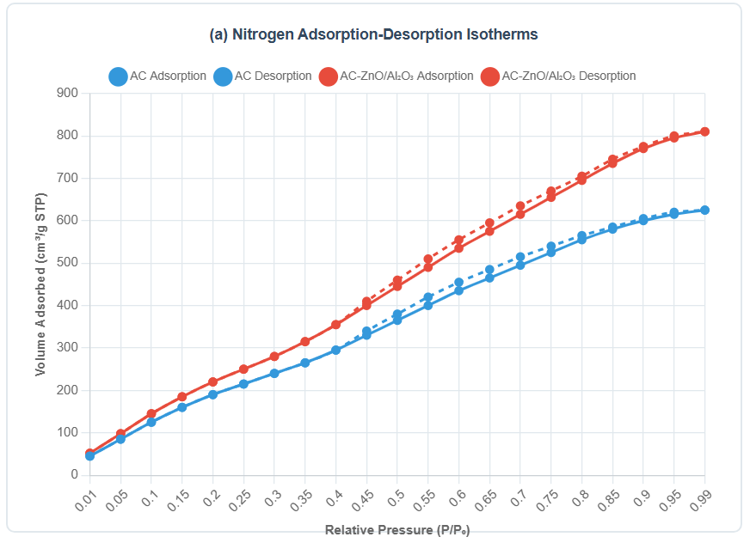

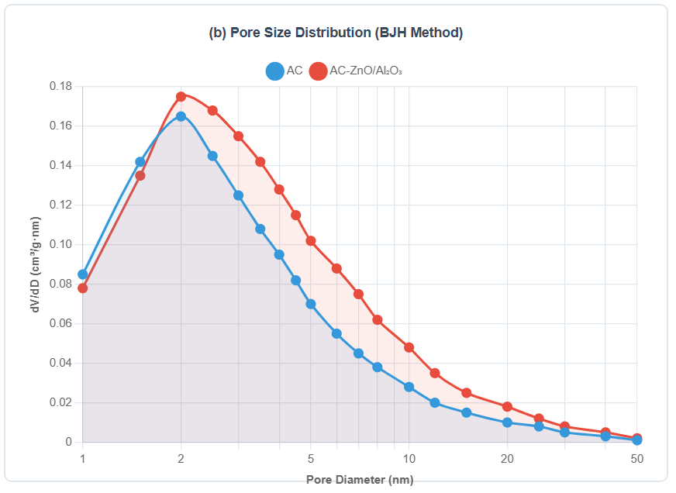

**Figure S1.** Complete nitrogen adsorption-desorption isotherms with pore size distribution analysis

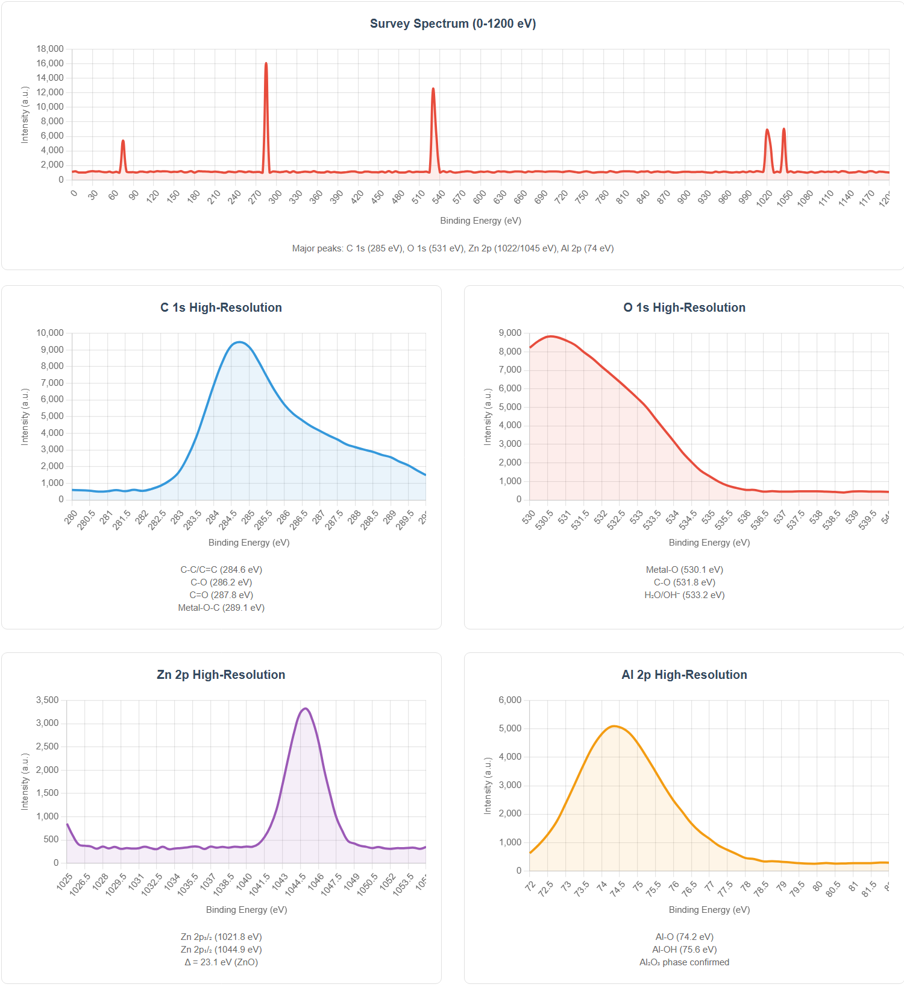

**Figure S2.** XPS spectra showing surface chemical states

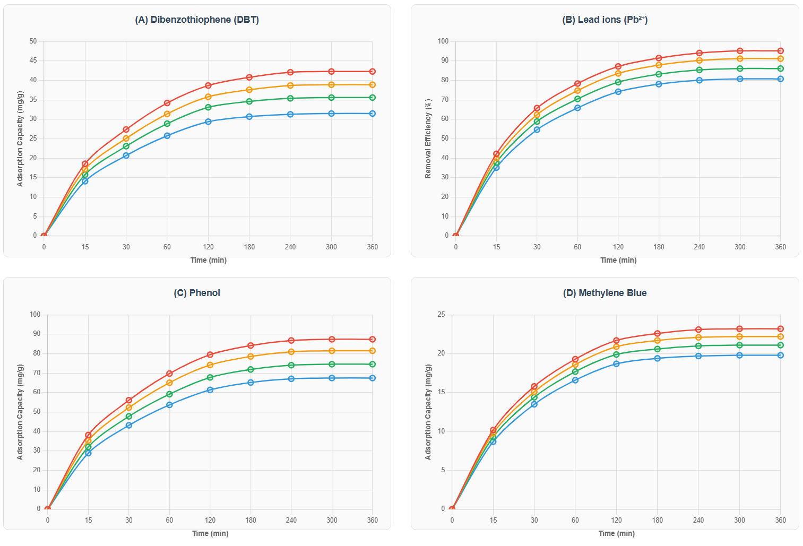

**Figure S3.** Complete kinetic profiles for all pollutants at different temperatures

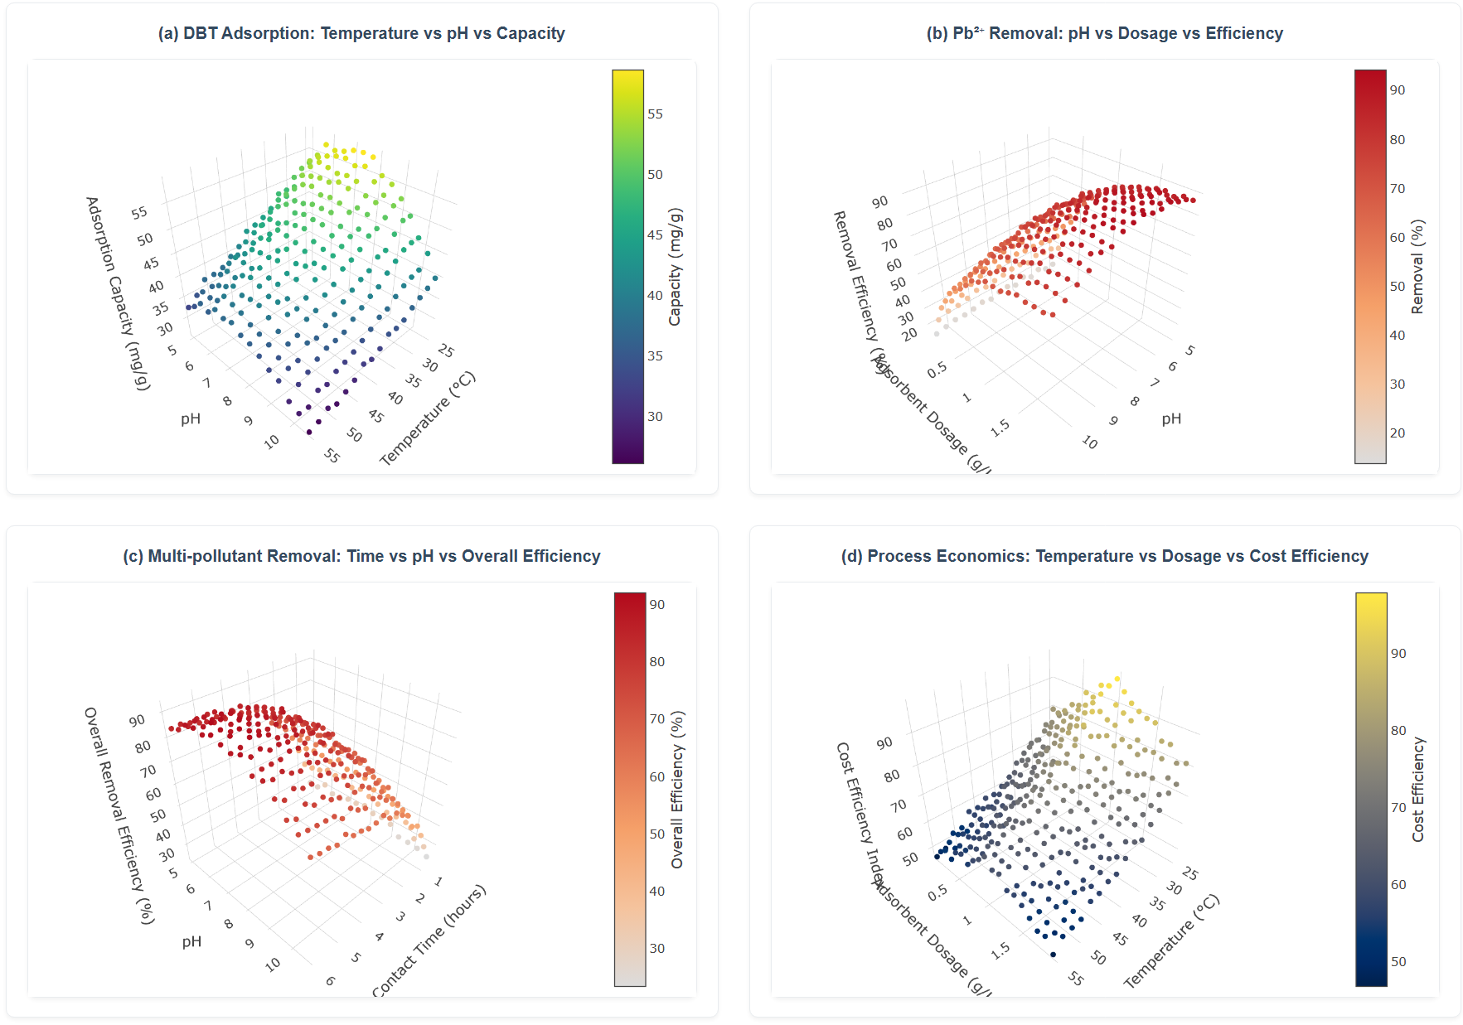

**Figure S4.** 3D response surface plots for optimization studies

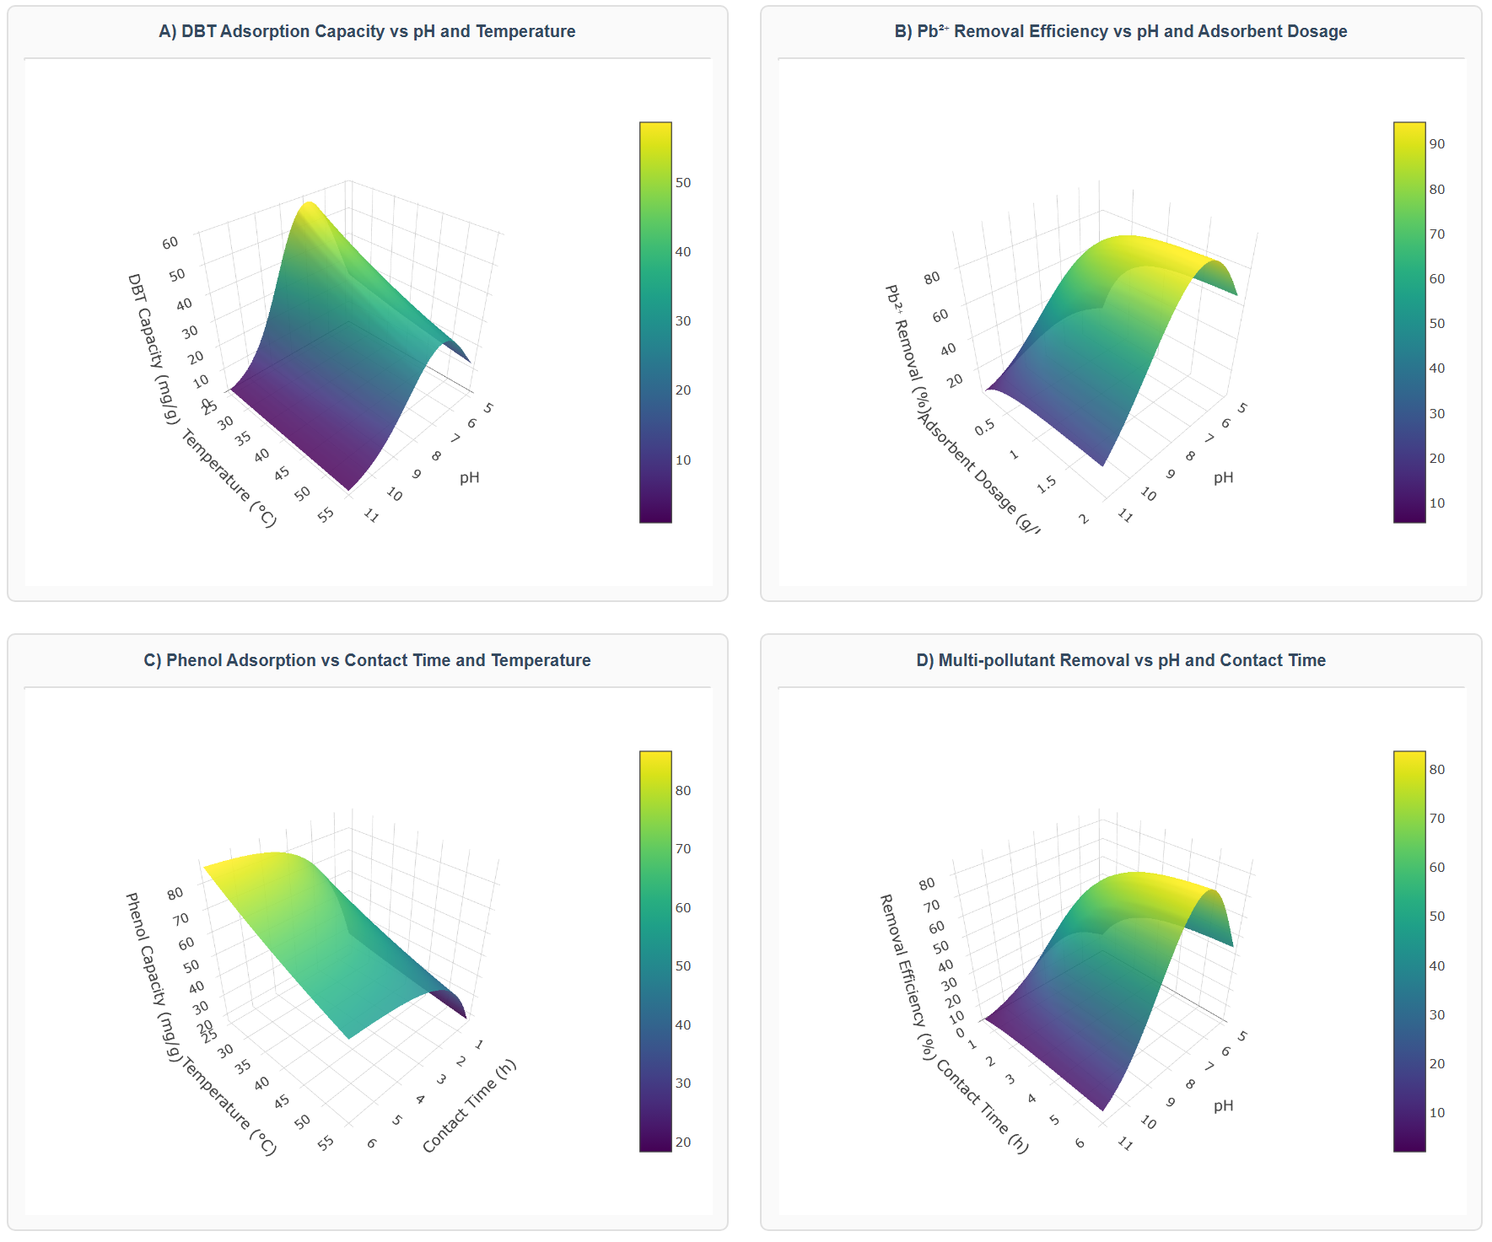

**Figure S5.** Regeneration efficiency over extended cycles (10 cycles)

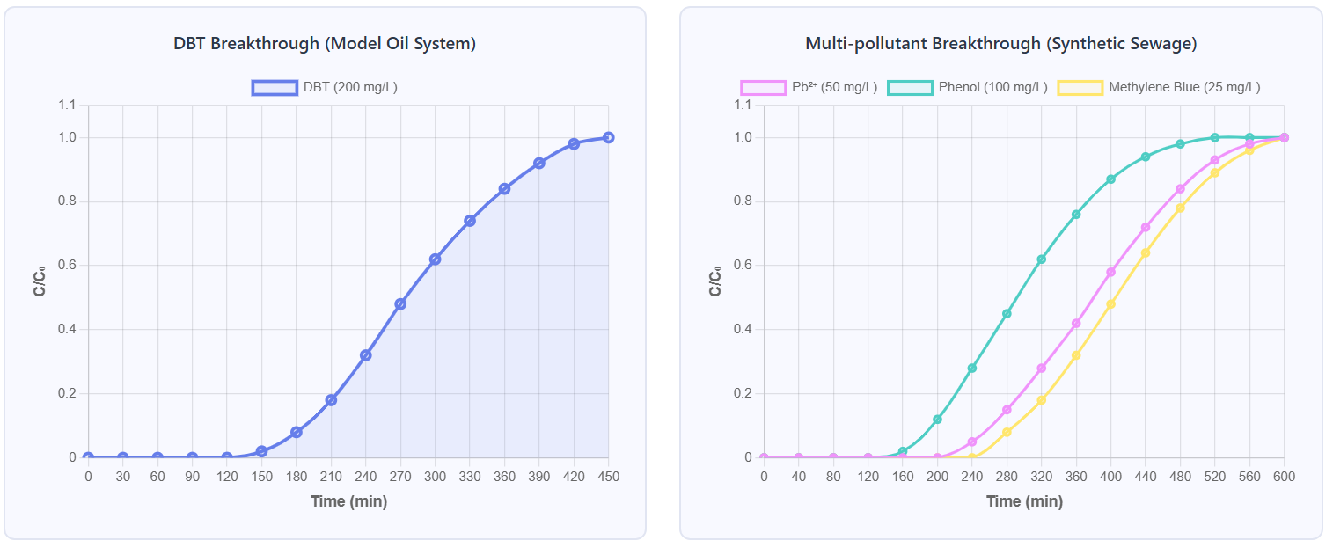

**Figure S6.** Pilot-scale column breakthrough curves

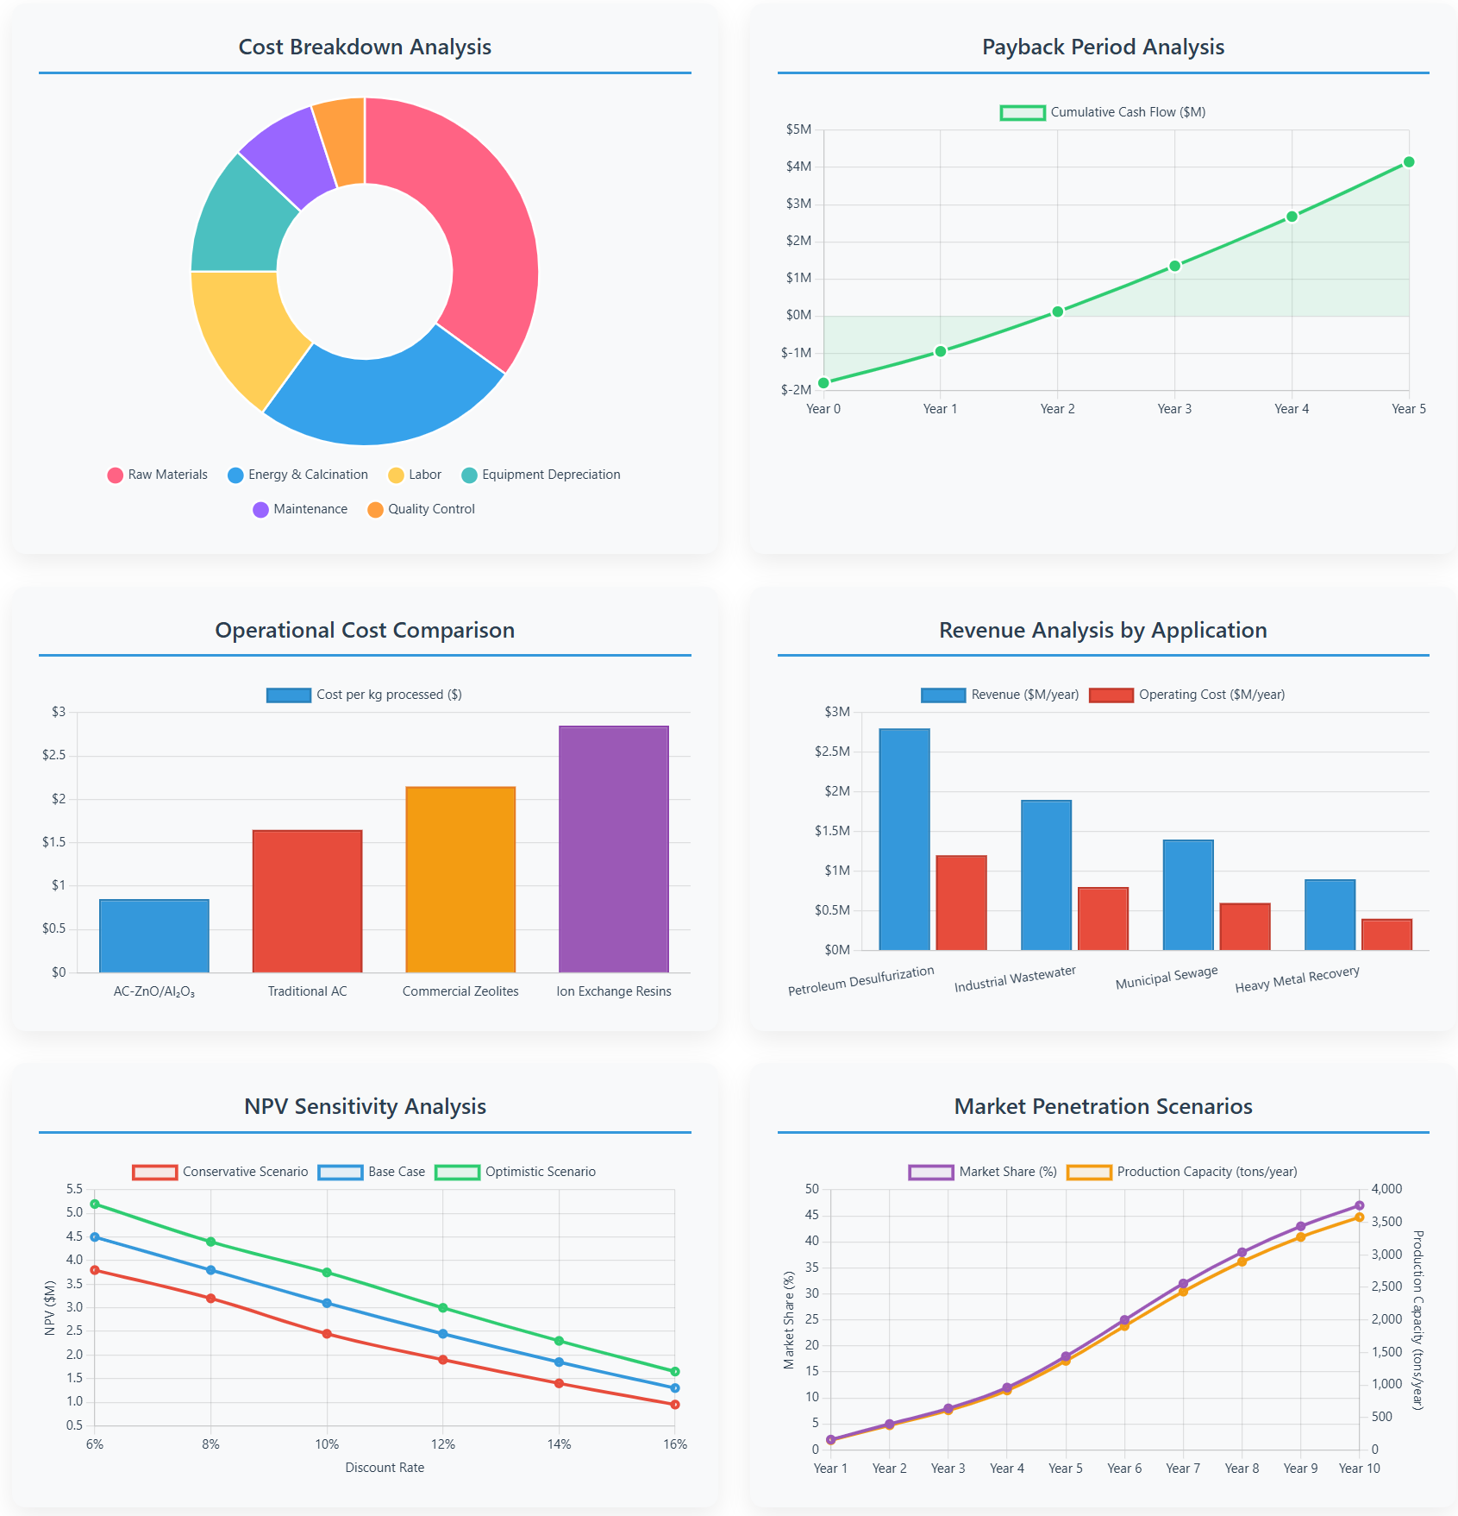

**Figure S7.** Economic feasibility analysis charts