**Table S.1.** Results of elemental analysis of the obtained Ln(III) coordination polymers.

|  |  |  |  |  |
| --- | --- | --- | --- | --- |
| **Compound** | **% C** | | **% H** | |
|  | Calc | Found | Calc | Found |
| Eu-1 | 48.34 | 47.74 | 3.38 | 3.29 |
| Eu-2 |  | 49.57 |  | 3.86 |
| Eu-3 |  | 48.50 |  | 4.34 |
| Eu-4 |  | 71.08 |  | 5.68 |
| Tb-1 | 47.42 | 47.37 | 3.39 | 3.37 |
| Tb-2 |  | 49.29 |  | 2.59 |
| Tb-3 |  | 46.84 |  | 2.81 |
| Tb-4 |  | 70.13 |  | 3.82 |

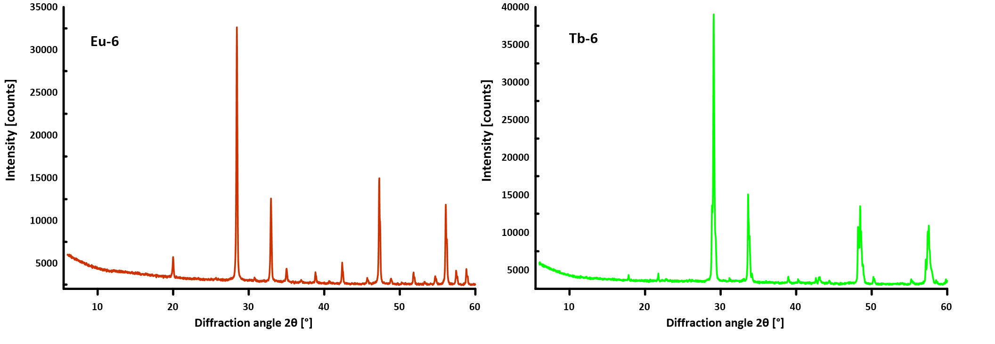

**Fig. S.1.** Powder diffraction patterns of lanthanide oxides Eu-6 and Tb-6 obtained by calcination of corresponding coordination polymers.

**Table S.2.** ASAP data of the obtained Ln(III) complex compounds and Ln(III) oxides.

|  |  |  |
| --- | --- | --- |
| **Compound** | **BET Surface Area [m²/g]** | **Adsorption average pore width (4V/A by BET) [nm]** |
| Eu-1 | 19.9405 | 17.86448 |
| Tb-1 | 17.1862 | 14.67751 |
| Eu-6 | 3.8233 | 24.06367 |
| Tb-6 | 2.1190 | 7.80916 |

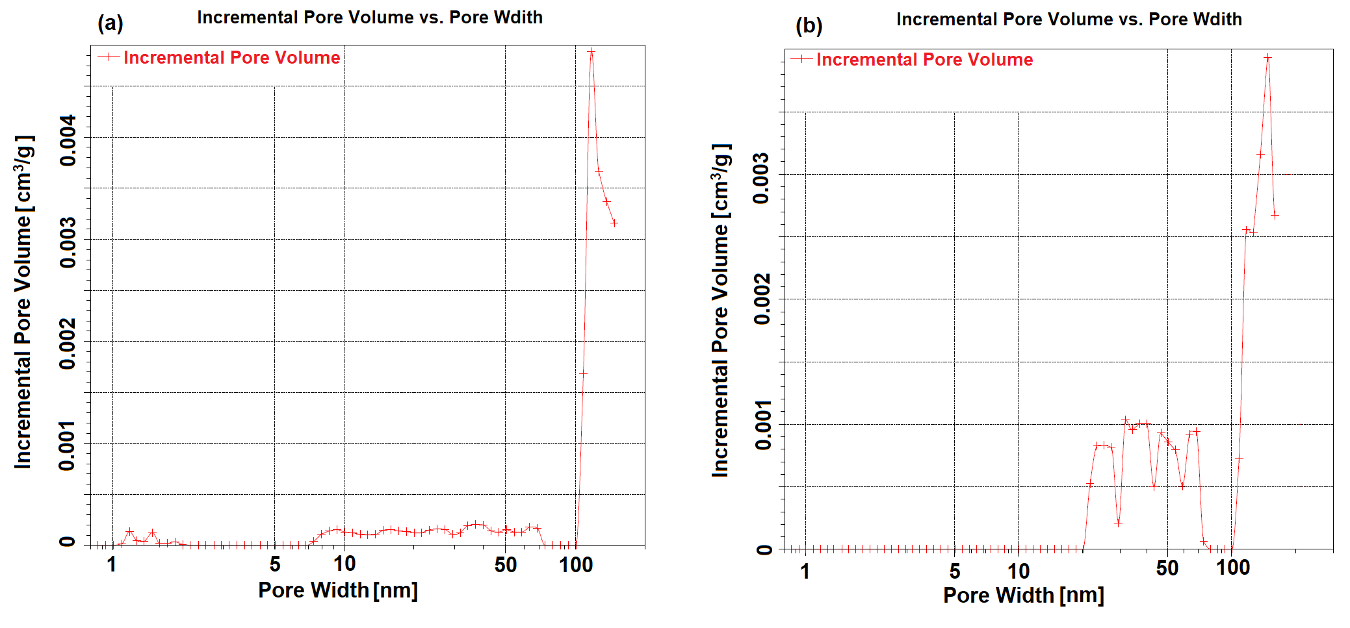

**Fig. S.2.** The DFT pore size distributions of (a) Eu-6 and (b) Tb-6.

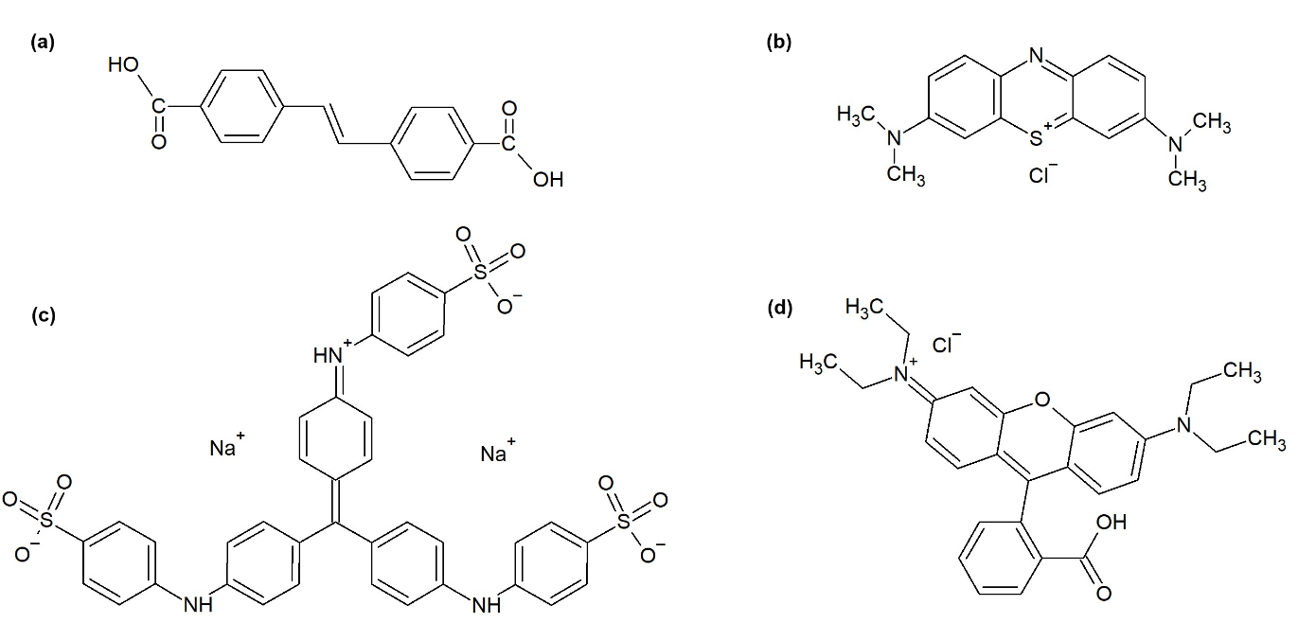

**Fig. S.3.** Structures of (a) ligand H2SDC, (b) methylene blue (BM1), (c) methyl blue (BM2), and (d) rhodamine B (RB).