Supplementary Information
Evaluation of 2-(1H-1,2,3-triazol-1-yl)acetic acid derivatives as potential human hypoxia inducible factor (HIF) prolyl hydroxylase domain-2 (PHD2) inhibitors

Abrar Mohammad Sayaf^{1*}, June Sun Cheah^{1*}, Abbas Khan^{2,4}, Christopher J. Schofield³, Abdelali Agouni², and Kar Kheng Yeoh¹
✉ Kar Kheng Yeoh kkyeoh@usm.my
- School of Chemical Sciences, Universiti Sains Malaysia, Penang 11800, Malaysia
- Department of Pharmaceutical Sciences, College of Pharmacy, QU Health, Qatar University, P.O. Box 2713, Doha, Qatar.
- Chemical Research Laboratory, Department of Chemistry, University of Oxford, OX1 3TA, United Kingdom.
- School of Medical and Life Sciences, Sunway University, No. 5, Jalan Universiti,
Bandar Sunway, 47500 Selangor Darul Ehsan, Malaysia.

Tables

Table 1: Percentage yields, melting points and FT-IR spectral data--------------------2
Table 2: HRMS spectral data---------------------------------------------------------------- 2
Table 3: NMR spectral data-------------------------------------------------------------------3
Figures
Figure 1 and 2: FT-IR spectrum of selected compounds --------------------------------4
Figure 3 and 4: ESI-HRMS of selected compounds--------------------------------------5
Figure 5 to 30: NMR spectrum of selected compounds------------------------------6-18

Tables

Table 1: Percentage yields, melting points and FTIR spectral data of the triazole based compounds 1-14

Compounds | Yield (%) | M.P (°C) | FTIR  (ν, cm⁻¹) | N-H | O-H | C-H, sp² | C-H, Sp³ | C-H, Aldehyde | C=O | C=C,  Aromatic | C-N | C-O
1 | 33.7 | 177-181 | - | 3426 | 3159 | 2946 | - | - | 1710 | 1618/  1449 | 1390 | 1241
2 | 31.5 | - | - | 3415 | 3146 | 2954 | - | - | 1736 | 1636/  1455 | 1340 | 1226
3 | 26.3 | - | - | 3441 | 3147 | 2950 | - | - | 1736 | 1638/  1447 | 1385 | 1231
4 | 55.7 | 114-117 | - | 3414 | 3174 | 2902 | - | - | 1729 | 1617/  1472 | 1418 | 1226
5 | 32.6 | 125-128 | - | 3417 | 3168 | 3003 | - | - | 1730 | 1600/  1496 | 1342 | 1229
6 | 28.3 | 191-193 | - | 3226 | 3138 | 2938 | - | - | 1742 | 1618/  1474 | 1351 | 1269
7 | 57.8 | 233-234 | 3471 | 3471 | 3143 | 2938 | - | - | 1737 | 1628/  1465 | 1386 | 1303
8 | 24.2 | - | - | 3421 | 3143 | 2925 | - | - | 1740 | 1610/  1465 | 1382 | 1252
9 | 61.3 | 193-196 | - | 3415 | 3174 | 2925 | - | - | 1736 | 1609/  1494 | 1340 | 1218
10 | 27.1 | 176-177 | - | 3416 | 3145 | 2936 | 2845/  2754 | 1727/  1718 | 1601/  1438 | 1338 | 1225
11 | 63.8 | 211-213 | - | 3481 | 3149 | 2958 | - | - | 1726/  1715 | 1626/  1437 | 1398 | 1203
12 | 62.2 | 229-231 | - | 3458 | 3143 | 2947 | - | - | 1724/  1711 | 1625/  1435 | 1363 | 1224
13 | 64.5 | 218-220 | - | 3453 | 3141 | 2926 | - | - | 1731/  1716 | 1615/  1442 | 1363 | 1230
14 | 60.1 | 216-218 | - | 3416 | 3146 | 2961 | - | - | 1729/  1719 | 1611/1465 | 1359 | 1239

Table 1 HRMS spectral data of the triazole based compounds

Compound | HRMS
 | Observed molar mass | Calculated molar mass (amu)
1 | (+ESI, m/z, amu): 310.1204 | 310.1204
2 | (+ESI, m/z, amu): 234.0869 | 233.0873
3 | (+ESI, m/z, amu): 248.0895 | 248.1030
4 | (+ESI, m/z, amu): 248.1018 | 248.1030
5 | (+ESI, m/z, amu): 234.0848 | 234.0873
6 | (+ESI, m/z, amu): 226.1190 | 226.1186
7 | (+ESI, m/z, amu): 225.1347 | 225.1346
8 | (+ESI, m/z, amu): 205.0457 | 205.0720
9 | (+ESI, m/z, amu): 234.0596 | 234.0873
10 | (-ESI, m/z, amu): 230.0596 | 232.0717
11 | (+ESI, m/z, amu): 287.0700 | 286.0775
12 | (+ESI, m/z, amu): 301.0931 | 301.0948
13 | (+ESI, m/z, amu): 315.1077 | 315.1088
14 | (+ESI, m/z, amu): 303.0716 | 303.0724

Table 3: 1H NMR spectral data of the triazole based compounds

Compound | 1H NMR (δ, ppm) Triazolyl proton
1 | 7.78
2 | 7.85
3 | 7.82
4 | 8.13
5 | 8.22
6 | 7.86
7 | 8.12
8 | 8.59
9 | 8.44
10 | 8.67
11 | 8.08
12 | 7.94
13 | 7.89
14 | 8.25

Figures

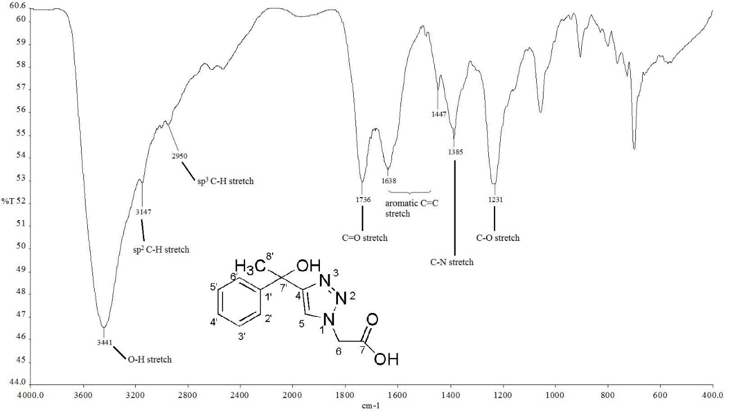
Figure 1: FT-IR spectrum of compound 3

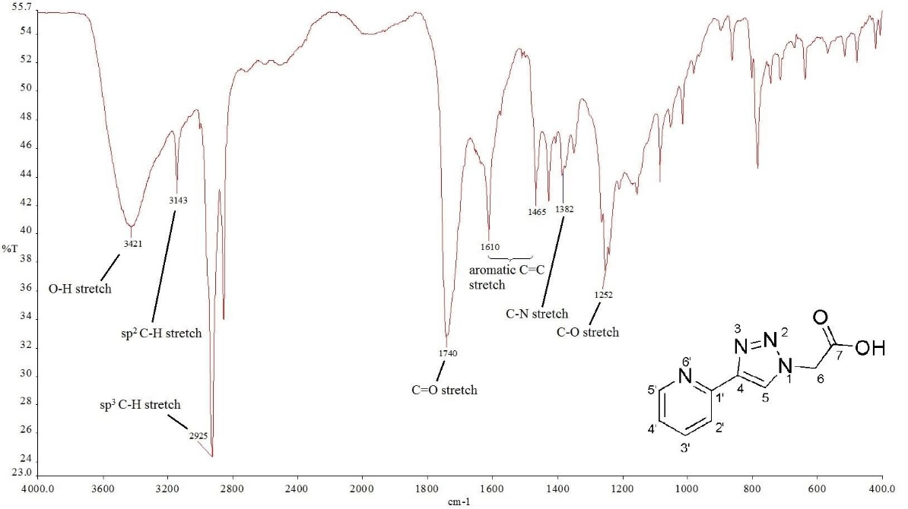
Figure 2: FT-IR spectrum of compound 8

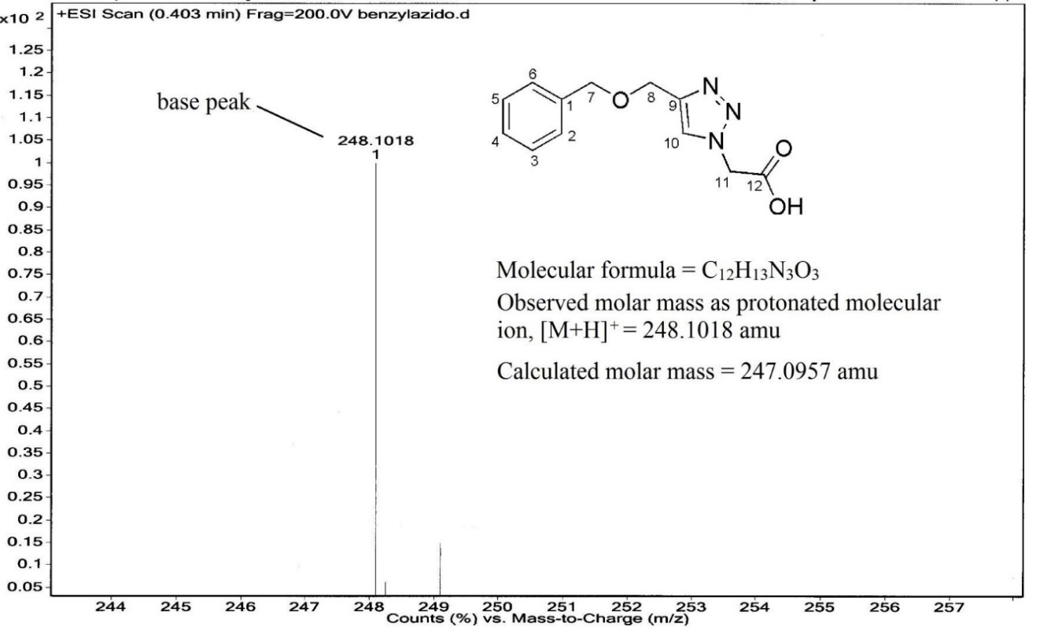
Figure 3: ESI-HRMS spectrum of compound 4
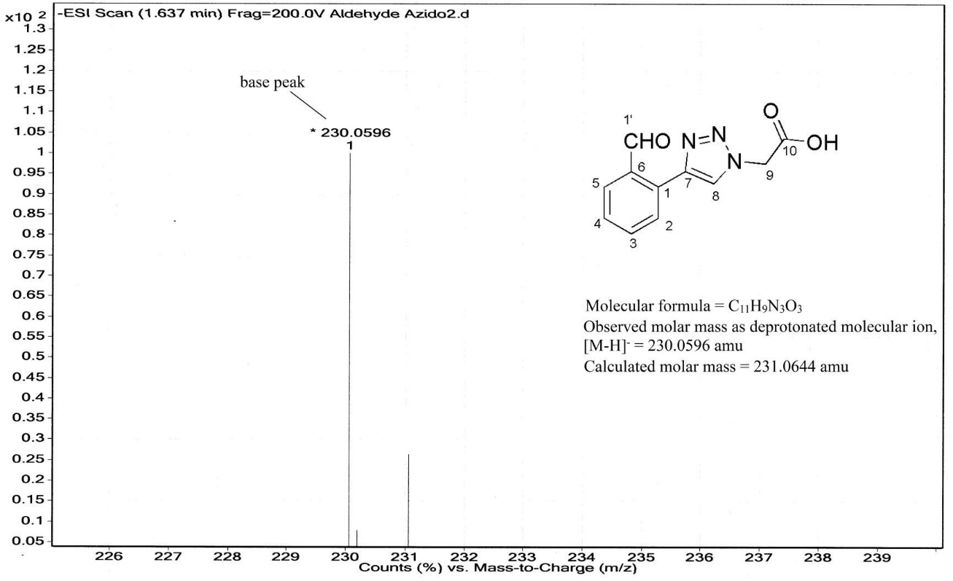
Figure 4: ESI-HRMS spectrum of compound 10
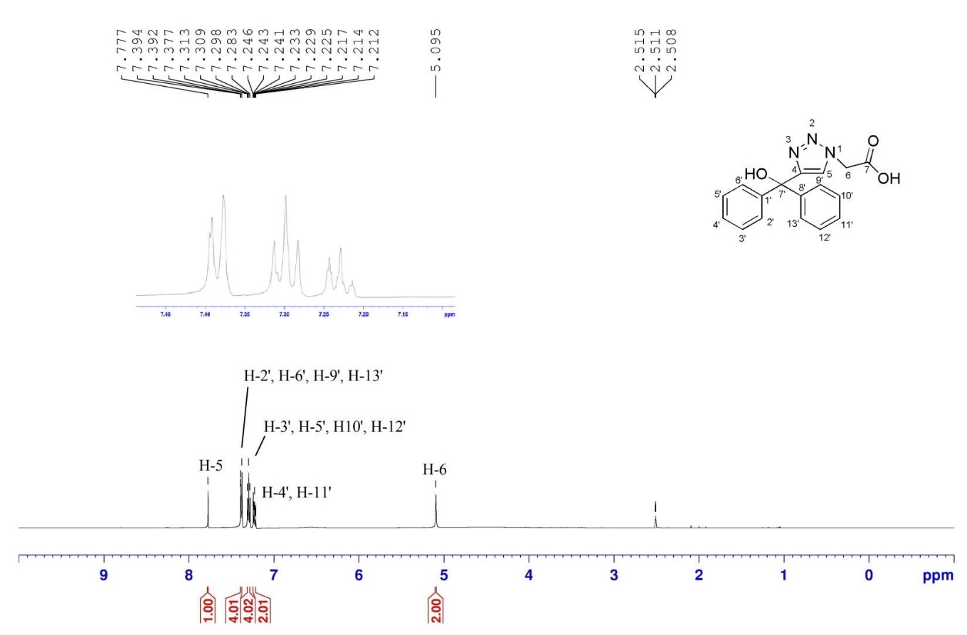
Figure 5: 1H NMR spectrum of compound 1 in DMSO-d6

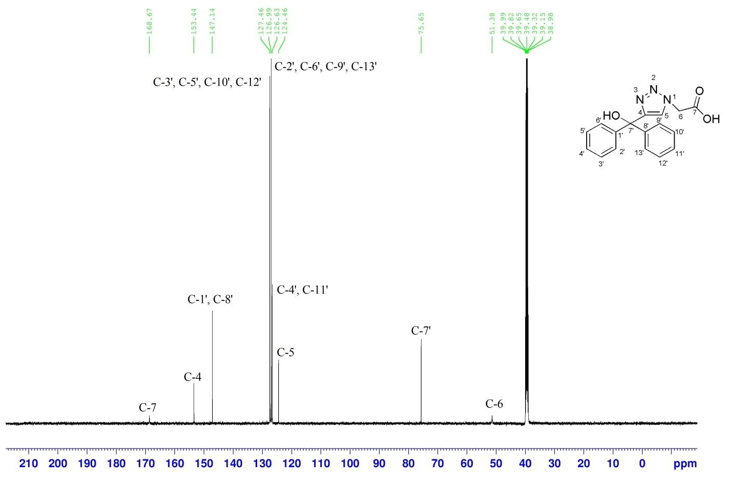
Figure 6: ¹³C NMR spectrum of compound 1 in DMSO-d6
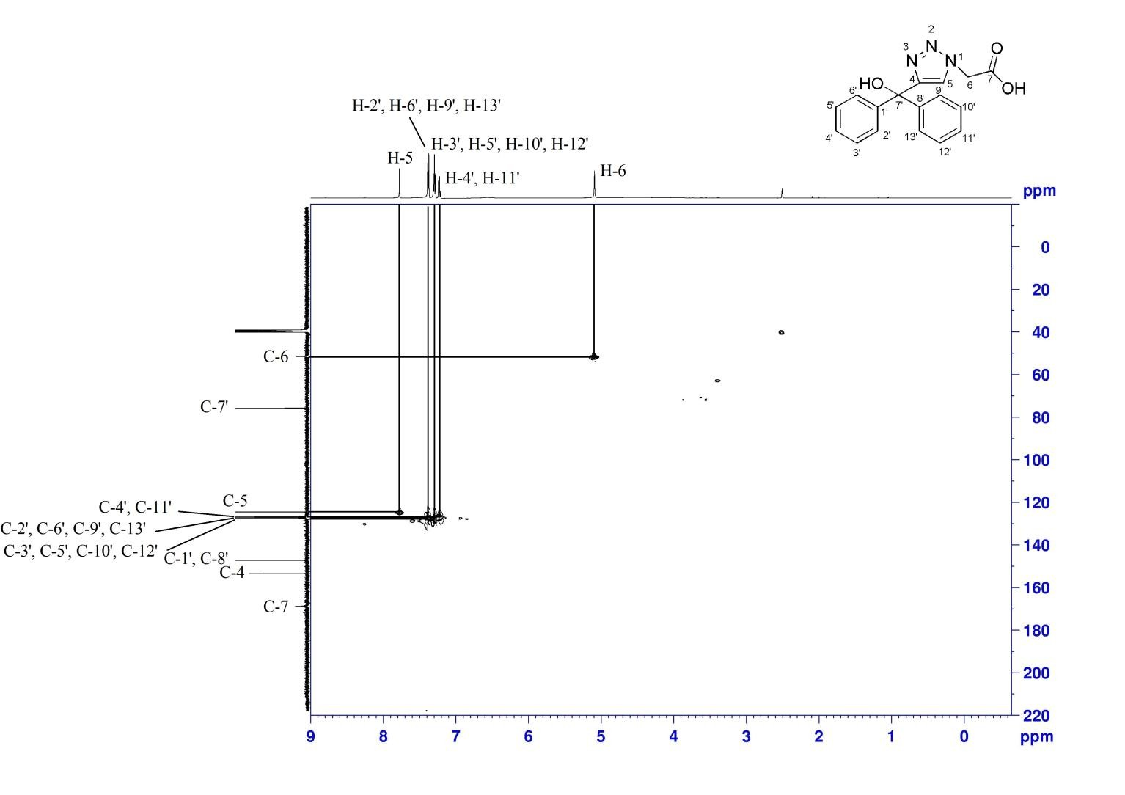
Figure 7: ¹H-¹³C HSQC spectrum of compound 1 in DMSO-d6
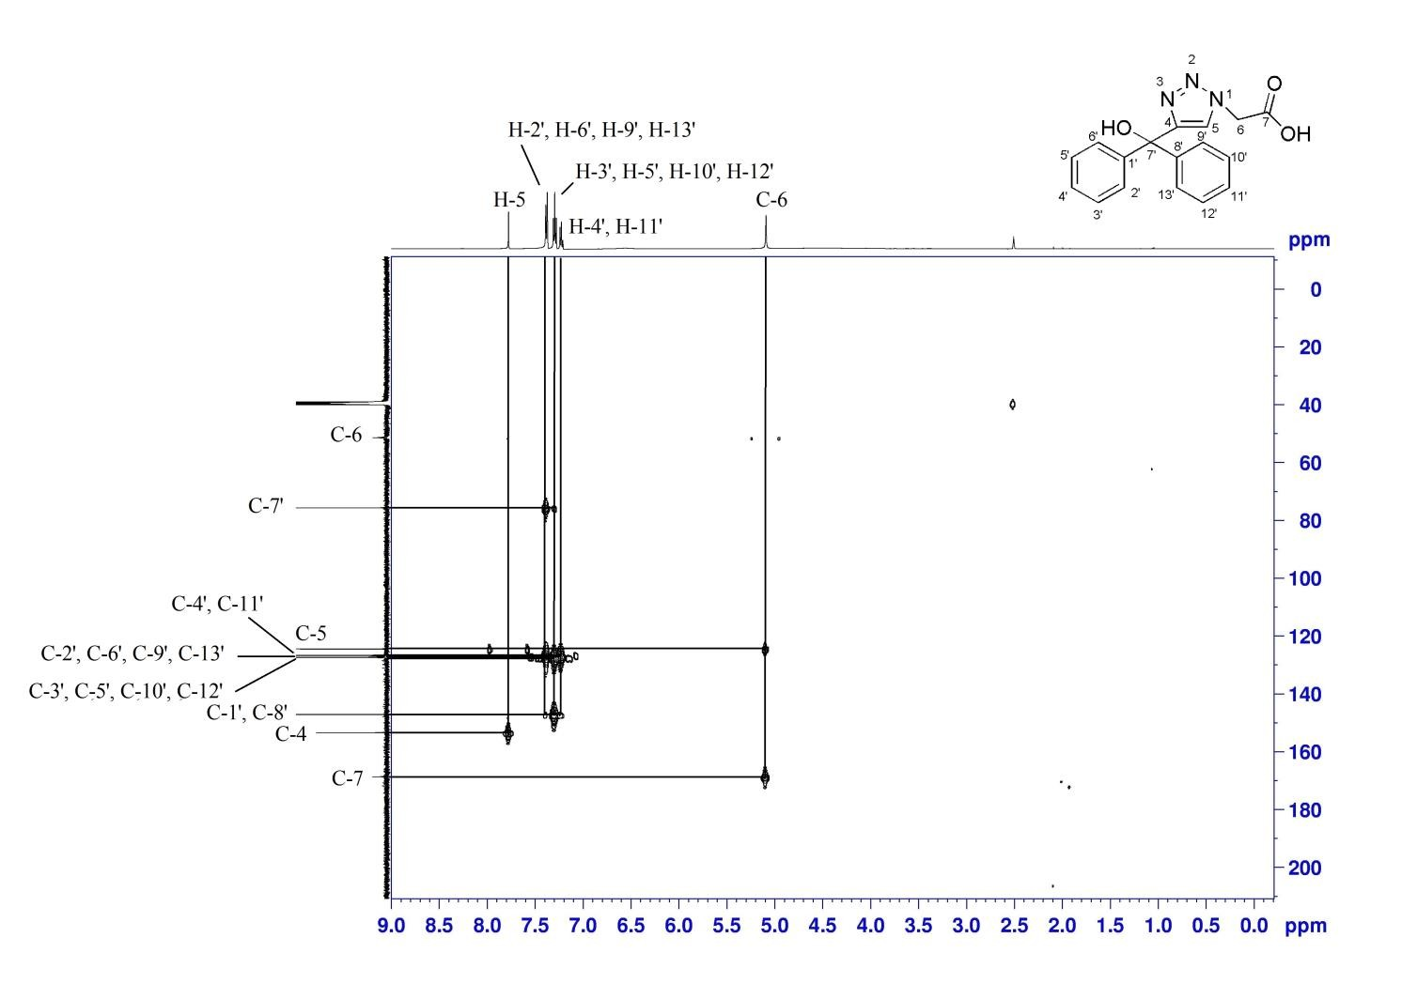
Figure 8: ¹H -¹³C HMBC spectrum of compound 1 in DMSO-d6
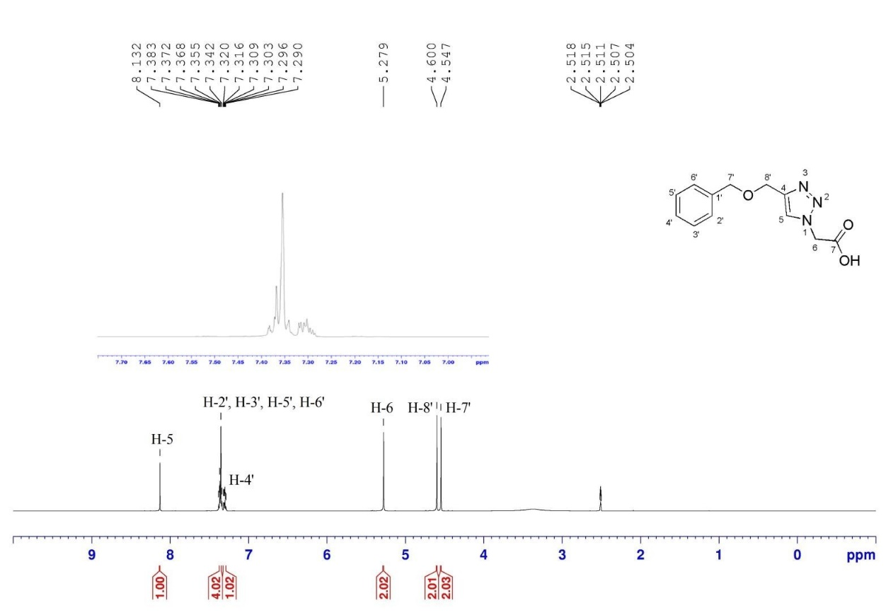
Figure 9: ¹H NMR spectrum of compound 4 in DMSO-d6
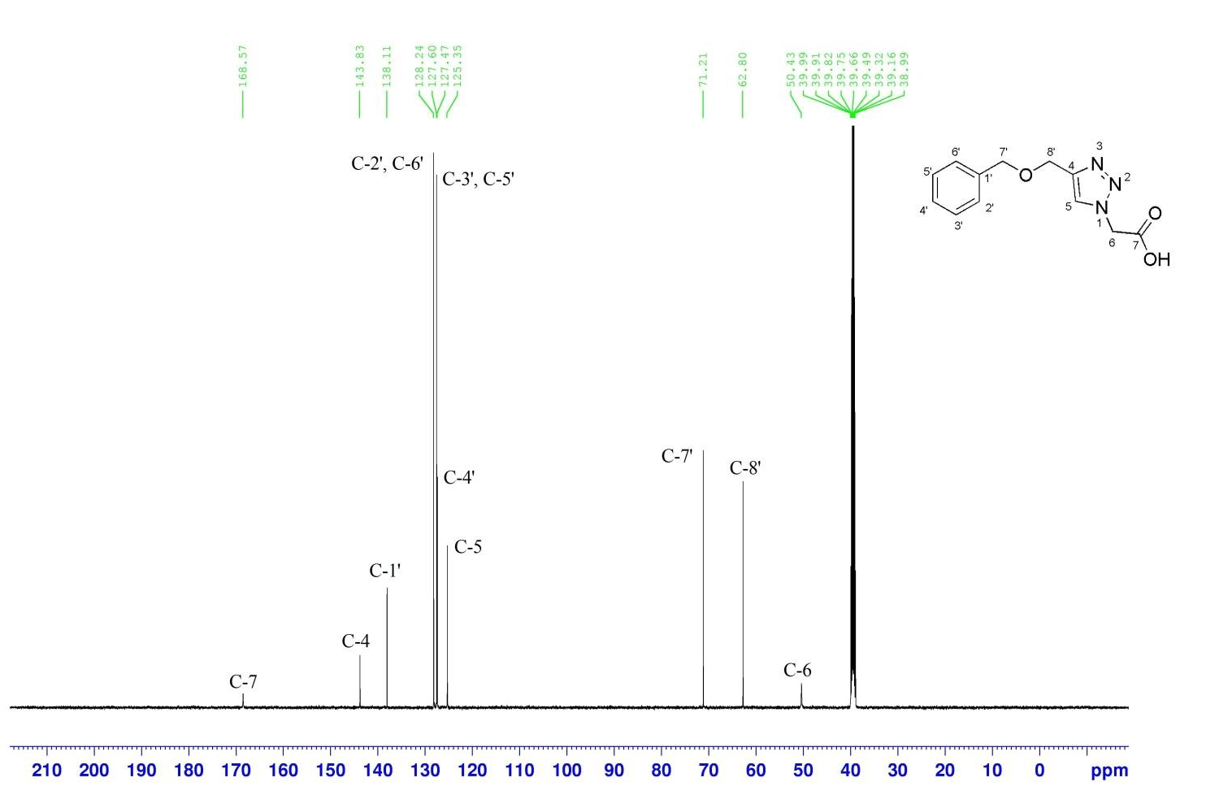
Figure 10: ¹³C NMR spectrum of compound 4 in DMSO-d6
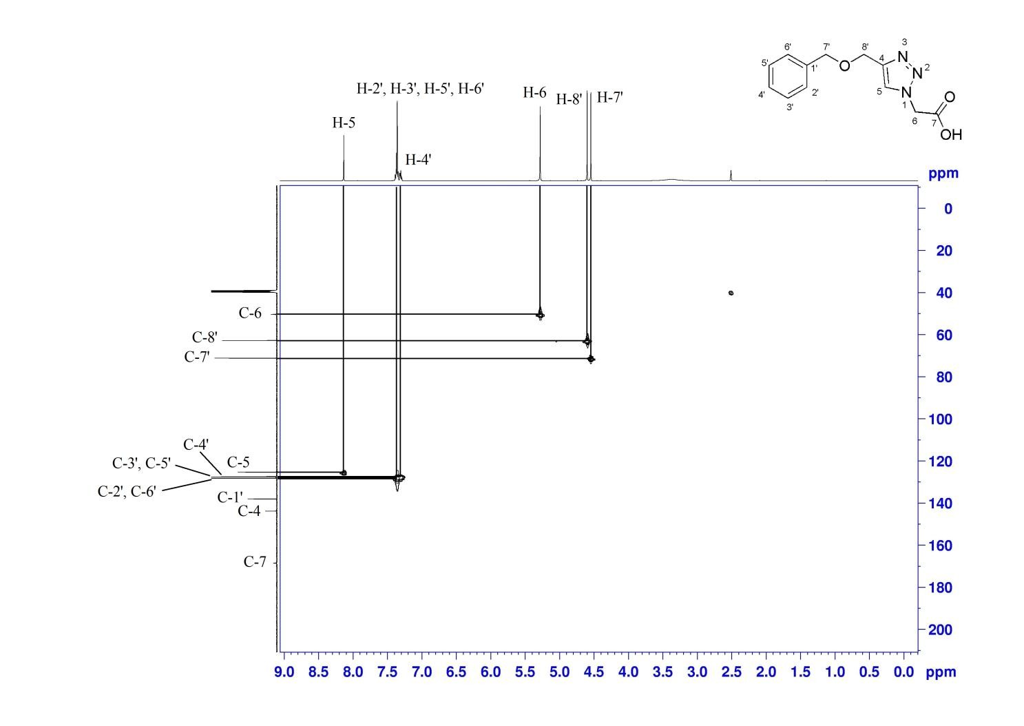
Figure 11: ¹H -¹³C HSQC spectrum of compound 4 in DMSO-d6
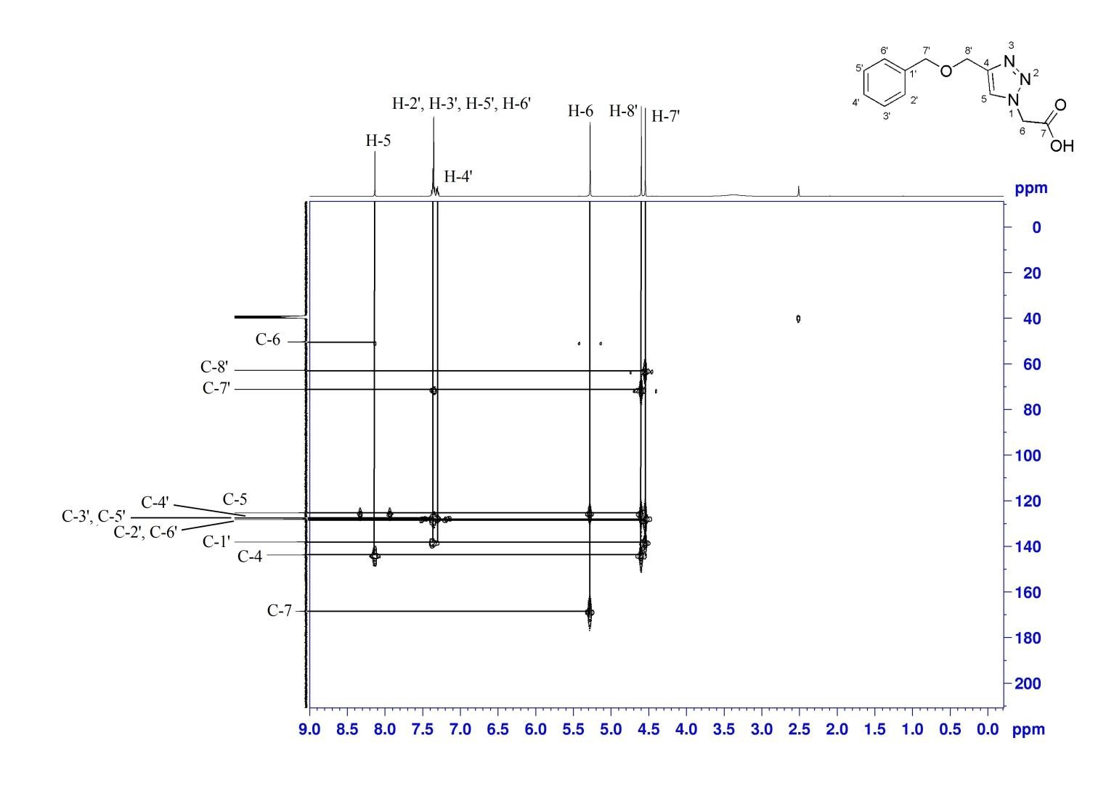
Figure 12: ¹H -¹³C HMBC spectrum of compound 4 in DMSO-d6
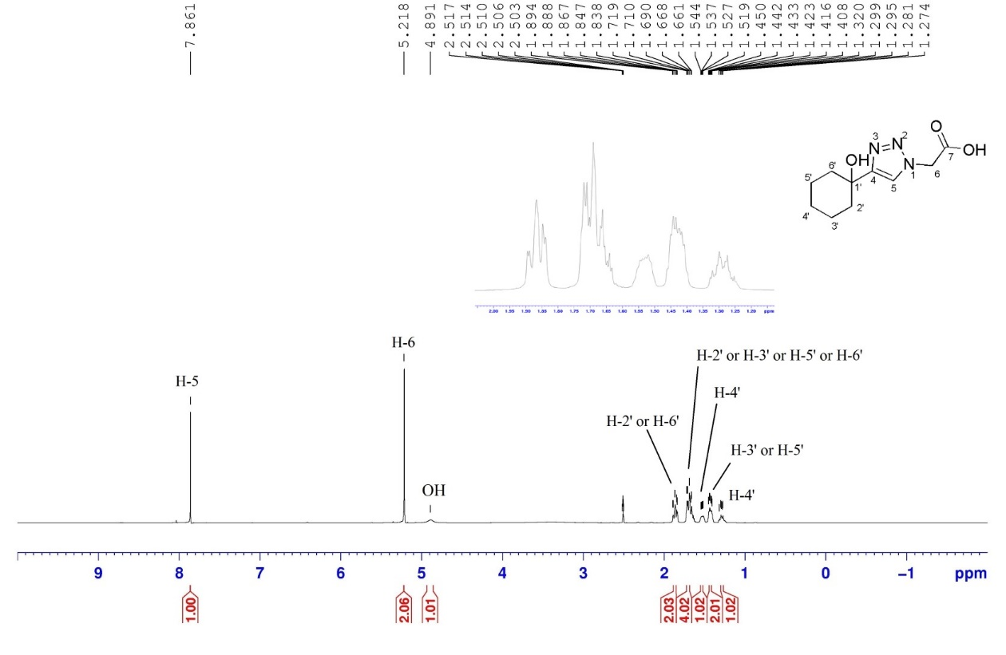
Figure 13: ¹H NMR spectrum of compound 6 in DMSO-d6
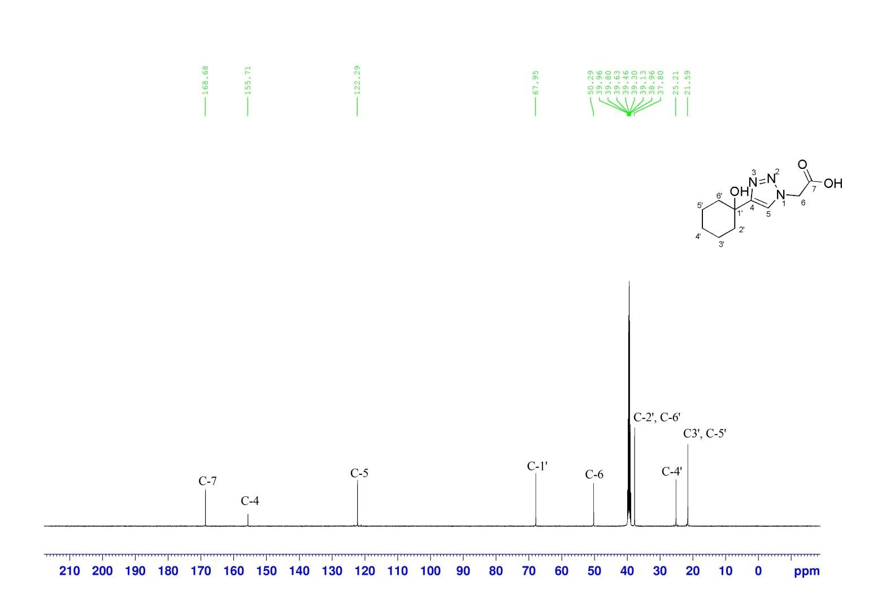
Figure 14: ¹³C NMR spectrum of compound 6 in DMSO-d6
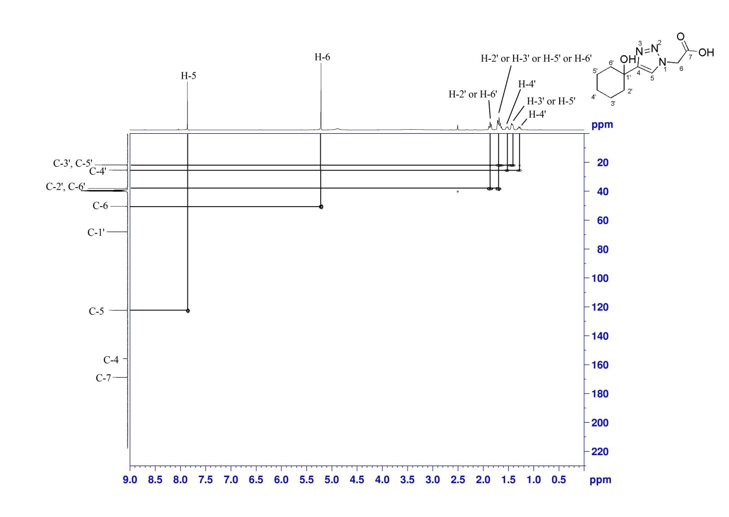Figure 15: ¹H -¹³C HSQC spectrum of compound 6 in DMSO-d6

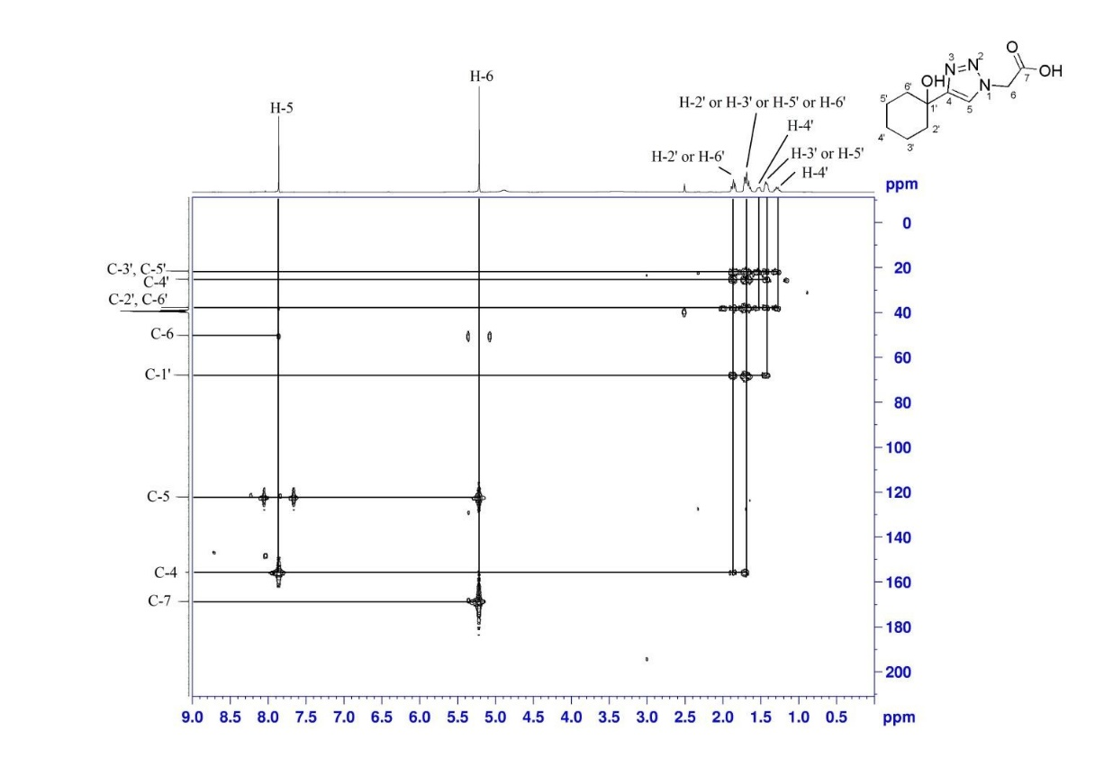
Figure 16: ¹H -¹³C HMBC spectrum of compound 6 in DMSO-d6

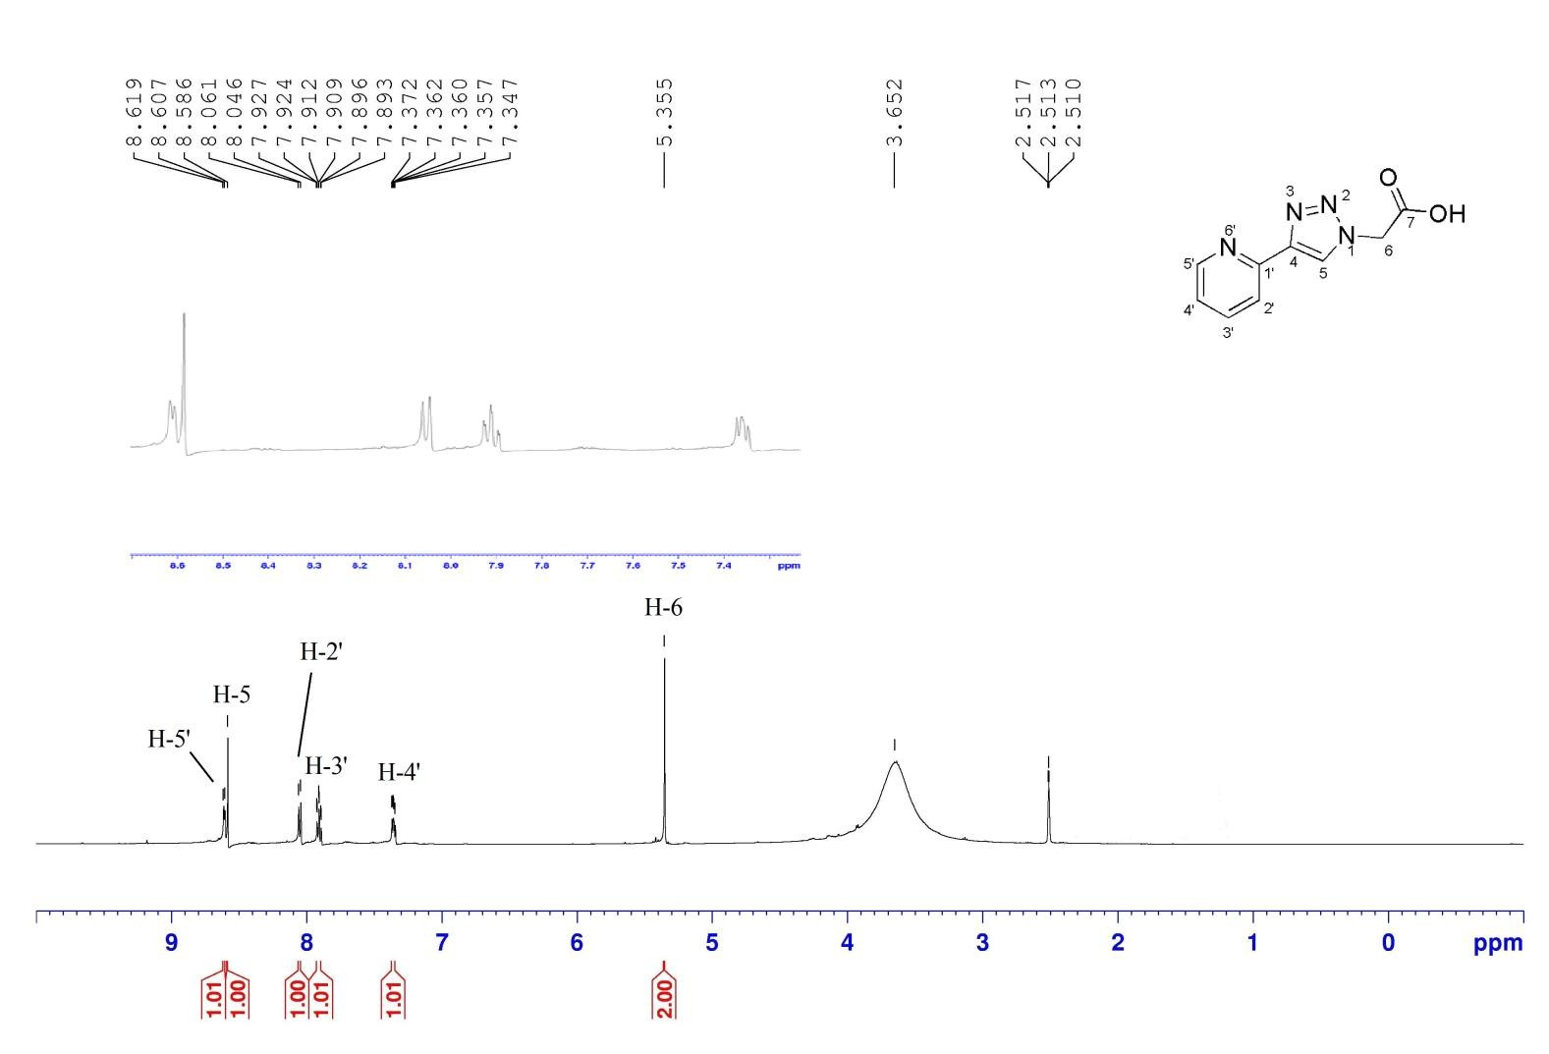

Figure 17: ¹H NMR spectrum of compound 8 in DMSO-d6
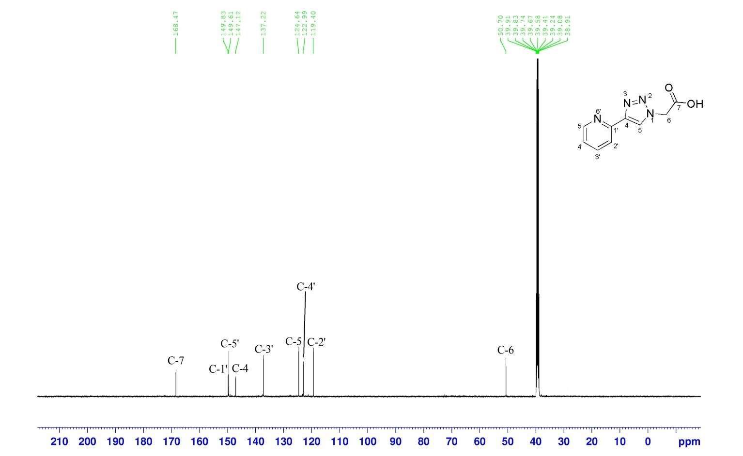
Figure 18: ¹³C NMR spectrum of compound 8 in DMSO-d6
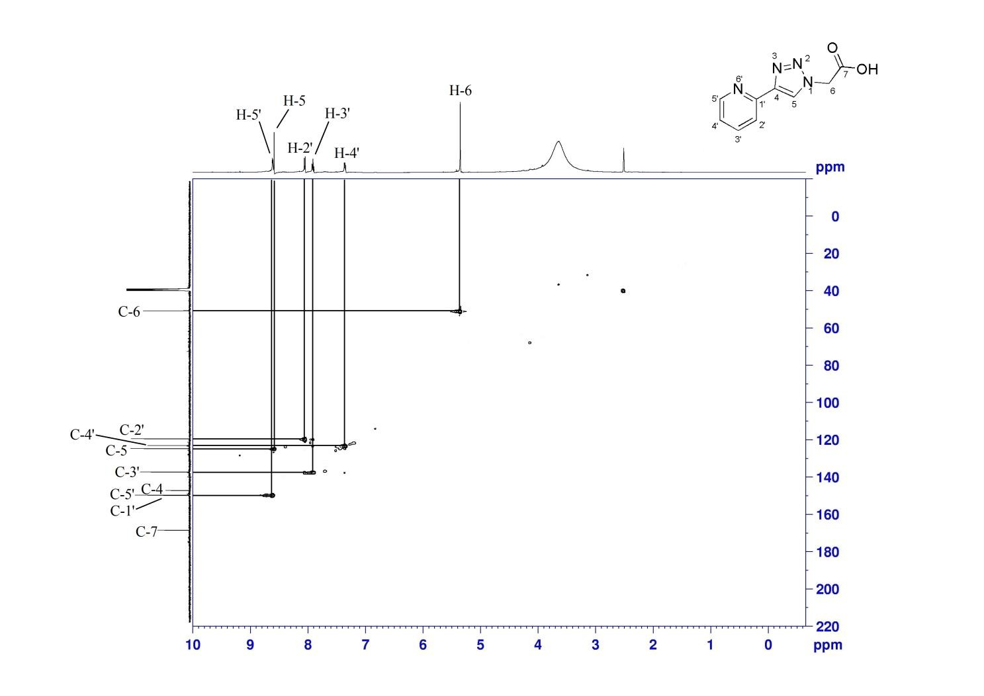

Figure 19: ¹H -¹³C HSQC spectrum of compound 8 in DMSO-d6
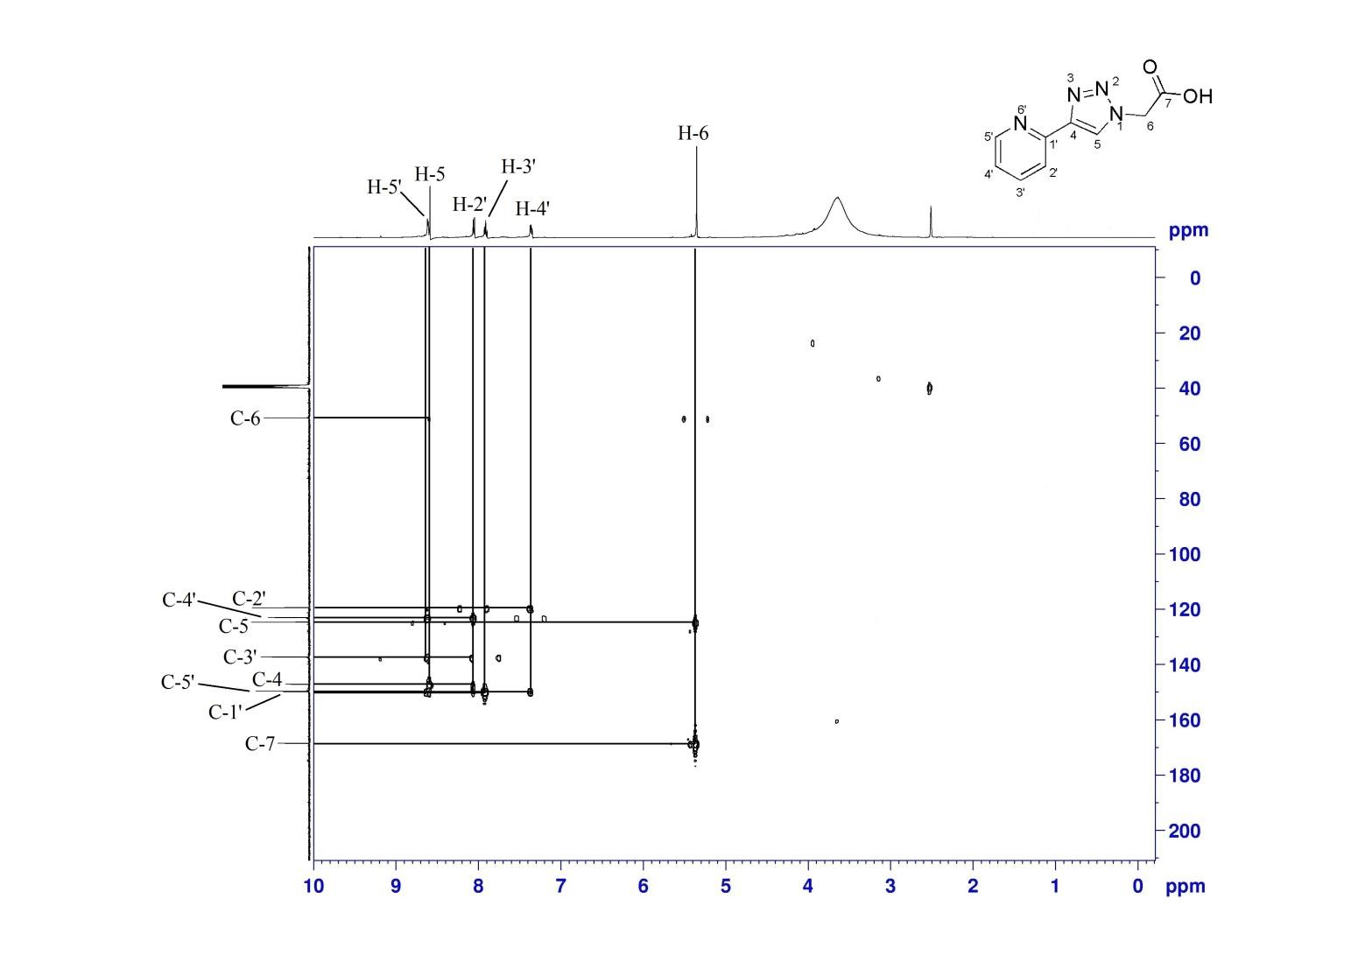
Figure 20: ¹H -¹³C HMBC spectrum of compound 8 in DMSO-d6
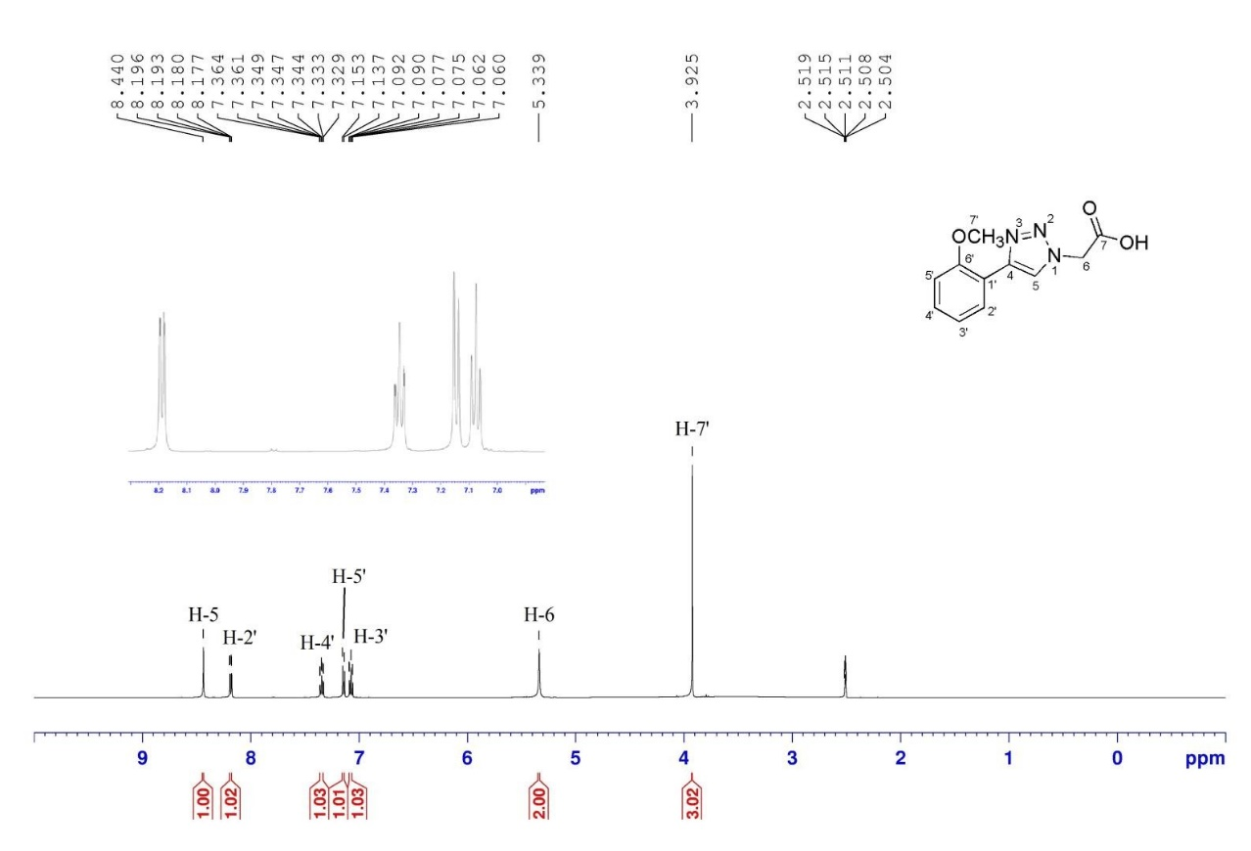
Figure 21: ¹H NMR spectrum of compound 9 in DMSO-d6
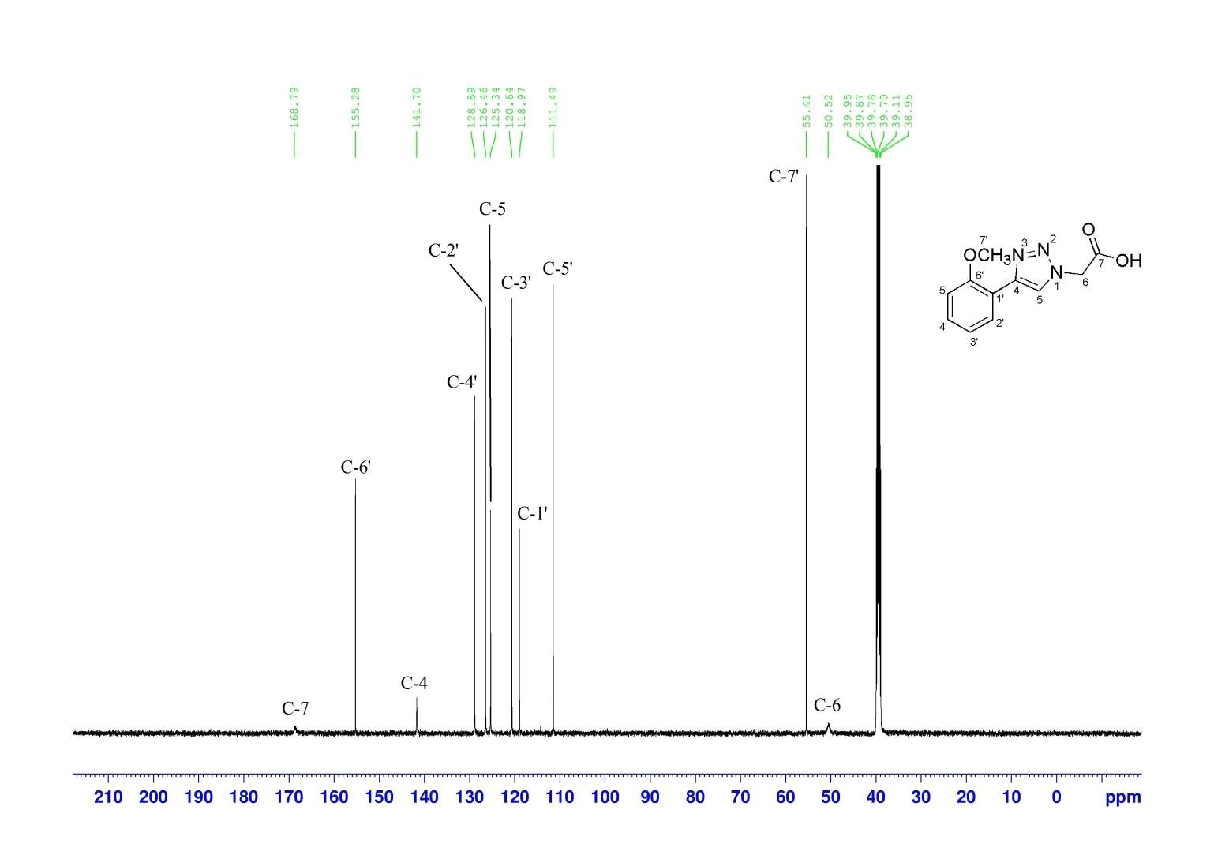
Figure 22: ¹³C NMR spectrum of compound 9 in DMSO-d6
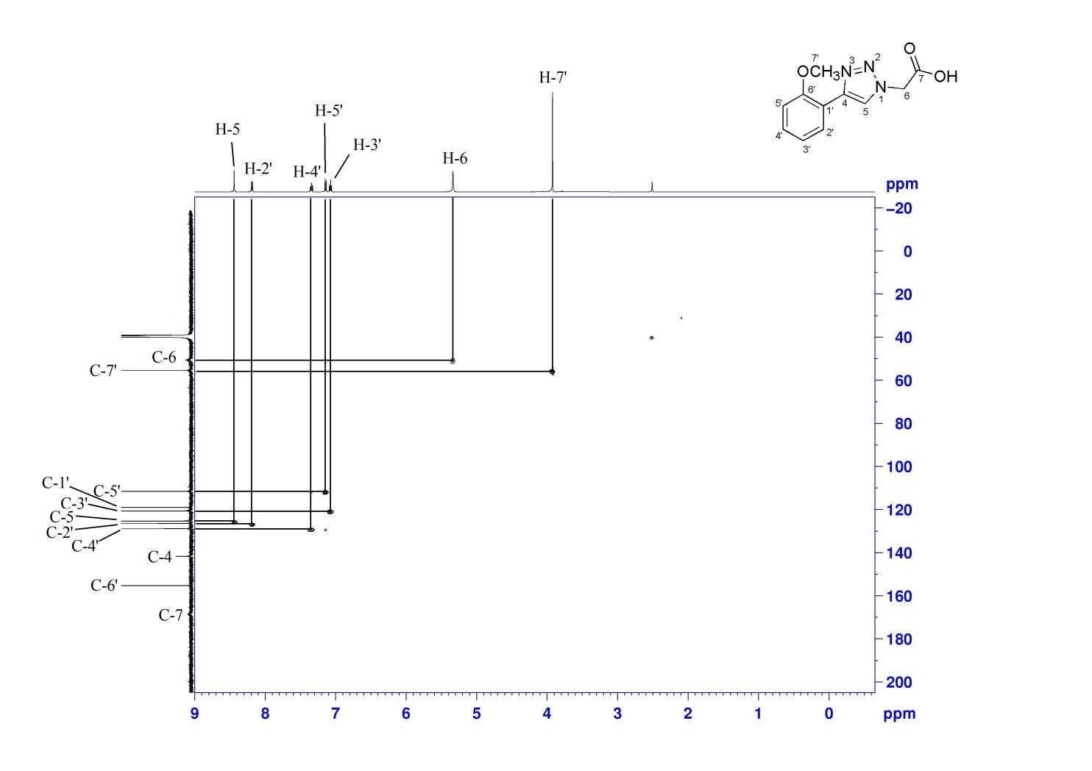
Figure 23: ¹H -¹³C HSQC spectrum of compound 9 in DMSO-d6
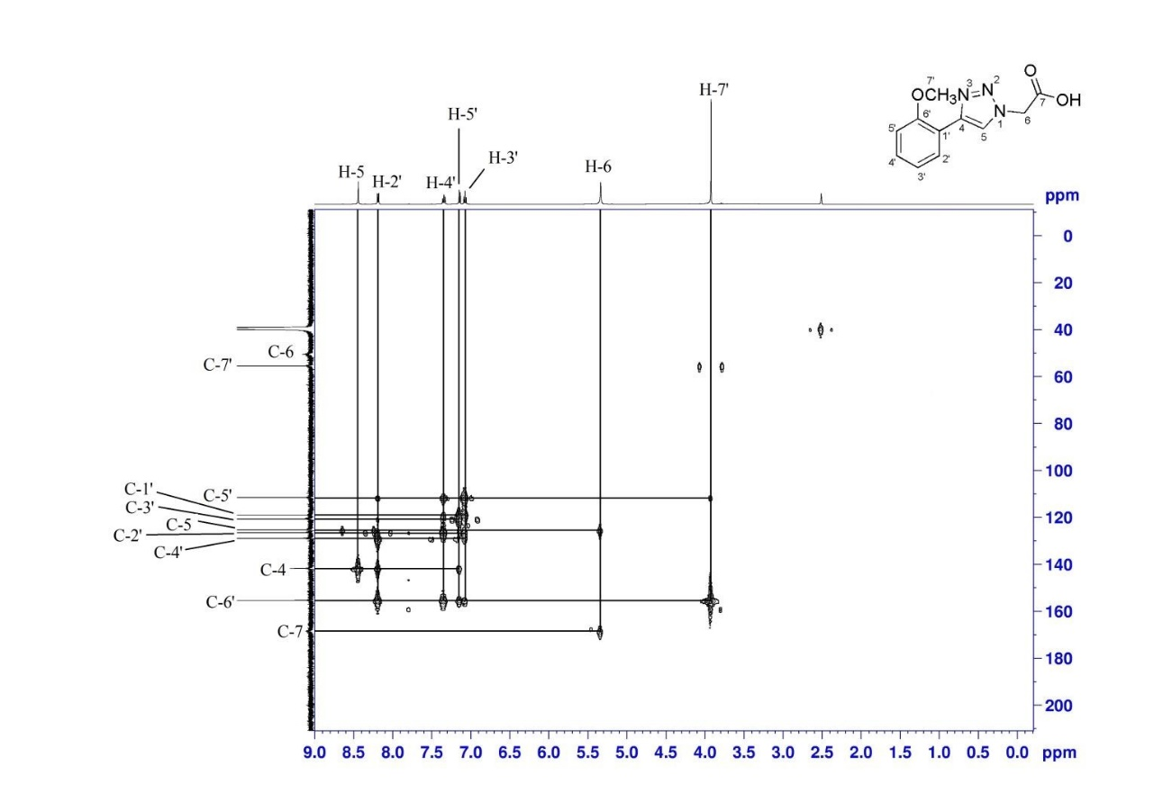
Figure 24: ¹H -¹³C HMBC spectrum of compound 9 in DMSO-d6

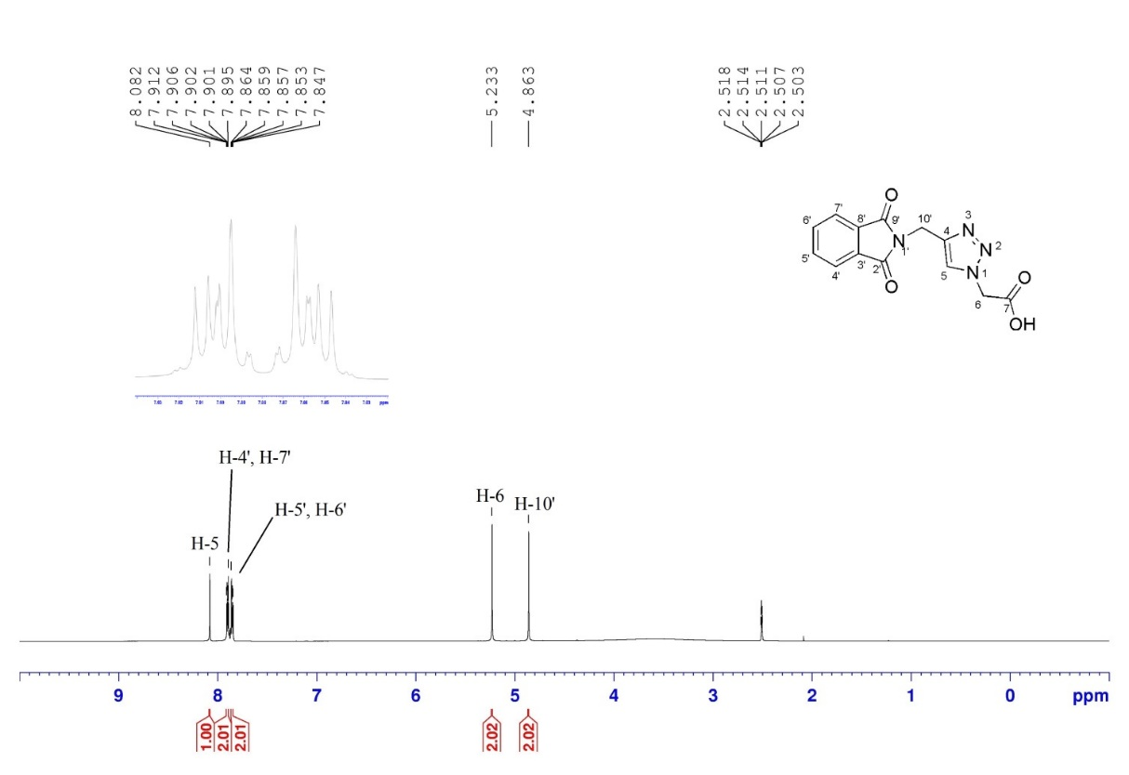

Figure 25: ¹H NMR spectrum of compound 11 in DMSO-d6
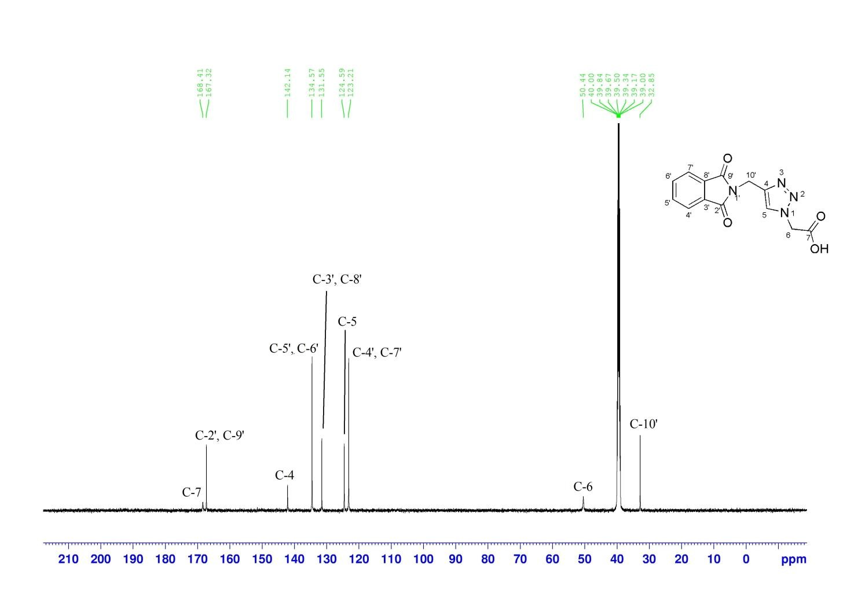
Figure 26: ¹³C NMR spectrum of compound 11 in DMSO-d6
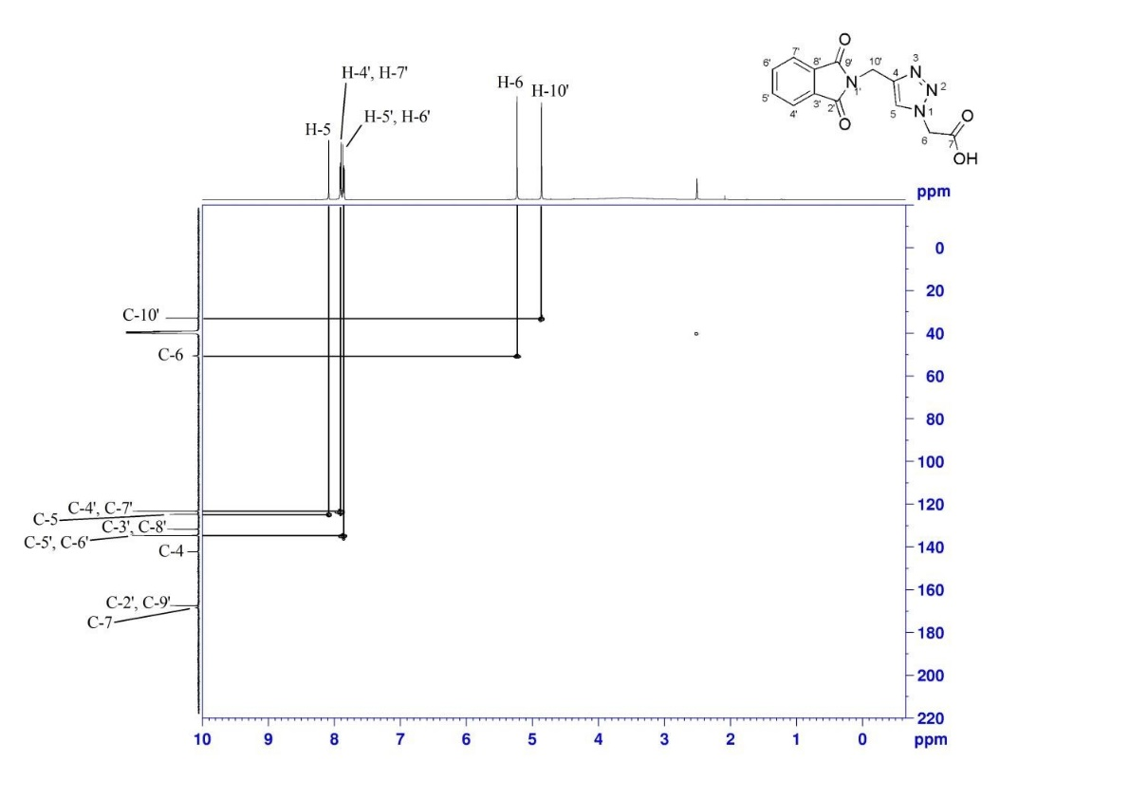
Figure 27: ¹H -¹³C HSQC spectrum of compound 11 in DMSO-d6
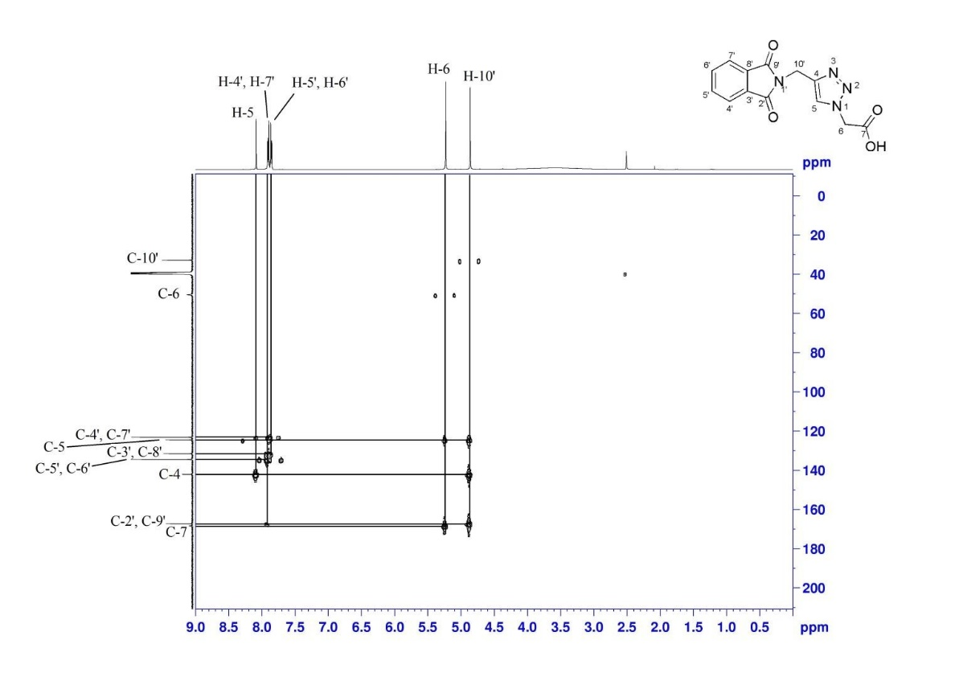
Figure 28: ¹H -¹³C HMBC spectrum of compound 11 in DMSO-d6

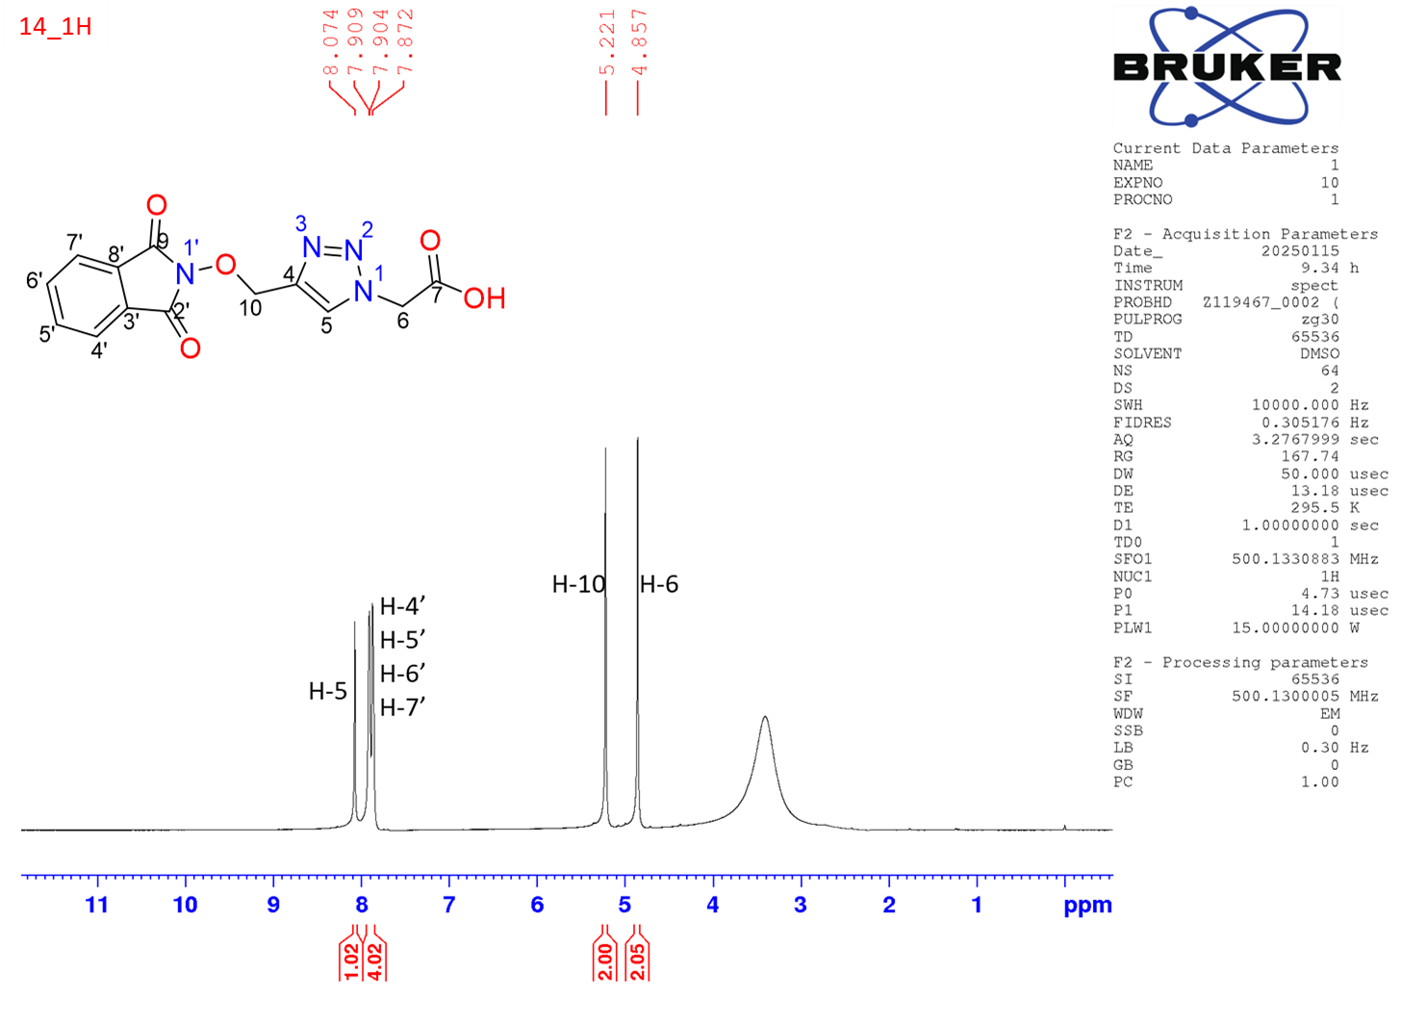
Figure 29: ¹H NMR spectrum of compound 14 in DMSO-d6
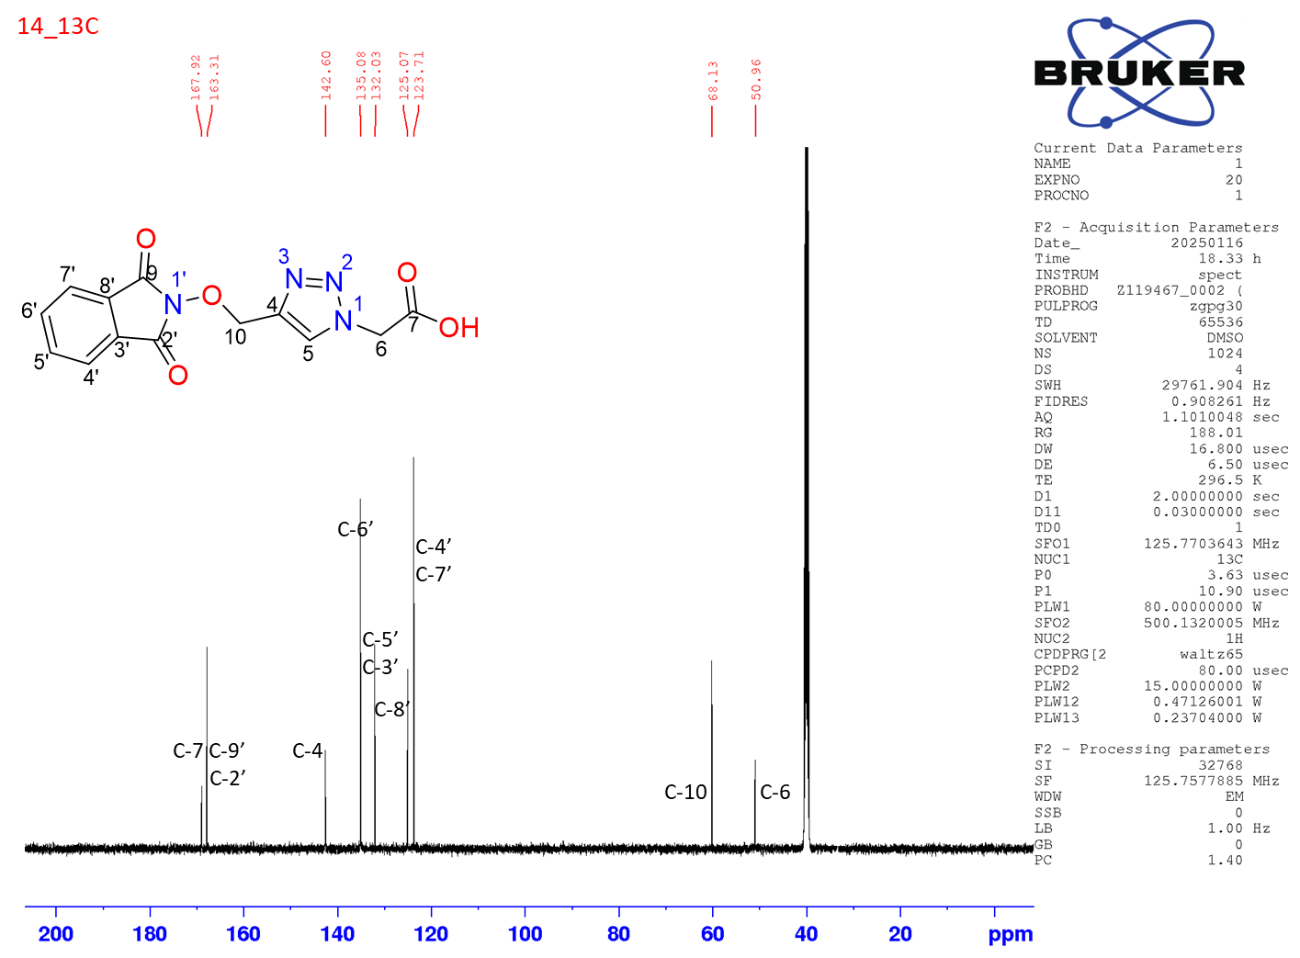
Figure 30: ¹³C NMR spectrum of compound 14 in DMSO-d6

