Ozone-initiated degradation of 1,2-dichlorobenzene over ceria-supported manganese, nickel, vanadium and iron catalysts
Nomthandazo Mkhize ª and Viswandha Srirama Rajasekhar Pullabhotla ^{a*}

ª Department of Chemistry, Faculty of Science, Agriculture and Engineering, University of Zululand, P/Bag X1001, KwaDlangezwa 3886, South Africa.

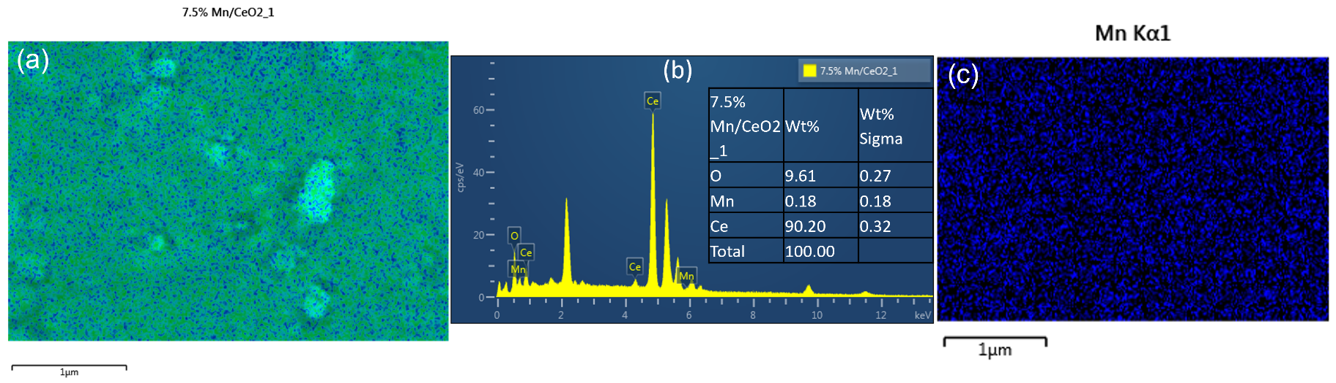
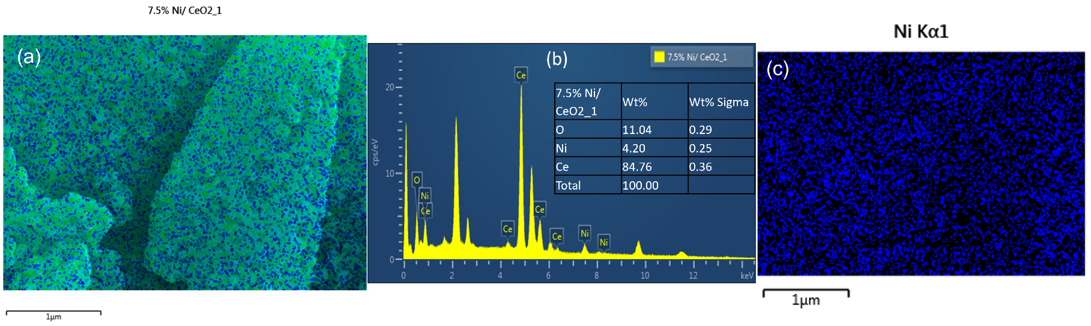
Figure S1. EDX results showing (a) elemental mapping, (b) EDX elemental spectrum, and (c) point mapping of 7.5% Mn/CeO₂ catalyst.
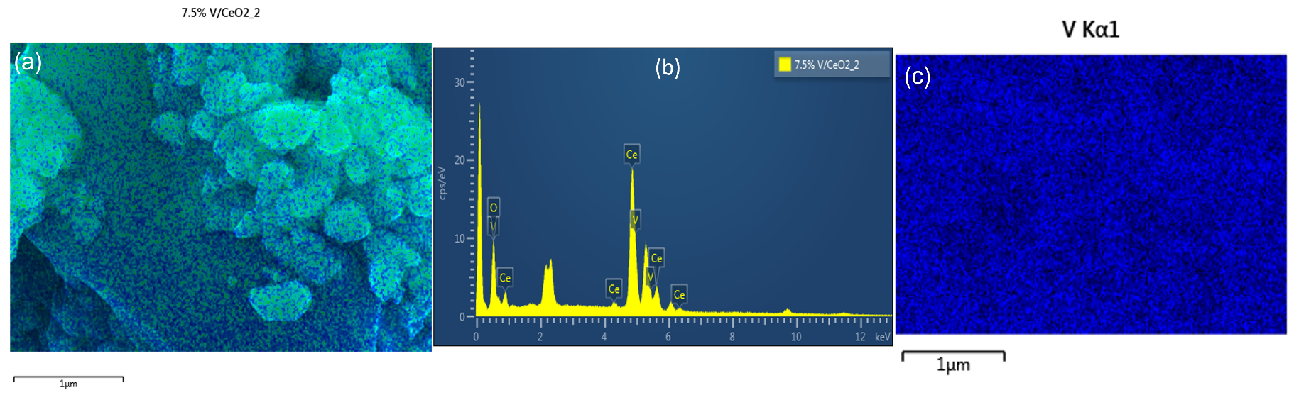
Figure S2. EDX results showing (a) elemental mapping, (b) EDX elemental spectrum, and (c) point mapping of 7.5% Ni/CeO₂ catalyst.
Figure S3. EDX results showing (a) elemental mapping, (b) EDX elemental spectrum, and (c) point mapping of 7.5% V/CeO₂ catalyst.

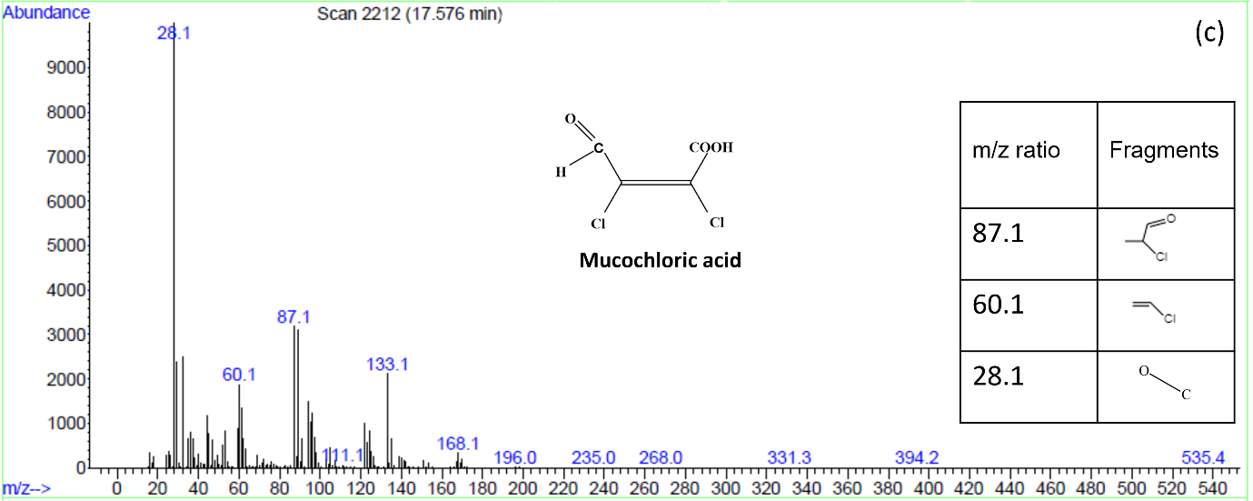
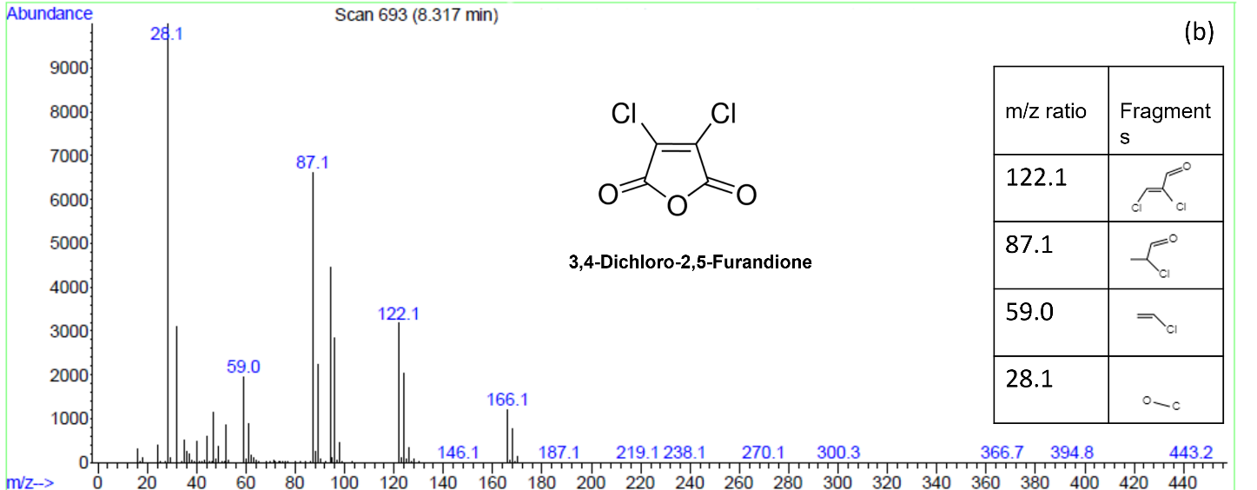
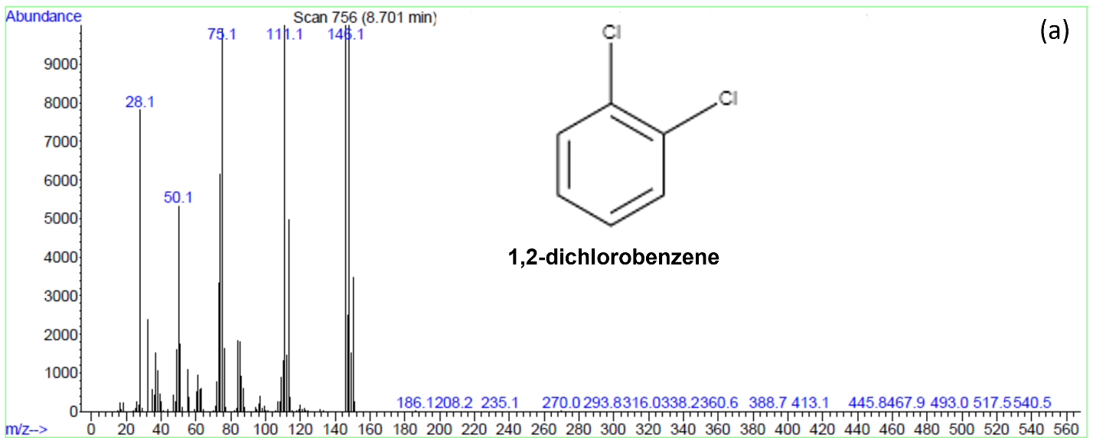
Figure S4. Mass spectra of (a) 1,2-dichlorobenzene (b) 3,4-dichloro-2,5-furadione and (c) Mucochloric acid.

Table S1. Summary of percentage conversion and selectivity in 2.5% Fe/CeO₂ catalyzed ozonation reaction of 1,2-dichlorobenzene.
Ozonation time (h) | Conversion (%) |  | Selectivity (%)
Ozonation time (h) | Conversion (%) | Mucochloric acid | 3,4-dichloro-2,5-furandione | Unidentified products
3 | 2 | 55 | 45 | -
6 | 6 | 61 | 39 | -
9 | 11 | 62 | 23 | 15
12 | 14 | 65 | 19 | 16
15 | 29 | 67 | 25 | 8
18 | 47 | 75 | 23 | 2
24 | 62 | 87 | - | 13

Table S2. Summary of percentage conversion and selectivity in 5% Mn/CeO₂ catalyzed ozonation reaction of 1,2-dichlorobenzene.
Ozonation time (h) | Conversion (%) |  | Selectivity (%)
Ozonation time (h) | Conversion (%) | Mucochloric acid | 3,4-dichloro-2,5-furandione | Unidentified products
3 | 2 | 30 | 60 | -
6 | 5 | 45 | 55 | -
9 | 13 | 47 | 50 | 3
12 | 15 | 51 | 39 | 10
15 | 32 | 68 | 26 | 6
18 | 45 | 84 | 10 | 6
24 | 53 | 90 | - | 10

Table S3. Summary of percentage conversion and selectivity in 7.5% Mn/CeO₂ catalyzed ozonation reaction of 1,2-dichlorobenzene.
Ozonation time (h) | Conversion (%) |  | Selectivity (%)
Ozonation time (h) | Conversion (%) | Mucochloric acid | 3,4-dichloro-2,5-furandione | Unidentified products
3 | 3 | 54 | 33 | 13
6 | 4 | 57 | 35 | 8
9 | 9 | 53 | 39 | 8
12 | 11 | 54 | 41 | 5
15 | 27 | 46 | 38 | 16
18 | 36 | 56 | 33 | 11
24 | 55 | 98 | - | 2

Table S4. Summary of percentage conversion and selectivity in 7.5% Ni/CeO₂ catalyzed ozonation reaction of 1,2-dichlorobenzene.
Ozonation time (h) | Conversion (%) |  | Selectivity (%)
Ozonation time (h) | Conversion (%) | Mucochloric acid | 3,4-dichloro-2,5-furandione | Unidentified products
3 | 8 | 35 | 22 | 43
6 | 11 | 39 | 21 | 40
9 | 13 | 41 | 23 | 36
12 | 19 | 57 | 25 | 18
15 | 27 | 48 | 27 | 25
18 | 34 | 71 | 25 | 4
24 | 51 | 85 | 10 | 5

Table S5. Summary of percentage conversion and selectivity in 7.5% V/CeO₂ catalyzed ozonation reaction of 1,2-dichlorobenzene.
Ozonation time (h) | Conversion (%) |  | Selectivity (%)
Ozonation time (h) | Conversion (%) | Mucochloric acid | 3,4-dichloro-2,5-furandione | Unidentified products
3 | 2 | 40 | 45 | 15
6 | 15 | 41 | 39 | 22
9 | 18 | 42 | 37 | 21
12 | 23 | 56 | 34 | 10
15 | 48 | 61 | 25 | 14
18 | 54 | 96 | - | 4
24 | 62 | 100 | - | -

