Electronic Supplementary Information
White light Emission from an Upconverted Emission Based on Triplet-Triplet Annihilation with Rose Bengal as the Sensitizer
Hung-Cheng Chen,*^{a,b} Chen-Yen Hung,ª Chih-Wei Lin, ^{a,c} Kuan-Hsiang Wang,^{a,c} Mandy M. Lee,ª Peilin Chen,^{d} Tashin J. Chow,*ª Chao-Ping Hsu,*ª and Shih-Sheng Sun*ª

ª Institute of Chemistry, Academia Sinica, Taipei 115, Taiwan, Republic of China
^{b} Department of Applied Chemistry, National University of Kaohsiung, Kaohsiung, 81148, Taiwan, Republic of China
^{c} Department of Chemistry, National Central University, Jhong-Li, 32001, Taiwan, Republic of China
^{d} Research Center for Applied Sciences, Academia Sinica, Taipei 115, Taiwan, Republic of China

E-mail: hungchengchen@nuk.edu.tw (H.-C. Chen)
tjchow@chem.sinica.edu.tw (T. J. Chow);
cherri@sinica.edu.tw (C.-P. Hsu);
sssun@chem.sinica.edu.tw (S.-S. Sun)

Fig. S1: Synthesis routes of triplet acceptor/annihilator 9-(triphenyl)ethynyl-10-phenylanthracene (TPE-PAn).

9-phenylanthracene , PAN
PAN was synthesized following the procedures in ref 1 and the structure was characterized by ¹H NMR and ¹³C NMR. The product was isolated as a white solid with a yield of 85%.
¹H NMR (400 MHz, CDCl₃)：δ 7.34 (t, J = 7.6 Hz, 2H), 7.42-7.47 (m, 4H), 7.59-7.52 (m, 3H), 7.65 (d, J = 8.4 Hz, 2H), 8.04 (d, J = 8.4 Hz, 2H), 8.49 (s, 1H). ¹³C NMR (100 MHz, CDCl₃)：δ 125.0, 125.3, 126.5, 126.8, 127.4, 128.3, 128.3, 130.2, 130.2, 131.2, 131.3, 137.0, 138.8.

9-Bromo,10-phenylanthracene , BrPAN
BrPAN was synthesized following the procedures in ref 2 and the structure was characterized by ¹H NMR and ¹³C NMR. The product was isolated as a white solid with a yield of 68%.
¹H NMR (400 MHz, CDCl₃)：δ 7.38 (m, 4H), 7.58 (m, 5H), 7.65 (d, J = 8.8 Hz, 2H), 8.61 (d, J = 9 Hz, 2H)；¹³C NMR (100 MHz, CDCl₃)：δ 125.5, 126.9, 127.3, 127.7, 127.8, 128.4, 130.1, 131.0, 131.1, 138.3.

Triphenyl-ethynyl , TPE
TPE was synthesized following the procedures in ref 3 and the structure was characterized by ¹H NMR and ¹³C NMR. The product was isolated as a white solid with a yield of 80%.
¹H NMR (500 MHz, CDCl₃)：δ 2.78 (s, 1H), 7.39 (m, 15H); ¹³C NMR (125 MHz ,CDCl₃)：δ 55.29, 73.35, 99.74, 126.36, 127.47, 128.50, 144.59.

9-(triphenyl)ethynyl,10-phenylanthracene , TPEPAN
A mixture of BrPAN (1.01 g, 3.03 mmol), TPE (0.97 g, 3.60 mmol), Pd(PPh₃)₄ (104 mg, 3 mol%), CuI (28.6 mg , 5 mol%), 10 mL of distilled tetrahydrofuran (THF), and 20 mL of distilled triethylamine (TEA) was heated to 90 ºC for 18 h under nitrogen. The solution was cooled and then diluted with CH₂Cl₂. The undissolved portion was filtered off by celite and the filtrate was concentrated under reduced pressure. Column chromatography with CH₂Cl₂/hexane (1:10) as eluent afforded the pale yellow solid of TPEPAN (1.25g, 2.40 mmol) with a yield of 80%.
¹H NMR (400 MHz, CD₂Cl₂)：δ 7.28-7.42 (m, 14H), 4.49-7.66 (m, 12H), 8.59 (d, J = 8.6 Hz, 2H)；¹³C NMR (100 MHz, CDCl₃)：δ 1.02, 82.7, 107.1, 117.8, 125.4, 126.2, 126.9,127.3, 127.6, 128.1, 128.3, 129.1, 129.4, 124.9, 131.1, 132.7, 138.0, 138.5, 145.4 ；FAB-MS m/z：520.2 (M⁺)；HRMS m/z：calcd for C₄₁H₂₈ 520.2192, found 520.2191(M⁺).

References
1. D. Mosnaim, D. C. Nonhebel, J. A. Russell. Tetrahedron 25, 3485 (1969).
2. F. H. C. Stewart. Aust. J. Chem. 13, 478 (1960).
3. S. D. Karlen, R. Ortiz, O. L. Chapman, M. A. Garcia-Garibay. J. Am. Chem. Soc. 127, 6554 (2005).

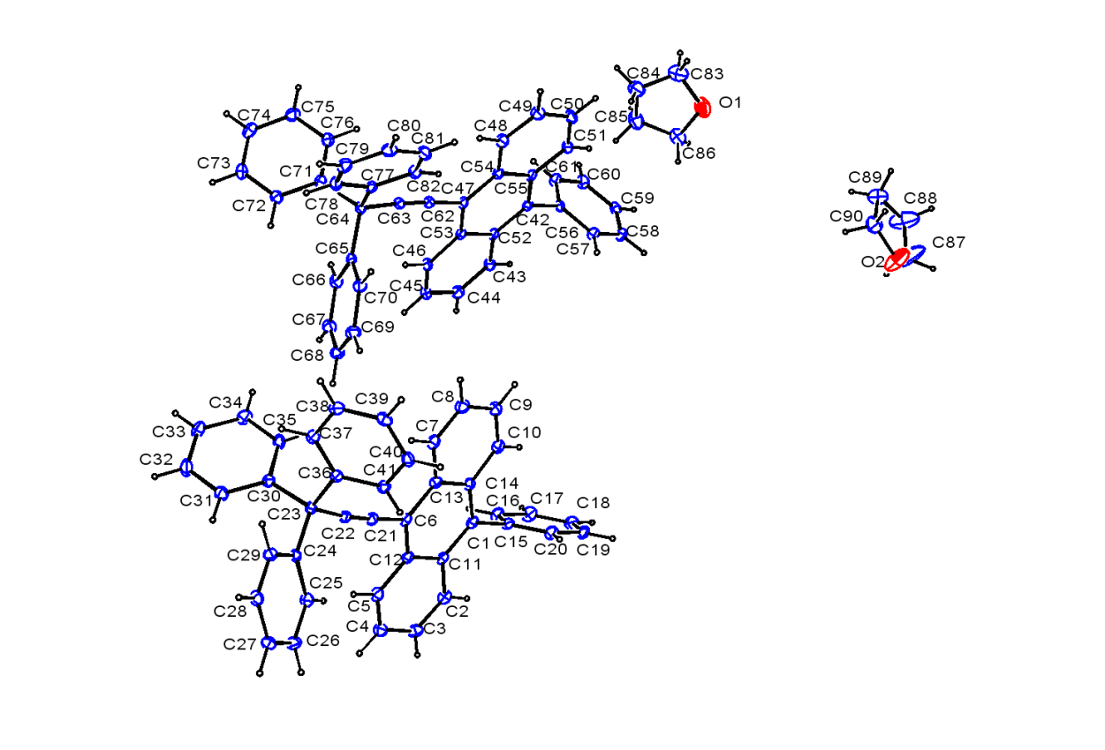
Fig. S1: X-ray structure of TPEPAN Ortep plot (thermal ellipsoids drawn at 50% probability) together with labeling scheme.

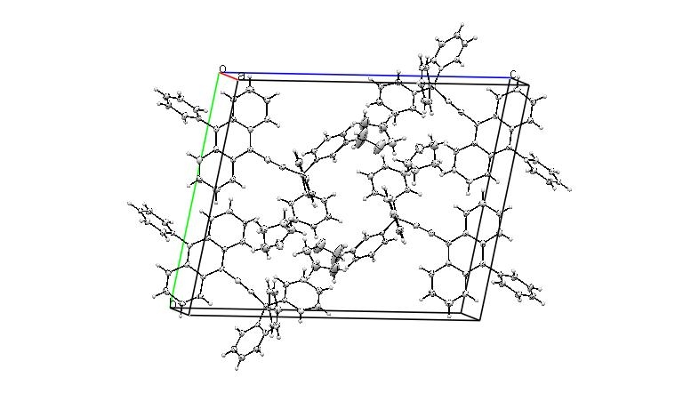

Fig. S2: X-ray structure of TPEPAN unit cell.

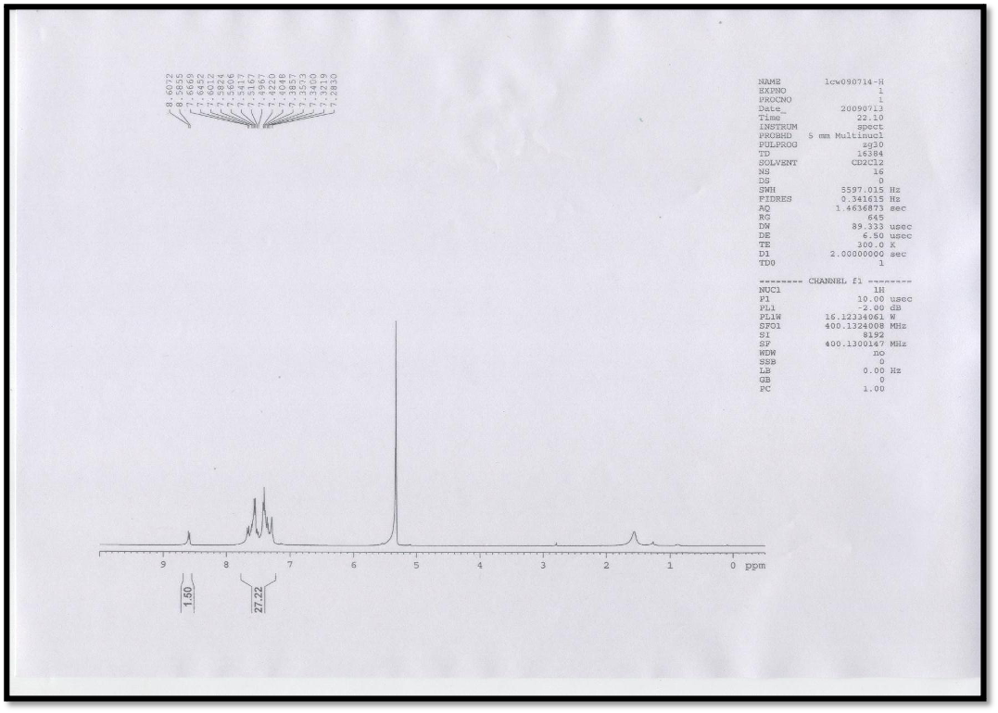
Fig. S3: ¹H NMR (400 M Hz, CD₂Cl₂ ) of TPEPAN
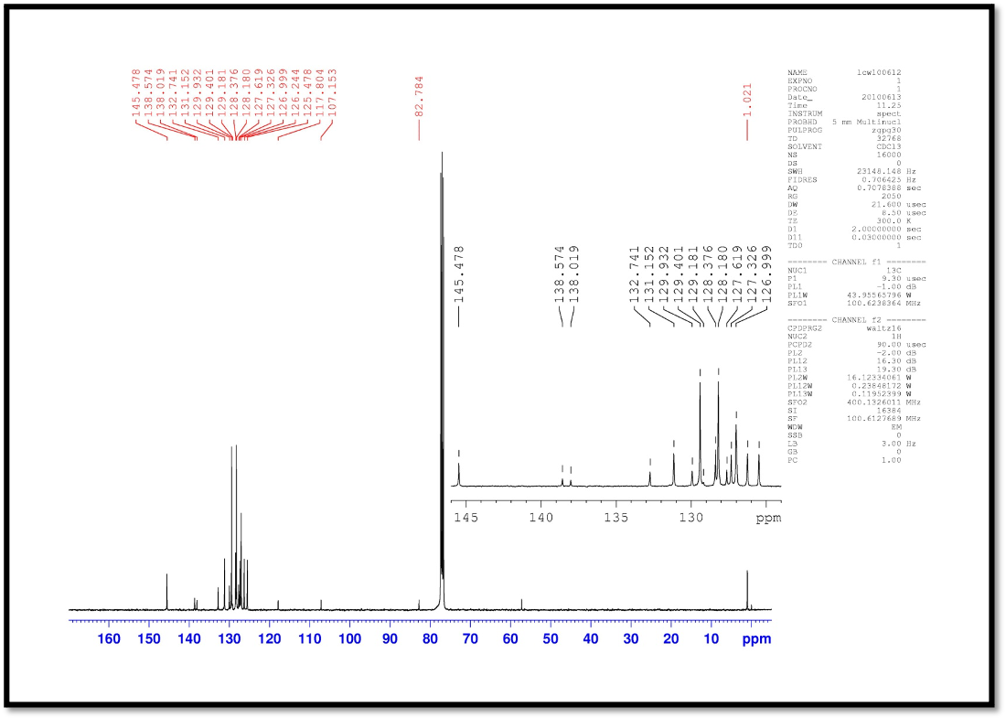
Fig. S4: ¹³C NMR (400 M Hz, CDCl₃ ) of TPEPAN
Fig. S5: Fluorescence spectra decays of the TPEPAN recorded on excitation at 375 nm. The fluorescence decays were monitored at 428 nm. Fits of a monoexponential function convoluted with the instrumental response function to the fluorescence decays. (a) in a 2:1 (v/v) THF/MeOH solution, τ_{f} = 4.87 ns. (b) in THF solution, τ_{f} = 4.72 ns.

Fig. S6: Emission spectra of TPEPAN and RB mixture in 2:1 (v/v) THF/MeOH solution ([RB] = 1.36×10⁻⁵ M, [TPEPAN] = 1.4×10⁻² M) excited at 532 nm with five different laser excitation powers. The background scattering from the incident 532 nm light source were removed. These spectra were used to calculate the CIE coordinates shown in Fig 6 of the main text.

Fig. S7: Time-resolved emission spectra of RB and TPEPAN mixture in deaerated 2:1 (v/v) THF/MeOH solution ([RB] = 1.36×10⁻⁵ M, [TPEPAN] = 1.4×10⁻² M) following a 532 nm, 6 ns laser pulse.
Fig. S8: Decay traces emission spectra of [RB]=1.36×10⁻⁵ M, [TPEPAN]= 1.4×10⁻² M mixture in 2:1 (v/v) THF/MeOH solution. excited at 532 nm. The fluorescence decay was monitored at the 450 nm and the τ_{f} = 732.9 μs.

