Supplementary data

**RP-HPLC conditions**

Clarified milk samples (20 µL) were injected directly into the column (Discovery BIO Supelco C5) after a wash of the needle with acetonitrile/water 50/50 v/v solution. Solvents used during the analysis were mobile phase A (0,025% TFA in H2O LC-MS v/v) and mobile phase B (0,02% TFA in acetonitrile v/v). The elution gradient was:

- From 29,5% to 34% B in 16 min;

- From 34% to 35,5% B in 0,1 min;

- From 35,5% to 37,5% B in 14,9 min;

- From 37,5% to 42% B in 14 min;

- From 42% to 95% B in 0,1 min;

- 95% for 5 min;

- From 95% to 29,5% B in 0,1 min;

- 29,5% B for 10 min.

**Chromatographic profile and mass spectra**

The following figures show the chromatographic profiles of IAR bulk milk (Figure 1), commercial A2 milk (Figure 2), A2A2 cow (Figure 4), A1A2 cow (Figure 5), BA2 cow Figure 6), BA1 cow (Figure 7), and A2A3/I cow (Figure 8). In addition, all the mass spectra related to IAR bulk milk (Figure 9-24) have been reported as well as the mass spectrum related to β-casein A2 from A2 commercial milk (Figure 3).

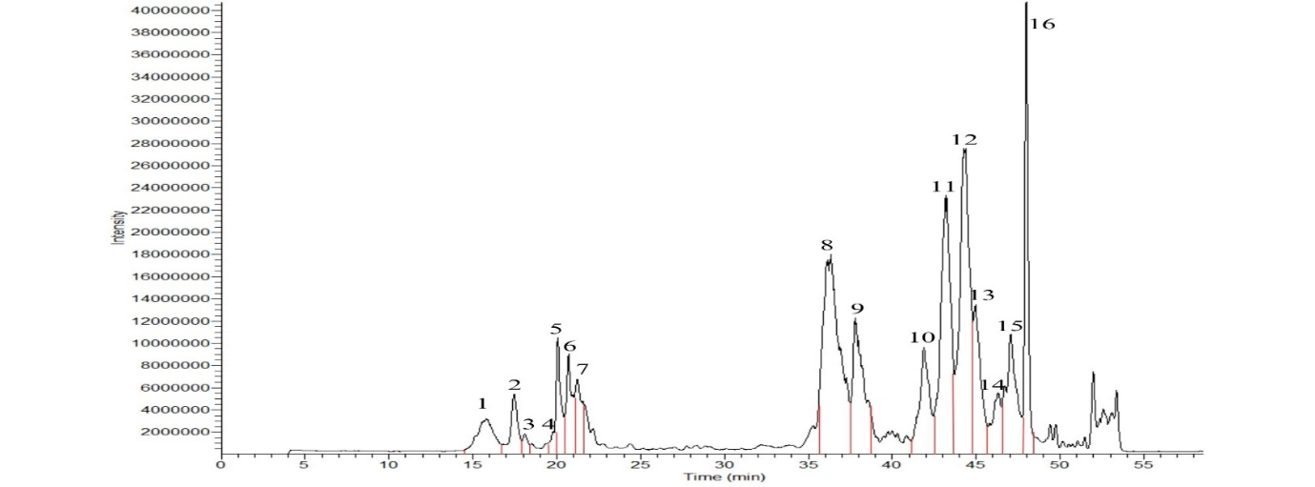

Figure : Chromatographic profile of IAR bulk milk

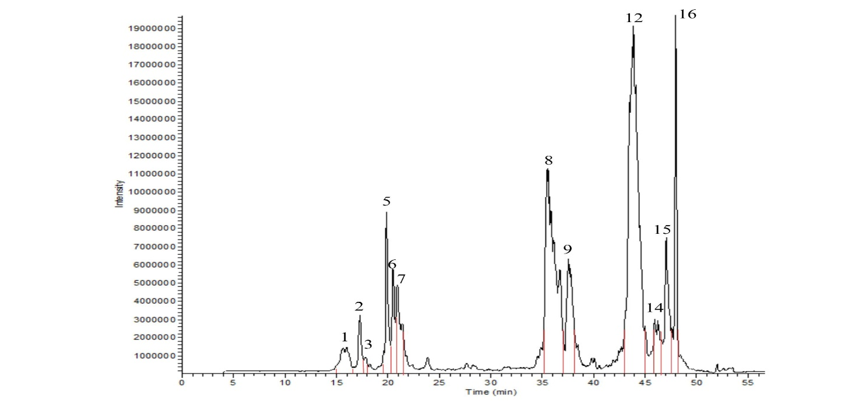

Figure : Chromatographic profile of A2 commercial milk

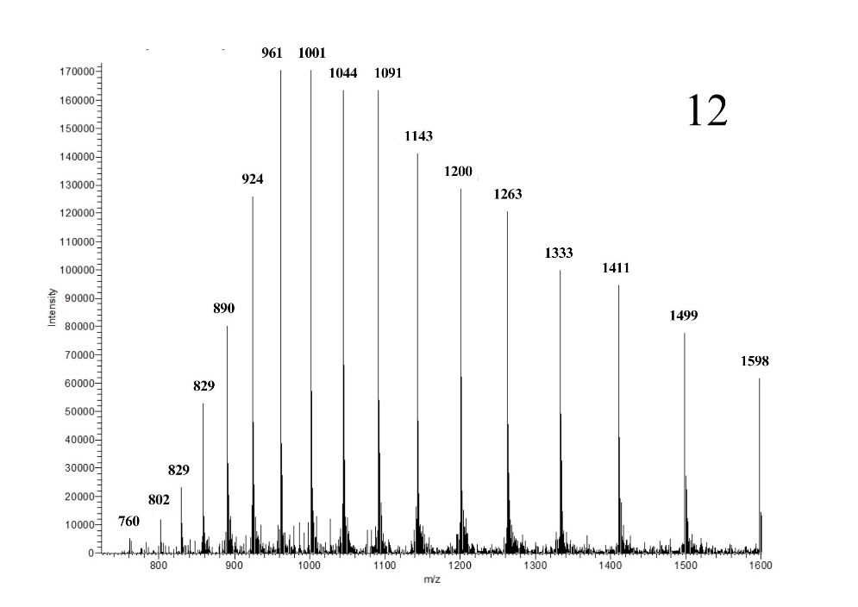

Figure : Mass spectrum of β-casein A2 from A2 commercial milk

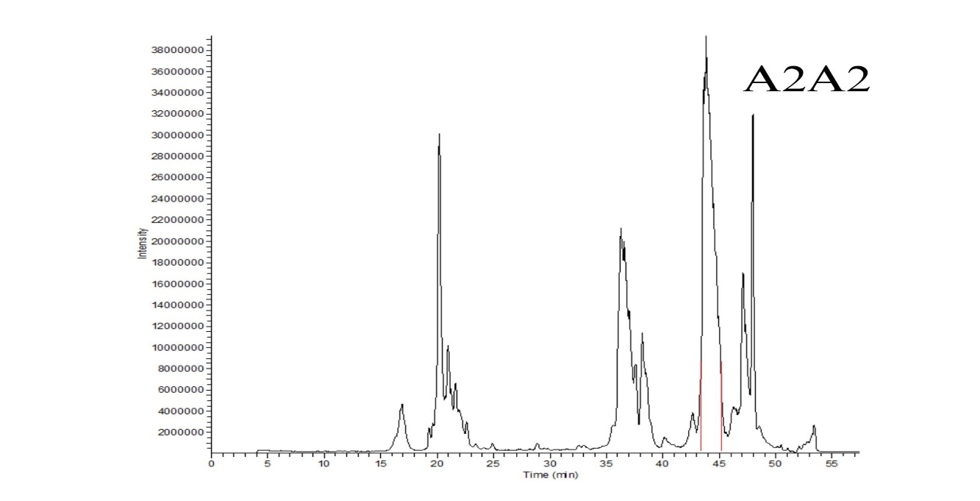

Figure : Chromatographic profile of A2A2 cow’s genotype

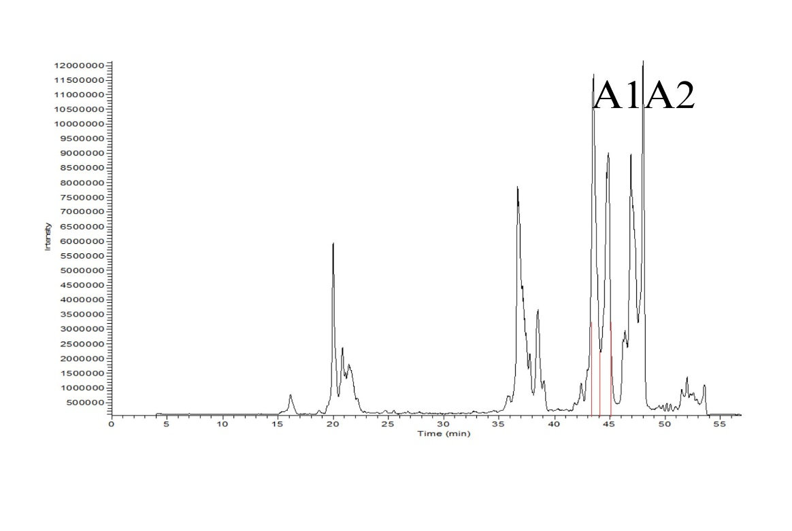

Figure : Chromatographic profile of A1A2 cow’s genotype

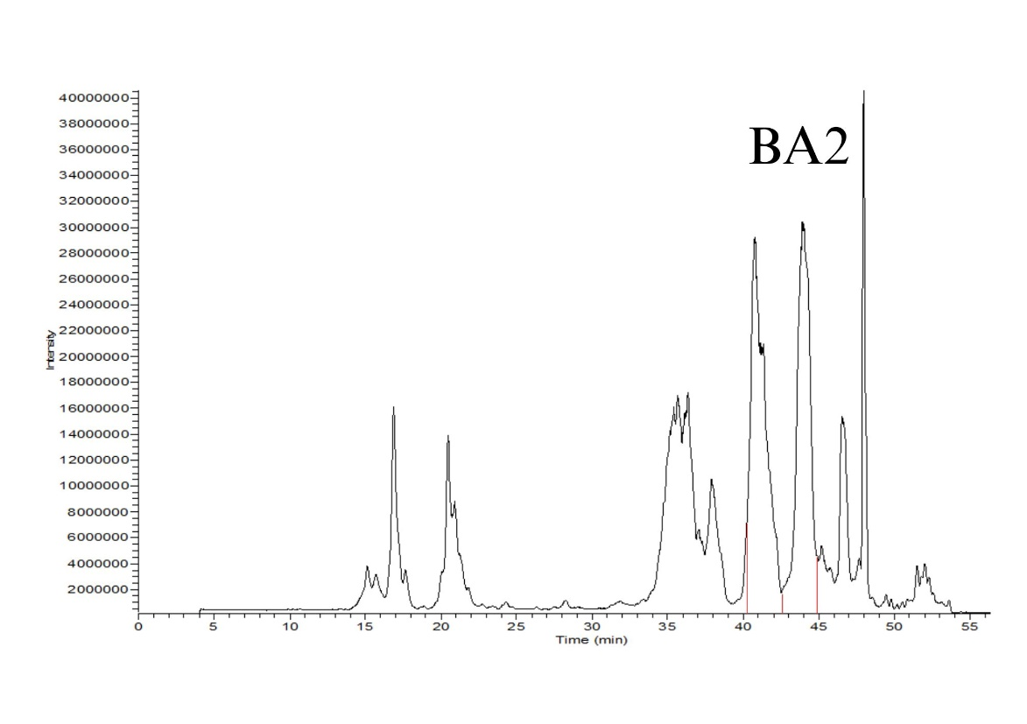

Figure : Chromatographic profile of BA2 cow’s genotype

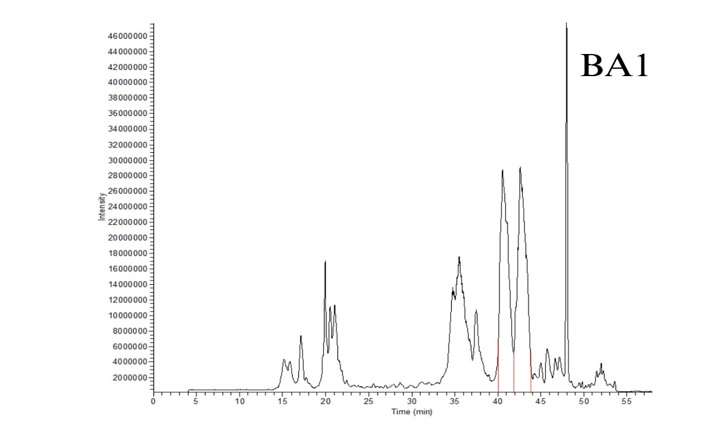

Figure : Chromatographic profile of BA1 cow’s genotype

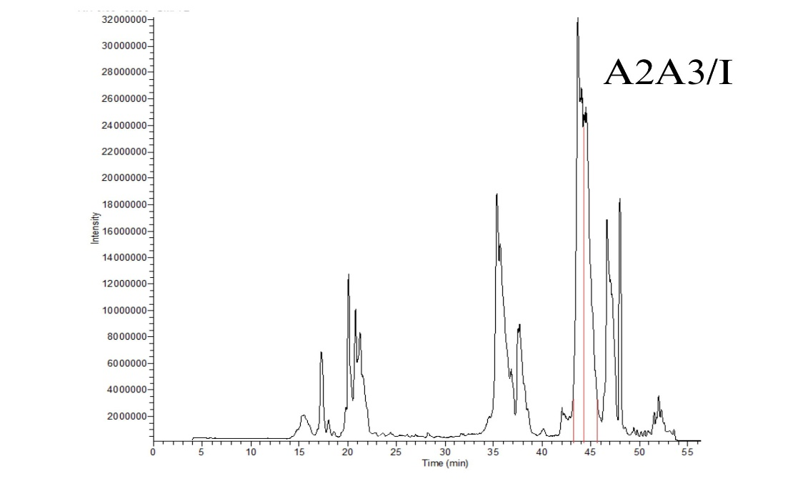

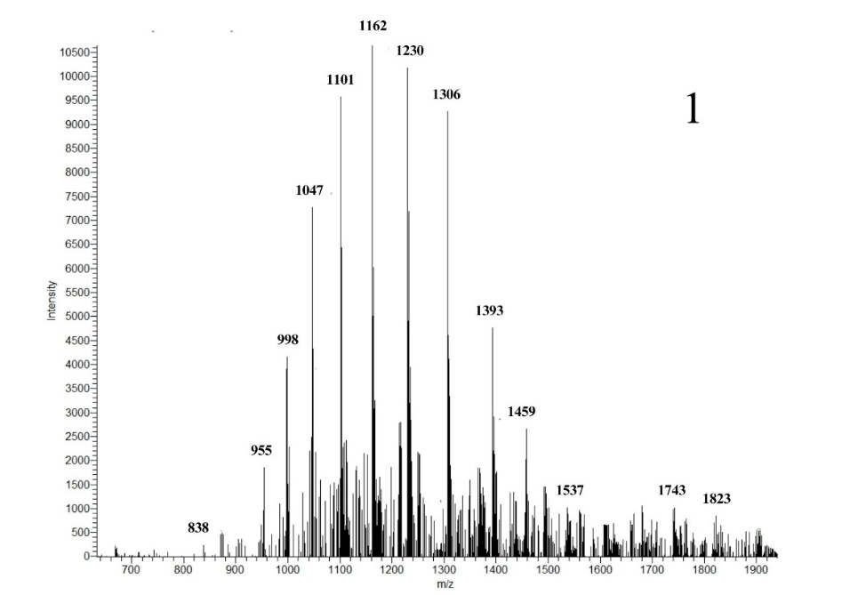Figure : Chromatographic profile of A2A3/I cow’s genotype

Figure : Mass spectrum of k-casein B 1P 2OG from IAR bulk milk. MW 20901 Da

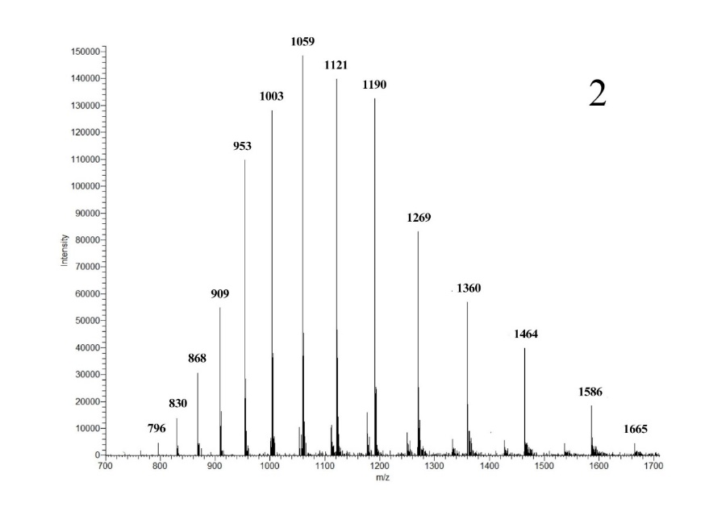

Figure : Mass spectrum of k-casein A 1P from IAR bulk milk. MW 19033 Da

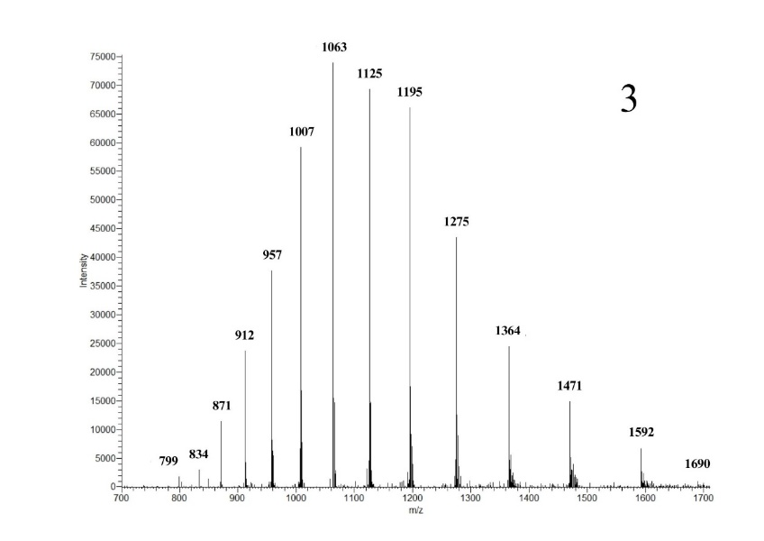

Figure : Mass spectrum of k-casein A 2P from IAR bulk milk. MW: 19114

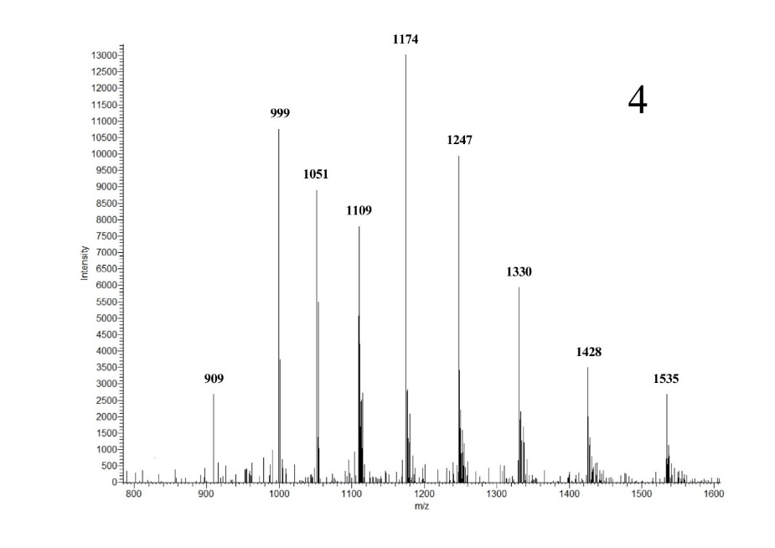

Figure : Mass spectrum of k-casein B 1P 1OG from IAR bulk milk. MW: 19949

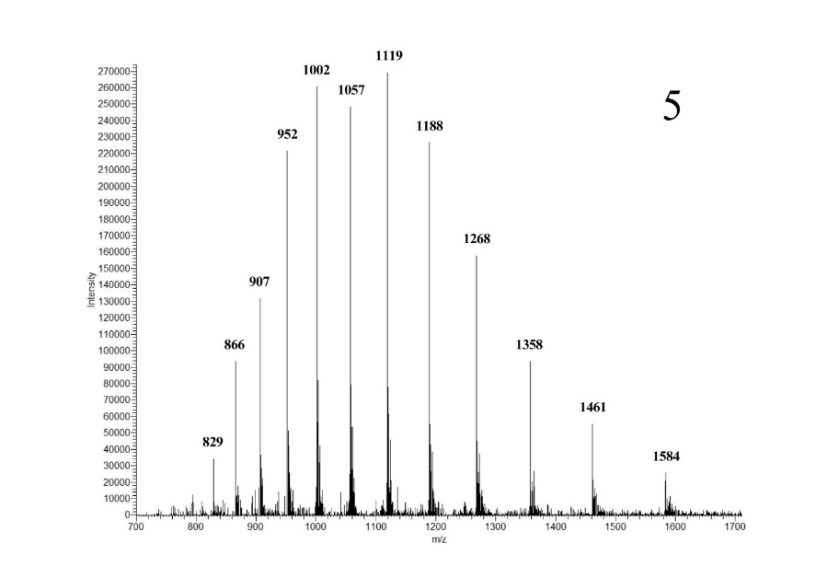

Figure : Mass spectrum of k-casein B 1P from IAR bulk milk. MW: 19014

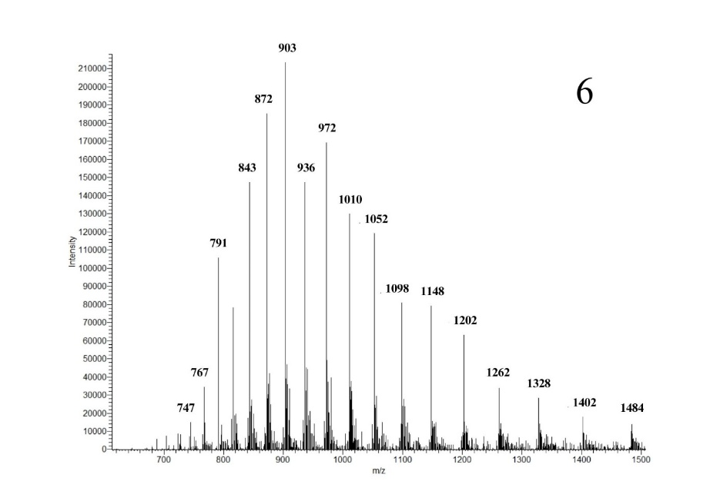

Figure : Mass spectrum of αs2-casein A 11P from IAR bulk milk. MW: 25244

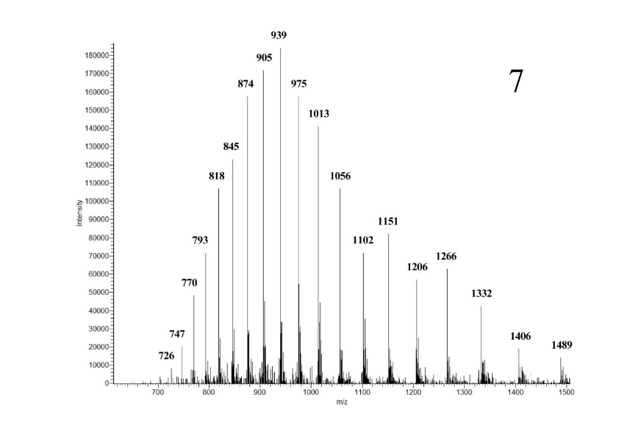

Figure : Mass spectrum of αs2-casein A 12P from IAR bulk milk. MW: 25317

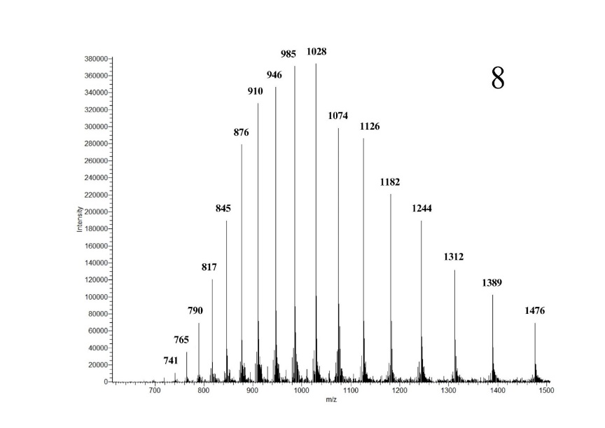

Figure : Mass spectrum of αs1-casein C 9P from IAR bulk milk. MW: 23622

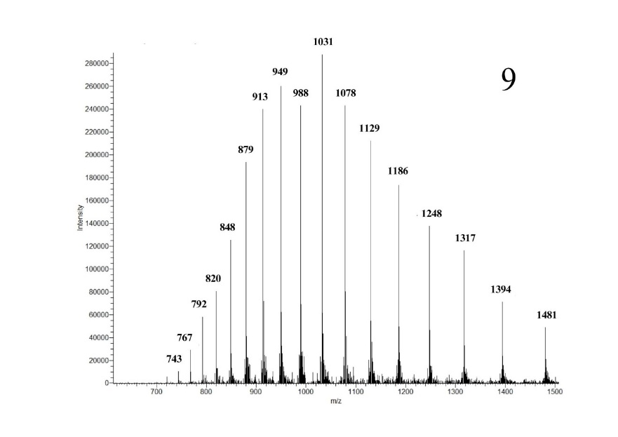

Figure : Mass spectrum of αs1-casein B 9P from IAR bulk milk. MW: 23700

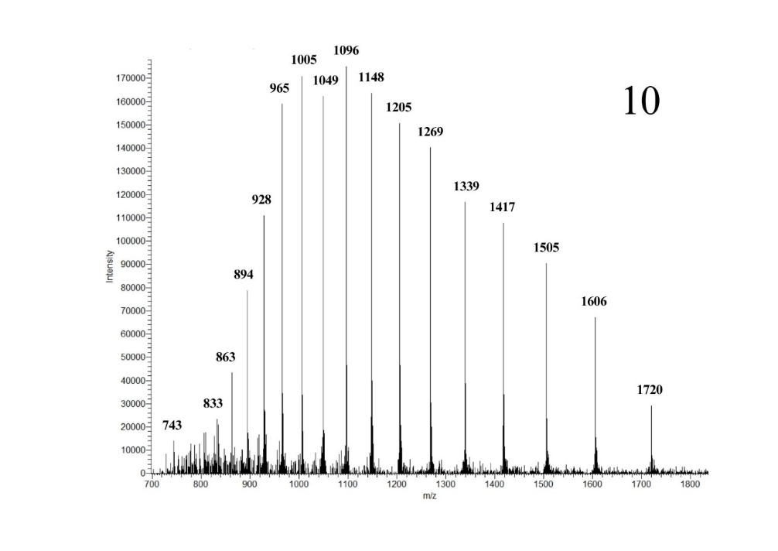

Figure : Mass spectrum of β-casein B 5P from IAR bulk milk. MW: 24098

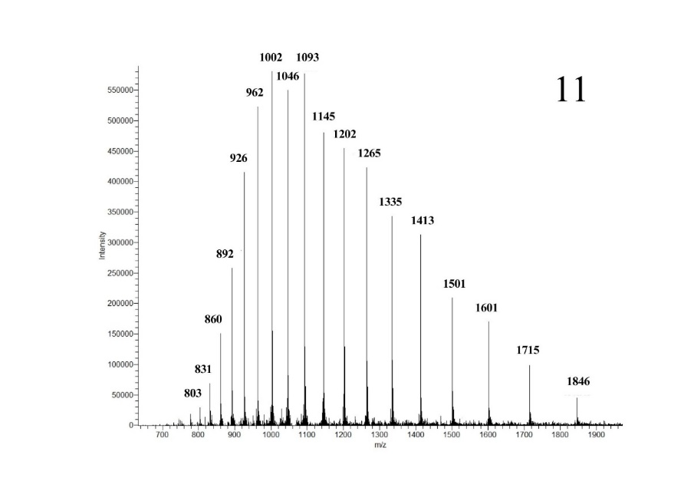

Figure : Mass spectrum of β-casein A1 5P from IAR bulk milk. MW: 24033

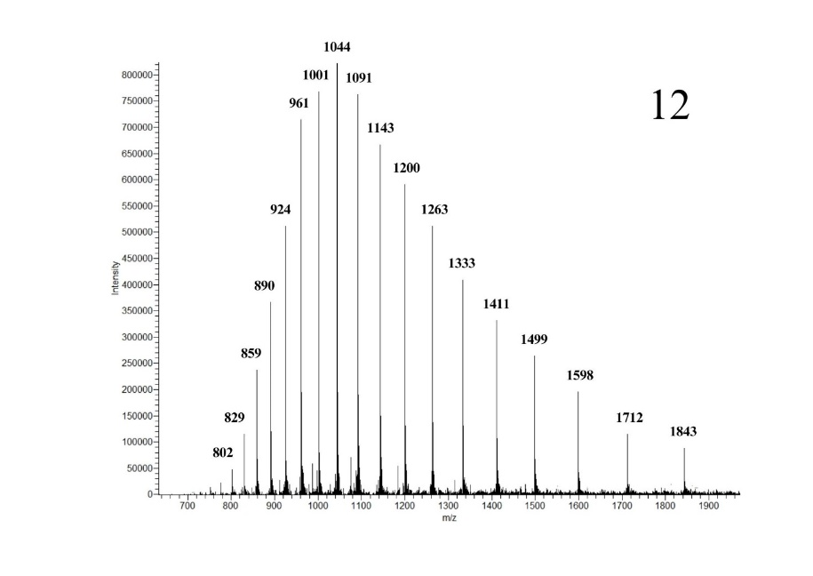

Figure : Mass spectrum of β-casein A2 5P from IAR bulk milk. MW: 23992

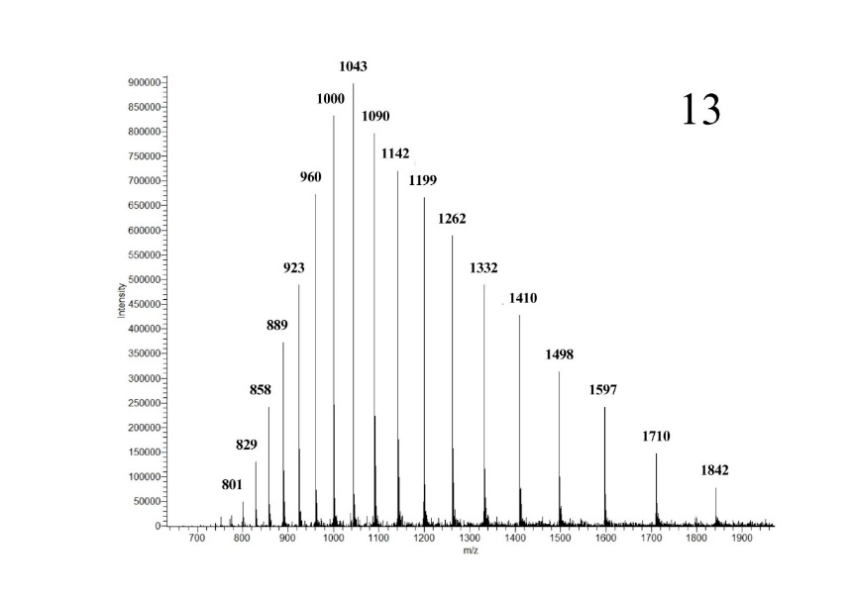

Figure : Mass spectrum of β-casein A3/I 5P from IAR bulk milk. MW: 23968

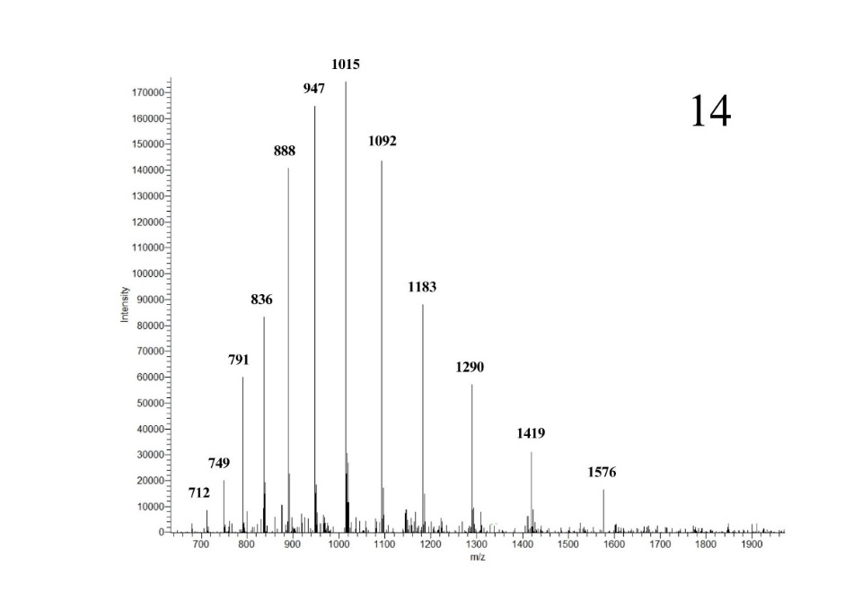

Figure : Mass spectrum of α-lactalbumin B from IAR bulk milk. MW: 14188

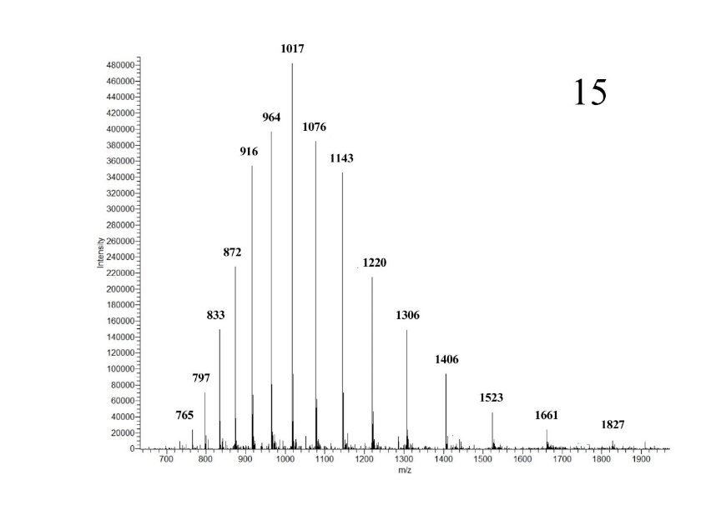

Figure : Mass spectrum of β-lactoglobulin B from IAR bulk milk. MW: 18289

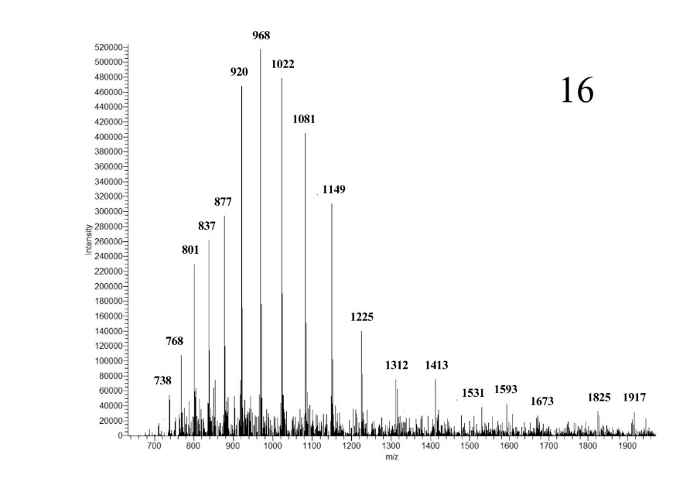

Figure : Mass spectrum of β-lactoglobulin A from IAR bulk milk. MW: 18378