Mitigating the Charge Trapping Effects of D-Sorbitol / poly(3,4-ethylenedioxythiophene): poly(styrenesulfonate) (PEDOT:PSS) Polymer Blend Contacts to Crystalline Silicon
Daniel Cohen, Esha S. Thakur, and Michael G. Walter*
*Department of Chemistry, University of North Carolina at Charlotte, Charlotte, NC 28223-0001
Michael.Walter@uncc.edu
Supplemental Information:

Note: PEDOT:PSS/s-PEDOT:PSS silicon device fabrication and testing were similar to previous reports,^{1, 2} using the device configuration below (Figure S1).

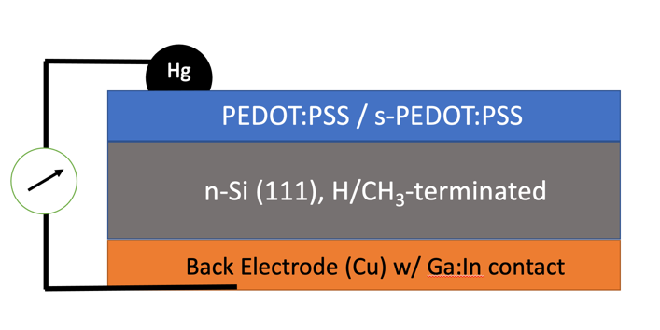
Figure S1. Device configuration used for measuring both dark and light current-voltage JV curve electrical properties of solution-processed PEDOT:PSS/s-PEDOT:PSS n-Si hybrid devices.

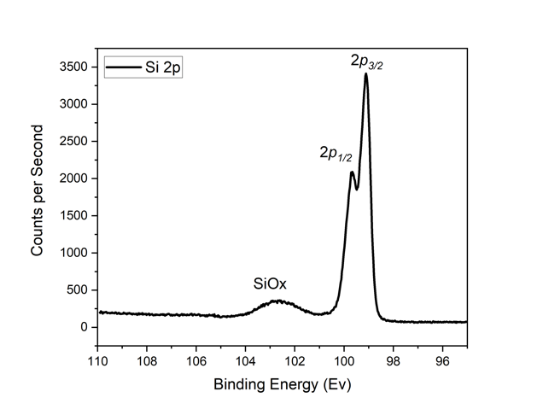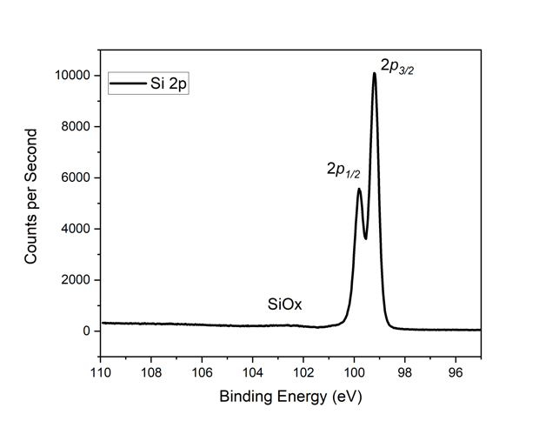
b)
a)
Figure S2. Silicon 2p XPS spectrum of H-Si(111)/PEDOT:PSS, (a) Me-Si(111)/PEDOT:PSS (b) after removal of the organic layer and surface cleaning.

1. Walter, M. G.; Liu, X.; O'Leary, L. E.; Brunschwig, B. S.; Lewis, N. S., Electrical Junction Behavior of Poly(3,4-ethylenedioxythiophene) (PEDOT) Contacts to H-Terminated and CH3-Terminated p-, n-, and n+-Si(111) Surfaces. J. Phys. Chem. C 2013, 117 (28), 14485-14492.
2. Cohen, D.; Bostian, M. E.; Nguyen, L.; Walter, M. G., Conductive poly(3,4-ethylenedioxythiophene): poly(styrene sulfonate) polymer glue as an ohmic and rectifying electrical contact for H-terminated n-Si and p-Si wafers. Polym Int 2018, 67 (7), 853-858.

