Supplementary Material to:

Desymmetrization in Geometry Optimization: Application to an ab initio study of copper(I) hydration.

Cory C. Pye*, Daniel C. M. Whynot, Christopher R. Corbeil, and Darren J. Mercer

Department of Chemistry, Saint Mary's University, 923 Robie Street, Halifax, NS Canada B3H 3C3
Table S2. Total Energies
Bold indicates a local minimum on the potential energy surface
 | HF/STO-3G | HF/3-21G
Cu⁺ K_{h} | -1620.0889276 (d⁸s²) | -1630.4158906 (d⁸s²)
Cu⁺ K_{h} | -1620.0889276 (d⁸s²) | -1630.4175773 (d⁸s²)
Cu⁺ K_{h} UHF | -1620.2204868 (d⁸s²) | -1630.5209328
Cu⁺ K_{h} |  | -1630.5609488
Cu⁺ K_{h} |  | -1630.6760974 (d⁹s¹)
Cu⁺ K_{h} | -1619.4310521 (d⁸s²) | -1630.5365768
Cu⁺ K_{h} | -1620.2028767 | -1630.6760969 (d⁹s¹)
Cu⁺ K_{h} | -1620.2204868
Cu⁺ K_{h} |  | -1630.5361396
H₂O C_{2v} | -74.9659012 | -75.5859598
Cu(H₂O)₁⁺ C_{2v} | -1695.1573763¹ | -1706.0699834
Cu(H₂O)₁⁺ C_{2v} | -1695.2862500² | -1706.3590148
Cu(H₂O)₁⁺ C_{2v} trip | -1695.3495185² | -1706.3638341
Cu(H₂O)₂⁺ D_{2d} |  | -1781.9828761
Cu(H₂O)₂⁺ D_{2d} | -1770.3076172 | -1782.0139252
Cu(H₂O)₂⁺ D_{2d} trip | -1770.3283674 | -1781.9915374
Cu(H₂O)₂⁺ D_{2h} | -1770.1197425¹ | -1781.6724591
Cu(H₂O)₂⁺ D_{2h} | -1770.3164800² | -1782.0130543²
Cu(H₂O)₂⁺ D_{2h} trip | -1770.3300555² | -1781.9910293²
Cu(H₂O)₂⁺ D_{2h} |  | -1781.9816561
Cu(H₂O)₂⁺ C₂ | -1770.1980313 | D_{2d}
Cu(H₂O)₃⁺ D_{3h} #1 | -1845.1253561 | -1857.5938777
Cu(H₂O)₃⁺ D_{3h} #1 | -1845.2853917 | -1857.6441758
Cu(H₂O)₃⁺ D_{3h} #1 trip | -1845.2900154
Cu(H₂O)₃⁺ D₃ |  | -1857.6429549
Cu(H₂O)₃⁺ C₃ | -1845.2522195

Table S2 (continued)
 | HF/6-31G* | HF/6-31+G* | HF/6-311+G*
Cu⁺ K_{h} | -1638.0417719 (d⁸s²) | -1638.0539765 (d⁸s²)
Cu⁺ K_{h} | -1638.0417719 (d⁸s²)
Cu⁺ K_{h} UHF | -1638.3528406 (d¹⁰) | -1638.4550683 (d¹⁰) | -1638.6050297
Cu⁺ K_{h} | -1638.3528179
Cu⁺ K_{h} | -1638.3528375
H₂O C_{2v} | -76.0107465 | -76.0177432 | -76.0377596
Cu(H₂O)₁⁺ C_{2v} | -1714.0943797 | -1714.1100484
Cu(H₂O)₁⁺ C_{2v} | -1714.4481785
Cu(H₂O)₁⁺ C_{2v} trip | -1714.4517988
Cu(H₂O)₁⁺ C_{2v} | -1714.4352078 | -1714.5257795 | -1714.6974194
Cu(H₂O)₂⁺ D_{2d} | -1790.5133812 | -1790.5926622 | -1790.7861053
Cu(H₂O)₂⁺ D_{2d} | -1790.5130447
Cu(H₂O)₂⁺ D_{2d} trip | -1790.4859411
Cu(H₂O)₂⁺ D_{2h} | -1790.1205655 | -1790.5924528 | -1790.7858599
Cu(H₂O)₂⁺ D_{2h} | as below
Cu(H₂O)₂⁺ D_{2h} trip | -1790.4857662²
Cu(H₂O)₂⁺ D_{2h} | -1790.5128478
Cu(H₂O)₂⁺ C₂ | D_{2d}
Cu(H₂O)₃⁺ D_{3h} #1 | -1866.5572082 | -1866.6370539 | -1866.8523345
Cu(H₂O)₃⁺ D_{3h} #1 | as above
Cu(H₂O)₃⁺ D_{3h} #2 | -1866.5600049 | -1866.6381871 | -1866.8536506
Cu(H₂O)₃⁺ D₃ | -1866.5604907 | -1866.6390152 | -1866.8545075
Cu(H₂O)₃⁺ C_{2v} #1 | -1866.5592836 | -1866.6384340 | -1866.8538656
Cu(H₂O)₃⁺ C_{2v} #2 | -1866.5602928 | -1866.6388772 | -1866.8543535
Cu(H₂O)₃⁺ C_{s} [2+1] | -1866.5516635 | -1866.6352103 | -1866.8506182
Table S2 (continued)
 | MP2/6-31G* | MP2/6-31+G* | MP2/6-311+G*
Cu⁺ K_{h}¹ | -1638.2003534 | -1638.2293274
Cu⁺ K_{h}² | -1638.5962821 | -1638.7476775 | -1638.9805098
H₂O C_{2v} | -76.1968478 | -76.2097766 | -76.2447096
Cu(H₂O)₁⁺ C_{2v} | -1714.4539231 | -1714.4939661
Cu(H₂O)₁⁺ C_{2v} | -1714.8919169 | -1715.0259546 | -1715.2950037
Cu(H₂O)₂⁺ D_{2d} | -1791.1875576 | -1791.3088825 | -1791.6141676
Cu(H₂O)₂⁺ D_{2h} | -1791.1862467 | -1791.3082031 | -1791.6132660
Cu(H₂O)₂⁺ C_{s} | -1791.1875579 | -1791.3089053 | N/A
Cu(H₂O)₂⁺ C₂ | -1791.1875582 | -1791.3089283 | N/A
Cu(H₂O)₃⁺ D_{3h} #1 | -1867.4109305 | -1867.5399440 | -1867.8829050
Cu(H₂O)₃⁺ D_{3h} #2 | -1867.4174132 | -1867.5425509 | -1867.8852858
Cu(H₂O)₃⁺ D₃ | -1867.4175633 | -1867.5433761 | -1866.8472983
Cu(H₂O)₃⁺ C_{2v} #1 | -1867.4153825 | -1867.5444636 | -1867.7985414
Cu(H₂O)₃⁺ C_{2v} #2 | -1867.4202747 | -1867.5457892 | -1867.8880149
Cu(H₂O)₃⁺ C₂ | -1867.4204003 | -1867.5461562 | -1867.8880240
Cu(H₂O)₃⁺ C₂ | -1867.4188026 | -1867.5449075 | N/A
Cu(H₂O)₃⁺ C_{s} #1 | -1867.4203488 | -1867.5458720 | N/A
Cu(H₂O)₃⁺ C_{s} #2 | -1867.4203323 | -1867.5459834 | -1867.8881271
Cu(H₂O)₃⁺ C₁ | -1867.4204048 | -1867.5463595 | N/A
Cu(H₂O)₃⁺ C_{s} [2+1] | -1867.4191658 | -1867.5509265 | -1867.8931784
Cu(H₂O)₃⁺ C₁ [2+1] | -1867.4191715 | -1867.5509392 | N/A

 | B3LYP/6-31G* | B3LYP/6-31+G* | B3LYP/6-311+G*
Cu⁺ K_{h} | -1639.860885 | -1640.0169542 | -1640.1769055
H₂O C_{2v} | -76.4089533 | -76.4225722 | -76.443809
Cu(H₂O)₁ C_{2v} | -1716.3911201 | -1716.5104134 | -1716.6923639
Cu(H₂O)₂ D_{2d} | -1792.8990982 | -1793.0035421 | -1793.2079951
Cu(H₂O)₂ D_{2h} | -1792.8977101 | -1793.0029600 | -1793.2073689
Cu(H₂O)₂ C_{s} | -1792.8991623 | -1793.0037125 | N/A
Cu(H₂O)₂ C₂ | -1792.8992070 | -1793.0035834 | N/A
Cu(H₂O)₃ D_{3h} #1 | -1869.3384402 | -1869.4466918 | -1869.6752768
Cu(H₂O)₃ D_{3h} #2 | -1869.3441930 | -1869.4488446 | -1869.6777787
Cu(H₂O)₃ D₃ | -1869.3444412 | -1869.4496906 | -1869.6786167
Cu(H₂O)₃ C_{2v} #1 | -1869.3422760 | -1869.4501076 | -1869.6777314
Cu(H₂O)₃ C_{2v} #2 | -1869.3453255 | -1869.4513135 | -1869.6794642
Cu(H₂O)₃ C₂ | -1869.3453343 | -1869.4514670 | N/A
Cu(H₂O)₃ C_{s} #1 | -1869.3453124 | -1869.4513008 | N/A
Cu(H₂O)₃ C_{s} #2 | -1869.3455338 | -1869.4514154 | N/A
Cu(H₂O)₃ C₁ | -1869.3454180 | -1869.4515991 | N/A
Cu(H₂O)₃⁺ C_{s} [2+1] | -1869.3444406 | -1869.4569468 | -1869.6849801
Cu(H₂O)₃⁺ C₁ [2+1] | -1869.3445304 | -1869.4569754 | N/A

Table S2 (continued)
 | HF/6-31G* | HF/6-31+G* | HF/6-311+G*
Cu(H₂O)₄⁺ D_{4h} #1 | -1942.5792468 | -1942.6678280 | -1942.9039011
Cu(H₂O)₄⁺ D_{4h} #2 | -1942.5818899 | -1942.6698173 | -1942.9059355
Cu(H₂O)₄⁺ D_{2h} #1 | -1942.5881286 | -1942.6755826 | -1942.9122776
Cu(H₂O)₄⁺ D₄ | -1942.5874357 | -1942.6748497 | -1942.9115580
Cu(H₂O)₄⁺ D_{2d} #1 | -1942.5980756 | -1942.6782045 | -1942.9148709
Cu(H₂O)₄⁺ D_{2d} #2 | -1942.5819090 | N/A | -1942.9059355
Cu(H₂O)₄⁺ D_{2d} #3 | -1942.5977246 | -1942.6777707 | -1942.9144397
Cu(H₂O)₄⁺ C_{4v} #1 | -1942.5819896 | N/A | N/A
Cu(H₂O)₄⁺ C_{4h} #1 | -1942.5794773 | -1942.6681329 | N/A
Cu(H₂O)₄⁺ C_{2v} #2 | -1942.5964694 | -1942.6765992
Cu(H₂O)₄⁺ C_{2v} #3 | C_{2v} #14 | D_{2h} #1
Cu(H₂O)₄⁺ C_{2v} #4 | N/A | N/A
Cu(H₂O)₄⁺ C_{2v} #5 | -1942.5819903 | N/A
Cu(H₂O)₄⁺ C_{2v} #6 | N/A | N/A
Cu(H₂O)₄⁺ C_{2v} #11 | D_{2d} #1 | N/A | N/A
Cu(H₂O)₄⁺ C_{2v} #14 [3+1] | -1942.5969389 | -1942.6810135 | -1942.9182726
Cu(H₂O)₄⁺ C_{2v} #16 [3+1] | -1942.5976115 | -1942.6811552 | -1942.9184067
Cu(H₂O)₄⁺ C_{2v} #17 | -1942.5863813 | -1942.6740161 | -1942.9106277
Cu(H₂O)₄⁺ C₄ #1 | -1942.5892014 | N/A | N/A
Cu(H₂O)₄⁺ C₄ #2 | C₄ #1 | D₄ | N/A
Cu(H₂O)₄⁺ C₄ #4 | C₄ #1 | N/A | N/A
Cu(H₂O)₄⁺ S₄ #1 | -1942.5989671 | -1942.6788936 | -1942.9156833
Cu(H₂O)₄⁺ S₄ #2 | N/A | S₄ #1 | N/A
Cu(H₂O)₄⁺ S₄ #3 | S₄ #1 | N/A | S₄ #1
Cu(H₂O)₄⁺ S₄ #4 | S₄ #1 | S₄ #1 | S₄ #1
Cu(H₂O)₄⁺ S₄ #5 | S₄ #1 | S₄ #1 | S₄ #1
Cu(H₂O)₄⁺ D₂ #1 | -1942.5984351 | -1942.6782127 | D_{2d} #1
Cu(H₂O)₄⁺ D₂ #2 | D_{2h} #1 | N/A | D_{2h} #1
Cu(H₂O)₄⁺ D₂ #3 | D₂ #1 | D₂ #1 | D_{2d} #1
Cu(H₂O)₄⁺ D₂ #8 | D₂ #1 | D₂ #1 | D_{2d} #1
Cu(H₂O)₄⁺ C₂ #1 | -1942.5992334 | S₄ #1
Cu(H₂O)₄⁺ C₂ #3 | C_{2v} #16 | N/A | N/A
Cu(H₂O)₄⁺ C₂ #4 | C₂ #1 | S₄ #1 | N/A
Cu(H₂O)₄⁺ C₂ #5 | C_{2v} #16 | C_{2v} #16 | C_{2v} #16
Cu(H₂O)₄⁺ C_{s} #1 | -1942.5866291 | -1942.6789056
Cu(H₂O)₄⁺ C_{s} #6 | D_{2d} #1 | N/A
Cu(H₂O)₄⁺ C_{s} #9 | D_{2d} #3 | D_{2d} #3
Cu(H₂O)₄⁺ C_{s} #10 | D_{2d} #1 | D_{2d} #1
Cu(H₂O)₄⁺ C_{i} #1 | D_{2h} #1 | D_{2h} #1
Cu(H₂O)₄⁺ C₁ #2 | C₂ #1 | C_{s} #1
Cu(H₂O)₄⁺ C_{2v} [2+2] | -1942.5855844 | -1942.6740251 | -1942.9110610
Cu(H₂O)₄⁺ C₂ [2+2] | -1942.5888599 | -1942.6767673 | -1942.9141166

Table S2 (continued)
 | MP2/6-31G* | MP2/6-31+G* | MP2/6-311+G*
Cu(H₂O)₄⁺ D_{4h} #1 | -1943.6198268 | -1943.7637739 | -1944.1415353
Cu(H₂O)₄⁺ D_{4h} #2 | -1943.6234706 | -1943.7644155 | -1944.1417151
Cu(H₂O)₄⁺ D_{2h} #1 | -1943.6365616 | -1943.7759879 | -1944.1542975
Cu(H₂O)₄⁺ D_{2h} #2 | -1943.6213525 | -1943.7640884 | -1944.1416316
Cu(H₂O)₄⁺ D_{2h} #3 | -1943.6246067 | -1943.7648049 | -1944.1419162
Cu(H₂O)₄⁺ D₄ | -1943.6308908 | -1943.7726593 | -1944.1516962
Cu(H₂O)₄⁺ D_{2d} #1 | -1943.6418381 | -1943.7771432 | -1944.1549841
Cu(H₂O)₄⁺ D_{2d} #2 | -1943.6236399 | -1943.7649735 | -1944.1432768
Cu(H₂O)₄⁺ D_{2d} #3 | -1943.6410956 | -1943.7755182 | -1944.1545072
Cu(H₂O)₄⁺ C_{4v} #1 | -1943.6241071 | N/A | N/A
Cu(H₂O)₄⁺ C_{4v} #2 | -1943.6198276 | N/A | N/A
Cu(H₂O)₄⁺ C_{4h} #1 | -1943.6218437 | -1943.7672050 | -1944.1433498
Cu(H₂O)₄⁺ C_{2v} #1 | -1943.6243648 [3+1] | -1943.7666616 [3+1] | -1944.1424480 [3+1]
Cu(H₂O)₄⁺ C_{2v} #2 | -1943.6401188 | -1943.7763051 | -1944.1543491
Cu(H₂O)₄⁺ C_{2v} #3 | C_{2v} #14 | D_{2h} #1 | -1944.1647947
Cu(H₂O)₄⁺ C_{2v} #4 | -1943.6375141 | -1943.7760049 | N/A
Cu(H₂O)₄⁺ C_{2v} #5 | -1943.6241068 | N/A | N/A
Cu(H₂O)₄⁺ C_{2v} #6 | N/A | -1943.7755322 | D_{2d} #3
Cu(H₂O)₄⁺ C_{2v} #7 | C_{2v} #1 | C_{2v} #1 | C_{2v} #1
Cu(H₂O)₄⁺ C_{2v} #8 | D_{2d} #3 | C_{2v} #6 | D_{2d} #3
Cu(H₂O)₄⁺ C_{2v} #9 | C_{4v} #1 | N/A | N/A
Cu(H₂O)₄⁺ C_{2v} #10 | D_{2d} #3 | N/A | N/A
Cu(H₂O)₄⁺ C_{2v} #11 | D_{2d} #1 | N/A | N/A
Cu(H₂O)₄⁺ C_{2v} #12 | C_{4v} #1 nearly | N/A | N/A
Cu(H₂O)₄⁺ C_{2v} #14 [3+1] | -1943.6487252 | -1943.7854294 | -1944.1647947
Cu(H₂O)₄⁺ C_{2v} #16 [3+1] | -1943.6506427 | -1943.7861365 | -1944.1652182
Cu(H₂O)₄⁺ C_{2v} #17 | -1943.6474137 [2+2] | -1943.7723059 | -1944.1507143
Cu(H₂O)₄⁺ C_{2h} #1 | -1943.6366541 | -1943.7766158 | -1944.1544223
Cu(H₂O)₄⁺ C_{2h} #2 | -1943.6475939 [2+2] | -1943.7906335 [2+2] | -1944.1699027 [2+2]
Cu(H₂O)₄⁺ C_{2h} #3 | -1943.6245606 | -1943.7678661 | -1944.1435562
Cu(H₂O)₄⁺ C_{2h} #4 | C_{2h} #3 | C_{2h} #3 | C_{2h} #3
Cu(H₂O)₄⁺ C_{2h} #5 | D_{2h} #1 | D_{2h} #1 | D_{2h} #1
Cu(H₂O)₄⁺ C_{2h} #6 | D_{2h} #1 | D_{2h} #1 | D_{2h} #1
Cu(H₂O)₄⁺ C_{2h} #7 | C_{2h} #1 | C_{2h} #1 | C_{2h} #1
Cu(H₂O)₄⁺ C_{2h} #8 | C_{2h} #1 | C_{2h} #1 | C_{2h} #1
Cu(H₂O)₄⁺ C₄ #1 | -1943.6346064 | -1943.7727688 | N/A
Cu(H₂O)₄⁺ C₄ #2 | C₄ #1 | -1943.7726601 (i A) | D₄
Cu(H₂O)₄⁺ C₄ #3 | C₄ #1 | N/A | N/A
Cu(H₂O)₄⁺ C₄ #4 | C₄ #1 | N/A | N/A
Cu(H₂O)₄⁺ S₄ #1 | -1943.6454207 | -1943.7779412 | -1944.1566119
Cu(H₂O)₄⁺ S₄ #2 | -1943.6436895 | -1943.7780450 | S₄ #1
Cu(H₂O)₄⁺ S₄ #3 | S₄ #2 | S₄ #2 | S₄ #1
Table S2 (continued)
Cu(H₂O)₄⁺ S₄ #4 | S₄ #2 | S₄ #2 | S₄ #1
Cu(H₂O)₄⁺ S₄ #5 | S₄ #2 | S₄ #2 | -1944.1563708
Cu(H₂O)₄⁺ D₂ #1 | -1943.6450357 | -1943.7778445 | -1944.1557085
Cu(H₂O)₄⁺ D₂ #2 | D_{2h} #1 | D_{2h} #1 | D_{2h} #1
Cu(H₂O)₄⁺ D₂ #3 | D₂ #1 | D₂ #1 | D₂ #1
Cu(H₂O)₄⁺ D₂ #4 | D_{2h} #1 | D_{2h} #1 | D_{2h} #1
Cu(H₂O)₄⁺ D₂ #6 | D_{2h} #1 | D_{2h} #1 | D_{2h} #1
Cu(H₂O)₄⁺ D₂ #8 | D₂ #1 | D₂ #1 | D₂ #1
Cu(H₂O)₄⁺ C₂ #1 | -1943.6466160 | C₂ #4
Cu(H₂O)₄⁺ C₂ #2 | C_{2v} #4 | N/A
Cu(H₂O)₄⁺ C₂ #3 | C_{2v} #16 | -1943.7861483 [3+1] | -1944.1652194 [3+1]
Cu(H₂O)₄⁺ C₂ #4 | C₂ #1 | -1943.7914365 [2+2] | -1944.1706864 [2+2]
Cu(H₂O)₄⁺ C₂ #5 | C_{2v} #16 | C₂ #3 | C₂ #3
Cu(H₂O)₄⁺ C₂ #6 | C_{2v} #16 | C₂ #3 | C₂ #3
Cu(H₂O)₄⁺ C₂ #7 | -1943.6490472 [2+2] | C₂ #4 | C₂ #4
Cu(H₂O)₄⁺ C₂ #8 | C₂ #1 | C₂ #4 | N/A
Cu(H₂O)₄⁺ C₂ #9 | C₂ #1 | C₂ #4 | N/A
Cu(H₂O)₄⁺ C₂ #12 | N/A | -1943.7784233
Cu(H₂O)₄⁺ C₂ #14 | C₂ #1 | C₂ #12 | -1944.1574372
Cu(H₂O)₄⁺ C_{s} #1 | -1943.6477237 [2+2] | -1943.7906052 [2+2] | -1944.1507142
Cu(H₂O)₄⁺ C_{s} #2 | -1943.6413091 | -1943.7765132 | -1944.1549520
Cu(H₂O)₄⁺ C_{s} #3 | C_{s} #2 | N/A | N/A
Cu(H₂O)₄⁺ C_{s} #4 | C_{s} #1 | N/A | N/A
Cu(H₂O)₄⁺ C_{s} #5 | -1943.6434422 | -1943.7774535 | -1944.1553705
Cu(H₂O)₄⁺ C_{s} #6 | C_{2v} #2 | N/A | N/A
Cu(H₂O)₄⁺ C_{s} #7 | C_{2v} #14 | C_{2v} #14 | C_{2v} #14
Cu(H₂O)₄⁺ C_{s} #8 | -1943.6315616 [3+1] | -1943.7702908 [3+1] | N/A
Cu(H₂O)₄⁺ C_{s} #9 | -1943.6401781 | C_{s} #7 | C_{2v} #14
Cu(H₂O)₄⁺ C_{s} #10 | N/A | -1943.7876553 [2+2] | N/A
Cu(H₂O)₄⁺ C_{s} #11 | -1943.6509525 [3+1] | -1943.7867466 [3+1] | -1944.1650462 [3+1]
Cu(H₂O)₄⁺ C_{s} #12 | -1943.6402154 | C_{s} #10
Cu(H₂O)₄⁺ C_{s} #13 | C_{s} #11 | C_{2h} #2
Cu(H₂O)₄⁺ C_{s} #14 | C_{s} #5 | C_{s} #10
Cu(H₂O)₄⁺ C_{s} #15 | -1943.6308015 [3+1] | N/A
Cu(H₂O)₄⁺ C_{i} #1 | -1943.6477620 [2+2] | -1943.7909691 [2+2] | -1944.1699027 [2+2]
Cu(H₂O)₄⁺ C_{i} #2 | C_{i} #1 | C_{i} #1 | C_{i} #1
Cu(H₂O)₄⁺ C_{i} #3 | C_{i} #1 | C_{i} #1 | N/A
Table S2 (continued)
Cu(H₂O)₄⁺ C₁ #2 | C₂ #1 | C₂ #4 | -1944.1592944
Cu(H₂O)₄⁺ C₁ #3 | C₂ #7 | -1943.7913445 [2+2]
Cu(H₂O)₄⁺ C₁ #4 | C₂ #7 | -1943.7812297
Cu(H₂O)₄⁺ C₁ #7 | -1943.6460610 | C₁ #4
Cu(H₂O)₄⁺ C₁ #8 | -1943.6512632 [3+1] | -1943.7869806 [3+1]
Cu(H₂O)₄⁺ C₁ #9 | -1943.6482458 [3+1] | C₁ #3
Cu(H₂O)₄⁺ C₁ #10 | N/A | -1943.7881574 [2+2]
Cu(H₂O)₄⁺ C₁ #13 | -1943.6483154 [3+1] | N/A
Cu(H₂O)₄⁺ C_{2v} [2+2] | -1943.6447565 | -1943.7879784 | -1944.1669969
Cu(H₂O)₄⁺ C_{s} #1 [2+2] | -1943.6447761 | -1943.7879784 | N/A
Cu(H₂O)₄⁺ C_{s} #2 [2+2] | -1943.6448329 | -1943.7881574 | N/A
Cu(H₂O)₄⁺ C₂ [2+2] | -1943.6490472 | -1943.7914365 | -1944.1706864

 | B3LYP/6-31G* | B3LYP/6-31+G* | B3LYP/6-311+G*
Cu(H₂O)₄⁺ D_{4h} #1 | -1945.7592101 | -1945.8809898 | -1946.1312305
Cu(H₂O)₄⁺ D_{4h} #2 | -1945.7608912 | -1945.8811790 | -1946.1313873
Cu(H₂O)₄⁺ D_{2h} #1 | -1945.7743730 | -1945.8920225 | -1946.1425887
Cu(H₂O)₄⁺ D_{2h} #2 | -1945.7601626 | -1945.8810919 | D_{4h} #1
Cu(H₂O)₄⁺ D_{2h} #3 | -1945.7621541 | -1945.8815049 | -1946.1314249
Cu(H₂O)₄⁺ D₄ | -1945.7691422 | -1945.8887019 | -1946.1397223
Cu(H₂O)₄⁺ D_{2d} #1 | -1945.7785957 | -1945.8927696 | -1946.1435303
Cu(H₂O)₄⁺ D_{2d} #2 | -1945.7615539 | -1945.8810820 | -1946.1318199
Cu(H₂O)₄⁺ D_{2d} #3 | -1945.7788028 | -1945.8916110 | -1946.1429256
Cu(H₂O)₄⁺ C_{4v} #1 | -1945.7613846 | N/A | N/A
Cu(H₂O)₄⁺ C_{4h} #1 | -1945.7616947 | -1945.8843163 | -1946.1328045
Cu(H₂O)₄⁺ C_{2v} #1 | -1945.7635482 [3+1] | -1945.8831791 | N/A
Cu(H₂O)₄⁺ C_{2v} #2 | -1945.7797133 | -1945.8923034
Cu(H₂O)₄⁺ C_{2v} #3 | N/A | C_{2v} #14 | C_{2v} #14
Cu(H₂O)₄⁺ C_{2v} #4 | -1945.7750006 | -1945.8920921 | -1946.1425887
Cu(H₂O)₄⁺ C_{2v} #6 | -1945.7788918 | N/A | N/A
Cu(H₂O)₄⁺ C_{2v} #7 | C_{2v} #1 | C_{2v} #1 | N/A
Cu(H₂O)₄⁺ C_{2v} #8 | C_{2v} #6 | D_{2d} #3 | D_{2d} #3
Cu(H₂O)₄⁺ C_{2v} #11 | C_{2v} #15 | N/A | N/A
Cu(H₂O)₄⁺ C_{2v} #12 | -1945.7617134 | N/A | N/A
Cu(H₂O)₄⁺ C_{2v} #13 | C_{2v} #15 | D_{2d} #1 | D_{2d} #1
Cu(H₂O)₄⁺ C_{2v} #14 [3+1] | -1945.7879676 | -1945.9018743 | -1946.1540298
Cu(H₂O)₄⁺ C_{2v} #15 | -1945.7787332 | N/A | N/A
Cu(H₂O)₄⁺ C_{2v} #16 [3+1] | -1945.7895962 | -1945.9024446 | -1946.1546757
Cu(H₂O)₄⁺ C_{2v} #17 | -1945.7704052 | -1945.888526 | -1946.1396328
Table S2 (continued)
Cu(H₂O)₄⁺ C_{2h} #1 | -1945.7747049 | -1945.8924946 | -1946.1425887
Cu(H₂O)₄⁺ C_{2h} #2 | -1945.7857337 [2+2] | -1945.9078276 [2+2] | N/A
Cu(H₂O)₄⁺ C_{2h} #3 | -1945.7641609 | -1945.8847153 | -1946.1328102
Cu(H₂O)₄⁺ C_{2h} #4 | C_{2h}#3 | C_{2h}#3 | C_{2h}#3
Cu(H₂O)₄⁺ C_{2h} #5 | D_{2h} #1 | D_{2h} #1 | D_{2h} #1
Cu(H₂O)₄⁺ C_{2h} #6 | D_{2h} #1 | D_{2h} #1 | D_{2h} #1
Cu(H₂O)₄⁺ C_{2h} #7 | C_{2h} #1 | C_{2h} #1 | C_{2h} #1
Cu(H₂O)₄⁺ C_{2h} #8 | C_{2h} #1 | C_{2h} #1 | D_{2h} #1
Cu(H₂O)₄⁺ C₄ #1 | -1945.7727384 | -1945.8888240 | N/A
Cu(H₂O)₄⁺ C₄ #2 | C₄ #1 | C₄ #1 | D₄
Cu(H₂O)₄⁺ C₄ #4 | C₄ #1 | N/A | N/A
Cu(H₂O)₄⁺ S₄ #1 | -1945.7813923 | -1945.8930439 | -1946.1444451
Cu(H₂O)₄⁺ S₄ #2 | S₄ #1 | -1945.8935888 | S₄ #1
Cu(H₂O)₄⁺ S₄ #3 | S₄ #1 | S₄ #2 | S₄ #1
Cu(H₂O)₄⁺ S₄ #4 | S₄ #1 | S₄ #2 | S₄ #1
Cu(H₂O)₄⁺ S₄ #5 | S₄ #1 | S₄ #2 | S₄ #1
Cu(H₂O)₄⁺ D₂ #1 | -1945.7823218 | -1945.8931847 | -1946.1438260
Cu(H₂O)₄⁺ D₂ #2 | D_{2h} #1 | D_{2h} #1 | D_{2h} #1
Cu(H₂O)₄⁺ D₂ #3 | D₂ #1 | D₂ #1 | D₂ #1
Cu(H₂O)₄⁺ D₂ #4 | D_{2h} #1 | D_{2h} #1 | D_{2h} #1
Cu(H₂O)₄⁺ D₂ #6 |  | D_{2h} #1
Cu(H₂O)₄⁺ D₂ #8 | D₂ #1 | D₂ #1 | D₂ #1
Cu(H₂O)₄⁺ C₂ #1 | -1945.784843 | C₂ #4
Cu(H₂O)₄⁺ C₂ #2 |  | D_{2h} #1
Cu(H₂O)₄⁺ C₂ #3 | C_{2v} #16 | -1945.9025095 [3+1] | C_{2v} #16
Cu(H₂O)₄⁺ C₂ #4 | C₂ #1 | -1945.9086611 [2+2]
Cu(H₂O)₄⁺ C₂ #5 | C₂ #3 | C₂ #3
Cu(H₂O)₄⁺ C₂ #6 | C_{2v} #16 | C₂ #3 | C_{2v} #16
Cu(H₂O)₄⁺ C₂ #7 | -1945.7875205 [2+2] | -1945.9085038 [2+2] | N/A
Cu(H₂O)₄⁺ C₂ #8 | C₂ #1 | C₂ #7 | N/A
Cu(H₂O)₄⁺ C₂ #9 | -1945.7848301 | C₂ #4 | -1946.1600943 [2+2]
Cu(H₂O)₄⁺ C₂ #14 | C₂ #9 | C₂ #4 | C₂ #9
Cu(H₂O)₄⁺ C_{s} #1 | -1945.7862774 [2+2] | -1945.9077535 [2+2] | -1946.1396764
Cu(H₂O)₄⁺ C_{s} #2 | -1945.7798813 | -1945.8917063 | N/A
Cu(H₂O)₄⁺ C_{s} #5 | -1945.7805016 | -1945.8917063 | -1946.1435616
Cu(H₂O)₄⁺ C_{s} #6 | C_{s} #5 | N/A | N/A
Cu(H₂O)₄⁺ C_{s} #7 | C_{2v} #14 | C_{2v} #14 | N/A
Cu(H₂O)₄⁺ C_{s} #8 | -1945.7691079 [3+1] | -1945.8832207 [3+1] | N/A
Cu(H₂O)₄⁺ C_{s} #9 | C_{s} #2 | C_{s}#7 | N/A
Cu(H₂O)₄⁺ C_{s} #10 | N/A | -1945.9041675 [2+2] | N/A
Cu(H₂O)₄⁺ C_{s} #11 | -1945.7887506 [3+1] | -1945.9026850 [3+1] | -1946.1540996 [3+1]
Cu(H₂O)₄⁺ C_{s} #12 |  | -1945.9043770 [2+2]
Cu(H₂O)₄⁺ C_{s} #13 |  | C_{2h} #2
Table S2 (continued)
Cu(H₂O)₄⁺ C_{s} #14 |  | C_{s} #12
Cu(H₂O)₄⁺ C_{i} #1 | -1945.7862090 [2+2] | -1945.9082071 [2+2] | -1946.1595667 [2+2]
Cu(H₂O)₄⁺ C_{i} #2 | -1945.7862782 [2+2] | C_{i} #1 | -1946.1596848 [2+2]
Cu(H₂O)₄⁺ C_{i} #3 | C_{i} #2 | C_{i} #1 | N/A
Cu(H₂O)₄⁺ C₁ #1 |  | -1945.9085598 [2+2]
Cu(H₂O)₄⁺ C₁ #2 | C₂ #1 | C₂ #4 | -1946.1458124
Cu(H₂O)₄⁺ C₁ #4 |  | -1945.8952382
Cu(H₂O)₄⁺ C₁ #5 |  | -1945.9085185 [2+2]
Cu(H₂O)₄⁺ C₁ #8 |  | -1945.9029827 [3+1]
Cu(H₂O)₄⁺ C₁ #9 |  | -1945.9087125 [2+2]
Cu(H₂O)₄⁺ C₁ #10 |  | -1945.9046881 [2+2]
Cu(H₂O)₄⁺ C_{2v} [2+2] | -1945.7823680 | -1945.9044673 | -1946.1558621
Cu(H₂O)₄⁺ C_{s} #1 [2+2] | -1945.7825794 | -1945.904622 | N/A
Cu(H₂O)₄⁺ C_{s} #2 [2+2] | -1945.7825900 | -1945.904598 | N/A
Cu(H₂O)₄⁺ C₂ [2+2] | -1945.7875205 | -1945.9085039 | -1946.1600943

Table S2 (continued)
 | HF/6-31G* | HF/6-31+G* | HF/6-311+G*
Cu(H₂O)₅⁺ C_{2v} #1 [5+0] | -2018.6214662 | -2018.7087888 | -2018.9664789
Cu(H₂O)₅⁺ C_{2v} #2 [5+0] | -2018.6245880 | -2018.7094253 | -2018.9670684
Cu(H₂O)₅⁺ C_{2v} #3 [5+0] | -2018.6256997 | -2018.7115457 | -2018.9694302
Cu(H₂O)₅⁺ C_{2v} #4 [5+0] | C_{2v} #1 [4+1] | C_{2v} #1 [4+1] | C_{2v} #1 [4+1]
Cu(H₂O)₅⁺ C₂ #1 [5+0] | -2018.6250324 | C₂ #3 [5+0] | C₂ #3 [5+0]
Cu(H₂O)₅⁺ C₂ #2 [5+0] | C₂ #3 [5+0] | C₂ #3 [5+0] | C₂ #3 [5+0]
Cu(H₂O)₅⁺ C₂ #3 [5+0] | -2018.6295060 | -2018.7117663 | -2018.9697448
Cu(H₂O)₅⁺ C_{s} #1 [5+0] | C_{2v} #2 [5+0] | C_{2v} #2 [5+0] | C_{2v} #2 [5+0]
Cu(H₂O)₅⁺ C_{s} #2 [5+0] | -2018.6237967 | -2018.7115537 | -2018.9694288
Cu(H₂O)₅⁺ C_{s} #5 [5+0] | N/A | C_{s} #2 [5+0] | N/A
Cu(H₂O)₅⁺ C_{2v} #1 [4+1] | -2018.6338101 | -2018.7182514 | -2018.9767820
Cu(H₂O)₅⁺ C_{2v} #2 [4+1] | -2018.6328524 | -2018.7174248 | -2018.9758465
Cu(H₂O)₅⁺ C₂ #1 [4+1] | -2018.6345940 | -2018.7189468 | -2018.9774176
Cu(H₂O)₅⁺ C₂ #2 [4+1] | C₂ #1 [4+1] | C₂ #1 [4+1] | C₂ #1 [4+1]
Cu(H₂O)₅⁺ C_{s} #4 [4+1] | C_{2v} #1 [4+1] | C_{2v} #1 [4+1] | C_{2v} #1 [4+1]
Cu(H₂O)₅⁺ C_{2v} #1 [3+2] | -2018.6207510 | -2018.7118052 | -2018.9705138
Cu(H₂O)₅⁺ C_{2v} #2 [3+2] | -2018.6239096 | -2018.7135357 | -2018.9725275
Cu(H₂O)₅⁺ C_{2v} #3 [3+2] | -2018.6226179 | -2018.7126633 | -2018.9715387
Cu(H₂O)₅⁺ C_{2v} #4 [3+2] | -2018.6251569 | -2018.7142029 | -2018.9731897
Cu(H₂O)₅⁺ C_{2v} #5 [3+2] | -2018.6263911 | -2018.7155726 | -2018.9748001
Cu(H₂O)₅⁺ C_{2v} #6 [3+2] | -2018.6264118 | -2018.7160496 | -2018.9752409
Cu(H₂O)₅⁺ C_{2v} #7 [3+2] | -2018.6292856 | -2018.7192994 | -2018.9780519
Cu(H₂O)₅⁺ C_{2v} #8 [3+2] | -2018.6261449 | -2018.7151925 | -2018.9744358
Cu(H₂O)₅⁺ C₂ #1 [3+2] | C_{2v} #4 [3+2] | -2018.7143972 | -2018.9732795
Cu(H₂O)₅⁺ C_{s} #1 [3+2] | C_{2v} #2 [3+2] | C_{2v} #2 [3+2] | C_{2v} #2 [3+2]
Cu(H₂O)₅⁺ C₂ #2 [3+2] | C_{2v} #4 [3+2] | C₂ #1 [3+2] | C₂ #1 [3+2]
Cu(H₂O)₅⁺ C₂ #3 [3+2] | C_{2v} #4 [3+2] | C₂ #1 [3+2] | C₂ #1 [3+2]
Cu(H₂O)₅⁺ C_{s} #4 [3+2] | C_{2v} #4 [3+2] | C_{2v} #4 [3+2] | C_{2v} #4 [3+2]
Cu(H₂O)₅⁺ C_{s} #6 [3+2] | -2018.6287186 | -2018.7178326 | -2018.9769375
Cu(H₂O)₅⁺ C₂ #5 [3+2] | C_{2v} #7 [3+2] | C_{2v} #7 [3+2] | C_{2v} #7 [3+2]
Cu(H₂O)₅⁺ C₂ #6 [3+2] | -2018.6265306 | N/A | N/A
Cu(H₂O)₅⁺ C₂ #8 [3+2] | C₂ #6 [3+2] | C_{2v} #6 [3+2] | C_{2v} #6 [3+2]
Cu(H₂O)₅⁺ C_{s} #13 [3+2] | N/A | -2018.7155425 | C_{2v} #7 [3+2]
Cu(H₂O)₅⁺ C_{s} #1 [2+3] | -2018.6217766 | -2018.7146560 | -2018.9736155
Cu(H₂O)₅⁺ C_{s} #2 [2+3] | -2018.6212446 | -2018.7145057 | -2018.9734344

Table S2 (continued)
 | MP2/6-31G* | MP2/6-31+G* | MP2/6-311+G*
Cu(H₂O)₅⁺ C_{2v} #1 [5+0] | -2019.8528274 | -2020.0018355 | -2020.4164238
Cu(H₂O)₅⁺ C_{2v} #2 [5+0] | -2019.8587524 | -2020.0035129 | -2020.4171013
Cu(H₂O)₅⁺ C_{2v} #3 [5+0] | -2019.8599942 | -2020.0070288 | -2020.4207252
Cu(H₂O)₅⁺ C_{2v} #4 [5+0] | C_{2v} #1 [4+1] | C_{2v} #1 [4+1] | C_{2v} #1 [4+1]
Cu(H₂O)₅⁺ C₂ #1 [5+0] | -2019.8607812 | C₂ #5 [3+2] | -2020.4187911
Cu(H₂O)₅⁺ C₂ #2 [5+0] | C₂ #3 [5+0] | C₂ #6 [3+2] | C₂ #6 [3+2]
Cu(H₂O)₅⁺ C₂ #3 [5+0] | -2019.8668800 | C₂ #5 [3+2] | C₂ #5 [3+2]
Cu(H₂O)₅⁺ C_{s} #1 [5+0] | C_{2v} #2 [5+0] | -2020.0040334 | -2020.4174225
Cu(H₂O)₅⁺ C_{s} #2 [5+0] | -2019.8570791 | C_{s} #5 [4+1] | C_{s} #5 [4+1]
Cu(H₂O)₅⁺ C_{s} #3 [5+0] | N/A | C_{s} #1 [5+0] | C_{s} #1 [5+0]
Cu(H₂O)₅⁺ C_{s} #4 [5+0] | N/A | C_{s} #2 [4+1] | C_{s} #2 [4+1]
Cu(H₂O)₅⁺ C_{s} #5 [5+0] | N/A | -2020.0072057 | -2020.4213737
Cu(H₂O)₅⁺ C_{s} #6 [5+0] | N/A | C_{s} #6 [4+1] | C_{s} #6 [4+1]
Cu(H₂O)₅⁺ C_{2v} #1 [4+1] | -2019.8706940 | -2020.0144312 | -2020.4298880
Cu(H₂O)₅⁺ C_{2v} #2 [4+1] | -2019.8696699 | -2020.0137006 | -2020.4289326
Cu(H₂O)₅⁺ C₂ #1 [4+1] | -2019.8733045 | -2020.0170891 | -2020.4315439
Cu(H₂O)₅⁺ C₂ #2 [4+1] | C₂ #1 [4+1] | C₂ #1 [4+1] | C₂ #1 [4+1]
Cu(H₂O)₅⁺ C_{s} #1 [4+1] | N/A | -2020.0146271 | -2020.4299036
Cu(H₂O)₅⁺ C_{s} #2 [4+1] | N/A | -2020.0150998 | -2020.4300875
Cu(H₂O)₅⁺ C_{s} #3 [4+1] | N/A | -2020.0159750 | -2020.4322705
Cu(H₂O)₅⁺ C_{s} #4 [4+1] | C_{2v} #1 [4+1] | -2020.0145916 | C_{s} #1 [4+1]
Cu(H₂O)₅⁺ C_{s} #5 [4+1] |  | -2020.0118177 | -2020.4271442
Cu(H₂O)₅⁺ C_{s} #6 [4+1] |  | -2020.0178453 | -2020.4327087
Cu(H₂O)₅⁺ C_{2v} #1 [3+2] | -2019.8587015 | -2020.0108682 | -2020.4266517
Cu(H₂O)₅⁺ C_{2v} #2 [3+2] | -2019.8635226 | -2020.0123857 | -2020.4285407
Cu(H₂O)₅⁺ C_{2v} #3 [3+2] | -2019.8630644 | -2020.0129218 | -2020.4287697
Cu(H₂O)₅⁺ C_{2v} #4 [3+2] | -2019.8659240 | -2020.0137477 | -2020.4297949
Cu(H₂O)₅⁺ C_{2v} #5 [3+2] | -2019.8720797 | -2020.0189333 | -2020.4346339
Cu(H₂O)₅⁺ C_{2v} #6 [3+2] | -2019.8738383 | -2020.0209354 | -2020.4367404
Cu(H₂O)₅⁺ C_{2v} #7 [3+2] | -2019.8800590 | -2020.0254449 | -2020.4401724
Cu(H₂O)₅⁺ C_{2v} #8 [3+2] | -2019.8695781 | -2020.0165168 | -2020.4322453
Cu(H₂O)₅⁺ C₂ #1 [3+2] | -2019.8678220 | -2020.0168901 | -2020.4322428
Cu(H₂O)₅⁺ C_{s} #1 [3+2] | C_{2v} #2 [3+2] | C_{2v} #2 [3+2] | C_{2v} #2 [3+2]
Cu(H₂O)₅⁺ C_{s} #2 [3+2] | -2019.8634107 | -2020.0133996 | -2020.4274315
Cu(H₂O)₅⁺ C₂ #2 [3+2] | C₂ #1 [3+2] | C₂ #1 [3+2] | C₂ #1 [3+2]
Cu(H₂O)₅⁺ C_{s} #3 [3+2] | -2019.8696759 | -2020.0165468 | -2020.4313892
Cu(H₂O)₅⁺ C₂ #3 [3+2] | C₂ #1 [3+2] | C₂ #1 [3+2] | C₂ #1 [3+2]
Cu(H₂O)₅⁺ C_{s} #4 [3+2] | -2019.8659369 | -2020.0138301 | C_{2v} #4 [3+2]
Cu(H₂O)₅⁺ C_{s} #5 [3+2] | -2019.8676290 | -2020.0157213 | -2020.4301185
Cu(H₂O)₅⁺ C₂ #4 [3+2] | C₂ #1 [3+2] | C₂ #1 [3+2] | C₂ #1 [3+2]
Cu(H₂O)₅⁺ C_{s} #6 [3+2] | -2019.8744422 | -2020.0209028 | -2020.4361376
Cu(H₂O)₅⁺ C_{s} #7 [3+2] | C_{s} #4 [3+2] | C_{s} #4 [3+2] | N/A
Cu(H₂O)₅⁺ C₂ #5 [3+2] | -2019.8801815 | -2020.0261011 | -2020.4403038
Cu(H₂O)₅⁺ C_{s} #8 [3+2] | -2019.8727695 | -2020.0195144 | N/A
Cu(H₂O)₅⁺ C_{s} #9 [3+2] | N/A | -2020.0189332 | N/A
Cu(H₂O)₅⁺ C₂ #6 [3+2] | -2019.8742718 | -2020.0215729 | -2020.4367587
Cu(H₂O)₅⁺ C_{s} #10 [3+2] | -2019.8741568 | -2020.0211966 | N/A
Cu(H₂O)₅⁺ C_{s} #11 [3+2] | N/A | C_{s} #2 [2+3] | C_{s} #2 [2+3]
Cu(H₂O)₅⁺ C₂ #7 [3+2] | C₂ #5 [3+2] | C₂ #5 [3+2] | C₂ #5 [3+2]
Cu(H₂O)₅⁺ C_{s} #12 [3+2] | -2019.8803111 | -2020.0258887 | -2020.4402370
Cu(H₂O)₅⁺ C₂ #8 [3+2] | C₂ #6 [3+2] | C₂ #6 [3+2] | C₂ #6 [3+2]
Cu(H₂O)₅⁺ C_{s} #13 [3+2] | -2019.8715802 | -2020.0192835 | C_{s} #12 [3+2]
Cu(H₂O)₅⁺ C₂ #9 [3+2] |  | -2020.0151598 | -2020.4299584
Cu(H₂O)₅⁺ C_{s} #1 [2+3] | -2019.8732486 | -2020.0271038 | -2020.4431769
Cu(H₂O)₅⁺ C₁ [2+3] | -2019.8734468 | -2020.0272470 | N/A
Cu(H₂O)₅⁺ C_{s} #2 [2+3] | -2019.8717710 | -2020.0263884 | -2020.4423098

Table S2 (continued)
 | B3LYP/6-31G* | B3LYP/6-31+G* | B3LYP/6-311+G*
Cu(H₂O)₅⁺ C_{2v} #1 [5+0] | -2022.2029604 | -2022.3267385 | C_{2v} #5
Cu(H₂O)₅⁺ C_{2v} #2 [5+0] | -2022.2077724 | -2022.3283650 | -2022.600794
Cu(H₂O)₅⁺ C_{2v} #3 [5+0] | -2022.2104692 | -2022.3316714 | -2022.6037445
Cu(H₂O)₅⁺ C_{2v} #4 [5+0] | C_{2v} #1 [4+1] | C_{2v} #1 [4+1] | C_{2v} #1 [4+1]
Cu(H₂O)₅⁺ C₂ #1 [5+0] | C₂ #6 [3+2] | C₂ #6 [3+2] | N/A
Cu(H₂O)₅⁺ C₂ #2 [5+0] | -2022.2153883 | C₂ #5 [3+2] | C₂ #5 [3+2]
Cu(H₂O)₅⁺ C₂ #3 [5+0] | C₂ #5 [3+2] | C₂ #5 [3+2] | C_{2v} #6 [3+2]
Cu(H₂O)₅⁺ C_{s} #1 [5+0] | -2022.2092328 | C_{s} #14 [3+2] | N/A
Cu(H₂O)₅⁺ C_{s} #2 [5+0] | C_{s} #5 [4+1] | C_{s} #5 [4+1] | N/A
Cu(H₂O)₅⁺ C_{s} #3 [5+0] | N/A | C_{s} #1 [3+2] | -2022.6007647
Cu(H₂O)₅⁺ C_{s} #4 [5+0] | C_{2v} #1 [5+0] | C_{s} #2 [4+1] | C_{2v} #1 [5+0]
Cu(H₂O)₅⁺ C_{s} #5 [5+0] | C_{s} #15 [3+2] | C_{s} #15 [3+2] | C_{s} #1 [2+3]
Cu(H₂O)₅⁺ C_{s} #6 [5+0] | C_{s} #6 [4+1] | C_{s} #6 [4+1] | C_{s} #6 [4+1]
Cu(H₂O)₅⁺ C_{2v} #1 [4+1] | -2022.2209440 | -2022.3405284 | -2022.6153333
Cu(H₂O)₅⁺ C_{2v} #2 [4+1] | -2022.2203291 | -2022.3401199 | -2022.6146170
Cu(H₂O)₅⁺ C₂ #1 [4+1] | -2022.2235923 | -2022.3430741 | -2022.6169139
Cu(H₂O)₅⁺ C₂ #2 [4+1] | C₂ #1 [4+1] | C₂ #1 [4+1] | C₂ #1 [4+1]
Cu(H₂O)₅⁺ C_{s} #1 [4+1] | N/A | -2022.3405988 | N/A
Cu(H₂O)₅⁺ C_{s} #2 [4+1] | N/A | -2022.3408409 | N/A
Cu(H₂O)₅⁺ C_{s} #3 [4+1] | -2022.2208367 | -2022.3417255 | -2022.6149447
Cu(H₂O)₅⁺ C_{s} #4 [4+1] | C_{2v} #1 [4+1] | C_{s} #1 [4+1] | C_{2v} #1 [4+1]
Cu(H₂O)₅⁺ C_{s} #5 [4+1] | -2022.2165543 | -2022.3382946 | N/A
Cu(H₂O)₅⁺ C_{s} #6 [4+1] | -2022.2249107 | -2022.3435728 | -2022.6177731
Cu(H₂O)₅⁺ C_{2v} #1 [3+2] | -2022.2117173 | -2022.3392639 | -2022.6139253
Cu(H₂O)₅⁺ C_{2v} #2 [3+2] | -2022.2158440 | -2022.3408269 | -2022.6161584
Cu(H₂O)₅⁺ C_{2v} #3 [3+2] | -2022.2160039 | -2022.3412797 | -2022.6160497
Cu(H₂O)₅⁺ C_{2v} #4 [3+2] | -2022.2182594 | -2022.3421719 | -2022.6174575
Cu(H₂O)₅⁺ C_{2v} #5 [3+2] | -2022.2223138 | -2022.3464072 | -2022.6212618
Cu(H₂O)₅⁺ C_{2v} #6 [3+2] | -2022.2234829 | -2022.3485361 | -2022.6233378
Cu(H₂O)₅⁺ C_{2v} #7 [3+2] | -2022.2293186 | -2022.3511746 | -2022.6259022
Cu(H₂O)₅⁺ C_{2v} #8 [3+2] | -2022.2209125 | -2022.3449496 | -2022.6200863
Cu(H₂O)₅⁺ C₂ #1 [3+2] | -2022.2194361 | -2022.3445749 | -2022.6191545
Cu(H₂O)₅⁺ C_{s} #1 [3+2] | C_{2v} #2 [3+2] | C_{2v} #2 [3+2] | C_{2v} #2 [3+2]
Cu(H₂O)₅⁺ C_{s} #2 [3+2] | -2022.2147134 | -2022.3410059 | -2022.6149139
Cu(H₂O)₅⁺ C₂ #2 [3+2] | C₂ #1 [3+2] | C₂ #1 [3+2] | C₂ #1 [3+2]
Cu(H₂O)₅⁺ C_{s} #3 [3+2] | -2022.2191989 | -2022.3436135 | -2022.6177720
Cu(H₂O)₅⁺ C₂ #3 [3+2] | C₂ #1 [3+2] | C₂ #1 [3+2] | C₂ #1 [3+2]
Cu(H₂O)₅⁺ C_{s} #4 [3+2] | -2022.2183264 | -2022.3422277 | C_{2v} #4 [3+2]
Cu(H₂O)₅⁺ C_{s} #5 [3+2] | -2022.2173366 | -2022.3424222 | -2022.6165856
Cu(H₂O)₅⁺ C₂ #4 [3+2] | C₂ #1 [3+2] | C₂ #1 [3+2] | C₂ #1 [3+2]
Cu(H₂O)₅⁺ C_{s} #6 [3+2] | -2022.2245952 | -2022.3478126 | -2022.6230382
Cu(H₂O)₅⁺ C_{s} #7 [3+2] | C_{s} #4 [3+2] | C_{s} #4 [3+2] | N/A
Cu(H₂O)₅⁺ C₂ #5 [3+2] | -2022.2297648 | -2022.3518178 | -2022.6259068
Cu(H₂O)₅⁺ C_{s} #8 [3+2] | -2022.2228509 | -2022.3467205 | N/A
Cu(H₂O)₅⁺ C₂ #6 [3+2] | 2022.2240121 | -2022.3489903 | N/A
Cu(H₂O)₅⁺ C_{s} #10 [3+2] | -2022.2240265 | -2022.3487170 | N/A
Cu(H₂O)₅⁺ C_{s} #11 [3+2] | -2022.2235012 | C_{s} #2 [2+3] | C_{s} #2 [2+3]
Cu(H₂O)₅⁺ C₂ #7 [3+2] | C₂ #5 [3+2] | C₂ #5 [3+2] | C₂ #5 [3+2]
Cu(H₂O)₅⁺ C_{s} #12 [3+2] | -2022.2299880 | -2022.3516829 | N/A
Cu(H₂O)₅⁺ C₂ #8 [3+2] | C₂ #6 [3+2] | C₂ #6 [3+2] | C_{2v} #6 [3+2]
Cu(H₂O)₅⁺ C_{s} #13 [3+2] | -2022.2219622 | -2022.3470182 | -2022.6208418
Cu(H₂O)₅⁺ C_{s} #14 [3+2] |  | -2022.3422464
Cu(H₂O)₅⁺ C_{s} #15 [3+2] | -2022.2192390 | -2022.3437850
Cu(H₂O)₅⁺ C_{s} #1 [2+3] | -2022.2238573 | -2022.3547489 | -2022.6296289
Cu(H₂O)₅⁺ C₁ [2+3] | -2022.2240967 | -2022.3548227 | N/A
Cu(H₂O)₅⁺ C_{s} #2 [2+3] | -2022.2221847 | -2022.3541524 | -2022.6291369

Table S2 (continued)
 | HF/6-31G* | HF/6-31+G* | HF/6-311+G*
Cu(H₂O)₆⁺ T_{h} | -2094.6395626 | -2094.7417447 | -2095.0203996
Cu(H₂O)₆⁺ S₆ | -2094.6503084 | -2094.7449338 | -2095.0239760
Cu(H₂O)₆⁺ C₃ #1 | -2094.6527582 | N/A | N/A
Cu(H₂O)₆⁺ C_{3h} | -2094.6527109 | -2094.7426398 | -2095.0214074
Cu(H₂O)₆⁺ C₃ #2 | C_{3h} | N/A | N/A
Cu(H₂O)₆⁺ C₃ #3 | N/A | S₆ | S₆
Cu(H₂O)₆⁺ D_{2d} [2+4] | -2094.6537586 | -2094.7516905 | -2095.0322519

 | MP2/6-31G* | MP2/6-31+G* | MP2/6-311+G*
Cu(H₂O)₆⁺ T_{h} | -2096.0556818 | -2096.2307288 | -2096.6805584
Cu(H₂O)₆⁺ S₆ | -2096.0756071 | -2096.2385139 | -2096.6875753
Cu(H₂O)₆⁺ C₃ #1 | [3+3] | N/A | N/A
Cu(H₂O)₆⁺ C_{3h} | -2096.0815521 | -2096.2364256 | -2096.6851475
Cu(H₂O)₆⁺ C₃ #2 | C_{3h} | N/A | N/A
Cu(H₂O)₆⁺ C₃ #3 | N/A | S₆ | S₆
Cu(H₂O)₆⁺ D_{2d} [2+4] | -2096.0959938 | -2096.2616871 | -2096.7145110
Cu(H₂O)₆⁺ C₂ [2+4] | -2096.0965706 | -2096.2618003 | N/A

 | B3LYP/6-31G* | B3LYP/6-31+G* | B3LYP/6-311+G*
Cu(H₂O)₆⁺ T_{h} | -2098.6149401 | -2098.7633140 | -2099.0584589
Cu(H₂O)₆⁺ S₆ | -2098.6339140 | -2098.7707286 | -2099.0664014
Cu(H₂O)₆⁺ C₃ #1 | C_{3h} | N/A | N/A
Cu(H₂O)₆⁺ D_{2h} #1 | -2098.6160838 | N/A | N/A
Cu(H₂O)₆⁺ C_{3h} | -2098.6398305 | -2098.7687088 | -2099.0641592
Cu(H₂O)₆⁺ C₃ #2 | C_{3h} | N/A | N/A
Cu(H₂O)₆⁺ C₃ #3 | N/A | S₆ | S₆
Cu(H₂O)₆⁺ C_{2h} #1 [4+2] | -2098.6369967 | N/A | N/A
Cu(H₂O)₆⁺ C_{2h} #2 | -2098.6226472 | N/A | N/A
Cu(H₂O)₆⁺ C_{2h} #3 [4+2] | -2098.6371395 | N/A | N/A
Cu(H₂O)₆⁺ C_{2v} #1 [3+3] | -2098.6579018 | N/A | N/A
Cu(H₂O)₆⁺ C_{2v} #2 [3+3] | -2098.6578769 | N/A | N/A
Cu(H₂O)₆⁺ C_{2v} #3 | C_{2v} #2 | N/A | N/A
Cu(H₂O)₆⁺ D_{2d} [2+4] | -2098.6584535 | -2098.7995582 | -2099.0979085
Cu(H₂O)₆⁺ C₂ [2+4] | -2098.6590013 | -2098.7998157 | N/A

Figure S1. Structures formed by desymmetrization of highest coordination structure. 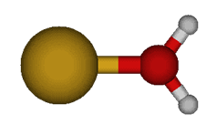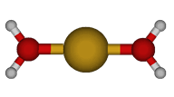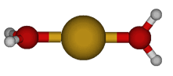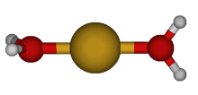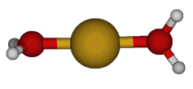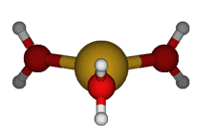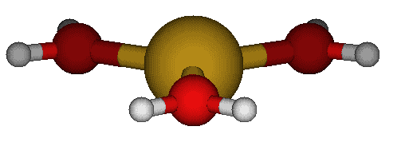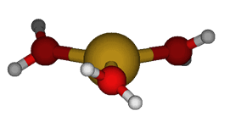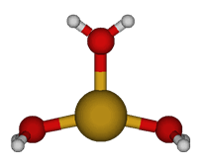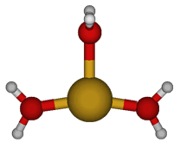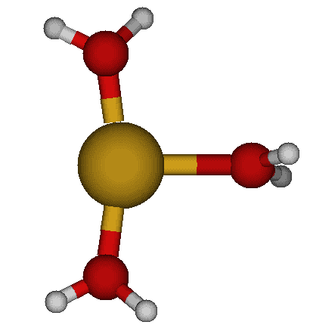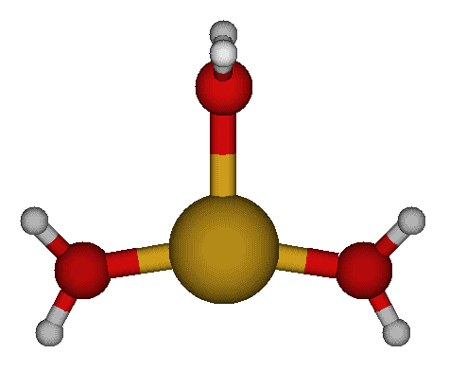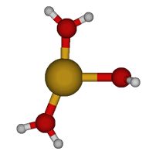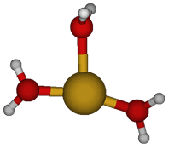
Cu(H₂O)₁⁺ C_{2v}
Cu(H₂O)₂⁺ C_{s}

Cu(H₂O)₂⁺ C₂

Cu(H₂O)₃⁺ D_{3h} #1

Cu(H₂O)₃⁺ D_{3h} #2

Cu(H₂O)₃⁺ D₃
Cu(H₂O)₃⁺ C_{2v} #2

Cu(H₂O)₃⁺ C₂
Cu(H₂O)₃⁺ C_{s} #1

Cu(H₂O)₃⁺ C_{s} #2
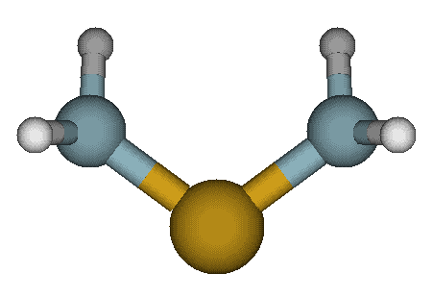

Cu(H₂O)₃⁺ C_{2v} #1

Cu(H₂O)₂⁺ D_{2d}
Cu(H₂O)₂⁺ D_{2h}
Cu(H₂O)₃⁺ C₁

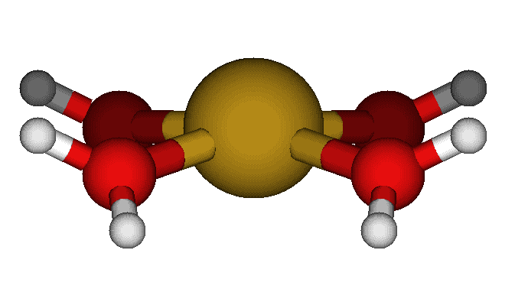
Figure S1 (continued) 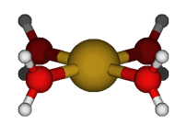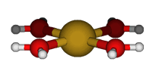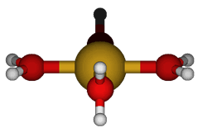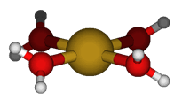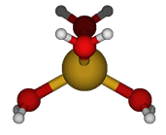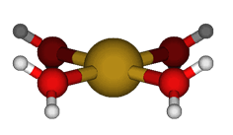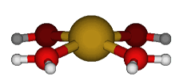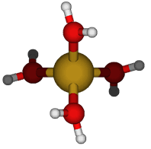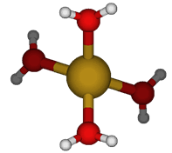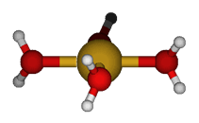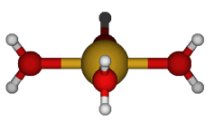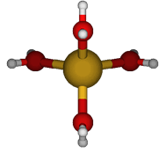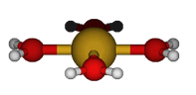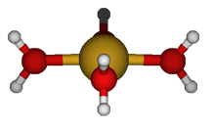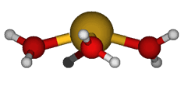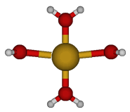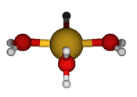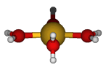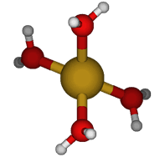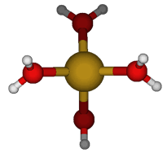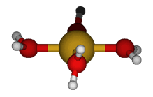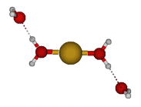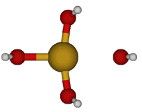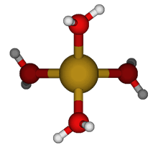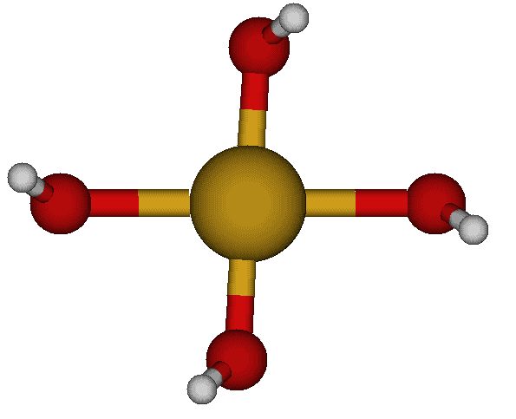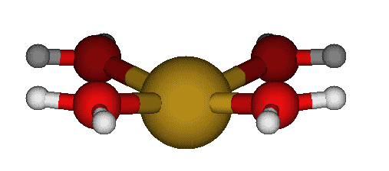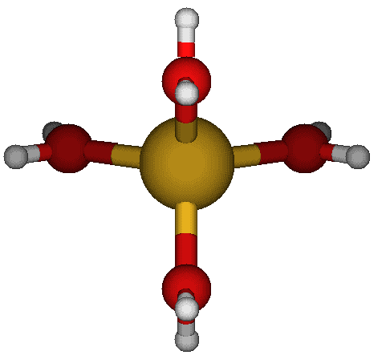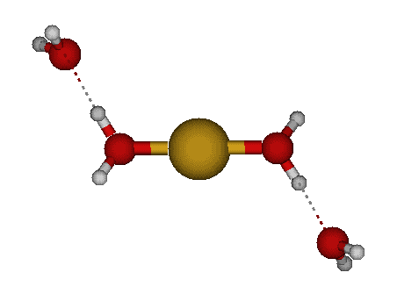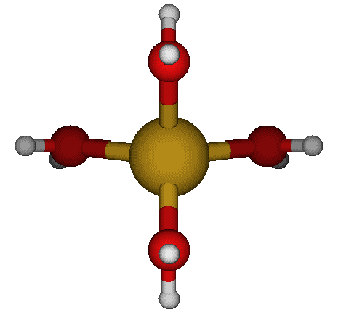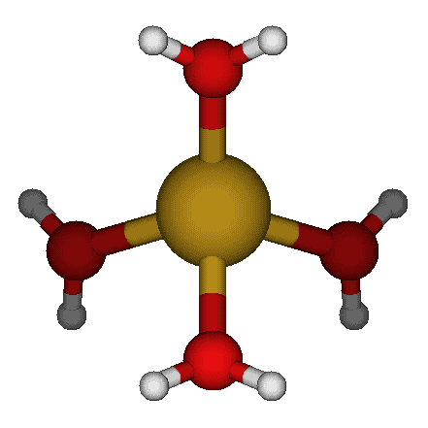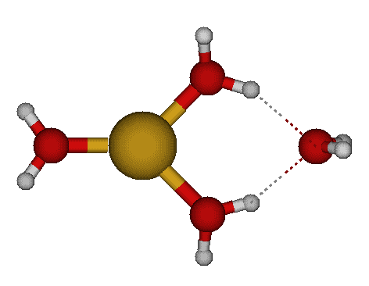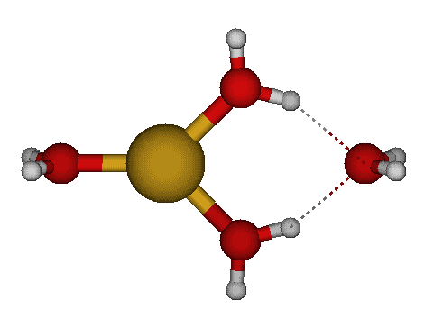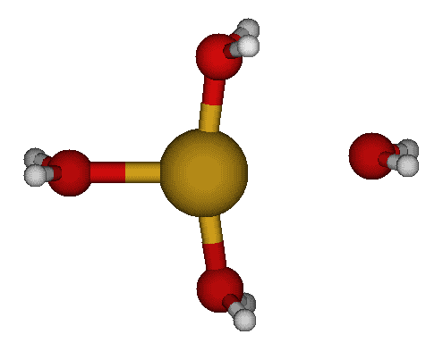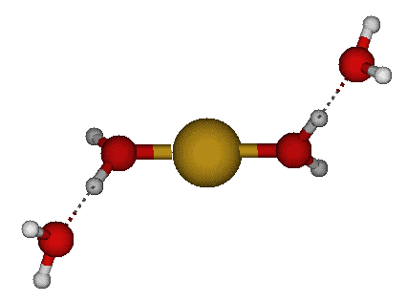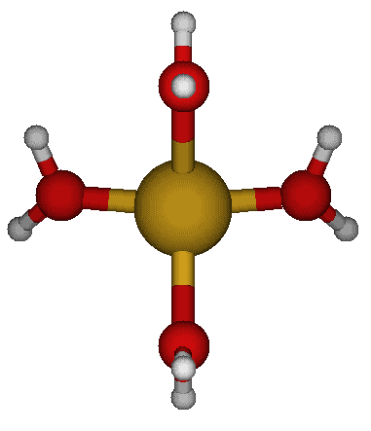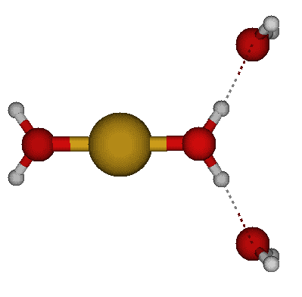 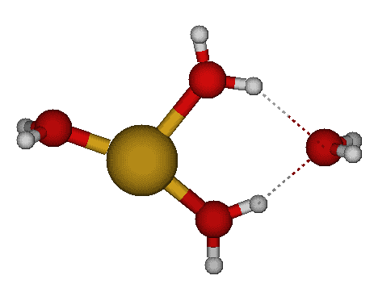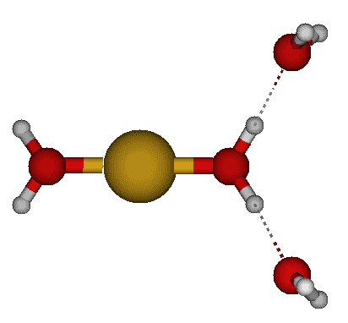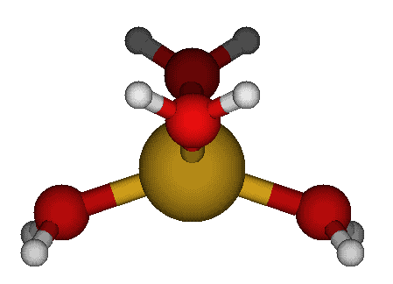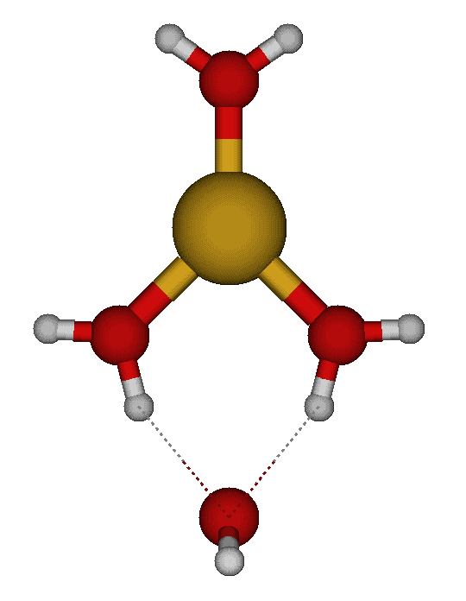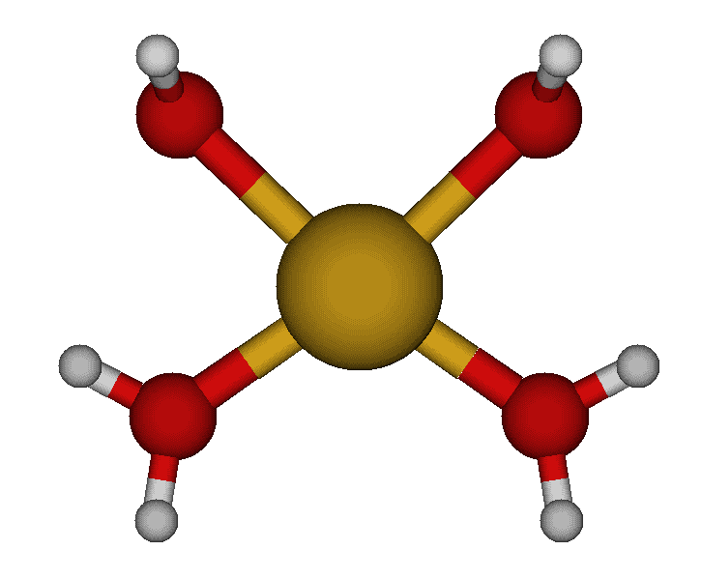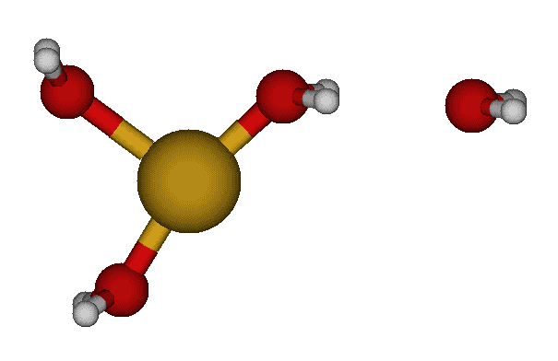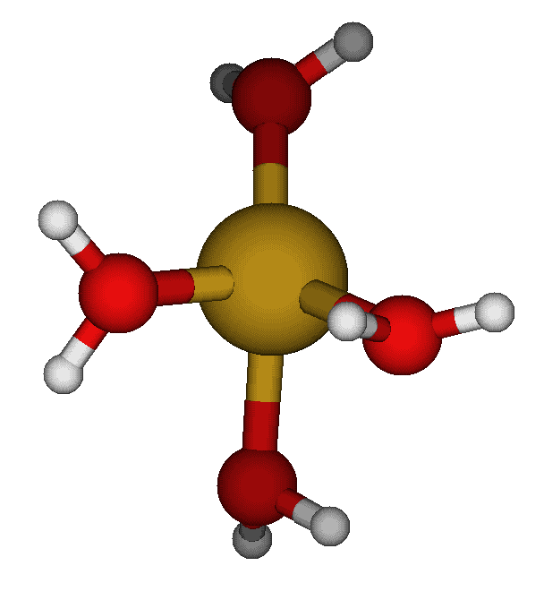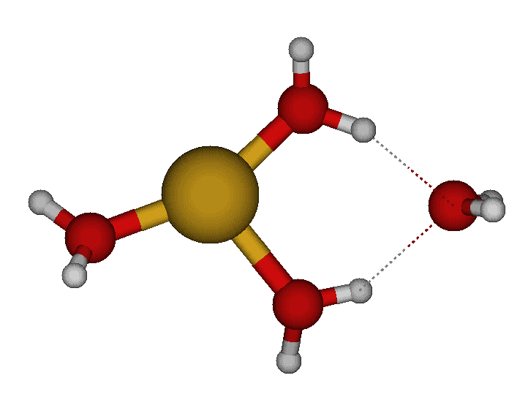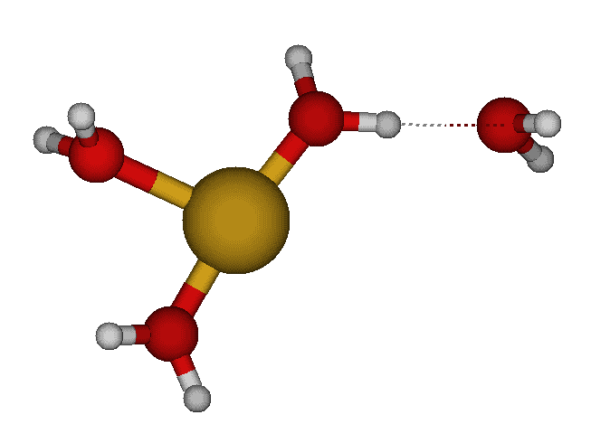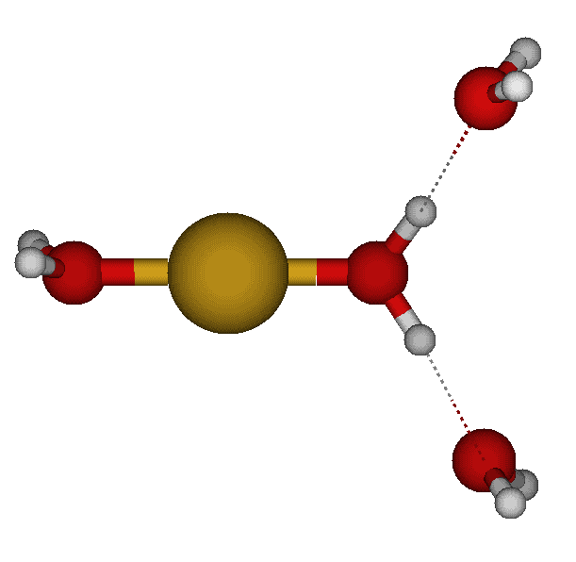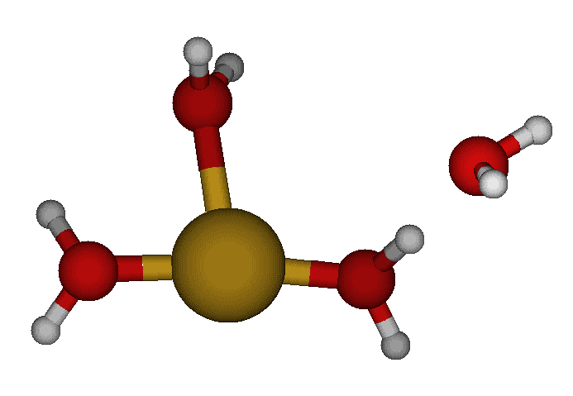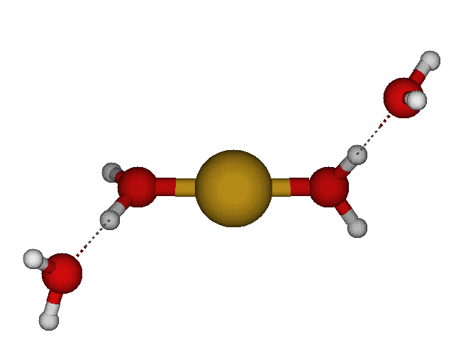
Cu(H₂O)₄⁺ D_{4h} #1
Cu(H₂O)₄⁺ D₄

Cu(H₂O)₄⁺ D_{2d} #1
Cu(H₂O)₄⁺ D_{2d}#2
Cu(H₂O)₄⁺ C_{4v} #1

Cu(H₂O)₄⁺ S₄ #1
Cu(H₂O)₄⁺ C_{4h}

Cu(H₂O)₄⁺ D_{2h} #2

Cu(H₂O)₄⁺ D₂

Cu(H₂O)₄⁺ D_{2h}#1
Cu(H₂O)₄⁺ D_{4h} #2
Cu(H₂O)₄⁺ D_{2d} #3

Cu(H₂O)₄⁺ D_{2h} #3

Cu(H₂O)₄⁺ C_{4v} #2

Cu(H₂O)₄⁺ C₄
Cu(H₂O)₄⁺ C_{2v} #4

Cu(H₂O)₄⁺ C_{2v} #3

Cu(H₂O)₄⁺ C_{2v} #2

Cu(H₂O)₄⁺ C₂ #1

Cu(H₂O)₄⁺ C_{s} #1
Cu(H₂O)₄⁺ C_{2h} #1

Cu(H₂O)₄⁺ C_{2h} #2

Cu(H₂O)₄⁺ C_{2v} #1

Cu(H₂O)₄⁺ S₄ #2
Cu(H₂O)₄⁺ C_{2h} #3

Cu(H₂O)₄⁺ C_{2v} #5

Cu(H₂O)₄⁺ C_{2v} #6

Cu(H₂O)₄⁺ C_{i} #1
Cu(H₂O)₄⁺ C_{s} #2
Cu(H₂O)₄⁺ C_{s} #5
Cu(H₂O)₄⁺ C₂ #3

Cu(H₂O)₄⁺ C_{2v} #14
Cu(H₂O)₄⁺ C_{s} #8
Cu(H₂O)₄⁺ C₂ #4

Cu(H₂O)₄⁺ C_{s} #9
Cu(H₂O)₄⁺ C_{s} #10
Cu(H₂O)₄⁺ C₁ #3

Cu(H₂O)₄⁺ C₁ #4
Cu(H₂O)₄⁺ C_{s} #11

Cu(H₂O)₄⁺ C_{s} #12

Cu(H₂O)₄⁺ C_{2v} #12

Cu(H₂O)₄⁺ C_{2v} #15
Cu(H₂O)₄⁺ C_{2v} #16

Cu(H₂O)₄⁺ C_{2v} #17

Cu(H₂O)₄⁺ C_{s} #15

Cu(H₂O)₄⁺ C₁ #8
Cu(H₂O)₄⁺ C₁ #9
Cu(H₂O)₄⁺ C₁ #10
Cu(H₂O)₄⁺ C₁ #13

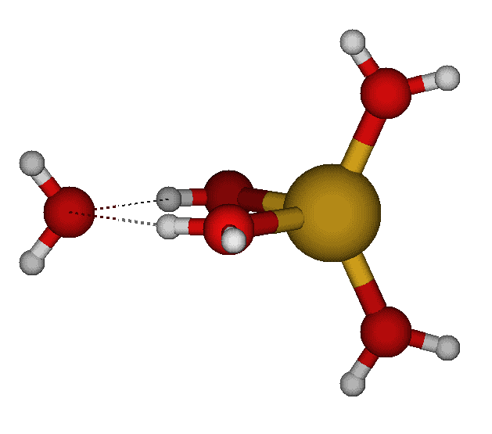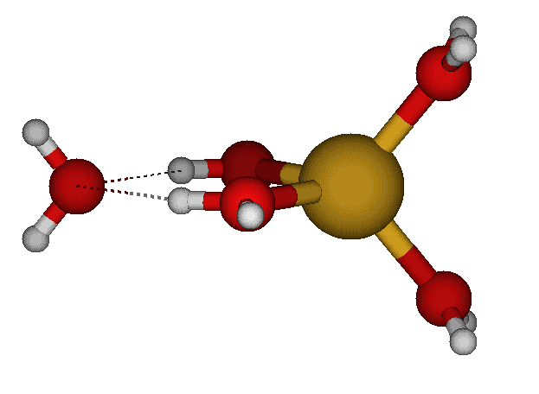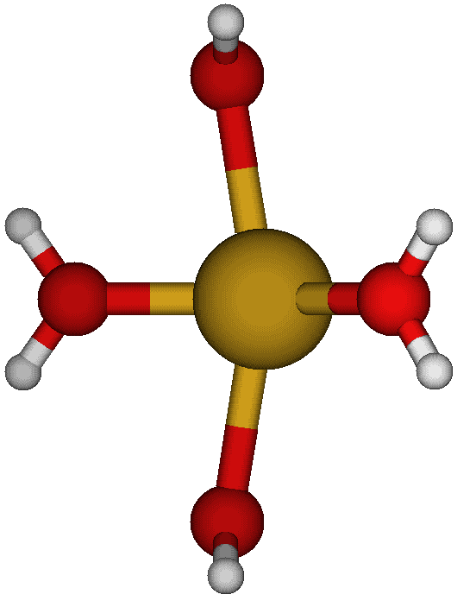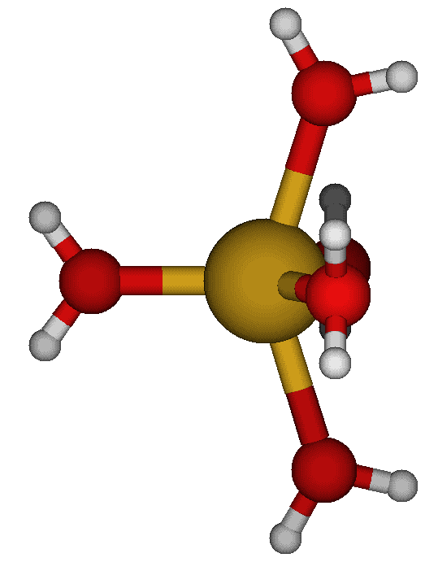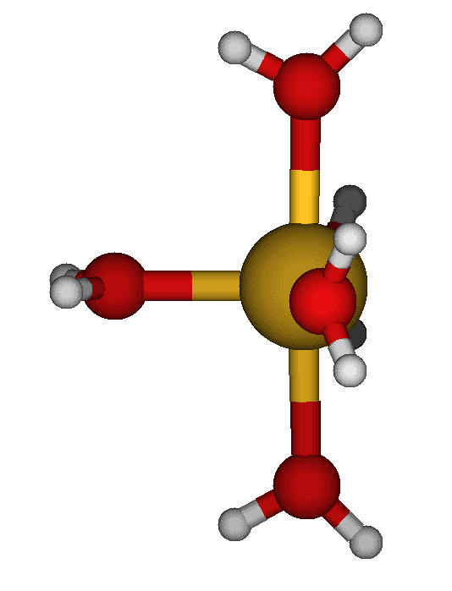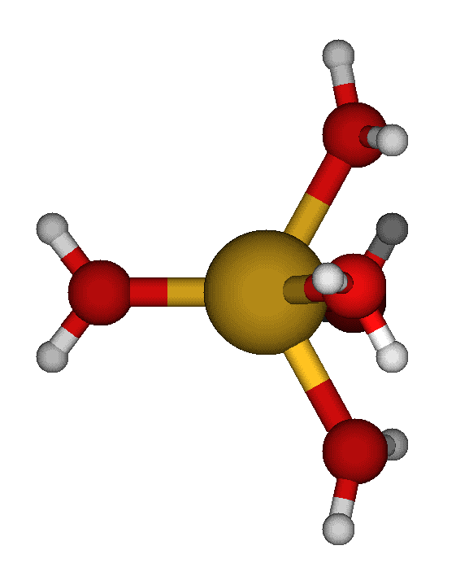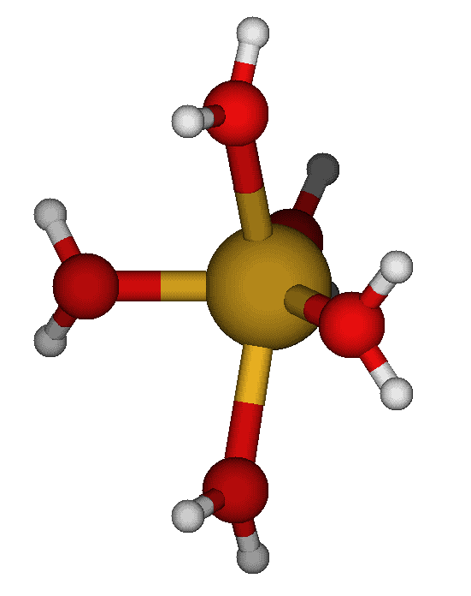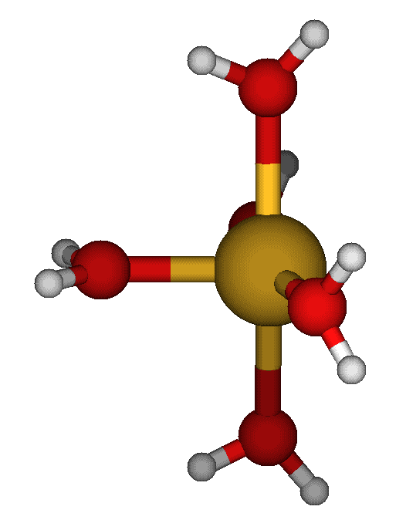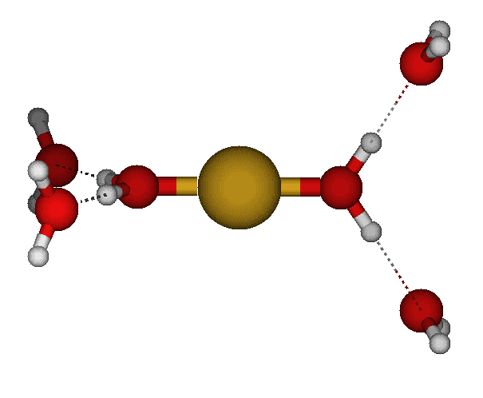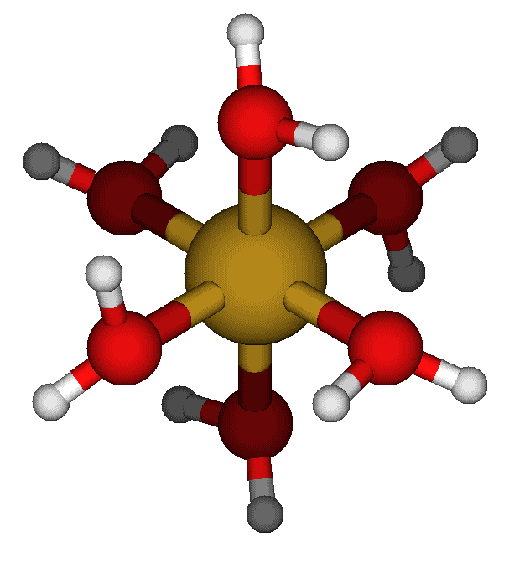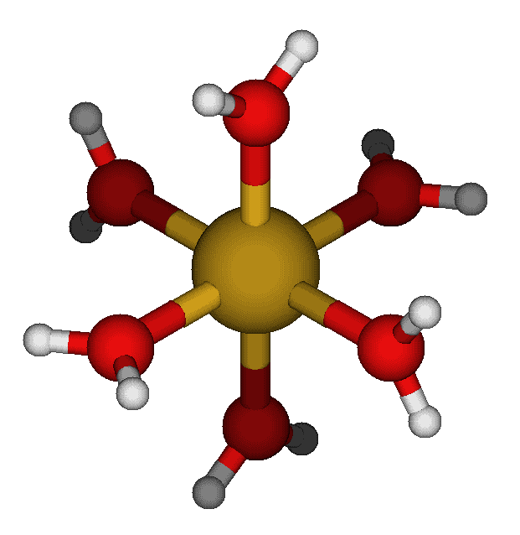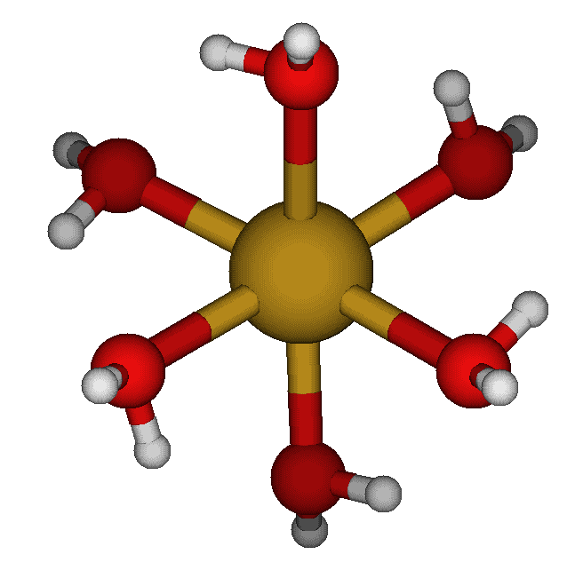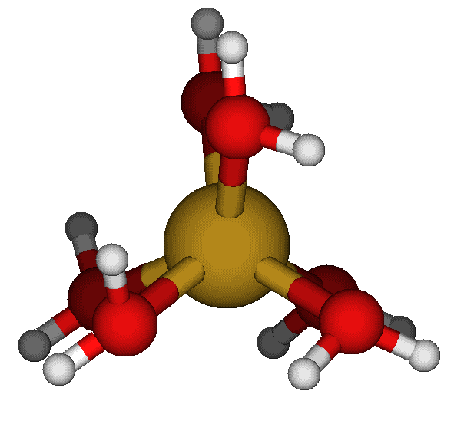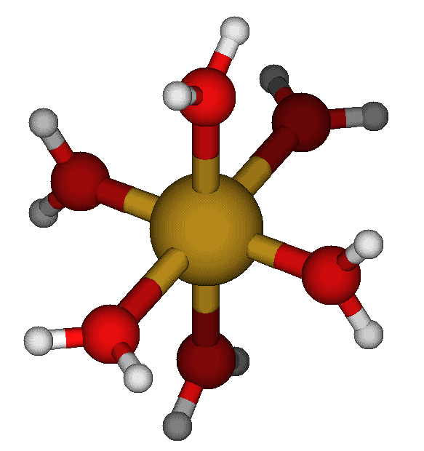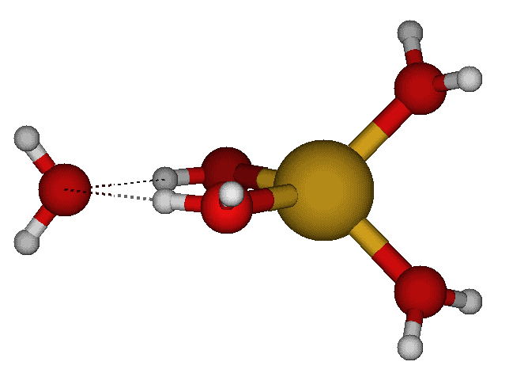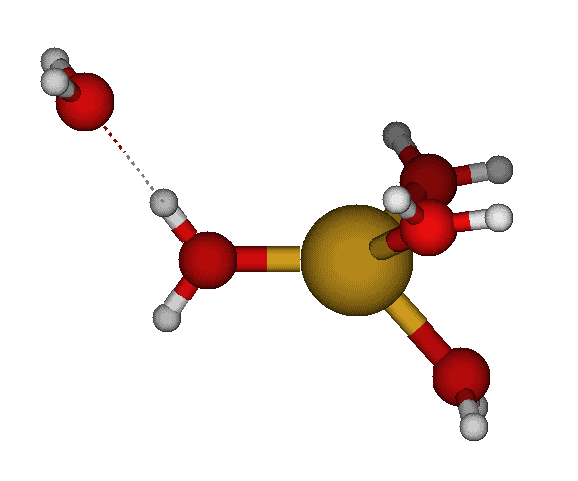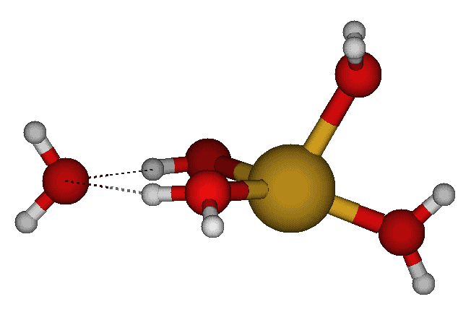
Cu(H₂O)₅⁺ C_{s} #5

Cu(H₂O)₄₊₁⁺ C₂ #1
Cu(H₂O)₅⁺ C_{2v} #1

Cu(H₂O)₅⁺ C_{2v} #2

Cu(H₂O)₅⁺ C_{2v} #3

Cu(H₂O)₄₊₁⁺ C_{2v} #1
Cu(H₂O)₄₊₁⁺ C_{2v} #2

Cu(H₂O)₅⁺ C₂ #3

Cu(H₂O)₅⁺ C_{s} #1

Cu(H₂O)₄₊₁⁺ C_{s} #5
Cu(H₂O)₄₊₁⁺ C_{s} #6
Cu(H₂O)₆⁺ T_{h}

Cu(H₂O)₆⁺ S₆
Cu(H₂O)₆⁺ C₃ #1
Cu(H₂O)₆⁺ C_{3h}

Cu(H₂O)₆⁺ D_{2h}
Cu(H₂O)₂₊₄⁺ D_{2d}

Z-matrices of copper(I) aqua complexes and useful hints for running calculations with Z-matrices and simultaneously respecting symmetry.

The 5 columns give the HF/6-31G*, HF/6-31+G*, MP2/6-31G*, MP2/6-31+G*, and B3LYP/6-31+G* optimized structures, respectively.

Hint #1. The first atom of the complex should be the central atom. If there is no central atom but plenty of symmetry, then the first atom should be a dummy atom which passes through as many symmetry elements as possible.

Hint #2. The second atom should be an atom on the principal axis of symmetry. If no such atom exists, then the second atom should be a dummy atom which passes through the principal axis. If there is no principal axis of symmetry, then the second atom should be a real or dummy atom in a plane of symmetry. The third atom should be on a non-principal axis of symmetry or in a symmetry plane.

Level HF HF MP2 MP2 B3LYP
Basis Set 6-31G* 6-31+G* 6-31G* 6-31+G* 6-31+G*

CuAq1_+_C2v
Cu
O1 Cu O1Cu
H1A O1 H1AO Cu H1AOCu
H1B O1 H1AO Cu H1AOCu H1A 180.0

O1Cu= 1.94408 2.06213 1.81210 1.93699 1.94052
H1AO= 0.95335 0.95366 0.97540 0.97751 0.97393
H1AOCu= 126.603 126.496 126.460 126.302 125.870

CuAq2_+_D2d
Cu
X*1 Cu 1.0
O1 Cu O1Cu X*1 90.0
H1A O1 H1AO Cu H1AOCu X*1 0.0
H1B O1 H1AO Cu H1AOCu X*1 180.0
O2 Cu O1Cu X*1 90.0 O1 180.0
H2A O2 H1AO Cu H1AOCu X*1 90.0
H2B O2 H1AO Cu H1AOCu X*1 -90.0

O1Cu= 1.92412 2.03350 1.81615 1.87035 1.90404
H1AO= 0.95247 0.95274 0.97441 0.97632 0.97255
H1AOCu= 126.241 1 26.365 126.057 125.946 125.715

(alternate Z-matrix for D2d)
Cu
X*1 Cu 1.0
O1 Cu O1Cu X*1 90.0
X*2 Cu 1.0 O1 90.0 X*1 180.0
H1A O1 H1AO Cu H1AOCu X*1 45.0
H1B O1 H1AO Cu H1AOCu X*2 45.0
O2 Cu O1Cu X*1 90.0 O1 180.0
H2A O2 H1AO Cu H1AOCu X*1 45.0
H2B O2 H1AO Cu H1AOCu X*2 45.0
CuAq2_+_D2h
Cu
X*1 Cu 1.0
O1 Cu O1Cu X*1 90.0
H1A O1 H1AO Cu H1AOCu X*1 0.0
H1B O1 H1AO Cu H1AOCu X*1 180.0
O2 Cu O1Cu X*1 90.0 O1 180.0
H2A O2 H1AO Cu H1AOCu X*1 0.0
H2B O2 H1AO Cu H1AOCu X*1 180.0

O1Cu= 1.92696 2.03570 1.82078 1.87430 1.90772
H1AO= 0.95244 0.95276 0.97426 0.97629 0.97248
H1AOCu= 126.286 126.390 126.127 125.986 125.744

The D_{2h} Z-matrix can be obtained from the first D_{2d} Z-matrix by changing two torsions.

CuAq2_+_C2
Cu
X*1 Cu 1.0
O1 Cu O1Cu X*1 O1CuX
H1A O1 H1AO Cu H1AOCu X*1 H1AOCuX
H1B O1 H1BO Cu H1BOCu X*1 H1BOCuX
O2 Cu O1Cu X*1 O1CuX O1 180.0
H2A O2 H1AO Cu H1AOCu X*1 H1AOCuX
H2B O2 H1BO Cu H1BOCu X*1 H1BOCuX

Initial Final
O1Cu= 1.81615 1.81637 1.87158 1.90532
H1AO= 0.97441 0.97452 0.97687 0.97297
H1BO= 0.97441 0.97449 0.97678 0.97290
O1CuX= 90.0 89.310 89.290 89.161
H1AOCu= 126.057 125.681 124.422 124.432
H1BOCu= 126.057 126.001 124.640 124.673
H1AOCuX= 45.0+10 49.509 55.927 54.889
H1BOCuX= -135.0-10 -139.416 -146.844 -145.674

The C₂ Z-matrix can be obtained from the second D_{2d} Z-matrix by removing the references to X*2, replacing these torsions by -135.0. We also start with the optimized parameters for the optimized D_{2d} Z-matrix, replicating the lines and changing the variable name when necessary, and adding in missing angles and dihedrals, remembering to give the hydrogens a little twist and wag from the maximum in that coordinate (dihedral) by adding/subtracting 10.0. Only the correlated calculations needed to be run at this symmetry as the D_{2d} structure was stable at the HF levels.

CuAq2_+_Cs
Cu
X*1 Cu 1.0
O1 Cu O1Cu X*1 90.0
H1A O1 H1AO Cu H1AOCu X*1 0.0
H1B O1 H1BO Cu H1BOCu X*1 180.0
O2 Cu O2Cu X*1 O2CuX O1 180.0
H2A O2 H2AO Cu H2AOCu X*1 H2AOCuX
H2B O2 H2AO Cu H2AOCu X*1 -H2AOCuX

Initial Final
O1Cu= 1.81614 1.81618 1.87010 1.90207
H1AO= 0.97441 0.97441 0.97629 0.97255
H1BO= 0.97441 0.97443 0.97638 0.97263
O2Cu= 1.81614 1.81631 1.87180 1.90354
H2AO= 0.97441 0.97448 0.97681 0.97287
H1AOCu= 126.057 126.191 126.058 125.813
H1BOCu= 126.057 125.923 125.845 125.659
O2CuX= 90.0 90.823 90.999 90.814
H2AOCu= 126.057 125.906 124.529 124.708
H2AOCuX= 90.0-10 86.205 78.641 80.401

The C_{s} Z-matrix can be obtained from the first D_{2d} Z-matrix by unfixing the final hydrogen torsions. We also start with the optimized parameters for the optimized D_{2d} Z-matrix, replicating the lines and changing the variable name when necessary, and adding in missing angles and dihedrals, remembering to give the hydrogens a little wag from the maximum in that coordinate (dihedral) by subtracting 10.0. Only the correlated calculations needed to be run at this symmetry as the D_{2d} structure was stable at the HF levels.

CuAq3_+_D3h_1
Cu
X*1 Cu 1.0
O1 Cu O1Cu X*1 90.0
H1A O1 H1AO Cu H1AOCu X*1 0.0
H1B O1 H1AO Cu H1AOCu X*1 180.0
O2 Cu O1Cu X*1 90.0 O1 120.0
H2A O2 H1AO Cu H1AOCu X*1 0.0
H2B O2 H1AO Cu H1AOCu X*1 180.0
O3 Cu O1Cu X*1 90.0 O1 -120.0
H3A O3 H1AO Cu H1AOCu X*1 0.0
H3B O3 H1AO Cu H1AOCu X*1 180.0

O1Cu= 2.07768 2.16196 1.97320 2.04594 2.06295
H1AO= 0.95091 0.95126 0.97281 0.97461 0.97121
H1AOCu= 126.807 126.633 127.099 126.684 126.435

The two different D_{3h} structures only differ by the fixed torsion angle of the hydrogens, with the first structure having the hydrogens in the σ_{v} planes and the second in the σ_{h} plane.

CuAq3_+_D3h_2
Cu
X*1 Cu 1.0
O1 Cu O1Cu X*1 90.0
H1A O1 H1AO Cu H1AOCu X*1 90.0
H1B O1 H1AO Cu H1AOCu X*1 -90.0
O2 Cu O1Cu X*1 90.0 O1 120.0
H2A O2 H1AO Cu H1AOCu X*1 90.0
H2B O2 H1AO Cu H1AOCu X*1 -90.0
O3 Cu O1Cu X*1 90.0 O1 -120.0
H3A O3 H1AO Cu H1AOCu X*1 90.0
H3B O3 H1AO Cu H1AOCu X*1 -90.0

O1Cu= 2.05595 2.15075 1.94146 2.02336 2.04365
H1AO= 0.95071 0.95125 0.97256 0.97450 0.97105
H1AOCu= 126.896 126.688 127.314 126.805 126.591

The D₃ structure only has one additional parameter, the hydrogen torsion, and can be derived from either D_{3h} structure by adding a second dummy atom opposite to the first one and referencing the appropriate hydrogen torsion to the appropriate dummy atom. This structure is the minimum energy structure at the Hartree-Fock levels.

CuAq3_+_D3
Cu
X*1 Cu 1.0
O1 Cu O1Cu X*1 90.0
X*2 Cu 1.0 O1 90.0 X*1 180.0
H1A O1 H1AO Cu H1AOCu X*1 H1AOCuX
H1B O1 H1AO Cu H1AOCu X*2 H1AOCuX
O2 Cu O1Cu X*1 90.0 O1 120.0
H2A O2 H1AO Cu H1AOCu X*1 H1AOCuX
H2B O2 H1AO Cu H1AOCu X*2 H1AOCuX
O3 Cu O1Cu X*1 90.0 O1 -120.0
H3A O3 H1AO Cu H1AOCu X*1 H1AOCuX
H3B O3 H1AO Cu H1AOCu X*2 H1AOCuX

O1Cu= 2.05805 2.15018 1.94345 2.02640 2.04627
H1AO= 0.95083 0.95138 0.97262 0.97474 0.97124
H1AOCu= 126.762 126.568 127.195 126.628 126.395
H1AOCuX= 58.781 51.852 69.250 55.850 54.353

For the two C_{2v} structures, they can be derived from the D_{3h} structure by first making O2 and O3 different from O1 in their parameters and allowing the angle to deviate from 120.0. After making the hydrogens on O2 and O3 different than O1, and redefining the hydrogen torsions on O2 and O3, the appropriate hydrogens are then twisted.

CuAq3_+_C2v_1
Cu
X*1 Cu 1.0
O1 Cu O1Cu X*1 90.0
H1A O1 H1AO Cu H1AOCu X*1 90.0
H1B O1 H1AO Cu H1AOCu X*1 -90.0
O2 Cu O2Cu X*1 90.0 O1 O2CuXO
H2A O2 H2AO Cu H2AOCu O1 H2AOCuO
H2B O2 H2AO Cu H2AOCu O1 -H2AOCuO
O3 Cu O2Cu X*1 90.0 O1 -O2CuXO
H3A O3 H2AO Cu H2AOCu O1 H2AOCuO
H3B O3 H2AO Cu H2AOCu O1 -H2AOCuO

O1Cu= 2.04630 2.15031 1.88027 2.16813 2.15865
H1AO= 0.95076 0.95122 0.97262 0.97498 0.97135
O2Cu= 2.07744 2.15609 1.99321 1.95849 2.00148
H2AO= 0.95098 0.95141 0.97298 0.97676 0.97253
H1AOCu= 126.659 126.509 126.752 126.841 126.561
H2AOCu= 126.683 126.433 127.046 120.361 120.956
O2CuXO= 120.019 116.857 129.009 98.096 101.627
H2AOCuO= 92.903 93.919 87.311 112.312 110.754

CuAq3_+_C2v_2
Cu
X*1 Cu 1.0
O1 Cu O1Cu X*1 90.0
H1A O1 H1AO Cu H1AOCu X*1 0.0
H1B O1 H1AO Cu H1AOCu X*1 180.0
O2 Cu O2Cu X*1 90.0 O1 O2CuXO
H2A O2 H2AO Cu H2AOCu O1 0.0
H2B O2 H2BO Cu H2BOCu O1 180.0
O3 Cu O2Cu X*1 90.0 O1 -O2CuXO
H3A O3 H2AO Cu H2AOCu O1 0.0
H3B O3 H2BO Cu H2BOCu O1 180.0

O1Cu= 2.08698 2.18052 2.14597 2.28101 2.26041
H1AO= 0.95106 0.95140 0.97459 0.97568 0.97197
O2Cu= 2.04509 2.13466 1.84571 1.91413 1.95405
H2AO= 0.95082 0.95136 0.97229 0.97473 0.97119
H2BO= 0.95065 0.95127 0.97228 0.97476 0.97098
H1AOCu= 126.781 126.621 127.586 127.201 126.884
H2AOCu= 125.394 125.071 124.666 123.865 123.991
H2BOCu= 128.090 128.022 127.548 128.112 127.723
O2CuXO= 117.224 114.829 97.148 96.354 99.131

For the C₂ structure (MP2, B3LYP), the initial structure was taken from the C_{2v} #2 structure (the lowest in energy among the two C_{2v} and D₃ forms). The atoms were rearranged so that the skeletal atoms came first and the dummy atom removed. The appropriate hydrogens are then twisted by 20 degrees at all levels.

For the C_{s} #1 structure (MP2, B3LYP), the initial structure was taken from the C_{2v} #2 structure (the lowest in energy among the two C_{2v} and D₃ forms). H1A and H1B were made non-equivalent, the O2CuX angle was added, and the H2AOCuO and H2BOCuO dihedral angles were added.

CuAq3_+_C2
Cu
O1 Cu O1Cu
O2 Cu O2Cu O1 O2CuO
O3 Cu O2Cu O1 O2CuO O2 180.0
H1A O1 H1AO Cu H1AOCu O2 H1AOCuO
H1B O1 H1AO Cu H1AOCu O3 H1AOCuO
H2A O2 H2AO Cu H2AOCu O1 H2AOCuO
H2B O2 H2BO Cu H2BOCu O1 H2BOCuO
H3A O3 H2AO Cu H2AOCu O1 H2AOCuO
H3B O3 H2BO Cu H2BOCu O1 H2BOCuO

Initial
O1Cu= 2.14597 2.15026 2.28241 2.27193
H1AO= 0.97459 0.97463 0.97575 0.97204
O2Cu= 1.84571 1.84520 1.91568 1.95472
H2AO= 0.97229 0.97317 0.97600 0.97201
H2BO= 0.97228 0.97306 0.97589 0.97167
O2CuO= 97.148 95.587 95.507 97.998
H1AOCu= 127.586 127.580 127.186 126.913
H2AOCu= 124.666 122.051 120.177 121.076
H2BOCu= 127.548 125.470 124.114 124.852
H1AOCuO= 70.0 71.455 69.561 75.632
H2AOCuO= 20.0 26.744 31.147 24.042
H2BOCuO= -160.0 -181.861 -185.140 172.510

CuAq3_+_Cs #1
Cu
X*1 Cu 1.0
O1 Cu O1Cu X*1 90.0
H1A O1 H1AO Cu H1AOCu X*1 0.0
H1B O1 H1BO Cu H1BOCu X*1 180.0
O2 Cu O2Cu X*1 O2CuX O1 O2CuXO
H2A O2 H2AO Cu H2AOCu O1 H2AOCuO
H2B O2 H2BO Cu H2BOCu O1 H2BOCuO
O3 Cu O2Cu X*1 O2CuX O1 -O2CuXO
H3A O3 H2AO Cu H2AOCu O1 -H2AOCuO
H3B O3 H2BO Cu H2BOCu O1 -H2BOCuO

Initial
O1Cu= 2.14597 2.15322 2.29087 2.25498
H1AO= 0.97459 0.97470 0.97571 0.97197
H1BO= 0.97459 0.97470 0.97581 0.97206
O2Cu= 1.84571 1.84474 1.91370 1.95525
H2AO= 0.97229 0.97289 0.97537 0.97132
H2BO= 0.97226 0.97285 0.97537 0.97109
H1AOCu= 127.586 129.751 129.403 127.431
H1BOCu= 127.586 125.469 125.059 126.352
O2CuX= 90.0 92.684 91.450 90.765
H2AOCu= 124.666 122.867 121.776 123.546
H2BOCu= 127.548 126.174 125.959 127.194
O2CuXO= 97.147 96.192 95.851 99.226
H2AOCuO= 20.0 14.484 14.895 7.353
H2BOCuO= 160.0 170.712 167.606 174.149

For the C_{s} #2 structure (MP2,B3LYP), the initial structure was taken from the C_{2v} #2 structure (the lowest in energy among the two C_{2v} and D₃ forms). The atoms were rearranged so that the skeletal atoms came first and the dummy atom removed. All skeletal atoms are in the symmetry plane, but O2 and O3 are no longer equivalent. H1A and H1B remain symmetry-equivalent, but their dihedrals can now vary. The hydrogens on O2 and O3 are still in the plane but are not equivalent to each other.

CuAq3_+_Cs #2
Cu
O1 Cu O1Cu
O2 Cu O2Cu O1 O2CuO
O3 Cu O3Cu O1 O3CuO O2 180.0
H1A O1 H1AO Cu H1AOCu O2 H1AOCuO
H1B O1 H1AO Cu H1AOCu O2 -H1AOCuO
H2A O2 H2AO Cu H2AOCu O1 0.0
H2B O2 H2BO Cu H2BOCu O1 180.0
H3A O3 H3AO Cu H3AOCu O1 0.0
H3B O3 H3BO Cu H3BOCu O1 180.0

Initial
O1Cu= 2.14597 2.14659 2.30265 2.27544
O2Cu= 1.84571 1.85446 1.92103 1.96055
O3Cu= 1.84571 1.84752 1.91014 1.94669
H1AO= 0.97459 0.97457 0.97605 0.97227
H2AO= 0.97229 0.97245 0.97527 0.97154
H2BO= 0.97228 0.97197 0.97435 0.97060
H3AO= 0.97229 0.97238 0.97465 0.97114
H3BO= 0.97228 0.97243 0.97506 0.97127
O2CuO= 97.148-10 88.853 83.402 86.716
O3CuO= 97.148+10 109.012 111.491 112.413
H1AOCu= 127.586 126.566 124.583 124.614
H2AOCu= 124.666 122.585 120.168 120.734
H2BOCu= 127.548 129.314 131.106 130.455
H3AOCu= 124.666 126.993 126.419 126.073
H3BOCu= 127.548 125.644 125.879 125.858
H1AOCuO= 90.0 99.434 105.110 104.041

For the C₁ structure (MP2, B3LYP), the initial structure was taken from the C₂ structure (the lowest in energy at B3LYP among the two C_{s} and C₂ forms). The atoms were rearranged so that the skeletal atoms came first and the dummy atom removed. All skeletal atoms are in the symmetry plane, but O2 and O3 are no longer equivalent. H1A and H1B remain symmetry-equivalent, but their dihedrals can now vary. The hydrogens on O2 and O3 are still in the plane but are not equivalent to each other.

CuAq3_+_C1
Cu
O1 Cu O1Cu
O2 Cu O2Cu O1 O2CuO
O3 Cu O3Cu O1 O3CuO O2 O3CuOO
H1A O1 H1AO Cu H1AOCu O2 H1AOCuO
H1B O1 H1BO Cu H1BOCu O3 H1BOCuO
H2A O2 H2AO Cu H2AOCu O1 H2AOCuO
H2B O2 H2BO Cu H2BOCu O1 H2BOCuO
H3A O3 H3AO Cu H3AOCu O1 H3AOCuO
H3B O3 H3BO Cu H3BOCu O1 H3BOCuO

Initial
O1Cu= 2.15026 2.15155 2.32977 2.31286
O2Cu= 1.84520 1.84845 1.91709 1.95611
O3Cu= 1.84520 1.84593 1.90908 1.94558
H1AO= 0.97463 0.97468 0.97615 0.97245
H1BO= 0.97463 0.97455 0.97612 0.97234
H2AO= 0.97317 0.97309 0.97675 0.97266
H2BO= 0.97306 0.97271 0.97542 0.97130
H3AO= 0.97317 0.97315 0.97611 0.97210
H3BO= 0.97306 0.97315 0.97633 0.97211
O2CuO= 95.589-10 90.453 81.855 84.184
O3CuO= 95.589+10 102.683 109.616 110.891
H1AOCu= 127.580 127.231 124.896 124.521
H1BOCu= 127.580 127.024 123.672 124.194
H2AOCu= 122.051 121.103 116.117 116.861
H2BOCu= 125.470 126.816 126.924 127.259
H3AOCu= 122.051 123.828 122.091 122.757
H3BOCu= 125.470 124.286 121.906 122.841
O3CuOO= 180.0 179.268 179.115 178.772
H1AOCuO= 71.455 79.697 90.178 92.053
H1BOCuO= 71.455 66.223 57.402 60.855
H2AOCuO= 26.744 21.658 19.644 17.651
H2BOCuO= -181.861 -184.921 -197.251 163.680
H3AOCuO= 26.744 28.928 45.639 34.416
H3BOCuO= -181.861 -178.819 -171.965 181.466

CuAq4_+_D4h #1
Cu
X*1 Cu 1.0
O1 Cu O1Cu X*1 90.0
H1A O1 H1AO Cu H1AOCu X*1 0.0
H1B O1 H1AO Cu H1AOCu X*1 180.0
O2 Cu O1Cu X*1 90.0 O1 90.0
H2A O2 H1AO Cu H1AOCu X*1 0.0
H2B O2 H1AO Cu H1AOCu X*1 180.0
O3 Cu O1Cu X*1 90.0 O1 180.0
H3A O3 H1AO Cu H1AOCu X*1 0.0
H3B O3 H1AO Cu H1AOCu X*1 180.0
O4 Cu O1Cu X*1 90.0 O1 -90.0
H4A O4 H1AO Cu H1AOCu X*1 0.0
H4B O4 H1AO Cu H1AOCu X*1 180.0

O1Cu= 2.18191 2.27892 2.07572 2.16830 2.18170
H1AO= 0.94995 0.95020 0.97267 0.97404 0.97074
H1AOCu= 127.033 126.811 127.512 127.086 126.798

CuAq4_+_D4h #2
Cu
X*1 Cu 1.0
O1 Cu O1Cu X*1 90.0
H1A O1 H1AO Cu H1AOCu X*1 90.0
H1B O1 H1AO Cu H1AOCu X*1 -90.0
O2 Cu O1Cu X*1 90.0 O1 90.0
H2A O2 H1AO Cu H1AOCu X*1 90.0
H2B O2 H1AO Cu H1AOCu X*1 -90.0
O3 Cu O1Cu X*1 90.0 O1 180.0
H3A O3 H1AO Cu H1AOCu X*1 90.0
H3B O3 H1AO Cu H1AOCu X*1 -90.0
O4 Cu O1Cu X*1 90.0 O1 -90.0
H4A O4 H1AO Cu H1AOCu X*1 90.0
H4B O4 H1AO Cu H1AOCu X*1 -90.0

O1Cu= 2.16684 2.27258 2.05572 2.16766 2.18028
H1AO= 0.94979 0.95020 0.97283 0.97420 0.97079
H1AOCu= 127.337 127.090 128.043 127.582 127.306

The two different D_{4h} structures only differ by the fixed torsion angle of the hydrogens, with the first structure having the hydrogens in the σ_{v} planes and the second in the σ_{h} plane.

The D₄ structure only has one additional parameter, the hydrogen torsion, and can be derived from either D_{4h} structure by adding a second dummy atom opposite to the first one and referencing the appropriate hydrogen torsion to the appropriate dummy atom. The initial torsion was set to 70 degrees.

The D_{2h} #1 structure is derived from either D_{4h} structure by making a trans pair of oxygen atoms and their hydrogens different from the other pair, and rotating these hydrogens by 90 degrees.

CuAq4_+_D4
Cu
X*1 Cu 1.0
O1 Cu O1Cu X*1 90.0
X*2 Cu 1.0 O1 90.0 X*1 180.0
H1A O1 H1AO Cu H1AOCu X*1 H1AOCuX
H1B O1 H1AO Cu H1AOCu X*2 H1AOCuX
O2 Cu O1Cu X*1 90.0 O1 90.0
H2A O2 H1AO Cu H1AOCu X*1 H1AOCuX
H2B O2 H1AO Cu H1AOCu X*2 H1AOCuX
O3 Cu O1Cu X*1 90.0 O1 180.0
H3A O3 H1AO Cu H1AOCu X*1 H1AOCuX
H3B O3 H1AO Cu H1AOCu X*2 H1AOCuX
O4 Cu O1Cu X*1 90.0 O1 -90.0
H4A O4 H1AO Cu H1AOCu X*1 H1AOCuX
H4B O4 H1AO Cu H1AOCu X*2 H1AOCuX

O1Cu= 2.15580 2.25323 2.04708 2.14618 2.16098
H1AO= 0.95001 0.95046 0.97296 0.97462 0.97118
H1AOCu= 126.764 126.583 127.220 126.799 126.561
H1AOCuX= 49.549 48.893 49.587 47.107 46.652

CuAq4_+_D2h #1
Cu
X*1 Cu 1.0
O1 Cu O1Cu X*1 90.0
H1A O1 H1AO Cu H1AOCu X*1 0.0
H1B O1 H1AO Cu H1AOCu X*1 180.0
O2 Cu O2Cu X*1 90.0 O1 90.0
H2A O2 H2AO Cu H2AOCu X*1 90.0
H2B O2 H2AO Cu H2AOCu X*1 -90.0
O3 Cu O1Cu X*1 90.0 O1 180.0
H3A O3 H1AO Cu H1AOCu X*1 0.0
H3B O3 H1AO Cu H1AOCu X*1 180.0
O4 Cu O2Cu X*1 90.0 O1 -90.0
H4A O4 H2AO Cu H2AOCu X*1 90.0
H4B O4 H2AO Cu H2AOCu X*1 -90.0

O1Cu= 2.26695 2.34942 2.32240 2.44108 2.43912
H1AO= 0.95055 0.95074 0.97405 0.97527 0.97187
O2Cu= 2.06034 2.16922 1.85966 1.93829 1.97251
H2AO= 0.94949 0.95017 0.97129 0.97391 0.97021
H1AOCu= 127.063 126.797 127.868 127.428 127.162
H2AOCu= 126.273 126.246 125.788 125.736 125.508

The D_{2d} #2 structure is derived from either D_{4h} structure by allowing the hydrogen torsions to vary. Two extra dummy atoms are added to define the opposite direction for a C₂ axis to help with the hydrogen torsion definitions, and a second C₂ axis to help define the oxygen positions.

The D_{2d} #1 structure is derived from the D_{4h} #2 structure by allowing the hydrogen torsions to vary and the oxygen atoms to move out of the symmetry plane (initial O1CuX=80.0). Two extra dummy atoms are added to define the opposite direction for a C₂ axis to help with the hydrogen torsion definitions, and a second C₂ axis to help define the oxygen positions.
CuAq4_+_D2d #2
Cu
X*1 Cu 1.0
X*3 Cu 1.0 X*1 90.0
X*2 Cu 1.0 X*3 90.0 X*1 180.0
O1 Cu O1Cu X*1 90.0 X*3 0.0
H1A O1 H1AO Cu H1AOCu X*1 H1AOCuX
H1B O1 H1AO Cu H1AOCu X*2 H1AOCuX
O2 Cu O1Cu X*2 90.0 X*3 90.0
H2A O2 H1AO Cu H1AOCu X*1 -H1AOCuX
H2B O2 H1AO Cu H1AOCu X*2 -H1AOCuX
O3 Cu O1Cu X*1 90.0 X*3 180.0
H3A O3 H1AO Cu H1AOCu X*1 H1AOCuX
H3B O3 H1AO Cu H1AOCu X*2 H1AOCuX
O4 Cu O1Cu X*2 90.0 X*3 -90.0
H4A O4 H1AO Cu H1AOCu X*1 -H1AOCuX
H4B O4 H1AO Cu H1AOCu X*2 -H1AOCuX

O1Cu= 2.16708 2.05722 2.16525 2.17957
H1AO= 0.94979 0.97279 0.97423 0.97077
H1AOCu= 127.294 127.911 127.347 127.020
H1AOCuX= 73.707 64.619 52.756 47.054

CuAq4_+_D2d #1
Cu
X*1 Cu 1.0
X*3 Cu 1.0 X*1 90.0
X*2 Cu 1.0 X*3 90.0 X*1 180.0
O1 Cu O1Cu X*1 O1CuX X*3 0.0
H1A O1 H1AO Cu H1AOCu X*1 H1AOCuX
H1B O1 H1AO Cu H1AOCu X*1 -H1AOCuX
O2 Cu O1Cu X*2 O1CuX X*3 90.0
H2A O2 H1AO Cu H1AOCu X*2 H1AOCuX
H2B O2 H1AO Cu H1AOCu X*2 -H1AOCuX
O3 Cu O1Cu X*1 O1CuX X*3 180.0
H3A O3 H1AO Cu H1AOCu X*1 H1AOCuX
H3B O3 H1AO Cu H1AOCu X*1 -H1AOCuX
O4 Cu O1Cu X*2 O1CuX X*3 -90.0
H4A O4 H1AO Cu H1AOCu X*2 H1AOCuX
H4B O4 H1AO Cu H1AOCu X*2 -H1AOCuX

O1Cu= 2.13749 2.23052 2.03291 2.12034 2.14425
H1AO= 0.95005 0.95056 0.97258 0.97486 0.97114
O1CuX= 58.373 58.435 63.959 62.589 60.133
H1AOCu= 126.199 125.717 125.014 122.322 122.559
H1AOCuX= 82.248 80.872 75.520 70.541 71.548

The C_{4v} #1 structure is derived from the D_{4h} #2 structure by allowing the hydrogen torsions to vary and the oxygen atoms to move out of the symmetry plane (initial O1CuX=80.0). An extra dummy atom is added to help define the oxygen positions.

The D_{2h} #3 structure is derived from the D_{4h} #2 structure by making a trans pair of oxygen atoms and their hydrogens different from the other pair. The structure is then perturbed along the Cu-O distance.

CuAq4_+_C4v #1
Cu
X*1 Cu 1.0
X*3 Cu 1.0 X*1 90.0
O1 Cu O1Cu X*1 O1CuX X*3 0.0
H1A O1 H1AO Cu H1AOCu X*1 H1AOCuX
H1B O1 H1AO Cu H1AOCu X*1 -H1AOCuX
O2 Cu O1Cu X*1 O1CuX X*3 90.0
H2A O2 H1AO Cu H1AOCu X*1 H1AOCuX
H2B O2 H1AO Cu H1AOCu X*1 -H1AOCuX
O3 Cu O1Cu X*1 O1CuX X*3 180.0
H3A O3 H1AO Cu H1AOCu X*1 H1AOCuX
H3B O3 H1AO Cu H1AOCu X*1 -H1AOCuX
O4 Cu O1Cu X*1 O1CuX X*3 -90.0
H4A O4 H1AO Cu H1AOCu X*1 H1AOCuX
H4B O4 H1AO Cu H1AOCu X*1 -H1AOCuX

O1Cu= 2.16817 2.05757
H1AO= 0.94973 0.97283
O1CuX= 83.167 80.485
H1AOCu= 127.318 127.753
H1AOCuX= 91.360 95.624

CuAq4_+_D2h #3
Cu
X*1 Cu 1.0
O1 Cu O1Cu X*1 90.0
H1A O1 H1AO Cu H1AOCu X*1 90.0
H1B O1 H1AO Cu H1AOCu X*1 -90.0
O2 Cu O2Cu X*1 90.0 O1 90.0
H2A O2 H2AO Cu H2AOCu X*1 90.0
H2B O2 H2AO Cu H2AOCu X*1 -90.0
O3 Cu O1Cu X*1 90.0 O1 180.0
H3A O3 H1AO Cu H1AOCu X*1 90.0
H3B O3 H1AO Cu H1AOCu X*1 -90.0
O4 Cu O2Cu X*1 90.0 O1 -90.0
H4A O4 H2AO Cu H2AOCu X*1 90.0
H4B O4 H2AO Cu H2AOCu X*1 -90.0

Initial
O1Cu= 2.05572+0.1 2.29001 2.41826 2.42038
H1AO= 0.97283 0.97347 0.97460 0.97131
O2Cu= 2.05572-0.1 1.89444 1.98967 2.01888
H2AO= 0.97283 0.97138 0.97356 0.96993
H1AOCu= 128.043 128.676 128.098 127.837
H2AOCu= 128.043 126.981 126.781 126.512

The C_{4h} #1 structure only has one additional parameter, the hydrogen torsion, and can be derived from the D_{4h} #1 structure by adding a second dummy atom opposite to the first one and referencing the appropriate hydrogen torsion to the appropriate dummy atom. The initial torsion was set to 20 degrees.

The D_{2d} #3 structure is derived from D_{4h} #1 by allowing the oxygens to deviate from the plane. The two hydrogens on each oxygen atom then become inequivalent. Initial O1CuX=80.
CuAq4_+_C4h #1
Cu
X*1 Cu 1.0
O1 Cu O1Cu X*1 90.0
X*2 Cu 1.0 O1 90.0 X*1 180.0
H1A O1 H1AO Cu H1AOCu X*1 H1AOCuX
H1B O1 H1AO Cu H1AOCu X*2 -H1AOCuX
O2 Cu O1Cu X*1 90.0 O1 90.0
H2A O2 H1AO Cu H1AOCu X*1 H1AOCuX
H2B O2 H1AO Cu H1AOCu X*2 -H1AOCuX
O3 Cu O1Cu X*1 90.0 O1 180.0
H3A O3 H1AO Cu H1AOCu X*1 H1AOCuX
H3B O3 H1AO Cu H1AOCu X*2 -H1AOCuX
O4 Cu O1Cu X*1 90.0 O1 -90.0
H4A O4 H1AO Cu H1AOCu X*1 H1AOCuX
H4B O4 H1AO Cu H1AOCu X*2 -H1AOCuX

O1Cu= 2.18100 2.27682 2.07741 2.17061 2.18889
H1AO= 0.95023 0.95053 0.97384 0.97575 0.97232
H1AOCu= 124.019 123.410 119.726 117.630 117.379
H1AOCuX= 16.015 16.943 24.840 26.864 26.715

CuAq4_+_D2d #3
Cu
X*1 Cu 1.0
X*3 Cu 1.0 X*1 90.0
X*2 Cu 1.0 X*3 90.0 X*1 180.0
O1 Cu O1Cu X*1 O1CuX X*3 0.0
H1A O1 H1AO Cu H1AOCu X*1 0.0
H1B O1 H1BO Cu H1BOCu X*1 180.0
O2 Cu O1Cu X*2 O1CuX X*3 90.0
H2A O2 H1AO Cu H1AOCu X*2 0.0
H2B O2 H1BO Cu H1BOCu X*2 180.0
O3 Cu O1Cu X*1 O1CuX X*3 180.0
H3A O3 H1AO Cu H1AOCu X*1 0.0
H3B O3 H1BO Cu H1BOCu X*1 180.0
O4 Cu O1Cu X*2 O1CuX X*3 -90.0
H4A O4 H1AO Cu H1AOCu X*2 0.0
H4B O4 H1BO Cu H1BOCu X*2 180.0

O1Cu= 2.13886 2.23224 2.03418 2.11596 2.14027
H1AO= 0.94992 0.95031 0.97231 0.97389 0.97055
H1BO= 0.95013 0.95056 0.97208 0.97406 0.97066
O1CuX= 55.289 55.406 61.248 57.913 57.384
H1AOCu= 130.394 129.831 131.8123 130.389 130.218
H1BOCu= 123.400 123.522 122.951 123.343 123.126

The D_{2h} #2 structure is derived from D_{4h} #1 by making a trans pair of oxygen atoms and their hydrogens different from the other pair. The structure is then perturbed along the Cu-O distance.

The C_{4v} #2 structure is derived from the D_{4h} #1 structure by allowing the hydrogen atoms on each oxygen to become nonequivalent and the oxygen atoms to move out of the symmetry plane (initial O1CuX=100.0).

CuAq4_+_D2h #2
Cu
X*1 Cu 1.0
O1 Cu O1Cu X*1 90.0
H1A O1 H1AO Cu H1AOCu X*1 0.0
H1B O1 H1AO Cu H1AOCu X*1 180.0
O2 Cu O2Cu X*1 90.0 O1 90.0
H2A O2 H2AO Cu H2AOCu X*1 0.0
H2B O2 H2AO Cu H2AOCu X*1 180.0
O3 Cu O1Cu X*1 90.0 O1 180.0
H3A O3 H1AO Cu H1AOCu X*1 0.0
H3B O3 H1AO Cu H1AOCu X*1 180.0
O4 Cu O2Cu X*1 90.0 O1 -90.0
H4A O4 H2AO Cu H2AOCu X*1 0.0
H4B O4 H2AO Cu H2AOCu X*1 180.0

Initial
O1Cu= 2.0757-0.1 1.89858 2.00062 2.05687
H1AO= 0.9727 0.97155 0.97365 0.97027
O2Cu= 2.0757+0.1 2.33313 2.39408 2.34702
H2AO= 0.9727 0.97304 0.97428 0.97099
H1AOCu= 127.51 126.744 126.576 126.390
H2AOCu= 127.51 128.006 127.488 127.137

CuAq4_+_C4v #2
Cu
X*1 Cu 1.0
O1 Cu O1Cu X*1 O1CuX
H1A O1 H1AO Cu H1AOCu X*1 0.0
H1B O1 H1BO Cu H1BOCu X*1 180.0
O2 Cu O1Cu X*1 O1CuX O1 90.0
H2A O2 H1AO Cu H1AOCu X*1 0.0
H2B O2 H1BO Cu H1BOCu X*1 180.0
O3 Cu O1Cu X*1 O1CuX O1 180.0
H3A O3 H1AO Cu H1AOCu X*1 0.0
H3B O3 H1BO Cu H1BOCu X*1 180.0
O4 Cu O1Cu X*1 O1CuX O1 -90.0
H4A O4 H1AO Cu H1AOCu X*1 0.0
H4B O4 H1BO Cu H1BOCu X*1 180.0

O1Cu= 2.07572 2.07575
H1AO= 0.97267 0.97275
H1BO= 0.97267 0.97261
H1AOCu= 127.512 127.836
H1BOCu= 127.512 127.193
O1CuX= 100.0 91.775

The C_{2v} #1 structure is derived from D_{4h} #1 by making a pair of oxygen atoms along the symmetry axis inequivalent and the other two equivalent to each other. The hydrogen atom are allowed to wag as well to perturb the system (H2AOCuO=80.0).

CuAq4_+_C2v #1
Cu
X*1 Cu 1.0
O1 Cu O1Cu X*1 90.0
H1A O1 H1AO Cu H1AOCu X*1 0.0
H1B O1 H1AO Cu H1AOCu X*1 180.0
O2 Cu O2Cu O1 O2CuO X*1 90.0
H2A O2 H2AO Cu H2AOCu O1 H2AOCuO
H2B O2 H2AO Cu H2AOCu O1 -H2AOCuO
O3 Cu O3Cu X*1 90.0 O1 180.0
H3A O3 H3AO Cu H3AOCu X*1 0.0
H3B O3 H3AO Cu H3AOCu X*1 180.0
O4 Cu O2Cu O1 O2CuO X*1 -90.0
H4A O4 H2AO Cu H2AOCu O1 H2AOCuO
H4B O4 H2AO Cu H2AOCu O1 -H2AOCuO

O1Cu= 2.0756 3.05377 2.84621
H1AO= 0.9727 0.97183 0.97487
O2Cu= 2.0756 1.89099 1.96654
H2AO= 0.9727 0.97464 0.97611
O3Cu= 2.0756 2.13647 2.25324
H3AO= 0.9727 0.97334 0.97435
H1AOCu= 127.51 128.322 127.962
O2CuO= 90.0 78.200 82.860
H2AOCu= 127.51 114.552 116.037
H3AOCu= 127.51 127.600 127.236
H2AOCuO= 80.0 60.132 61.936

Starting with HF/STO-3G, guess=read at all other levels
Starting with HF/STO-3G Stable=Opt, guess=read and Stable=Opt at all other levels. Default (RHF) initially assumed, RHF takes alpha-orbital guess from previous calculation if UHF.
Starting with HF/STO-3G SCF=DSymm Stable=Opt, guess=read at all other levels
Starting with HF/3-21G Stable=Opt, guess=read and Stable=Opt at all other levels. Required SCF=XQC for convergence.
Starting with HF/3-21G SCF=XQC, guess=read at all other levels.
Starting with HF/STO-3G, guess=read at all other levels
Starting with HF/STO-3G Stable=Opt, guess=read and Stable=Opt at all other levels. Default (RHF) initially assumed, RHF takes alpha-orbital guess from previous calculation if UHF.
Starting with HF/3-21G SCF=XQC, guess=read at all other levels.
Starting with HF/3-21G SCF=XQC, guess=read at all other levels.

