Supporting Information for

2-Deoxy glycosylation towards more effective and bioavailable neuroprotective molecules inspired by nature

Catarina Dias,^{1,2} Ana M. Matos,^{1,2,3} Maria T. Blásquez-Sanchez,^{1,2} Patrícia Calado,^{1,2} Alice Martins,^{1,2} Philipp Dätwyler,⁴ Beat Ernst,⁴ M. Paula Macedo,^{3,5} Nicola Colabufo,⁶ Amélia P. Rauter.^{1,2,*}

¹H and ¹³C NMR spectra of final products
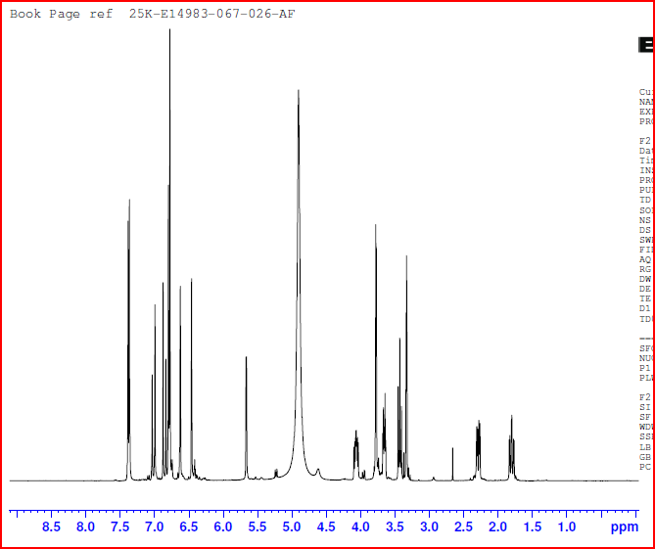
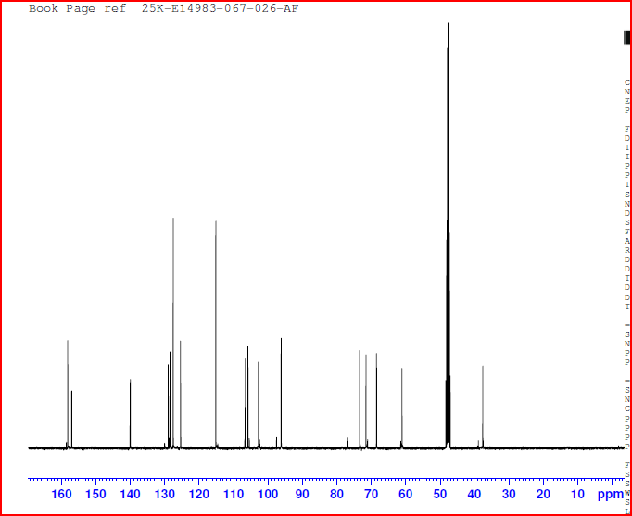
Fig. S1. ¹H and ¹³C NMR spectra of compound 6.
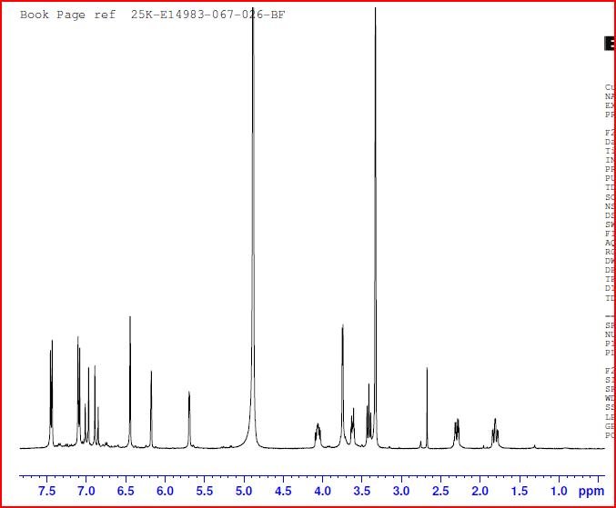
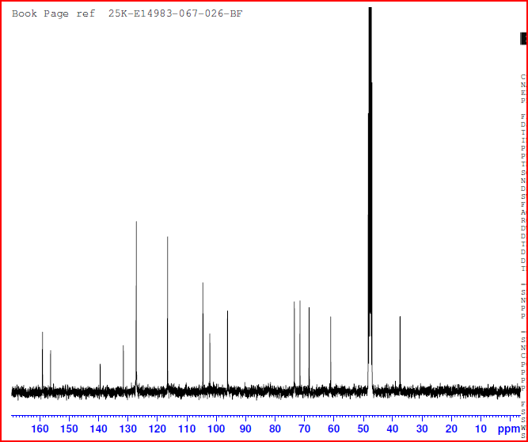
Fig. S2. ¹H and ¹³C NMR spectra of compound 7.
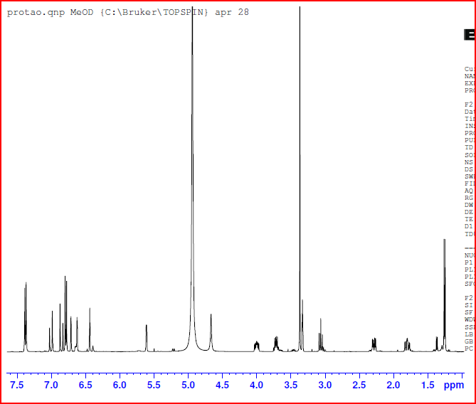
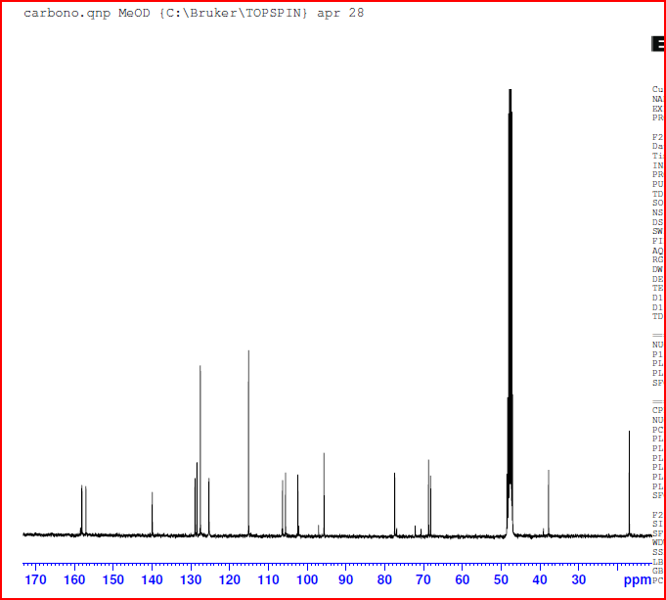
Fig. S3. ¹H and ¹³C NMR spectra of compound 10.
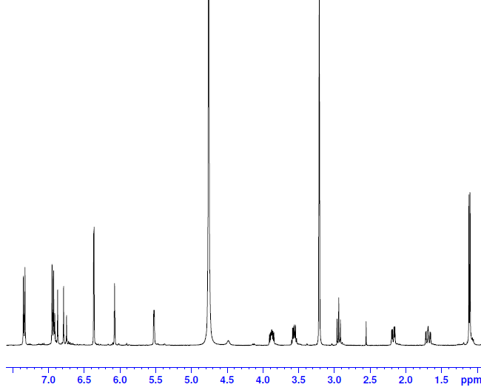
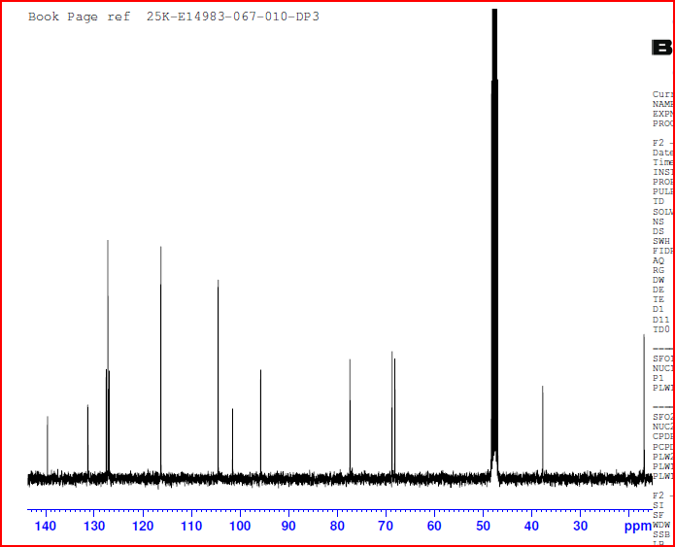
Fig. S4. ¹H and ¹³C NMR spectra of compound 11.
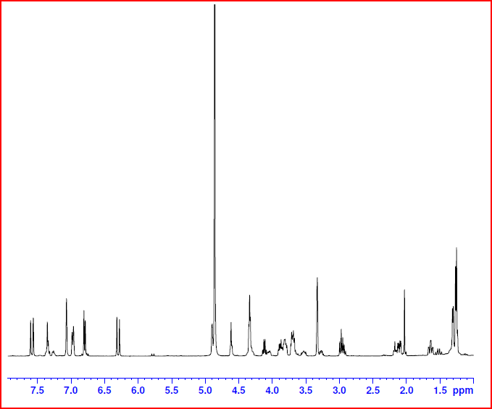
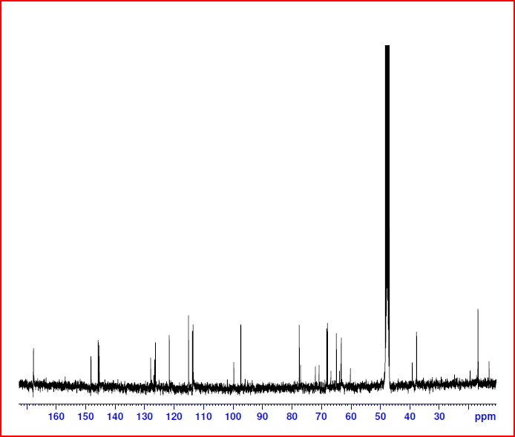
Fig. S5. ¹H and ¹³C NMR spectra of compounds 17a,b.

